**TOSHKENT DAVLAT TRANSPORT UNIVERSITETI**

“TRANSPORTDA AXBOROT TIZIMLARI VA TEXNOLOGIYALARI” KAFEDRASI

**LABORATORIYA ISHI**

BAJARDI: AT-32 GURUH TALABASI

YUSUPOV U.Sh

TEKSHIRDI: TOSHMETOV T

TOSHKENT – 2021

LABORATORIYA ISHI – 2

1-shart



import java.util.Scanner;

public class Main

{

public static void main(String[] args) {

Scanner scanner = new Scanner(System.in);

System.out.print("Malumotlarni baytlarda kiriting. Biz uni kilobaytda chiqarib beramiz. byte = ");

int bytes = scanner.nextInt();

int kilobytes = bytes / 1024;

System.out.print(kilobytes + " kb");

}

}

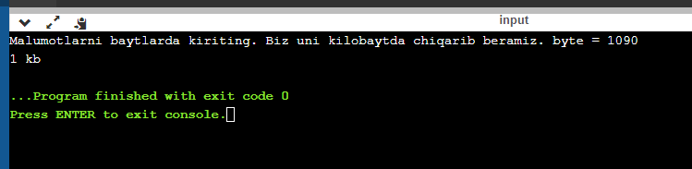

2-shart

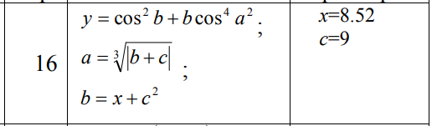

import java.util.Scanner;

public class Main

{

public static void main(String[] args) {

Scanner scanner = new Scanner(System.in);

final double x = 8.52;

System.out.print("c = ");

double c = scanner.nextInt();

double b = x + Math.pow(c, 2);

double a = Math.pow(Math.abs(b + c), 1/3);

double y = Math.pow(Math.cos(b), 2) + b * Math.pow(Math.cos(Math.pow(a, 2)), 4);

System.out.print("a = " + a + " b = " + b + " y = " + y);

}

}

