**TOSHKENT DAVLAT TRANSPORT UNIVERSITETI**

“TRANSPORTDA AXBOROT TIZIMLARI VA TEXNOLOGIYALARI” KAFEDRASI

**LABORATORIYA ISHI**

BAJARDI: AT-32 GURUH TALABASI

YUSUPOV U.Sh

TEKSHIRDI: TOSHMETOV T

TOSHKENT – 2021

LABORATORIYA ISHI – 3

1-shart



import java.util.Scanner;

public class Main

{

public static void main (String[]args)

{

Scanner scanner = new Scanner (System.in);

System.out.print("X = ");

int X = scanner.nextInt();

System.out.print("Y = ");

int Y = scanner.nextInt();

System.out.print("Z = ");

int Z = scanner.nextInt();

if (X % 5 == 0 && Y % 5 != 0 && Z % 5 != 0 || X % 5 != 0 && Y % 5 == 0 && Z % 5 != 0 || X % 5 != 0 && Y % 5 != 0 && Z % 5 == 0) {

System.out.print(true);

} else {

System.out.print(false);

}

}

}

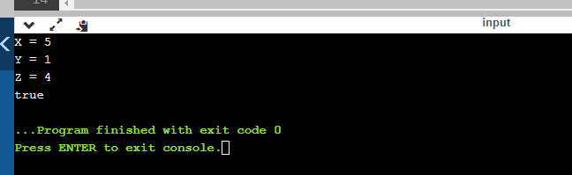

2-shart

import java.util.Scanner;

public class Main

{

public static void main (String[]args)

{

Scanner scanner = new Scanner (System.in);

System.out.print("A = ");

int A = scanner.nextInt();

System.out.print("B = ");

int B = scanner.nextInt();

System.out.print("C = ");

int C = scanner.nextInt();

System.out.print("D = ");

int D = scanner.nextInt();

int count = 0;

int [] arr = {A, B, C, D};

for (int i = 0; i < 4; i++) {

if (arr[i] % 2 == 0) {

count++;

}

}

if (count == 2) {

System.out.print("Rostan ham 2 tasi juft");

} else {

System.out.print("2 tasi juftmas yoki kam yoki ko`p");

}

}

}