To what extend does food from a microwave harmful for the organism of a human?

Yulia Dichenko

Physics SL IA

Candidate Number: 006047-0009

(1930w)

May 2016

**Table of contents**

Objective..…………………………………………………………………...3

Process of working microwave……………………………………………...4

Theory……………………………………………………………………….5

Materials……………………………………………………………………..6

Method 1………………………………………….…………………………6

Data 1………………………………………….…………………………….6

Method 2………………………………………….…………………………6

Data 2………………………………………….…………………………….7

Is polarization of dipoles harmful for the human body? ……………………7

The opinions of scientists "for" and "against"……………………………….8

Advices for usage of microwave…………………………………………….9

Conclusion………………………………………………………………….10

Bibliography………………………………………………………………..11

**Objective**

We live in a high technological age. Technological progress has reached incredible peaks, but people have not become less sick. Furthermore, with the development of technology and increase of electrical machinery, there is a number of diseases, existence of which no one would assume. Even 10 years ago, no one thought that instead of a huge TV and a computer monitor will come LCD and plasma models. A phone now is almost the size of a matchbox, and in the kitchen there is a lot of technology. Microwave is a household appliance that is designed for fast food or quick-heating food. It is used as a microwave for defrosting food.

Every day I have to warm up my food using the microwave oven, because such a furnace has long been a familiar subject in our kitchen. Recently, however, an increasing number of information tells that food cooked in a microwave oven can cause irreparable harm to human health. Under the influence of microwave food is destroyed at the molecular level, irreversible changes take place, and as a result of our "harmless" foods produced substances that can cause cancer. After getting this information I tried to find out, is it really a risk eating food from the microwave?

**Process of a working microwave**

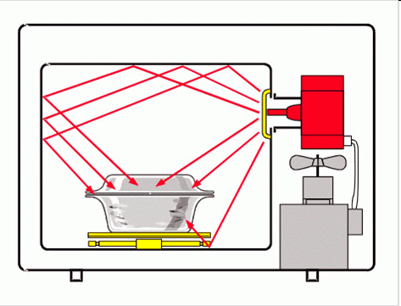

  Initially, I found out how the microwave works. It turns out the most important part of any microwave is a magnetron. Thanks to him, the electrical energy from your network is converted to a high-frequency electric field frequency of 2450 megahertz (MHz). Magnetron, creating an electric field that directs it through the waveguide into the cooking chamber, houses the product containing water (water is a dipole, since water molecule consists of positive and negative charges).

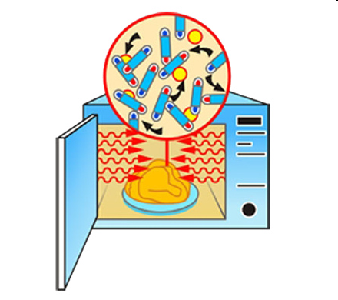

Exposure to external electric field on the product leads to the fact that the dipoles are beginning to polarize, dipoles begin to turn. When you turn the dipoles arise friction forces, which are converted, to heat. Since the polarization of the dipoles occurs throughout the volume of the product, causing it to become hot. Microwave’s magnetron is very short electromagnetic waves that travel through space at the speed of light (299,792 kilometers per second).

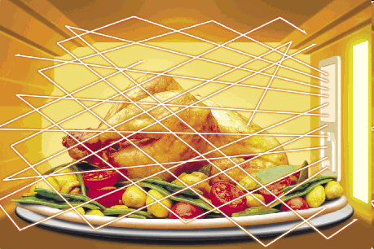

Once the microwaves enter into the furnace chamber begins its reflection from the metallic walls. Thus, microwaves can all sides affect prepared products.

Microwaves are one of great importance for the modern man; they are used for telephone communication, the transmission of television programs in the world of the Internet and via satellite. In this case, the microwaves are used for rapid cooking. Microwave operates at a frequency of 2.45 GHz (a wavelength of 12.24 cm). From a conventional oven or a microwave oven is characterized in that it heating of foods does not occur at the surface but the most part of volume products containing water. This is due to the fact that almost all foods radio waves penetrate to a greater depth, thereby reducing the cooking time.

**Theory**

In the media, I found the information that the rumors of radiation, which allegedly subjected to microwave ovens owners, refute many prominent scientists. They argue that there is no reason to fear. Microwaves appear only after the complete closure of the door and turn on the oven. In a working stove, microwave applies only to food during cooking. Waves protect us from glass coated with a special protective mesh and sealed housing.

         With the penetration of food, energy, the oven is completely converted into heat, while there remains no "rest" energy that can hurt you in the use of food cooked in the oven. Virtually all-modern microwave ovens do not work when you open the oven door. Do not switch on an empty microwave oven, since the magnetron will not interact with anything and it may malfunction. Its box is constructed so that the emitted wavelength cannot escape. But there is a version that the gap around the door, the microwave can pass. Therefore it is recommended to depart in the direction when you turn the stove.

**Materials**

* 2 Cellphones
* Microwave

**Method 1**

* Put the mobile phone into an microwave, not turning it on
* Close the door
* Call on the phone.

**Data 1**

The signal didn’t reach, because it said: "the phone number is out of the coverage" which means that the walls of my microwave are safe and they "hold" waves in the microwave. You can try this test with your microwave. If calls "reach" your phone, then better not to use the stove. If microwave is reliably hold back the waves during cooking, then they cannot "get out.

**Method 2**

To have more information about harm from microwaves on humans’ body I decided to make a one-question survey. “Is a microwave harmful for human’s body? 100 people answered this question. These people are from Russia, but they are from different cities and towns. This survey was anonyms.

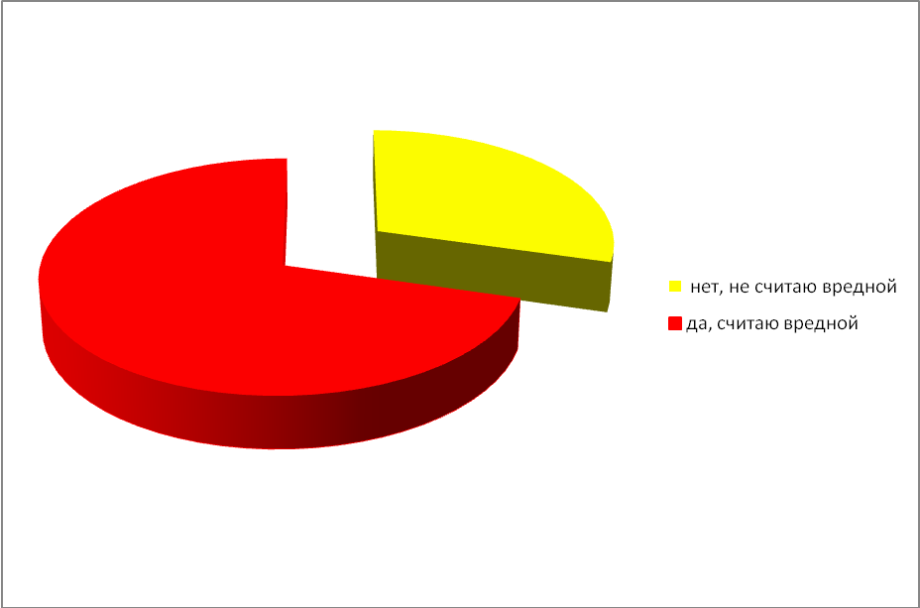**Data 2**

(Yellow part translates as “No, don’t consider as harmful”; Red part translates as “Yes, consider as harmful”)

As we see from a cercal diagram, more than 60% of people think, that microwave is not harmful. I think these results are based on assumption, that if they use it every day in their lives and now they are not dying, that’s mean there is no problem.

**Is polarization of dipoles harmful for the human body?**

Microwaves Disputes over effects on the body break all records. Once in market appeared microwave and immediately arose horror story: "Food from the microwave causes cancer." Another scary stories were, that the food from the microwave downright crowded carcinogens ... So I tried to figure out: Is polarization of dipoles harmful for the human body?

In 1989, Swiss biologist Hertel with Professor Bernard Blanc tried to investigate the effect of microwave meals per person. Since the money for a full-scale study they were not allowed, the scientists were limited to one guinea, which in turn eaten food cooked on the stove, and then - in a microwave oven. Scientists have claimed that after microwave food in the blood of the experimental changes occurred, reminiscent of the beginning of the pathological process. That is cancer. In other words, increasing the number of leukocytes. Therefore, regular eating of microwaved food may lead to cancer of the blood, say scientists. But their words are not heeded.

**The opinions of scientists "for" and "against"**

          American scientists claim that thanks to the microwave in the Americas decreased stomach cancer. And all because the food cooked in the microwave, do not add oil. A method of cooking reminds the most gentle - steam. And microwave two times better preserve the vitamins and minerals in food due to low cooking time. The Institute of Nutrition Academy of Sciences estimated that in the preparation of food on the plate is destroyed up to 60% of vitamin C, but under the influence of microwaves is only from 2% to 25%. And this year the World Health Organization issued a verdict: to the microwave radiation is used that does not adversely affect either the man or the food. The only "but": implanted pacemakers may be sensitive to the flow rate of the microwaves. Therefore, who recommends to those who have a pacemaker, to abandon cell phones and microwave ovens.

On the Internet I found the answers to the most interesting preconceptions about the dangers of microwaves: the microwaves make food radioactive or radioactive. This is incorrect: the microwaves are classified as non-ionizing radiation. They do not exert any influence on the radioactive substance, biological tissues and food products. Microwaves alter the molecular structure or make food products carcinogenic. This is also incorrect. The operating principle of the microwaves is different from that of X-rays or ionizing radiation, and make the products they may be carcinogenic. On the contrary, since the cooking using microwaves require a very small amount of fat, ready meal contains less fat blown with altered by heat-treating the molecular structure. Therefore, cooking with microwaves healthier and poses no danger to humans.

            Microwave ovens emit dangerous radiation. This is not true. Although the direct impact of microwaves can cause thermal tissue damage, the risk for the use of a working microwave oven is completely absent. The furnace design provides tough measures to prevent the escape of radiation out: there is duplicate devices lock the microwave source when you open the oven door, and the door itself will prevent the microwaves outside the cavity. Neither the body nor any other part of the furnace or placed in oven foods do not accumulate the electromagnetic radiation in the microwave range. Once the furnace is turned off, the emission of microwaves is stopped.

For those who are afraid even to come close to the microwave oven, you need to know that microwaves quickly decay in the atmosphere. As a consequence of such a strong attenuation, the contribution of the microwaves in the general background of the surrounding electromagnetic radiation is not higher than, say, from the TV, to which we are ready to sit for hours without fear or mobile phone, which we so often hold his temple. Just not worth it based on the elbow working microwave oven, or a person to lean against the door, trying to see what is happening in the cavity. It is enough to move away from the oven at arm's length, and you can feel completely safe.

**Advices for usage of microwave**

Now let's talk about the pot in which the food is heated. The fact is that certain types of dishes reflect the microwaves. It is the best to use a clear glass bowl; it is the best to let microwaves go through. However, do not put in the microwave dishes and cups of crystal. Almost all of its types of porcelain are suitable for cooking in the microwave, but you cannot use dishes with gilded or silvered pattern.

Utensils made of plastic can easily be deformed if it is sensitive to heat. Therefore, when using plastic, make sure that it was the inscription on the "thermal stability up to 140 degrees."

Microwaves are reflected from the aluminum foil and cannot penetrate. However, these properties can be made to benefit if the aluminum foil cover those parts of products that can easily burn slightly, for example wings or legs of poultry, fish tail or head, during the thawing process.

Metal utensil absolutely is not suitable for cooking in the oven. This applies to pots, pans made of steel, cast iron, enamel, and utensils made of aluminum and copper. There is a simple test to determine the suitability of utensils used in microwave ovens. If you reheat a bowl and heat only the food, but a piece of plate is not present, such a vessel can be used. Microwaves do not heat up such utensils, but, with time, this tableware is heated by heat, which accumulates in the heated food.

**Conclusion**

 The final verdict of the microwave oven has not been passed. Many scholars continue to study its effect on the human body. And while not completely proven harm from the microwave, try if possible to cook on the stove and in the microwave just to warm up or defrost food. Try not to be near the stove turned on and not allow children close to 2 meters from the microwave included. Do not use a faulty furnace. It is especially important that the door closes properly and is not damaged. Before using, carefully read the instructions in the oven, in order to properly use it. Do not try to repair the oven yourself, use the services of qualified professionals.

**Bibliography**

"Microwaves Don't Cook From the Inside Out." *Today I Found Out*.

N.p., 22 Oct. 2010. Web. 22 Jan. 2016.

"Microwave Ovens." *Microwave Ovens*. N.p., n.d. Web. 22 Jan.

2016.

"Microwaves." *The Electromagnetic Spectrum:*. N.p., n.d. Web. 22

Jan. 2016.

"Producing Microwaves." *Instructables.com*. N.p., n.d. Web. 22 Jan.

2016.

"SCI-TECH ... The Cool Site for Hot Science." *SCI-TECH ... The Cool*

*Site for Hot Science*. N.p., n.d. Web. 22 Jan. 2016.

"Why Are the Microwaves in a Microwave Oven Tuned to Water?"

*Science Questions with Surprising Answers*. N.p., n.d. Web. 22

Jan. 2016.