Asignacion5.R

aby

2021-04-26

#YULIA ABIGAIL ORTIZ CUEVAS   
#26.04.2021  
#ASIGNACIÓN 5  
  
  
# Ejercicio 1 -------------------------------------------------------------  
  
  
speed <- c(2, 3, 5, 9, 14, 24, 29, 34)   
head(speed)

## [1] 2 3 5 9 14 24

abundance <- c(6, 3, 5, 23, 16, 12, 48, 43)   
head(abundance)

## [1] 6 3 5 23 16 12

#media  
mean(speed)

## [1] 15

mean(abundance)

## [1] 19.5

#Diagrama  
plot(speed, abundance, col= "red", xlab = "Variable independiente",   
 ylab= "Variable dependiente", pch=20)  
abline(lm(abundance~ speed))

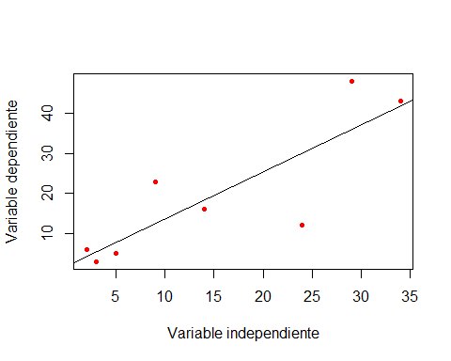

#correlacion  
cor.test(speed, abundance)

##   
## Pearson's product-moment correlation  
##   
## data: speed and abundance  
## t = 3.8568, df = 6, p-value = 0.008393  
## alternative hypothesis: true correlation is not equal to 0  
## 95 percent confidence interval:  
## 0.3442317 0.9711386  
## sample estimates:  
## cor   
## 0.8441408

#Datos  
#grados de libertad = 6   
#Correlación o r = 0.84   
#Valor de significancia = 0.0083  
#Existe una significancia ya que p-value es menor a 0.05   
#hipotesis alternativa  
  
# Ejercicio 2 -------------------------------------------------------------  
  
#Importar datos  
  
suelo <- read.csv("https://raw.githubusercontent.com/YuliaAbigail18/PrincipiosDeEstad-stica2021/main/suelo.csv")  
head(suelo)

## X Group Contour Depth Gp Block pH N Dens P Ca Mg K Na  
## 1 1 1 Top 0-10 T0 1 5.40 0.188 0.92 215 16.35 7.65 0.72 1.14  
## 2 2 1 Top 0-10 T0 2 5.65 0.165 1.04 208 12.25 5.15 0.71 0.94  
## 3 3 1 Top 0-10 T0 3 5.14 0.260 0.95 300 13.02 5.68 0.68 0.60  
## 4 4 1 Top 0-10 T0 4 5.14 0.169 1.10 248 11.92 7.88 1.09 1.01  
## 5 5 2 Top oct-30 T1 1 5.14 0.164 1.12 174 14.17 8.12 0.70 2.17  
## 6 6 2 Top oct-30 T1 2 5.10 0.094 1.22 129 8.55 6.92 0.81 2.67  
## Conduc  
## 1 1.09  
## 2 1.35  
## 3 1.41  
## 4 1.64  
## 5 1.85  
## 6 3.18

#correlacion ph-n  
cor.test(suelo$pH, suelo$N)

##   
## Pearson's product-moment correlation  
##   
## data: suelo$pH and suelo$N  
## t = 5.5994, df = 46, p-value = 1.149e-06  
## alternative hypothesis: true correlation is not equal to 0  
## 95 percent confidence interval:  
## 0.4303716 0.7797377  
## sample estimates:  
## cor   
## 0.636654

#Diagrama ph-n  
plot(suelo$pH, suelo$N)

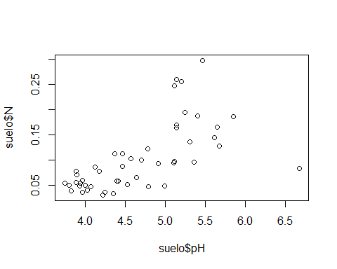

#correlación ph-dens  
cor.test(suelo$pH, suelo$Dens)

##   
## Pearson's product-moment correlation  
##   
## data: suelo$pH and suelo$Dens  
## t = -4.9436, df = 46, p-value = 1.062e-05  
## alternative hypothesis: true correlation is not equal to 0  
## 95 percent confidence interval:  
## -0.7479775 -0.3661760  
## sample estimates:  
## cor   
## -0.5890264

#diagrama ph-dens  
plot(suelo$pH, suelo$Dens)

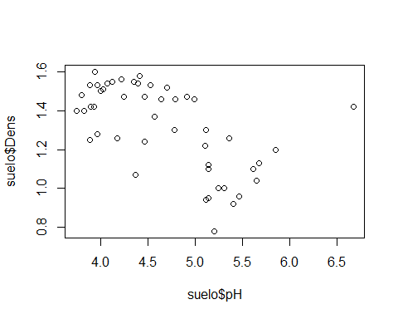

#correlacion ph-p  
cor.test(suelo$pH, suelo$P)

##   
## Pearson's product-moment correlation  
##   
## data: suelo$pH and suelo$P  
## t = 4.9694, df = 46, p-value = 9.74e-06  
## alternative hypothesis: true correlation is not equal to 0  
## 95 percent confidence interval:  
## 0.3688348 0.7493286  
## sample estimates:  
## cor   
## 0.5910303

#diagrama  
plot(suelo$pH, suelo$P)

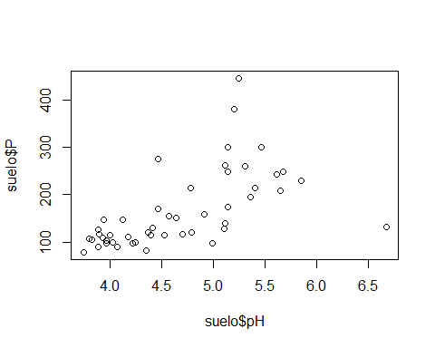

#correlacion ph-ca  
cor.test(suelo$pH, suelo$Ca)

##   
## Pearson's product-moment correlation  
##   
## data: suelo$pH and suelo$Ca  
## t = 9.3221, df = 46, p-value = 3.614e-12  
## alternative hypothesis: true correlation is not equal to 0  
## 95 percent confidence interval:  
## 0.6809493 0.8885997  
## sample estimates:  
## cor   
## 0.8086293

#Diagrama  
plot(suelo$Ca, suelo$Ca)

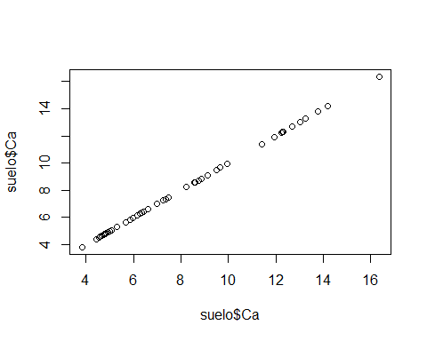

#correlacion ph-mg  
cor.test(suelo$pH, suelo$Mg)

##   
## Pearson's product-moment correlation  
##   
## data: suelo$pH and suelo$Mg  
## t = -2.923, df = 46, p-value = 0.005361  
## alternative hypothesis: true correlation is not equal to 0  
## 95 percent confidence interval:  
## -0.6111857 -0.1257936  
## sample estimates:  
## cor   
## -0.3957821

#diagrama  
plot(suelo$pH, suelo$Mg)

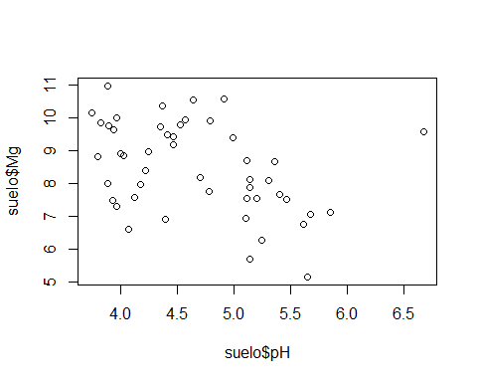

#correlacion ph-k  
cor.test(suelo$pH, suelo$K)

##   
## Pearson's product-moment correlation  
##   
## data: suelo$pH and suelo$K  
## t = 4.8236, df = 46, p-value = 1.585e-05  
## alternative hypothesis: true correlation is not equal to 0  
## 95 percent confidence interval:  
## 0.3536810 0.7415855  
## sample estimates:  
## cor   
## 0.5795727

#diagrama ph-k  
plot(suelo$pH, suelo$K)

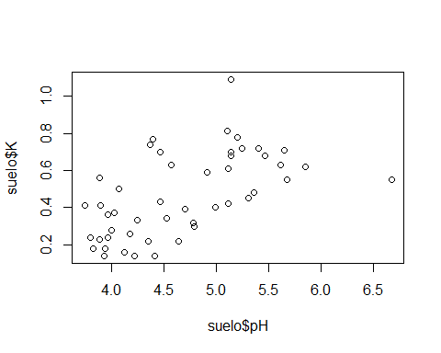

#correlacion ph  
cor.test(suelo$pH, suelo$Na)

##   
## Pearson's product-moment correlation  
##   
## data: suelo$pH and suelo$Na  
## t = -6.5242, df = 46, p-value = 4.724e-08  
## alternative hypothesis: true correlation is not equal to 0  
## 95 percent confidence interval:  
## -0.8165520 -0.5094849  
## sample estimates:  
## cor   
## -0.6932614

#Diagrama  
plot(suelo$pH, suelo$Na)

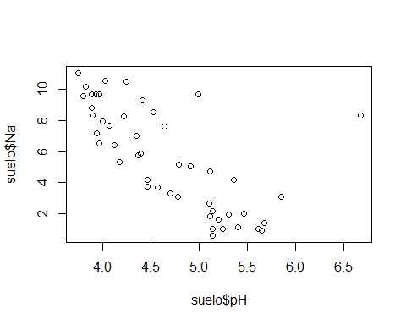

#correlacion ph-conduct  
cor.test(suelo$pH, suelo$Conduc)

##   
## Pearson's product-moment correlation  
##   
## data: suelo$pH and suelo$Conduc  
## t = -8.0515, df = 46, p-value = 2.484e-10  
## alternative hypothesis: true correlation is not equal to 0  
## 95 percent confidence interval:  
## -0.8616916 -0.6141322  
## sample estimates:  
## cor   
## -0.7648104

#diagrama  
plot(suelo$pH, suelo$Conduc)

