Yulia Mostovoi
CSD-310 | Assignment 1.2

GitHub Repository Setup

Repository URL
https://github.com/YuliaMostovoi/csd-310

1. Local Directory Screenshot
Terminal output showing the csd-310 working directory and the module-1 folder created using mkdir and verified using ls.
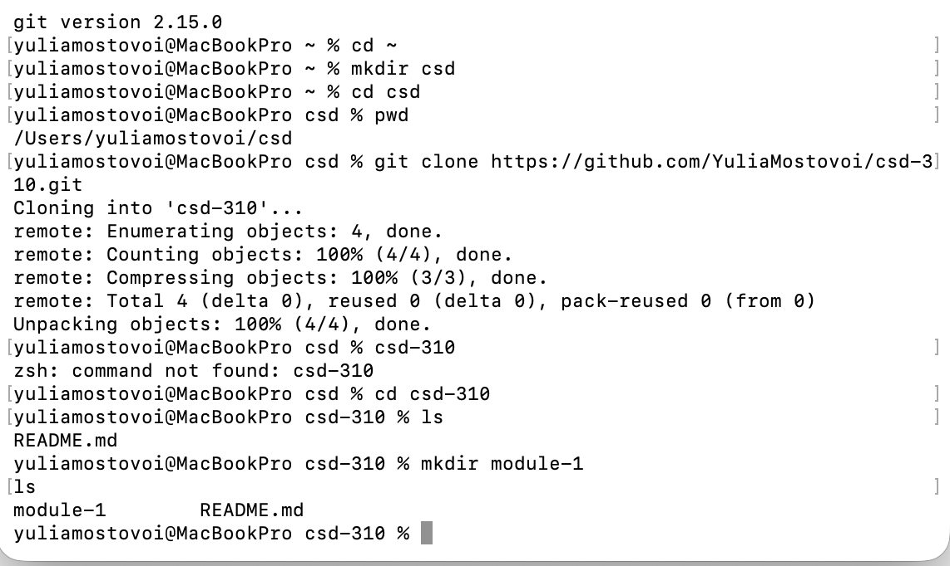

2. GitHub Repository Screenshot
Initial repository view showing the public csd-310 repository, README.md, and Python .gitignore.


