Name: Yulia Mostovoi
Date: November 1, 2026
Assignment: CSD-310 Module 2.3 – Data Models

Entity Relationship Diagram (ERD)
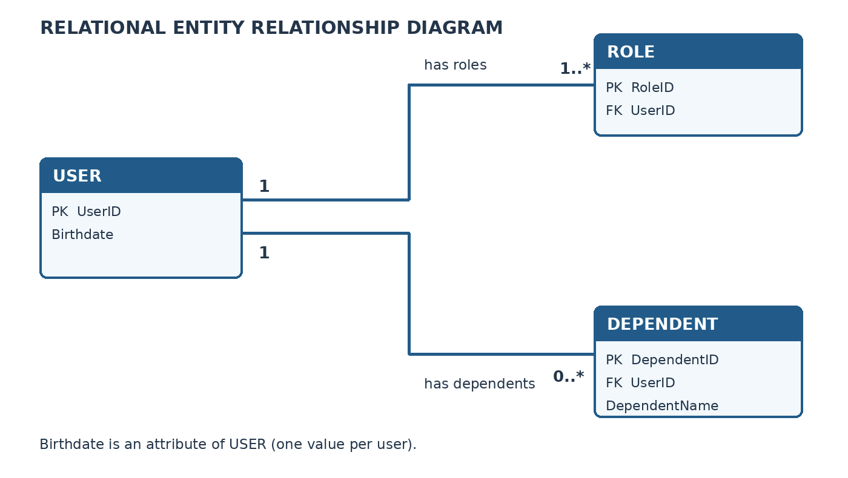
A USER has many ROLES, one BIRTHDATE, and may have many DEPENDENTS. Birthdate is represented as a single-valued USER attribute.

NoSQL Data Structure
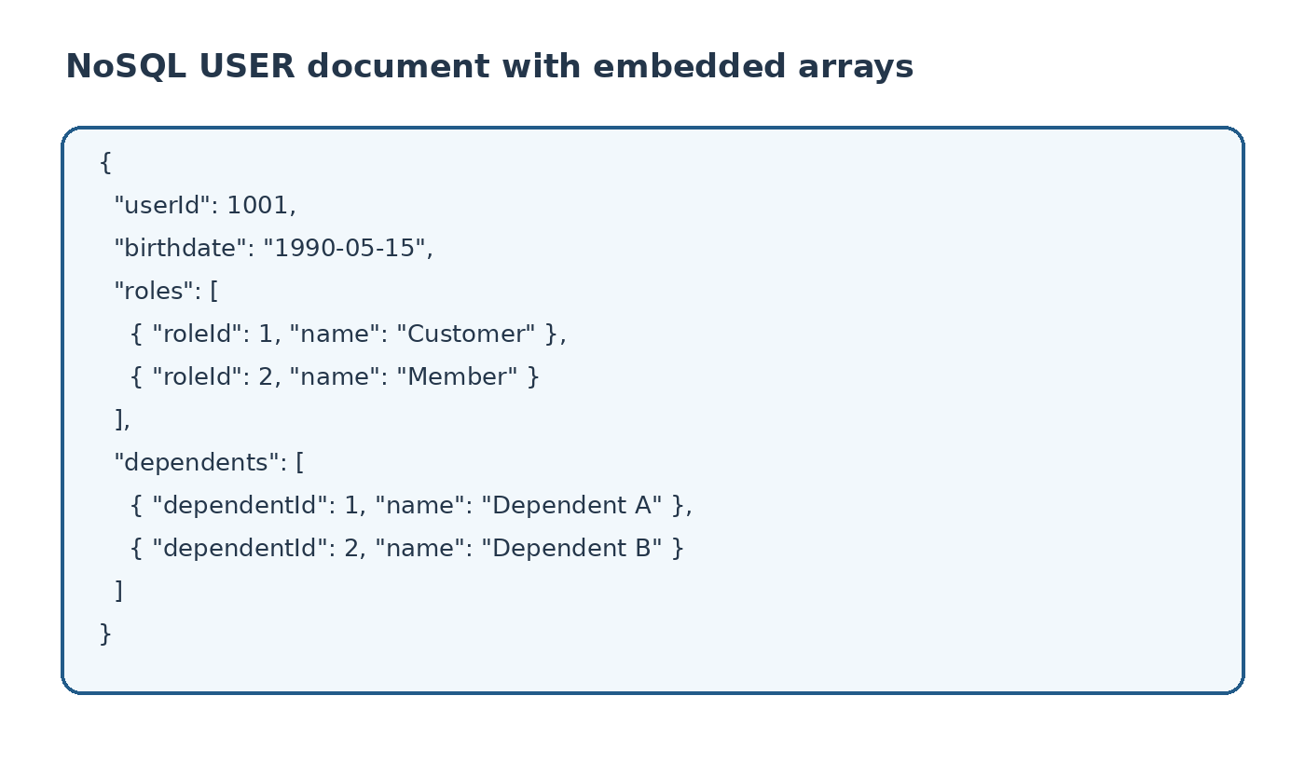
The NoSQL model embeds roles and dependents as arrays in one USER document. Example values are illustrative.

