Yulia Mostovoi
CSD-325 – Assignment 3.2: Brownfield + Flowchart(s)
November 8, 2026

Cho-Han Program Flowchart
Flow of the supplied Cho-Han game, including the updated YM input prompts, 12% house fee, and bonus for dice totals of 2 or 7.
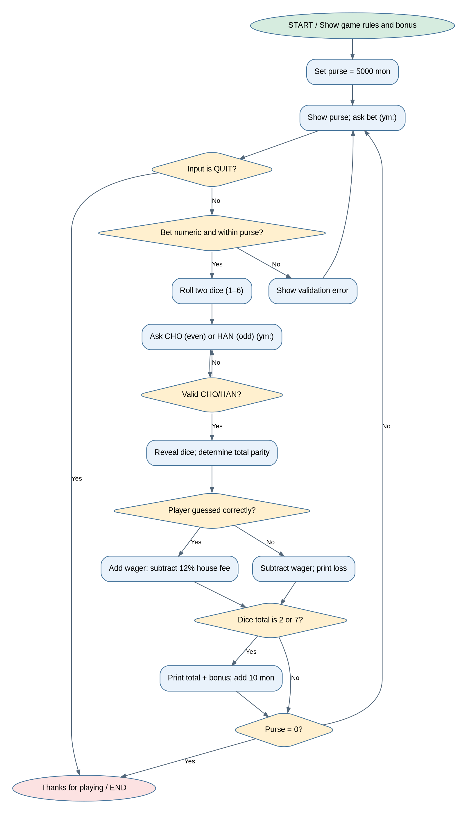
Source: Cho-Han by Al Sweigart, provided in the course assignment. Modified by Yulia Mostovoi for CSD-325 Module 3.2.

