Yulia Mostovoi
October 25, 2026
CSD-325 | Module 1.2 Assignment
GitHub Repository Setup

GitHub Repository Link
https://github.com/YuliaMostovoi/csd-325

Local Directory Screenshot
Terminal output showing the cloned csd-325 repository and the module-1 folder.
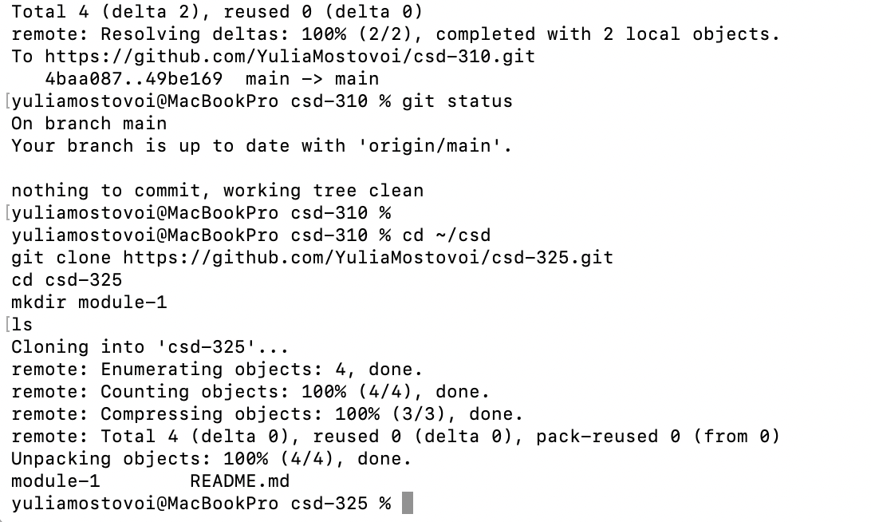

GitHub Repository Screenshot
Insert a screenshot of the csd-325 GitHub repository showing the module-1 folder and Mostovoi-Assignment1_2.docx after the first push. Save the document and push the updated version to GitHub.

