Part 1: Executive Summary & Introduction
Executive Summary
This project aims to predict song popularity on Spotify using machine learning techniques.
The dataset contained over 32K tracks with audio and playlist metadata.
The workflow followed a structured data-science lifecycle: Data Preparation, Exploratory Analysis, Data Cleansing, Feature Engineering, Feature Selection, and Model Evaluation.
Three different feature-selection strategies were tested to optimize predictive accuracy and interpretability.
The second approach, which integrated Target Encoding, a method that replaced artist and playlist names with their average popularity scores, produced the most balanced and stable results and was selected as the final model.
The fine-tuned XGBoost model achieved an R² of about 0.55 on unseen data, demonstrating moderate predictive power.
The analysis shows that playlist exposure and artist recognition are the strongest factors associated with track popularity, while musical features such as energy, valence, and instrumentalness have weaker effects.
These findings suggest that track popularity depends not only on the song’s sound but also on how visible it is through playlists and well-known artists within the Spotify ecosystem.
Introduction
Music streaming platforms such as Spotify generate enormous amounts of user interaction data.
Predicting the popularity of a song - measured by Spotify’s internal popularity score (0-100), can help playlist curators, record labels, and recommendation systems identify which tracks are likely to attract listeners.
This project explores Spotify track-level data and develops predictive models to estimate a song’s popularity based on its audio profile, release information, and playlist metadata.
The focus was to build a clean, explainable, and reproducible pipeline aligned with data-science best practices, from raw data to model interpretation.
Objectives
The primary objectives of the analysis were:
- To explore and clean the raw Spotify dataset and understand its structure.
- To identify relationships between track features (such as energy, valence, or loudness) and popularity.
- To engineer new variables that might improve predictive power (e.g., keyword flags, release-date components, artist/playlist statistics).
- To compare several feature-selection and modeling strategies and select the most effective one.
- To deliver an interpretable, reproducible model capable of supporting data-driven playlist curation.

Part 2: Data Journey & Methodology
The project followed a complete end-to-end data science pipeline, structured in six notebooks:
- Data Preparation - Importing and cleaning the raw dataset from Kaggle’s Spotify Songs Dataset, containing 32,833 tracks and 23 initial columns.
Text normalization was performed (removing emojis, dashes, and special characters) to create a flat, structured dataset suitable for further processing.
- Exploratory Data Analysis (EDA) - Understanding data distributions and initial correlations between variables.
- Data Cleansing - Identifying and handling missing values, identifying and handling outliers using IQR (Interquartile Range) based thresholds, correlation checks and distribution analysis.
- Feature Engineering - Creating derived variables such as release components, counts, and keyword flags.
- Feature Selection - Comparing multiple approaches to identify the most informative predictors.
- Modeling and Evaluation - Training, tuning, and evaluating machine learning models to predict track popularity.
All notebooks were executed in Google Colab, with storage and intermediate results managed in Google Drive (Pickle files).
Python libraries used included: pandas, numpy, matplotlib, seaborn, scikit-learn, xgboost, and category_encoders.
The project maintained clear reproducibility by saving cleaned and processed data at every step.

Data Preparation
- The dataset contained 32,833 tracks and 23 features, including both audio and metadata attributes.
- The main target variable was track_popularity (integer, 0-100).
- The data included identifiers (track_id, album_id, playlist_id), categorical variables (playlist_genre, subgenre, key, mode), and continuous variables (danceability, energy, loudness, etc.).
- During data preparation, several text fields (e.g., track_name, track_artist) were normalized by removing punctuation, emojis, and inconsistent capitalization to ensure a clean, flat text format.

Exploratory Data Analysis (EDA)
The exploratory analysis aimed to understand the dataset’s composition and detect data-quality issues before modeling.

- Initial Findings
- track_album_release_date had multiple date formats - some only with year (e.g., “2010”), others with year and month, and others full dates.
- Genre distribution showed 6 main genres and 24 subgenres.

- Insights from EDA

Automated profiling (via Sweetviz) and manual inspection revealed:
- Continuous features were mostly within expected musical ranges.
- Early histograms suggested several right-skewed distributions (e.g., speechiness, instrumentalness, acousticness).
- Correlation heatmaps- Spearman correlation was used instead of Pearson because several variables were non-normally distributed. energy and loudness showed a strong positive correlation (0.66), while energy and acousticness were moderately negative (-0.49). danceability correlated moderately with valence (0.33), reflecting that happier songs are often more danceable. release_year had a moderate correlation with duration variables (0.45), suggesting that newer songs tend to be slightly longer. Duration features were perfectly correlated with each other. No strong linear correlation with popularity was evident, confirming the need for feature engineering.

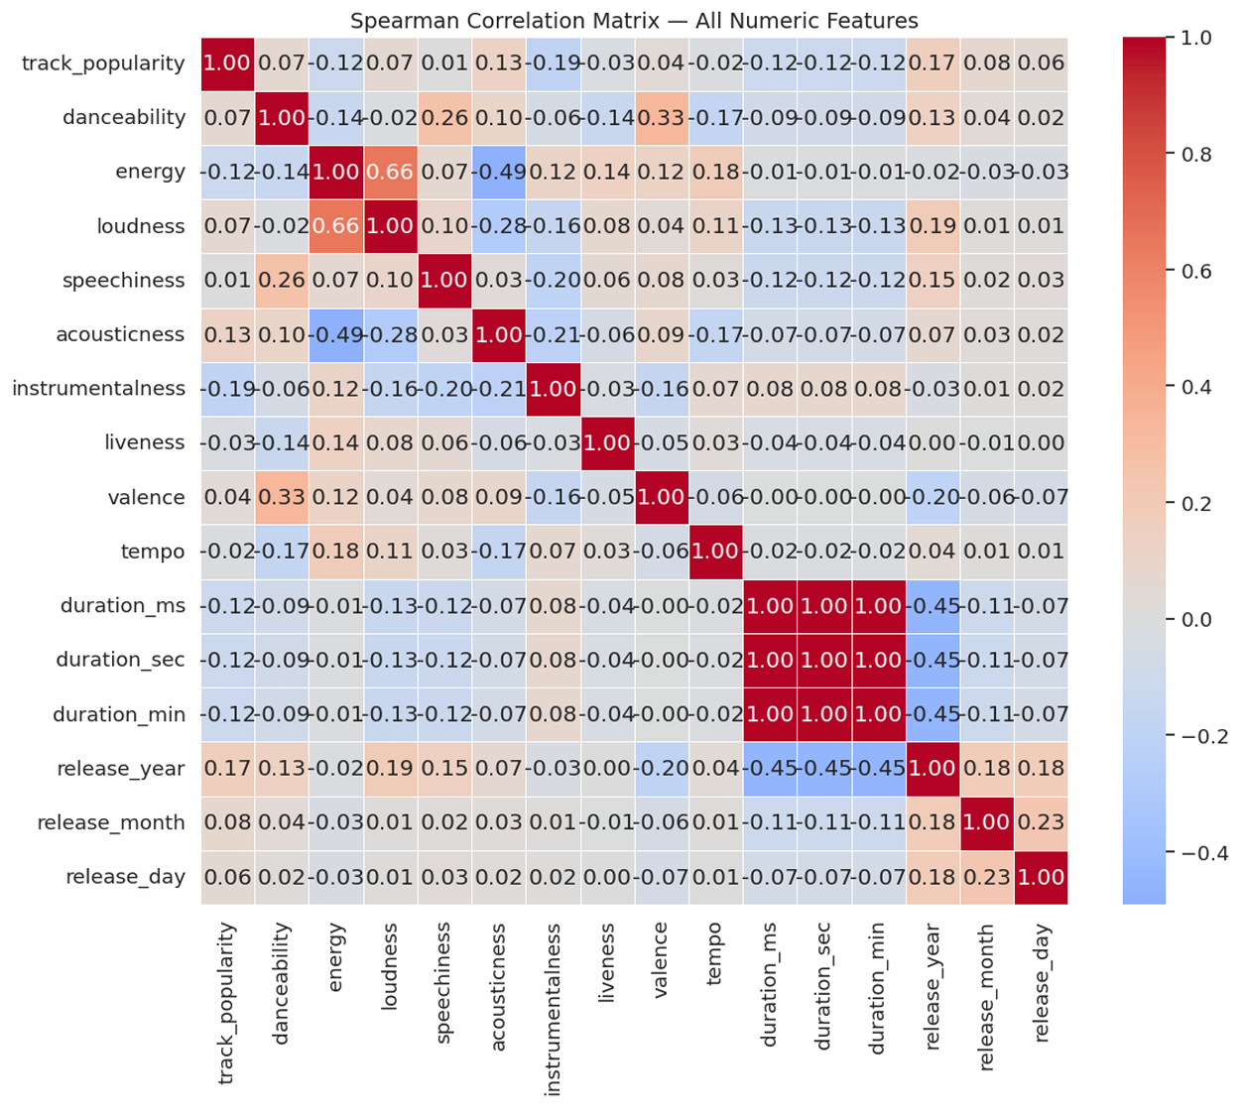

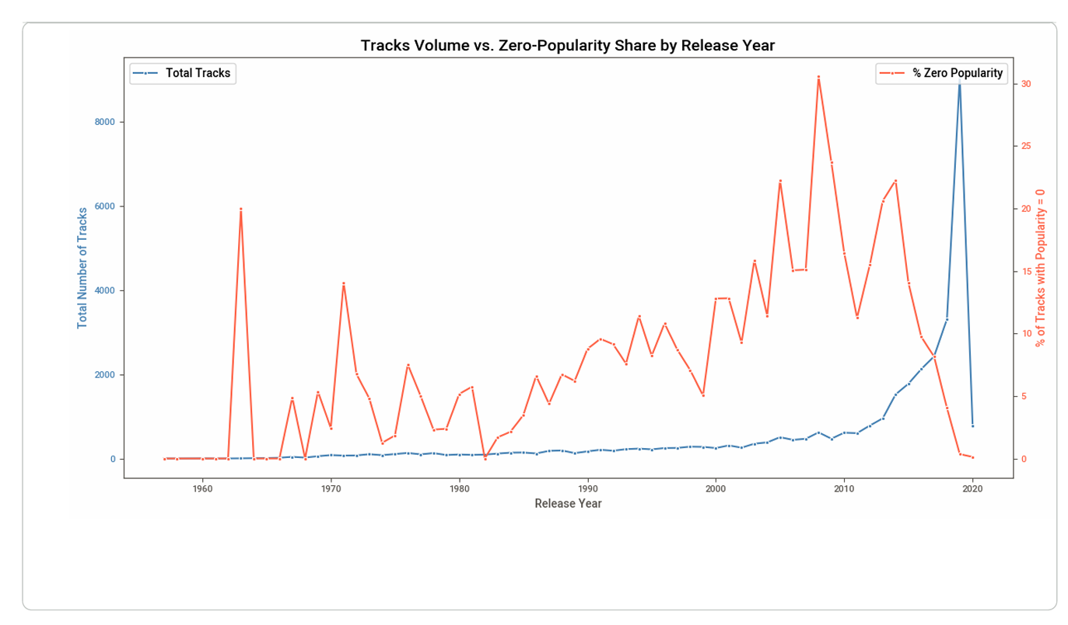
The chart compares the total number of tracks released per year (blue line) with the share of tracks that have zero popularity (red line).
A major spike in zero-popularity tracks appears in 2008, aligning with Spotify’s launch while the total number of tracks remained unchanged. Another increase occurs around 2014, yet it is not consistent with the moderate rise in total track volume.
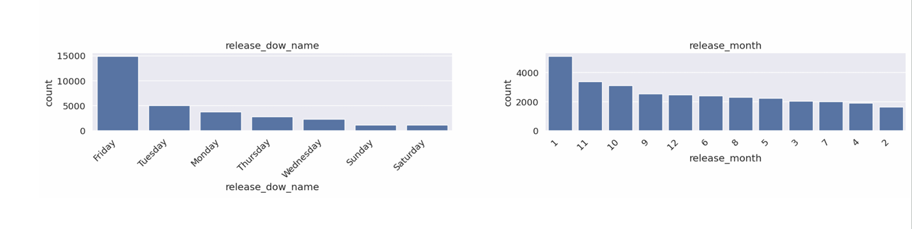
The majority of tracks were released on Fridays.
Additionally, most releases occurred in January, possibly reflecting artists’ and labels’ tendency to publish new material at the beginning of the calendar year.
The EDA phase provided a data-driven foundation for the cleaning and feature engineering steps that followed.

Part 3: Data Cleansing
The cleansing stage ensured data consistency, managed outliers, and handled missing values.
Outlier Detection
Outliers were assessed for ten continuous variables using the IQR method.
The percentage of outliers for each feature was calculated and visualized via boxplots and histograms.
Feature | % Outside IQR
instrumentalness | 21.41%
Speechiness | 9.67%
Acousticness | 6.72%
Liveness | 5.61%
duration_ms | 4.22%
Loudness | 3.11%
Tempo | 1.74%
Danceability | 0.89%
Energy | 0.84%
Valence | 0.00%

Treatment Strategy
When outliers distorted the overall distribution without affecting correlation patterns, they were temporarily replaced with NaN. These NaN values were later imputed using the MICE (Multiple Imputation by Chained Equations) technique to maintain dataset consistency.

Log Transformation
Due to high skewness, instrumentalness was log-transformed into a new variable instrumentalness_log. This transformation didn't improved its distribution.

Missing Values
The release-date components had varying levels of completeness:
• release_year – fully complete, release_month, release_day, and release_dow–approximately 5.7% missing each
Missing values were imputed using the MICE (Multiple Imputation by Chained Equations) method to maintain consistency across temporal variables and prevent bias.
After cleansing, dataset shape remained (32,833, 31). The dataset was ready for structured feature engineering.

Part 4: Feature Engineering
Feature Engineering aimed to enrich the dataset by creating variables that capture relationships not explicitly represented in the raw data.
Release-Date Derivatives
From track_album_release_date, several components were extracted:
release_year, release_month, release_day, and release_dow (day of week).
This allowed studying trends in popularity over time and weekdays.
Playlist- and Artist-Based Counts
Using groupby aggregations:
- artist_song_count – number of unique songs per artist
- artist_album_count – number of albums per artist
- playlist_song_count – number of tracks in each playlist
- playlist_album_count, playlist_artist_count – additional playlist-level metrics
These reflected how exposure (number of appearances) related to popularity.

Text-Based Feature Engineering
Keyword flags were created from track_name most frequent words to capture common popularity-related patterns:
Tracks containing these words often showed different average popularity levels - e.g., “feat” tracks tended to perform better.
Additional Structural Features
- playlist_name_word_count – measures playlist name length
- duration_sec and duration_min – derived from duration_ms for interpretability.
- instrumentalness_log – a log-transformed version of the original variable was tested to reduce skewness; however, it did not improve correlations or model performance.

Categorical Data Handling
Categorical variables were prepared according to their role in the modeling phase:
• Text-based columns (track_name, track_artist, track_album_name, playlist_name) were initially preserved as strings for later encoding.
• Genre-related columns (playlist_genre, playlist_subgenre, key, mode) were converted to categorical dtype to ensure proper encoding and memory efficiency.
• In the first feature-selection experiment, all categorical variables were encoded using one-hot encoding.
• In the second and third experiments, high-cardinality columns (track_artist, playlist_name) were instead encoded using Target Encoding (Leave-One-Out) to reduce dimensionality and improve generalization.

Feature–Target Relationship Testing
Before final feature selection, all numerical variables were examined for their relationship with track_popularity.
Two correlation analyses were performed. The first included all numeric columns, capturing both continuous and encoded categorical variables .The second focused exclusively on continuous features to avoid misleading correlations from binary or count-based fields. This refined analysis highlighted playlist-related and artist-level variables as the strongest predictors of track popularity.
In addition, keyword-based flags (has_feat, has_remix) demonstrated above-average popularity scores, supporting their inclusion in the final feature set.
To verify whether differences in popularity across feature categories were statistically significant, several non-parametric tests were applied.
Since many variables were non-normally distributed, the Mann–Whitney U test (for two-group comparisons) and Kruskal–Wallis test (for multiple groups) were used instead of parametric ANOVA.
Given the large dataset size (~33K observations), all statistical tests (Mann–Whitney, Kruskal–Wallis) returned significant p-values. Therefore, interpretation focused on effect size and practical differences rather than statistical significance.
Keyword-Based Popularity Patterns
A Mann–Whitney U test was applied to evaluate differences in track_popularity between tracks containing specific words in their titles and those that did not.
The analysis revealed distinct trends:
• Titles containing “remaster”, “with”, and “feat” were associated with significantly higher popularity (mean difference ≈ +10–12 points, p < 0.001).
• In contrast, titles including “remix”, “radio”, “edit”, “version”, or “original” tended to be less popular, with mean differences ranging from –3 to –25 points (all p < 0.001).
• Words such as love, like, and down showed minimal or non-significant effects and were excluded from further modeling.
To reduce noise, neutral or meaningless words (e.g., common stopwords or terms without measurable impact on popularity) were discarded.
The final keyword flags focused only on words that demonstrated practical and statistical significance, ensuring that new features captured meaningful linguistic patterns related to audience engagement.

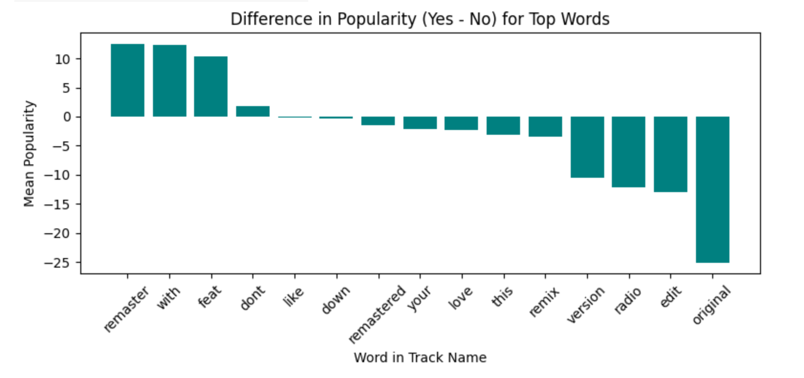

Multicollinearity Check
A Spearman correlation heatmap was used to identify multicollinearity among numeric, ordinal, and binary variables.
As expected, strong correlations were observed within feature families - such as between the three duration variables (duration_ms, duration_sec, duration_min) and between playlist- and artist-related counts.
No severe multicollinearity (|ρ| > 0.9) was detected across independent features, indicating that the dataset is suitable for linear and tree-based models without further dimensionality reduction.
The issue was addressed later during the Feature Selection stage, where redundant variables were removed, and only representative features were retained for modeling.
Summary
After feature engineering, the dataset expanded to 57 variables.
These features combined musical, temporal, textual, and contextual information, forming the base for feature selection and modeling.

Feature Selection Experiments
Three alternative feature-selection pipelines were tested, each producing different sets of predictors for the regression models.
Experiment 1 – Base Feature Selection
Notebook: Feature_Selection.ipynb (linked with Models.ipynb)
One-hot encoding applied to categorical variables.
A total of 25 features were evaluated using four algorithms — Lasso, Ridge, Gradient Boosting, and Random Forest.
Features selected by at least two models were retained as part of the initial candidate set.
Consistently Selected Features (≥2 model votes):
- song_playlist_count – selected by all four models, the most consistently chosen variable.
- energy, artist_album_count, artist_playlist_count, instrumentalness_log,
playlist_song_count, playlist_album_count, playlist_artist_count –
selected by three models each.
- playlist_subgenre_permanent_wave and playlist_subgenre_progressive_electro_house –
subgenre dummies also chosen by three models.
- Additional features selected by two models include:
loudness, speechiness, valence, tempo, release_year, release_month,
release_day, duration_ms, album_song_count, and playlist_name_word_count.

Part 6: Modeling and Evaluation
The first modeling phase used the initial feature set of approximately 25 variables, without applying Target Encoding. The dataset was split into TRAIN (70%), DEV (15%), and TEST (15%) subsets. Scaling was applied on numeric variables using StandardScaler (fit on TRAIN and applied to DEV and TEST).
The following algorithms were tested: Linear Regression, Decision Tree, Random Forest, Gradient Boosting, AdaBoost, K-Nearest Neighbors (KNN), Support Vector Regressor (SVR), and XGBoost. Random Forest reached R²≈0.94 on TRAIN but 0.54 on DEV, overfitting.
XGBoost provided the most balanced performance and was selected for fine-tuning.
Before fine-tuning:
• TRAIN: RMSE = 13.09 | MAE = 10.08 | R² = 0.73
• DEV: RMSE = 17.07 | MAE = 13.34 | R² = 0.53
• TEST: RMSE = 17.61 | MAE = 13.61 | R² = 0.51

After fine-tuning (GridSearchCV, 216 combinations):
• DEV: RMSE = 16.56 | MAE = 12.70 | R² = 0.56
• TEST: RMSE = 17.10 | MAE = 12.99 | R² = 0.53

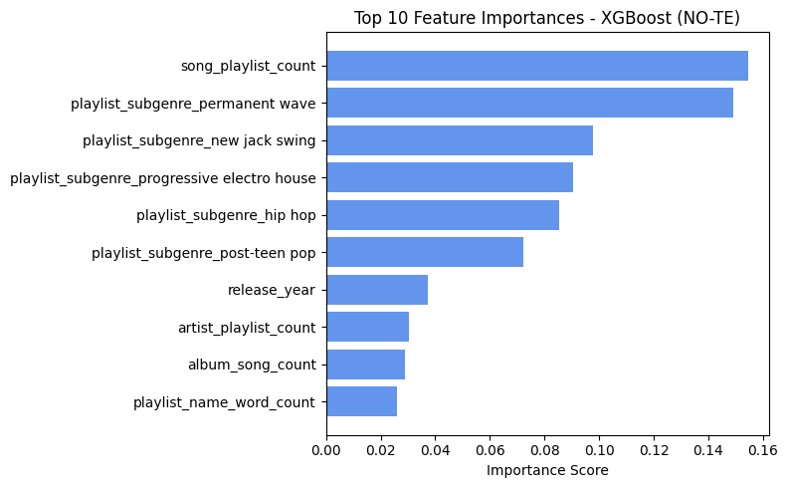
The fine-tuned model slightly improved accuracy and generalization, but R² remained around 0.53-0.56, indicating limited predictive power for unseen data.
To address this, the following experiment introduced Target Encoding for high-cardinality categorical features (track_artist, playlist_name), aiming to enhance representation and reduce feature sparsity.

Experiment 2 – Feature Selection with Target Encoding
Notebook: Feature_Selection2.ipynb (linked with Models2.ipynb)
To prevent data leakage, the dataset was split before any encoding or scaling into TRAIN (70%), DEV (15%), and TEST (15%) subsets.
Scaling (StandardScaler) was then fitted on the TRAIN set and applied to DEV and TEST.
After introducing Target Encoding for high-cardinality variables (track_artist, playlist_name), the feature-selection process was repeated using Lasso, Ridge, Gradient Boosting, and Random Forest models.
Features selected by at least two models (Sum ≥ 2) formed the final refined feature set of 16 variables:
track_artist_TE, playlist_name_TE, album_song_count, song_playlist_count, release_year, speechiness, instrumentalness_log, acousticness, release_day, duration_ms, energy, liveness, artist_playlist_count, track_artist_count, valence, and danceability.
The following algorithms were tested: Linear Regression, Decision Tree, Random Forest, Gradient Boosting, AdaBoost, K-Nearest Neighbors (KNN), Support Vector Regressor (SVR), and XGBoost. Random Forest reached R²≈0.94 on TRAIN but 0.55 on DEV, overfitting.
XGBoost provided the most balanced performance and was selected for fine-tuning.
Before fine-tuning:
• TRAIN: RMSE = 12.62 | MAE = 9.47 | R² = 0.74
• DEV: RMSE = 17.53 | MAE = 13.58 | R² = 0.50
• TEST: RMSE = 18.15 | MAE = 14.15 | R² = 0.49

After fine-tuning (GridSearchCV, 216 combinations):
• DEV: RMSE = 16.47 | MAE = 12.59 | R² = 0.56
• TEST: RMSE = 17.10 | MAE = 13.12 | R² = 0.55

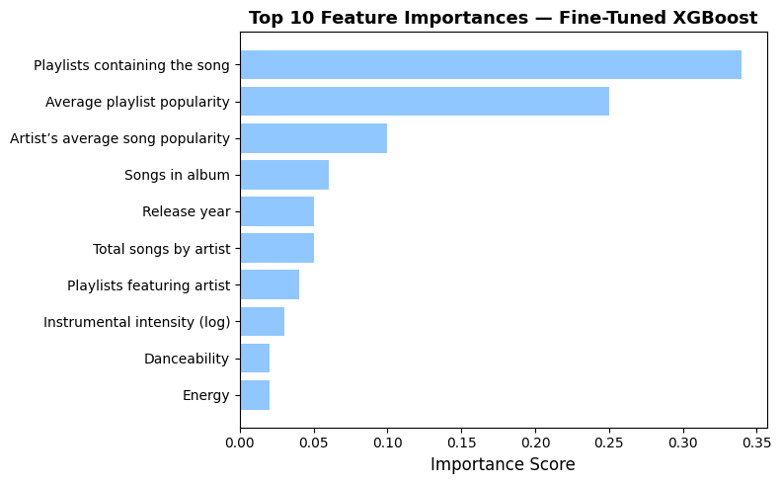
The fine-tuned model slightly improved accuracy and generalization, but R² remained around 0.55-0.56, indicating limited predictive power for unseen data.

Experiment 3 – Combined Feature & Model Tuning
Notebook: Feature_Selection_Model_Combo.ipynb
Since the fine-tuned model’s performance remained moderate (R² ≈ 0.55), the next experiment combined Target Encoding for high-cardinality categorical features (track_artist, playlist_name) with the most influential predictors identified in Experiment 1, in order to test whether this hybrid approach could further improve predictive accuracy.
The following algorithms were tested: Linear Regression, Decision Tree, Random Forest, Gradient Boosting, AdaBoost, K-Nearest Neighbors (KNN), Support Vector Regressor (SVR), and XGBoost. Random Forest reached R²≈0.94 on TRAIN but 0.55 on DEV, overfitting.
XGBoost provided the most balanced performance and was selected for fine-tuning.
Before fine-tuning:
• TRAIN: RMSE = 12.62 | MAE = 9.47 | R² = 0.74
• DEV: RMSE = 17.43 | MAE = 13.52 | R² = 0.51
• TEST: RMSE = 18.14 | MAE = 14.16 | R² = 0.49

After fine-tuning (GridSearchCV, 216 combinations):
• DEV: RMSE = 16.69 | MAE = 12.88 | R² = 0.55
• TEST: RMSE = 17.41 | MAE = 13.46 | R² = 0.53

Overall Comparison
Experiment | Encoding Type | Features | Test R²
1 | One-hot | 25 | 0.53
2 | Target Encoding | 16 | 0.55
3 | Combined | 20 | 0.53

Final Choice: Feature Set #2 (Target Encoding).
It achieved the highest accuracy with the smallest, most interpretable feature space.

Conclusion
Feature Set #2 (Target Encoding) achieved the best predictive balance and was selected as the final version for deployment. The model explains about 55% of the variance in track popularity.

Part 7: Discussion and Insights
Key Predictors
The top predictors in the final XGBoost model highlight both exposure-related and temporal aspects:
• song_playlist_count and playlist_name_TE – by far the strongest predictors, showing that playlist exposure and playlist characteristics drive popularity most.
• track_artist_TE – artist-level popularity captured through Target Encoding contributed significantly.
• album_song_count and release_year – indicate that newer and larger-album releases perform better.
• instrumentalness_log, danceability, and energy – musical characteristics still play a secondary but consistent role in predicting popularity.
Overall, playlist-related factors showed a stronger influence on track popularity than intrinsic audio characteristics, indicating that exposure and playlist placement have greater predictive power than musical composition itself.

Business Interpretation
The model explained approximately 55% of the variance in track popularity, showing moderate predictive accuracy.
While playlist- and artist-related exposure features (number of playlists a song appears in, the average popularity level of the playlists themselves, and the average popularity of the artist’s previous releases) were the most influential predictors, nearly 45% of the outcome remains unexplained, likely reflecting external factors such as marketing campaigns, social media trends, or Spotify’s internal recommendation algorithms.
These findings suggest that playlist visibility and artist engagement play a measurable role, but popularity is also shaped by dynamics not captured in this dataset.
Practically, the model can still provide valuable guidance for playlist curation and promotional prioritization - for example, identifying which songs or artists have the highest potential to perform well when featured in high-exposure playlists.

Limitations
- Subjectivity of popularity scores (Spotify algorithm-defined). Spotify’s track_popularity metric is defined by the platform’s proprietary algorithm, which combines play counts, recency, and user engagement. This introduces some subjectivity and prevents full transparency into how “popularity” is calculated.
- The dataset lacks information about marketing, label promotion or social media exposure. These external influences likely explain part of the 45% unexplained variance in the model.
- Feature importance may shift over time as listening trends evolve. Listener preferences and streaming algorithms evolve over time, so feature importance may shift. Models trained on past data may not fully reflect future trends.

Part 9: Project Notebooks
Notebook | Description
1_Prep / Spotify_Project_DataPrep.ipynb | Data loading, text cleaning, and initial inspection
2_EDA / Spotify_Project_EDA.ipynb | Exploratory data analysis, correlation
3_Cleansing / Spotify_Cleansing.ipynb | Outlier detection and Missing Data treatment
4_Feature_Engineering / Spotify_Feature_Engineering.ipynb | Creation of new variables and transformations
5_Feature_Selection / Feature_Selection*.ipynb | Three experiments comparing selection strategies
6_Models / Models*.ipynb | Model training, tuning, and evaluation
All notebooks stored and executed in Google Colab, with intermediary files saved to Drive for reproducibility.

