Author Biographies
  - Dynamic Collaboration Mode Selection in Hierarchical Federated Learning

Tingting Yang
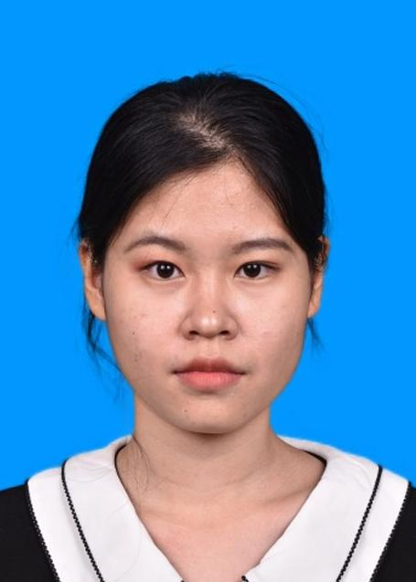
Tingting Yang is pursuing a Ph.D. at Beijing University of Posts and Telecommunications, China. She completed her undergraduate studies at North China Electric Power University in 2023. Her current research areas include artificial intelligence and data analytics.

Wenbo Zhang
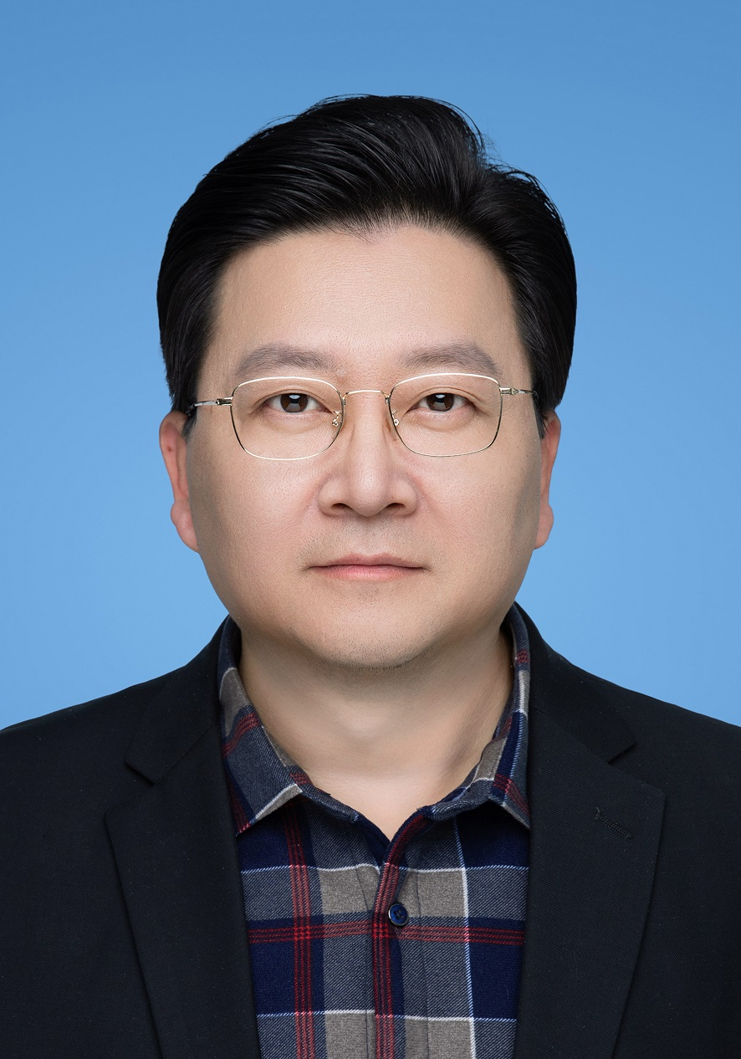
Wenbo Zhang received the B.S. and M.Sc. degrees from Hebei University in 1997 and 2000, respectively, and the Ph.D. degree from Nankai University in 2003. He is currently an Associate Professor at Beijing University of Posts and Telecommunications. His research areas include data analysis, network and cyber security, malware threat profiling, and machine learning.

Shaohua Liu

Shaohua Liu is pursuing a Ph.D. at Beijing University of Posts and Telecommunications, China. She completed her master's degree at Hebei University in 2023 and her undergraduate studies at North China University of Water Resources and Electric Power. Her current research areas include system optimization and malware detection techniques.

Lihua Zhang
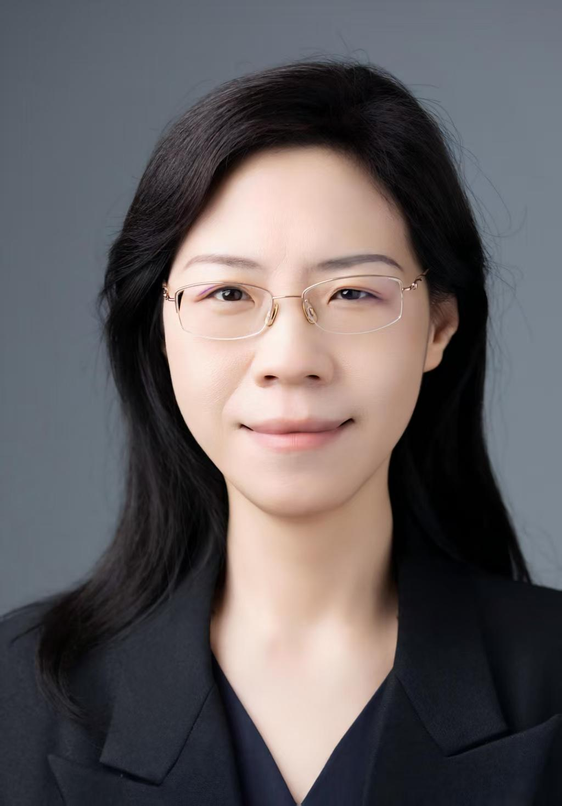
Lihua Zhang received the B.S. degree from Shanxi University in 2001, the M.Sc. degree in 2004, and the Ph.D. degree from Beijing Normal University in 2007. She is currently an associate professor at the School of Mathematical Sciences, Beijing University of Posts and Telecommunications. Her research fields include data analysis, causal inference, and machine learning.

Xinyuan Lin
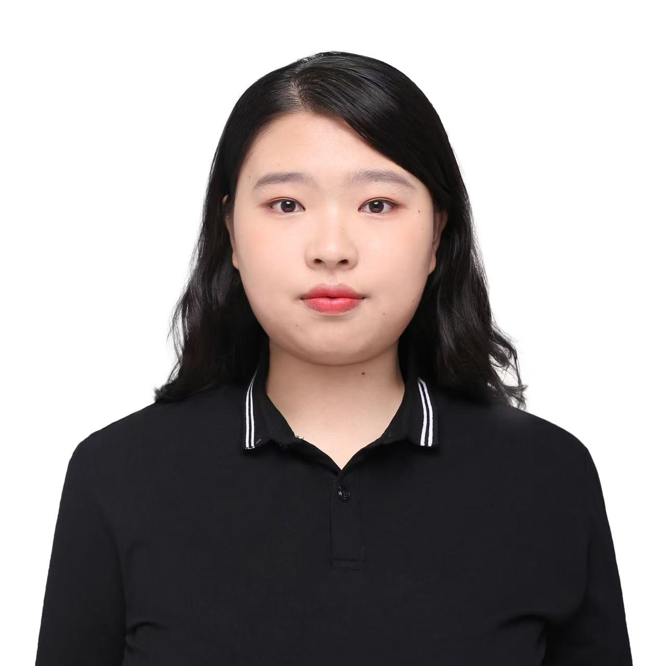
Xinyuan Lin received the B.S. degree in statistics from Shanxi University, China, in 2025. Currently, she is pursuing a Ph.D. degree in systems science at Beijing University of Posts and Telecommunications (BUPT), China. Her research interests include cloud-edge collaborative inference, edge intelligence, and malware detection.

Qian Liu

Qian Liu was born in Hebei, China, in 2002. She received the B.S. degree in Economic Statistics from Hebei University (HBU), Baoding, China, in 2025. She is currently pursuing the M.S. degree in Systems Science at Beijing University of Posts and Telecommunications (BUPT). Her current research interests include cybersecurity and deep learning.

