Business Template

Museum Database
Logo / Image

Contents
Business Description 3
1.1 the Benefits of implementing a database. Project Vision 3
2 Model description 3
2.1 Definitions & Acronyms 3
2.2 Logical Scheme 3
2.3 Objects 3

Business Description

the Benefits of implementing a database. Project Vision
The vision for this project is to transform the museum’s operations into a centralized, high-integrity digital ecosystem. By moving away from manual tracking, the database becomes an archive that not only manages daily tasks but also protects the history of every artifact, staff member, and visitor.
This database solves the core challenge of managing complex, disconnected information. By linking collections, exhibition schedules, and financial data in one place, we eliminate "data silos." For example, the system ensures that a storage manager and an exhibition curator are looking at the same real-time data, preventing errors like scheduling an item for two different places at once. It replaces fragile paper trails with a secure, searchable digital foundation.
To keep data reliable, the model uses Relational Constraints. Every entry is cross-referenced; for instance, a visitor cannot buy a ticket unless there is a matching price in the system, and an artifact cannot be moved unless it is already registered in the collection. This creates a high level of Traceability—every event is timestamped and linked to a specific ID, creating a perfect audit trail that shows exactly what happened, when, and who was involved.
The structure is built to grow without needing a complete overhaul. Because it follows Third Normal Form (3NF) standards, the database is modular. If the museum expands—perhaps adding a gift shop or an educational department—these can be plugged in as new tables without breaking the existing core. The unified locations table means the museum can add 5 new buildings just by adding rows, not by changing the code.

Model description

Definitions & Acronyms
Entity and Role Definitions
- Artifact – the central physical entity representing any item in the museum's collection, including artworks, historical objects, and specimens; it serves as the permanent anchor for all historical tracking.
- Artifact Movement Log – a specialized process entity that records every change in an item's location or status; it is the primary mechanism for ensuring "no-overwrite" traceability.
- Employee – a primary entity representing individuals hired by the museum; this role acts as the foundation for administrative responsibility and operational history.
- Employee Log – a temporal role definition that tracks a staff member’s evolution within the museum, documenting changes in their position and physical working location over time.
- Location – a spatial entity defining any physical area under museum control, ranging from public exhibition galleries to restricted high-security storage facilities.
- Exhibition – a process entity representing a planned event (either physical or online) where specific artifacts are displayed to the public for a set duration.
- External Partner – a role representing third-party organizations, such as other museums or galleries, that temporarily borrow artifacts from the museum's collection.
- Visitor – an entity representing a consumer of museum services; this role can transition from an anonymous "Guest" to a registered profile with specific demographic data.
- Price List – a governance entity that defines the financial rules for entry; it maps specific monetary values to combinations of visitor categories and locations or events.
- Visit Log – a transactional entity that records the intersection of a visitor, a specific point in time, and a financial tariff, serving as the basis for revenue and attendance audits.

Clarification of Terms
- Status – refers to the current operational "state" of an artifact (e.g., 'Stored' vs. 'On Display'); without definition, this could be confused with the physical condition of the item.
- Inventory Number – a unique alphanumeric string used as a business key; it is distinct from the database-generated artifact_id and is used for physical identification.
- Category – a term used in two contexts: for Visitors (defining pricing tiers like 'Student') and for Locations (defining usage like 'Storage' or 'Gallery').
- Online – a boolean attribute for exhibitions indicating a digital-only presence, which changes how location tracking and visit logging are interpreted.
- Responsible Employee – the specific role assigned to a staff member who is legally or administratively accountable for a particular exhibition or movement.

Abbreviations and Repeated Role Names
- PK / FK – Primary Key and Foreign Key; appearing in every table to define unique identifiers and relational links.
- ID – Identifier; used as a suffix for all primary keys (e.g., artifact_id, visitor_id) to maintain naming consistency.
- Log – signifies a "History" or "Journal" table; repeated across artifact_movement_log, employee_log, and visit_log to indicate time-series data.
- Timestamp – refers to a high-precision date and time data type (YYYY-MM-DD HH:MM:SS), used repeatedly to mark the exact moment of changes or visits.
- Nullable (?) – indicates attributes that may be left empty (NULL), specifically used in logs where an artifact might be at a location or a partner, but not both.

Logical Scheme
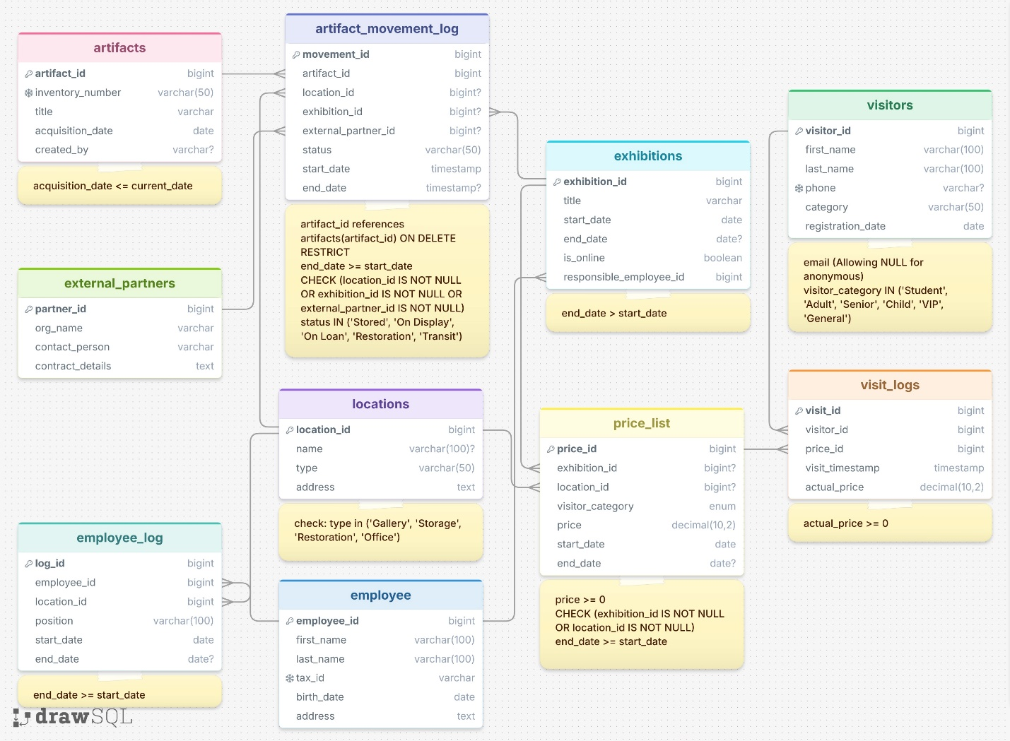
The toughest challenge was deciding whether to force every visitor into a unique row or to allow "orphaned" transactions. If we made visitor_id optional in the visit_logs, we would lose the ability to count total visits easily. If we forced a new row for every guest, the visitors table would quickly fill with thousands of empty, useless records.
The Solution: I chose to implement a System-Defined "Guest" Entity. By creating a single record (ID=1) to represent all anonymous traffic, I preserved the relational integrity of the model without cluttering the database. This decision was difficult because it requires the software layer to "know" to use ID=1 whenever a customer refuses to provide data, but it is the only way to keep the financial and attendance analytics 100% accurate.
By adhering to the 3NF, the model ensures that every piece of information is stored in exactly one place. For instance, employee details like names and tax IDs are kept strictly within the employee table. If a staff member changes their phone number, the update is made in one single row. Without this structure, a "Partial Update Anomaly" could occur, where the old phone number remains in some records while the new one appears in others, leading to confusion and lost contact.
A common "Inconsistency Anomaly" occurs when historical reports are affected by current changes. In many systems, if the price of a student ticket is updated from $10 to $15, all previous sales records might suddenly appear to have been $15, ruining the financial audit trail. My design prevents this by using a Data Snapshot approach: while the price_list defines the current rates, the visit_logs table records the actual_price at the exact moment of the transaction. This "freezes" the financial history, ensuring that past reports remain accurate regardless of future price hikes.
In a system that tracks the movement of artifacts and employee careers, "Temporal Anomalies" are a major risk—such as a record showing an item was removed from a gallery before it was ever placed there. The model prevents this through Check Constraints on the log tables. By requiring that the end_date must always be greater than or equal to the start_date, the system programmatically forbids impossible timelines. This ensures the integrity of the "no-overwrite" historical trail, allowing curators to trust the reconstructed history of any object.
The model is highly scalable because it is Modular. If you wanted to add a "Restoration Department" with its own specific staff and equipment, you wouldn't need to change the Artifacts or Visitors tables. You would simply add a new table and link it to the artifact_movement_log as a new possible location. The 3NF (Third Normal Form) structure ensures that adding new features doesn't require "breaking" what already works.
The Price_List is the most "fragile" part of the model. Currently, it assumes a simple relationship: Category + Event = Price. If the museum introduces complex Loyalty Programs (e.g., "Members get 10% off everything, but Seniors get 50% off only on Tuesdays"), the current table would struggle. We would likely need to expand this into a more complex "Discount Engine" or "Promotion" table to handle those extra variables.

Objects
Table artifacts:
Concept: This table serves as the master catalog for every unique physical item within the museum’s collection. It stores the permanent, non-changing attributes of each object.
Reason for separation: Keeping artifact details separate from their movement or exhibition history prevents massive data redundancy. If we stored the description or origin within the movement logs, we would repeat that data every time the object moved, leading to potential inconsistencies.
Normalization (3NF): This table is in 3NF because all attributes (title, acquisition date, inventory number) are functionally dependent only on the artifact_id. There are no transitive dependencies.
Dependencies: All attributes depend solely on the primary key. Since the key is a simple surrogate (artifact_id), no partial dependencies exist.
Primary Key (PK): artifact_id (serial/bigint) is a surrogate key that provides a stable, internal identifier independent of the inventory_number, which might occasionally be subject to administrative changes.
Foreign Keys (FK): None. This is a top-level parent entity.

Table Name | Field name | Field Description | Data Type
artifacts | artifact_id | Internal ID, PK, NOT NULL | bigint
 | inventory_number | Museum catalog code, NOT NULL | varchar(50)
 | title | Name of the object, NOT NULL | varchar
 | acquisition_date | Date of entry, CHECK (<= CURRENT_DATE) | date
 | created_by | Staff member who logged entry, NOT NULL | varchar

Example with data

artifact_id | inventory_number | title | acquisition_date | created_by
1 | M-2026-001 | Scythian Gold Comb | 2026-01-15 | O. Petrenko
2 | M-2026-002 | Mammoth Tusk Fragment | 2026-02-10 | A. Koval
3 | M-2026-003 | Oil Painting: "Lviv Morning" | 2026-03-05 | O. Petrenko

Table artifact_movement_log:
Concept: A transaction log capturing every location change and status update for artifacts, ensuring full traceability of the collection.
Reason for separation: This table maintains the "audit trail" history. If status were stored in the artifacts table, previous history would be overwritten, making it impossible to track an item's past locations.
Normalization (3NF): Every record is an "event" where the status and timestamps depend solely on the movement_id.
Primary Key (PK): movement_id (bigint) is the surrogate primary key.
Foreign Keys (FK):
- artifact_id (references artifacts): ON DELETE RESTRICT to protect collection history.
- location_id (references locations): The internal destination.
- exhibition_id (references exhibitions): Link to specific events.
- external_partner_id (references external_partners): Link to external loans.
Table-level Constraints:
- CHECK (end_date >= start_date): Enforces chronological timeline integrity.
- CHECK (location_id IS NOT NULL OR exhibition_id IS NOT NULL OR external_partner_id IS NOT NULL): Ensures an artifact is always physically assigned to a valid destination.

Table Name | Field name | Field Description | Data Type
artifact_movement_log | movement_id | Log ID, PK, NOT NULL | bigint
 | artifact_id | Target artifact, FK, NOT NULL | bigint
 | location_id | Internal location reference, FK | bigint
 | exhibition_id | Event reference, FK | bigint
 | external_partner_id | Partner reference, FK | bigint
 | status | Current state, NOT NULL | varchar(50)
 | start_date | Movement start, NOT NULL | timestamp
 | end_date | Movement end, NULLABLE | timestamp

Example with data

movement_id | artifact_id | location_id | exhibition_id | external_partner_id | status | start_date | end_date
101 | 1 | NULL | NULL | 2 | Stored | 2026-01-15 10:00 | 2026-03-01 09:00
102 | 1 | NULL | 10 | NULL | On Display | 2026-03-01 09:00 | NULL

Table visitors:
Concept: Represents the museum's customers; stores personal contact details and classification.
Reason for separation: Allows for repeat visits without duplicating contact data. Includes a system-defined "Guest" record for anonymous entries.
Normalization (3NF): All attributes like email and category depend solely on the visitor_id.
Primary Key (PK): visitor_id (bigint).
Foreign Keys (FK): None.
Table-level Constraints: * UNIQUE (phone): Prevents multiple profiles for the same phone (allows NULL for guests).

Table Name | Field name | Field Description | Data Type
visitors | visitor_id | Unique customer ID, PK, NOT NULL | bigint
 | first_name | Visitor first name, NULLABLE | varchar(100)
 | last_name | Visitor last name, NULLABLE | varchar(100)
 | phone | Contact phone, UNIQUE | varchar
 | category | Pricing category, NOT NULL | varchar(50)
 | registration_date | Profile creation date, NOT NULL | date

Example with data
visitor_id | first_name | last_name | email | category | registration_date
1 | Guest | Museum | NULL | General | 2026-01-01
2 | Ivan | Bondar | 380445550192 | Adult | 2026-02-15
3 | Olena | Shevchenko | 380679876543 | Student | 2026-03-10

Table visit_logs:
Concept: This transactional table records every instance of a museum entry, linking a visitor to a specific price and time.
Reason for separation: This resolves the many-to-many relationship between visitors and prices. It prevents "Price Drift" by storing the actual_price snapshot.
Normalization (3NF): Storing the snapshot price removes the transitive dependency on the price_list for historical financial reporting.
Primary Key (PK): visit_id (bigint).
Foreign Keys (FK): * visitor_id (references visitors): Link to the customer.
- price_id (references price_list): Link to the active tariff.
Table-level Constraints:
- CHECK (actual_price >= 0): Ensures no negative revenue is recorded.

Table Name | Field name | Field Description | Data Type
visit_logs | visit_id | Unique transaction ID, PK, NOT NULL | bigint
 | visitor_id | Reference to visitor profile, FK, NOT NULL | bigint
 | price_id | Reference to tariff, FK, NOT NULL | bigint
 | visit_timestamp | Exact time of entry, NOT NULL | timestamp
 | actual_price | Price paid at time of visit, NOT NULL | decimal(10,2)

Example with data

visit_id | visitor_id | price_id | visit_timestamp | actual_price
5001 | 1 | 201 | 2026-04-20 10:05:00 | 150.00
5005 | 6 | 203 | 2026-04-21 14:15:00 | 0.00

Table price_list:
Concept: This table acts as the museum's financial rulebook, defining the cost of entry based on the visitor's category and the specific event or location.
Reason for separation: Prices change frequently. Separating them from the visit logs allows the museum to update its "Current Tariff" without altering the logic of the entry system. It also supports dynamic pricing for temporary exhibitions.
Normalization (3NF): Complies with 3NF. The price and category are dependent on the price_id.
Primary key (PK): price_id (bigint).
Foreign keys (FK):
- exhibition_id (bigint, nullable) – references exhibitions(exhibition_id).
- location_id (bigint, nullable) – references locations(location_id).
Constraints:
- CHECK (price >= 0): Prevents negative pricing.
- CHECK (exhibition_id IS NOT NULL OR location_id IS NOT NULL): Ensures every price is linked to a valid target.
- CHECK (end_date >= start_date): Validates time interval.

Table Name | Field name | Field Description | Data Type
price_list | price_id | Unique tariff ID, PK, NOT NULL | bigint
 | exhibition_id | Exhibition link, FK | bigint
 | location_id | Location link, FK | bigint
 | visitor_category | Pricing tier, NOT NULL | varchar(50)
 | price | Cost of ticket, NOT NULL | decimal(10,2)
 | start_date | Activation date, NOT NULL | date
 | end_date | Expiration date, NULLABLE | date

Example with data

price_id | exhibition_id | location_id | visitor_category | price | start_date | price_id
201 | NULL | 1 | Adult | 150.00 | 2026-01-01 | 201
206 | 12 | NULL | VIP | 500.00 | 2026-04-01 | 206

Table employee:
Concept: This primary entity represents any individual currently or previously employed by the museum. It acts as the central anchor for all personal data and identification records.
Reason for separation: Personal information is stored separately to support a multi-property architecture. Storing names directly in operational tables would lead to massive data redundancy and update anomalies if an employee's personal details changed.
Normalization (3NF): This table is in 3rd Normal Form (3NF) because all attributes, such as name, address, and birth date, are functionally dependent only on the employee_id. There are no partial dependencies since the key is not composite, and no transitive dependencies exist as no non-key fields determine other non-key fields.
Primary Key (PK): employee_id (bigint) is used as a surrogate primary key to provide a stable, unique identifier that is independent of changing business names or personal data.
Foreign Keys (FK): None. This is a top-level parent table.
Table-level Constraints:
- Unique Tax ID: A unique constraint on the tax_id prevents multiple profiles from being created for the same legal person.

Table Name | Field name | Field Description | Data Type
employee | employee_id | Unique staff ID, PK, NOT NULL | bigint
 | first_name | Legal first name, NOT NULL | varchar(100)
 | last_name | Legal last name, NOT NULL | varchar(100)
 | tax_id | National tax identifier, NOT NULL | varchar
 | birth_date | Date of birth, NOT NULL | date
 | address | Current physical residence | text

Example with data (2-3 rows)

employee_id | first_name | last_name | tax_id | birth_date | address
1 | Olena | Petrenko | 2901234567 | 1985-05-12 | 12 Liberty Ave, Lviv
2 | Andriy | Koval | 2804567890 | 1990-11-22 | 45 Coastal Rd, Odessa

Table employee_log:
Concept: A specialized history table that tracks the professional evolution and physical placement of staff members within the museum.
Reason for separation: This table is essential for the "Project Vision" of full traceability. Instead of overwriting an employee's current room or title, we record every change here to maintain an immutable career history.
Normalization (3NF): Complies with 3NF; every record is an "event" where the position and location depend solely on the unique log_id for a specific timeframe.
Primary Key (PK): log_id (bigint) – a surrogate identifier for every administrative action or change in role.
Foreign Keys (FK):
- employee_id (references employee): ON DELETE SET NULL to ensure the audit trail remains even if a staff member leaves.
- location_id (references locations): Identifies the physical room or department assigned during this period.
Table-level Constraints:
- CHECK (end_date >= start_date): Ensures the professional timeline remains chronologically logical.

Table Name | Field name | Field Description | Data Type
employee_log | log_id | Unique career log ID, PK, NOT NULL | bigint
 | employee_id | Reference to staff member, FK, NOT NULL | bigint
 | location_id | Assigned physical space, FK, NOT NULL | bigint
 | position | Job title during this period, NOT NULL | varchar(100)
 | start_date | Date assignment began, NOT NULL | date
 | end_date | Date assignment ended, NULLABLE | date

Example with data

log_id | employee_id | location_id | position | start_date | end_date
801 | 1 | 5 | Junior Curator | 2026-01-01 | 2026-03-01
802 | 1 | 2 | Head of Exhibition | 2026-03-01 | NULL

Table exhibitions:
Concept: This table manages the lifecycle of museum events, supporting both physical and online display planning.
Reason for separation: Separating exhibitions from artifacts allows for flexible scheduling and planning. It prevents data redundancy by defining event parameters (like dates and online status) once for all included items.
Normalization (3NF): This table satisfies 3NF because all attributes (title, dates, online status) are direct facts about the exhibition_id.
Primary Key (PK): exhibition_id (bigint) – a stable, unique identifier for the administrative event.
Foreign Keys (FK):
- responsible_employee_id (references employee): Designates the curator or staff member legally accountable for the event.
Table-level Constraints:
- CHECK (end_date > start_date): Prevents incorrect duration settings, such as closing before opening.

Table Name | Field name | Field Description | Data Type
exhibitions | exhibition_id | Unique event ID, PK, NOT NULL | bigint
 | title | Name of the exhibition, NOT NULL | varchar
 | start_date | Opening date, NOT NULL | date
 | end_date | Closing date, NULLABLE | date
 | is_online | Digital format flag, NOT NULL | boolean
 | responsible_employee_id | Lead curator, FK, NOT NULL | bigint

Example with data (2-3 rows)

exhibition_id | title | start_date | end_date | is_online | responsible_employee_id
10 | Scythian Treasures | 2026-03-01 | 2026-06-01 | false | 1
11 | Digital History 101 | 2026-01-15 | NULL | true | 3

Table locations:
Concept: Represents the physical infrastructure or business units (galleries, storage sectors) managed by the museum.
Reason for separation: Supports a multi-property architecture and prevents update anomalies; changing a hall's address or name updates it globally without affecting individual artifact records.
Normalization (3NF): Complies with 3NF; attributes like name and type are functionally dependent only on the location_id.
Primary Key (PK): location_id (bigint) – a stable surrogate key independent of room numbers or physical naming.
Foreign Keys (FK): None.

Table Name | Field name | Field Description | Data Type
locations | location_id | Unique space ID, PK, NOT NULL | bigint
 | name | Name of hall/room, NOT NULL | varchar(100)
 | type | Category (Gallery, Storage, Office), NOT NULL | varchar(50)
 | address | Physical street address/building info | text

Example with data

location_id | name | type | address
1 | Main Entrance | Office | 12 Museum St
2 | Gallery Hall A | Gallery | 12 Museum St
3 | Admin Office | Office | 14 Museum St

Table external_partners:
Concept: Defines third-party organizations (museums, galleries) involved in collection exchanges or long-term loans.
Reason for separation: Separating partners from movement logs allows for seamless scaling as the museum grows its international network. It avoids duplicating organizational contact details for every item loaned.
Normalization (3NF): 3NF is satisfied as all attributes depend solely on the partner_id.
Primary Key (PK): partner_id (bigint) – a unique handle for every collaborating entity.
Foreign Keys (FK): None.

Table Name | Field name | Field Description | Data Type
external_partners | partner_id | Unique organization ID, PK, NOT NULL | bigint
 | org_name | Name of the partner institution, NOT NULL | varchar
 | contact_person | Primary liaison or curator name | varchar
 | contract_details | Summary of loan/partnership terms | text

Example with data (2-3 rows)

partner_id | org_name | contact_person | contract_details
1 | National Art Museum | Dr. A. Smith | Cultural exchange agreement #45
2 | City Archive | Peter Parker | Document restoration partnership

