**Report to the “Task 1”**

Next goals were achieved:

1. Check availability of the site from the load tool => Passed:

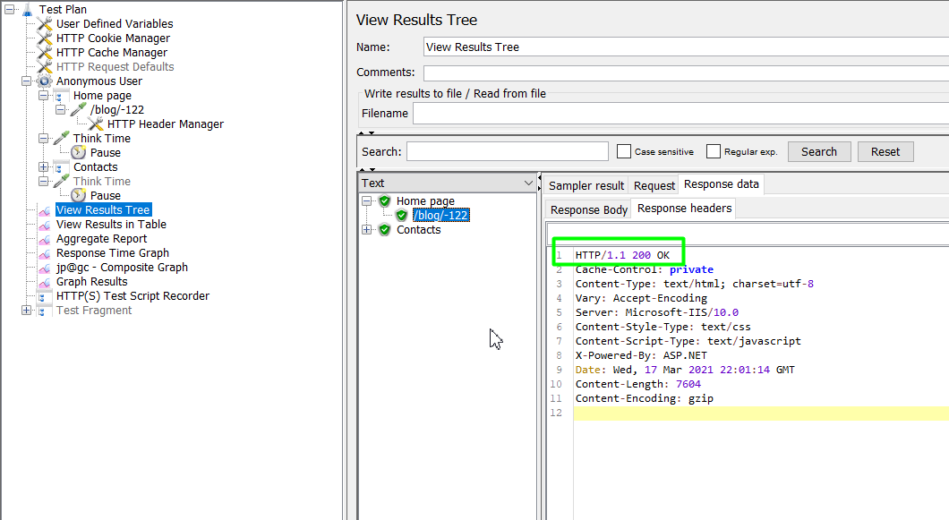

2. The site is configured for multiuser mode => All requests are passed successfully:

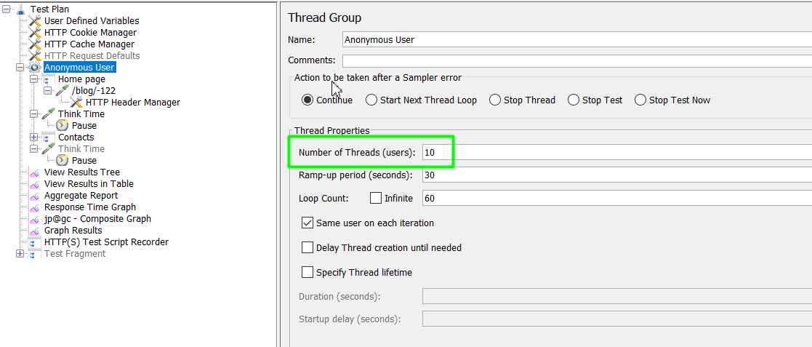

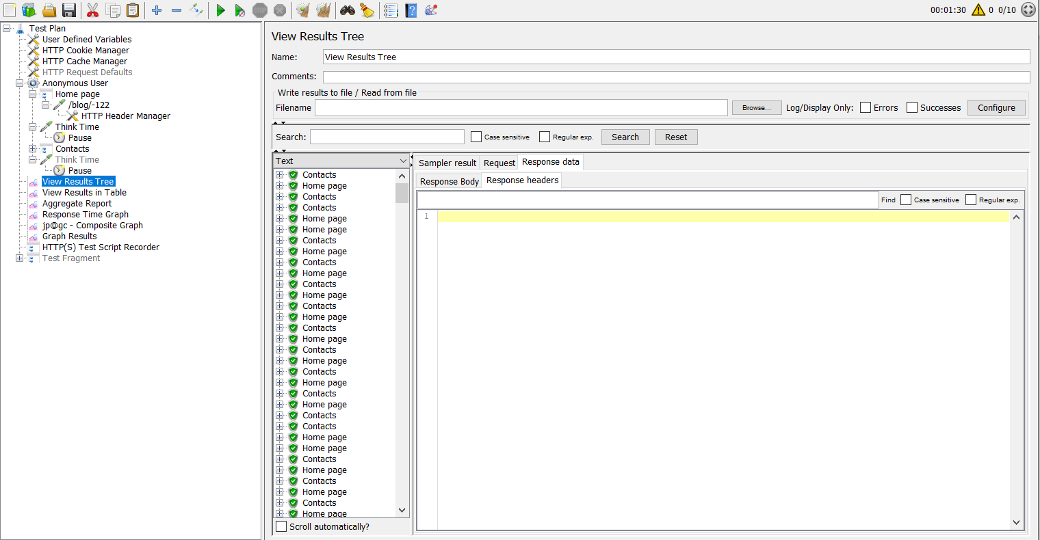

3. Basic metrics are set up and collected:

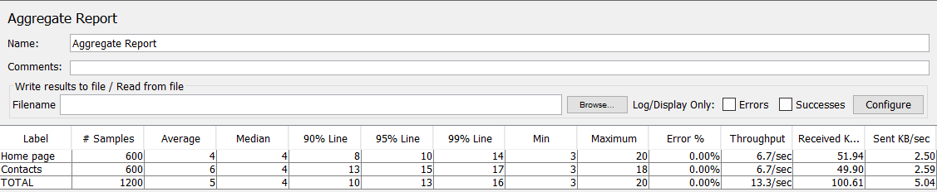

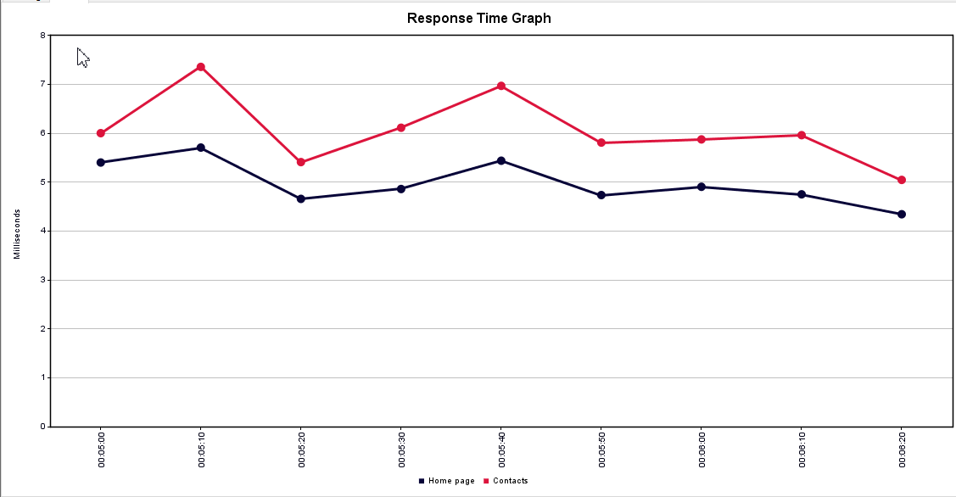

4. Setup ramp-up mode in the scenario => We have run tests with 10 users with the results:

