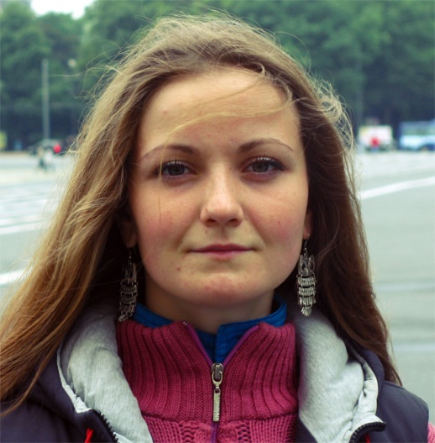

**Panova (Tokmakova) Yuliia**

Date of Birth: Jan 3, 1991

Phone: 066 308 47 14, 066 462 55 60

E-mail: sheila13@bk.ru

**Objective:** To work as a Junior Software Engineer (Front-End Developer).

**Education:**

* 2014/ Master Degree/ Information technology/ Computer-aided programming/ National Aerospace University “Kharkiv Aviation Institute”;
* 2013/ Bachelor/ Information technology/ Computer-aided programming/ National Aerospace University “Kharkiv Aviation Institute”.

**Courses:**

* March – May 2015/ EPAM Systems/ Pre-production course “The Education Program at Front-End Laboratory”;
* October 2014 – March 2015/ EPAM Systems/ External course “Front-End Laboratory”;
* April-March 2013/ W3 Ukraine/ HTML&CSS.

**Professional experience:**

* May – November 2015/ EPAM Systems/ Junior Software Engineer (Front-End Developer)/ Responsibilities: creation and correction of components and styles, add behavior (js-codding), team work of 20 people on the methodology Agile (Scrum), usage CMS AEM CQ.

**Computer skills:**

* **Programs:** MS Office Word, Excel, Power Point;
* **IDE:** WebStorm, Aptana Studio, IntelliJ IDEA, Notepad++, Dreamweaver;
* **Etc.:** Photoshop, WampServer, PHP MyAdmin;
* **Programming languages:** JavaScript(ES5), HTML5&CSS3, SQL, Object Pascal, C++;
* **Graphic Packages (2D&3D):** SolidWorks, CATIA, AutoCAD(AutoLISP), Компас;
* **Programming technologies and libraries:** JQuery, JQuery UI, JQueryMobile, Git, SVN, SASS, LESS, Gulp.js, Grunt.js, Bootstrap, Foundation, 960 Grid, Underscore.js, AJAX, JSON, npm, bower, Node.js, Express.js, Require.js;
* **Life-circle methodology:** Scrum (Agile).

**Languages:**

* Russian (native),
* Ukrainian (native),
* English (pre-intermediate A2).

**Personal qualities:**

Active lifestyle (I love very much tourism, sports, and spiritual and psychological practice), dedication (always try to achieve the target), sociability (like working in a team and to discuss the solution of problems and goals), responsibility (it's even my negative character trait, as too responsible), self-discipline, initiative, fast learner.

My goal is taking part in large-scale innovative projects, to become a professional high-end work in a team and bring benefits. Love to see a good result of your labor and be in demand.

**Other:**

* Driving license category B;
* Married;
* Аctive rest (Encounter, Quest, kayaking, rafting, hiking, climbing, biking);
* Hobbies musical instruments (acoustic guitar, drums, darbuka).

**Social links:**

* LinkedIn - <https://ua.linkedin.com/in/юлия-токмакова-панова-8a6b9bb3>;
* VK – <http://vk.com/id_terra>.

**Samples on github:**

* client-side program (my task for graduate from pre-production): <https://github.com/YuliiaPanova/WheatherApp.git>;
* email templates <https://github.com/YuliiaPanova/Email-templates.git>:
* markup for conference <https://github.com/YuliiaPanova/Landing-page-for-Conference.git>.