Yuling Xiong

E-63 Big Data Analytics

[yuling.xiong@gmail.com](mailto:yuling.xiong@gmail.com)

312-646-9280

Assignment02

Due by 11:59 PM on Friday, 02/10/2017

## 

**Problem 1.** The following is the content ofMovies database.Bring that database into Neo4J using **curl**.

CREATE (matrix1:Movie { title : 'The Matrix', year : '1999-03-31' }) return id(matrix1)

CREATE (matrix2:Movie { title : 'The Matrix Reloaded', year : '2003-05-07' }) return id(matrix2)

CREATE (matrix3:Movie { title : 'The Matrix Revolutions', year : '2003-10-27' }) return id(matrix3)

CREATE (keanu:Actor { name:'Keanu Reeves' }) return id(keanu)

CREATE (laurence:Actor { name:'Laurence Fishburne' })

CREATE (carrieanne:Actor { name:'Carrie-Anne Moss' })

CREATE (keanu)-[:ACTS_IN { role : 'Neo' }]->(matrix1)

CREATE (keanu)-[:ACTS_IN { role : 'Neo' }]->(matrix2)

CREATE (keanu)-[:ACTS_IN { role : 'Neo' }]->(matrix3)

CREATE (laurence)-[:ACTS_IN { role : 'Morpheus' }]->(matrix1)

CREATE (laurence)-[:ACTS_IN { role : 'Morpheus' }]->(matrix2)

CREATE (laurence)-[:ACTS_IN { role : 'Morpheus' }]->(matrix3)

CREATE (carrieanne)-[:ACTS_IN { role : 'Trinity' }]->(matrix1)

CREATE (carrieanne)-[:ACTS_IN { role : 'Trinity' }]->(matrix2)

CREATE (carrieanne)-[:ACTS_IN { role : 'Trinity' }]->(matrix3)

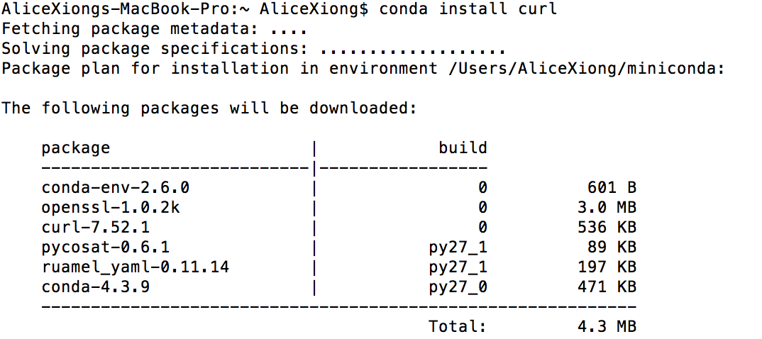

**Repeat the following steps for all other queries. Just need to change ‘ into \”, which is the escape character in mac.**

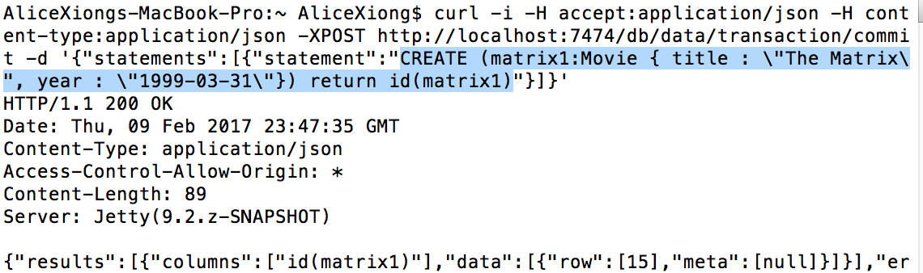

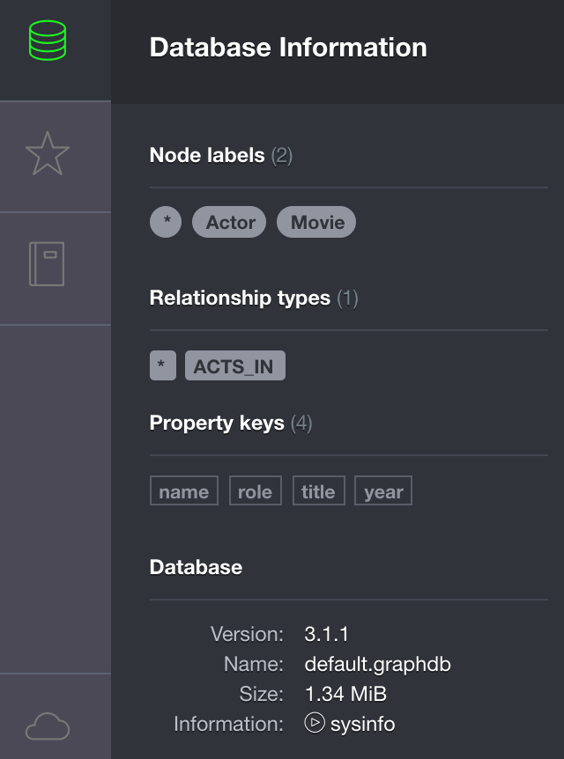

**Problem 2**.

* **Keanu Reeves** acted in the movie “John Wick” which is not in the database. That movie was directed by **Chad Stahelski** and **David Leitch**. Cast of the movie included **William Dafoe** and **Michael Nyquist.** Add all of those people and the roles they played in this movie to the database using JAVA REST API or some other **APIs** for Neo4J in a language of your choice.

**I utilized Python API to perform this task:**

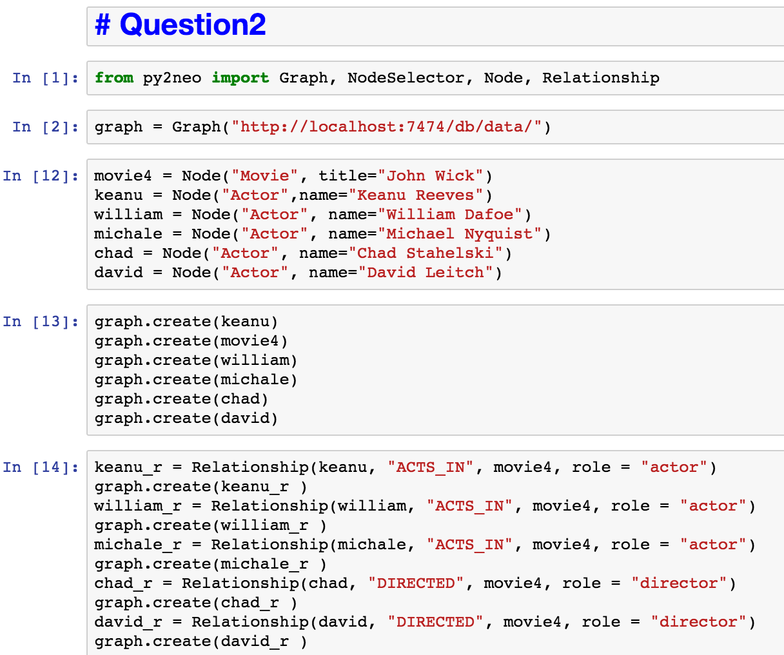

* Demonstrate that you have successfully brought data about John Wick movie into the database. You can use **Cypher Browser** or any other means.

**Access data from python:**

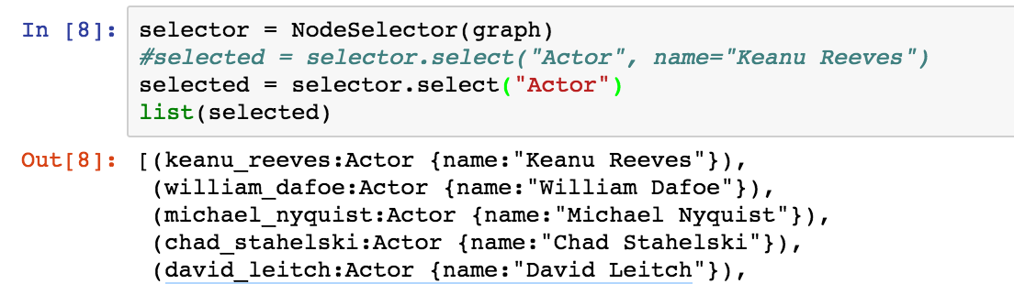

**Access data from Cypher:**

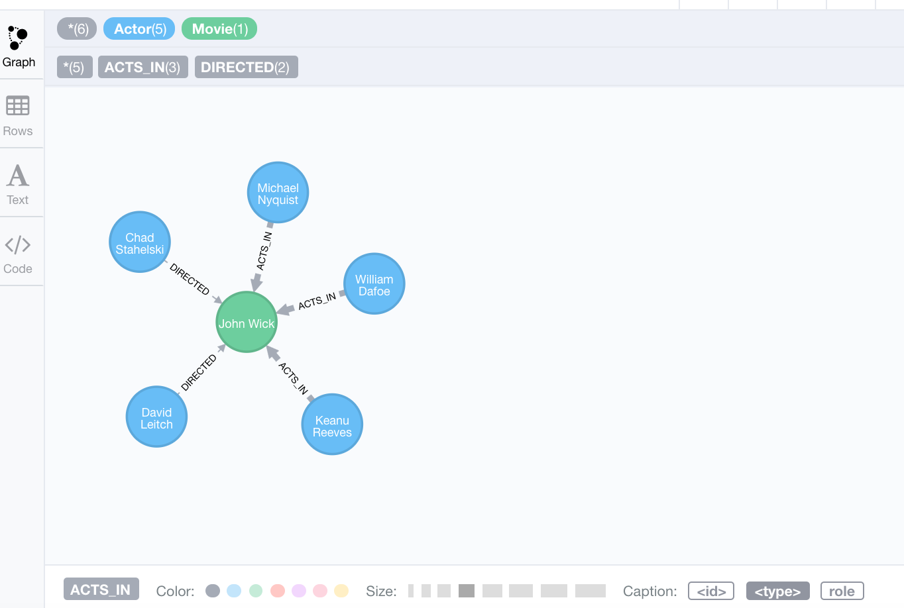

**Problem 3**.

* Find a list of actors playing in movies in which Keanu Reeves played.

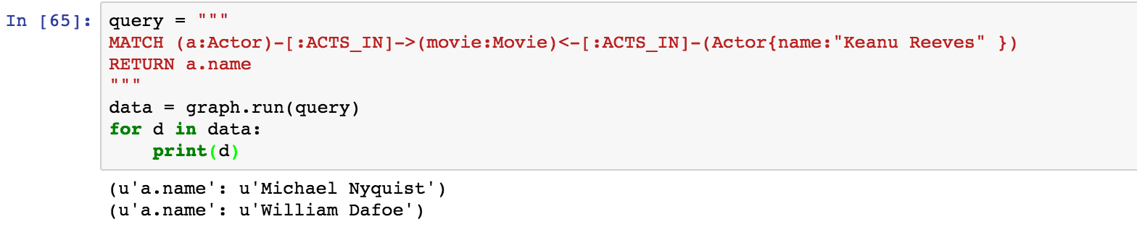

* Find directors of movies in which K. Reeves played. Please use any programming language of your convenience.

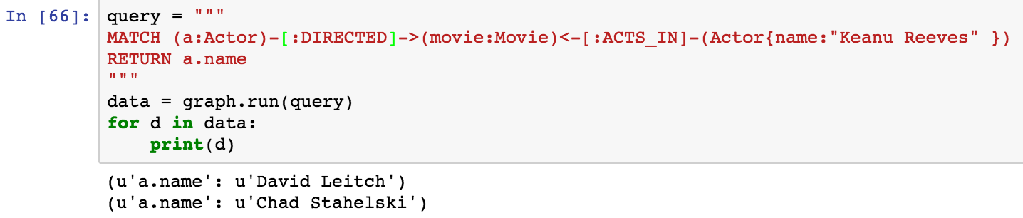

* Verify your results using Cypher queries in Cypher Browser

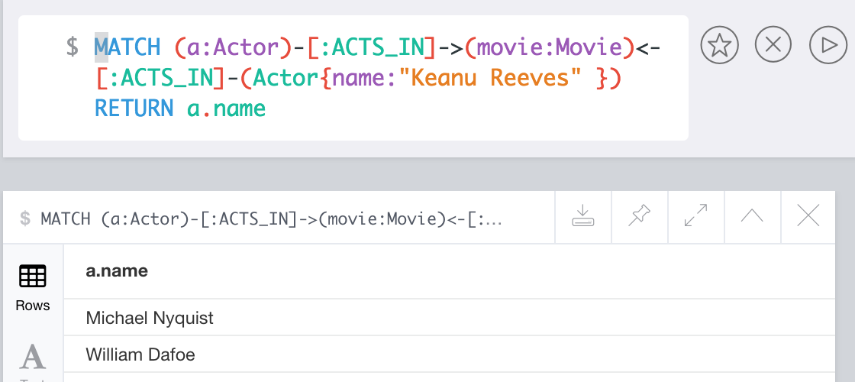

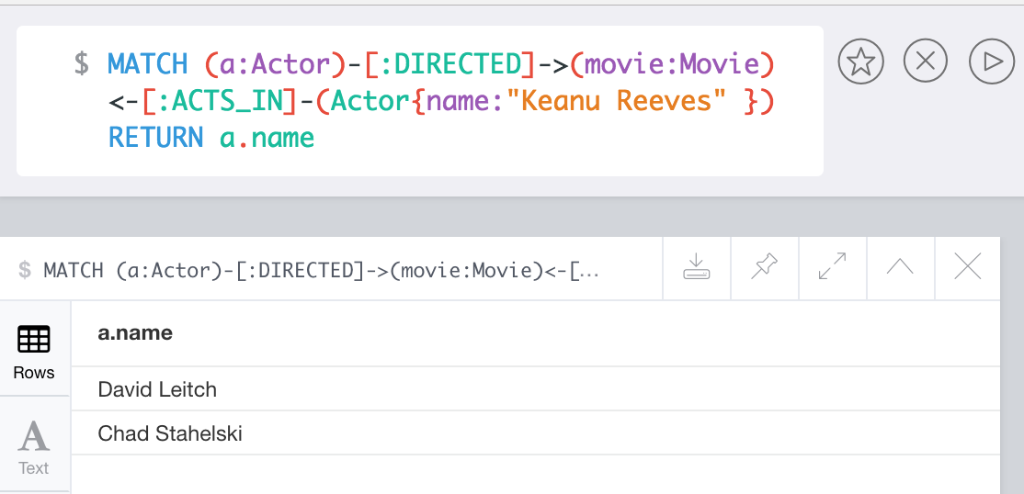

**Problem 4**.

* Find a way to export data from Neo4j into a set of CSV files.

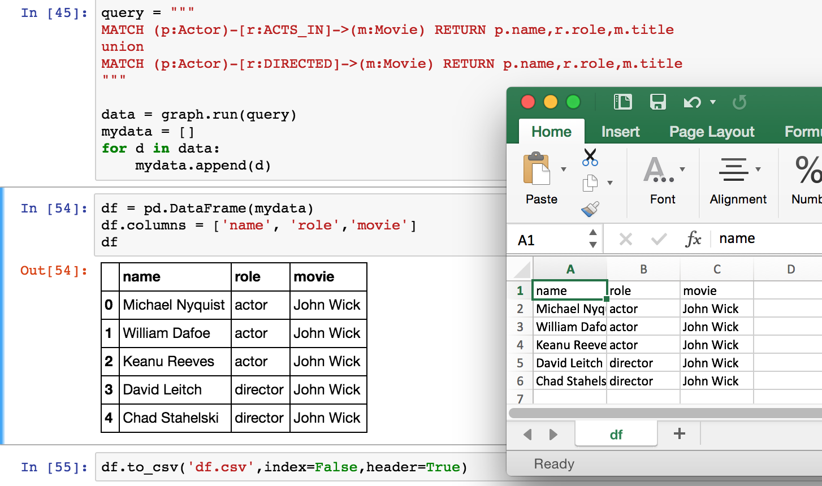

* Delete your database

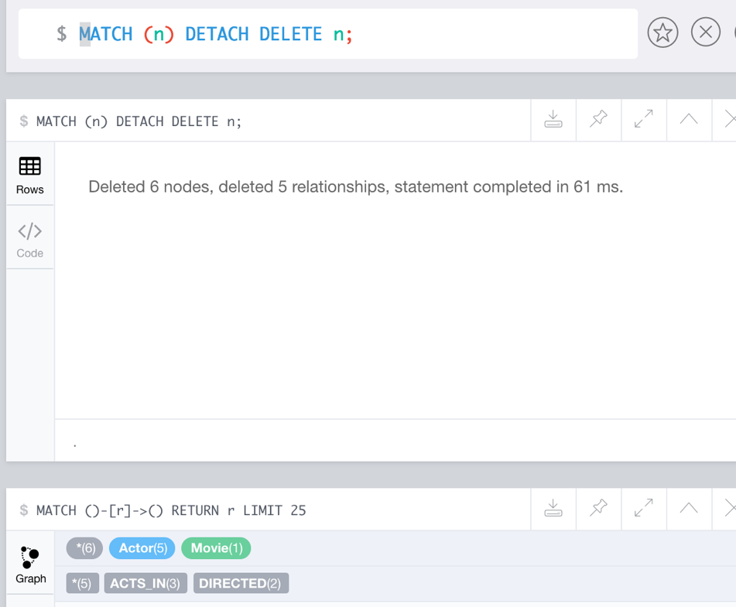

* Demonstrate that you can recreate the database by loading those CSV files:

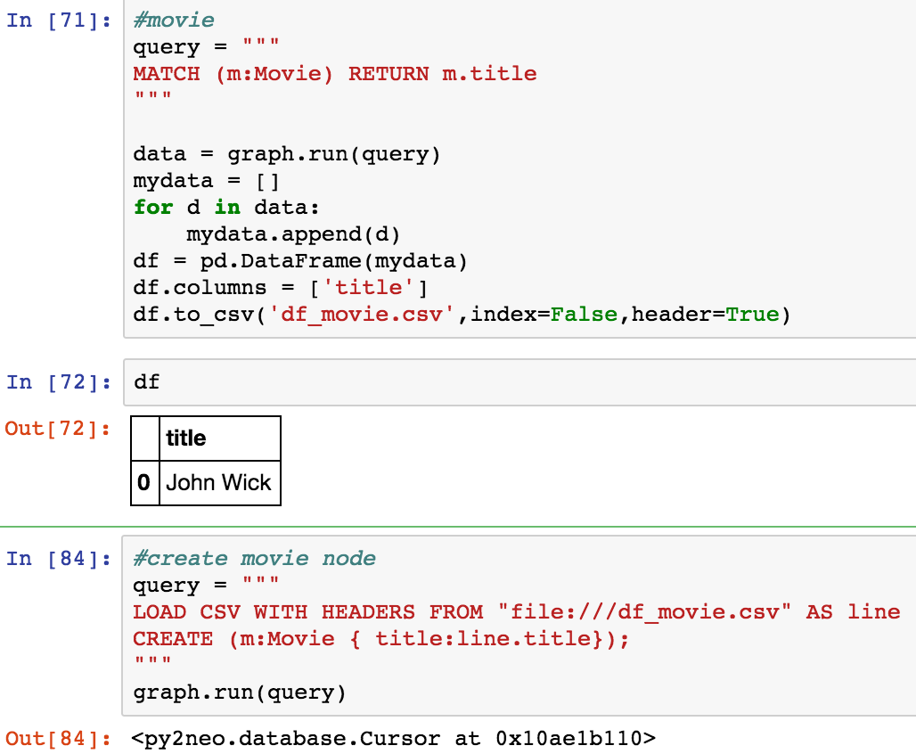

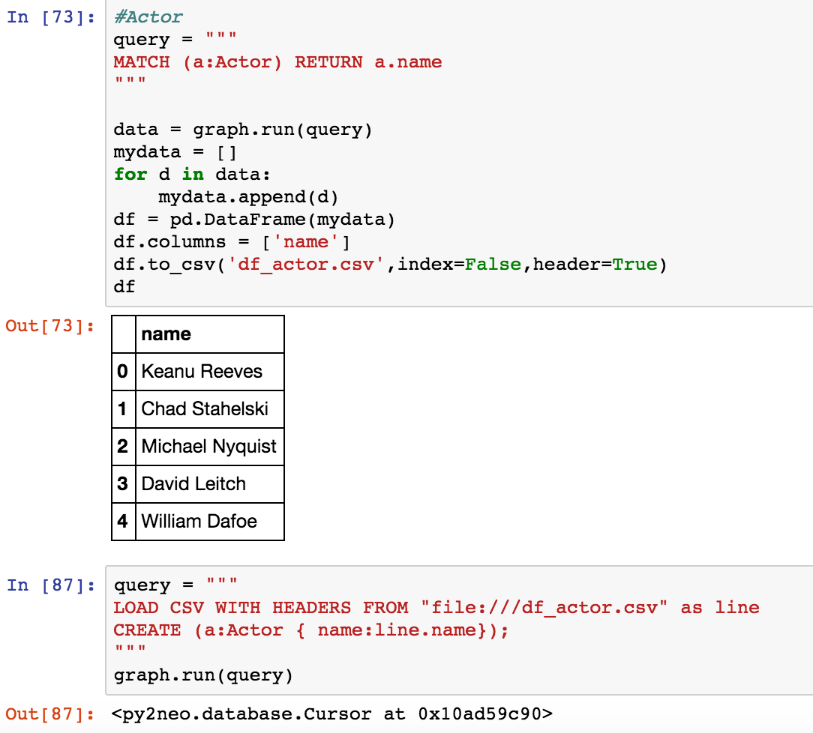

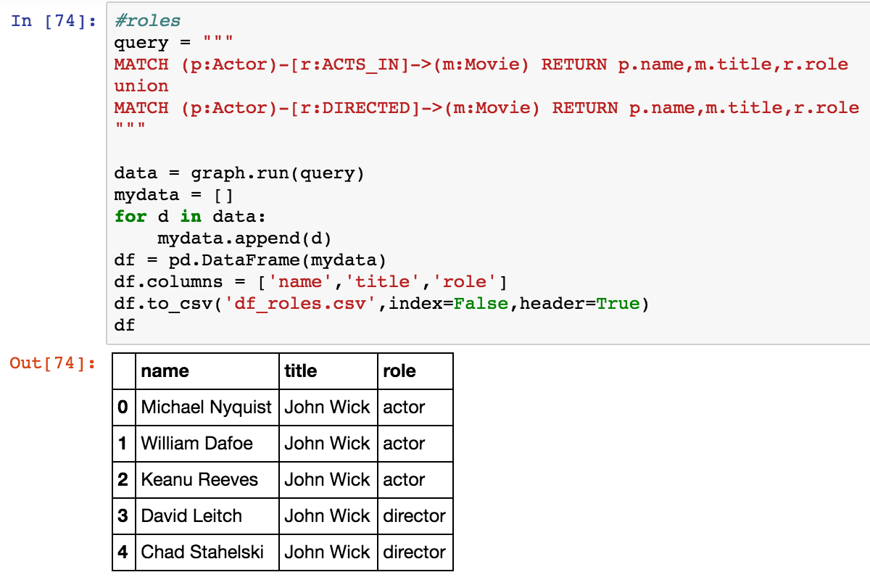

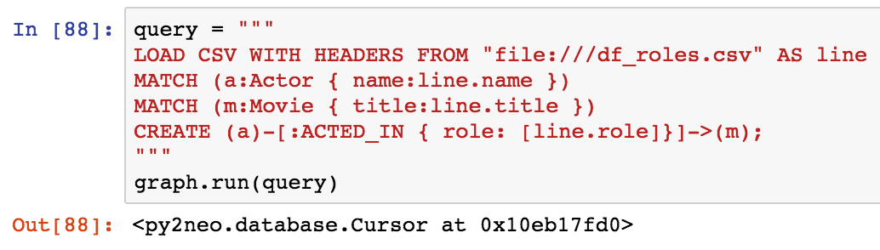

Verify the result from curl below:

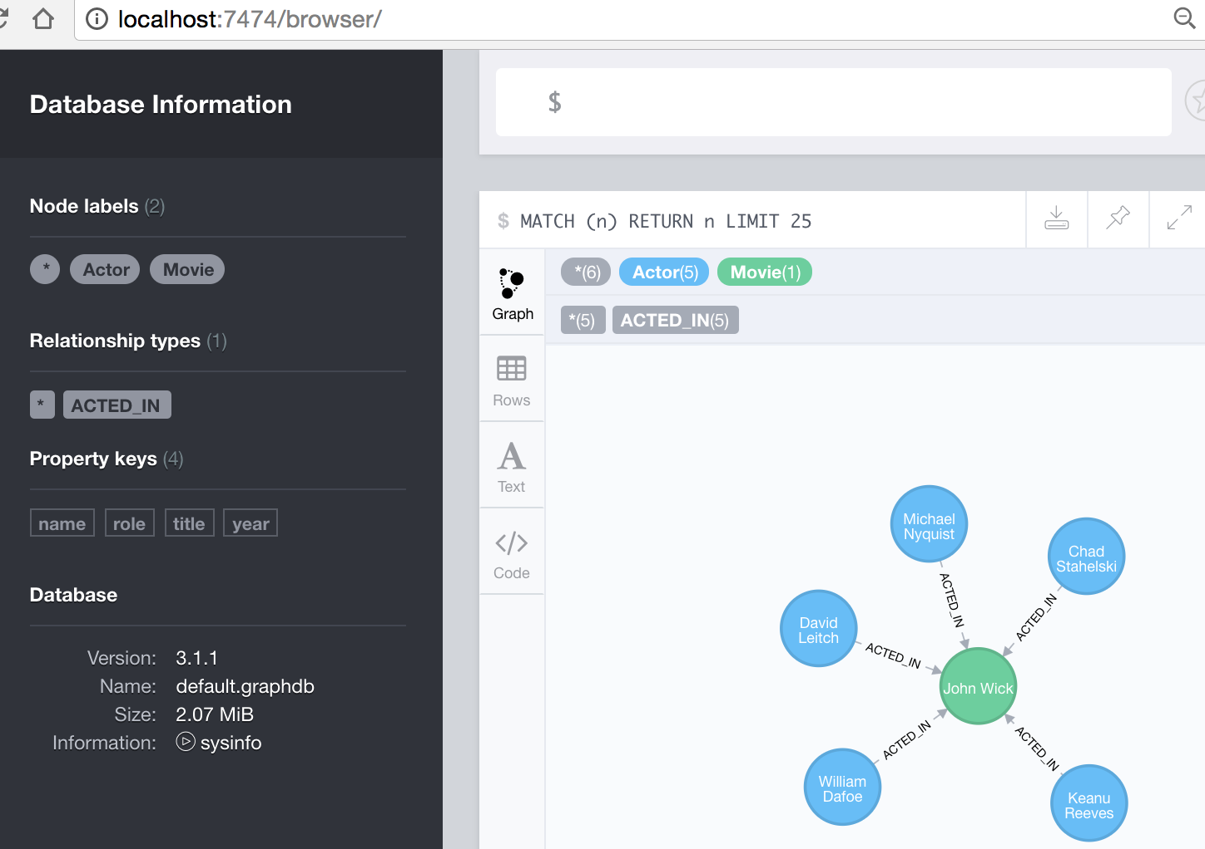

Python script is attached: pyNeo4j.ipynb

The code extension has been changed to .doc