Abstract
Background: Depression in young adulthood is rising and is an established cardiovascular disease (CVD) risk factor, yet the evidence base draws predominantly from older populations. Whether depressive symptomatology improves CVD risk discrimination beyond demographics in adults under 40 is unclear. We hypothesised that the Patient Health Questionnaire-9 (PHQ-9) would add reproducible discriminative value over demographics alone.
Methods: We analysed the NHANES pre-pandemic cycle (2017-March 2020), restricted to adults aged 18-39 with a usable PHQ-9 (n = 2,728). Data driven cardiovascular risk profiles were derived by K-means clustering of 13 self-reported and behavioural risk indicators. Three classifiers (logistic regression, random forest and gradient boosting) predicted profile membership from PHQ-9 plus demographics, each versus a demographics-only model. Discrimination used 5 fold stratified cross-validation over three seeds, compared by paired t-test; sensitivity analyses examined age, clustering method and fairness.
Results: Clustering identified two profiles (silhouette 0.37); the elevated-risk profile (22.0%) was marked by physician-recorded lifestyle advice and self-reported hypertension and dyslipidaemia. Its prevalence was 35.3% with PHQ-9 ≥ 10 versus 20.6% below 10. Adding PHQ-9 raised cross-validated ROC-AUC from 0.602 to 0.637 (logistic regression), 0.592 to 0.638 (random forest) and 0.599 to 0.642 (gradient boosting); every increment was significant (all p < 10⁻⁵), and PHQ-9 ranked highest by permutation importance.
Conclusions: Depressive symptomatology provides a small but statistically robust, algorithm-independent improvement in predicting cardiovascular risk profiles in young adults. The modest discrimination (AUC ≈ 0.64) indicates the PHQ-9 should complement, not replace, structured cardiovascular assessment. Code and dataset-access instructions are openly available.

1. Introduction
Depression is among the leading contributors to the global disease burden, and its prevalence in young people has risen sharply over the past decade (Thapar et al., 2022). Large epidemiological studies have established depression as an independent cardiovascular disease (CVD) risk factor: the American Heart Association’s Life’s Essential 8 was recently extended to Life’s Crucial 9 with a psychological-health dimension, motivated by NHANES evidence linking depression to cardiovascular mortality (Ge et al., 2024; Xu et al., 2024). Subsequent analyses show depression severity tracks cardiovascular-kidney-metabolic (CKM) syndrome progression (He et al., 2025; Wang et al., 2025), mortality in diabetes (Zhang Z et al., 2025), and is mediated in part by inflammation (Meng et al., 2025).
Most of this evidence draws on older adults. Younger adults accumulate sub-clinical risk for years before events occur, so risk stratification must rely on modifiable factors and family history. Machine learning (ML) is well suited here, capturing non-linear interactions and producing data-driven phenotypes classical risk equations may miss (Dipnall et al., 2016). NHANES has become a workhorse for such analyses (Zhang YZ et al., 2025; Vu et al., 2025; Wu et al., 2025; Liu et al., 2025), and lifestyle and metabolic correlates of depression are well documented in it (Liu et al., 2024; Zhou et al., 2024; Guo et al., 2025; Tian et al., 2025).
What remains under-explored is whether the routinely available PHQ-9 can predict a data-driven CV risk phenotype specifically in young adults. We therefore asked: can depression in younger adults be used to predict cardiovascular risk profiles using machine learning? In NHANES adults aged 18-39 we derived unsupervised CV risk profiles, trained three classifiers to predict profile membership from PHQ-9 plus demographics, and compared against a demographics only baseline, hypothesising that depression would offer incremental discriminative value.
2. Methods
2.1 Data source and rationale
NHANES is a continuous multi-stage stratified probability sample of the US non-institutionalised civilian population. Three features make it well-suited to ML for early-adulthood CV research: (i) it couples the validated PHQ-9 with self-reported diagnoses, medication and physiological measurements in the same participants; (ii) the per-cycle sample (≈ 15,000 overall; ≈ 3,000 aged 18-39) supports repeated stratified CV and stable feature importance; (iii) every variable is documented in a public codebook with stable cross-cycle coding, supporting reproducibility, a benchmark met by the NHANES-ML literature (Vu et al., 2025; Wu et al., 2025; Zhang YZ et al., 2025).
NHANES uses stratified multi-stage cluster sampling with oversampling of minority and low-income strata. We treat it as a learning sample and report unweighted ML metrics, since accuracy, F1 and AUC describe the model on data from this design rather than a simple random sample; the minority oversampling aids fairness audits but means sample prevalence ≠ national prevalence. We used the 2017-March 2020 pre-pandemic combined cycle, the most recent NHANES release containing PHQ-9 alongside the cardiovascular and medical-conditions modules.
2.2 Sample
Three considerations motivated the 18-39 window: CV risk accumulates at this stage before events, when modifiable factors remain amenable to intervention; depressive-symptom prevalence peaks in early adulthood (Thapar et al., 2022); and restricting to younger adults reduces confounding by comorbidities and polypharmacy.
From 3,260 participants aged 18-39 we excluded pregnant respondents and those without a usable PHQ-9 (≤ 2 items missing); n = 2,728.
2.3 Variables
Depression. The PHQ-9 is a nine-item self-report scale (total 0-27); PHQ-9 ≥ 10 is the conventional threshold for clinically significant symptoms. We modelled PHQ-9 as continuous in the supervised models and binary in cross-tabulations.
Cardiovascular risk indicators (13): self-reported hypertension (BPQ020), antihypertensive use (BPQ050A), high cholesterol (BPQ080), lipid-lowering use (BPQ100D), doctor-reported overweight (MCQ080), four physician lifestyle directives (MCQ366A-D), family history of premature MI (MCQ300A) and diabetes (MCQ300C), insufficient sleep (< 7 h) and household tobacco exposure. Because clinical events are rare before age 40, physician-recognised risk factors provide a more informative substrate.
Demographics and socioeconomic status: age, sex, race/ethnicity, education, marital status, and family poverty-to-income ratio.
2.4 Pre-processing
NHANES refused/don’t-know codes were set to missing; binary indicators were mode-imputed, continuous indicators median-imputed. Categorical variables were one-hot encoded; continuous variables z-score scaled, with scaling parameters estimated on the training fold only to avoid leakage.
2.5 Cardiovascular risk-profile derivation
Rationale for clustering rather than a published score: (i) calibrated scores (Framingham, AHA PREVENT, QRISK3) were derived on adults ≥ 30-40 and collapse near “low risk” here; (ii) they require measured biomarkers unavailable in our subset; (iii) a fixed-weight composite ignores risk-factor co-occurrence patterns recognised in cardiovascular-kidney-metabolic phenotyping (He et al., 2025; Wang et al., 2025).
K-means (k-means++, 20 restarts) on the standardised indicators recovers the constellation in which physician-flagged lifestyle issues, diagnoses and family history co-occur, a learned “clinician-recognised at-risk” phenotype (Figure 1B) treated as an analytic target, not a clinical diagnosis (Section 4.4). K was selected by mean silhouette over K ∈ {2,3,4}.
2.6 Supervised models
Three classifiers with deliberately different inductive biases were used: multinomial logistic regression (L2-regularised, linear, with directly interpretable log-odds coefficients); a random forest (bagged CART trees); and gradient boosting. Models were implemented in Python; full code is in the GitHub repository. For each algorithm we fit a demographics only baseline alongside the full model: a signal surviving linear, bagged and boosted models alike is unlikely to be a single-model artefact.
2.7 Hyperparameter tuning
Hyperparameters were selected by grid search with 3-fold stratified CV on an 80% tuning subset (n = 2,182). Selection criterion: mean macro F1. The LR grid spanned 16 configs, RF 27 and GB 12 (Table 2); the full 55-config grid is in results/hyperparameter_search.csv.
Algorithm | Hyperparameter | Values tested | Selected
Logistic regression | C (inverse L2) | 0.01, 0.1, 1, 10 | 1
Logistic regression | Learning rate | 0.1, 0.3, 0.5, 1.0 | 1.0
Random forest | n_estimators | 40, 60, 100 | 60
Random forest | max_depth | 4, 6, 8 | 8
Random forest | min_samples_leaf | 20, 30, 50 | 30
Gradient boosting | n_estimators | 40, 60, 100 | 60
Gradient boosting | Learning rate | 0.05, 0.1 | 0.05
Gradient boosting | max_depth | 2, 3 | 3
Table 2. Hyperparameter search space and selected configurations (√p features per split fixed for the tree ensembles).
2.8 Evaluation and interpretability
Performance was estimated by stratified 5-fold CV over three seeds (15 folds), with minority-class oversampling on training folds only. We report accuracy, balanced accuracy, macro F1 and macro-averaged one-versus-rest ROC-AUC; the full-vs-baseline macro F1 difference was tested with a paired t-test. On a held-out 25% split we computed RF permutation importance, LR coefficients, subgroup performance (sex, race/ethnicity, income tertile), and calibration (Brier score, predicted vs observed prevalence).
2.9 Software and ethics
Python 3.10, NumPy 2.2, pandas 2.3, matplotlib 3.10, seaborn 0.13; reproducible from code/run_analysis.py. NHANES is public-domain de-identified data; IRB approval was not required.
3. Results
3.1 Cohort
The analytic cohort comprised 2,728 adults aged 18-39 (mean age 28.0; 51.0% female; 9.2% with PHQ-9 ≥ 10). Table 1 summarises characteristics by derived risk profile; every cardiovascular indicator and the PHQ-9 is higher in the elevated-risk profile.
Characteristic | Overall | Low-risk profile | Elevated-risk profile
n | 2,728 | 2,128 | 600
Age, mean (SD) | 28.0 (6.6) | 27.6 (6.5) | 29.5 (6.5)
Female, % | 51.0 | 48.6 | 59.7
Non-Hispanic White, % | 31.3 | 31.7 | 29.7
Non-Hispanic Black, % | 25.0 | 25.0 | 25.0
Mexican American, % | 14.8 | 13.8 | 18.5
Non-Hispanic Asian, % | 12.1 | 12.8 | 9.7
PHQ-9 total, mean (SD) | 3.4 (4.2) | 3.0 (3.9) | 4.5 (4.8)
PHQ-9 ≥ 10, % | 9.2 | 7.7 | 14.8
Self-reported hypertension, % | 12.1 | 7.5 | 28.3
Self-reported high cholesterol, % | 10.6 | 5.5 | 28.7
Doctor-reported overweight, % | 33.7 | 19.1 | 85.3
Family history, premature MI, % | 8.6 | 7.2 | 13.3
Family history, diabetes, % | 34.6 | 30.7 | 48.3
Insufficient sleep (< 7 h), % | 23.7 | 23.3 | 25.3
Household smoker, % | 35.6 | 36.3 | 33.0
Table 1. Cohort characteristics, overall and by derived cardiovascular risk profile (n = 2,728).
3.2 Cardiovascular risk profiles
K-means selected K = 2 (silhouette 0.373 versus 0.274 and 0.285 for K = 3 and K = 4; Figure 1A). The two profiles separate sharply on physician-given lifestyle advice (Figure 1B): in profile 1 (n = 600, 22.0%), standardised scores for being told to lose weight, exercise, reduce salt and reduce fat ranged +1.12 to +1.58 SD versus −0.44 to −0.31 SD in profile 0, with elevated self-reported hypertension (+0.50 SD) and hypercholesterolaemia (+0.59 SD). We label profile 0 “low” and profile 1 “elevated” CV risk.
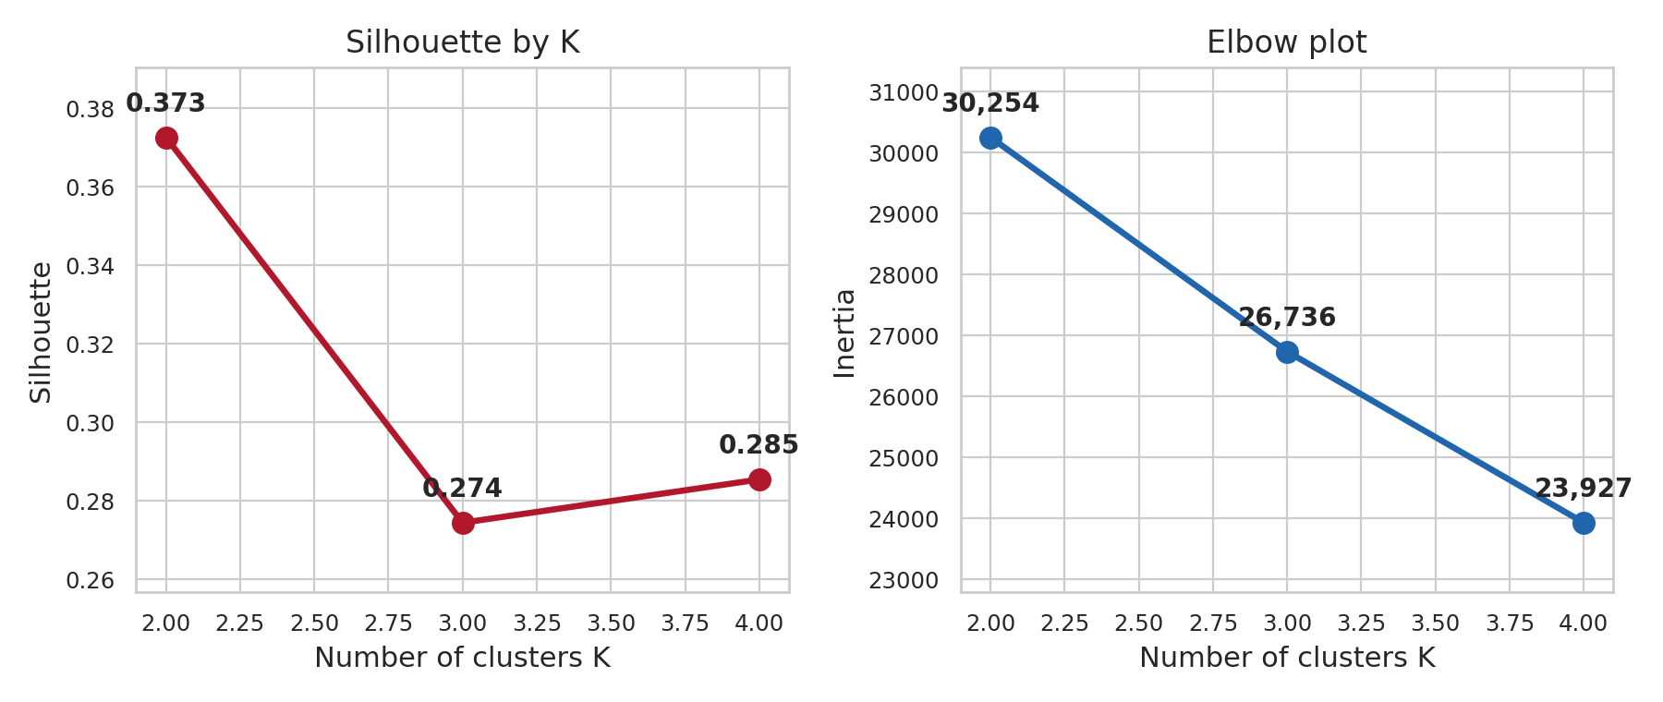
Figure 1A. Silhouette and elbow plots for K-means cluster selection over K ∈ {2,3,4}.
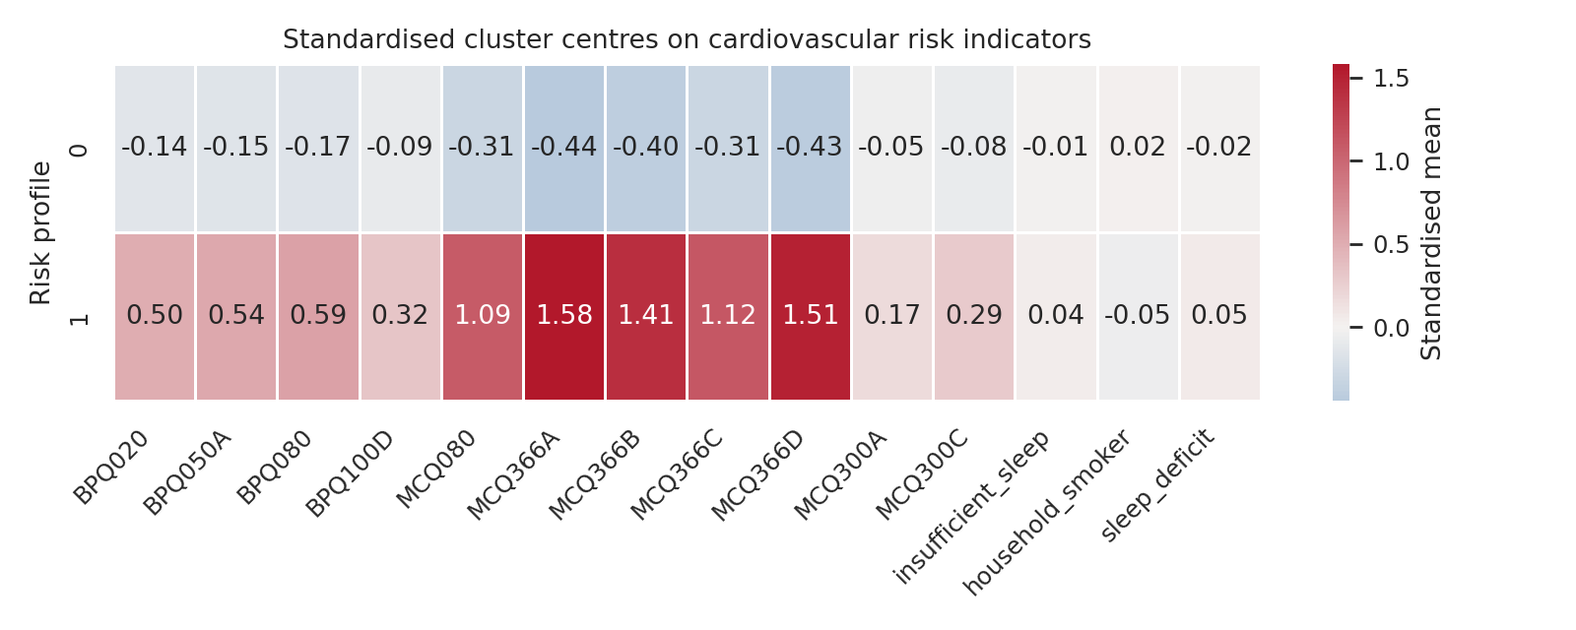
Figure 1B. Standardised K-means centroids on cardiovascular risk indicators. The elevated-risk profile is dominated by physician-given lifestyle directives (MCQ366A-D) and self-reported hypertension and dyslipidaemia.
3.3 Crude depression-risk-profile association
The elevated-risk profile contained 35.3% of participants with PHQ-9 ≥ 10 versus 20.6% of those with PHQ-9 < 10: clinically significant depression doubled the odds of the elevated-risk profile (odds ratio 2.10, 95% CI 1.59-2.77; χ² = 28.7, p < 0.001). Median PHQ-9 was 2 in the low-risk profile versus 3 in the high-risk profile (Figure 2).
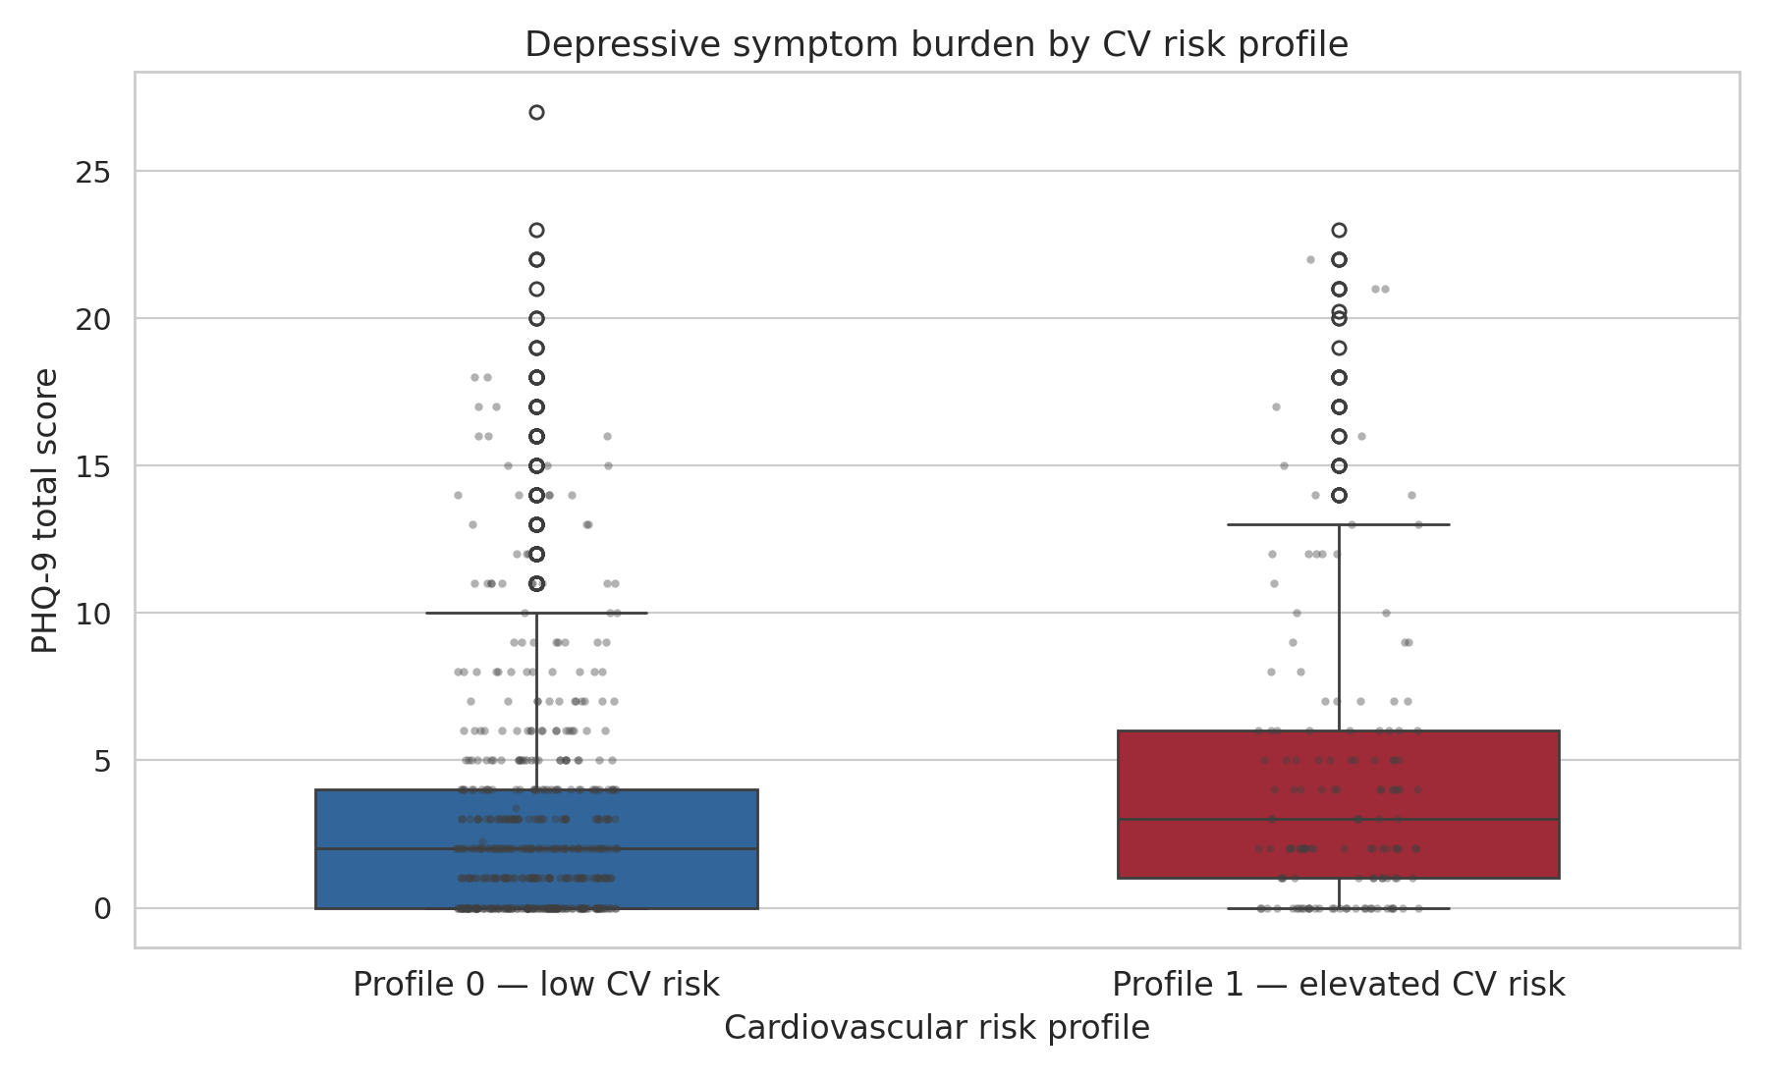
Figure 2. Distribution of PHQ-9 total scores by cardiovascular risk profile. Box plot summarises the inter-quartile range; scattered points show a sub-sample of individual participants.
3.4 Model performance
Cross-validated discrimination is in Table 3 and Figure 3. Adding PHQ-9 raised ROC-AUC by ≈ 0.04 in all three algorithms (LR: 0.602 → 0.637; RF: 0.592 → 0.638; GB: 0.599 → 0.642), the boosted ensemble marginally strongest, with good stability across folds (SDs 0.02-0.04). Paired t-tests confirmed significant macro-F1 improvement under every algorithm (LR t = 4.49; RF t = 7.47; GB t = 5.48; all p < 10⁻⁵).
Model | Accuracy | Balanced acc | Macro F1 | ROC-AUC
Logistic regression (demographics only) | 0.575 ± 0.020 | 0.573 ± 0.022 | 0.525 ± 0.018 | 0.602 ± 0.026
Logistic regression (+ PHQ-9) | 0.605 ± 0.020 | 0.591 ± 0.029 | 0.547 ± 0.022 | 0.637 ± 0.031
Random forest (demographics only) | 0.608 ± 0.022 | 0.565 ± 0.021 | 0.536 ± 0.019 | 0.592 ± 0.031
Random forest (+ PHQ-9) | 0.634 ± 0.022 | 0.604 ± 0.027 | 0.568 ± 0.023 | 0.638 ± 0.034
Gradient boosting (demographics only) | 0.592 ± 0.026 | 0.571 ± 0.028 | 0.532 ± 0.024 | 0.599 ± 0.034
Gradient boosting (+ PHQ-9) | 0.620 ± 0.025 | 0.606 ± 0.035 | 0.562 ± 0.028 | 0.642 ± 0.036
Table 3. Cross-validated performance (mean ± SD, 5-fold × 3 seeds). Adding PHQ-9 improves every model.
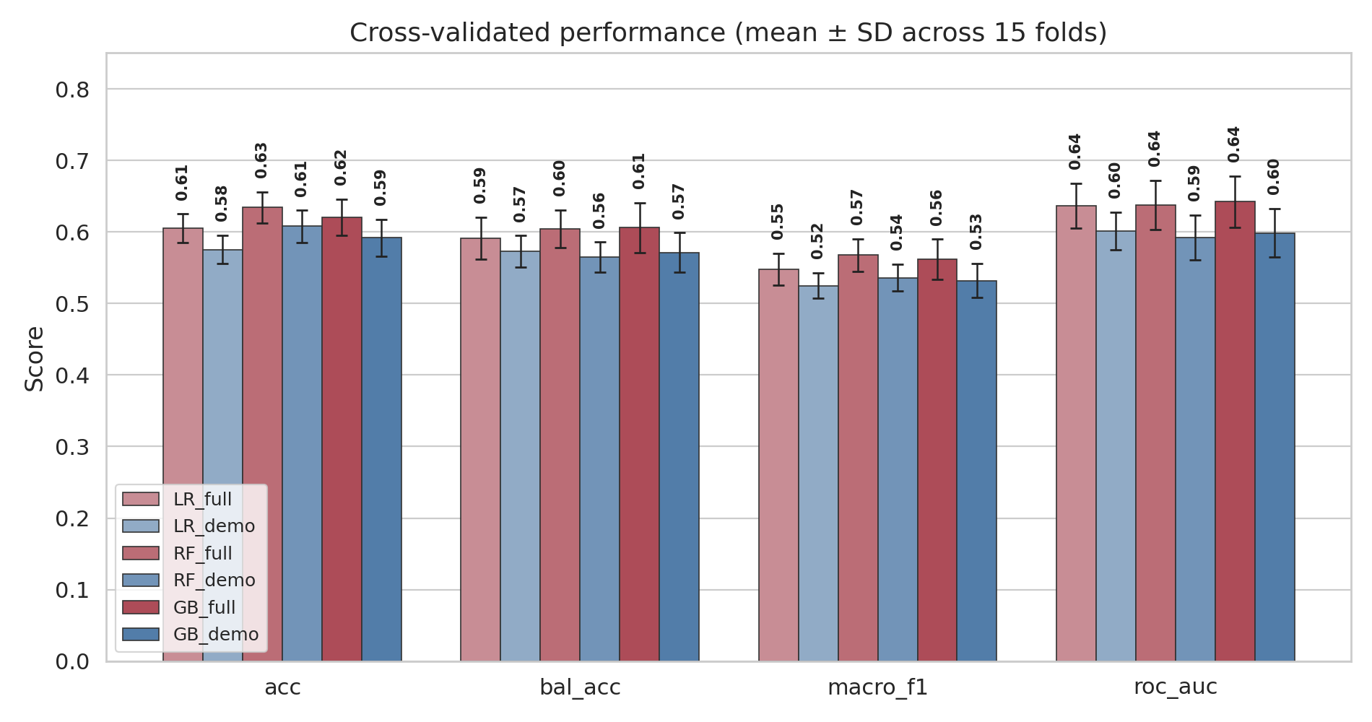
Figure 3. Cross-validated performance of the six models (three algorithms × full / demographics-only). Adding PHQ-9 consistently improves on the demographics-only baseline.
3.5 Confusion and interpretability
On the held-out 25% split the RF confusion matrix (Figure 4A) showed moderate sensitivity for the elevated-risk class (≈ 0.53), with false positives expected from training-time oversampling (Section 4.3).
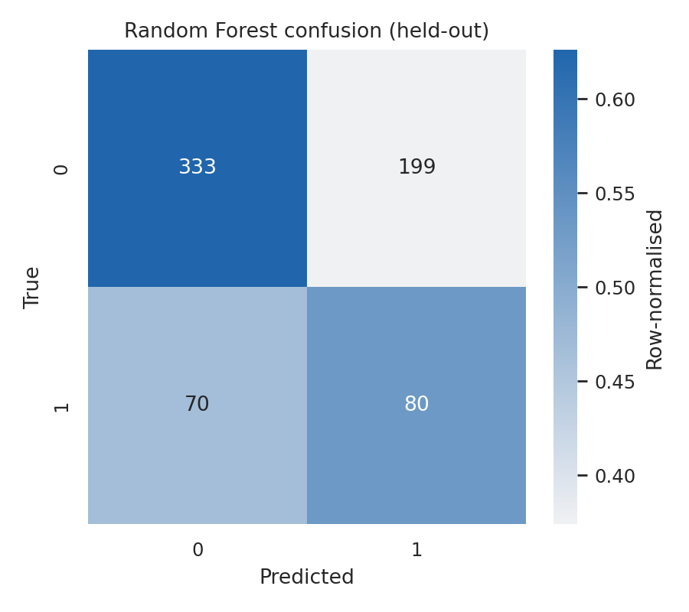
Figure 4A. Random forest confusion matrix on the held-out 25% test set. Cell shading shows row-normalised proportion; numerals are raw counts.
Permutation importance ranked PHQ-9 as the single most informative feature (Figure 4B; macro-F1 drop 0.032 ± 0.013), well ahead of any other variable; LR coefficients corroborated this (PHQ-9 +0.19 standardised, comparable to age +0.21). The marginal RF effect of PHQ-9 (Figure 5) was monotonic, rising from ≈ 0.48 at PHQ-9 = 0 to ≈ 0.65 at PHQ-9 = 20.
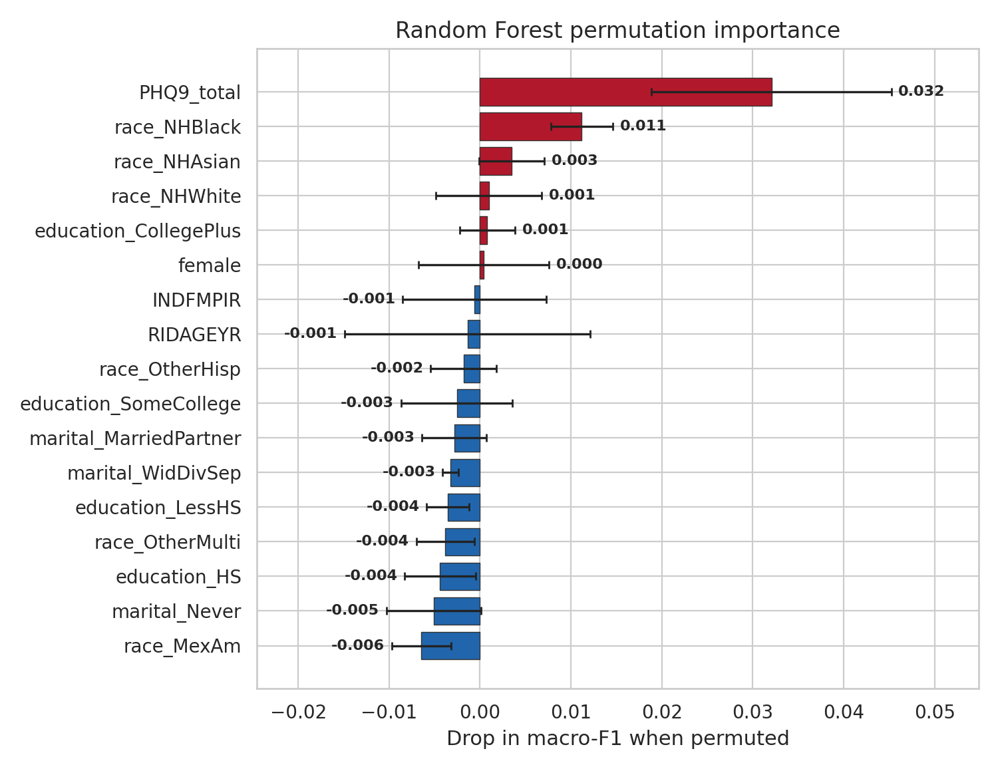
Figure 4B. Random forest permutation importance (8 permutations, macro F1 drop). PHQ-9 total is the single most informative feature.
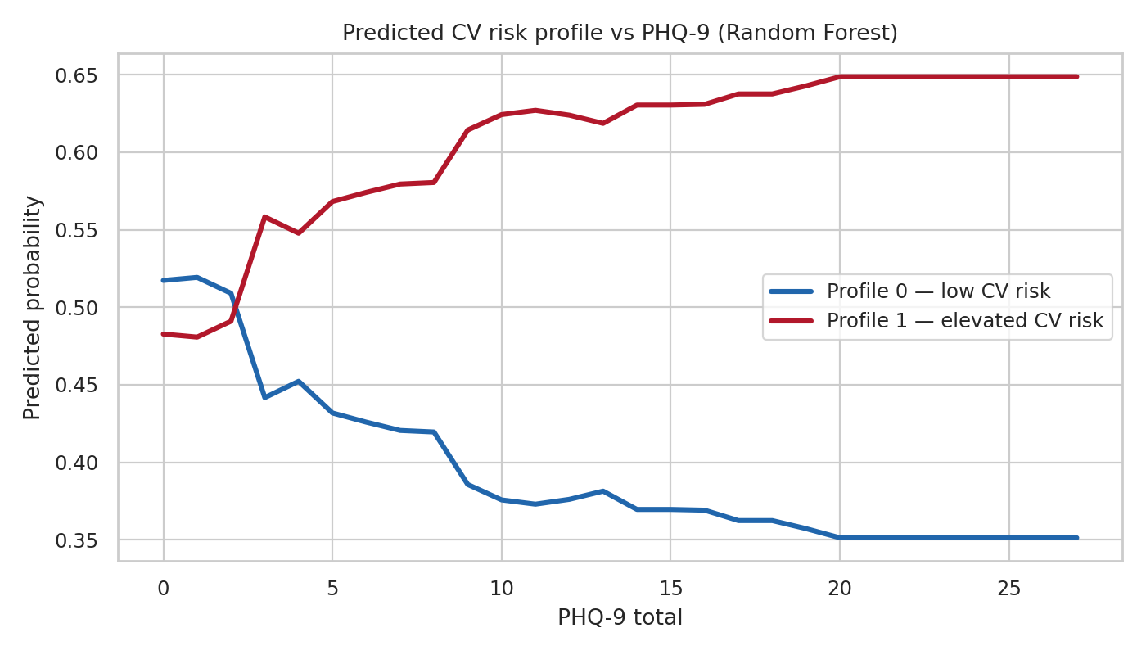
Figure 5. Marginal random-forest predicted probability of each risk profile as a function of PHQ-9 total, with demographics held at sample means.
3.6 Sensitivity analyses
Age window. Re-running on broader age windows (Table 4) showed the incremental PHQ-9 ROC-AUC was largest in 18-39 (+0.036 LR / +0.042 RF) and roughly halved in 18-64 and 18+. Baseline AUC rose with age range as accumulated risk factors carry more weight in older adults; all ablations stayed significant (p < 0.005). Depression's marginal value is therefore greatest in the under 40 window.
Clustering method. Re-deriving the profiles with K-modes (the matching-dissimilarity method appropriate for binary data) agreed closely with the K-means profiles (98.3% agreement, adjusted Rand index 0.92) and preserved the depression gradient (31.7% elevated-risk in PHQ-9 ≥ 10 vs 19.1% otherwise). The phenotype is not an artefact of K-means on binary data.
Cohort | n | Elev % | LR demo AUC | LR + PHQ AUC | ΔAUC | RF demo AUC | RF + PHQ AUC | ΔAUC
18-39 (primary) | 2,728 | 22.0 | 0.602 | 0.637 | +0.036 | 0.595 | 0.637 | +0.042
18-64 (working-age) | 6,254 | 34.5 | 0.668 | 0.685 | +0.017 | 0.675 | 0.691 | +0.016
18+ (all adults) | 8,223 | 36.7 | 0.654 | 0.677 | +0.024 | 0.671 | 0.692 | +0.021
Table 4. Age-window sensitivity analysis (5-fold CV × 2 seeds). PHQ-9’s incremental discriminative value is largest in the under 40 cohort.
3.7 Subgroup performance (fairness check)
Held-out RF subgroup performance is in Table 5. Sex parity was good (AUC 0.608 vs 0.606); race/ethnicity AUC ranged 0.586 to 0.631, balanced accuracy lowest in Mexican American (0.511); income tertiles showed a modest gradient (AUC 0.598 → 0.622).
Subgroup | n | % elevated | Bal acc | Macro F1 | ROC-AUC
Overall | 682 | 22.0 | 0.580 | 0.543 | 0.609
Sex: Female | 354 | 23.7 | 0.568 | 0.500 | 0.608
Sex: Male | 328 | 20.1 | 0.577 | 0.568 | 0.606
Race: Mexican American | 102 | 26.5 | 0.511 | 0.470 | 0.587
Race: Non-Hispanic Asian | 90 | 11.1 | 0.544 | 0.460 | 0.586
Race: Non-Hispanic Black | 162 | 25.9 | 0.611 | 0.589 | 0.631
Race: Non-Hispanic White | 209 | 23.4 | 0.586 | 0.561 | 0.613
Race: Other Hispanic | 80 | 22.5 | 0.637 | 0.623 | 0.617
Income (PIR) low <1.47 | 227 | 20.7 | 0.576 | 0.550 | 0.598
Income (PIR) mid 1.47-2.46 | 226 | 22.1 | 0.570 | 0.544 | 0.610
Income (PIR) high ≥2.46 | 229 | 23.1 | 0.588 | 0.526 | 0.622
Table 5. Held-out RF subgroup performance (n = 682 test split). The Other/Multi-race subgroup (n = 39) is omitted because its small size renders metrics unstable.
4. Discussion
4.1 Summary of key findings
The results broadly support the hypothesis that depressive symptomatology carries cardiovascular-risk information in young adults beyond what demographics provide. Even in an under 40 sample where overt CVD is rare, the PHQ-9 added a small but reproducible improvement to discrimination of a data-driven CV risk phenotype. The most informative finding is the consistency of the signal: three algorithms with different inductive biases converged on ROC-AUC ≈ 0.64, every ablation was significant, and PHQ-9 ranked as the most important input by permutation importance. Crude elevated-risk prevalence was 71% higher among PHQ-9 ≥ 10 participants (35.3% vs 20.6%).
These findings align with the accumulating NHANES literature linking depression to cardiovascular health (Ge et al., 2024; Xu et al., 2024; Wu et al., 2025; He et al., 2025; Wang et al., 2025; Zhang Z et al., 2025; Meng et al., 2025). Our contribution is to show the signal is recoverable from PHQ-9 alone against a learned multivariate phenotype, with incremental value greatest in the under 40 window.
4.2 Model comparison and trade-offs
All three algorithms converged on near-identical discrimination (ROC-AUC 0.637-0.642), itself informative: the depression-CV-risk signal is largely additive and linearly accessible, with little extra recoverable from non-linear interactions. This shapes the model-choice trade-off. Logistic regression is the most transparent (coefficients read as log-odds, fast, simple to audit and recalibrate); the tree ensembles capture interactions but at the cost of interpretability (needing post-hoc tools such as SHAP) and greater computational expense. For a primary-care screening application, where transparency matters and the boosted model's 0.005 AUC edge is not clinically meaningful, logistic regression is preferable; for a research setting prioritising predictive ceiling, gradient boosting would be chosen. The pipeline retains all three.
4.3 Calibration and clinical utility
Discrimination and calibration are distinct, and the headline metric concerns only the former. An AUC of 0.64 falls below the 0.70 conventionally taken as the minimum for acceptable discrimination: given one elevated-risk and one low-risk participant, the model ranks them correctly 64% of the time. Calibration is weaker still. Because training folds were oversampled to 50:50, the random forest's predicted probabilities are inflated (mean 0.46 against a true prevalence of 0.22) and its Brier score (0.229) is worse than simply predicting the base rate (0.172); a non-oversampled model is well calibrated (mean 0.22, Brier 0.166) but loses minority-class sensitivity. The probabilities in Figure 5 should therefore be read as relative ordering, not true risks. Clinically, this is not a deployable individual risk calculator. Its defensible uses are narrower: a low-stakes triage signal, where even weak discrimination can carry net benefit because flagging a young adult for fuller cardiovascular assessment is cheap and low-harm, and population-level evidence. It should not inform treatment decisions.
4.4 Strengths and limitations
The analysis has several strengths: a strict ablation against a demographics-only baseline, documented grid-search tuning, and age-window, clustering-method and subgroup-fairness sensitivity analyses. In keeping with open-science practice the whole pipeline is fully reproducible, with all code, result files and dataset-access instructions openly available for independent re-running and audit. Six limitations qualify the interpretation. (i) The design is cross-sectional, so reverse causation remains plausible. (ii) CV indicators are self-reported, biasing ascertainment toward those with healthcare access. (iii) Measured biomarkers were unavailable. (iv) Discrimination (AUC ≈ 0.64) is modest. (v) The K-means phenotype is an analytic target, not a prospectively validated risk class; external validation against incident events is essential before clinical use. (vi) Although NHANES is a probability sample, the complete-case analytic subset may under-represent the most survey- and healthcare-disengaged young adults, modestly limiting external validity. A minor redundancy is also noted: sleep enters the clustering through two correlated indicators, mildly over-weighting it, though its near-zero cluster separation (Figure 1B) makes the effect negligible.
4.5 Ethics, fairness and interpretability
The subgroup audit (Table 5) shows good sex parity (AUC 0.61 vs 0.61) but uneven race/ethnicity discrimination, weakest in Mexican American (AUC 0.59, balanced accuracy 0.51) and Non-Hispanic Asian (AUC 0.59) participants, with a modest income gradient (AUC 0.60 → 0.62). These disparities reflect underlying differences in CV-risk prevalence and clinician flagging rather than biological causation, but indicate the model would under-serve some subgroups in deployment. The reliance on self-reported diagnoses compounds this: groups with poorer healthcare access are under-diagnosed and so receive systematically lower risk estimates, risking under-recognition of those most in need. Clinical-translation pipelines should remove race or replace it with social-determinant-of-health proxies (Vu et al., 2025; Wu et al., 2025). Using depression as a CV risk marker also risks stigma for high-PHQ-9 patients; deployment would require governance and fairness audits.
4.6 Implications and future development
The findings support integrating mental-health screening into early-adulthood CV cohorts. Future work should pool additional NHANES cycles to enlarge the under 40 sample, validate the phenotype against incident cardiovascular events, and re-derive the risk profiles on measured biomarkers.
5. Conclusion
Overall, the findings tell a coherent story. In NHANES adults aged 18-39, depressive symptomatology measured by the PHQ-9 contributes a small but reproducible improvement over demographics in predicting a data-driven cardiovascular risk phenotype, consistent across three algorithms and largest in the under 40 window. The effect is modest and should not be overinterpreted: PHQ-9 is not a stand-alone risk tool, but it carries enough signal to support depression screening in early-adulthood CV risk assessment, reinforcing the view that psychological health is part of cardiovascular health.
References
1. Dipnall, J.F., Pasco, J.A., Berk, M. et al. (2016) 'Into the Bowels of Depression: Unravelling Medical Symptoms Associated with Depression by Applying Machine-Learning Techniques to a Community Based Population Sample', PLoS One, 11(12), e0167055. [PubMed]
2. Ge, J., Peng, W. and Lu, J. (2024) 'Predictive Value of Life’s Crucial 9 for Cardiovascular and All-Cause Mortality: A Prospective Cohort Study From the NHANES 2007 to 2018', Journal of the American Heart Association, 13(19), e036669. [PubMed]
3. Guo, T., Zhou, Y., Yang, G., Sheng, L. and Chai, X. (2025) 'Association between cardiometabolic index and hypertension among US adults from NHANES 1999-2020', Scientific Reports, 15, 87029. [PubMed]
4. He, Y., Lan, L., Liu, Y. et al. (2025) 'Depression severity as a predictor of cardiovascular-kidney-metabolic syndrome progression and mortality: Results from two nationally representative cohort studies', Journal of Affective Disorders, 388, 119606. [PubMed]
5. Liu, H., Dong, H., Zhou, Y. et al. (2024) 'The association between Metabolic Score for Visceral Fat and depression in overweight or obese individuals', Frontiers in Endocrinology, 15, 1482003. [PubMed]
6. Liu, X., Luo, Z., Jing, F. et al. (2025) 'Estimating cardiovascular mortality in patients with hypertension using machine learning: the role of depression classification based on lifestyle and physical activity', Journal of Psychosomatic Research, 189, 112030. [PubMed]
7. Meng, X., Han, L., Fu, J., Hu, C. and Lu, Y. (2025) 'Associations between metabolic syndrome and depression, and the mediating role of inflammation: Based on the NHANES database', Journal of Affective Disorders, 375, pp. 214-221. [PubMed]
8. Thapar, A., Eyre, O., Patel, V. and Brent, D. (2022) 'Depression in young people', The Lancet, 400(10352), pp. 617-631. [PubMed]
9. Tian, Q., Guo, J., Ding, J. and Zhu, Y. (2025) 'The relationship between unhealthy lifestyle behaviors and depression: Evidence from NHANES', Journal of Affective Disorders, 384, pp. 214-221. [PubMed]
10. Vu, T., Dawadi, R., Yamamoto, M. et al. (2025) 'Prediction of depressive disorder using machine learning approaches: findings from the NHANES', BMC Medical Informatics and Decision Making, 25, 83. [PubMed]
11. Wang, G., Wu, Y., Chen, A. et al. (2025) 'Association between depressive symptoms and mortality in patients with Cardiovascular-Kidney-Metabolic syndrome: the mediating role of inflammatory biomarkers', Journal of Affective Disorders, 386, 119429. [PubMed]
12. Wu, Z., Xu, P., Zhai, Y. et al. (2025) 'The Association of Elevated Depression Levels and Life’s Essential 8 on Cardiovascular Health With Predicted Machine Learning Models and Interpretations: Evidence From NHANES 2007-2018', Depression and Anxiety, 2025, 8865176. [PubMed]
13. Xu, Y., Ning, W., Zhang, Y. et al. (2024) 'Associations Between Cardiovascular Health (Life’s Essential 8) and Mental Disorders', Clinical Cardiology, 47(10), e70019. [PubMed]
14. Zhang, Y.-Z., Wu, H.-Y., Ma, R.-W. et al. (2025) 'Machine Learning-Based predictive model for adolescent metabolic syndrome: Utilizing data from NHANES 2007-2016', Scientific Reports, 15, 88156. [PubMed]
15. Zhang, Z., Xu, H., Meng, Y., Yan, Y. and Wang, Y. (2025) 'Association between depressive symptoms and all-cause and cardiovascular mortality in diabetes patients: A national cohort study', Journal of Affective Disorders, 391, 119957. [PubMed]
16. Zhou, X., Tao, X.-L., Zhang, L. et al. (2024) 'Association between cardiometabolic index and depression: National Health and Nutrition Examination Survey (NHANES) 2011-2014', Journal of Affective Disorders, 351, pp. 939-947. [PubMed]

