Designed for Adjustment:
Coal-Power Lock-in and the Missing Exit Pathway in China, 2000–2023
Abstract
Coal transition is often inferred from improvements in energy intensity, emissions, or the coal share of energy use. These measures need not imply the retirement of coal-power assets. [] This study examines China’s transition architecture using a 31-province panel for 2000–2023, reconstructed coal, wind, and solar project histories from Global Energy Monitor trackers, and coal-unit retirement records. We distinguish operating, compositional, and asset-exit margins, and interpret the 2012–2023 policy architecture as designed primarily for operating adjustment, cleaner utilization, and system adequacy rather than fleet-wide asset exit. Provincial patterns show post-2012 reductions in coal-use intensity and coal’s share of five-energy final use in more coal-exposed provinces. Direct asset evidence shows no statistically detectable acceleration of coal-unit retirement in high-coal-exposure provinces in the current survival specifications. Reconstructed national coal-power operating capacity increased from approximately 686 GW in 2011 to 1,143 GW in 2023, even as wind and solar capacity expanded. National composition measures nevertheless show a real shift: the coal share of the five-energy final-use basket fell from 68.2% in 2006 to 58.8% in 2022, while thermal capacity and generation shares declined. This is a transition at the operating and composition margins, not yet at the exit margin. Resource-linked fiscal and employment exposure, continuing reliability requirements, uneven renewable absorption, and active project pipelines characterize the conditions under which adjustment can reinforce, rather than unwind, lock-in. The findings do not indicate failure at the operating margin. They reveal a policy-design gap between greening the stock and exiting the stock, and motivate a second-generation transition framework that joins retirement, replacement, grid integration, and local adjustment for long-run decarbonization.
Keywords: coal-power retirement; carbon lock-in; policy design; energy transition; transition finance; China; just transition

Introduction
Energy transition is frequently evaluated through changes in carbon intensity, fuel shares, renewable investment, or pollutant emissions. However, the discussion of whether incumbent fossil assets have actually exited remains scarce. Even though the iteration of relative technology could lead to coal generators consuming less coal per unit of output, operate fewer hours, install pollution-control equipment, or be supplemented by renewable generation while remaining in service. For systems with long-lived plants, the distinction between changing operation and retiring assets is central to both climate policy and electricity security.
China provides a consequential setting because the relevant policy architecture was oriented primarily to adjustment within the coal-power system, given the total consumption of electricity rising chronologically. The 2012 Green Credit Guidelines placed environmental and social risk within bank lending practice (China Banking Regulatory Commission 2012); subsequent energy, environmental, and carbon policies operated alongside an overriding concern with system adequacy and orderly transition. Such a configuration can support efficiency improvement, cleaner utilization, renewable deployment, and reliability. It does not, by itself, allocate the costs of retiring viable but carbon-intensive assets, secure replacement services, or arrange fiscal and labour adjustment. We therefore characterize the 2012–2023 architecture as a first-generation transition policy: an operating-margin framework oriented to adjustment, cleaner utilization, and security of supply.
The distinction has practical consequences for policy evaluation. A fall in energy intensity can reflect technical improvement, changes in output composition, denominator growth, or the relocation of energy-intensive activity. A fall in a coal share can reflect the expansion of electricity, gas, or renewables while leaving coal generators in place. Even a lower thermal generation share is not equivalent to retirement when capacity remains available for peak demand, reserve, or security-of-supply purposes. Treating each of these outcomes as a common measure of “transition” therefore risks conflating the use of coal with the persistence of coal assets. The error is especially consequential in coal regions, where a plant closure has distributional effects that efficiency improvement does not.
The article treats the post-2012 years as a policy window in which to observe whether an operating-margin transition automatically spilled over into asset exit. It did not. We do not interpret the 2012 Green Credit Guidelines, or any later national policy, as an intervention intended to retire coal assets, nor as a province-level treatment with a clean untreated comparison. The Guidelines are institutional context, not the causal treatment in this study: the available provincial credit measure does not observe lending to coal assets, the available bank-network instrument is weak, and a national policy date cannot distinguish finance from concurrent energy, industrial, and environmental policies. The absence of an automatic spillover is therefore not evidence that policy failed. It is consistent with a policy architecture that was not designed to produce fleet-wide retirement.
The analysis instead triangulates three bodies of evidence. First, it uses a balanced 31-province panel for 2000–2023 to distinguish operating outcomes, coal-use composition, and thermal-power structure. Second, it reconstructs annual additions, retirements, and operating stocks of coal, wind, and solar projects from the Global Energy Monitor (GEM) trackers and analyzes retirement histories for 4,323 coal units. This provides a direct asset measure rather than using an insignificant change in a thermal-generation share as a proxy for exit. Third, it maps transition constraints with measures of resource-linked employment, fiscal and industrial-asset exposure, coal-unit operating and standby requirements, renewable consumption, utilization, and project pipelines. Shanxi and Inner Mongolia are used as structured comparison cases, not as a causal two-province experiment.
The findings show a transition with different margins moving at different speeds. More coal-exposed provinces display larger post-2012 declines in coal-use intensity and in the coal share of final energy in baseline specifications. The coal-share dynamics are comparatively clean; intensity and selected pollutant results are sensitive to pre-trends or province-specific trends. At the national level, the share of coal in the observed five-energy final-use basket fell from 68.2% in 2006 to 58.8% in 2022; thermal capacity and generation shares also fell. These are meaningful compositional changes. Yet reconstructed coal-power operating capacity rose from 686 GW in 2011 to 1,143 GW in 2023, and current unit-level survival models do not detect a post-2012 acceleration of retirement in high-coal-exposure provinces. Renewable expansion was substantial, but it did not automatically displace the coal fleet.
This distinction contributes a policy-design dimension to research on carbon lock-in and regional transition. Lock-in need not result from the absence of environmental policy. It can be reinforced by the particular form of policy: a form that improves and legitimates incumbent assets without establishing a credible path to retire them. The paper calls this mechanism lock-in through adjustment. It distinguishes greening the stock from exiting the stock, while keeping the empirical claim bounded: the evidence documents the coexistence of the two margins; it does not identify one policy instrument or one provincial constraint as their cause.
The paper’s contribution is therefore diagnostic rather than causal. It proposes that a policy diagnosis should first establish whether change is occurring at the operating, compositional, or asset margin; it should then ask whether policy design connects those margins. This measurement discipline is particularly appropriate where interventions overlap and data observe regional systems more clearly than lender–borrower transactions. The policy implication is prospective. Measures that clean and optimize the existing stock may achieve their immediate purpose, but long-run decarbonization also requires a second-generation transition policy that makes retirement, replacement, grid integration, and local adjustment jointly feasible.

Transition path dependence: from greening the stock to exiting it
The analysis distinguishes three margins of change. Operating adjustment concerns changes within an incumbent system: fuel input per unit of output, utilization, pollutant emissions, and efficiency. Compositional adjustment concerns the relative role of coal in final energy use or generation. Asset exit concerns the retirement, cancellation, mothballing, or permanent repurposing of coal units. The margins may move together, but they impose different coordination problems and are addressed by different instruments.
The distinction follows from policy-design and path-dependence theory. Policy mixes embody choices about objectives, instruments, and the distribution of adjustment costs (Howlett 2010). Increasing returns can make an initially practical institutional arrangement self-reinforcing as infrastructure, capabilities, expectations, and compensation claims accumulate (Arthur 1989; Pierson 2000; Mahoney 2000). Carbon lock-in similarly resides in the co-evolution of durable technical systems, institutions, and political-economic interests (Unruh 2000). In this setting, environmental regulation and transition finance can affect operation without resolving retirement. Firms can improve technology, inputs, and abatement practices when environmental costs are internalized (Porter and Linde 1995; Popp 2002; Acemoglu et al. 2012); lenders can incorporate environmental risk into screening, pricing, covenants, and monitoring (Stiglitz and Weiss 1981; Campiglio 2016; Dikau and Volz 2021). Many of these responses are feasible within the life of an existing asset. They do not require the coordinated closure agreement that asset exit does.
This creates a specific form of transition path dependence. Cleaner operation can reduce pollution and fuel use, and renewable additions can lower coal’s share, while a retained fleet remains embedded in reliability arrangements, local tax bases, state-owned balance sheets, and employment systems. The transition then proceeds through regime-level optimization rather than through a pathway that dismantles or replaces the incumbent regime (Geels 2002; Geels and Schot 2007; Markard, Raven, and Truffer 2012). We term the resulting pattern lock-in through adjustment: policy can make the installed fleet cleaner or less intensively used, yet defer the political-economic decisions necessary for exit. The concept does not treat adjustment as harmful; it specifies why adjustment and exit are potentially competing, not automatically sequential, transition strategies.
Asset exit is more demanding. Coal generators are durable and capital-intensive. Their continued operation may support system adequacy, local employment, tax bases, and state-owned enterprise balance sheets. Their retirement can require replacement capacity, flexible generation or storage, transmission and dispatch arrangements, debt restructuring, land remediation, worker support, and fiscal adjustment. These complementarities make the relevant unit of transition larger than an individual lending decision. They also explain why the security-of-supply and build-before-breaking logic is reasonable in the short run, while still leaving a long-run design question: who provides the replacement service, bears the financial loss, and supports affected localities?
The difference is not merely technical. A first-generation transition policy can succeed on its own terms when it improves operation, reduces local pollution, deploys renewables, and preserves adequate service. It remains incomplete for long-run decarbonization if it leaves retirement dates, retirement finance, replacement capacity, grid integration, and regional adjustment outside the policy package. A second-generation framework would address those linked conditions explicitly. Its just-transition dimension matters because exit redistributes costs across asset owners, workers, local governments, and electricity consumers (Newell and Mulvaney 2013).
Regional conditions determine how acute these constraints are. Resource-linked employment, mining assets, taxes, and state industrial assets can raise the local cost of a rapid coal transition. At the same time, renewable resources and project development do not guarantee that renewable output can replace local coal generation. Grid access, consumption obligations, curtailment, storage, and interprovincial trade matter. The literature on regional capabilities similarly cautions that resource opportunities become new development paths only when they can be connected to knowledge, infrastructure, firms, and institutions (Cohen and Levinthal 1990; Hansen and Coenen 2015; Boschma 2017).
This perspective avoids a misleading opposition between brown and green regions. A province may be coal-dependent and possess excellent wind or solar resources. It may nevertheless retain coal assets if its development model depends on electricity exports, if renewable output is curtailed or dispatched at low value, or if coal generators retain a reliability role. Conversely, a province with fewer local renewable resources may reduce coal capacity through trade and transmission. The empirical task is not to assign provinces a single transition label. It is to examine whether the observed asset trajectory is compatible with the operating indicators and to describe the constraint bundle when it is not.
The empirical expectation follows directly. Operating and compositional adjustment can appear before, or without, asset exit. An observed gap does not establish that any one constraint caused the outcome. It establishes that a policy architecture centered on efficiency, cleaner utilization, or renewable investment does not automatically produce the exit margin. The evidence below asks whether the margins moved together in China and describes the configuration of constraints surrounding the observed divergence.

Data and empirical approach

Provincial operating and constraint data
The provincial panel contains 31 mainland provincial units for 2000–2023, or 744 province-year observations. It combines energy balances, generation and capacity data, emissions, macroeconomic indicators, resource-linked employment and fiscal measures, renewable-consumption indicators, monthly generation data, and provincial government-work-report text. The five-energy final-use measures cover coal, petroleum products, liquefied petroleum gas, natural gas, and electricity. They are useful for a consistent long panel but should not be described as total primary energy. The final-energy series ends in 2022; several power-system and renewable-consumption measures begin later. All tables report outcome-specific coverage.
The mixed coverage is analytically important. Long historical series are best suited to describing the operating and compositional margins; the richest measures of reliability, renewable consumption, and utilization arrive later. The paper does not fill those later observations backward or treat them as pre-policy conditions. Instead, it uses them to characterize the contemporary transition environment. This choice loses the appearance of a single balanced causal design, but it avoids imposing a causal sequence that the data cannot support. The resulting evidence is deliberately layered: a long-run panel establishes the operating pattern, direct project histories establish the asset trajectory, and later administrative measures describe the conditions relevant to future exit.
The operating outcomes are final-energy intensity, final-coal intensity, the coal share of five-energy final use, selected industrial emissions, and thermal capacity and generation shares. Green total factor productivity and global Malmquist–Luenberger indices are not used as headline evidence because their underlying production-function inputs cannot be fully reconstructed from the available source files. The resource-dependence measures use pre-policy mining employment, coal-mining assets, resource-tax revenue, and, in one extension, raw-coal output. Renewable-consumption reports cover all provinces from 2015, while coal-unit reliability indicators cover the 30 coal-unit provinces from 2018. Grid utilization and curtailment measures have later and incomplete coverage. They are used to describe constraints rather than to identify a pre-policy moderator.

Direct asset evidence
The asset data are reconstructed from the January 2026 Global Coal Plant Tracker, February 2026 Global Wind Power Tracker, and February 2026 Global Solar Power Tracker (Global Energy Monitor 2026). For each Chinese project or unit with a recorded start and, where applicable, retirement year, annual provincial additions, retirements, and operating stocks are calculated. Coal coverage includes units of at least 30 MW; Tibet is absent from the source and is coded zero in the provincial panel. The current release identifies 4,323 coal units entering the retirement analysis and 952 retirements. The project histories are retrospective records from a 2026 snapshot rather than historical tracker vintages. Missing early start years imply that reconstructed early stocks should be interpreted as a lower bound.
The paper uses two complementary asset analyses. First, descriptive trajectories show national and provincial additions, retirements, and reconstructed operating stock. Second, a left-truncated Cox model divides each coal unit’s observed risk time into four calendar periods: 2000–2011, 2012–2015, 2016–2020, and 2021–2025. The specification controls for unit capacity and vintage, clusters uncertainty by province, and interacts period with pre-policy provincial coal exposure. It is designed to ask whether retirement hazards differed across coal-exposure areas over time. It is not a quasi-experiment for the Green Credit Guidelines.
The survival design has two additional advantages over a province-year retirement share. It preserves the timing of retirement events and avoids treating a province with a single very large closure as equivalent to one with many small unit retirements. It also conditions the comparison on plant capacity and vintage, both of which are mechanically related to retirement risk. The design still has important limits. Exposure is measured at the province, not owner or plant, level; policy periods are not random; and province-clustered uncertainty remains demanding with 30 coal-unit provinces. The estimates are consequently reported as evidence on the location and timing of retirement, not as a test of a policy shock.

Supporting provincial pattern
For comparability with the prior analysis, the paper also estimates province and year fixed-effect models interacting a post-2012 indicator with the 2008–2011 provincial coal share in five-energy final use. Controls include log GDP, population, the secondary-industry share, urbanization, the environmental-expenditure share, and the marketization index. The coefficient describes a differential post-2012 association. Continuous-exposure event studies, province-specific trends, and alternative exposure measures are reported as diagnostics. This is deliberately a supporting analysis: a national policy was implemented without an untreated province, and several contemporaneous policies may have changed coal-intensive regions differently.
Evidence architecture and inference boundary
Evidence layer | Main measures | Permitted inference
Asset exit | GEM additions, retirements, stocks; unit retirement histories | Direct evidence on whether coal assets exited. Retrospective source and observational comparison.
Operating adjustment | Energy and coal intensity, coal share, selected emissions | Differential provincial patterns, with explicit trend and construction limitations.
Transition constraints | Resource-linked employment, tax and assets; reliability; renewable consumption and utilization; project pipeline | Descriptive characterization of conditions associated with a difficult transition, not identified mechanisms.
Finance diagnostics | Provincial proxy and bank-network trial instrument | Explanation of why this paper does not make a local green-credit transmission claim.
Notes: The unit of inference differs across rows. The study treats convergence across the evidence layers as a policy diagnosis, not as a single causal estimator.

Results

Coal capacity continued to grow while renewable capacity expanded
The direct asset series establishes the basic empirical setting. National reconstructed coal operating capacity rose from 686.3 GW in 2011 to 1,142.9 GW in 2023. Wind and solar operating capacity also expanded sharply, from 43.6 GW to 722.6 GW over the same years. The latter increase is material, but it is not evidence that coal assets exited. Coal additions remained positive in every year of the sample. Retirements occurred, including large closure waves in several years, but they were insufficient to reduce the national operating stock.
Figure 1 makes the distinction visible. Annual coal retirements were non-zero, but they remained below annual commissioning in every year of the reconstructed 2000–2023 series. Net coal additions therefore remained positive, including during the years of rapid wind and solar expansion. The lower panel separates this flow result from the stock result: wind and solar operating capacity expanded rapidly, while the coal operating stock also continued to increase. This is an additive transition pattern, not evidence that renewable deployment had yet produced coal-asset exit at the national level.
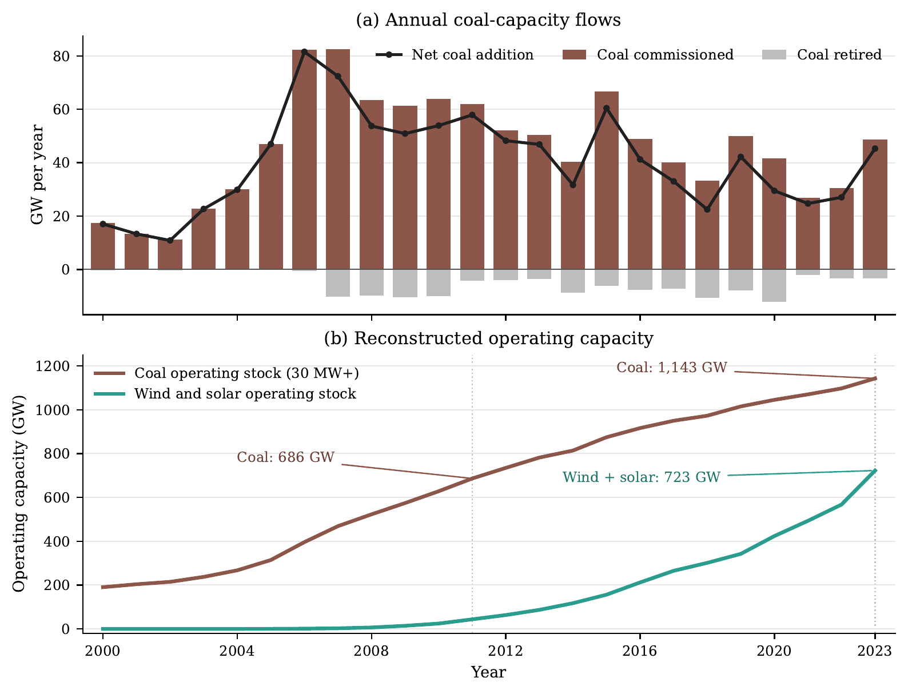 | Notes: National sums are reconstructed from the January–February 2026 Global Energy Monitor tracker snapshots. Panel (a) reports annual coal capacity commissioned, retired, and net added. Panel (b) reports reconstructed operating capacity. Coal includes units of at least 30 MW. The histories are retrospective records based on reported start and retirement years; missing early start years imply that reconstructed early stocks are lower bounds.
Coal additions, retirements, and operating stock alongside wind and solar expansion in China, 2000–2023
This pattern changes the interpretation of conventional structural indicators. A stable or declining thermal-generation share can result from faster growth of total generation or renewables, a change in utilization, or new nonthermal capacity. None of these outcomes alone reveals whether coal units were retired. The GEM histories do. They show a transition in which the system accumulated renewable assets while retaining and expanding a large coal fleet.
Direct asset evidence on China’s power transition
Indicator | 2011 | 2023
Coal operating stock (GW) | 686.3 | 1,142.9
Wind and solar operating stock (GW) | 43.6 | 722.6
Coal capacity commissioned during year (GW) | 62.1 | 48.6
Coal capacity retired during year (GW) | 4.2 | 3.3
Notes: Stocks, additions, and retirements are reconstructed from GEM’s 2026 tracker snapshot. Coal capacity is based on units of at least 30 MW. Values are national sums of province-year data and are rounded to one decimal place.
The provincial distribution also matters. Coal capacity is concentrated in provinces that differ substantially in resource dependence, grid role, and renewable deployment. Some provinces combine large coal fleets with large renewable portfolios; others retain coal capacity without comparable renewable absorption. The appropriate question is therefore not whether renewable growth occurred nationally. It is whether the conditions required for replacement and retirement are present in particular regional systems.

High coal exposure did not show a detectable post-2012 retirement acceleration
The retirement analysis does not show that coal-intensive provinces moved more quickly toward exit after 2012. Before 2012, one standard-deviation higher provincial coal exposure was associated with a hazard ratio of 1.26 for retirement ($p=0.063$). The estimated hazard ratio is 1.01 in 2012–2015 ($p=0.955$), 1.08 in 2016–2020 ($p=0.713$), and 1.12 in 2021–2025 ($p=0.613$). These estimates are imprecise, but their substantive implication is bounded: the current data do not detect a faster retirement hazard in more coal-exposed provinces during the post-2012 policy window. Hazard ratios near one, with confidence intervals spanning one, are consistent with an architecture that prioritized operating adjustment and system adequacy rather than differential asset exit. They should not be read as evidence that a policy intended to retire the fleet was ineffective.
Figure 2 shows the result in two complementary forms. The left panel tracks the unadjusted cumulative retirement of units operating at the start of 2012, split at the median province-level coal exposure; the curves remain close through 2025. The right panel reports the corresponding calendar-period associations from the left-truncated Cox model after adjusting for capacity and vintage. The confidence intervals are wide and each post-2012 interval includes a hazard ratio of one. These results delimit the evidence: the data do not show a detectable retirement acceleration in coal-exposed provinces, but they do not identify the cause of the observed pattern.
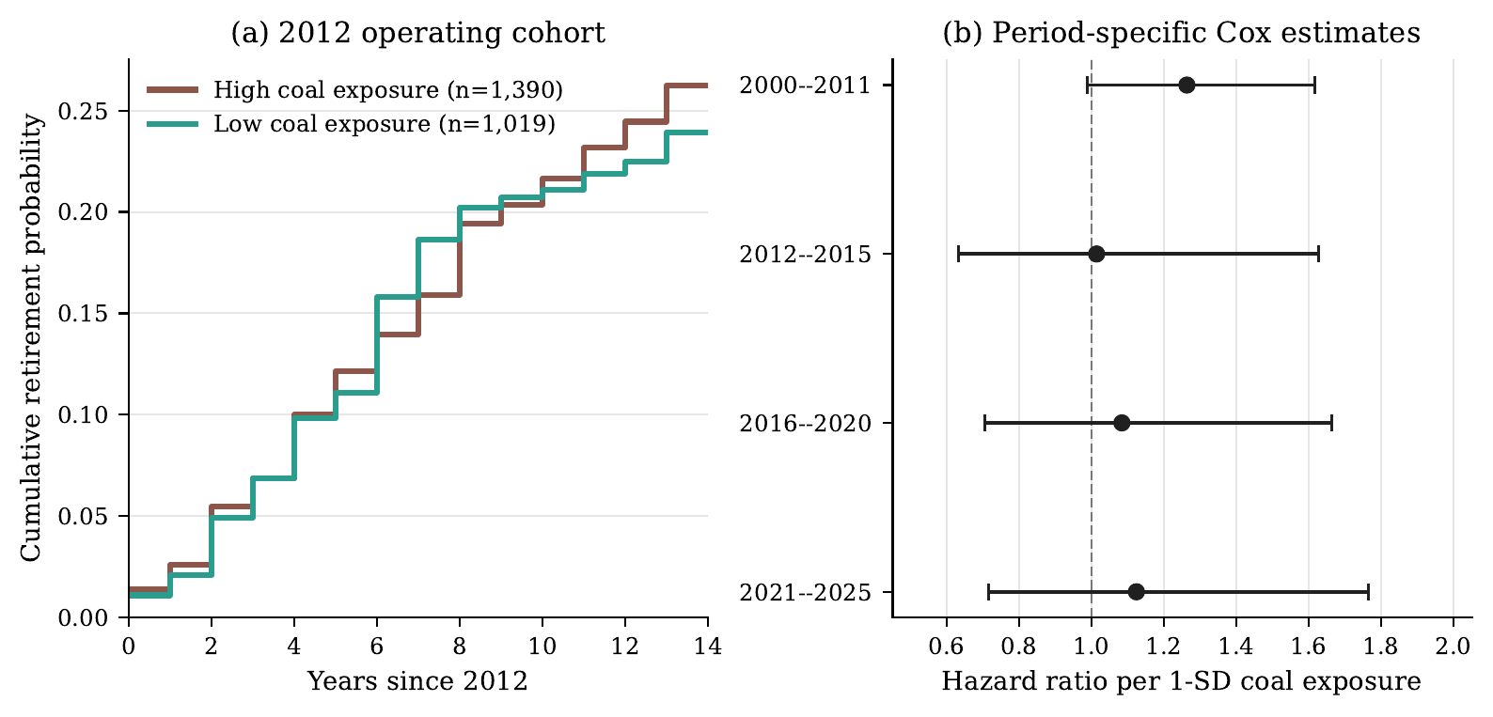 | Notes: Panel (a) is an unadjusted Kaplan–Meier display for the 2,409 coal units operating at the start of 2012. High and low coal exposure are defined using the province-level median of pre-policy coal exposure. Panel (b) reports hazard ratios per one provincial standard deviation of pre-policy coal exposure from left-truncated Cox models with capacity and vintage controls; horizontal bars are 95% confidence intervals using province-clustered robust standard errors. The displays are observational and do not identify a policy effect.
Coal-unit retirement evidence by provincial coal exposure
The province-year lifecycle regressions lead to the same cautious conclusion. Post-2012 coal exposure is not significantly associated with coal additions, coal retirements, net coal additions, or the reconstructed coal stock share. The absence of a detected differential does not prove that policy had no effect. It does show why a paper built only on energy intensity or coal shares would overstate structural change. Direct asset measures are necessary to evaluate the exit margin.
Notes: Left-truncated Cox model with 12,344 unit-period observations, capacity and vintage controls, and province-clustered standard errors. Coal exposure is standardized at the provincial level. Calendar-period contrasts are diagnostic and should not be read as causal policy tests.

Operating adjustment is visible, but it does not identify a single policy channel
The supporting provincial panel provides the other half of the puzzle. In the baseline fixed-effect specifications, higher pre-policy coal exposure is associated with larger post-2012 reductions in five-energy final intensity ($-0.289$, $p=0.021$), final-coal intensity ($-0.426$, $p<0.001$), and the five-energy coal share ($-0.250$, $p=0.003$). The coal-share event study has no evidence of differential pre-trends ($p=0.840$). By contrast, the intensity event studies have joint pre-trend $p$ values of 0.052 and 0.041, and both estimates become statistically indistinguishable from zero once province-specific linear trends are added.
These diagnostics require a bounded interpretation. The data show an observed pattern of operating and compositional adjustment among more coal-exposed provinces. They do not isolate the Green Credit Guidelines, and they do not establish that declining emissions resulted from treatment investment rather than output, fuel, relocation, or other regulations. Nor does a lower coal share establish coal-asset retirement. The value of the operating results is therefore diagnostic: they document progress at lower-cost margins, while showing that those margins did not automatically yield the distinct institutional outcome of asset exit.
Notes: Province and year fixed effects, province-clustered standard errors, 2007–2022 or 2007–2023 depending on outcome availability. Baseline coefficients are for Post-2012 $×$ pre-policy coal exposure. The table is a diagnostic summary, not a causal policy-effect table.

Transition constraints are visible in the provincial setting
The asset and operating evidence motivate an examination of the conditions surrounding exit. Resource-linked fiscal and employment measures identify provinces where coal is embedded in local economic systems. Coal-unit reliability reports add a distinct operational consideration: even when coal’s annual share falls, operating and standby requirements can preserve units as capacity resources. Renewable-consumption and utilization measures add the demand-side constraint. New wind and solar capacity has transition value only when generation can be absorbed, transmitted, stored, or used to replace thermal output rather than merely supplementing it.
The coverage of these measures limits causal claims but is useful for policy diagnosis. Renewable consumption is available for all provinces from 2015 through 2023. Coal-unit reliability measures cover 2018–2023. Wind and solar utilization measures principally cover 2018–2023, and project-pipeline data are a 2026 status snapshot. These data cannot establish whether pre-policy grid conditions caused a later retirement decision. They do show that coal exit is conditioned by a bundle of fiscal, labour, reliability, and absorption issues that are absent from an operating-intensity regression.
Figure 3 makes this bundle visible without converting it into a mechanism test. Provinces are placed by their reconstructed coal operating stock and renewable-consumption share, while colour records their pre-policy resource dependence. Shanxi and Inner Mongolia occupy the high-coal-stock, below-median renewable-consumption quadrant, but their resource-dependence profiles differ. The figure is a descriptive policy typology: it identifies combinations of transition conditions that require different policy packages; it does not estimate the effect of any individual condition on retirement.
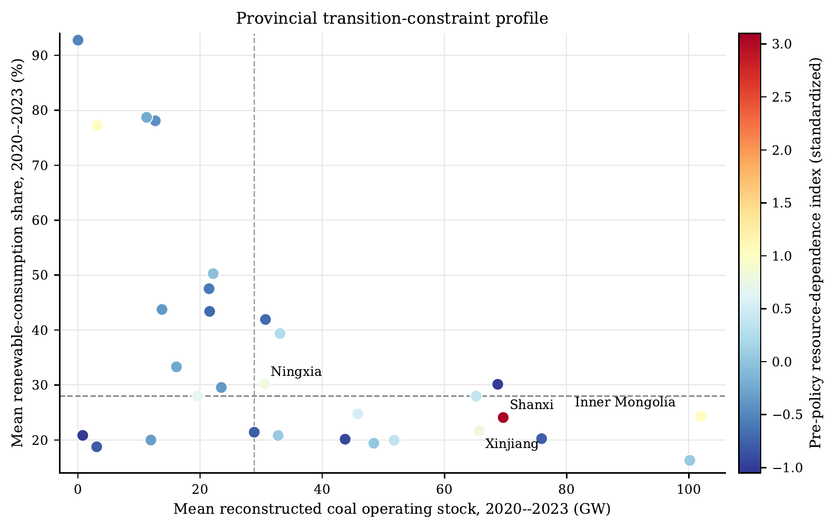 | Notes: Each point is a province. The horizontal axis is mean reconstructed coal operating stock and the vertical axis is mean renewable-consumption share, both over 2020–2023. Dashed lines mark the province medians. Colour denotes the standardized pre-policy resource-dependence index, constructed from mining employment, coal-mining assets, and resource-tax exposure where available. The figure is descriptive and should not be read as a causal classification or a retirement model.
Descriptive provincial transition-constraint profile
The pipeline data add a forward-looking warning. A large renewable pipeline may improve the feasibility of replacement, but an active coal construction or pre-construction pipeline can reproduce lock-in even while older units retire. Existing coal stock and prospective coal investment must therefore be considered together. Likewise, a high renewable capacity share is not a complete measure of substitution when consumption and utilization remain constrained. These are not empirical claims about the net effect of each variable. They are reasons to reject a one-indicator approach to provincial transition readiness.
Shanxi and Inner Mongolia illustrate two configurations of the same adjustment-first architecture. Figure 4 shows that both accumulated wind and solar capacity while their coal operating stocks continued to increase. By 2023, the reconstructed coal and wind-solar stocks were 74.3 and 42.8 GW in Shanxi, and 115.1 and 82.1 GW in Inner Mongolia, respectively. Shanxi’s trajectory is marked by a large coal stock and a strong coal-linked economic base. Inner Mongolia combines very large coal capacity with a much larger wind and solar project system and an external-power orientation. The cases show that renewable endowment and resource dependence shape the configuration of adjustment, but neither configuration automatically supplies an exit pathway. Neither case is a clean counterfactual for the other. Government-work-report text supports only a narrow contrast: after 2012, Inner Mongolia used more green-finance and clean-coal language than Shanxi, while the renewable-energy and pollution-control text differences are not statistically stable. The comparison therefore illustrates different transition conditions rather than proving a policy mechanism.
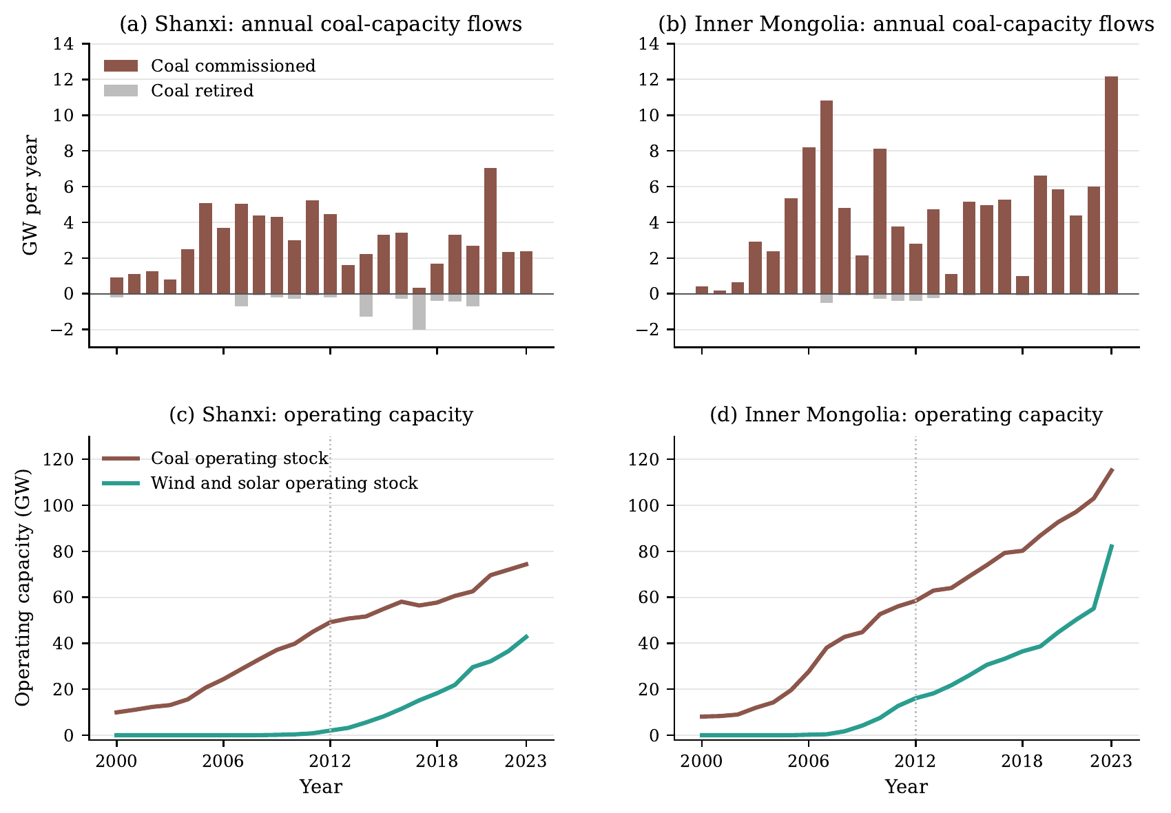 | Notes: Panels (a)–(b) report annual coal capacity commissioned and retired; panels (c)–(d) report reconstructed coal and wind-solar operating capacity. The vertical dotted line marks 2012. National tracker conventions apply: coal includes units of at least 30 MW, and historical stocks are reconstructed retrospectively from the 2026 GEM tracker snapshot. The case comparison is descriptive, not a causal two-province design.
Shanxi and Inner Mongolia: coal-capacity flows and operating stocks, 2000–2023
Figure 5 provides a national composition check that keeps each denominator explicit. In the observed five-energy final-use basket, coal’s share declined from 68.2% in 2006 to 58.8% in 2022, while electricity and natural-gas shares increased. In the power system, thermal capacity fell from 77.6% of installed capacity in 2006 to 47.6% in 2023, and thermal generation fell from 80.9% to 65.6%. The latter changes are substantial, but non-thermal power is not synonymous with renewable power, and electricity in the final-use basket is not itself a clean energy source. More importantly, shares do not identify the treatment of the pre-existing coal fleet. The figure therefore sharpens, rather than weakens, the central diagnosis: China experienced compositional transition alongside continued coal-asset accumulation.
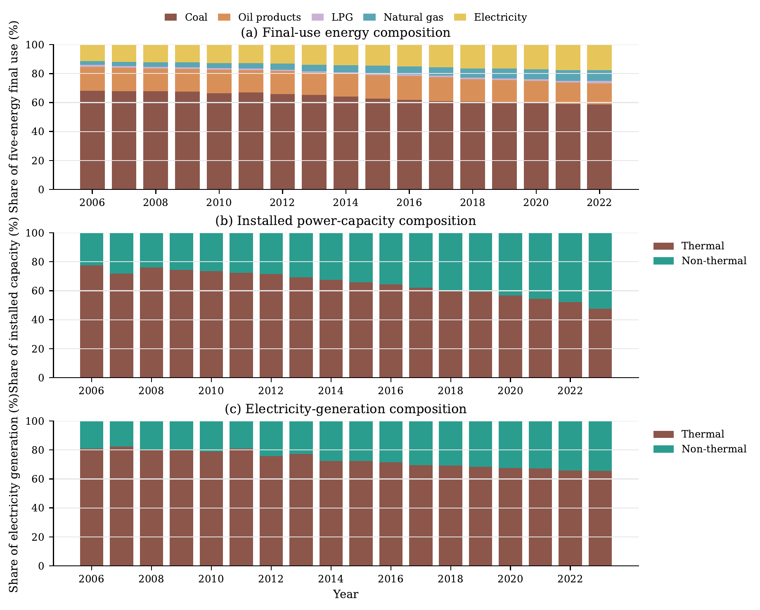 | Notes: Panel (a) uses the five-energy final-use basket: coal, oil products, LPG, natural gas, and electricity. It is not a total-primary-energy measure, and electricity should not be interpreted as a clean-energy category. Panels (b) and (c) use total installed capacity and total generation, respectively; non-thermal includes all non-thermal sources, not only wind and solar. Values are annual sums across provinces before shares are computed. The panels describe composition and do not measure coal-unit retirement.
Annual energy and power-system composition, national provincial sums

Alternative interpretations and the scope of the evidence
Several alternative interpretations deserve consideration. First, coal capacity growth may reflect a security-of-supply response rather than a failure of transition. This is plausible, particularly in a system facing demand growth, regional imbalance, and variable renewable output. The argument of this paper is not that every retained coal unit is irrational or should close immediately. It is that a security rationale for retention has policy consequences that are invisible in intensity measures. If coal capacity is retained for reliability, then a second-generation exit framework must specify the replacement service, its location, and the institution responsible for providing it.
Second, the national stock trajectory might be driven by a small number of provinces and therefore say little about coal-intensive regions in general. The provincial survival analysis addresses this concern imperfectly but directly. It asks whether exposure to coal-intensive final energy use predicts a differential retirement pattern. The data do not reveal a post-2012 acceleration. The inference remains observational, yet it is more informative than a national capacity series alone because it connects the exit margin to the regional distribution of coal dependence.
Third, the observed operating pattern may be driven by policies unrelated to finance, including energy-conservation targets, coal-consumption controls, air-pollution action plans, industrial restructuring, or supply-side reform. The paper regards this as a substantive limitation, not a nuisance to be removed by additional controls. These policies often acted on the same coal-intensive regions and may have shared implementation channels. The right conclusion is that the operating pattern is consistent with a period of tighter constraints on coal-intensive activity. It should not be assigned to green credit, nor should it be used to claim that finance alone explains the absence of asset exit.
Finally, renewable additions can contribute to decarbonization even if they do not retire coal units immediately. The relevant policy question is whether those additions are embedded in a pathway that eventually changes the coal fleet. Direct asset data provide a way to monitor that question over time. They also make it possible to distinguish a transition in which renewables are additive from one in which renewable deployment is linked to a credible schedule of replacement and retirement.

Discussion: from first-generation adjustment to second-generation exit
The principal policy implication is a sequencing argument, not a verdict of policy failure. First-generation transition policy has a coherent short-run rationale: efficiency standards, environmental enforcement, cleaner utilization, renewable investment, and reliability measures can reduce coal use at the operating margin while maintaining adequate electricity service. The evidence in this paper is compatible with that objective. It shows an adjustment and composition transition, even though it does not isolate the effect of a single instrument.
The long-run problem is a policy-design gap. Cleaner operation and renewable additions do not determine the retirement date of an existing generator. When the costs of closure are concentrated in asset owners, local governments, workers, and system operators, a system can improve its indicators while retaining the assets whose eventual disposition still must be resolved. This is not because first-generation policy failed, but because its design logic was incomplete for long-run decarbonization. A credible second-generation transition policy must explicitly connect the operating margin to the retirement margin.
That second-generation framework has four linked elements. First, it requires credible retirement or repurposing pathways, including owner-level transition plans, debt resolution, compensation rules, and safeguards against refinancing new coal expansion. Retirement finance is not a generic green-finance product; it must be tied to verifiable closure, remediation, and replacement milestones. Second, it requires dependable replacement capacity. Demand response, storage, flexible low-carbon generation, transmission, and market arrangements must supply the energy, capacity, and flexibility services previously provided by coal. This is the operational content that makes a build-before-breaking principle credible rather than rhetorical.
Third, exit requires local fiscal and labour adjustment. Resource-tax dependence, mining employment, and state-owned industrial assets make retirement a regional-development issue, not a plant-level transaction. Policies that leave these costs wholly local will predictably favour continued operation or new construction. Fourth, renewable investment must be connected to grid absorption and dispatch. Capacity targets alone do not ensure that renewable generation displaces coal generation; consumption, transmission, storage, and dispatch rules determine whether new assets substitute for the incumbent stock. These elements are complementary: advancing one while ignoring the others recreates the adjustment–exit gap.
This framework clarifies the limited role of a green-credit interpretation in the present data. Finance remains relevant because lending conditions affect new coal construction, retrofit, renewable investment, and the viability of closure transactions. Yet the study neither observes bank-to-plant lending nor identifies a sufficiently strong province-by-bank credit shock. It should not infer that green credit caused the observed operating changes or that green credit failed. The defensible conclusion is narrower and more useful: financial and environmental measures directed at coal use can advance first-generation objectives, but they do not complete an asset transition on their own.
The analysis has several limitations. GEM’s histories are reconstructed from a current tracker release and may understate early capacity where start dates are missing. The survival estimates are observational and contain a limited number of province clusters. Provincial operating measures do not resolve all difference-in-trends concerns, and some constraint data start well after the 2012 policy break. The study also cannot measure owner debt, plant profitability, local capacity-market arrangements, or worker outcomes directly. These are not minor omissions; they identify the next data requirements for causal work on coal exit.
The next research step is correspondingly clear. A causal account of financial transmission would require bank-by-province pre-policy lending weights, bank-specific changes in green and high-carbon lending, and owner or plant-level debt and retirement information. A causal account of grid constraints would require historically comparable provincial transmission, dispatch, and power-trade data. Until those data are assembled, evidence should be used to distinguish the observed transition problem from its possible mechanisms, not to infer a single mechanism from a national policy date.

Conclusion
China’s transition cannot be assessed from operating indicators alone. This paper shows that reductions in coal-use intensity and coal’s share of energy can coexist with a growing coal-power operating stock and no detected acceleration of retirement in high-coal-exposure provinces. The difference is not semantic. It separates a transition in how existing assets operate from a transition in whether those assets exit.
The evidence does not attribute this pattern to green credit or another single national policy. It instead identifies a policy-design boundary that becomes visible only when direct asset evidence is placed beside operating and composition data. The 2012–2023 architecture can be understood as first-generation transition policy: it sought operating adjustment, cleaner utilization, renewable expansion, and adequate supply, rather than fleet-wide retirement. The observed lack of automatic asset exit is therefore not evidence that this framework failed at its operating margin.
Measures directed at coal use may succeed on their own terms, but they cannot complete a transition that ultimately requires asset exit. A credible long-run strategy must move from a first-generation operating-margin framework to a second-generation framework that joins retirement, replacement, grid integration, and local fiscal and labour adjustment. The practical question is no longer whether China has begun to transition. The evidence shows that it has, at the operating and composition margins. The unresolved question is whether policy design will convert that adjustment into an orderly, credible exit pathway for the coal fleet.

Data availability
The provincial panel, processing scripts, regression outputs, and derived project-lifecycle measures are available from the authors upon reasonable request, subject to the redistribution terms of the underlying Wind and Global Energy Monitor data. Public source records and variable-coverage files are documented in the replication materials. The Global Energy Monitor tracker data are cited in the reference list.

Declaration of competing interests
The authors declare that they have no known competing financial interests or personal relationships that could have appeared to influence the work reported in this paper. This statement must be confirmed by all authors before submission.

Funding
This research did not receive any specific grant from funding agencies in the public, commercial, or not-for-profit sectors. Replace this sentence if any author received relevant funding.

Reference
Acemoglu, Daron, Philippe Aghion, Leonardo Bursztyn, and David Hémous. 2012. “The Environment and Directed Technical Change.” American Economic Review 102 (1): 131–66. https://doi.org/10.1257/aer.102.1.131.
Arthur, W. Brian. 1989. “Competing Technologies, Increasing Returns, and Lock-in by Historical Events.” Economic Journal 99 (394): 116–31. https://doi.org/10.2307/2234208.
Boschma, Ron. 2017. “Relatedness as Driver of Regional Diversification: A Research Agenda.” Regional Studies 51 (3): 351–64. https://doi.org/10.1080/00343404.2016.1254767.
Campiglio, Emanuele. 2016. “Beyond Carbon Pricing: The Role of Banking and Monetary Policy in Financing the Transition to a Low-Carbon Economy.” Ecological Economics 121: 220–30. https://doi.org/10.1016/j.ecolecon.2015.03.020.
China Banking Regulatory Commission. 2012. “Green Credit Guidelines.” CBRC Notice No. 4 of 2012. https://www.gov.cn/gzdt/2012-02/24/content_2076079.htm.
Cohen, Wesley M., and Daniel A. Levinthal. 1990. “Absorptive Capacity: A New Perspective on Learning and Innovation.” Administrative Science Quarterly 35 (1): 128–52. https://doi.org/10.2307/2393553.
Dikau, Simon, and Ulrich Volz. 2021. “Central Bank Mandates, Sustainability Objectives and the Promotion of Green Finance.” Ecological Economics 184: 107022. https://doi.org/10.1016/j.ecolecon.2021.107022.
Geels, Frank W. 2002. “Technological Transitions as Evolutionary Reconfiguration Processes: A Multi-Level Perspective and a Case-Study.” Research Policy 31 (8–9): 1257–74. https://doi.org/10.1016/S0048-7333(02)00062-8.
Geels, Frank W., and Johan Schot. 2007. “Typology of Sociotechnical Transition Pathways.” Research Policy 36 (3): 399–417. https://doi.org/10.1016/j.respol.2007.01.003.
Global Energy Monitor. 2026. “Global Coal Plant Tracker, January 2026; Global Wind Power Tracker, February 2026; and Global Solar Power Tracker, February 2026.” Global Energy Monitor trackers. https://zenodo.org/records/20843067.
Hansen, Teis, and Lars Coenen. 2015. “The Geography of Sustainability Transitions: Review, Synthesis and Reflections on an Emergent Research Field.” Environmental Innovation and Societal Transitions 17: 92–109. https://doi.org/10.1016/j.eist.2014.11.001.
Howlett, Michael. 2010. Designing Public Policies: Principles and Instruments. Routledge. https://doi.org/10.4324/9780203838631.
Mahoney, James. 2000. “Path Dependence in Historical Sociology.” Theory and Society 29 (4): 507–48. https://doi.org/10.1023/A:1007113830879.
Markard, Jochen, Rob Raven, and Bernhard Truffer. 2012. “Sustainability Transitions: An Emerging Field of Research and Its Prospects.” Research Policy 41 (6): 955–67. https://doi.org/10.1016/j.respol.2012.02.013.
Newell, Peter, and Dustin Mulvaney. 2013. “The Political Economy of the ‘Just Transition’.” The Geographical Journal 179 (2): 132–40. https://doi.org/10.1111/geoj.12008.
Pierson, Paul. 2000. “Increasing Returns, Path Dependence, and the Study of Politics.” American Political Science Review 94 (2): 251–67. https://doi.org/10.2307/2586011.
Popp, David. 2002. “Induced Innovation and Energy Prices.” American Economic Review 92 (1): 160–80. https://doi.org/10.1257/000282802760015658.
Porter, Michael E., and Claas van der Linde. 1995. “Toward a New Conception of the Environment–Competitiveness Relationship.” Journal of Economic Perspectives 9 (4): 97–118. https://doi.org/10.1257/jep.9.4.97.
Stiglitz, Joseph E., and Andrew Weiss. 1981. “Credit Rationing in Markets with Imperfect Information.” American Economic Review 71 (3): 393–410. https://doi.org/10.2307/1802787.
Unruh, Gregory C. 2000. “Understanding Carbon Lock-in.” Energy Policy 28 (12): 817–30. https://doi.org/10.1016/S0301-4215(00)00070-7.

