Input | Address pin 1 (A) | Address pin 2(B) | Address pin3 (C)
Bytes0 | 0 | 0 | 0
Byters1 | 0 | 0 | 1
Bytes2 | 0 | 1 | 0
Bytes3 | 0 | 1 | 1
Bytes4 | 1 | 0 | 0
Bytes5 | 1 | 0 | 1
Bytes6 | 1 | 1 | 0
Bytes7 | 1 | 1 | 1

3
Input | Boolean Expression
Bytes0 | A’B’C’
Bytes1 | A’B’C
Bytes2 | A’BC’
Bytes3 | A’BC
Bytes4 | AB’C’
Bytes5 | AB’C
Bytes6 | ABC’
Byes7 | ABC

4
A | B | Selected input
1 | 0 | Data2
0 | 1 | Data 1
1 | 1 | Data3
0 | 0 | Data0

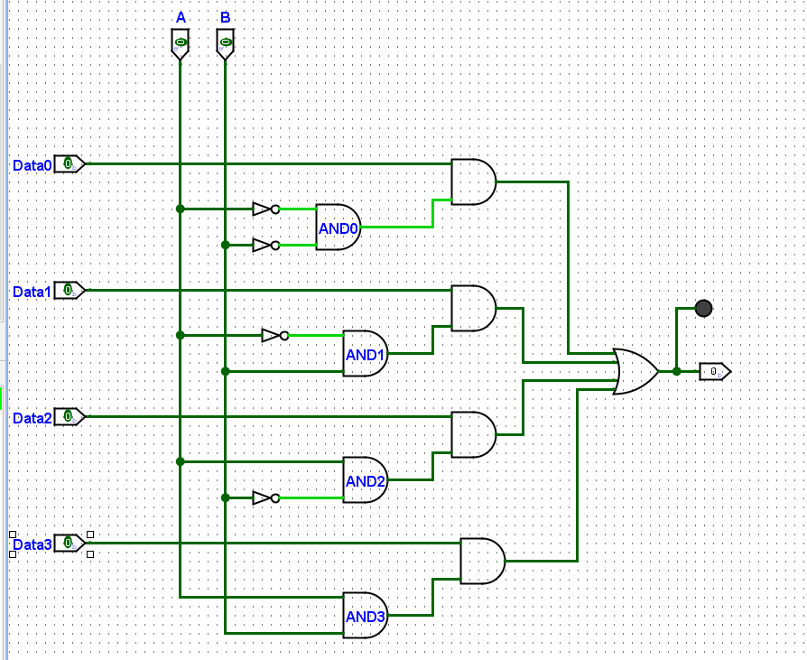

6
A | B | C | Selected input
1 | 1 | 1 | Data7
1 | 1 | 0 | Data6
1 | 0 | 1 | Data5
1 | 0 | 0 | Data4

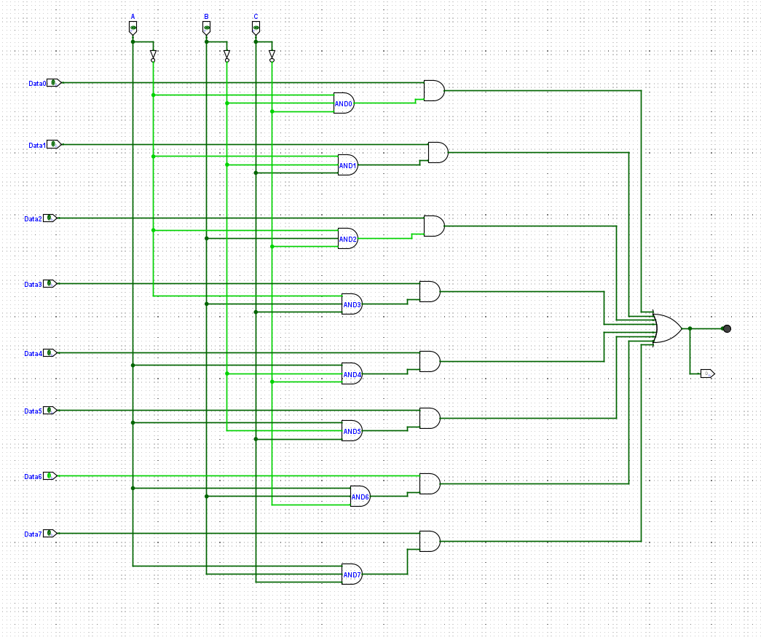

7.
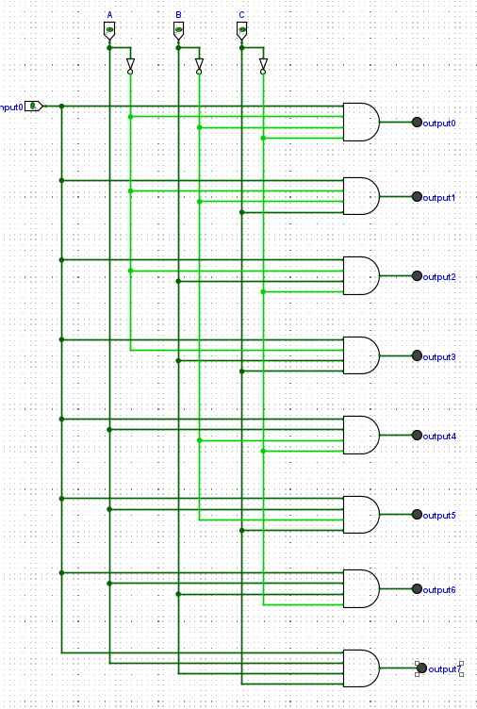

8. ID J24041603
Last 4 digits =1603
Octal =3103
Last 3 digits of octal=103
