《面向对象分析与设计》试卷

OOA & OOD Final Exam

Student No. ___201764683069_____ Name ________________ Score____________

1. Single Choice & Short Answer (each choice worths 2 points, each blank worths 1 points , 25 points total )
1) A UML composition is ( D )
A. a process for instantiating UML models
B. the interrelation among components and packages
C. a specific dependency among objects
D. an aggregation with additional semantics

2) Which of the following are not the Extension Mechanisms of UML? ( C )
A. TaggedValue
B. Constraint
C. Concurrent
D. Stereotype

3) Constraints can be represented in UML by: ( B )
A. [ text string ]
B. { text string }
C. notes
- constraint

4） UML interfaces are used to: ( D )
- define an API for all classes.
- program in Java, but not in C++ or Smalltalk.
- define executable logic to reuse across classes.
- specify required services for types of objects.

5) Which of the following are NOT TRUE about the strengths and weaknesses of activity diagrams? ( C )
A. Activity diagrams are good at enumerating object collaborations to accomplish a task.
B. Activity diagrams are good at exploring the interactions related to one or more use cases.
C. It is difficult to discern exactly how to map the activity diagram actions to object model specifics.
- Since activity diagrams allow parallel behavior modeling, they are good for workflow modeling.

6) What is true about messages in scenarios? ( A )
A. The operation of the calling object.
B. The operation of the called object.
C. It is sent by the actor to the system.
D. It is sent by the system to the actor.
- dynamic model describe the system change with time. includes:

___Sequence Diagram______ ， __Activity Diagram________ and __State Diagram___.

- What are the four view in Rose Model?

___Logical___________ ，____Process_____________，

__Development____________ and ____Physical____________ .

- Which two UML diagrams can represent concurrent processing?

___Activity Diagram___________ and ___Sequence Diagram_____ .

- The UML architecture is a four-layer metamodeling architecture. This architecture is a proven infrastructure for defining the precise semantics required by complex models ,Which include

_____meta-metamodel___________ , _metamodel________________ ,

_____model___________ and _____user model____________ .

- Explain the following Concepts and Give an Example . (each question worths 3 points. 15 points total )
  - Collaboration Diagrams
用于现实对象如何交互以执行特定用例或用例的一部分的行为。他们是用于确定类职责和接口的主要信息来源。

  - Generalization

  - Transition

It’s the last phrase of UP. Transfer the product to the end user.

  - Stereotype

  - Encapsulation

3. Draw class diagram for the following scenario. Be sure to include multiplicities on the ends of the connectors. (10 points)

Pet Store
The following scenario is for a pet store. Each pet store has up to 20 furry(毛皮的) friends and 10 birds. Each pet has a vaccination（疫苗） history. Furry friends are either dogs or cats. Each furry friend has a microchip（微型芯片） implant for identification. Each microchip has a unique id number.

4. Point out the wrong place in the following diagram . (10 points )

Class Diagram: 分析类 / 分析类图
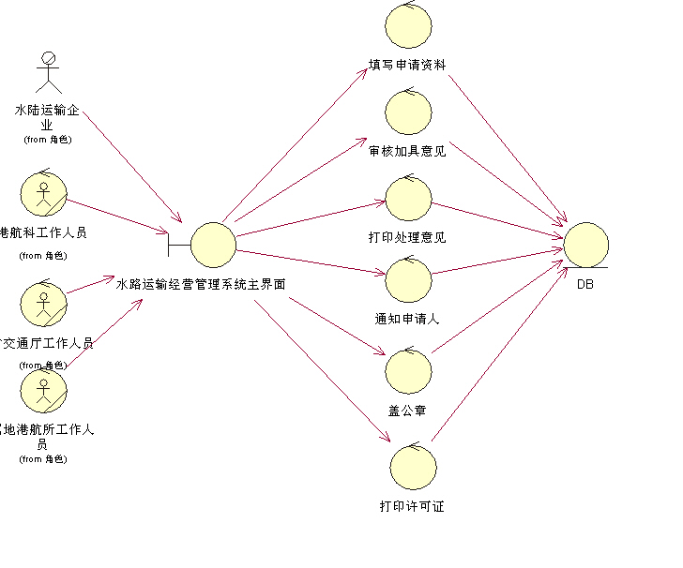

5. OO Modeling (40 Points total )
Consider the following problem:
基于WEB的网上购物系统越来越受到人们的关注，例如小型电子商务订单处理系统，使得客户可以给购物推车添加项目，查看购物推车，查看具体项目，购买商品，删除购物车中的项目，浏览商品，提供反馈单；库房经理可以进行盘点，返回库房项目，提供订单；采购经理可以增加销售的新项目，删除销售项目，购买库存。
Question：对该“订单处理系统”进行面向对象分析并运用UML建模设计出Use-Case diagram。

