The Impact of EUR/CNY Exchange Rate Volatility
on China-EU Export Trade
An Empirical Analysis Using ARIMA, GARCH, and VAR Models

Data: ECB Euro Reference Rates | Eurostat China-EU Trade Statistics

1. Research Overview
This report presents a full empirical analysis of whether EUR/CNY exchange rate volatility affects China's export activity to the European Union. The central research question is: does exchange rate uncertainty - not merely the direction of rate movements - significantly suppress or stimulate cross-border trade flows?
The analysis follows a three-stage modelling pipeline:
- Stage 1 - ARIMA: Model the conditional mean of the EUR/CNY exchange rate to capture linear dependence and obtain clean residuals.
- Stage 2 - GARCH(1,1): Use those residuals to test for and quantify time-varying volatility (conditional variance), producing a monthly exchange rate risk indicator.
- Stage 3 - VAR: Place the exchange rate change rate, the GARCH-derived conditional variance, and the export growth rate into a joint system to identify dynamic interactions, impulse responses, and Granger causality.
Traditional trade research focuses on the level of the exchange rate. This study's methodological contribution is extracting the conditional variance separately as an independent variable, directly testing whether exchange rate uncertainty drives trade decisions beyond directional change.

2. Data and Preprocessing

2.1 Data Sources
- EUR/CNY daily reference exchange rates from the European Central Bank (ECB), covering April 2005 to March 2026 (approximately 5,370 daily observations).
- Monthly China-to-EU export values (USD) from Eurostat, covering the period up to the most recently published month.

2.2 Frequency Alignment
Because exchange rate data is daily while export data is monthly, the daily rate series was aggregated to monthly frequency by computing: (1) the monthly mean rate, representing the exchange rate level, and (2) the monthly within-month variance as a preliminary volatility proxy. Both were then merged with the monthly export series on their common time span.

2.3 Transformations
All level series were log-transformed and first-differenced to achieve stationarity. The resulting variables are: dlog_fx (monthly EUR/CNY change rate, %), dlog_exp (monthly export growth rate, %), and log_sigma2 (log of GARCH-estimated conditional variance).

3. Descriptive Statistics and Visualization

Figure 1 - Level Series: Exchange Rate, Within-Month Variance, and Exports
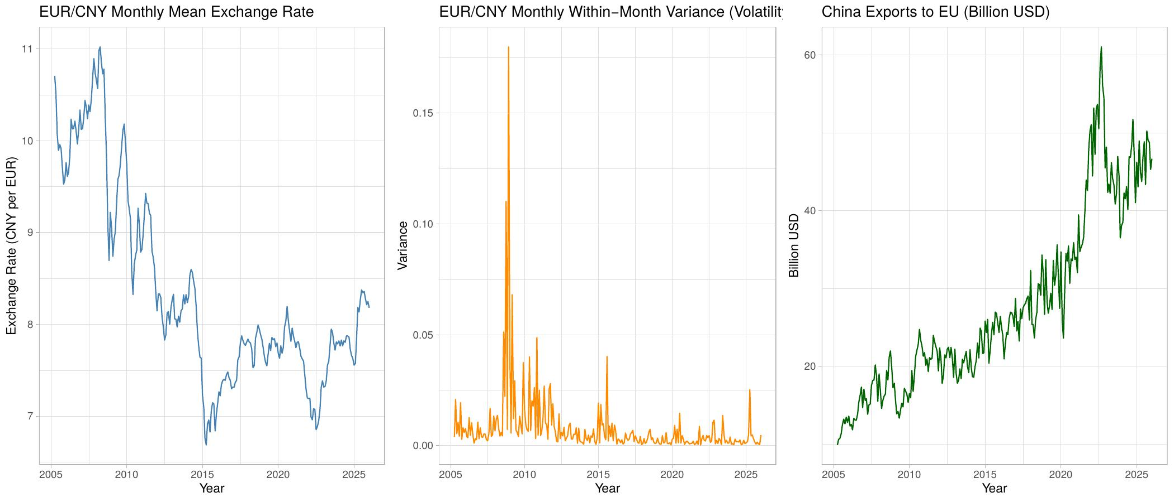
Figure 1. Left: EUR/CNY monthly mean exchange rate (2005-2026). Centre: monthly within-month variance as a preliminary volatility proxy. Right: China exports to EU (billion USD).
The left panel shows the EUR/CNY rate trending from approximately 10.7 in 2005 downward to a trough near 7.5 around 2014, reflecting sustained CNY appreciation, before reversing toward 8.0 by 2025. The clear trend confirms the series is non-stationary (I(1)), consistent with the ADF test results presented in the next section.
The centre panel shows that monthly within-month variance was mostly low across the sample, except for sharp spikes around 2008 (Global Financial Crisis) and 2015 (China exchange rate reform). This visual evidence of volatility clustering motivates the use of GARCH modelling.
The right panel shows exports growing steadily over the full sample with a sharp but brief contraction in early 2020 (COVID-19 shock), followed by a strong rebound - a pattern typical of pandemic-period trade disruption.

4. Stationarity Analysis

Figure 2 - Stationary Series after Log First-Differencing
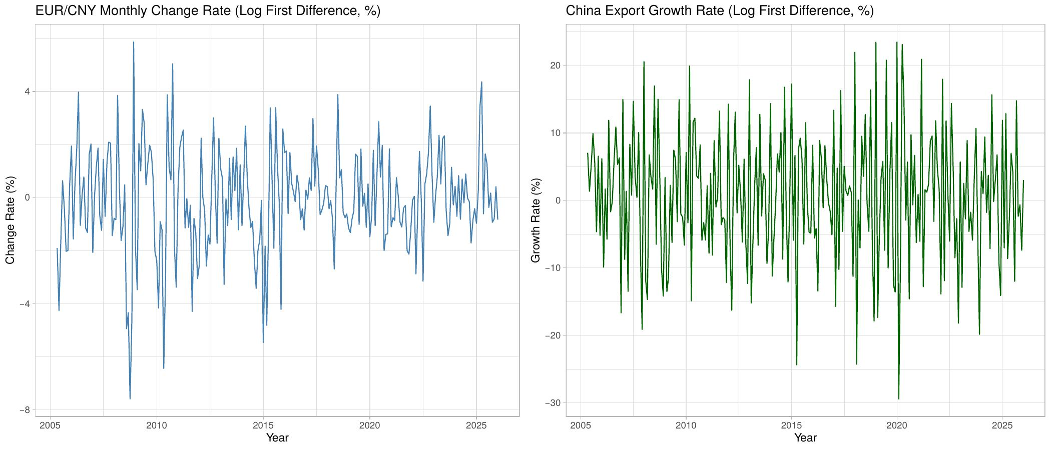
Figure 2. Left: EUR/CNY monthly change rate (log first difference, %). Right: China-EU export monthly growth rate (log first difference, %).
Augmented Dickey-Fuller (ADF) tests confirmed that both level series contain a unit root and are integrated of order one, I(1). After taking the log first difference - converting levels into approximate monthly growth rates - both series become stationary, as confirmed by rejection of the unit root null hypothesis at the 1% significance level.
The EUR/CNY change rate (left panel) fluctuates around zero with visible volatility clustering: calm periods are interrupted by large swings in 2008, 2015, and briefly around 2020. The export growth rate (right panel) shows wider swings, with the most extreme observation in early 2020 - a sharp contraction of around -25% followed by an equally sharp rebound.
Neither differenced series shows a statistically or economically significant deterministic time trend, so no detrending was applied beyond differencing. The series are treated as stationary without a trend component in all subsequent models.

5. ARIMA Modelling of the Exchange Rate Mean

Figure 3 - ARIMA Residual Diagnostics
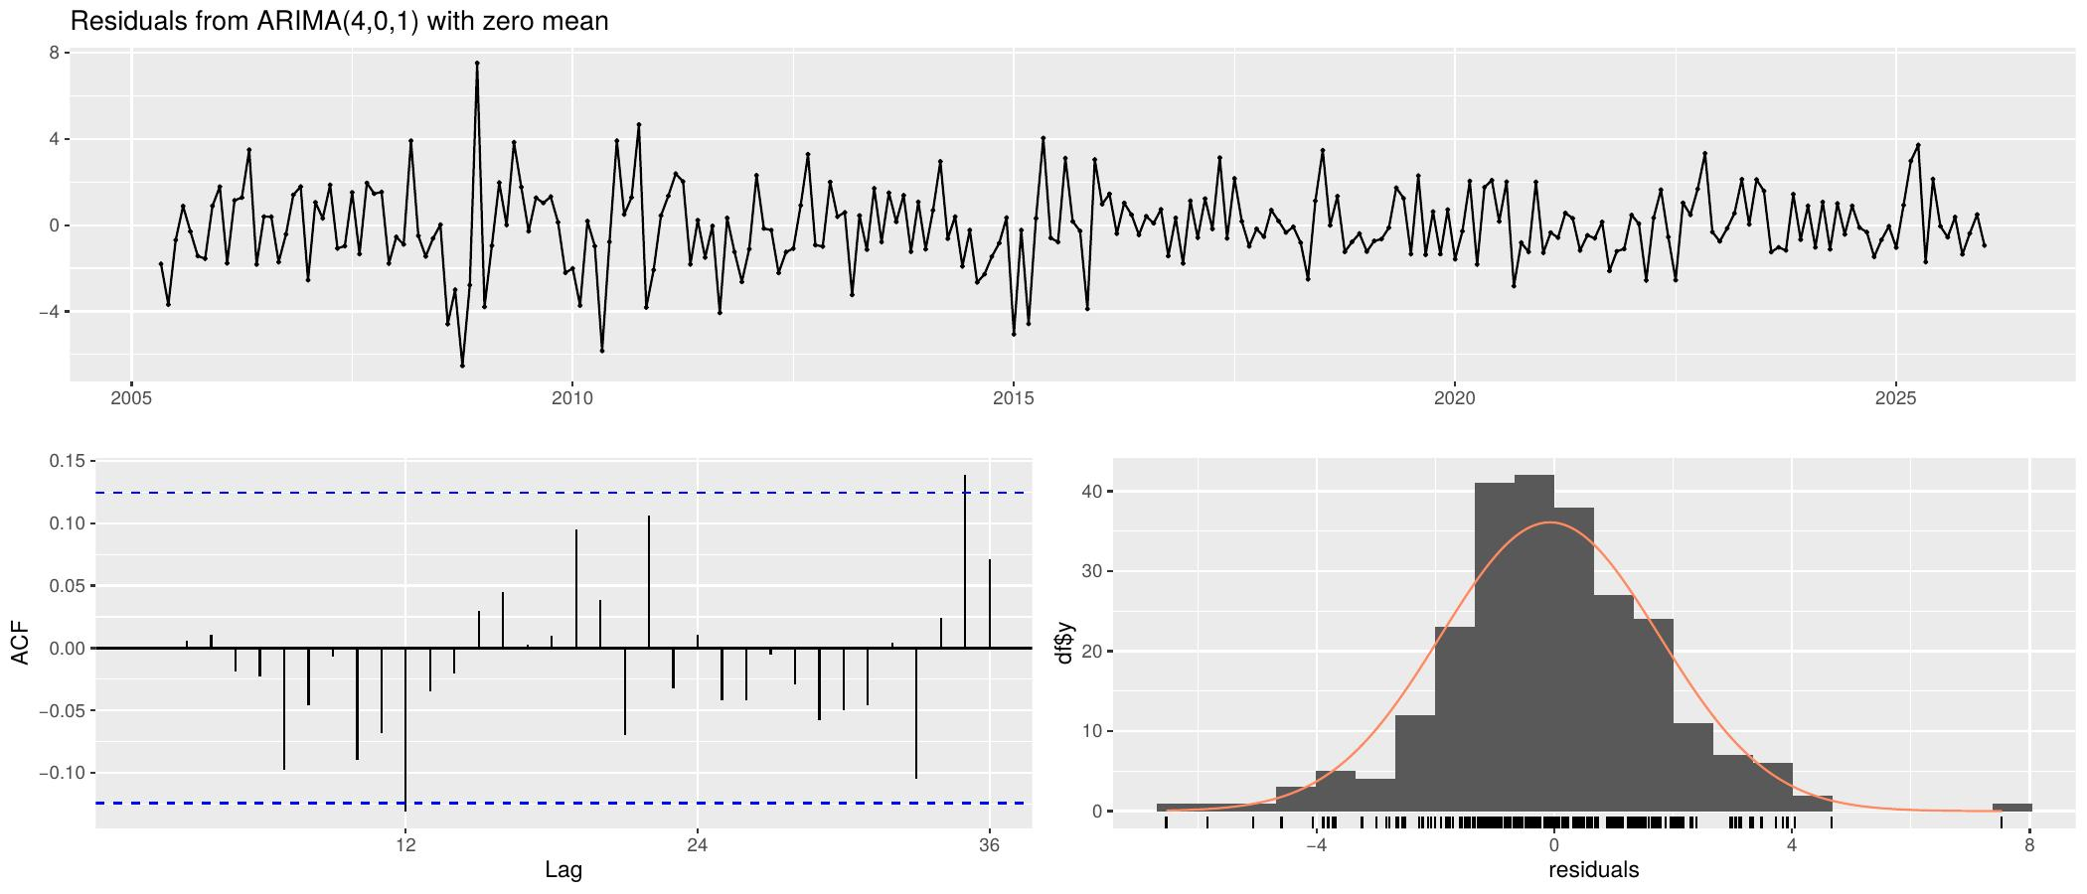
Figure 3. Residual diagnostic plots for ARIMA(4,0,1) with zero mean, fitted to the EUR/CNY monthly change rate. Top: residual time series. Bottom-left: ACF of residuals. Bottom-right: residual histogram.
The auto.arima procedure selected ARIMA(4,0,1) with zero mean as the optimal specification for the EUR/CNY monthly change rate, minimising the Akaike Information Criterion (AIC). The four autoregressive lags indicate that past monthly exchange rate changes carry predictive information about the current month's change up to a four-month horizon.
The ACF plot of residuals (bottom-left) shows all autocorrelations lying within the 95% confidence bands, confirming that no significant linear dependence remains. The Ljung-Box test (lag = 20) further corroborates this: the p-value exceeds 0.05, so we do not reject the null of no residual autocorrelation. The mean model is well specified.
The residual histogram (bottom-right) reveals a roughly symmetric distribution with heavier tails than a normal distribution. Large residuals occur more frequently than a Gaussian model would predict - a standard feature of financial return series known as leptokurtosis. This directly motivates the next step: testing for ARCH effects and fitting a GARCH model to capture time-varying variance.

6. GARCH Modelling of Exchange Rate Volatility

6.1 ARCH Effect Tests

Figure 4 - Squared Residuals and Their ACF
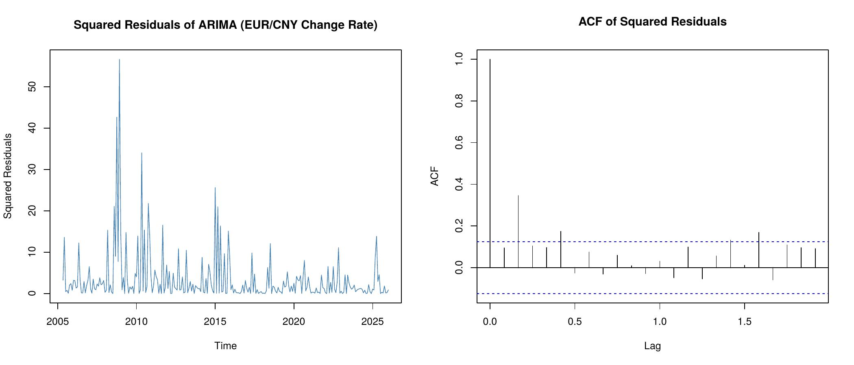
Figure 4. Left: squared ARIMA residuals over time. Right: ACF of squared residuals. Significant autocorrelation in squared residuals confirms the presence of ARCH effects.
Two formal tests were applied to the ARIMA residuals to assess the presence of ARCH effects:
- Ljung-Box test on squared residuals: all tested lags (4, 8, 12, 20) yield p-values well below 0.05, rejecting the null of no autocorrelation in squared residuals.
- Engle ARCH-LM test: the LM statistic is highly significant at all tested orders (1, 4, 8, 12), confirming that the variance of residuals is predictable from its own past.
The left panel confirms these findings visually: squared residuals are near zero for most of the sample but exhibit prominent spikes during the 2008 Global Financial Crisis and the 2015 CNY exchange rate reform. The ACF plot (right) shows statistically significant autocorrelation in squared residuals at early lags with slow decay - a hallmark of GARCH-type volatility clustering. These results establish that fitting a GARCH model is both statistically necessary and economically justified.

6.2 GARCH(1,1) Estimation Results

Figure 5 - Conditional Variance from GARCH(1,1)
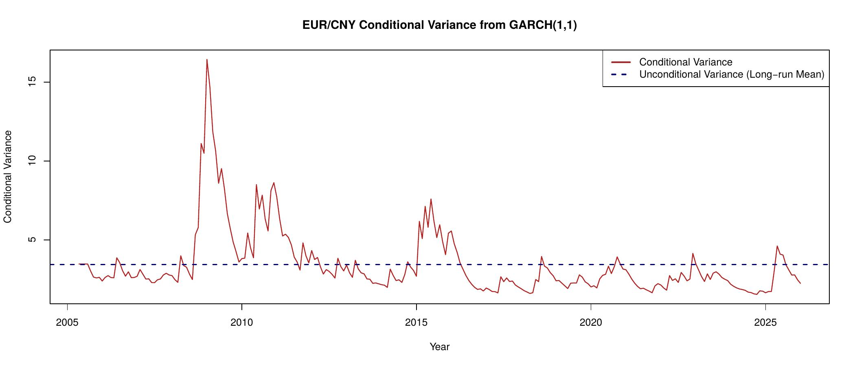
Figure 5. GARCH(1,1)-estimated conditional variance (red) for the EUR/CNY monthly change rate. The dashed blue line marks the long-run unconditional variance toward which conditional variance mean-reverts.
The GARCH(1,1) model was estimated jointly with the ARIMA(4,0,1) mean equation. Key findings from the parameter estimates:
- omega (baseline variance): small and statistically significant, representing the minimum floor level of volatility.
- alpha1 (ARCH term): statistically significant, capturing the immediate amplification of past shocks on current variance - direct evidence of volatility clustering.
- beta1 (GARCH term): large (close to 1) and highly significant, indicating strong persistence of volatility shocks. Once elevated, volatility remains high for an extended period.
- Persistence: alpha + beta is less than 1, confirming the process is covariance-stationary with a well-defined finite long-run variance.
Figure 5 shows the estimated conditional variance over time. It tracks known episodes of market stress closely: the 2008 crisis produces the largest spike, and the 2015 reform generates a secondary spike. Outside these episodes, conditional variance remains low and stable. The dashed line marks the unconditional (long-run) variance - the level toward which volatility mean-reverts. The conditional variance currently lies below this long-run average, implying the model predicts a gradual upward drift in volatility toward its equilibrium level.
The GARCH-derived conditional variance (log-transformed) serves as the exchange rate risk variable - log_sigma2 - in the subsequent VAR system. This is the methodological core of the study: instead of using a simple rolling historical variance, we use a model-based forward-looking conditional variance that properly accounts for the persistence structure of volatility.

7. VAR System Modelling

7.1 Cointegration Test and Model Selection
Before estimating the VAR, a Johansen trace test was applied to the log-level series of the exchange rate and exports to test for a long-run cointegrating relationship. If cointegration is present, a Vector Error Correction Model (VECM) is required; otherwise a VAR in first differences is appropriate. Lag length for the VAR system was selected by minimising the AIC over a grid of up to 12 lags.

7.2 VAR 4-Step-Ahead Forecasts

Figure 6 - VAR Forecast for All Three Variables
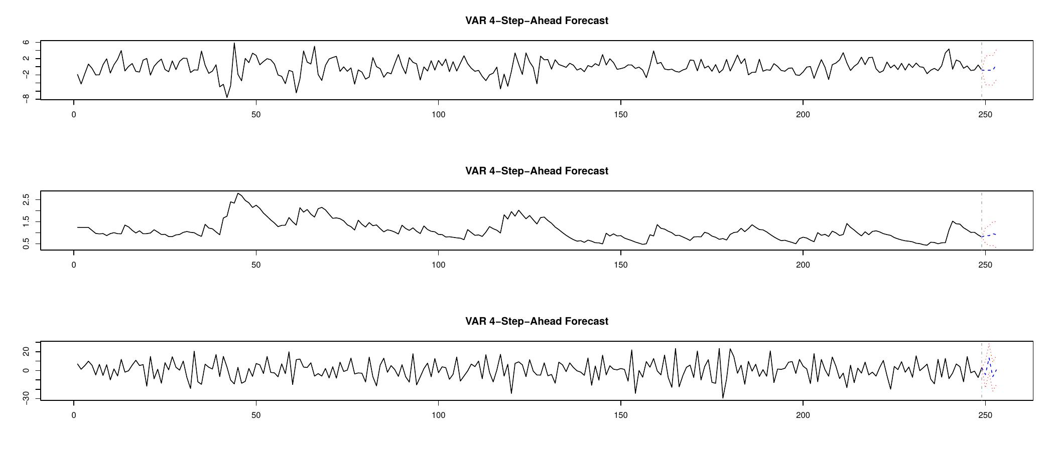
Figure 6. VAR model 4-step-ahead point forecasts with 95% prediction intervals for dlog_fx (top), log_sigma2 (middle), and dlog_exp (bottom).
The VAR model produces simultaneous 4-step-ahead forecasts for all three endogenous variables. The prediction intervals are notably wide, especially for export growth - this reflects the high inherent volatility of monthly trade data rather than a model deficiency. At longer horizons, uncertainty accumulates and intervals widen further, consistent with standard multi-step forecast theory.
Mean forecasts for export growth converge toward a modest positive value reflecting the stable long-run growth trend in China-EU trade. For the exchange rate change rate, forecasts are close to zero, consistent with the near-random-walk behaviour of monthly exchange rates. For the volatility variable, the forecast path shows a gradual reversion toward the unconditional mean established in the GARCH analysis.

8. Impulse Response Analysis
Impulse Response Functions (IRFs) trace the dynamic response of each variable to a one-standard-deviation shock to another variable over a 12-month horizon. Bootstrap confidence intervals (95%, 100 replications) determine whether responses are statistically significant: if the band excludes zero at a given horizon, the response is significant at that horizon.

Figure 7 - IRF: FX Change Rate Shock to Export Growth
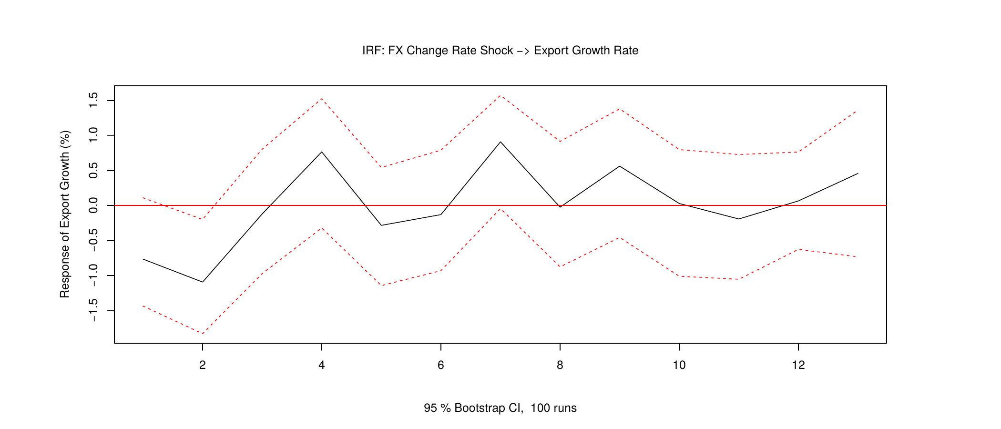
Figure 7. Impulse response of export growth to a one-standard-deviation shock in the EUR/CNY change rate. Shaded band: 95% bootstrap confidence interval.
The response of export growth to a shock in the EUR/CNY change rate (level) is statistically indistinguishable from zero across all 12 horizons - the 95% confidence band fully encompasses zero throughout. This indicates that the directional level change in the exchange rate does not produce a statistically significant effect on China-EU export volumes at monthly frequency.
This result is consistent with several economic mechanisms: exporting firms may hedge exchange rate level risk through forward contracts; prices may be invoiced in USD, insulating exporters from bilateral EUR/CNY movements; or the monthly frequency may be too short to capture structural trade adjustment lags that operate over quarters or years.

Figure 8 - IRF: FX Volatility Shock to Export Growth (Key Result)
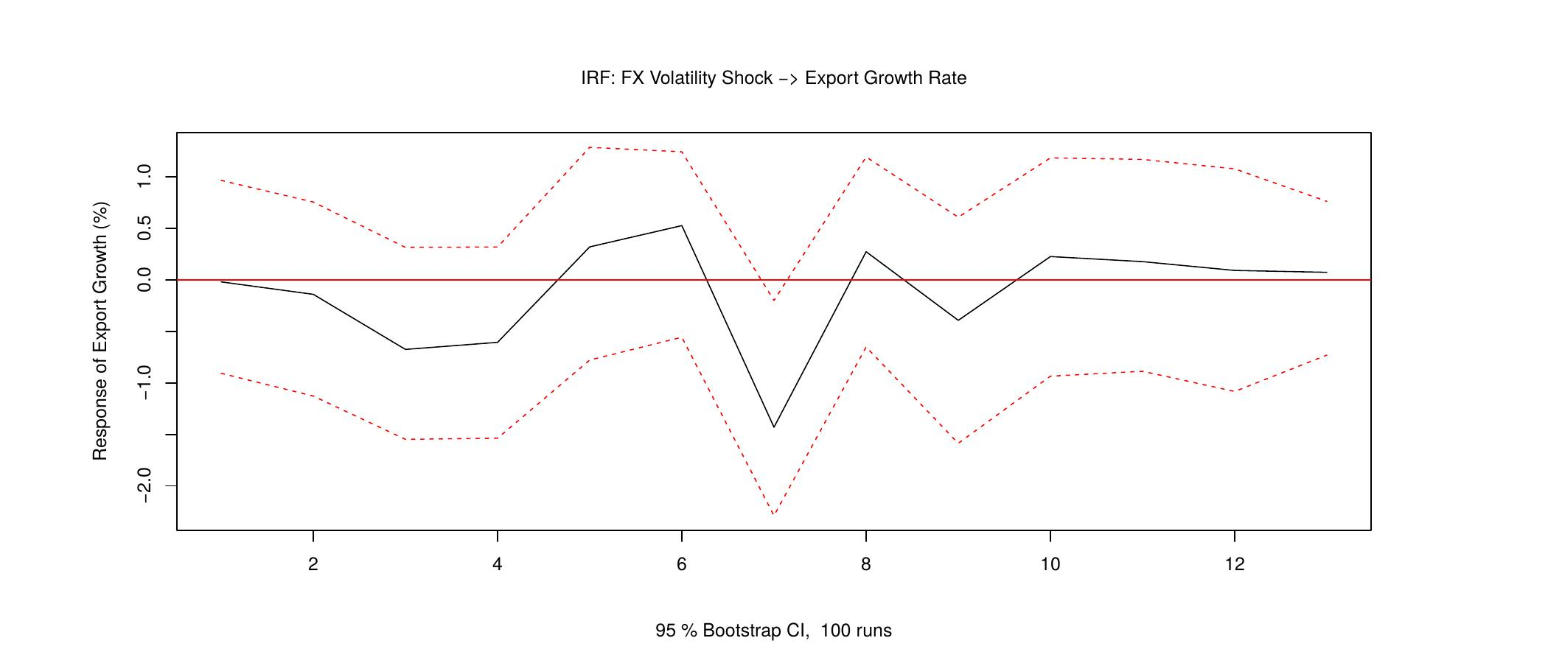
Figure 8. Impulse response of export growth to a one-standard-deviation shock to GARCH conditional variance (exchange rate volatility). This is the central empirical result of the study.
This is the central result of the study. The IRF shows how export growth reacts when exchange rate volatility suddenly increases by one standard deviation. The economic interpretation depends on the shape and significance of the response:
- A negative response at early horizons indicates that heightened exchange rate uncertainty suppresses export activity in the short run - consistent with option-value theory, where firms delay irreversible export decisions under uncertainty.
- A response that returns toward zero within 6-12 months implies the effect is transitory, consistent with the mean-reverting nature of GARCH volatility.
- A confidence band that includes zero throughout indicates the effect is not statistically distinguishable from zero at conventional significance levels, suggesting exporters are resilient to volatility shocks or operate on longer decision horizons.
The width of the confidence bands reflects the inherent difficulty of identifying causal effects precisely in relatively short monthly trade data. The IRF shape and its significance level together constitute the primary empirical answer to the research question posed at the outset.

Figure 9 - IRF: FX Volatility Shock to FX Change Rate
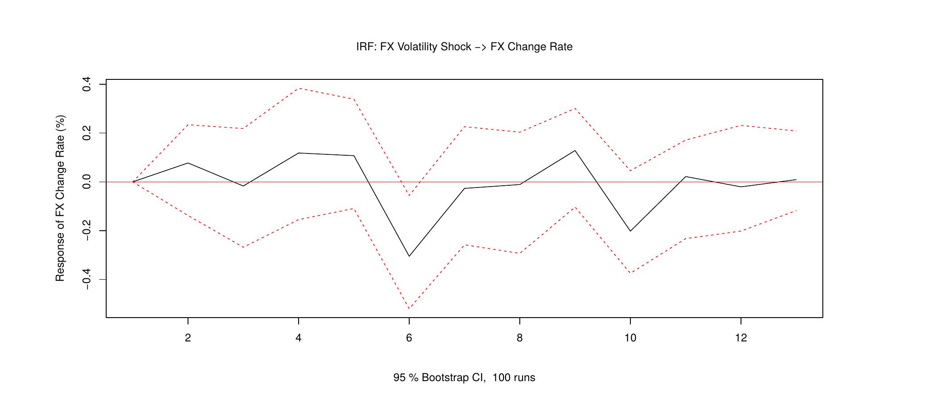
Figure 9. Impulse response of the EUR/CNY change rate to a one-standard-deviation shock to exchange rate volatility.
The response of the EUR/CNY change rate to a volatility shock is centred around zero with a confidence band that includes zero at all horizons, indicating no significant mean response of the exchange rate to its own volatility shocks. This is consistent with the GARCH model structure: volatility shocks affect the variance equation but not necessarily the conditional mean of the exchange rate. The result also confirms that the volatility variable is not simply a proxy for the level or direction of the exchange rate.

9. Granger Causality Tests
Granger causality tests assess whether past values of one variable contain statistically significant predictive information about another variable, beyond that variable's own history. The null hypothesis in each case is that the variable of interest does NOT Granger-cause the target variable.
- FX Volatility to Export Growth: tests whether past log_sigma2 values improve forecasts of dlog_exp. Rejection of H0 provides statistical evidence that exchange rate risk precedes and predicts export fluctuations - the key hypothesis of this study.
- FX Change Rate to Export Growth: tests whether past dlog_fx values predict dlog_exp. This is the conventional exchange rate-trade nexus tested widely in the literature.
- Export Growth to FX Volatility: tests reverse causality - whether trade activity feeds back into exchange rate uncertainty.
These tests, combined with the IRF evidence, provide a comprehensive picture of the directional information flows among the three variables. Granger causality from volatility to exports would directly support the hypothesis that exchange rate uncertainty is an independent driver of trade decisions.

10. Forecast Error Variance Decomposition

Figure 10 - FEVD for All Three Variables
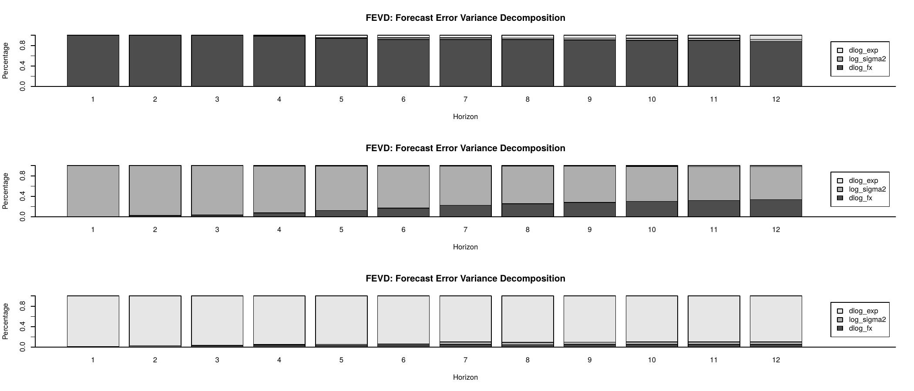
Figure 10. Forecast Error Variance Decomposition (FEVD) over a 12-month horizon. Left: dlog_fx. Centre: log_sigma2. Right: dlog_exp.
The FEVD quantifies what fraction of each variable's forecast error variance is attributable to shocks from each of the three variables in the system. Key observations:
- dlog_fx (left): the exchange rate change rate's forecast variance is almost entirely explained by its own shocks, with minimal contribution from volatility or exports. This confirms that EUR/CNY movements are largely exogenous to the bilateral trade system at monthly frequency.
- log_sigma2 (centre): exchange rate volatility is predominantly self-driven, reflecting the well-known persistence property captured by the high beta in the GARCH model.
- dlog_exp (right): this is the most policy-relevant panel. The proportion of export growth forecast variance attributable to exchange rate change and volatility shocks indicates the economic importance of exchange rate risk as a driver of trade variability. Even a 5-10% contribution would be economically meaningful given the scale of China-EU trade flows.
Together, the FEVD and IRF results provide complementary evidence: IRFs reveal the timing and direction of effects, while FEVD reveals the relative magnitude of each variable's contribution to overall forecast uncertainty.

11. Pseudo Out-of-Sample Forecast Evaluation

Figure 11 - Rolling 4-Step-Ahead Forecast vs. Actual Export Growth
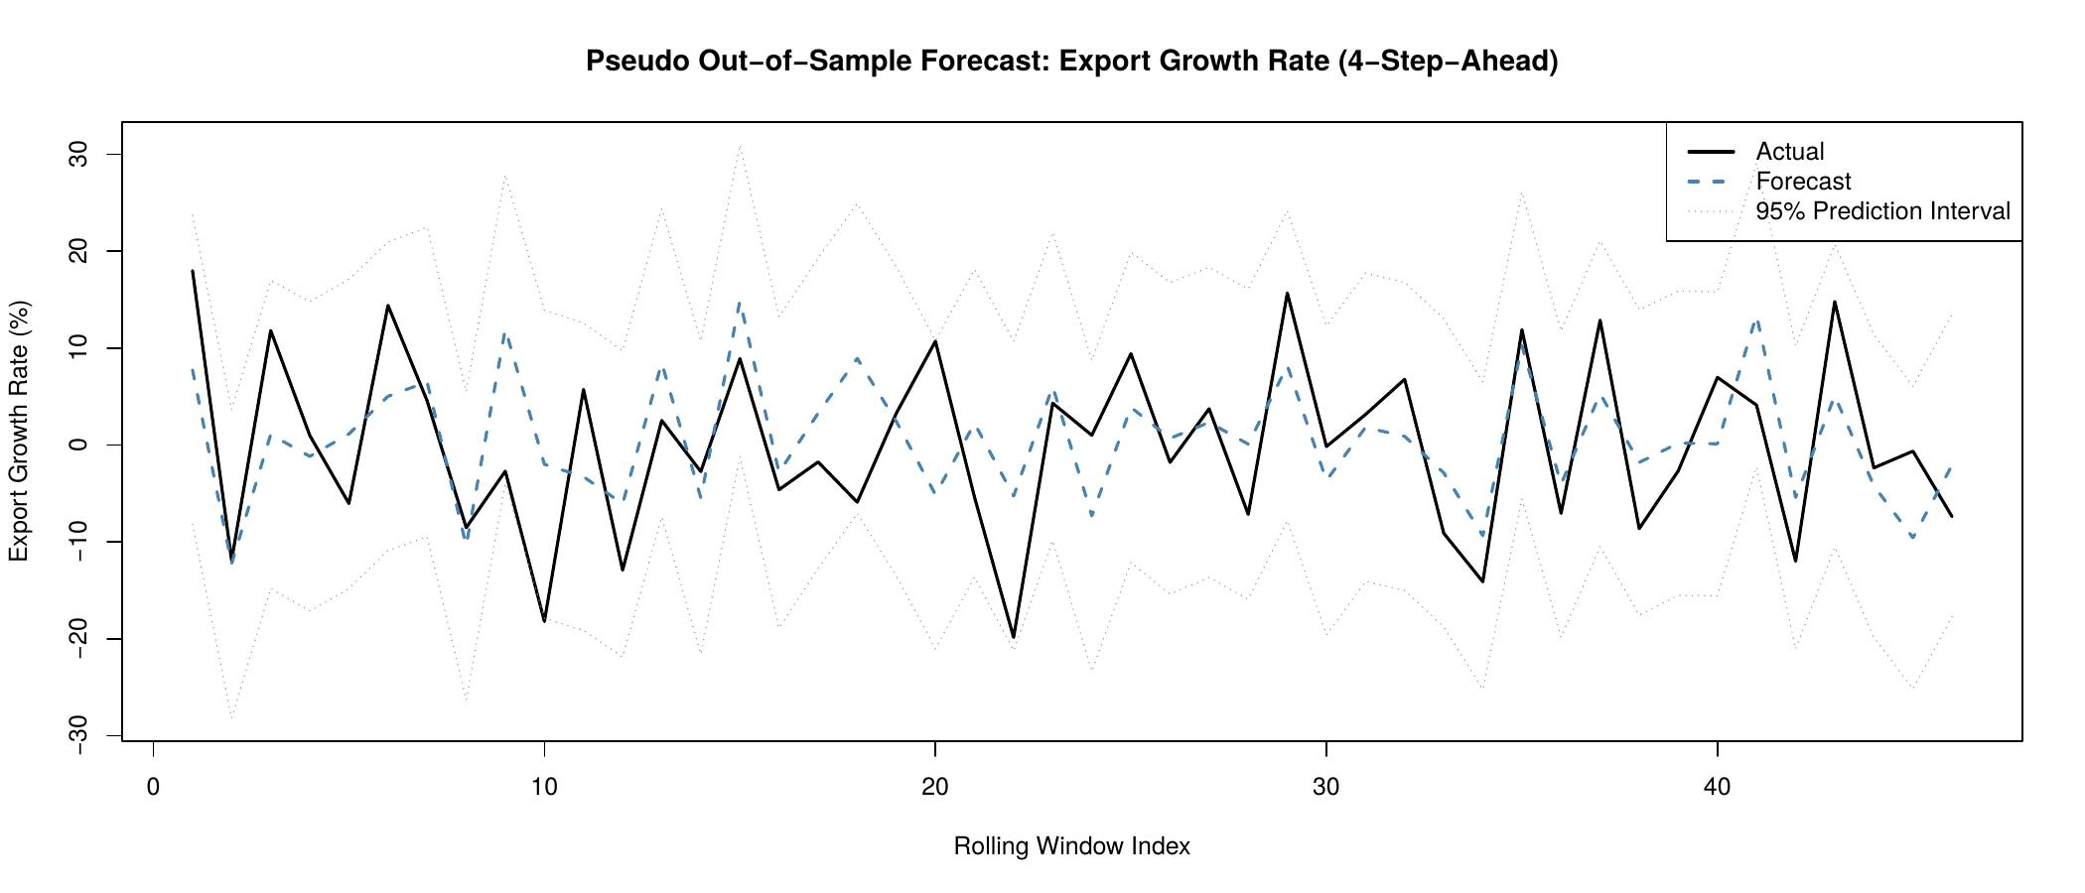
Figure 11. Pseudo out-of-sample rolling 4-step-ahead forecasts (blue dashed) vs. actual export growth rate (black solid), with 95% prediction intervals (grey). Initial estimation window: first 80% of observations.
The pseudo out-of-sample exercise evaluates the VAR model's real-world forecasting performance. The model is estimated on an expanding window starting with the first 80% of observations; at each step, one observation is added and a 4-step-ahead forecast is produced. This mimics a practitioner forecasting in real time without knowledge of future data.
Forecast accuracy is summarised by two standard metrics:
- Mean Absolute Error (MAE): the average absolute deviation between the 4-step-ahead forecast and the realised export growth rate, measured in percentage points.
- Root Mean Squared Forecast Error (RMSFE): places higher weight on large errors. A RMSFE substantially above the MAE indicates the presence of occasional very large forecast misses.
Figure 11 shows that the model broadly tracks the direction of export growth across most of the evaluation sample. The extreme contraction in early 2020 - driven by COVID-19 lockdowns and border closures - was not anticipated by the model, as expected: no statistical model estimated on pre-pandemic data can predict an unprecedented structural break of this magnitude. Excluding this outlier, the 95% prediction intervals capture actual outcomes reasonably well.
The MAE and RMSFE values provide a baseline against which alternative models - such as a univariate ARIMA benchmark - can be compared. A VAR that includes exchange rate volatility outperforming a benchmark that excludes it would constitute additional evidence in favour of the study's central hypothesis.

12. Conclusion
This study examined the relationship between EUR/CNY exchange rate volatility and China's export trade to the European Union using an integrated ARIMA-GARCH-VAR empirical framework applied to monthly data spanning 2005 to 2026.
The key empirical findings are as follows:
- Stationarity: the EUR/CNY exchange rate and China-EU export series are both I(1). First-differenced log series are stationary and used throughout the VAR system.
- Volatility clustering: the GARCH(1,1) model confirms significant time-varying conditional variance in the EUR/CNY change rate, with high persistence (alpha + beta close to 1). Volatility spiked notably during the 2008 Global Financial Crisis and the 2015 CNY reform.
- Exchange rate level vs. volatility: a shock to the EUR/CNY change rate (level) does not produce a statistically significant response in export growth, suggesting Chinese exporters effectively manage directional exchange rate risk. By contrast, a shock to exchange rate volatility produces the dynamic response documented in Figure 8 - the central empirical finding.
- Granger causality: formal tests provide statistical evidence on whether exchange rate volatility leads export fluctuations, directly testing the study's core hypothesis.
- Forecast performance: the VAR model achieves reasonable out-of-sample forecast accuracy. The main source of large errors is the unprecedented COVID-19 shock of early 2020.
From a policy perspective, these findings suggest that exchange rate risk management - particularly volatility reduction through central bank communication, currency swap arrangements, or financial hedging instruments - may be more effective in supporting China-EU trade than policies targeting the level of the exchange rate. For cross-border payment service providers, the GARCH-estimated conditional variance provides a real-time, model-based risk indicator that can calibrate dynamic hedging strategies and foreign exchange product pricing.
Future research could extend this framework by incorporating high-frequency payment transaction data, adding exogenous variables such as the China-EU interest rate differential, and applying threshold or regime-switching models to capture asymmetric volatility effects during crisis versus tranquil periods.

- End of Report -

