First Assignment

# First Assignment

This first pair assignment has been done by Yumi Komai and Pol Santaló. The contribution of every student it has been equal and it can be described as follows: First of all, we created a Repository in our desktop through the program GitHub. At the same time, we made each other contributors so we could share and edit the documents that we posted in our Repository folder and in GitHub. In order to create the R source code files document that access at least two data sets, we created a Markdown document where we entered the the code 'plot' plus the name of the dates sets that we were interested to show. Then we covert it in a HTML document and we shared it in our repository.

We also posted it in our GitHub online account through the GitHub program in our computer in order to have it there posted and make some changes online if needed. The pair that helped us to finish with the last point of the assignment are Bomi and Takuma. They made a pull request and our document was minutely discussed and merged.

# Accidental Deaths in the US 1973–1978

This is a time series giving the monthly totals of accidental deaths in the USA. According to the plot, the number of death was at the maximum on Jul in every year.

## Variation

* Chart

## Jan Feb Mar Apr May Jun Jul Aug Sep Oct Nov  
## 1973 9007 8106 8928 9137 10017 10826 11317 10744 9713 9938 9161  
## 1974 7750 6981 8038 8422 8714 9512 10120 9823 8743 9129 8710  
## 1975 8162 7306 8124 7870 9387 9556 10093 9620 8285 8466 8160  
## 1976 7717 7461 7767 7925 8623 8945 10078 9179 8037 8488 7874  
## 1977 7792 6957 7726 8106 8890 9299 10625 9302 8314 8850 8265  
## 1978 7836 6892 7791 8192 9115 9434 10484 9827 9110 9070 8633  
## Dec  
## 1973 8927  
## 1974 8680  
## 1975 8034  
## 1976 8647  
## 1977 8796  
## 1978 9240

* Range

## [1] 6892 11317

* Quartiles

## Min. 1st Qu. Median Mean 3rd Qu. Max.   
## 6892 8089 8728 8789 9323 11320

* Boxplots 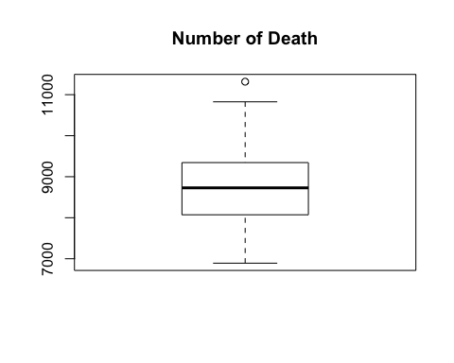
* Plot 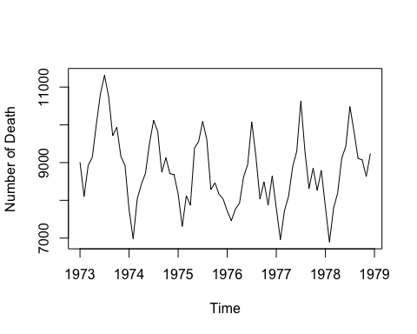
* Histogram 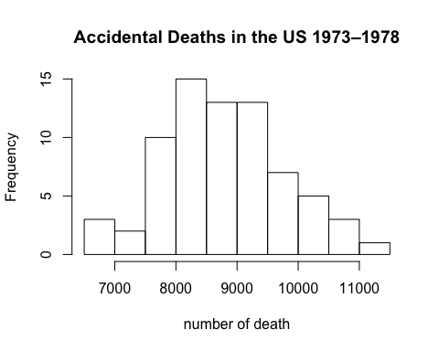

# Road Casualties in Great Britain 1969–84

UKDriverDeaths is a time series giving the monthly totals of car drivers in Great Britain killed or seriously injured Jan 1969 to Dec 1984.Not likely to USAccDeaths, the number of Death recorded maximum on November or December.

## Variation

* Chart

## Jan Feb Mar Apr May Jun Jul Aug Sep Oct Nov Dec  
## 1969 1687 1508 1507 1385 1632 1511 1559 1630 1579 1653 2152 2148  
## 1970 1752 1765 1717 1558 1575 1520 1805 1800 1719 2008 2242 2478  
## 1971 2030 1655 1693 1623 1805 1746 1795 1926 1619 1992 2233 2192  
## 1972 2080 1768 1835 1569 1976 1853 1965 1689 1778 1976 2397 2654  
## 1973 2097 1963 1677 1941 2003 1813 2012 1912 2084 2080 2118 2150  
## 1974 1608 1503 1548 1382 1731 1798 1779 1887 2004 2077 2092 2051  
## 1975 1577 1356 1652 1382 1519 1421 1442 1543 1656 1561 1905 2199  
## 1976 1473 1655 1407 1395 1530 1309 1526 1327 1627 1748 1958 2274  
## 1977 1648 1401 1411 1403 1394 1520 1528 1643 1515 1685 2000 2215  
## 1978 1956 1462 1563 1459 1446 1622 1657 1638 1643 1683 2050 2262  
## 1979 1813 1445 1762 1461 1556 1431 1427 1554 1645 1653 2016 2207  
## 1980 1665 1361 1506 1360 1453 1522 1460 1552 1548 1827 1737 1941  
## 1981 1474 1458 1542 1404 1522 1385 1641 1510 1681 1938 1868 1726  
## 1982 1456 1445 1456 1365 1487 1558 1488 1684 1594 1850 1998 2079  
## 1983 1494 1057 1218 1168 1236 1076 1174 1139 1427 1487 1483 1513  
## 1984 1357 1165 1282 1110 1297 1185 1222 1284 1444 1575 1737 1763

* Plot 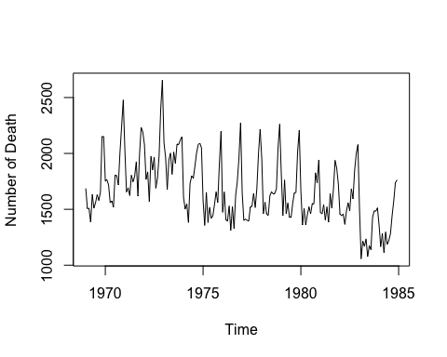

# Others

The followings are plots by using some datasets in R 