**Invest in Bitcoin and Gold**

# Memorandum

To: Investors

From: MCM Team #2202151

Date: Feb 22nd, 2022

Subject: Strategies to Trade Bitcoin and Gold

## **The Necessity of Getting to Know Bitcoin**

From 2009 to the present, Bitcoin has gone from nothing to nothing, from unknown to known to the world, in just a decade. Admittedly or not, Bitcoin is the trendsetter of our time. Gold, on the other hand, is a very mature investment, and has been synonymous with "wealth" for the past few centuries.

## **Some suggestions**

Therefore, from now if you want to invest Bitcoin and gold, there are two aspects that need to be considered here to match them both through Adapting Markowitz Pair-Portfolio. With this in mind:

1. The Conditional Value at Risk model can effectively capture the current market's risk.
2. We need to combine several different lengths of future revenue expectations to obtain revenue metrics.

In summary, please keep a clear head and avoid risky investments, loss and gain together.

**Invest in Bitcoin and Gold**

## **Conclusion**

We think that everyone can benefit from a proper understanding of risk and return in order to make rational and positive investments. Of course, using the matching model in this process can make all the difference.

## **Our Result**

The chart below shows how the bitcoin to gold ration has changed throughout the course of the transaction, from 2016.9 to 2021.9.

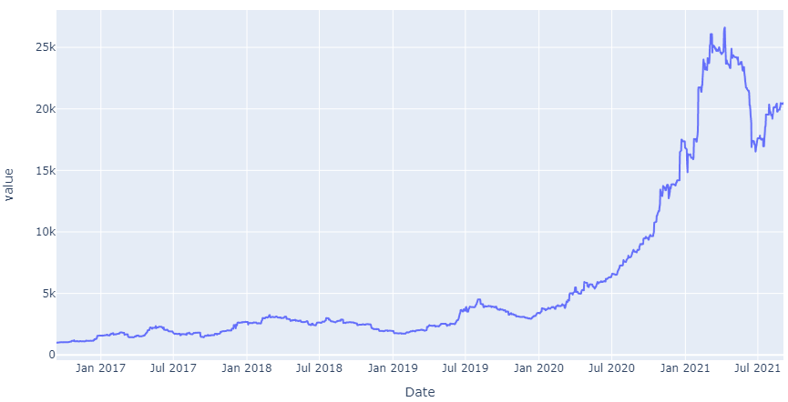

We managed to almost 20 times our $1000 principal to over $20,000 in five years. This proves that the rationing model is stable and profitable.