Software Requirements Specification for

Badminton Court Reservation System

Table of Contents

Table of Contents ii

1. **Introduction** 1

1.1 Purpose of the Requirements Document 1

1.2 Project Scope and Product Features 1

1.3 Definition 1

1. **General Description** 1

2.1 Product Perspective 1

2.2 Product Functions 1

2.3 User Classes and Characteristics 1

2.4 Operating Environment 3

2.5 Design and Implementation Constraints 3

2.6 User Documentation 3

2.7 Assumptions 3

1. System Features 3

3.1 Check the Court Booking Status 3

3.2 Check and Print Reservation Order Report

3.3 Handle Refund 6

3.4 Book Courts

3.5 Deliver the Deposit 5

3.6 Cancel the Reservation

1. External Interface Requirements 7

4.1 User Interfaces 7

4.2 Hardware Interfaces 8

4.3 Software Interfaces 8

4.4 Communications Interfaces 8

1. Other Nonfunctional Requirements 8

5.1 Performance Requirements 8

5.2 Safety Requirements 9

5.3 Security Requirements 9

5.4 Software Quality Attributes 9

1. Introduction

1.1 Purpose of the Requirement Document

This SRS first gives an overview of the overall functional structure of the entire Badminton Court Reservation System (CRS), and then describes the functional requirements and other non-functional requirements in detail. The use case model of use case diagram is used to describe the functional requirements. This document describes in detail the requirements and specifications of Badminton Court Reservation System. These specifications are the basis for design, and also the main basis for writing test cases and system testing. At the same time, the document is also the main basis for users to determine the software functional requirements.

1.2 Project Scope and Product Features

The Badminton Self-service Webpage will be used to provide self-service booking service for customers on different hardware like mobile phone or computer. And the company manager can check the reservation conveniently. The main function of the web page is to provide a useful reservation platform for customers to make reservation and cancel easily, and for managers to confirm and manage the reservation conveniently.

1.3 Definition

The course reservation system should provide a self-service Web interface for customer reservation and reservation management. Administrators need to manage the rental status of badminton venues through the page.

2. General Description

2.1 Product Perspective

Badminton court reservation system has replaced the traditional offline booking or telephone booking mode. Its main function is to let the user book the badminton court on the Internet, the operator in the network background to understand the badminton court booking situation. The context diagram in Figure 1 illustrates the external entities and system interfaces for this CRS. This system is ultimately connecting to the Internet ordering services for bad guy company and to credit and debit card authorization (Alipay or WeChat Pay) services.

2.2 Product Functions

The function of the badminton venue reservation system is more convenient for the convenience of the people love to play badminton in the badminton venue, scheduled for the convenience of the management, badminton hall also prevent some people illegally occupy the field of badminton hall, the system can realize the online booking sites or event and pay the deposit, then can be used in a due time.

2.3 User Classes and Characteristics

Customer Customers can book the venue and time on request. Customers can enter a date and time to book, and pay a fee in advance. If the customer wants to cancel the reservation, he/she must cancel at least 2 days in advance and the fee will be refunded. But the fee will not be refunded If he/she doesn’t cancel two days in advance.

Operator Operator is the only employee at the Bad Guy Badminton hall. He is responsible for setting up and checking the badminton venue bookings. The company currently has 12 badminton courts. The courts are available for use from 8AM to 10PM daily. Operator needs to confirm that the badminton court is not occupied and in optimum condition, and to turn on and off the lights of the court before and after the client has booked the court.

2.4 Operating Environment

1. The Badminton Court Reservation System shall operate with the following web browsers: Microsoft Internet Explorer versions 10 and 11.
2. The Badminton Court Reservation System shall operate on a server running the current corporate approved versions of Linux and WebServer.
3. The Badminton Court Reservation System shall allow access from the company Intranet or, if the user is authorized to have external access through the company firewall, from the user's home Internet connection.
   1. Design and Implementation Constrains

CO-1: All HTML code shall conform to the HTML 4.0 standard.

CO-2: The system’s design, code, and maintenance documentation shall conform to the Process Impact Intranet Development Standard, Version 1.3.

CO-3: There will be a few customers (for example, elderly customers) that may struggle using the webpage.

CO-4: The new booking system will require maintenance charge.

* 1. User Documentation

UD-1: The system is suggested to provide an online hierarchical and cross-linked help system in HTML that illustrates all system functions.

UD-2: When a new custom accesses the system for the first time, the system should provide an online tutorial to allow customers to practice ordering slot using a static tutorial. The system must not store the ordered slot using this template.

* 1. Assumptions and Dependencies

AS-1: The free court is allowed to be booked on every day in every time slot for any user.

There is no dependency for Court Reservation System.

3. System Features

3.1 Check the Court Booking Status

|  |  |
| --- | --- |
| Use Case ID: | UC001 |
| Use Case Name: | Check the Court Booking Status |
| Actors: | Operator |
| Description: | Confirm that the badminton court is not occupied and in the best condition according to the customer's reservation |
| Trigger: | Check the usage of court according to customer's reservation |
| Preconditions: | 1. Operator opens the browser on his/her machine.  2. Operator checks the booking status according to the web page. |
| Post conditions: | Operator opens and closes the court according to the content of the web. |
| Normal Flow: | 1. Operator opens the browser on his/her machine.  2. Operator enters URL.  3. The system displays the time period of the day.  4. The system shows the court and time of customer reservation.  5. The operator checks the customer's payment and reservation status.  6. The operator will turn off and on the lights of the court according to the booking situation and the scheduled time. A time period is an hour.  7. Switch on and off the lighting of the court every hour. |
| Alternative Flows: | 1.1 Book multiple courts at the same time  1.The system shows the same person booking multiple venues  2. Use Case resumes on step 6.  3.Turn on the lights in multiple courts  1.2 Book a court for multiple sessions  1. The system shows the customer books multiple time periods.  2. Use Case resumes on step 6.  3. Instead of operating every hour, operator turns on the light at the beginning of the scheduled time and turns off the light at the end.  1.3 Book a court for the whole day  4. The system shows the customer booked all day.  5. Use Case resumes on step 6.  6. The lights are on at opening time and off at closing time. |
| Exceptions: | 1. The badminton court cannot be booked.  2. The lights in the court are damaged. |
| Includes: | Record the number of people booked daily, the use of the court and the light condition. |
| Notes and Issues: | 1. The courts are available for use from 8AM to 10PM daily.  2. If someone takes up the space illegally, he/she can't book it again for a month. |

3.2 Check and Print Reservation Order Report

|  |  |
| --- | --- |
| Use Case ID: | UC002 |
| Use Case Name: | Check and Print Reservation Order Report |
| Actors: | Operator |
| Description: | The operator gets the reservation order report through the web page every day, which is exported by Excel and printed by printer. |
| Trigger: | Send the report to company manager per mouth. |
| Preconditions: | 1. Operator opens the browser on his/her machine.  2. Operator gets the reservation order report through the web. |
| Post conditions: | Operator prints the report according to the content of the web. |
| Normal Flow: | 1. Operator opens the browser on his/her machine.  2. Operator enters URL.  3. Keep track of how many people are booked every day.  4. The system shows the reservation order report.  5. The operator checks the reservation order report.  6. The system exports the reservation order in excel.  7. The operator prints the reservation form once a month. |
| Alternative Flows: | Compare daily ridership and adjust prices in the future according to ridership. |
| Exceptions: | 1. Printer is damaged.  2. Internet is wrong. |
| Includes: | Compare daily ridership and adjust prices in the future according to ridership.   1. Raise prices during periods of high ridership. |
| Notes and Issues: | Organize and print orders once a month. |

3.3 Handle Refund

|  |  |
| --- | --- |
| Use Case ID: | UC003 |
| Use Case Name: | Handle Refund |
| Actors: | Operator |
| Description: | When the badminton court has a problem, notify the user and give a refund. |
| Trigger: | For the user's experience, the operator should cancel the user's reservation and give a refund when there is a problem with the badminton court. |
| Preconditions: | 1. Operator opens the browser on his/her machine.  2. Operator checks the status of badminton court.  3. Operator handle the booking status according to the web page. |
| Post conditions: | 1. Operator opens and closes the court according to the status of badminton court.  2. The operator cancels the order and refunds the user.  3. The operator notifies the user. |
| Normal Flow: | 1. Operator checks badminton court status  2. The operator found a problem with the badminton court.  3. Operator opens the browser on his/her machine.  4. Operator enters URL.  5. The system shows the court and time of customer reservation.  6. The operator checks the court status and the court has problem.  7. Operator cancels order.  8. Operator refunds the user.  9. Operator notifies the user. |
| Alternative Flows: | When there are other badminton courts available at the same time, the operator will change the badminton courts.  The following steps added:  1. Operator changes the reserved badminton court.  2. The operator notifies the user of the new badminton court number and explains the reason. |
| Exceptions: | The refund message cannot be notified to the user. |
| Includes: | Record the number of people booked daily, the use of the court and the light condition. |
| Notes and Issues: | If a refund has been made, be sure to notify the user, either via text message or phone call. |

3.4 Book Courts

|  |  |
| --- | --- |
| Use case ID | UC004 |
| Use case name | Book Courts |
| Actors | Customer |
| Description | Book courts and time based on customer's requirement |
| Trigger | The customer wants to play badminton and found the court to book |
| Precondition | 1. The customer opens a browser on his/her machine. 2. The costumer knows what time and how many courts he/her wants to book. |
| Post condition | The system presents a list of results after the user has selected the site and time. |
| Normal flow | 1. The customer opens a browser on his/her machine. 2. The customer enters URL. 3. The customer chooses the time they want and the number of places they want to book. 4. The customer receives the successful reservation message. |
| Alternative Flows | Apply filter  The following steps are added:   1. The customer applies filters to the results by typing keywords into the filter. 2. The customer can enter a date keyword to select a date, and then a period keyword to select a period. 3. The system filters the previous result list and displays a new result list to the customer. |
| Exceptions | The system cannot load date and time period (the database is not available). |
| Includes | None |
| Notes and issues | If all the courts are booked for the same period of time, that period will be shown as full. If there are no courts available at all times of the day, an empty list will be returned showing that all courts are booked. |

3.5 Delivery of the Deposit

|  |  |
| --- | --- |
| Use case ID | UC005 |
| Use case name | Delivery of the Deposit |
| Actors | Customer |
| Description | A deposit is required when the customer makes a successful booking. |
| Trigger |  |
| Precondition | 1. The customer has already booked the time and venue. 2. The customer has enough money to pay the deposit. |
| Post condition | The customer will receive a notification of successful payment |
| Normal flow | 1. The customer enters the payment interface after opening the website and successfully booking. 2. The order number is generated in the background of the webpage. 3. The customer makes sure they have enough money to pay the deposit, and they pay the deposit on the website. 4. The page background detected that the order has been paid. 5. The customer completes the appointment and the payment was successful. |
| Alternative Flows | Method of payment  The following steps added:   1. When the customer pays a deposit, they can choose payment methods, such as bank card payment, WeChat payment or Alipay payment. 2. After selecting the payment method, enter the payment password to complete the payment. |
| Exceptions | A network error caused the payment to fail |
| Includes | None |
| Notes and issues | After the payment is completed, the customer is given a result that the payment has been made successfully |

3.6 Cancel the Reservation

|  |  |
| --- | --- |
| Use case ID | UC006 |
| Use case name | Cancel the Reservation |
| Actors | Customer |
| Description | When the customer needs to cancel an appointment |
| Trigger | Customers have to cancel for other reasons |
| Precondition | 1. The customer has paid and booked successfully 2. The customer wants to cancel the reservation |
| Post condition | 1. The system cancels the reservation 2. Court at this point in time can be rescheduled 3. The customer will receive a refund for the deposit |
| Normal flow | 1. The customer opens the reserved page 2. The customer chooses their own scheduled time 3. The customer chose to cancel the appointment 4. Successful cancellation |
| Alternative Flows | Apply filter  The following steps are added:   1. The customer can still use the filter to filter their scheduled times (if they have booked a lot of time) 2. The customer can choose the time period they want to cancel |
| Exceptions | The system cannot load date and time period the customer wants to cancel (the database is not available). |
| Includes | None |
| Notes and issues | The customer must cancel at least 2 days in advance. Otherwise the reservation cannot be cancelled |

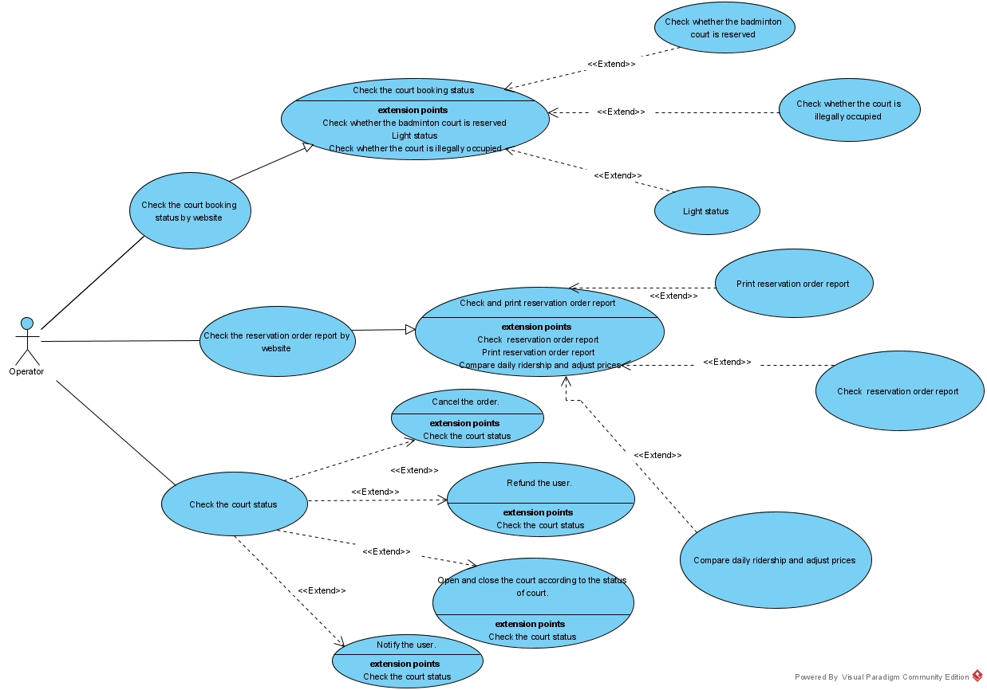

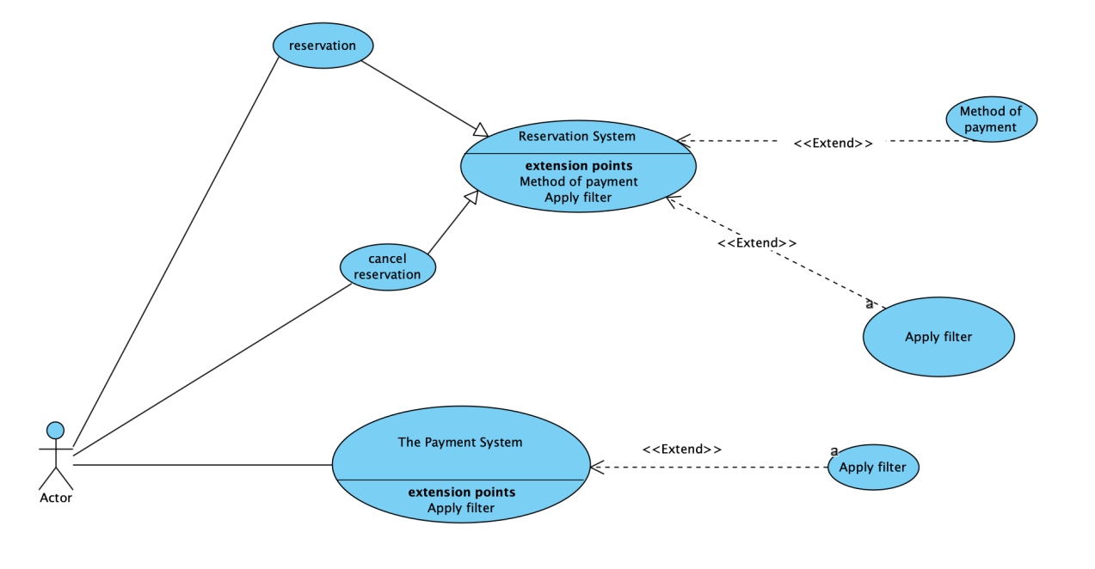

4. External Interface Requirements

4.1 User Interfaces

UI-1: The Badminton Court Reservation screen displays shall conform to the Process Impact Internet Application User Interface Standard, Version 2.0   
 UI-2: The reservation shall provide a help link from each displayed HTML page to explain how to use that page.  
 UI-3: The Web pages shall permit complete navigation and court booking using the keyboard alone, in addition to using mouse and keyboard combinations.

4.2 Hardware Interfaces

HI-1: External storage devices (for example, the hard disk of the manager's computer) to store customers booking records.

HI-2: Printer, keyboard and mouse for print the records of customers’ reservation.

4.3 Software Interfaces

SI-1:  Alipay system, card payment or Wechat payment system. The self-service webpage should be able to call the third-party payment platform to charge customers for reservation.

SI-1.1: To allow customers to pay for reservation.

SI-1.2: To allow company to collect payment of customers from payment systems.

SI-1.3: To submit a payment request for a completed reservation.

SI-1.4: To reverse all previous charge because customers cancel the reservation at least two days in advance.

SI-2:  Microsoft Excel enables managers to get customer reservation and payment records.

SI-2.1: To allow managers to read the reservation of customers.

SI-2.2: To allow managers to print the reservation records of customers.

5. Other Nonfunctional Requirements

5.1 Performance Requirements

PE-1: All Web pages generated by the system shall be fully downloadable in no more than 10 seconds over a 40KBps modem connection.

PE-2: The response time for general operations should be within 120 Milliseconds.

PE-3: There should be no difficulty with the operating environment requirements mentioned earlier.

5.2 Safety Requirements

There is no safety requirements for this BOS.

5.3 Security Requirements

SE-1: All online transactions involving financial information or personally identifiable information should be encrypted in accordance with BR-33.

SE-2: The user is required to log in to the badminton court reservation system to perform all operations except for viewing the available slot.

SE-3: users should log in in accordance with the restricted computer system access policy in BR-35.

SE-4: According to BR-24, the system only allows operators on the list of authorized order operators to modify orders.

SE-5: The system only allows users to view their previous orders, and does not allow users to view orders placed by other users.

5.4 Software Quality Attributes

The finished system must be easy to operate, easy to get started, with a simple interface and helpful hints system.

If the user's connection to the system is interrupted before the order is confirmed or cancelled, the Badminton Court Reservation System shall allow the user to restore the unfinished order.