Course Work Submission

|  |  |  |  |
| --- | --- | --- | --- |
| Name | Yumin | Wang |  |
| ID Number | 1825179 | |  |
| Programme | Information and Computer Science | |  |
| Module Title | Computer Graphics | |  |
| Module Code | CPT205 | |  |
| Assignment Title | 2D Modelling Project | |  |
| Submission Deadline | Monday, 9 November 2020 | |  |
| Lecturer Responsible | Yong.Yue | |  |

I certify that:

* I have read and understood the University’s definitions of COLLUSION and PLAGIARISM (available in the Student Handbook of Xi’an Jiaotong-Liverpool University).

With reference to these definitions, I certify that:

* I have not colluded with any other student in the preparation and production of this work;
* this document has been written solely by me and in my own words except where I have clearly indicated and acknowledged that I have quoted or used figures from published or unpublished sources (including the web);
* where appropriate, I have provided an honest statement of the contributions made to my work by other people including technical and other support staff.

I understand that unauthorised collusion and the incorporation of material from other works without acknowledgement (plagiarism) are serious disciplinary offences.

Signature ……Yumin.Wang 王昱旻…… Date ……5/11/2020*……*………

|  |  |  |  |
| --- | --- | --- | --- |
| For  Academic  Office use: |  |  |  |
|  |  |  |

## CSE105 Assessment 1 Report

## Features of the Birthday Card

First, draw some basic Geometry.

Draw Circle / Draw Half Circle: GL_POLYGON

Draw Candles: GL_TRIANGLES and GL_POLYGON

Draw Sinwave: GL_LINE_STRIP

Draw Ellipse: GL_POLYGON

Draw Smile: GL_POLYGON and GL_POINTS and GL_LINES

Draw Tree: GL_POLYGON and GL_POINTS

Draw Cake: GL_POLYGON

Secondly, Transform(e.g. glTranslatef, glScalef, glRotatef) the base graphics to draw the composite graphics, and animated figures that moving.

**Tree:**

To draw a tree, Let me first draw the body of the tree with a circle, two ellipses and a rectangle. And then I'm going to outline the tree with two sine waves.

**Kid:**

A child consists of a head and a body. Draw a child, first use two points, a curve and a circle to draw the face, then draw a polygon and four lines as the child's body.

**Candles:**

To draw the candle, draw a rectangle for the main body. Then, a circle and a triangle are placed on top to paint a sparkling flame.

**Cake:**

The cake consists of two layers and a cream border. The upper part consists of two different-colored ellipses and a rectangle. The lower part of the cake consists of two larger ellipses and rectangles. Butter is a curved sine wave painting. Four cream waves of different colors and sizes are obtained by transformation.

**Balloons:**

The four balloons are made up of ropes and four ellipses. Two of them will keep moving. They can also be moved and stopped by keyboard and mouse.

**Flowers:**

Flowers are made up of hearts, petals, leaves and stems. The center of the flower is a circle, the petals are nine semicircles that rotate, the leaves are two ellipses, and the stem is a straight line.

Lastly, the greeting text “Happy Birthday” is drawn in the font “Comic Sans MS”.

## 2.Interactive instructions

## Mouse interaction:

## When the left mouse button is clicked, the balloon moves to the left.

## When the right mouse button is clicked, the balloon moves to the right.

1. Keyboard Interaction (balloons) :

Key Q: Exit and close the window

Key A: Stop moving

Key S: Move right

Key D: Move left

**3.Screenshots**

Default:

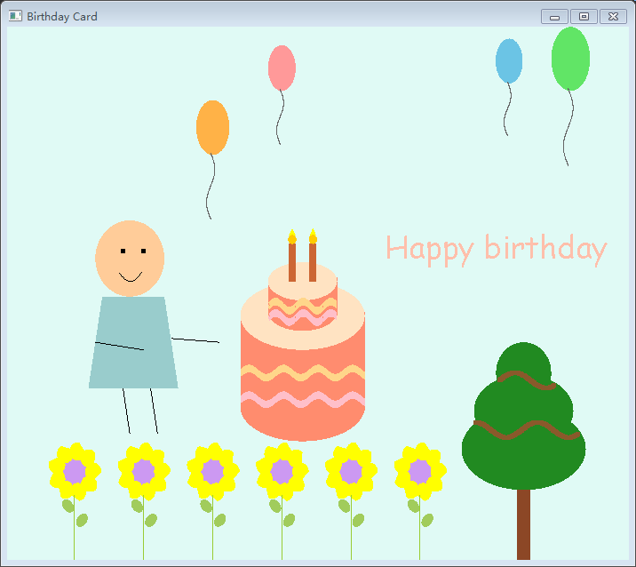

As the balloon moves:

