Dept. of Electronic Engineering EE302 – John Maloco

Embedded and Realtime Systems

Laboratory 2

Name: _____ Yuen Lin__________

Student ID: __832401211 / 24125491__________

Laboratory Exercise

- Using Pseudo code, outline the design of your program. (15 marks)

BEGIN ButtonPressCounter

setup():
Initialise LCD in 8-bit mode // Lcd8_Init(); also sets ADCON1 = 0x07
Configure RB0, RB1 and RB2 as digital inputs
Set buttonCount = 0
Clear the LCD
Display "Laboratory 2" on line 1, column 1
Display "EE302" on line 2, column 1

loop():
IF Inc (RB0) is pressed THEN
Delay 20 ms // debounce the press
IF Inc is still pressed THEN
IF buttonCount < 20 THEN
buttonCount = buttonCount + 1
END IF
Clear the LCD
Display "Button Press" on line 1, column 2
Display "= " + two-digit buttonCount on line 2, column 5
WAIT UNTIL Inc is released
Delay 20 ms // debounce the release
END IF
ELSE IF Dec (RB1) is pressed THEN
Delay 20 ms
IF Dec is still pressed THEN
IF buttonCount > 0 THEN
buttonCount = buttonCount - 1
END IF
Clear the LCD
Display "Button Press" on line 1, column 2
Display "= " + two-digit buttonCount on line 2, column 5
WAIT UNTIL Dec is released
Delay 20 ms
END IF
ELSE IF Reset (RB2) is pressed THEN
Delay 20 ms
IF Reset is still pressed THEN
buttonCount = 0
Clear the LCD
Display "Button Press" on line 1, column 2
Display "= " + two-digit buttonCount on line 2, column 5
WAIT UNTIL Reset is released
Delay 20 ms
END IF
END IF

main():
setup()
REPEAT FOREVER
loop()
END REPEAT

END ButtonPressCounter

- Using MPLAB create a project and write the C program for the above.
Include good comments and a title section for your code. (40 marks)

The code is included in the appendix at the end of the report.

- In the ee302lcd.h header file there is a LCD initialisation function called, Lcd8_Init(). In this function the ADC special function register ADCON1 is set to 0x07.
- Why is this necessary for the digital LCD device to work?
ADCON1 is the A/D Port Configuration register. Bits 3–0, PCFG3:PCFG0, select which of the analog-capable pins AN0–AN7 are analog inputs and which are digital I/O. The value 0x07 sets PCFG3:PCFG0 = 0111. Table 11-2 of the PIC16F87XA datasheet shows that the 011x row configures AN7–AN0 as digital (D) with no voltage reference channels (C/R = 0/0). The A/D converter is therefore disconnected from these pins and PORTE can drive them as normal digital outputs.
The reason this is essential is given by the note in Register 11-2: “On any device Reset, the port pins that are multiplexed with analog functions (ANx) are forced to be an analog input.” The LCD control lines are RS = RE0, RW = RE1 and EN = RE2. On the PIC16F877A these pins are also AN5, AN6 and AN7. If they remained analog inputs, writing to PORTE would not produce valid digital levels on RS, RW and EN, so the 1602 would never receive its initialization commands or any data. The display would remain blank (or show dark blocks). Lcd8_Init() therefore writes ADCON1 = 0x07 before it starts the LCD reset sequence.
The data bus is less critical in this respect because RD0–RD7 are digital-only pins, but the three control lines on PORTE definitely require the ADCON1 setting. This is also why the application must not overwrite ADCON1 during its own initialization.

- Which analog input pins AN0 to AN7 must be configured to digital I/O in order for the LCD to work?
For the LCD to work, AN5, AN6 and AN7 must be digital I/O. Their port pin mapping is shown in Table 1: AN5 = RE0 = RS, AN6 = RE1 = RW and AN7 = RE2 = EN. The eight LCD data lines are RD0–RD7, which have no analog function and are always digital. AN0–AN3 are on RA0–RA3 and AN4 is on RA5; they are not connected to the LCD, although ADCON1 = 0x07 makes them digital as well. In summary, the three pins that are actually required for the LCD are AN5, AN6 and AN7.

- Give another value for bits 3-0 (PCFG3:PCFG0) which would also enable the LCD to work? (25 marks)
PCFG3:PCFG0 = 0110. This setting configures all AN0–AN7 pins as digital I/O. Since RE0, RE1, RE2 (AN5, AN6, AN7) become digital outputs, the LCD control signals RS, RW and EN function correctly, so the LCD operates normally. The upper bits of ADCON1 are not modified for this requirement, only the four PCFG bits are considered.

- Download your program to the PIC DIP-40 board and verify the function of the program using the PICkit3 debugger. Demonstrate your working program to a lab demonstrator. (20 marks)

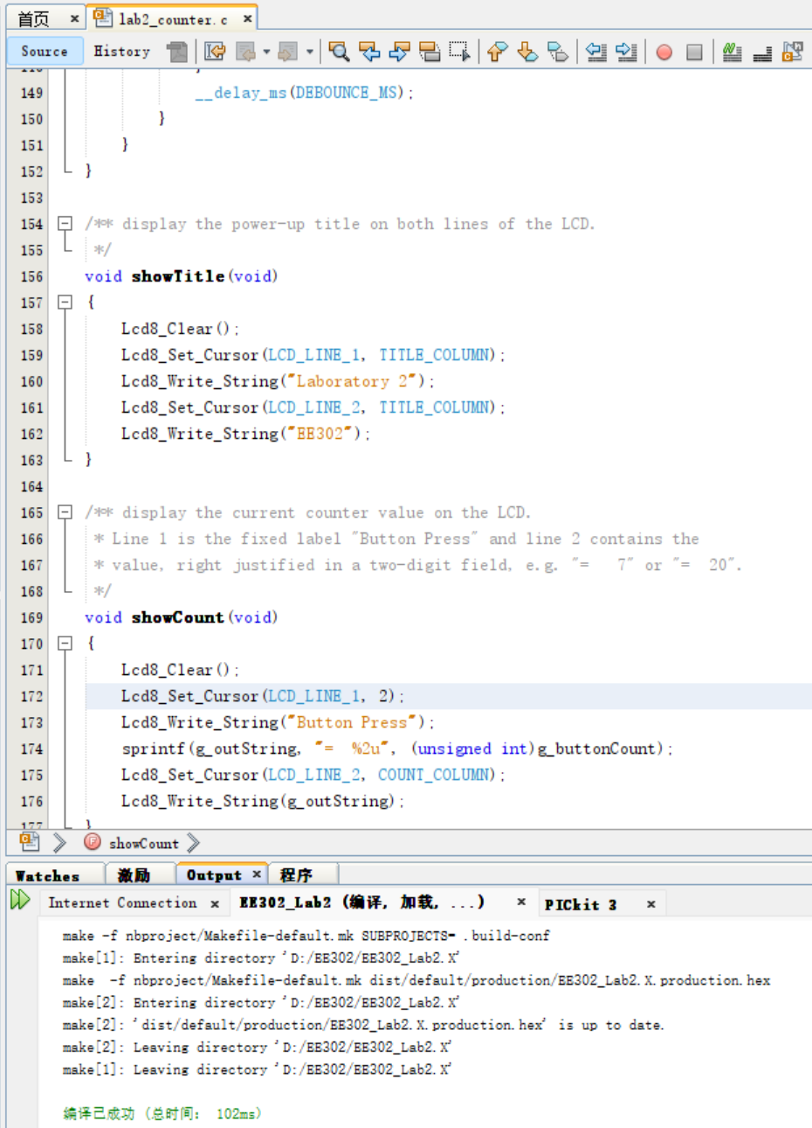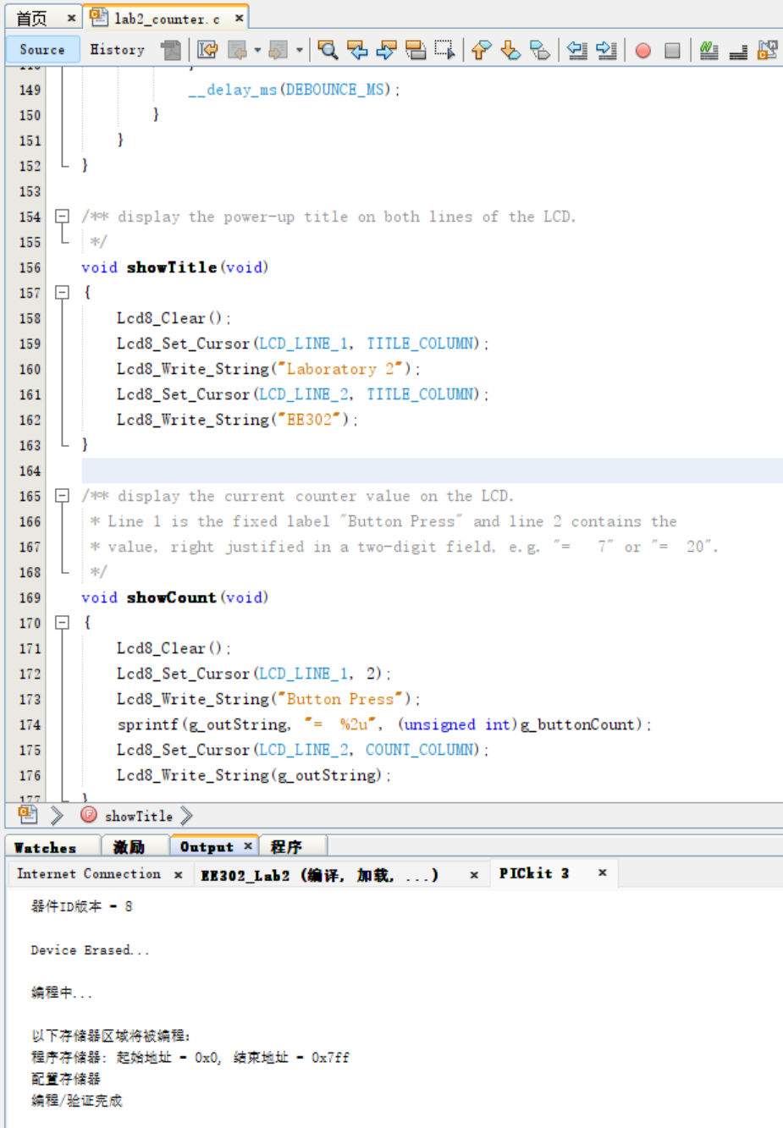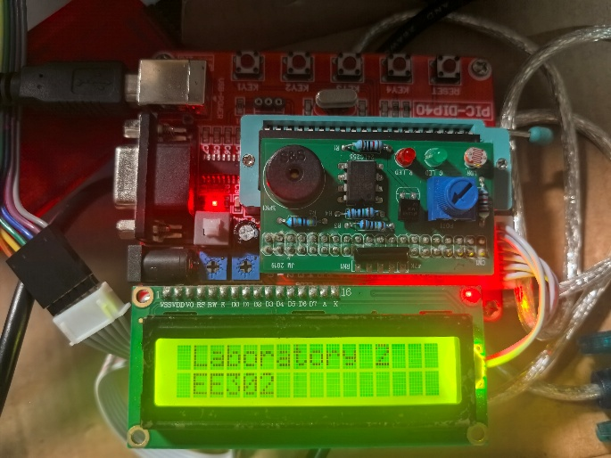
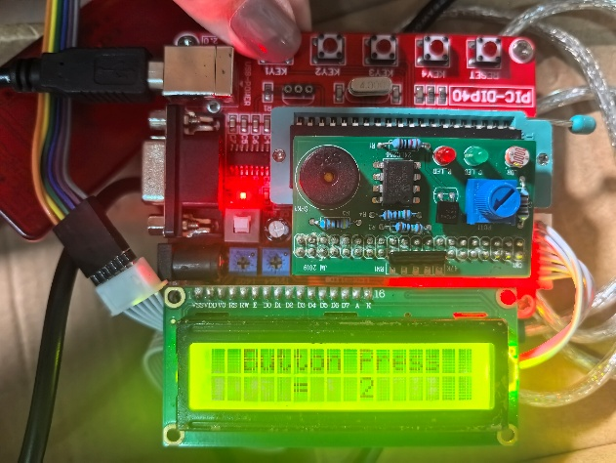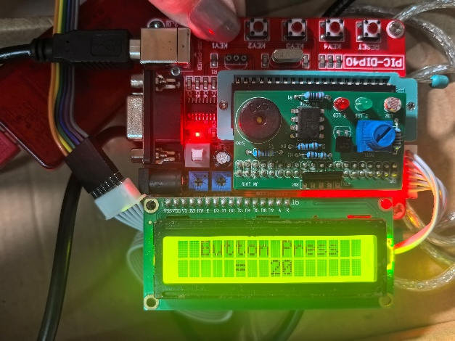

Appendix:
/** EE302 LABORATORY 2 - BUTTON PRESS COUNTER
*
* A 0 to 20 up/down counter for the PIC DIP-40 board. The program
* displays a two-line title at power-up. Pressing Inc increments the
* counter (maximum 20), pressing Dec decrements it (minimum 0), and
* pressing Reset sets it back to 0. Every accepted key press updates
* the LCD. Each key is debounced and only one count is allowed per
* press, even if the key is held down.
*
* Target System: PIC DIP-40 board with PIC16F877A @ 4 MHz,
* 2 x 16 alphanumeric LCD (1602) and three switches.
* Inc = RB0, Dec = RB1, Reset = RB2 (all active low).
* LCD RS/RW/EN = RE0/RE1/RE2, LCD data = RD0-RD7.
*
* Created: 18 October 2026
* Name: Yuen Lin
* Student ID: 832401211/24125491
*/

// CONFIG
#pragma config FOSC = XT // Oscillator Selection bits (XT oscillator)
#pragma config WDTE = OFF // Watchdog Timer Enable bit (WDT disabled)
#pragma config PWRTE = OFF // Power-up Timer Enable bit (PWRT disabled)
#pragma config BOREN = OFF // Brown-out Reset Enable bit (BOR disabled)
#pragma config LVP = OFF // Low-Voltage Programming disabled (RB3 is digital I/O)
#pragma config CPD = OFF // Data EEPROM code protection off
#pragma config WRT = OFF // Flash program memory write protection off
#pragma config CP = OFF // Flash program memory code protection off

// includes ____________________________________________________

#include <xc.h>
#include <stdio.h>
#include "ee302lcd.h"

#ifndef _XTAL_FREQ
// Unless already defined assume 4 MHz system frequency.
// This definition is required to calibrate __delay_us() and __delay_ms().
#define _XTAL_FREQ 4000000
#endif

// constants ___________________________________________________

#define SWITCH_PRESSED 0 // Switches are connected to ground when pressed
#define SWITCH_OPEN 1 // 47 kOhm pull-ups hold the input high when open

#define SW_INC RB0 // Inc switch on PORTB bit 0
#define SW_DEC RB1 // Dec switch on PORTB bit 1
#define SW_RESET RB2 // Reset switch on PORTB bit 2

#define COUNT_MIN 0 // Lowest allowed counter value
#define COUNT_MAX 20 // Highest allowed counter value

#define DEBOUNCE_MS 20 // Key debounce delay in milliseconds

#define LCD_LINE_1 1 // LCD top line
#define LCD_LINE_2 2 // LCD bottom line

#define TITLE_COLUMN 1 // One character margin for the title
#define COUNT_COLUMN 5 // Start column for the centred counter value

// globals _____________________________________________________

unsigned char g_buttonCount = 0; // Current button-press count (0 to 20)
char g_outString[17]; // LCD text buffer: 16 characters + null

// prototypes __________________________________________________

void init(void);
void scanSwitches(void);
void showTitle(void);
void showCount(void);

/** main entry point to the application.
* Initialise the LCD and switches, display the title, then run the
* superloop that scans the three switches.
*/
void main(void)
{
init(); // Initialise LCD and switch inputs
showTitle(); // Display the power-up title on both LCD lines

for (;;) // Superloop
{
scanSwitches();
}
}

/** initialise the application prior to running the superloop.
* Lcd8_Init() configures the LCD and also sets ADCON1 = 0x07 so that
* all analog-capable pins, including RE0/RE1/RE2, are digital I/O.
* PORTB bits 0, 1 and 2 are then configured as inputs.
*/
void init(void)
{
Lcd8_Init(); // Initialise the 1602 LCD in 8-bit mode
TRISB = 0x07; // RB0, RB1 and RB2 are inputs; RB3-RB7 are outputs
}

/** scan the three switches once per superloop iteration.
* A key must be stable for DEBOUNCE_MS before it is accepted. After
* an accepted press the function waits for the key to be released,
* which guarantees one count per press even when the key is held.
*/
void scanSwitches(void)
{
if (SW_INC == SWITCH_PRESSED) // Inc pressed?
{
__delay_ms(DEBOUNCE_MS); // Wait for contact bounce to end
if (SW_INC == SWITCH_PRESSED) // Still pressed: valid press
{
if (g_buttonCount < COUNT_MAX) // Saturate at 20
{
g_buttonCount++;
}
showCount(); // Update the LCD
while (SW_INC == SWITCH_PRESSED) // Wait for key release
{
}
__delay_ms(DEBOUNCE_MS); // Debounce the release
}
}
else if (SW_DEC == SWITCH_PRESSED) // Dec pressed?
{
__delay_ms(DEBOUNCE_MS);
if (SW_DEC == SWITCH_PRESSED)
{
if (g_buttonCount > COUNT_MIN) // Saturate at 0
{
g_buttonCount--;
}
showCount();
while (SW_DEC == SWITCH_PRESSED)
{
}
__delay_ms(DEBOUNCE_MS);
}
}
else if (SW_RESET == SWITCH_PRESSED) // Reset pressed?
{
__delay_ms(DEBOUNCE_MS);
if (SW_RESET == SWITCH_PRESSED)
{
g_buttonCount = 0; // Reset the count
showCount();
while (SW_RESET == SWITCH_PRESSED)
{
}
__delay_ms(DEBOUNCE_MS);
}
}
}

/** display the power-up title on both lines of the LCD.
*/
void showTitle(void)
{
Lcd8_Clear();
Lcd8_Set_Cursor(LCD_LINE_1, TITLE_COLUMN);
Lcd8_Write_String("Laboratory 2");
Lcd8_Set_Cursor(LCD_LINE_2, TITLE_COLUMN);
Lcd8_Write_String("EE302");
}

/** display the current counter value on the LCD.
* Line 1 is the fixed label "Button Press" and line 2 contains the
* value, right justified in a two-digit field, e.g. "= 7" or "= 20".
*/
void showCount(void)
{
Lcd8_Clear();
Lcd8_Set_Cursor(LCD_LINE_1, 2);
Lcd8_Write_String("Button Press");
sprintf(g_outString, "= %2u", (unsigned int)g_buttonCount);
Lcd8_Set_Cursor(LCD_LINE_2, COUNT_COLUMN);
Lcd8_Write_String(g_outString);
}

