My First Date with Quarto
Dr. Kam Tin Seong
2025-09-15
Table of contents

1 Getting Started
Code chunk below perform the following tasks:
- loading knitr, DT, and tidyverse family of r packages onto R environment by using p_load() of pacman package.
- importing Exam_data.csv into R and save it as a tibble data frame by using read_csv() of readr package.
pacman::p_load(tidyverse, knitr, DT)
exam_data <- read_csv("data/Exam_data.csv")

2 Hello Plot
Code chunk below is used to plot a histogram of Maths score by using functions of ggplot2 package.
ggplot(data = exam_data,
aes(x = MATHS)) +
geom_histogram(bins = 10,
boundary = 100,
color = "black",
fill = "pink") +
ggtitle("Distribution of Maths Scores")
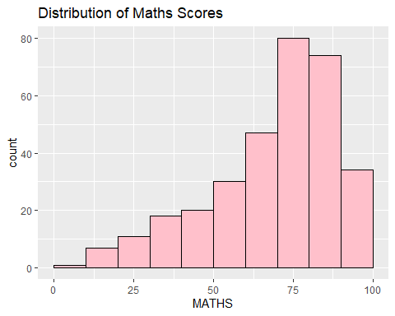

2.1 Dual columns slide
In this sub-sections, columns function of Quarto is used to split the display area into two equal parts.
The code chunk.
ggplot(data = exam_data,
aes(x = MATHS)) +
geom_histogram(bins = 10,
boundary = 100,
color = "black",
fill = "light blue") +
ggtitle("Distribution of Maths Scores")
The plot
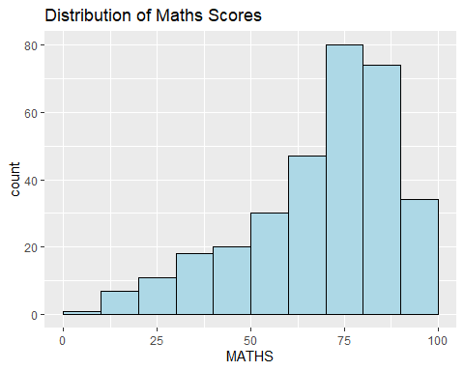

3 Adding Table

3.1 Static html table
This slide shows an example of displaying a professional looking table on Quarto using kable() of knitr package.
ID | CLASS | GENDER | RACE | ENGLISH | MATHS | SCIENCE
Student321 | 3I | Male | Malay | 21 | 9 | 15
Student305 | 3I | Female | Malay | 24 | 22 | 16
Student289 | 3H | Male | Chinese | 26 | 16 | 16
Student227 | 3F | Male | Chinese | 27 | 77 | 31
Student318 | 3I | Male | Malay | 27 | 11 | 25
Student306 | 3I | Female | Malay | 31 | 16 | 16

3.2 Interactive table
This slide shows an example of displaying a professional looking table on Quarto using datatable() of DT package.
datatable(data = exam_data,
options = list(
scrollY = "400px",
scrollX = TRUE,
scrollCollapse = TRUE,
paging = FALSE),
width = "100%")

