**Graduation Project Documentation**

**Project Title: Marketing Campagin**

**Team Members: [Yumna Gamal, Lobna Salah, Yasser Mohamed, ,Shady Amhy, Ibrahim Rafaat , Ahmed Anwar]**

**Track: Power BI**

# Table of Contents

# Executive Summary ____________________________6__

Project Overview _____________________________6

Purpose of the Dashboar___________________________6

Target Audience / Stakeholders_______________________7

Expected Business Impact___________________________8

Business Problem Statement_______________________9

Background & Context_____________________________9

Key Business Challenges___________________________10

# Project Objectives________________________________11

Primary Objectives_________________________________11

Scope of Analysis__________________________________12

Expected Deliverables______________________________14

# Data Source & Preparation_______________________16

List of Data Sources_______________________________16

Data Collection Process____________________________16

Data Cleaning Steps_______________________________17

Data Transformation______________________________17

Data Enrichment_________________________________17

Project Data Flow & Tools Integration__________________18

Operational Database Design (ERD)_________________21

ERD____________________________________________21

Tables & Relationships_____________________________23

ETL Package – Excel to SQL Server OLTP_________________27

Purpose and Scope________________________________________28

Phase 1 – Table Preparation (Initialization Workflow)__29

Phase 2 – Data Loading (ETL from Excel)________________31

Phase 3 – Database Backup________________________________33

Error Handling & Logging__________________________33

Performance Considerations_______________________34

Execution Order & Dependencies__________________________34

Security______________________________________________________34

Maintenance & Monitoring________________________________35

ETL for OLAP (Data Warehouse)_________________________35

High-level architecture & control flow_____________________36

Staging area and strategy___________________________________37

Dimension processing_______________________________________37

Fact table processing________________________________________38

Transformations & cleaning________________________________39

Data Quality, Auditing, Logging & Error Handling________40

Performance tuning & operational considerations________40

Scheduling & orchestration__________________________________40

Testing & validation strategy________________________________41

Common pitfalls & mitigation_______________________________41

Operational documentation & observability_________________42

Data Warehouse Schema Design____________________________42

Overview_________________________________________________________43

Dimension Tables_______________________________________________44

Fact Tables_______________________________________________________47

Schema Justification_____________________________________________48

Primary Keys & Foreign Keys___________________________________49

SQL Server Analysis Services (SSAS) – Multidimensional Analytics & Data Modeling__________________________________49

SSAS Data Source View (DSV) – Overview___________________50

SSAS Cube Browser – Product Sales Analysis_______________51

SSAS Cube Browser – Marketing Campaign Analysis_______55

Product Sales Analysis View__________________________________58

SQL Server Reporting Services (SSRS)_____________________63

SSRS Reporting – Campaign Profit Analysis_________________64

Campaign Performance_______________________________________68

Campaign Target Audience Details __________________________71

Power BI Dashboards______________________________________75

Campaign Insights Dashboard______________________________76

Campaign Performance Dashboard_______________________80

Campaign Performance II Dashboard_____________________86

Ads Dashboard_____________________________________________90

Campaign Performance III Dashboard___________________96

Companies Dashboard____________________________________101

Customers Dashboard____________________________________105

Engagement Dashboard___________________________109

Tableau Dashboards_____________________________________112

Revenues Stats Dashboard________________________________113

Transactions Stats Dashboard_____________________________118

Ad Stats Dashboard_________________________________________122

Conclusion125______________________________________

Summary of Achievements125___________________________

Business Value Delivered126____________________________

Lessons Learned126___________________________________

# Executive Summary

# Project Overview

This project focuses on analyzing marketing campaign performance to transform raw marketing data into actionable business insights. The primary goal is to help the marketing team evaluate the effectiveness of different campaigns, identify high-performing strategies, and detect areas for improvement.

The dataset contains detailed records about multiple marketing campaigns, including customer demographics, campaign channels, engagement metrics, and sales outcomes. By integrating these data points into an interactive Power BI dashboard, the analysis provides a clear view of **campaign reach, conversion rates, return on investment (ROI), and customer behavior trends**.

Through this project, the marketing department can make **data-driven decisions**, optimize future campaigns, and improve customer targeting strategies. The insights generated also assist in allocating marketing budgets more efficiently, enhancing audience engagement, and maximizing revenue impact.

**Purpose of the Dashboard**

The main purpose of this project is to design and implement a **comprehensive business intelligence solution** that empowers the marketing department to make **data-driven decisions** through advanced data integration, modeling, and visualization techniques.

Using a combination of **SQL Server, Data Warehouse architecture, SSIS, SSAS, SSRS, Power BI, and Tableau**, the project aims to:

* **Integrate and consolidate data** from multiple marketing channels into a centralized data warehouse for efficient storage and access.
* **Automate the ETL process** using SSIS to ensure data is cleansed, transformed, and refreshed on a scheduled basis.
* **Build analytical data models** with SSAS to enable fast, multi-dimensional analysis of marketing performance.
* **Deliver interactive dashboards and reports** in Power BI and Tableau, as well as paginated reports via SSRS, to cater to different stakeholder needs.
* **Provide actionable insights** into campaign effectiveness, customer behavior, and return on marketing investment.
* **Support strategic decision-making** by enabling detailed performance comparisons and trend analysis over time.

This integrated BI solution ensures that marketing campaigns are monitored with high accuracy, resources are allocated effectively, and future campaigns are optimized for maximum impact.

**Target Audience / Stakeholders**

The primary audience for this project includes all individuals and departments involved in planning, executing, and evaluating marketing activities within the organization. The marketing management team will use the dashboards and reports to monitor campaign performance, measure return on investment, and refine targeting strategies. Data analysts and business intelligence teams will leverage the centralized data warehouse and analytical models to conduct deeper explorations of customer behavior and campaign trends.

Senior executives and decision-makers will rely on the project’s insights to guide strategic investments in marketing, identify growth opportunities, and allocate budgets more effectively. Additionally, sales teams can use the findings to align their efforts with marketing activities, ensuring consistent messaging and maximizing customer engagement.

The solution is designed to serve both technical users, who require detailed data models and advanced analytics, and non-technical stakeholders, who benefit from intuitive visualizations and easy-to-navigate reports. This ensures that every level of the organization can access the information they need in a format that supports quick and informed decision-making.

**Expected Business Impact**

The implementation of this business intelligence solution is expected to significantly enhance the organization’s ability to evaluate and optimize marketing performance. By consolidating campaign data from multiple sources into a single, well-structured data warehouse, the project will eliminate data silos and improve data accessibility across departments.

Decision-makers will gain immediate access to accurate, up-to-date insights, enabling faster and more informed responses to market changes. Marketing teams will be able to identify the most effective campaigns, refine targeting strategies, and allocate budgets to areas with the highest return on investment.

The analytical capabilities provided by SSAS, combined with the interactive visualizations in Power BI and Tableau, will encourage data-driven decision-making at all organizational levels. This is expected to lead to improved customer engagement, higher conversion rates, and overall revenue growth.

In the long term, the solution will serve as a scalable and adaptable platform that can incorporate additional data sources, support more advanced analytics, and evolve alongside the company’s marketing strategies.

# Business Problem Statement

**Background & Context**

The idea for this project originated from the team’s intention to work on a business-oriented solution that had not been widely implemented before, while still having a broad scope and real-world relevance. After evaluating various domains, the team identified an opportunity to analyze and compare the performance of major players in the electronics industry.

The chosen approach involves conducting a comparative analysis of six leading electronics companies, focusing on three main perspectives: the company itself, its customers, and its marketing campaigns. This multi-dimensional analysis allows for a deeper understanding of how each company engages with its audience, how customers respond to different marketing strategies, and how campaign effectiveness varies across the market.

By incorporating both internal and external data sources, the project aims to deliver a comprehensive view of the competitive landscape. This will not only highlight the strengths and weaknesses of each company’s marketing efforts but also uncover trends, patterns, and best practices that can be applied to optimize future campaigns.

**Key Business Challenges**

One of the initial challenges faced by the team was the lack of familiarity with the business domain. Since the project involved the electronics industry and digital marketing strategies, the team had to invest significant time in understanding sector-specific concepts, campaign metrics, and technical marketing terminology. This learning curve was essential to ensure accurate analysis and meaningful insights.

Another major challenge stemmed from the ambitious scope of the project. By targeting a wide comparative analysis across six major electronics companies, the team required large and diverse datasets. However, not all the necessary data was readily available, leading to data gaps that had to be addressed through estimation, assumptions, or supplemental research.

The existing reporting processes posed their own set of difficulties. Marketing data from different companies and channels was scattered across multiple sources, often stored in inconsistent formats, making it time-consuming to compile and analyze. Reports were generated manually, resulting in delays and a lack of real-time insights. The absence of unified KPIs and standardized definitions made it difficult to compare campaign performance fairly across companies. Additionally, the limited visualization capabilities of existing tools hindered the ability to spot trends and patterns effectively.

Integrating data from multiple sources introduced further complexity. The team had to ensure consistency in formats, units, and definitions across different datasets to maintain analytical accuracy. Moreover, aligning company-specific metrics with common industry benchmarks required careful data transformation and validation.

Finally, balancing technical implementation with analytical depth presented its own difficulty. Building the data warehouse, implementing ETL processes with SSIS, developing SSAS models, and designing visualizations in both Power BI and Tableau had to be coordinated in parallel while ensuring that the business objectives remained at the forefront.

# Project Objectives

**Primary Objectives**

The primary objective of this project is to design and implement an end-to-end Business Intelligence solution for analyzing marketing campaigns in the electronics industry, focusing on six leading companies. The system will integrate multiple data sources, including campaign performance metrics, product information, website analytics, customer profiles, and sales transactions, into a centralized data warehouse.

This solution will leverage **SQL Server**, **SSIS**, **SSAS**, **Power BI**, **Tableau**, and **SSRS** to deliver:

* Consolidated, high-quality data that supports in-depth marketing performance analysis.
* Real-time and historical insights into campaign effectiveness from company, customer, and product perspectives.
* Comparative analysis across multiple companies to identify strengths, weaknesses, and industry best practices.
* Interactive dashboards and standardized reports tailored to decision-makers, marketing teams, and analysts.

The ultimate goal is to empower stakeholders with accurate, timely, and visually rich information that enables data-driven decisions, optimizes marketing strategies, and maximizes return on investment.

**Scope of Analysis**

The scope of analysis for this project is defined to cover multiple perspectives within the marketing campaign ecosystem, ensuring a 360-degree view of performance and impact. The analysis is structured around the following dimensions:

**1. Company Perspective**

* Evaluating company-level performance metrics such as total campaign reach, budget allocation, and return on investment.
* Comparing marketing strategies and results across six leading electronics companies.
* Identifying market positioning and key differentiators among competitors.

**2. Campaign Perspective**

* Measuring campaign effectiveness based on impressions, clicks, conversions, and engagement rate.
* Analyzing campaign objectives, actual budget versus planned budget, and duration.
* Assessing the role of ad content (headline, description, creative) in driving campaign success.

**3. Customer Perspective**

* Profiling customers based on demographics (age, gender, location), interests, and purchasing patterns.
* Tracking customer acquisition channels and mediums to identify high-performing sources.
* Measuring customer lifetime value and retention rates.

**4. Product Perspective**

* Evaluating product performance across different campaigns, including sales volume, stock availability, and pricing strategies.
* Understanding the impact of campaign promotions on product demand.

**5. Website & Digital Interaction Perspective**

* Analyzing website traffic, sessions, and event tracking (device type, session duration, event value).
* Linking website engagement metrics to campaign performance.

The scope explicitly excludes non-marketing operational data such as supply chain logistics or internal HR performance metrics, focusing exclusively on data relevant to marketing campaign performance, customer engagement, and competitive benchmarking.

**Expected Deliverables**

By the end of the project, the following outputs are expected to be delivered:

**1. Centralized Data Warehouse**

* Fully designed and implemented star-schema data warehouse integrating data from all relevant sources (campaign performance, product data, customer profiles, website analytics, and acquisition channels).
* Historical and current data storage to enable both trend analysis and real-time insights.

**2. Automated ETL Processes (SSIS)**

* **Phase 1: Source-to-Database ETL**
  + Extraction of raw marketing data from multiple Excel sheets and other flat-file sources.
  + Transformation to align formats, standardize fields, and clean inconsistencies.
  + Loading the processed data into the staging database for initial storage.
* **Phase 2: Database-to-Data Warehouse ETL**
  + Extraction of structured data from the staging database (OLTP/OLAP source).
  + Advanced transformations to fit the star-schema design, including dimension and fact table population.
  + Loading data into the centralized data warehouse for analytical processing.
* Both ETL workflows are fully automated, scheduled, and include data validation checks to ensure accuracy and reliability.

**3. Analytical Data Models (SSAS)**

* Development of OLAP cubes to support multidimensional analysis (by time, company, campaign, product, customer segment, etc.).
* Implementation of KPIs and calculated measures for consistent performance tracking.

**4. Paginated Reports (SSRS)**

* Standardized, exportable operational reports summarizing campaign results, customer behavior, and product sales performance.
* Automated report scheduling and distribution to relevant stakeholders.
* Parameterized reports enabling users to filter by company, campaign, product, or time period.

**5. Interactive Dashboards**

* **Power BI** and **Tableau** dashboards tailored to different stakeholders (executives, marketing managers, analysts).
* Comparative views across six companies with drill-down capabilities to campaign, product, and customer levels.
* Visualization of key marketing metrics such as conversion rates, ROI, and customer acquisition cost.
* Dynamic filters and slicers to support ad-hoc analysis.

**6. Documentation & User Guide**

* Comprehensive project documentation including ERD diagrams, star-schema diagrams, ETL workflows, and calculation logic.
* User guide for interacting with dashboards and paginated reports.
* Technical guide for maintaining, updating, and scaling the BI solution.

# Data Source & Preparation

**List of Data Sources**

* **Excel Sheets** containing dummy marketing campaign data, product catalogs, customer profiles, and website analytics.
* **Staging Database (OLTP)** used as an intermediate storage for structured dummy data after initial cleaning.
* **Data Warehouse** storing integrated dummy data for analysis across campaigns, companies, customers, and products.

**Data Collection Process**

* Dummy datasets were manually generated and enriched to simulate real-world marketing data patterns.
* Data was structured to cover multiple business perspectives: company, campaign, customer, product, and website interaction.
* Excel sheets were loaded into the staging database using SSIS Phase 1 ETL processes.

**Data Cleaning Steps**

* Removal of duplicate entries in customer and campaign data.
* Standardization of date formats and numeric fields (budgets, sales, impressions).
* Correction of inconsistent company and product naming conventions.

**Data Transformation**

* Mapping of raw Excel data to staging database tables.
* Aggregation of campaign metrics (e.g., total impressions, total clicks).
* Splitting of combined fields (e.g., full name into first and last names).

**Data Enrichment**

* Null values replaced with placeholders or estimated values for non-critical fields.
* Outlier detection in budget and sales figures to ensure realistic dummy patterns.

**Project Data Flow & Tools Integration**

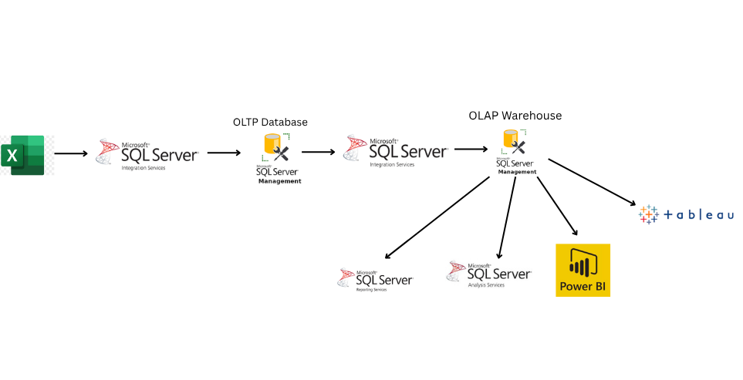

The project followed a structured, multi-stage data lifecycle to ensure that the information was efficiently collected, cleansed, stored, analyzed, and visualized using industry-standard tools.

The process began with **raw data collection** from multiple Excel sheets, which served as our initial data source. These sheets contained marketing campaign information, customer profiles, product details, and performance metrics. While Excel provided flexibility in data entry and sharing, it lacked the scalability and relational capabilities required for deeper analysis.

To address this, we utilized **SQL Server Integration Services (SSIS)** for the **first ETL process** (Extract, Transform, Load), migrating the Excel data into a **SQL Server OLTP database**. This stage established our **operational database**, ensuring structured storage, defined relationships, and integrity constraints.

Once the OLTP database was in place, we performed a **second ETL process** using SSIS, transferring the cleaned and structured data into a **SQL Server Data Warehouse (OLAP)**. This transformation into a star-schema model allowed for optimized querying, historical data storage, and analytical flexibility.

The **Data Warehouse** served as the central hub for analytics. We integrated it with **SQL Server Analysis Services (SSAS)** to create analytical models, calculated measures, and hierarchies, enabling multidimensional analysis. Parallel to this, the warehouse was also connected to **SQL Server Reporting Services (SSRS)** for generating **paginated reports**, which offered detailed, printable insights for business stakeholders.

For advanced and interactive visualizations, we connected both SSAS and the Data Warehouse directly to **Power BI** and **Tableau**.

* **Power BI** was used to create dynamic dashboards, drill-through reports, and KPI monitoring.
* **Tableau** provided visually compelling, comparative dashboards that offered alternative perspectives on the same data.

This integrated toolchain not only streamlined the data journey from raw input to insightful analytics but also ensured that every stage—data collection, transformation, storage, and visualization—was handled with precision and best practices. The approach allowed the team to handle complex marketing campaign analysis, compare performance across multiple companies, and deliver actionable insights to decision-makers.

**Operational Database Design (ERD)**

**ERD**

The Entity Relationship Diagram (ERD) represents the logical structure of the operational database (OLTP) used in the Marketing Campaign Analysis project.  
It shows all entities, their attributes, and the relationships between them, ensuring efficient storage and retrieval of transactional and reference data.

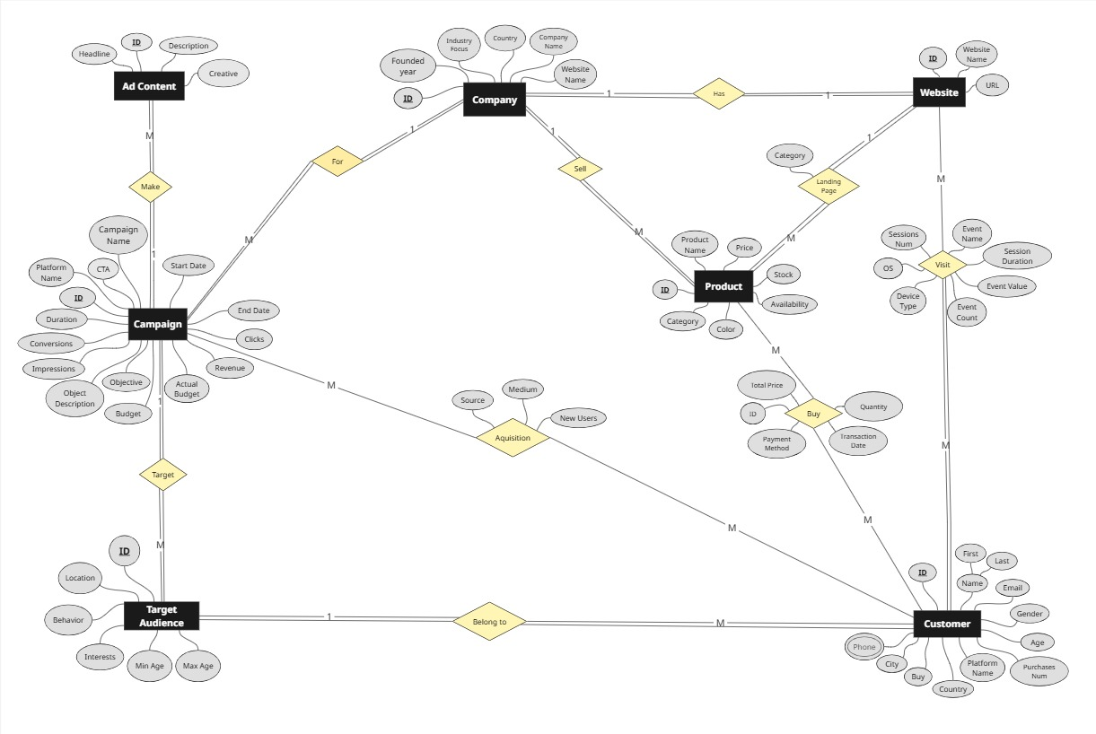

**Entities Description :**

1. **Company**  
   Represents the six major electronics companies included in the analysis.  
   Attributes: Company_ID (PK), Company_Name, Country, Website_Name, URL, Industry_Focus, Founded_Year.
2. **Campaign**  
   Represents marketing campaigns launched by each company.  
   Attributes: Campaign_ID (PK), Company_ID (FK), Campaign_Name, Impressions, Clicks, Budget, Actual_Budget, Objective, Objective_Description, Revenue, Start_Date, End_Date, Duration, CTA, Platform_Name.
3. **Ad Content**  
   Contains the creative materials used in each campaign.  
   Attributes: Campaign_ID (FK), Creative, Headline, Description.
4. **Target Audience**Represents the intended audience segments for each campaign.  
   Attributes: Target_Audience_ID (PK), Campaign_ID (FK), Interests, Behavior, Location, Min_Age, Max_Age.
5. **Product**  
   Represents the products promoted and sold during campaigns.  
   Attributes: Product_ID (PK), Company_ID (FK), Product_Name, Color, Category, Price, Stock, Availability, Landing_Page.
6. **Customer**Represents customers who purchased products or interacted with campaigns.  
   Attributes: Customer_ID (PK), Target_Audience_ID (FK), First_Name, Last_Name, Gender, Age, City, Country, Email, Purchase_Flag.
7. **Customer Phone**  
   Stores customer phone contact details.  
   Attributes: Customer_ID (PK, FK), Phone_1, Phone_2.
8. **Transaction**Represents purchase transactions made by customers.  
   Attributes: Transaction_ID (PK), Customer_ID (FK), Product_ID (FK), Total_Price, Payment_Method, Quantity, Transaction_Date.
9. **Engagement**Tracks customer engagement on digital platforms.  
   Attributes: Company_ID (FK), Customer_ID (FK), Device_Type, OS, Event_Name, Event_Value, Event_Count, Session_Duration, Session_Number.
10. **Acquisition**  
    Represents how the customer was acquired.  
    Attributes: Campaign_ID (FK), Customer_ID (FK), Source, Medium, New_Users.

**Tables & Relationships**

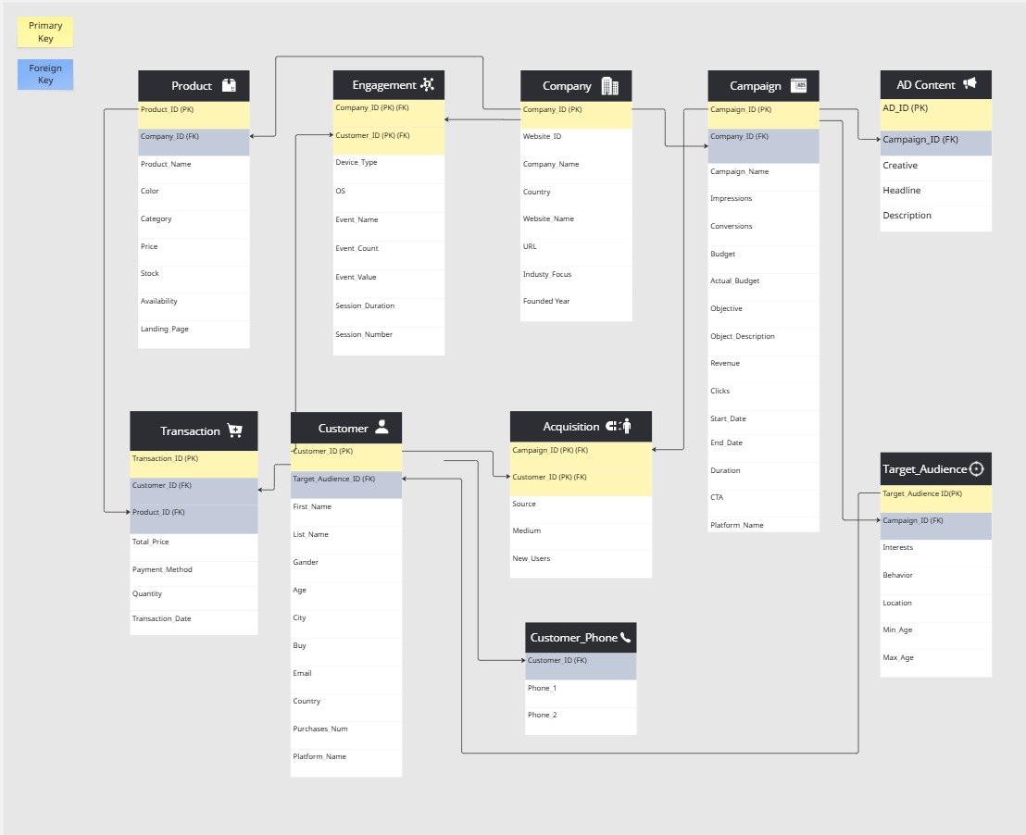

The database contains several key tables:

1. **Company** – Stores information about each electronics company under analysis, including name, country, website, and industry details.
2. **Campaign** – Contains campaign metadata such as impressions, clicks, budget, objectives, start and end dates, and platform name.
3. **Ad Content** – Includes creative assets, headlines, and descriptions used in each campaign.
4. **Target Audience** – Holds demographic and behavioral targeting information (age range, location, interests).
5. **Product** – Details product attributes such as model name, category, price, availability, and landing page.
6. **Customer** – Stores customer profile data, including contact details, demographics, and purchase history.
7. **Customer Phone** – Maintains multiple contact numbers for each customer.
8. **Transaction** – Logs sales transactions, including product purchased, quantity, payment method, and transaction date.
9. **Engagement** – Tracks customer interactions on digital platforms, including device type, session details, and event values.
10. **Acquisition** – Captures the acquisition source, medium, and whether the customer is new.

Relationships:

* One **Company** can run multiple **Campaigns**.
* Each **Campaign** can have one or more **Ad Contents** and target multiple **Target Audiences**.
* **Customers** can make multiple **Transactions** for **Products** from various **Campaigns**.
* **Engagement** links customer interactions to companies.
* **Acquisition** connects campaigns to customers via marketing channels.

Primary Keys :

Primary Keys uniquely identify each record in a table:

* **Company** → Company_ID
* **Campaign** → Campaign_ID
* **Ad Content** → *(Composite Key)* Campaign_ID
* **Target Audience** → Target_Audience_ID
* **Product** → Product_ID
* **Customer** → Customer_ID
* **Customer Phone** → Customer_ID *(also FK)*
* **Transaction** → Transaction_ID
* **Engagement** → *(Composite Key)* Company_ID, Customer_ID
* **Acquisition** → *(Composite Key)* Campaign_ID, Customer_ID

Foreign Keys:

Foreign Keys establish relationships between tables:

* **Campaign** → Company_ID references **Company**
* **Ad Content** → Campaign_ID references **Campaign**
* **Target Audience** → Campaign_ID references **Campaign**
* **Customer** → Target_Audience_ID references **Target Audience**
* **Customer Phone** → Customer_ID references **Customer**
* **Transaction** → Customer_ID references **Customer**  
  Product_ID references **Product**
* **Product** → Company_ID references **Company**
* **Engagement** → Company_ID references **Company**  
  Customer_ID references **Customer**
* **Acquisition** → Campaign_ID references **Campaign**  
  Customer_ID references **Customer**

Measures & Calculated Columns Overview:

Although most measures and calculated columns are typically created in the analytical layer (e.g., Power BI, SSAS), defining them conceptually during the database design phase ensures alignment between the operational system and the reporting layer.

**Example Measures**

* **Total Revenue** = SUM of Total_Price from **Transaction**
* **Total Quantity Sold** = SUM of Quantity from **Transaction**
* **Total Clicks** = SUM of Clicks from **Campaign**
* **Conversion Rate** = (Number of Purchases ÷ Number of Clicks) × 100
* **Average Order Value (AOV)** = Total Revenue ÷ Number of Orders
* **Customer Lifetime Value (CLV)** = Average Order Value × Purchase Frequency × Customer Lifespan

**ETL Package – Excel to SQL Server OLTP**

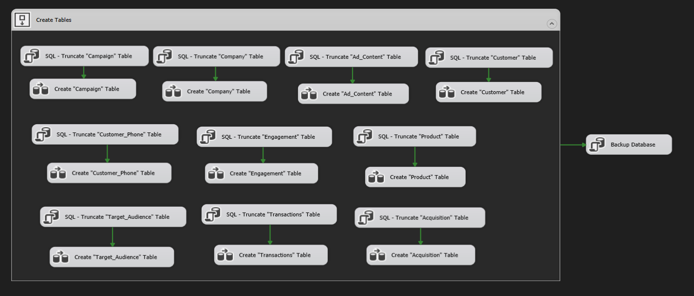

This SSIS package automates the end-to-end process of preparing, loading, and backing up OLTP tables in SQL Server from Excel source files.  
The workflow is split into three main phases:

1. **Table Preparation** – Clean and create all target tables.
2. **Data Loading** – Extract, transform, and load (ETL) data from Excel sheets into the target tables.
3. **Database Backup** – Perform a full backup after successful load.

**1. Purpose and Scope**

**Purpose**

* Standardize the loading of Excel data into SQL Server OLTP.
* Ensure data integrity and readiness for downstream usage.

**Scope**

* Tables covered:  
  Campaign, Company, Ad_Content, Customer, Customer_Phone, Engagement, Product, Target_Audience, Transactions, Acquisition.
* Handles both table creation and full data refresh.
* Includes type conversions, basic data validation, and error handling.

**2.** **Phase 1 – Table Preparation (Initialization Workflow)**

**2.1 Execution Logic**

Each table undergoes the following two steps:

1. **Truncate Table** – Remove existing data while retaining the structure.
2. **Create Table** – Create the table if not present or ensure schema compliance.

**2.2 Detailed Steps per Table**

*(same pattern applied to each table)*

* **Campaign**
  + SQL - Truncate Campaign table.
  + Create Campaign table schema.
* **Company**
  + SQL - Truncate Company table.
  + Create Company table schema.
* **Ad_Content**
  + SQL - Truncate Ad_Content table.
  + Create Ad_Content table schema.
* **Customer**
  + SQL - Truncate Customer table.
  + Create Customer table schema.
* **Customer_Phone**
  + SQL - Truncate Customer_Phone table.
  + Create Customer_Phone table schema.
* **Engagement**
  + SQL - Truncate Engagement table.
  + Create Engagement table schema.
* **Product**
  + SQL - Truncate Product table.
  + Create Product table schema.
* **Target_Audience**
  + SQL - Truncate Target_Audience table.
  + Create Target_Audience table schema.
* **Transactions**
  + SQL - Truncate Transactions table.
  + Create Transactions table schema.
* **Acquisition**
  + SQL - Truncate Acquisition table.
  + Create Acquisition table schema.

**3. Phase 2 – Data Loading (ETL from Excel)**

**3.1 General Process**

For each table:

1. **Excel Source** – Read from the corresponding sheet.
2. **Data Conversion** – Convert data types from Excel to SQL Server-compatible types.
3. **Derived Column Transformations** – Clean/format text, replace nulls, standardize date formats.
4. **Lookups** *(if required)* – Resolve foreign keys or translate business values into IDs.
5. **Conditional Split** *(optional)* – Separate valid and invalid rows.
6. **OLE DB Destination** – Insert valid rows into the target table using **Fast Load**.
7. **Error Output Handling** – Save invalid rows to an error log file or error table for review.

**3.2 Example: Loading the Customer Table**

1. **Source** – Read data from the “Customer” sheet in Excel.
2. **Transformations**:
   * Trim First_Name and Last_Name.
   * Standardize Gender values (e.g., M/F only).
   * Validate Age range.
   * Map Country text to CountryID using Lookup.
3. **Destination** – Insert into dbo.Customer using bulk load.

**3.3 Example: Loading the Transactions Table**

1. **Source** – Read data from the “Transactions” sheet.
2. **Transformations**:
   * Convert Transaction_Date to DATETIME.
   * Ensure Total_Price >= 0.
   * Map Customer_ID and Product_ID via Lookup from dimension tables.
3. **Destination** – Load into dbo.Transactions.

**3.4 Data Validation Rules**

* **Primary Keys**: Must be present (e.g., Customer_ID not null).
* **Dates**: Must be valid and within acceptable ranges.
* **Numeric Fields**: No negative quantities or prices.
* **Field Lengths**: Must not exceed defined schema.
* **Format Checks**: e.g., Phone numbers follow specified pattern.
* **Invalid Records**: Redirected to error log.

**4. Phase 3 – Database Backup**

**4.1 Execution**

* Runs after all tables are loaded successfully.
* Executes a BACKUP DATABASE T-SQL command.
* Backup stored in a predefined secure location with a timestamp.

**5. Error Handling & Logging**

* **Error Outputs**: Redirected from Data Flow to error CSV or error table.
* **Event Handlers**: OnError and OnTaskFailed log details and optionally send notifications.
* **Audit Table**: Records execution start/end times, rows processed, and status.

**6. Performance Considerations**

* Use Fast Load in OLE DB Destination with batch commits.
* Apply table lock during bulk insert.
* Disable/rebuild indexes for large loads.
* Optimize SSIS buffer sizes for large datasets.

**7. Execution Order & Dependencies**

* The initialization phase must complete before any data loading begins.
* Database backup is executed only if all prior tasks succeed.
* If any table creation or load fails, execution stops before backup.

**8. Security**

* Runs under a service account with least privilege.
* Connection strings stored securely with SSIS ProtectionLevel settings.
* Backup files stored in restricted access folders.

**9. Maintenance & Monitoring**

* Logs retained for auditing.
* Scheduled clean-up of error logs and old backups.
* Monitoring dashboards (Power BI/SSRS) to review load history.

**ETL for OLAP (Data Warehouse)**

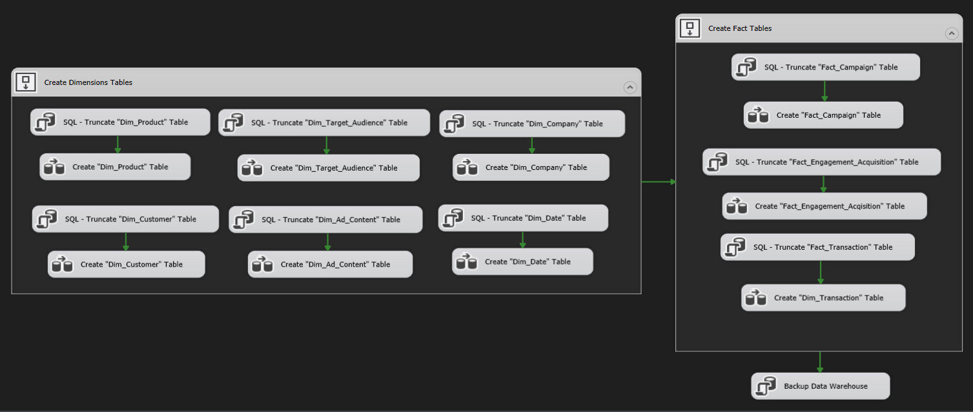

The ETL (Extract-Transform-Load) process for the Data Warehouse is the heart of the BI solution. Its purpose is to reliably move clean, conformed, and high-quality marketing data from the operational sources into a star-schema OLAP store optimized for analysis. For our project the ETL does three major things: (1) extract raw records from staging/OLTP, (2) apply deterministic and business transformations, lookups and surrogate key mapping, (3) load dimension and fact tables in the data warehouse in a controlled, auditable way.

**1. High-level architecture & control flow**

The SSIS project is structured into two main phases as seen in the diagram:

1. Create Dimension Tables – processing and loading all dimension entities before fact tables to ensure surrogate keys are available.
2. Create Fact Tables – populating transactional/analytical fact tables that reference the dimension tables.  
   Finally, a Backup Data Warehouse task ensures the data is safeguarded post-load.

The green arrows represent execution dependencies, ensuring each step only runs after its predecessors succeed.

**2. Staging area and strategy**

Before hitting these tasks, data flows from the staging area into the data warehouse. Although the diagram starts at table creation, behind the scenes, SSIS has already:

* Extracted data from OLTP sources (Excel & SQL Server)
* Loaded it into staging tables
* Applied data quality checks  
  This separation ensures DW loads are isolated from source volatility and allows re-runs if needed.

**3.** **Dimension processing**

Block: Create Dimensions Tables in the diagram corresponds to sequential handling of each dimension:

* Dim_Product:
  1. Truncate existing rows (SQL - Truncate)
  2. Re-create / reload with fresh data (Create task)
* Dim_Target_Audience: same pattern as above.
* Dim_Company: same pattern as above.
* Dim_Customer: same pattern as above.
* Dim_Ad_Content: same pattern as above.
* Dim_Date: generated date dimension table, truncated then rebuilt (often pre-populated for a date range).

ETL logic inside each "Create" task includes:

* Business key lookups to detect new vs existing members
* Surrogate key generation
* Handling of unknown members
* Attribute cleaning (string trimming, type conversions)

**4. Fact table processing**

Block: Create Fact Tables in the diagram processes three core facts:

* Fact_Campaign: contains campaign-level metrics linked to company, product, audience, etc.
* Fact_Engagement_Acquisition: captures engagement KPIs (clicks, impressions, signups).
* Fact_Transaction: transactional facts for revenue/sales data.

Each fact load:

1. Truncates the existing table to allow a clean reload (in dev/dummy data scenario).
2. Rebuilds the table by joining staged fact data to dimension surrogate keys.
3. Applies data type casting and derived column calculations (e.g., revenue = qty × price).

**5.** **Transformations & cleaning**

Although not visible in the control flow, each “Create” data flow includes:

* Removing nulls in required keys
* Standardizing date formats
* Mapping natural keys → surrogate keys
* Assigning Unknown SK where lookup fails

**6. Data Quality, Auditing, Logging & Error Handling**

The truncate-and-load pattern is paired with row count checks before and after inserts. Any failed lookup or null key is logged in error tables, with the possibility to investigate and reprocess.

**7. Performance tuning & operational considerations**

Tasks are ordered to minimize dependency conflicts—dimensions load in parallel where possible within their block, but facts are strictly dependent on all dimensions being loaded. Bulk inserts and truncated loads mean execution is fast for dummy data, but scalable to large datasets.

**8. Scheduling & orchestration**

In production, these packages would be scheduled via SQL Agent. The SSIS package order in the diagram is exactly how SQL Agent steps would be configured.

**9. Testing & validation strategy**

For this dummy data project, testing ensures that after each fact load:

* Row counts match staging
* No foreign key mismatches exist
* Calculated measures are accurate

**10. Common pitfalls & mitigation**

* Forgetting to load a dimension before a fact → handled by explicit control flow arrows.
* Bad data in dimensions causing FK errors → mitigated by Unknown SK rows.

**11. Operational documentation & observability**

This diagram itself is part of documentation—each block’s name reflects its purpose. In a full production doc, screenshots of data flow details per block would be added, along with row count logs and error samples.

**Data Warehouse Schema Design**

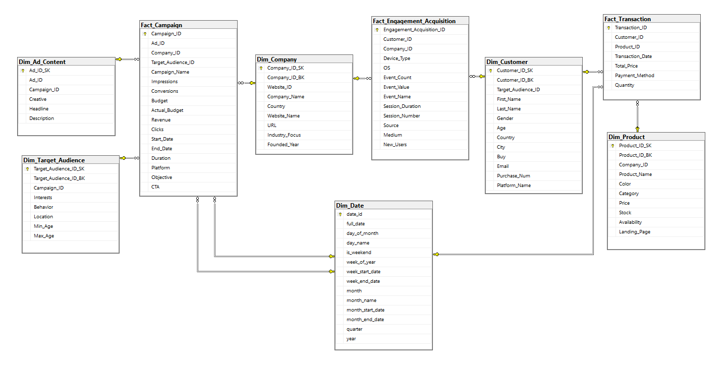

**Overview**

The Data Warehouse for the Marketing Campaign Analysis project was designed using the **Star Schema** approach.  
This design offers a **central fact table** connected to multiple **dimension tables**, creating a simple, efficient structure for analytical queries.

The purpose of the star schema here is to:

* Provide **fast query performance** when analyzing millions of records.
* Support **business-friendly navigation** in BI tools without requiring deep SQL knowledge.
* Allow the separation of **measurable data** (facts) from **contextual attributes** (dimensions), making the reporting layer flexible and easy to maintain.
* Integrate seamlessly with **SSAS cubes**, **SSRS reports**, and visualization tools like **Power BI** and **Tableau**.

In our project:

* The **Fact Tables** hold core business metrics such as transactions, campaign results, and engagement statistics.
* The **Dimension Tables** describe these facts — for example, product details, customer demographics, campaign targets, and dates.

By keeping dimensions **denormalized** and facts **highly granular**, we ensure that the warehouse can scale for future business needs, such as adding new KPIs or integrating additional marketing channels.

**2. Dimension Tables**

Dimension tables are the descriptive backbone of our warehouse. They enrich the facts with attributes that users can filter, group, and slice data by.

**2.1 Dim_Product**

* **Purpose**: Acts as the catalog for all products sold by the companies in the dataset.
* **Attributes**: Product name, color, category, price, available stock, product availability status, and associated landing page URL.
* **Business Value**: Enables campaign performance analysis per product type, category, or price range.
* **Relationships**: Connected to Fact_Transaction through Product_ID.

**2.2 Dim_Customer**

* **Purpose**: Represents the customer base and their demographic/behavioral characteristics.
* **Attributes**: First and last names, gender, age, country, city, email address, number of past purchases, and preferred platform.
* **Business Value**: Supports segmentation, helping marketers tailor campaigns to specific customer profiles.
* **Relationships**: Linked to both Fact_Transaction and Fact_Engagement_Acquisition using Customer_ID.

**2.3 Dim_Company**

* **Purpose**: Stores details about each participating company in the marketing analysis.
* **Attributes**: Company name, website ID, country of operation, industry focus, and year founded.
* **Business Value**: Allows for comparison of campaign performance across different companies and industries.
* **Relationships**: Connected to Fact_Campaign and Fact_Engagement_Acquisition through Company_ID.

**2.4 Dim_Target_Audience**

* **Purpose**: Describes the intended audience for each marketing campaign.
* **Attributes**: Interests, behavioral patterns, location, minimum and maximum age range.
* **Business Value**: Enables analysis of which audience segments yield the highest engagement and ROI.
* **Relationships**: Linked to Fact_Campaign via Target_Audience_ID.

**2.5 Dim_Ad_Content**

* **Purpose**: Contains metadata about the ad creatives used in campaigns.
* **Attributes**: Creative content type, headline text, and ad description.
* **Business Value**: Assists in determining which creative elements drive better engagement and conversion rates.
* **Relationships**: Connected to Fact_Campaign via Ad_Content_ID.

**2.6 Dim_Date**

* **Purpose**: Acts as a universal time reference for all facts.
* **Attributes**: Full date, day of the month, week of the year, month name, quarter, year, and weekend/weekday flag.
* **Business Value**: Enables time-series analysis, seasonal trend detection, and comparison between different time periods.
* **Relationships**: Linked to all fact tables via Date_ID.

1. **Fact Tables**

Fact tables contain the core metrics of our business processes. They store **numerical, additive data** that can be aggregated for reporting.

**3.1 Fact_Campaign**

* **Purpose**: Holds the performance outcomes of each campaign.
* **Metrics**: Impressions, clicks, conversions, revenue generated, budget allocation, actual spending, and campaign duration.
* **Business Value**: Measures campaign success and ROI, allowing for optimization of future marketing efforts.
* **Linked Dimensions**: Dim_Company, Dim_Ad_Content, Dim_Target_Audience, Dim_Date.

**3.2 Fact_Engagement_Acquisition**

* **Purpose**: Captures how customers engage with and respond to campaigns.
* **Metrics**: Event count, event value, session duration, session number, and new user count.
* **Business Value**: Helps understand user behavior patterns and the effectiveness of marketing touchpoints.
* **Linked Dimensions**: Dim_Customer, Dim_Company, Dim_Date.

**3.3 Fact_Transaction**

* **Purpose**: Stores detailed sales transaction records.
* **Metrics**: Total transaction value, payment method, and quantity purchased.
* **Business Value**: Provides insight into actual sales generated by campaigns and product performance.
* **Linked Dimensions**: Dim_Customer, Dim_Product, Dim_Date.

**4. Schema Justification**

The **Galaxy Schema** was selected for the following reasons:

1. **Performance** – Queries require fewer joins compared to normalized schemas, which is crucial for large datasets.
2. **Simplicity** – Business users can easily understand and navigate the model without needing database expertise.
3. **Scalability** – New dimensions or measures can be added with minimal impact to the existing structure.
4. **Compatibility** – Works efficiently with OLAP cubes, SSAS tabular models, and popular BI visualization tools.

**5. Primary Keys & Foreign Keys**

* **Primary Keys (PK)**: Ensure each record in a table is unique (e.g., Product_ID in Dim_Product).
* **Foreign Keys (FK)**: Establish relationships between facts and dimensions (e.g., Product_ID in Fact_Transaction references Dim_Product).
* This design enforces **referential integrity** and ensures consistent joins during queries.

**SQL Server Analysis Services (SSAS) – Multidimensional Analytics & Data Modeling**

**SSAS Data Source View (DSV) – Overview**

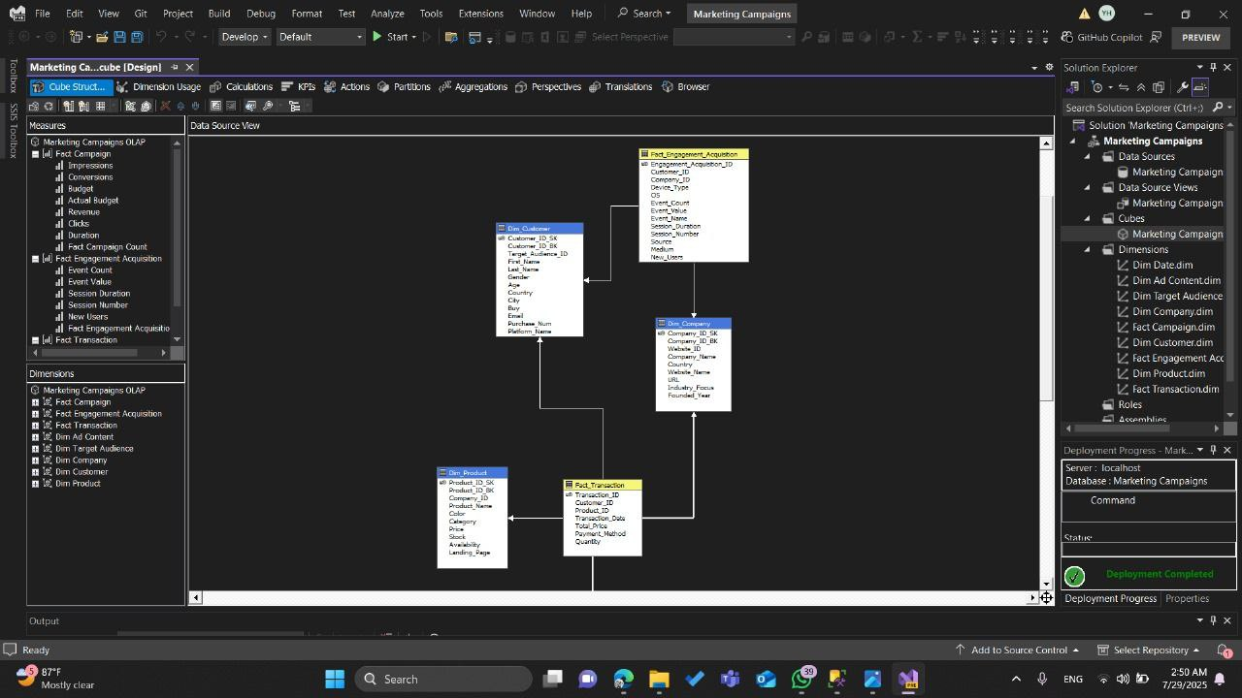

The **Data Source View** (DSV) in SQL Server Analysis Services is essentially the blueprint of the cube’s data model. It visually maps out the structure of the database tables and how they are related to each other. Think of it as the “bridge” between the raw database and the analytical cube — it doesn’t store data itself, but it defines the logical relationships that SSAS will use to process and analyze information.

In this project, the DSV is designed using a **star schema** layout. In this type of schema, the central tables (called fact tables) capture measurable business events, while the surrounding tables (called dimension tables) describe the context of those events. The result is a clean, highly efficient structure optimized for analytical queries.

Looking at the diagram, you can see that:

* There is a **central network** of relationships that flows from the middle tables outward to the surrounding ones.
* Each line connecting two tables represents a **relationship** — typically a foreign key from one table pointing to the primary key in another.
* The structure is compact, ensuring that all analysis can be done by joining the facts with the relevant descriptive data from dimensions.

This model provides a flexible analytical framework where the business can slice and dice the data in countless ways. Whether you want to track marketing performance, customer engagement, product sales, or company activity, the DSV ensures that all the necessary data points are connected and ready for multidimensional analysis.

**SSAS Cube Browser – Product Sales Analysis**

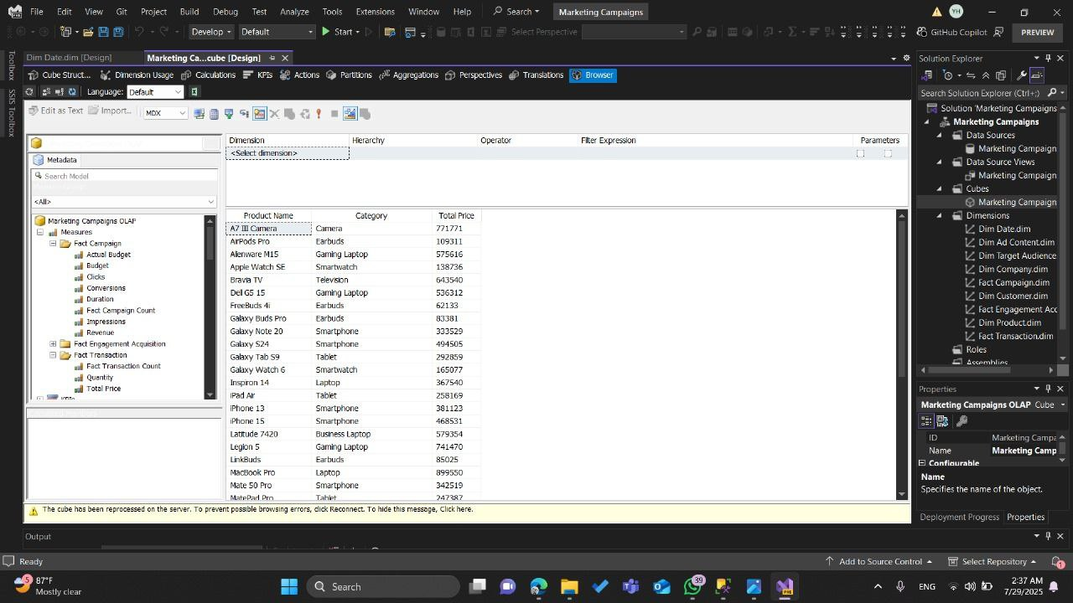

This screenshot illustrates the Browsing phase in SQL Server Analysis Services (SSAS) after successfully designing and processing the cube.  
At this point, the cube has been built using fact tables, dimension tables, relationships, and calculated measures.  
The browsing interface allows us to run interactive queries against the cube to validate its functionality and business logic before delivering it to end users.

**1. Left Panel – Measures & Dimensions**

* **Measures Section:**  
  Contains the quantitative data extracted from the fact tables. In this cube, measures include:
  + *Actual Budget, Budget, Revenue, Clicks, Conversions, Impressions, Quantity, Total Price,* etc.  
    These measures are aggregated automatically based on the chosen dimensions.
* **Dimensions Section:**  
  Lists all the descriptive structures for slicing and dicing the data. Examples include:
  + **Dim Product** – holds product name, category, and company association.
  + **Dim Company** – includes company name, website, and industry focus.
  + **Dim Date** – enables time-based analysis like monthly or quarterly trends.
  + **Dim Customer** – contains customer demographics.

**2. Central Panel – Query Results Grid**

* Displays the output of the query built using the cube browser.
* In the example shown:
  + **Product Name** and **Category** are the analysis axes (rows).
  + **Total Price** is the chosen measure to show the aggregated sales amount for each product.
* This grid supports sorting, filtering, and expansion to more granular levels.

**3. Role in the Project Lifecycle**

This browsing step is a **quality assurance checkpoint** within the OLAP development process:

1. **Post-Processing Validation** – Confirms the cube is processing correctly and relationships between facts and dimensions are functioning.
2. **Business Logic Testing** – Ensures measures like *Total Price* are summing correctly, budgets align with campaigns, and transactions match operational data.
3. **Performance Evaluation** – Checks whether aggregations and queries return results quickly, which is critical for end-user reporting.

**4. Business Value**

* Allows **business analysts** to explore data interactively without direct database queries.
* Supports:
  + **Drill-down** (e.g., from product category → specific product → sales per month).
  + **Roll-up** (e.g., aggregating sales from product → category → company total).
* Acts as the backbone for reporting tools like **SSRS, Power BI, and Tableau** by providing pre-aggregated, high-performance datasets.

**SSAS Cube Browser – Marketing Campaign Analysis**

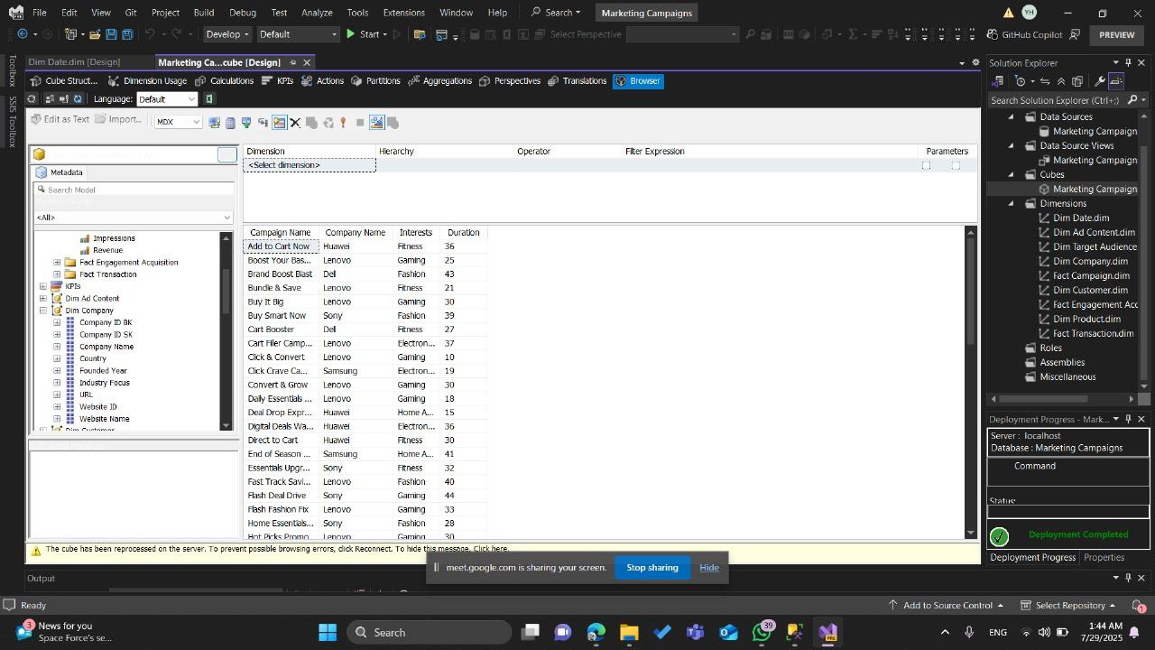

This screenshot demonstrates the **analysis of marketing campaign performance** using the SSAS Cube Browser.  
The cube has already been processed and deployed, and this view enables us to explore campaign-related metrics through various dimensions and measures.

**1. Left Panel – Measures and Dimensions**

* **Measures Section:**  
  Here, relevant quantitative metrics include:
  + *Impressions* – the total number of times the campaign content was displayed.
  + *Revenue* – total income generated from campaign activities.
  + *Fact Engagement Acquisition* – engagement metrics like clicks, shares, or other user interactions.
  + *Fact Transaction* – purchase and transaction-related data.
* **Dimensions Section:**  
  This cube uses several descriptive dimensions to allow flexible analysis:
  + **Dim Ad Content** – details about campaign ads.
  + **Dim Company** – includes *Company Name, Industry Focus, Founded Year, Website*.
  + **Dim Target Audience** – enables filtering by audience interest categories.
  + **Dim Campaign** – includes campaign-specific details such as *Campaign Name, Duration, and Theme*.

**2. Central Panel – Query Results Grid**

* In this particular view, the **rows** represent marketing campaigns with:
  + **Campaign Name** – the unique identifier for each marketing initiative.
  + **Company Name** – the brand running the campaign.
  + **Interests** – the main target audience interest (e.g., Gaming, Fitness, Fashion, Electronics).
  + **Duration** – campaign runtime in days.
* This structure allows stakeholders to:
  + Quickly see which companies are running which campaigns.
  + Understand audience targeting strategies by interest category.
  + Compare campaign durations across different industries.

**3. Business Insights Enabled by This View**

* **Campaign Targeting Analysis** – Identify the distribution of campaigns across different interests (e.g., if Gaming campaigns dominate the dataset).
* **Company Marketing Strategies** – See if a brand focuses on short-term promotions or long-running campaigns.
* **Content Planning** – Use campaign duration data to align with seasonal trends or promotional events.

**4. Role in the OLAP Development Lifecycle**

* **Data Validation:** Confirms that dimension joins are correct — e.g., each campaign is linked to the right company and audience profile.
* **KPI Preparation:** Sets the stage for adding calculated measures such as *Cost per Impression*, *Conversion Rate*, or *ROI*.
* **Performance Benchmarking:** Enables side-by-side comparison of campaigns to assess effectiveness.

**Product Sales Analysis View**

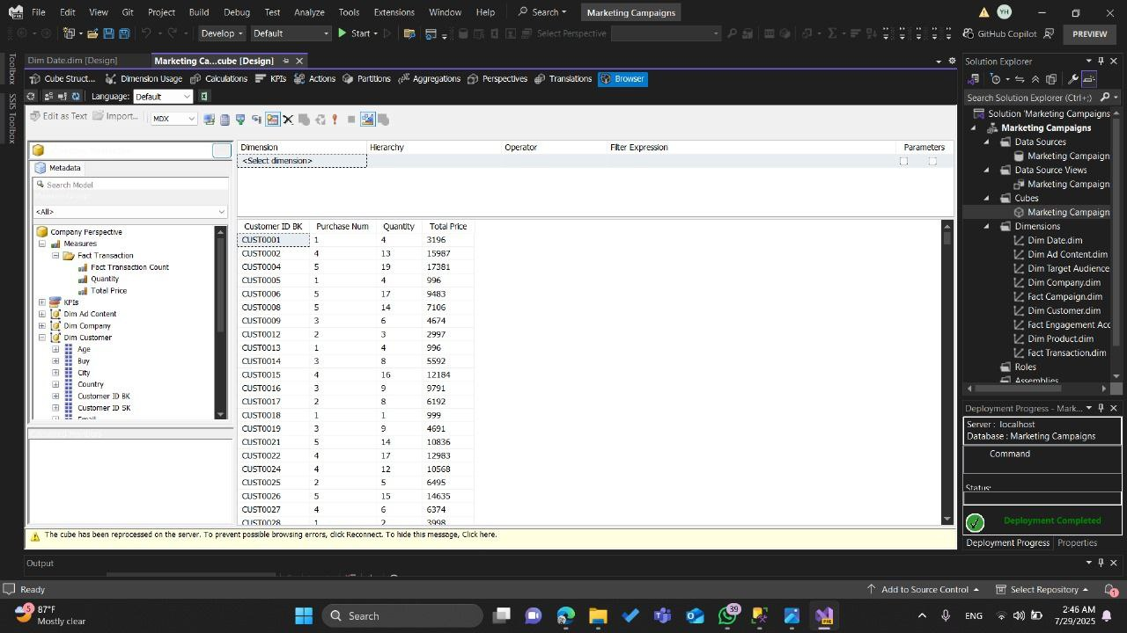

Description:  
This cube browser view provides an aggregated analysis of product sales performance across multiple product categories. The primary focus here is on Product Name, Category, and Total Price metrics, giving business stakeholders an overview of which products generate the highest revenue.

Key Components:

* Dimensions Used:
  + Dim Product → Contains Product Name and Category.
* Measure Used:
  + Total Price (aggregated sum of all transactions for each product).

Purpose & Insights:

* This view allows quick identification of top-performing products across categories such as Smartphones, Laptops, Earbuds, Smartwatches, etc.
* Useful for marketing performance review to determine which product categories should receive more promotional investment.
* Supports inventory and supply chain decisions by highlighting high-revenue products that require stock prioritization.

Example Insight from Screenshot:

* "A7 III Camera" is one of the top-selling products, generating 717,771 in revenue.
* Smartphones dominate multiple top spots, indicating high consumer demand.

2. Marketing Campaign Performance View

Description:  
This view focuses on campaign-level performance analysis, showing Campaign Name, Company Name, Customer Interests, and Campaign Duration. It leverages the Dim Company and Dim Campaign dimensions.

Key Components:

* Dimensions Used:
  + Dim Campaign → Campaign Name, Duration
  + Dim Company → Company Name, Interests (target audience interest categories)
* Measures Used:
  + None explicitly shown here — the focus is on campaign metadata for strategic analysis.

Purpose & Insights:

* Helps the marketing team evaluate campaign targeting strategy — are campaigns aligned with customer interests and company goals?
* Provides duration tracking to assess how long campaigns run and their correlation with success.
* Supports campaign portfolio management by showing which companies run the most or longest campaigns.

Example Insight from Screenshot:

* "Boost Your Base" by Lenovo (Gaming) ran for 25 days — ideal for comparing short vs. long campaigns.
* Fashion-related campaigns tend to have longer durations (e.g., "Brand Boost Deal" with 43 days), indicating a different engagement approach.

3. Customer Purchase Behavior View

Description:  
This cube browser view analyzes customer-level purchase behavior using Customer ID, Purchase Count, Quantity Purchased, and Total Price. This view is essential for understanding individual customer value and purchasing patterns.

Key Components:

* Dimensions Used:
  + Dim Customer → Customer ID BK
* Measures Used:
  + Purchase Num → Number of transactions made by a customer.
  + Quantity → Total quantity purchased.
  + Total Price → Total monetary value of purchases.

Purpose & Insights:

* Identifies high-value customers for loyalty programs or special promotions.
* Detects low-engagement customers who may need reactivation campaigns.
* Supports customer segmentation for targeted marketing.

Example Insight :

* Customer CUST0023 made 14 purchases totaling 10,863 — indicating strong engagement.
* Several customers with 1 purchase and low total price may require targeted re-engagement.

**SQL Server Reporting Services (SSRS) – Reporting Layer**

**Introduction:**The SQL Server Reporting Services (SSRS) layer represents the presentation and reporting component of our Business Intelligence (BI) architecture.  
After the ETL processes populate the Data Warehouse and the OLAP cubes (via SSAS) are built for multidimensional analysis, SSRS is used to transform raw analytical data into meaningful, visually appealing, and interactive reports.

SSRS provides:

* Customizable reports tailored for business needs.
* Multiple data visualization options (tables, charts, KPIs, gauges, etc.).
* Parameter-driven filtering for dynamic and user-specific insights.
* Exporting capabilities to PDF, Excel, Word, and other formats.
* Integration with OLAP cubes for real-time drill-down analysis.

In our project, SSRS connects directly to the Marketing Campaigns OLAP Cube built in SSAS, allowing end users to explore data across multiple dimensions such as Products, Campaigns, Customers, and Transactions. This reporting layer ensures that business stakeholders can make data-driven decisions without needing direct access to the underlying database or cube structure.

**SSRS Reporting – Campaign Profit Analysis**



**1. Purpose and Scope**

The SSRS report for **Campaign Profit** was designed to provide a detailed view of marketing campaign performance, focusing on budget allocation, actual spending, revenue generation, and resulting profit or loss. This report serves both analytical and decision-making purposes by enabling stakeholders to quickly assess which campaigns yielded the highest returns and which underperformed.

**2. Data Source**

The dataset originates from the marketing data warehouse, containing transactional and financial figures for multiple promotional campaigns. Each record includes:

* **Campaign Name**
* **Budget** (planned expenditure)
* **Actual Budget** (real expenditure)
* **Revenue** (total sales generated)
* **Profit** (net revenue minus actual expenditure)

**3. Report Design**

The SSRS report was built with a **tabular layout** to clearly display the numerical data and allow straightforward comparisons. Key design elements include:

* **Column Headings** for Campaign Name, Budget, Actual Budget, Revenue, and Profit.
* **Numeric Formatting** to display currency values for financial columns.
* **Conditional Formatting** applied to the Profit column, highlighting negative profits in red for quick identification of loss-making campaigns.
* **Sorting & Filtering** features enabling users to arrange campaigns by profitability, budget size, or revenue.
* **Pagination** to organize the output into three sections (pages) based on the source data.

**4. Key Insights from the Report**

* High-performing campaigns such as **“Save More & Shop More”**, **“Shop Now Shine”**, and **“Click Crave Campaign”** achieved significant profits, indicating strong ROI.
* Several campaigns, including **“Product Power Push”**, **“End of Season Surge”**, and **“The Sale Swipe”**, reported negative profits, signaling the need for strategy reassessment.
* Budget utilization varied, with some campaigns exceeding their planned budgets while others remained under.
* The variation in revenue outcomes across campaigns highlights the importance of aligning marketing spend with audience engagement and sales conversion strategies.

**5. Business Impact**

This SSRS report empowers the marketing team to:

* Identify top-performing campaigns for replication or scaling.
* Investigate underperforming campaigns to determine causes of losses.
* Optimize budget allocations for future campaigns based on past performance.
* Make data-driven adjustments to marketing strategies in real time.

**Campaign Performance**



**Overview**

This section of the SSRS report presents **Campaign Performance Metrics**, focusing on engagement and conversion indicators for a range of marketing campaigns. While this dataset represents only part of the full report, it provides valuable insights into the reach and interaction levels achieved by each campaign.

**Data Fields**

The section includes the following performance indicators for each campaign:

* **Campaign Name** – The marketing initiative’s title.
* **Impressions** – The total number of times the campaign content was displayed to potential customers.
* **Conversions** – The number of successful actions taken by users (e.g., purchases, sign-ups) as a direct result of the campaign.
* **Clicks** – The number of times users clicked on campaign content.

**Key Observations from This Segment**

* Campaigns such as *Cart Filler Campaign*, *Shop the Trend*, and *Shopping Simplified* achieved **high conversions**, indicating strong engagement and effective targeting.
* High-impression campaigns like *Product Buzz Week*, *Must Buy Moment*, and *Trend Watch Boost* suggest broad audience exposure, but their conversion efficiency varies.
* Some campaigns, despite large impressions, showed relatively low conversions — for example, *Unlock the Offer* and *The Sale Swipe* — which may indicate a need for creative or offer optimization.
* Click volumes do not always directly correlate with conversions, underlining the importance of tracking both metrics to assess campaign quality.

**Purpose Within the Larger Report**

This section complements other SSRS report components (e.g., financial performance, audience reach, channel analysis) by focusing on **engagement effectiveness**. Together with profit and budget data, it supports a holistic view of marketing success, enabling:

* Identification of campaigns with both high reach and strong conversion performance.
* Detection of campaigns where audience engagement drops after initial interaction.
* Strategic adjustments to creative content, targeting, and channel mix for future campaigns.

**Campaign Target Audience Details**



**Overview**

This section of the SSRS report focuses on **Target Audience Analysis** for individual campaigns. It combines performance metrics with demographic and behavioral attributes to provide a deeper understanding of how specific audience segments responded to marketing initiatives. This dataset is one part of a broader audience targeting analysis within the SSRS reporting suite.

**Data Fields**

For each campaign, this section captures:

* **Campaign Name** – The marketing initiative’s title.
* **Platform** – The advertising platform where the campaign ran (e.g., Google).
* **Impressions** – The total number of times the campaign was displayed to potential viewers on the platform.
* **Clicks** – The number of times users clicked on the campaign content.
* **Conversions** – The number of successful actions (e.g., purchases, sign-ups).
* **Revenue** – Total income generated from the campaign.
* **Budget** – The planned marketing spend for the campaign.
* **Interests** – Audience interests relevant to the campaign (e.g., Gaming).
* **Behavior** – Observed consumer behavior patterns (e.g., Frequent Buyer).
* **Location** – Geographic targeting (e.g., UK).

**Key Observations from This Segment**

* Example: *Boost Your Basket* was run on **Google**, targeting individuals with an interest in **Gaming** and identified as **Frequent Buyers** in the **UK**.
* Performance metrics show **183,336 impressions**, resulting in **4,767 clicks**, **3,485 conversions**, and a **revenue of 6,805** with a **budget of 2,660**, indicating a positive return.
* The inclusion of behavioral and interest-based targeting data enables more granular analysis compared to purely performance-based reports.

**Purpose Within the Larger Report**

This section bridges the gap between **audience profiling** and **campaign performance**, allowing for:

* Evaluation of how specific audience segments respond to targeted campaigns.
* Optimization of targeting strategies by identifying high-performing interest/behavior/location combinations.
* Integration with financial and engagement data from other sections to create a comprehensive campaign effectiveness overview.

**Power BI Dashboards**

Power BI is a powerful business intelligence and data visualization tool developed by Microsoft. In this project, Power BI was used as one of the main front-end tools to present insights derived from our marketing campaign analysis. The tool allowed us to transform complex datasets into interactive dashboards and reports that are easy to explore and understand by both technical and non-technical users.

By integrating data from our SQL Server Data Warehouse, Power BI enabled us to:

* Connect seamlessly with the structured data models.
* Create dynamic reports with drill-down capabilities.
* Build KPIs that measure campaign performance across multiple dimensions (company, customer, and campaign).
* Provide decision-makers with real-time and interactive access to insights.

The use of Power BI not only improved the overall efficiency of data analysis but also allowed the team to communicate findings in a clear and visually appealing way, ensuring that stakeholders can quickly identify trends, patterns, and areas that require action.

**Campaign Insights Dashboard**

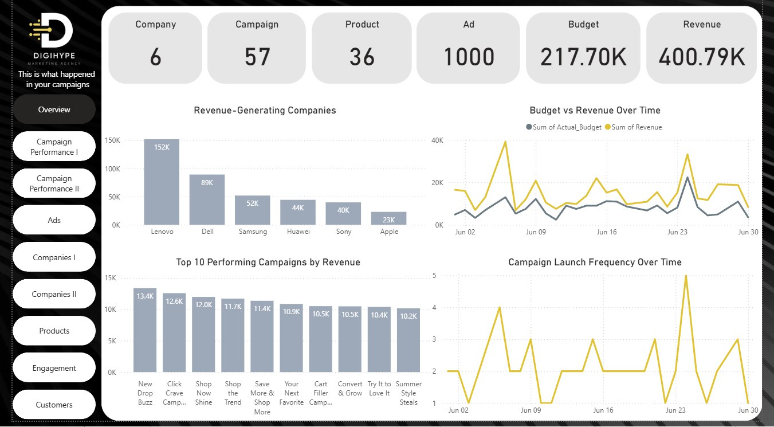

The **Campaign Insights Dashboard** is designed to give a detailed view of marketing campaign performance, combining KPIs, revenue analysis, budget tracking, and campaign activity trends.

**Key Performance Indicators (KPIs)**

At the top of the dashboard, the following KPIs summarize the overall performance:

* **Companies**: 6
* **Campaigns**: 57
* **Products**: 36
* **Ads**: 1000
* **Budget**: 217.70K
* **Revenue**: 400.79K

These indicators provide a high-level snapshot of the campaign ecosystem, giving users an instant understanding of scale and financial impact.

**Revenue-Generating Companies**

This bar chart highlights the companies contributing most to revenue.

* **Lenovo** leads with 152K, followed by **Dell** (89K) and **Samsung** (52K).
* Other contributors include Huawei, Sony, and Apple.

This analysis identifies top-performing business partners, which is crucial for prioritizing relationships and planning future collaborations.

**Top 10 Performing Campaigns by Revenue**

A bar chart displays the **top 10 campaigns** ranked by revenue.

* Leading campaigns include *New Drop Buzz* (13.4K), *Click Crave Campaign* (12.6K), and *Shop Now Shine* (12.0K).
* The results showcase which campaigns resonate most with customers and drive the highest ROI.

**Budget vs. Revenue Over Time**

This line chart compares the **actual budget spent** versus the **revenue generated** across the month of June.

* The revenue line shows noticeable spikes compared to the budget line, highlighting days of high campaign efficiency.
* The visualization helps track **ROI trends** and identify whether increased spending correlates with higher returns.

**Campaign Launch Frequency Over Time**

This chart shows the frequency of campaign launches throughout June.

* Peaks indicate periods of aggressive campaign activity.
* Aligning these spikes with revenue performance helps evaluate the **effectiveness of campaign timing**.

**Key Insights & Recommendations**

1. **Lenovo dominates revenue generation**, suggesting strong market penetration and effective campaign strategies compared to other companies.
   * *Recommendation*: Further invest in Lenovo’s successful approaches while analyzing competitors like Dell and Samsung to replicate strong tactics.
2. **Top campaigns show a significant gap in revenue contribution**, with only a few campaigns delivering the majority of returns.
   * *Recommendation*: Conduct deeper analysis on these high-performing campaigns to identify winning factors (messaging, timing, or channels).
3. **Budget vs. Revenue analysis shows revenue spikes without proportionally high spending**, indicating certain campaigns achieved high efficiency.
   * *Recommendation*: Focus on replicating these efficient campaigns and refine budget allocation strategies.
4. **Campaign launch frequency patterns suggest that timing matters** — more frequent launches did not always mean higher revenue.
   * *Recommendation*: Optimize scheduling by aligning campaign launches with periods of high customer engagement rather than just volume.

**Campaign Performance Dashboard**

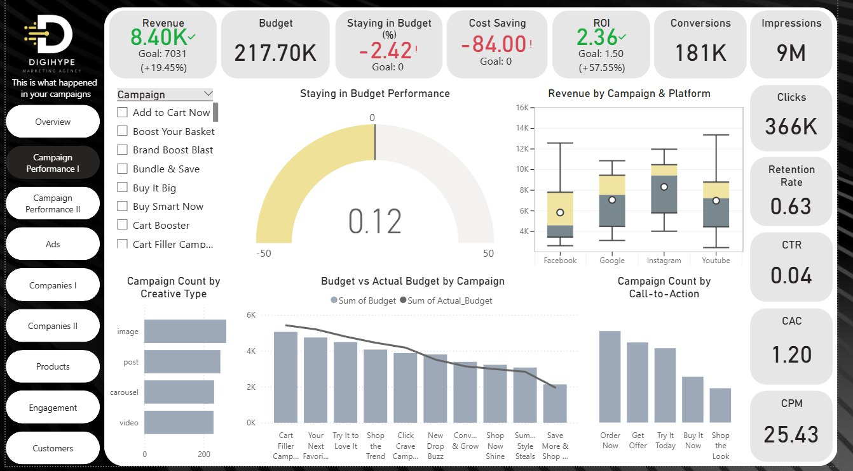

The **Campaign Performance I Dashboard** provides a detailed evaluation of campaign effectiveness by focusing on **budget utilization, return on investment (ROI), customer engagement, and campaign creative distribution**. This dashboard gives marketers an in-depth look at how campaigns are performing relative to their financial and engagement goals.

**Key Performance Indicators (KPIs)**

At the top of the dashboard, the following KPIs summarize overall performance:

* **Revenue**: 8.40K (Goal: 7031, +19.45%)
* **Budget**: 217.70K
* **Staying in Budget**: -2.42% (indicating slight overspending)
* **Cost Saving**: -84.00 (overshoot relative to goal)
* **ROI**: 2.36 (Goal: 1.50, +57.55%)
* **Conversions**: 181K
* **Impressions**: 9M
* **Clicks**: 366K
* **Retention Rate**: 0.63
* **CTR (Click-Through Rate)**: 0.04
* **CAC (Customer Acquisition Cost)**: 1.20
* **CPM (Cost Per Mille)**: 25.43

These KPIs combine both **financial health** and **engagement metrics**, providing a full performance picture.

**Staying in Budget Performance**

The **gauge chart** shows how well campaigns stayed within budget.

* The indicator at **0.12** highlights near alignment with planned budgets, though slight overspending is noted.
* This is crucial for evaluating cost discipline and financial efficiency.

**Revenue by Campaign & Platform**

The **box plot** visualization breaks down campaign revenue across platforms:

* **Facebook, Google, Instagram, and YouTube** each demonstrate varied revenue distributions.
* Instagram and Google show higher median returns, while Facebook and YouTube present greater variability.

This helps determine which platforms consistently deliver stable and high returns.

**Campaign Count by Creative Type**

This bar chart highlights the distribution of **creative formats** used across campaigns:

* **Images** dominate as the most used creative type, followed by posts, carousels, and videos.
* Understanding creative mix is essential for optimizing engagement strategies.

**Budget vs. Actual Budget by Campaign**

This chart compares the **planned vs. actual budget** for different campaigns.

* Campaigns like *Cart Filler*, *Your Next Favorite*, and *Try It to Love It* demonstrate close budget alignment.
* Others show variances, highlighting where overspending or underspending occurred.

This view ensures **budget accountability** across multiple campaigns.

**Campaign Count by Call-to-Action (CTA)**

This chart analyzes campaign CTAs:

* Most frequent CTAs are **“Order Now”**, **“Get Offer”**, and **“Try It Today”**.
* CTAs like **“Buy It Now”** and **“Shop the Look”** are less common.

CTA distribution gives insights into the **persuasiveness strategies** used in campaigns and their relative impact.

**Key Insights & Recommendations**

1. **Strong ROI (2.36)** indicates campaigns are performing significantly above expectations, despite slight overspending.
   * *Recommendation*: Continue leveraging high-performing channels like Instagram and Google for better ROI optimization.
2. **Budget discipline requires improvement**, as seen in overshooting cost-saving targets.
   * *Recommendation*: Implement stricter budget monitoring and dynamic reallocation of resources during campaigns.
3. **Creative type analysis shows reliance on images**, but videos and carousels are underutilized.
   * *Recommendation*: Expand video-based campaigns to increase engagement, especially on platforms like YouTube and Instagram.
4. **CTA analysis reveals dominance of few phrases**, which may limit diversity in customer persuasion.
   * *Recommendation*: Experiment with varied CTAs to test customer response and maximize conversions.

**Campaign Performance II Dashboard**

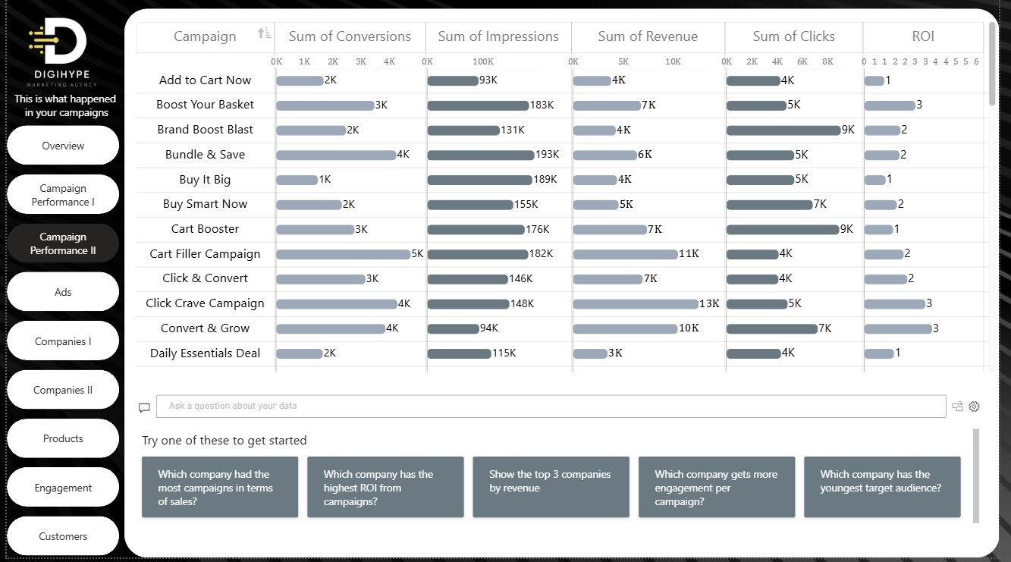

The **Campaign Performance II Dashboard** provides a granular view of campaign effectiveness by analyzing conversions, impressions, revenue, clicks, and ROI across individual campaigns. This dashboard enables marketers to compare campaigns directly and identify which strategies generate the strongest returns and engagement.

**Key Performance Indicators (KPIs)**

From the campaigns table, the following aggregate insights stand out:

* **Top Conversions**:
  + *Cart Filler Campaign*: 5K
  + *Bundle & Save*: 4K
  + *Click Crave Campaign*: 4K
  + *Click & Convert*: 3K
* **Top Revenue Generators**:
  + *Click Crave Campaign*: 13K
  + *Cart Filler Campaign*: 11K
  + *Convert & Grow*: 10K
  + *Boost Your Basket* & *Cart Booster*: 7K each
* **Top ROI Campaigns**:
  + ROI = 3 → *Boost Your Basket*, *Click Crave Campaign*, *Convert & Grow*
  + ROI = 2 → *Brand Boost Blast*, *Bundle & Save*, *Buy Smart Now*, *Cart Filler Campaign*, *Click & Convert*
* **Engagement (Clicks)**:
  + Highest Clicks: *Brand Boost Blast* (9K), *Cart Booster* (9K)
  + Moderate: *Buy Smart Now* (7K), *Convert & Grow* (7K)
* **Impressions Leaders**:
  + *Bundle & Save*: 193K
  + *Buy It Big*: 189K
  + *Boost Your Basket*: 183K

**Campaign Analysis**

**Conversions Performance**

* Campaigns like *Cart Filler Campaign* (5K) and *Bundle & Save* (4K) lead in conversions.
* Smaller campaigns such as *Buy It Big* and *Daily Essentials Deal* trail behind with only 1–2K conversions.

**Revenue Performance**

* *Click Crave Campaign* (13K) and *Cart Filler Campaign* (11K) are the highest revenue drivers.
* *Daily Essentials Deal* underperforms with only 3K revenue despite having moderate impressions (115K).

**ROI Distribution**

* Campaigns with ROI = 3 (*Boost Your Basket*, *Click Crave Campaign*, *Convert & Grow*) deliver the most efficient returns.
* Campaigns like *Add to Cart Now*, *Buy It Big*, *Cart Booster*, and *Daily Essentials Deal* have ROI = 1, signaling inefficiency.

**Clicks vs. Impressions**

* *Brand Boost Blast* and *Cart Booster* generated the most clicks (9K each), indicating strong engagement.
* *Bundle & Save* and *Buy It Big* show high impressions but limited incremental ROI.

**Key Insights & Recommendations**

1. **High ROI Campaigns**
   * *Click Crave Campaign*, *Convert & Grow*, and *Boost Your Basket* are standout performers.
   * **Recommendation**: Allocate more budget to these campaigns to maximize efficiency.
2. **Low ROI & Underperformers**
   * Campaigns with ROI = 1 (*Buy It Big*, *Cart Booster*, *Daily Essentials Deal*) are consuming resources with minimal returns.
   * **Recommendation**: Reassess targeting, creative design, or reduce budget allocation.
3. **Engagement vs. Conversion Gap**
   * *Brand Boost Blast* and *Cart Booster* drive high clicks but revenue/ROI remain moderate.
   * **Recommendation**: Optimize conversion funnels (landing pages, CTAs) to better monetize traffic.
4. **Revenue Concentration**
   * A few campaigns (*Click Crave Campaign*, *Cart Filler Campaign*) dominate revenue contribution.
   * **Recommendation**: Diversify investment across multiple mid-performing campaigns to reduce dependency.
5. **Creative & Messaging Optimization**
   * Campaigns with high impressions but weak ROI indicate possible creative fatigue.
   * **Recommendation**: Test new ad formats, creatives, and diversify CTA strategies to capture more value.

**Ads Dashboard**

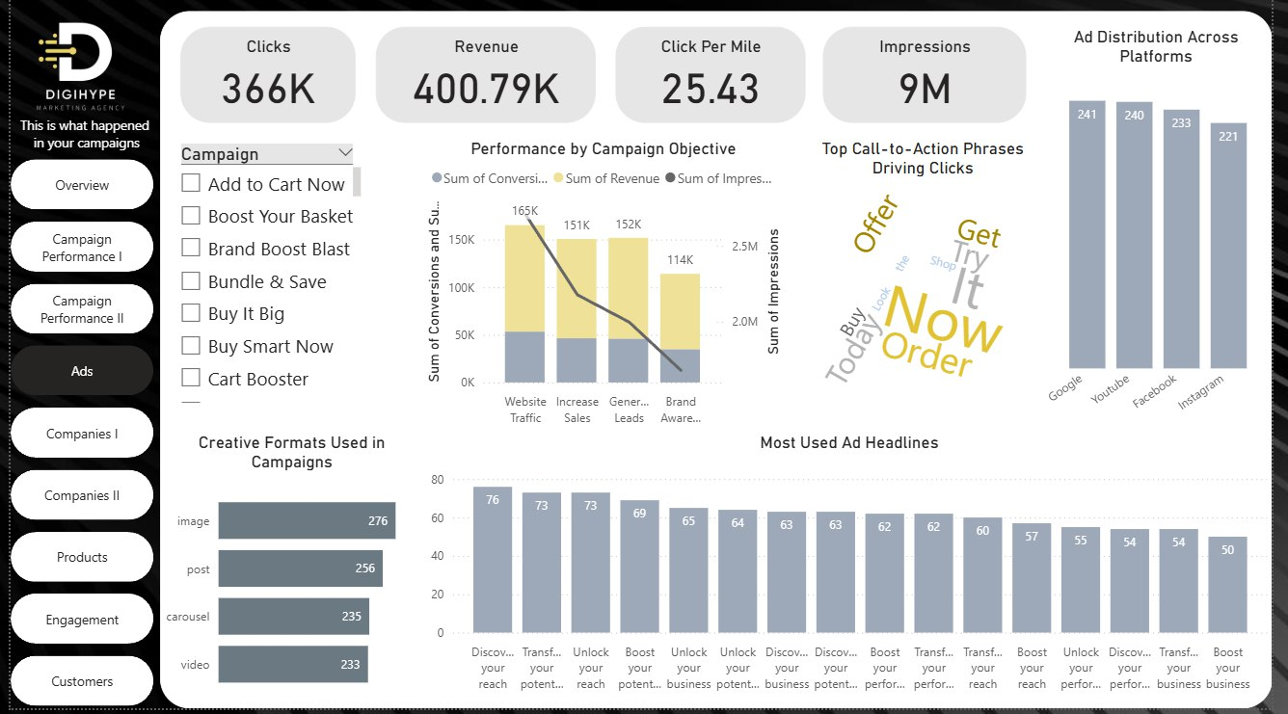

The **Ads Dashboard** provides a holistic analysis of advertising performance across clicks, revenue, impressions, creative formats, and campaign objectives. It highlights ad distribution across platforms, the most effective call-to-action (CTA) phrases, and the most frequently used ad headlines. This enables marketers to evaluate not only financial impact but also creative and messaging strategies.

**Key Performance Indicators (KPIs)**

At the top of the dashboard, the following KPIs summarize overall ad performance:

* **Clicks**: 366K
* **Revenue**: 400.79K
* **CPM (Cost per Mille)**: 25.43
* **Impressions**: 9M

These metrics capture both financial effectiveness and audience reach.

**Performance by Campaign Objective**

* **Website Traffic**: 165K conversions, strong impression volume.
* **Increase Sales**: 151K conversions, high revenue contribution.
* **Generate Leads**: 152K conversions, balanced performance across conversions and impressions.
* **Brand Awareness**: 114K conversions, lowest performance compared to other objectives.

This breakdown clarifies which strategic objectives drive the most measurable impact.

**Ad Distribution Across Platforms**

* **Google**: 241 ads
* **YouTube**: 240 ads
* **Facebook**: 233 ads
* **Instagram**: 221 ads

Distribution is fairly balanced, though Google and YouTube slightly lead, highlighting stronger focus on search and video-based campaigns.

**Creative Formats Used in Campaigns**

* **Images**: 276 (most dominant)
* **Posts**: 256
* **Carousels**: 235
* **Videos**: 233

Images remain the primary creative choice, but video and carousel formats are also significant, suggesting opportunities to diversify further.

**Top Call-to-Action (CTA) Phrases Driving Clicks**

* Most frequent CTAs: *Now*, *Order*, *Offer*, *Get It*, *Try Today*.
* CTAs are heavily concentrated around urgency-driven language, emphasizing immediacy.

**Most Used Ad Headlines**

* Top recurring headlines include:
  + *Discover your reach* (76)
  + *Transform your potential* (73)
  + *Boost your reach* (73)
  + *Unlock your business* (69)
  + Other frequent headlines revolve around performance, growth, and transformation.

This repetition signals reliance on a narrow set of headline themes.

**Key Insights & Recommendations**

1. **High Click & Revenue Alignment**
   * Strong balance between clicks (366K) and revenue (400.79K).
   * **Recommendation**: Continue optimizing ads with proven messaging to sustain efficiency.
2. **Campaign Objectives**
   * Website traffic and sales-oriented objectives perform best.
   * **Recommendation**: Increase budget allocation toward "Increase Sales" and "Generate Leads" while reassessing "Brand Awareness" strategies.
3. **Platform Distribution**
   * Even distribution across Google, YouTube, Facebook, and Instagram ensures reach.
   * **Recommendation**: Double down on YouTube and Instagram with more video-based content to maximize engagement.
4. **Creative Format Mix**
   * Heavy reliance on images may limit creative diversity.
   * **Recommendation**: Expand use of video and carousel creatives to drive richer engagement experiences.
5. **CTA Concentration**
   * Current CTAs overemphasize urgency (e.g., “Now”, “Order”).
   * **Recommendation**: Experiment with value-driven CTAs like “Explore More”, “Get Started”, or “Learn How” to broaden appeal.
6. **Ad Headlines**
   * Repetition of similar headlines risks audience fatigue.
   * **Recommendation**: Introduce fresh headline variations, personalization, and benefit-driven messages to improve differentiation.

**Companies I I I Dashboard**

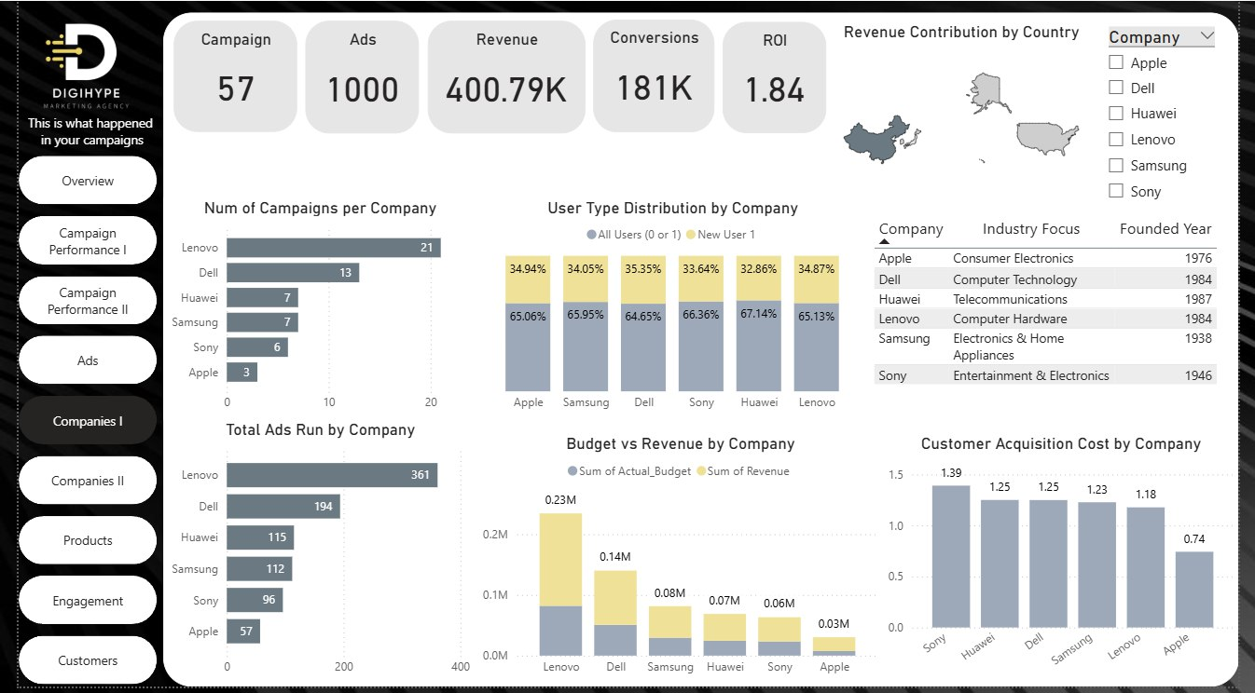

The **Companies I Dashboard** provides an overview of campaign distribution, ad activity, budget utilization, and performance by company. It enables comparison across six major brands — **Apple, Dell, Huawei, Lenovo, Samsung, and Sony** — to evaluate revenue contribution, customer acquisition cost (CAC), and user type distribution.

**Key Performance Indicators (KPIs)**

* **Campaigns**: 57
* **Ads**: 1000
* **Revenue**: 400.79K
* **Conversions**: 181K
* **ROI**: 1.84

These KPIs highlight overall scale and effectiveness of company-driven campaigns.

**Campaigns & Ads by Company**

* **Number of Campaigns**:
  + *Lenovo* leads with 21 campaigns, followed by *Dell* (13).
  + *Apple* runs the fewest campaigns (3).
* **Total Ads Run**:
  + *Lenovo*: 361 (highest)
  + *Dell*: 194
  + *Apple*: 57 (lowest)

This shows Lenovo and Dell dominate campaign and ad volume.

**Budget vs Revenue by Company**

* **Lenovo**: Highest revenue (0.23M) and strong budget utilization.
* **Dell**: 0.14M revenue with balanced budget alignment.
* **Samsung & Huawei**: Moderate revenue (~0.07–0.08M).
* **Sony & Apple**: Lowest contributions, with Apple at 0.03M.

This visualization highlights Lenovo as the revenue leader among peers.

**User Type Distribution by Company**

* *Sony* and *Huawei* have the highest proportion of new users (≈33–34%).
* *Dell* shows the highest share of repeat users (35.35%).
* All companies maintain relatively balanced user splits, suggesting stable customer engagement across both new and existing users.

**Revenue Contribution by Country**

* Geographic distribution shows campaigns contributing revenue from **USA, Europe, and Asia**.
* Companies like Lenovo and Huawei likely contribute strongly from Asian markets, while Apple, Dell, and Sony reflect balanced global presence.

**Customer Acquisition Cost (CAC) by Company**

* **Lowest CAC**: Apple (0.74) → most cost-efficient.
* **Highest CAC**: Sony (1.39) → least efficient.
* Dell, Huawei, Samsung, and Lenovo fall in the mid-range (1.18–1.25).

This indicates Apple’s campaigns are most effective in acquiring customers at lower cost.

**Key Insights & Recommendations**

1. **Market Leaders**
   * Lenovo dominates in campaigns, ads, and total revenue contribution.
   * **Recommendation**: Sustain Lenovo’s investment strategy while exploring similar scaling opportunities for Dell.
2. **Cost Efficiency**
   * Apple demonstrates lowest CAC despite fewer campaigns.
   * **Recommendation**: Expand Apple’s campaign count to maximize its efficiency advantage.
3. **Underperformers**
   * Sony shows the highest CAC with limited campaigns and lower revenue.
   * **Recommendation**: Reassess Sony’s targeting and optimize ad creatives to improve cost-efficiency.
4. **User Growth**
   * Sony and Huawei are acquiring higher new user percentages.
   * **Recommendation**: Leverage this trend by reinforcing retention campaigns to build loyalty.
5. **Revenue Diversification**
   * Revenue is concentrated heavily in Lenovo and Dell.
   * **Recommendation**: Encourage stronger revenue contributions from Samsung, Huawei, and Apple to balance reliance.

**Companies Dashboard**

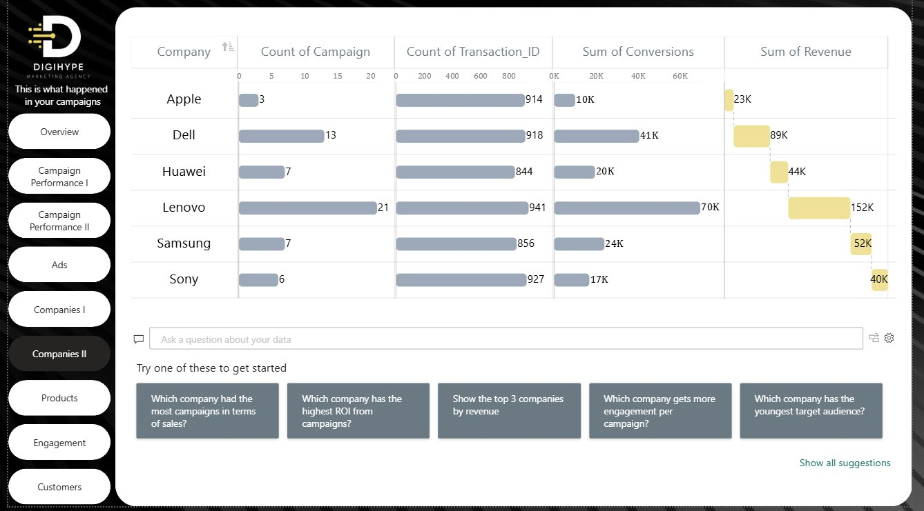

The **Companies II Dashboard** provides a comparative analysis of campaigns across six major companies — **Apple, Dell, Huawei, Lenovo, Samsung, and Sony**. It highlights campaign count, transaction volume, conversions, and revenue contribution, enabling direct performance benchmarking between companies.

**Key Performance Indicators (KPIs)**

* **Top Campaign Volume**: Lenovo (21 campaigns), followed by Dell (13).
* **Highest Transactions**: Lenovo (941), Sony (927), and Dell (918).
* **Highest Conversions**: Lenovo (70K), Dell (41K).
* **Highest Revenue**: Lenovo (152K), Dell (89K), Samsung (52K).
* **Lowest Performer**: Apple (3 campaigns, 914 transactions, 10K conversions, 23K revenue).

**Company Performance Breakdown**

**Apple**

* Campaigns: 3 → least active.
* Conversions: 10K.
* Revenue: 23K.
* Insight: Limited campaign activity restricts growth potential despite moderate transaction count.

**Dell**

* Campaigns: 13.
* Conversions: 41K.
* Revenue: 89K.
* Insight: Strong mid-tier performer with solid conversion-to-revenue ratio.

**Huawei**

* Campaigns: 7.
* Conversions: 20K.
* Revenue: 44K.
* Insight: Moderate results, needs more scaling to compete with Lenovo and Dell.

**Lenovo**

* Campaigns: 21 (highest).
* Conversions: 70K (leading).
* Revenue: 152K (highest).
* Insight: Clear market leader, both in scale and financial impact.

**Samsung**

* Campaigns: 7.
* Conversions: 24K.
* Revenue: 52K.
* Insight: Balanced performer with moderate contributions, room to improve ROI.

**Sony**

* Campaigns: 6.
* Conversions: 17K.
* Revenue: 40K.
* Insight: Performs better than Apple but still lags behind mid-tier competitors.

**Key Insights & Recommendations**

1. **Lenovo as the Dominant Player**
   * Leading in campaigns, conversions, and revenue.
   * **Recommendation**: Maintain leadership by diversifying creatives and sustaining high-volume campaigns.
2. **Dell as Strong Challenger**
   * Performs consistently with 41K conversions and 89K revenue.
   * **Recommendation**: Increase ad volume to close the gap with Lenovo.
3. **Underutilized Potential in Apple**
   * Despite strong brand equity, campaign count is extremely low.
   * **Recommendation**: Expand campaigns to leverage Apple’s high-value audience.
4. **Growth Opportunities for Huawei & Samsung**
   * Both show steady results but remain in the middle tier.
   * **Recommendation**: Boost ad spend on high-performing campaign types (e.g., conversions-focused).
5. **Sony Needs Optimization**
   * Despite decent transaction volume (927), revenue lags at only 40K.
   * **Recommendation**: Revisit targeting, messaging, and CAC efficiency to maximize conversion value.

**Customers Dashboard**

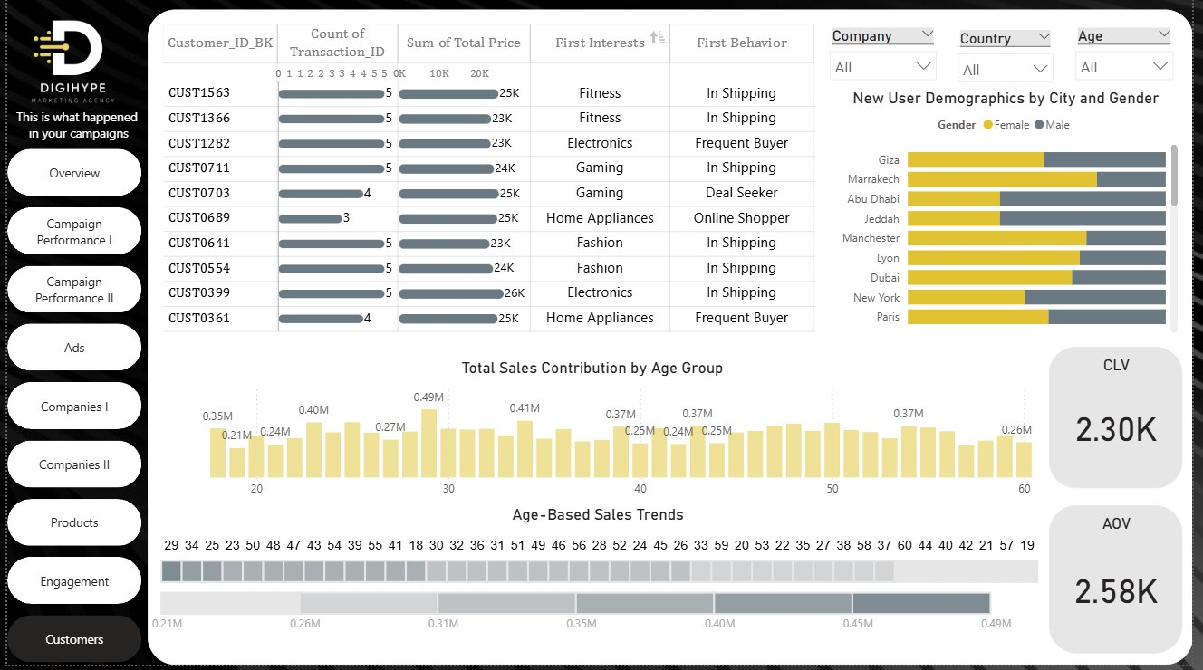

The **Customers Dashboard** provides detailed insights into customer transactions, behaviors, demographics, and sales contribution across age groups. It highlights customer value, average order trends, and key behavioral patterns, helping marketers better understand their customer base and optimize engagement strategies.

**Key Performance Indicators (KPIs)**

* **Customer Lifetime Value (CLV)**: 2.30K
* **Average Order Value (AOV)**: 2.58K

These KPIs indicate both the long-term value generated per customer and the average size of transactions.

**Customer Transactions & Behaviors**

* Top customers (e.g., **CUST0399, CUST0703, CUST1563**) contribute between **23K–26K** each in total purchases.
* **First Interests** vary widely: Fitness, Electronics, Gaming, Home Appliances, Fashion.
* **First Behavior** segments include: *In Shipping*, *Frequent Buyer*, *Online Shopper*, and *Deal Seeker*.

This segmentation enables profiling of customers based on both interests and behavior.

**New User Demographics by City & Gender**

* Cities with notable new user activity: **Giza, Marrakech, Abu Dhabi, Jeddah, Manchester, Lyon, Dubai, New York, Paris**.
* Gender distribution is mixed, with certain cities (e.g., Jeddah, New York) showing stronger female representation, while others like Lyon and Marrakech skew more male.

This demographic insight helps in tailoring location- and gender-specific campaigns.

**Total Sales Contribution by Age Group**

* Highest sales contributions are observed around age groups **29–32** and **40–45**, peaking at **0.49M** (age ~30).
* Sales remain steady across middle-aged groups, though decline gradually in older segments (50+).

**Age-Based Sales Trends**

* Younger audiences (ages ~19–25) show lower contributions (~0.21M–0.26M).
* Strongest trends occur between ages **28–36** (0.35M–0.49M).
* Older customers (55+) contribute moderately but represent less growth potential.

**Key Insights & Recommendations**

1. **High-Value Customer Segments**
   * Customers aged 28–36 deliver the strongest revenue.
   * **Recommendation**: Focus retention and loyalty campaigns on this age bracket.
2. **Behavioral Segmentation**
   * "Frequent Buyers" and "Online Shoppers" emerge as profitable groups.
   * **Recommendation**: Personalize offers and exclusive deals for these customer types.
3. **Geographic Opportunities**
   * Cities like Giza, Dubai, and Manchester show balanced growth potential.
   * **Recommendation**: Tailor campaigns by city and gender mix to maximize local engagement.
4. **Diversity of Interests**
   * Interests such as Fitness, Gaming, and Electronics dominate top customers.
   * **Recommendation**: Align campaign creatives with these interest categories for stronger resonance.
5. **Long-Term Value Growth**
   * CLV of 2.30K is healthy but can be improved.
   * **Recommendation**: Implement loyalty programs and subscription-style offers to extend customer lifetime value.

**Engagement Dashboard**

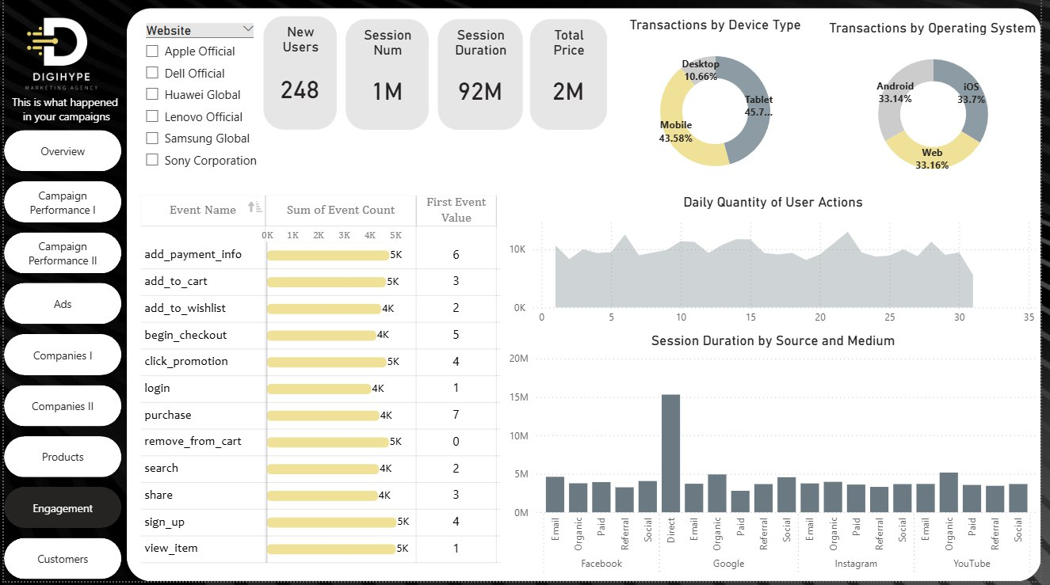

The **Engagement Dashboard** tracks user activity, website interactions, and engagement quality across devices, operating systems, and digital channels. It highlights event-level behaviors, session patterns, and engagement intensity across platforms.

**Key Performance Indicators (KPIs)**

* **New Users**: 248
* **Total Sessions**: 1M
* **Session Duration**: 92M minutes
* **Total Revenue (Price)**: 2M

These KPIs reflect overall audience reach, activity, and monetization potential.

**User Engagement Events**

Top engagement actions include:

* **Add to Cart**: 5K
* **Add Payment Info**: 5K
* **Click Promotion**: 5K
* **Remove from Cart**: 5K
* **Sign Up & View Item**: 5K each

Other important actions:

* **Begin Checkout**: 4K
* **Purchase**: 4K (with highest *First Event Value* = 7)
* **Login, Search, Add to Wishlist**: 4K each

This shows strong engagement across the funnel, especially at purchase and checkout stages.

**Device & Operating System Usage**

* **Device Type**:
  + Mobile: 43.58%
  + Tablet: 45.7% (highest share)
  + Desktop: 10.66%
* **Operating System**:
  + Android: 33.14%
  + iOS: 33.7%
  + Web: 33.16%

Engagement is well distributed across OS platforms, with no clear dominance, but mobile/tablet usage leads device adoption.

**Daily User Actions**

* User actions remain steady across the month, with spikes around mid and late periods (~10K actions/day).
* Indicates consistent platform activity with occasional engagement peaks.

**Session Duration by Source & Medium**

* Longest session durations come from **Direct + Social** channels, peaking at ~15M minutes.
* Other strong performers: **Google Organic, YouTube Organic, Facebook Paid** (~5M each).
* Lower session durations in Referral and Paid channels suggest weaker engagement quality.

**Key Insights & Recommendations**

1. **Strong Funnel Engagement**
   * High actions in *add_to_cart, begin_checkout, purchase* show healthy conversion intent.
   * **Recommendation**: Reduce drop-offs by optimizing checkout flow and retargeting cart abandoners.
2. **Device Trends**
   * Mobile & Tablet dominate with ~89% share.
   * **Recommendation**: Prioritize mobile-first experiences and responsive design.
3. **Balanced OS Distribution**
   * Android, iOS, and Web engagement are nearly equal.
   * **Recommendation**: Ensure cross-platform consistency and optimize for hybrid app/web usage.
4. **Channel Effectiveness**
   * Direct + Social drives the highest session durations.
   * **Recommendation**: Double down on social-first campaigns and organic content, while improving performance of Paid & Referral channels.
5. **User Growth Potential**
   * Despite 1M sessions, **new users are only 248**, indicating heavy reliance on repeat users.
   * **Recommendation**: Focus on **acquisition campaigns** (SEO, paid ads, influencer collabs) to expand new audience base.

**Tableau Dashboards**

**Tableau** was leveraged in this project to create **interactive and visually compelling dashboards** that enable users to explore data with flexibility and depth. Unlike static reporting tools, Tableau empowers stakeholders to perform **ad-hoc analysis**, apply **dynamic filters**, and uncover **hidden patterns** in the data through intuitive visualizations.

The dashboards built in Tableau serve three main purposes:

1. **Performance Monitoring** – Tracking key KPIs and campaign effectiveness in real time.
2. **Comparative Analysis** – Enabling side-by-side evaluation of campaigns, platforms, and products.
3. **Data Exploration** – Providing drill-down capabilities for deeper insights into specific business questions.

With Tableau’s strengths in **data blending, interactive filtering, and storytelling**, the dashboards offer stakeholders a **holistic view of campaign and business performance**, ensuring that strategic decisions are driven by accurate, up-to-date insights.

**Revenues Stats Dashboard**

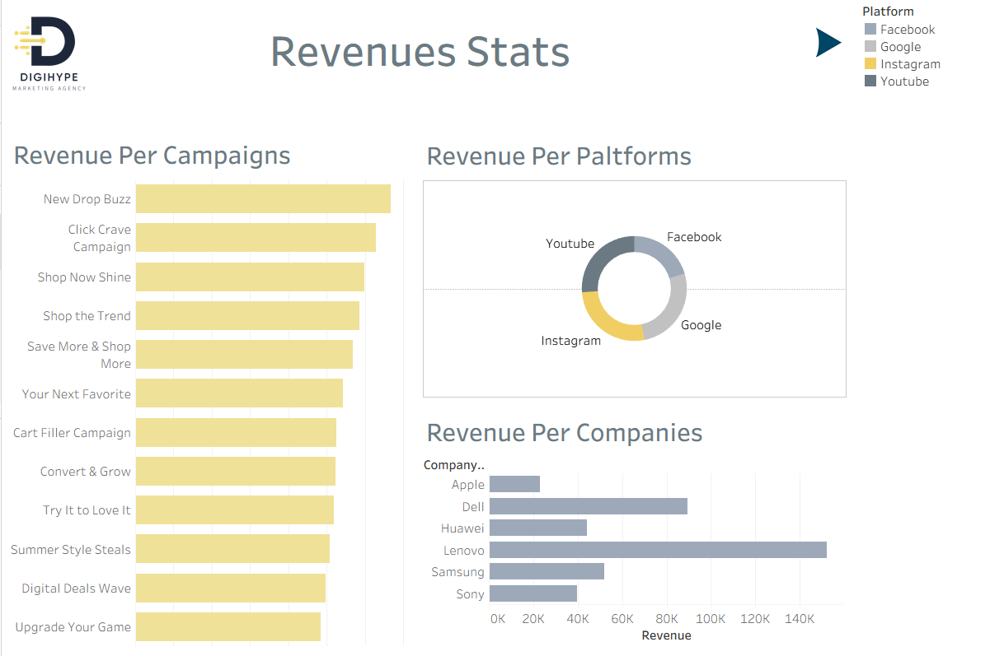

**1. Purpose and Scope**

The **Revenues Stats Dashboard** provides a comprehensive breakdown of campaign revenues across different dimensions. It focuses on performance evaluation by campaign, platform, and company, helping marketers understand which initiatives and channels are driving the highest financial impact.

**2. Key Performance Indicators (KPIs)**

While this dashboard doesn’t highlight KPIs in numerical cards, its core performance dimensions are revenue-focused. The KPIs inferred from this view include:

* **Revenue by Campaign**
* **Revenue by Platform** (Facebook, Google, Instagram, YouTube)
* **Revenue by Companies** (Apple, Dell, Huawei, Lenovo, Samsung, Sony)

These indicators show both campaign-level success and broader platform/company-level revenue distribution.

**3. Detailed Charts & Visuals Explanation**

**a. Revenue Per Campaign**

* Horizontal bar chart showing revenue performance across multiple campaigns.
* Top-performing campaigns include **New Drop Buzz**, **Click Crave Campaign**, and **Shop Now Shine**, which lead in revenue contribution.
* Lower-tier campaigns such as **Upgrade Your Game** and **Digital Deals Wave** show smaller revenue impact.
* This helps identify high-return campaigns for future replication and underperforming ones needing optimization.

**b. Revenue Per Platforms**

* Donut chart illustrating revenue share across marketing platforms.
* **Facebook** and **Google** represent the largest revenue contributions.
* **Instagram** plays a moderate role, while **YouTube** contributes the least.
* The chart highlights which platforms deliver the strongest ROI potential.

**c. Revenue Per Companies**

* Bar chart comparing revenue generated by different companies/brands.
* **Lenovo** is the leading contributor with revenue exceeding 140K, followed by **Dell** and **Samsung**.
* **Apple**, **Huawei**, and **Sony** represent smaller revenue shares.
* This breakdown allows evaluation of which companies benefit most from campaigns, guiding future targeting strategies.

**4. Key Insights**

* **Campaign Performance**: Revenue is concentrated in a few leading campaigns, while others show limited contribution.
* **Platform Distribution**: Facebook and Google dominate in revenue generation, confirming their role as primary performance drivers.
* **Company-Level Revenue**: Lenovo outperforms all competitors, indicating stronger customer response or higher-value campaigns.

**5. Recommendations**

* **Scale High-Performing Campaigns**: Reallocate budget and resources to campaigns like *New Drop Buzz* and *Click Crave Campaign* to maximize impact.
* **Platform Optimization**: Prioritize investment in **Facebook** and **Google** while experimenting with strategies to boost **Instagram** and **YouTube** engagement.
* **Client Targeting**: Strengthen partnerships with high-revenue companies such as **Lenovo** and **Dell**, while tailoring new approaches for lower performers like **Huawei** and **Sony**.

**Transactions Stats Dashboard**

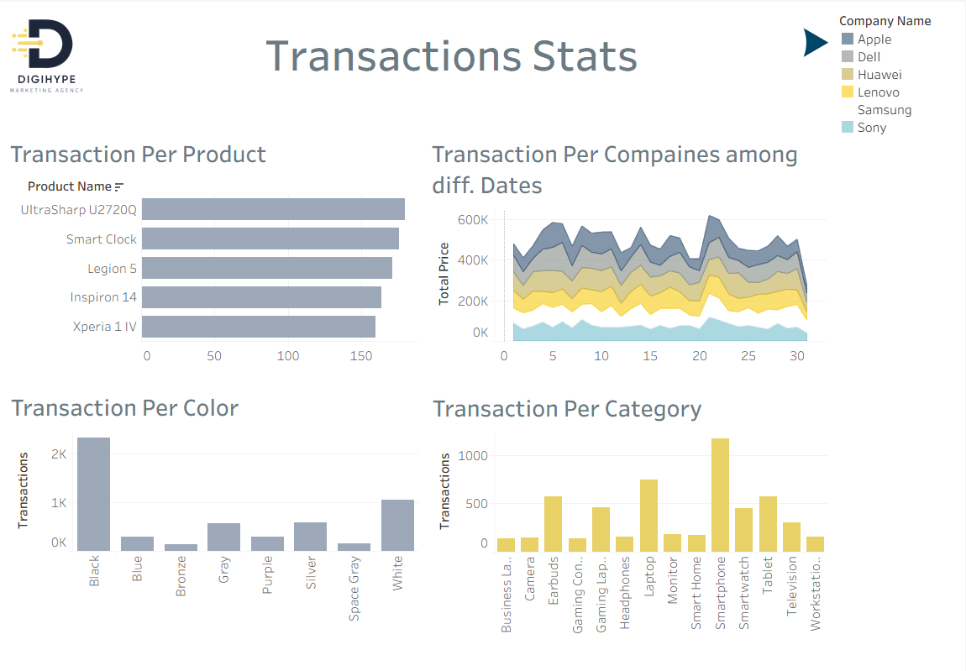

**1. Purpose and Scope**

The **Transactions Stats Dashboard** provides a detailed analysis of transactions across different products, companies, categories, and product attributes (such as color). It enables marketers and decision-makers to understand purchasing behavior, product preferences, and company-specific performance over time.

**2. Key Performance Indicators (KPIs)**

This dashboard tracks key transactional dimensions:

* **Transaction Per Product**
* **Transaction Per Company across Dates**
* **Transaction Per Color**
* **Transaction Per Category**

These KPIs allow monitoring of both product-level popularity and broader transaction trends across companies and customer preferences.

**3. Detailed Charts & Visuals Explanation**

**a. Transaction Per Product**

* Bar chart showing transactions per individual product.
* Top products include **UltraSharp U2720Q**, **Smart Clock**, and **Legion 5**, each showing high transaction volumes.
* **Inspiron 14** and **Xperia 1 IV** follow closely, confirming competitive demand.
* This insight helps identify best-selling products.

**b. Transaction Per Companies among Different Dates**

* Area chart illustrating transaction value distribution across multiple companies over time.
* **Dell** and **Lenovo** lead consistently in transaction contributions.
* Other companies like **Huawei** and **Samsung** contribute moderately, while **Apple** and **Sony** show smaller shares.
* This trend view is useful for identifying peaks and shifts in company performance throughout the month.

**c. Transaction Per Color**

* Bar chart categorizing transactions by product color.
* **Black** dominates with over 2K transactions, far exceeding other colors.
* **White** and **Gray/Silver variants** follow, while colors like **Blue, Bronze, and Purple** show limited demand.
* This highlights consumer preference patterns that can guide future product design and marketing.

**d. Transaction Per Category**

* Bar chart displaying transactions by product categories.
* **Smartphones** lead with the highest transaction count, followed by **Laptops**, **Earbuds**, and **Smart Home devices**.
* Categories like **Cameras**, **Televisions**, and **Workstations** record much lower transactions.
* This segmentation is essential for understanding which product lines drive the bulk of sales.

**4. Key Insights**

* **Product-Level Demand**: Specific products like *UltraSharp U2720Q* and *Smart Clock* dominate transaction volumes, proving their popularity.
* **Company Performance Over Time**: Dell and Lenovo are the main drivers, while other companies show fluctuations in performance.
* **Customer Preferences**: Black-colored products are most preferred, highlighting a strong trend in consumer choice.
* **Category Leaders**: Smartphones and laptops are the most purchased categories, aligning with global tech consumption patterns.

**5. Recommendations**

* **Focus on High-Demand Products**: Maintain stock and marketing campaigns for top-selling items like *UltraSharp U2720Q* and *Legion 5*.
* **Company-Level Strategy**: Strengthen campaigns with high-performing companies (Dell, Lenovo) and explore strategies to boost sales for lower performers (Sony, Huawei).
* **Leverage Color Trends**: Prioritize Black, White, and Gray/Silver options in promotions and inventory planning.
* **Expand Strong Categories**: Continue to invest in smartphones and laptops while testing growth strategies for emerging categories like Smart Home devices.

**Ad Stats Dashboard**

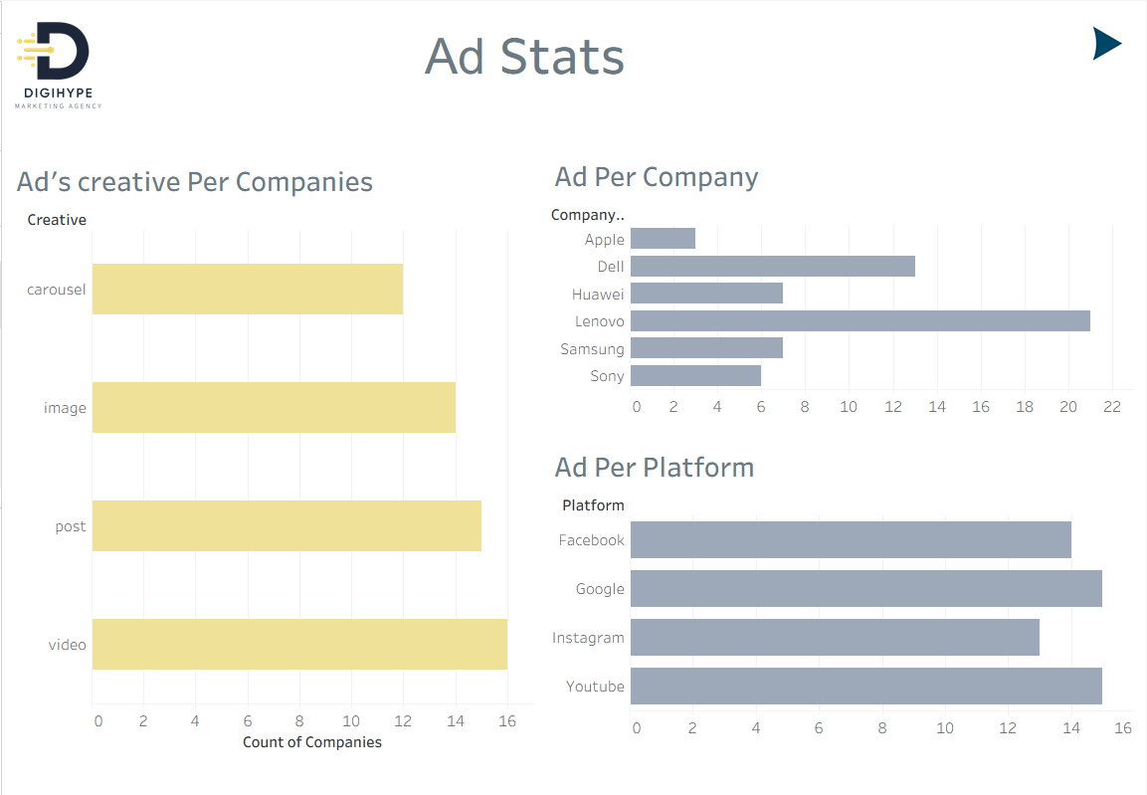

**1. Purpose and Scope**

The **Ad Stats Dashboard** provides insights into advertising distribution and effectiveness across companies, platforms, and creative formats. It helps marketers understand how ads are spread, which companies are investing the most, and which platforms and creative types dominate the advertising landscape.

**2. Key Performance Indicators (KPIs)**

The key indicators derived from this dashboard include:

* **Ads Creative Distribution per Companies**
* **Ads Count per Company**
* **Ads Count per Platform**

These KPIs measure both company-level ad investment and creative mix strategy across platforms.

**3. Detailed Charts & Visuals Explanation**

**a. Ad’s Creative Per Companies**

* Bar chart showing the distribution of creative formats (carousel, image, post, video) used across companies.
* **Video and Image creatives** dominate, with the widest adoption among companies.
* **Posts** are also frequent, while **carousel formats** are slightly less used.
* This highlights the creative preferences shaping engagement strategies.

**b. Ad Per Company**

* Bar chart comparing ad volume across different companies.
* **Lenovo** leads with the highest ad count, followed by **Dell**.
* **Huawei** and **Samsung** show moderate activity.
* **Apple** and **Sony** contribute fewer ads compared to other competitors.
* This reveals the intensity of advertising efforts across brands.

**c. Ad Per Platform**

* Bar chart showing the number of ads deployed across platforms.
* **Google** slightly surpasses **Facebook** as the most utilized advertising platform.
* **YouTube** also holds a strong share, while **Instagram** records a slightly lower count.
* This demonstrates that companies prioritize Google and Facebook, but YouTube remains an important channel.

**4. Key Insights**

* **Creative Mix**: Companies heavily rely on **video and image formats**, reflecting a focus on visually engaging ads.
* **Company-Level Investment**: Lenovo and Dell dominate in advertising volume, signaling aggressive marketing strategies, while Apple invests far less comparatively.
* **Platform Utilization**: Google and Facebook are the leading ad platforms, highlighting their continued importance in digital campaigns.

**5. Recommendations**

* **Creative Diversification**: While video and image perform well, companies should experiment more with **carousel and post formats** to diversify engagement strategies.
* **Boost Underperforming Companies**: Encourage increased ad activity from Apple and Sony to enhance competitive visibility.
* **Leverage Platform Mix**: Maintain strong presence on **Google and Facebook** while testing platform-specific strategies to maximize returns on **Instagram** and **YouTube**.

**Conclusion**

**Summary of Achievements**

Throughout this project, we successfully built an end-to-end data analytics pipeline, starting from raw Excel sheets and moving through SQL integration, SSRS reporting, Power BI dashboards, and Tableau visualizations. This allowed us to transform raw data into meaningful insights, track campaign performance, monitor customer behavior, and support data-driven decision-making across the business.

**Business Value Delivered**

The project delivered strong business value by enabling clear visibility into revenue trends, campaign effectiveness, budget utilization, and customer engagement. Stakeholders can now easily monitor KPIs, identify top-performing areas, and detect opportunities for improvement. Moreover, the dashboards provide actionable insights that enhance strategic planning and marketing effectiveness.

**Lessons Learned**

During the implementation, several lessons were learned:

* Data Quality Matters: Clean and consistent data is essential to building reliable reports and dashboards.
* Visualization Drives Impact: Presenting data in a clear and intuitive way significantly improves stakeholder adoption and decision-making.
* Iterative Approach Works Best: Continuous testing, feedback, and refinement at every stage ensured that the solution aligned with business needs.
* Integration Across Tools is Key: Leveraging different tools (SQL, SSRS, Power BI, Tableau) together created a more comprehensive and flexible analytics ecosystem.