COVER PAGE

Qualification |  | Module ID and Title
Higher national diploma in computing and software engineering |  | CNT 4008  Computer network
Student Name and ID |  | Assessor
Yumna Faris KD/HDCSE/CMU/81/18 |  | Mr. Navin Thattil
Handout Date |  | Submission Date
2025.11.25 |  | 2025.12.1
Assessment Type  WRTI coursework individual | Duration /Length Of The Assessment  1500 words | Weighting Of Assessment  50%

Learner declaration
I, Yumna Faris, certify that the work submitted for the assignment is my own and that research sources are fully acknowledged.

Marks awarded
First assessor
IV marks
Agreed grade
Signature of the assessor
Date

FEEDBACK FORM

Module:
Assessor:
Assignment:
Strong features of my work:

Areas for improvement:
Marks awarded:

ACKNOWLEDGEMENT
I would like to thank Cardiff Metropolitan University from the bottom of my heart for allowing me to study here. I consistently felt supported by the university’s resources and community, which gave me the confidence to excel in my studies. I am especially grateful to the faculty and staff at ICBT for their unwavering support and guidance throughout my course. I would like to extend my heartfelt thanks to my professor, Mr. Navin Thattil, for his exceptional instruction. He made the module easier to follow, patiently answered all my questions, and provided comprehensive explanations. His help and patience have been invaluable and are greatly appreciated. Above all, I want to express my deepest gratitude to my parents for their unconditional support and belief in me. I would not have reached this milestone without their endless efforts and affection. Finally, I appreciate the contributions of everyone who has participated in my academic and professional journey.

EXECUTIVE SUMMARY
This report presents a design for a secure, scalable computer network for GC Logistics to connect all departments, like Air Cargo Control, Package Tracking, Warehouse Operations, Customer Service, and IT & Cybersecurity, for improved efficiency and data security. The network utilizes a hierarchical model (Core, Distribution, Access) with a star topology and client-server LAN, accommodating the current 75 employees and future growth to 100 devices. A logical IP addressing scheme using the private Class C network `192.170.5.0` supports efficient management and enhanced security through dedicated IP ranges for each department. Key assumptions include provisioning new devices for 8 employees and implementing central servers for various functions. A multi-layered security strategy is recommended, including data encryption, mandatory HTTPS, role-based access control, and VPN for secure remote access, along with future enhancements like a Next-Generation Firewall and Zero Trust architecture. This design provides GC Logistics with a robust infrastructure to support collaboration and reliable package tracking, while laying the groundwork for future technological advancements.

TURNITIN REPORT

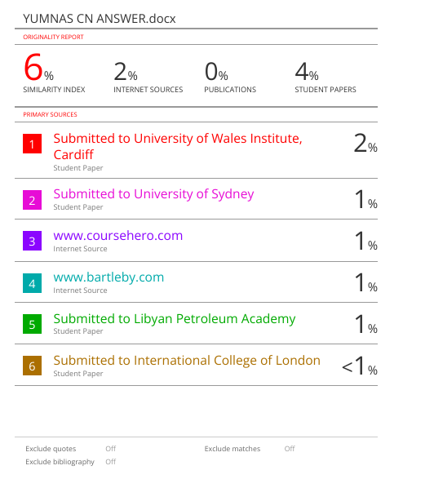

TABLE OF CONTENTS

Contents
COVER PAGE 1
FEEDBACK FORM 2
ACKNOWLEDGEMENT 3
EXECUTIVE SUMMARY 4
TURNITIN REPORT 5
TABLE OF CONTENTS 6
INTRODUCTION 7
TASKS 8
TASK 01: Fundamentals of Networking 8
TASK 02: Network design and IP addressing 10
TASK 03: Network security and Enhancements 12
TASK 04: Networking components and the OSI model 13
CONCLUSION 15
REFERENCES 16

TABLE OF FIGURES
Figure 1 12

TABLE OF TABLES
Table 1 9
Table 2 9
Table 3 12

INTRODUCTION
This report designs a new computer network for GC logistics. The goal is to connect all departments securely so they can work together efficiently. The design follows the rules of using class C IP addresses. To fill in the details not provided, I have made a few practical assumptions to ensure the network will work well in a real office.
Assumptions
- They have mentioned 75 employees in total. So, the number of devices and user accounts is based on the employee count and their listed equipment.
- Out of 75 employees, 8 employees don’t use PCs, so they should be given new circuits.
- All customers have access to real-time traffic updates.
- A domain controller can be used for logins, one file server to share files, and a web server for tracking systems.
- I have used class C, 192.170.5.0 IP for my network diagram.
- A separate LAN network can be used for departments (ISP).
- The number of computer capacities is currently 75, and we are projecting an increase to 100 within six months (Scalability).
- In my network diagram, I inserted a firewall, router, multilayer switch, and finally, to connect wireless devices, I have used an Access point.
- I have used a star topology in my network diagram.
- I have given a detailed calculation of usable IPs and how I assumed the network addresses for each department in task 2 b).

TASKS

TASK 01: Fundamentals of Networking

A computer network is a system of interconnected computers and devices that can communicate and share resources. (comer,d, 2012). These resources include data, applications, and hardware, such as printers and servers.

In a logistics company like GC Logistics, the computer network is like the brain and nervous system. It is essential because:

- Real-time tracking: By tracking packages live, all our teams have the same up-to-date information. This can solve the issue faster and inform customers exactly where their cargo is.
- Operational Efficiency: Using one shared system means all our teams have instant access to the same facts. This prevents mistakes and keeps everyone coordinated (Limoncelli, T., Hogan, C.J. and Chalup, S.R. , 2017).
- Centralized data management: By automating data sharing, we avoid slow, error-prone manual work. This gets cargo through customs and into plans much faster, which is critical for meeting tight deadlines (Kurose, J. & Ross, K., 2014).

Network type | Full name | Area covered | Main usage | Examples
LAN | Local area network | A single building | To connect devices in a small area for fast sharing of files, printers, and applications. | The network connects all devices within GC Logistics’ main logistics operation hub (comer,d, 2012).
WAN | Wide area network | A country | To connect LANs and MANs over long distances, often using third-party infrastructure. | The network connecting GC Logistics’ MLOH in Cardiff to its international offices and airport hubs around the word (Kurose, J. & Ross, K., 2014)
MAN | Metropolitan area network | A city | To connect multiple LANs across a city to share resources regionally. | A network connecting all GC Logistics warehouses and offices across the city of Cardiff (Tanenbaum, A.S. and Bos, H., 2015)
Table 1

Topology | Description | Advantage | Disadvantage
Bus | All devices connect to a single central cable. | Simple and cheap to set up for a very small network. | If the main cable fails, the entire network goes down (Lowe, D. , 2018)
Ring | Devices are connected in a circle; each connected to two others. | Data flows in one direction, reducing packet collisions. | If one device or cable fails, it can break the entire loop and stop the network (Roberts, R.M. and Easttom, C, 2020)
Star | All devices connect to a central device, like a switch. | Reliable: A single cable failure only affects one device. Easy to manage. | The central device is a single point of failure. If it fails, the network goes down.
Mesh | Every device is connected directly to every other device. | Highly reliable: multiple paths for data. If one link fails, traffic reroutes. | Very expensive and complex to set up and manage due to many connections (Tanenbaum, A.S. and Bos, H., 2015)
Table 2
Selection for GC Logistics
Most suitable topology: Star topology
Most suitable network type: LAN (with a client-server

Justification:
Star topology is the best choice for GC logistics for several key reasons:
- It is easy to control because everything connects to a central switch.
- It is reliable. If one computer breaks, it does not shut down the other departments (Tanenbaum, A.S. and Bos, H., 2015).
- This lets departments work on their own but still be part of the same company network.

The client-server LAN network is also the best type because it stores all important data on a few central servers, which are managed by the IT team. This is secure and makes it easy for all employees to get the information they need.
(word count – 561)

TASK 02: Network design and IP addressing
- The network utilizes a hierarchical distribution access model for improved scalability, manageability, and security. The central core switch facilitates fast data flow, while local departmental switches connect devices within each department.

- Access Layer:
- Each department has its own network with switches serving as central connection points.
- Distribution Layer:
- A multi-layer switch connects all departments, while the router directs data appropriately. The firewall blocks unauthorized traffic.
- Core Layer:
- The core switch links all departments at high speeds.

A logical IP addressing scheme is vital for an efficient network, offering the following advantages:

- Easy Management: IT staff can quickly identify device locations by IP address.
- Speed: Routers and firewalls can make fast decisions based on defined subnets.
- Security: Policies can isolate departments and control traffic, preventing, for example, warehouse access to IT servers.
- Scalability: The plan allows for future expansion to support up to 100 devices.

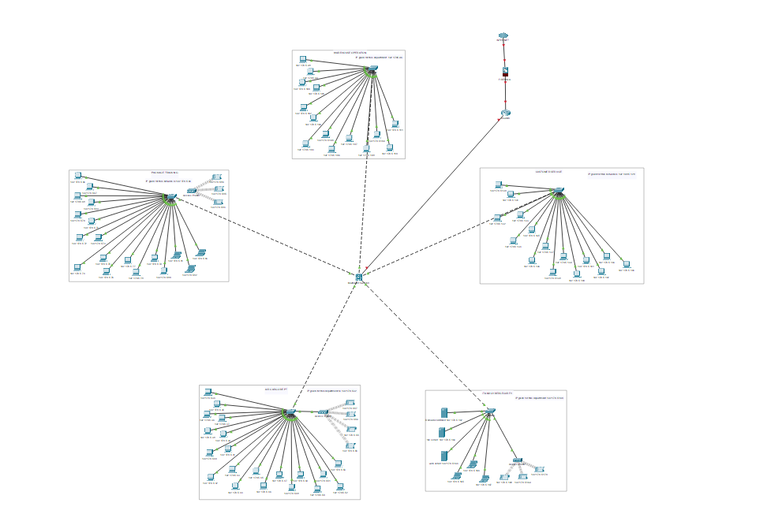Figure 1
- Using the class C private address range 192.170.5.0, we create subnets for each department. As per my assumptions, employees without PCs will be provided with a new switch, and the IT department will manage the server infrastructure.

Department | No of devices | Network address | Broadcast address (NA – 1) | Default gateway | Subnet mask | Usable address
Air cargo control | 24 | 192.170.5.32 | 192.170.5.31 | 192.170.5.33 | 255.255.255.224 | 192.170.5.33-192.170.5.62
Package tracking | 21 | 192.170.5.64 | 192.170.5.63 | 192.170.5.65 | 255.255.255.224 | 192.170.5.65-192.170.5.94
Warehouse operations | 14 | 192.170.5.96 | 192.170.5.95 | 192.170.5.97 | 255.255.255.224 | 192.170.5.97-192.170.5.126
Customer service | 15 | 192.170.5.128 | 192.168.5.127 | 192.168.5.129 | 255.255.255.224 | 192.170.5.129-192.170.5.158
IT and cyber security | 9 | 192.170.5.144 | 192.168.5.143 | 192.168.5.145 | 255.255.255.240 | 192.170.5.145-192.170.5.158
Table 3
The air cargo control department, package tracking department, warehouse operations department, and customer service department have 24 devices, so I assumed 2^5, which gives 32 bits as host bits, and which gives 255.255.255.224 as a subnet mask. (256 – 32 = 224). The IT and cybersecurity department holds 9 devices, so I took it as 16 bits according to the subnet. So, 2^4 = 16, which is the block size. Subnet mask of this department will be 255.255.255.240(256-16 = 240).
(Word count =325)

TASK 03: Network security and Enhancements
- We need multiple layers of security to keep sensitive cargo and customer data safe from leaks and unauthorized access.

- Encrypt all sensitive data on the file server. This protects the information even if the server is stolen (Roberts, R.M and easttom,c, 2020).
- Think of HTTP as sending a postcard. Anyone who handles it can read the message. HTTPS is like sending a letter in a locked armored truck. Even if someone intercepts it, they can’t read what’s inside. This protects data from eavesdroppers on your internal network.
- When you use a public internet connection (like at a coffee shop), it’s like shouting your private messages across a crowded room. A VPN is like putting a secure, private tube between you and your office. You whisper your message into the tube, and no one in the room can hear it. It creates a safe, encrypted tunnel for all your internet traffic (Kurose, J. & Ross, K., 2014).
- Give each employee a key that only opens the doors they need for their work. For example, a warehouse worker doesn’t need the key to the finance office. This way, if a worker's key is lost or misused, only a small part of the company is at risk, not everything. This is called the “least privilege” rule (Limoncelli, T., Hogan, C.J. and Chalup, S.R. , 2017).

- Proposed upgrades and advanced technologies, hardware, and software upgrades

- Next-Generation Firewall: Inspects data packets for hidden threats like viruses or hacking attempts, improving security beyond just checking addresses (Lowe, D. , 2018).
- Unified Threat Management: Combines antivirus, spam blocking, and intrusion prevention into a single, easy-to-manage system.
- VPN Connectivity: Enables secure connections for remote employees, maintaining network security without compromising access (Kurose, J. & Ross, K., 2014). I have introduced a VPN token system for employees working from home. We are adding a special number that changes frequently to their password, making it much harder for hackers to gain access.
- No more downtime (Failover connection): we are getting a backup internet line. If one stops working, it instantly switches to another, so no one gets kicked off, and no work is lost.
- Copies of everything (server backup and cloud): We will have a second server that is an active copy of the main one. If the main server has a problem, the backup takes over immediately. We will also save everything to the clouds for extra safety.
- Real-Time Monitoring: Alerts the IT team to issues instantly and analyzes security logs for the detection of complex attack patterns (Limoncelli, T., Hogan, C.J. and Chalup, S.R. , 2017).
- Zero Trust Architecture: Verifies every user and device each time they access files or applications, enhancing security by not trusting anyone by default. This stops threats that come from inside the company, which are very common (Roberts, R.M. and Easttom, C, 2020).
These upgrades will be expensive, but they are worth it to keep our company’s information safe and our systems running without problems.
(word count – 469)

TASK 04: Networking components and the OSI model
- The OSI model outlines seven layers that govern how devices communicate over a network, facilitating independent operation and troubleshooting. Key points include:
- Application Layer: User-facing layer; utilizes HTTPS for data encryption, DNS for address resolution, and SFTP for secure file transfers.
- Transport Layer: Manages data delivery; TCP ensures complete delivery of crucial data, while UDP is preferred for real-time tracking.
- Network Layer: Responsible for addressing and routing; IP assigns unique addresses, and ICMP is used for diagnosing connectivity issues.
- Data Link Layer: Manages local networks; Ethernet provides wired connections, and ARP locates specific device addresses (Kurose, J. & Ross, K., 2014).
The choice of protocols affects hardware, with routers directing internet traffic, firewalls securing networks, and switches managing data flow internally. All these elements rely on physical cables and Wi-Fi access points for data transmission.
- Together, these devices create a secure, efficient, and flexible network that supports all daily operations.
- Router: The front door to the internet. It enables the company to communicate with partners and customers worldwide for tracking packages and sending emails (Lowe, D. , 2018).
- Firewall: A security guard for the network. It blocks hackers to protect customers' and cargo information.
- Core switch: The network’s main meeting point. It connects all departments so they can share information quickly.
- Departmental switches: A team connector. It links all computers in one department for fast, internal teamwork.
- Wireless access point: A Wi-Fi creator. It lets mobile devices connect to the internet without cables.
(word count – 245)

(task 1–4-word count = 1600)

CONCLUSION
The report outlines a plan for a new computer network at GC Logistics aimed at connecting various departments with seamless and secure collaboration. Key elements include:
1. Network Design: A star topology supported by a client-server system for reliability and centralized data management.
2. IP Addressing: A structured logical system that assigns clear addresses to devices, enhancing organization and scalability.
3. Security Measures: Implementation of multiple protection layers, including data encryption, secure connections, and access controls to safeguard sensitive information.
4. Physical Equipment: Integration of routers, firewalls, and switches to create a cohesive networking system.
Overall, the network design aims to improve teamwork, enhance customer tracking reliability, and provide a secure foundation for future growth.

REFERENCES
comer,d, 2012. Computer Networks and Internets. 5th ed. boston,MA: Pearson Education.
Kurose, J. & Ross, K., 2014. Computer Networking: A Top-Down Approach. 6th ed. Boston, MA: Pearson Education.
Limoncelli, T., Hogan, C.J., and Chalup, S.R., 2017. Practice of System and Network Administration, Volume 1. 2nd ed. Boston, MA.: Addison-Wesley.
Lowe, D., 2018. Networking All-in-One For Dummies. 7th ed. Hoboken, New Jersey: John Wiley & Sons, Inc.
Roberts, R.M. and Easttom,c, 2020. Networking fundamentals. 1st ed. Tinley Park, IL: The Goodheart-Willcox Company, Inc.
Tanenbaum, A.S. and Bos, H., 2015. Modern Operating Systems.. 4th ed. Harlow, England.: Pearson Education.

