Cover page
Qualification |  | Module name and title
Higher diploma in computing and software engineering |  | CSE4005  Database Design and Development
Student name and ID |  | Assessor
Yumna Faris  KD/HDCSE/CMU/81/18 |  | Mr. Gihan Herath
Handout date |  | Submission date
2025.12.24 |  | 2026.01.05
Assessment type  WRTI 1 | Duration/ length of assignment  3000 WORD | Weighting of assessment  100%

Learner declaration
I, Yumna Faris, certify that the work submitted for the assignment is my own and that research sources are fully acknowledged.

Marks awarded
First assessor
IV marks
Agreed grade
Signature of the assessor
Date

Feedback form
Module:
Assessor:
Assignment:
Strong feature of my work:

Marks awarded:

Areas of improvement:

Acknowledgment
I would like to thank Cardiff Metropolitan University from the bottom of my heart for allowing me to study here. I like the tools and support the institution provides to students like me, and I think its learning system is excellent.
I am especially grateful to the professors at ICBT for their support and direction during my course. My educational experience has been much improved by the teachers' and staff's unwavering support. I would especially like to thank Gihan Herath, my professor, for being such an excellent lecturer. He made the module much easier to follow, answered all my questions, and provided comprehensive explanations. His help and patience are greatly appreciated.
Above all, I want to express my gratitude to my parents for their unwavering support and belief in me. I wouldn't have made it this far without their efforts and affection. I sincerely appreciate all that they have done for me.
I appreciate everyone's participation in my career.

Executive summary
The report outlines the design, construction, and testing of a database system for a University Course Registration System to assist Global University in managing its academic operations. The database includes key tables such as Department, Course, Instructor, Student, Semester, and Branch, along with connecting tables to handle complex relationships, like Branch_Department and Student_Course. A step-by-step approach was followed, starting with the relational model, creating an Entity Relationship Diagram, and normalizing the design before implementation in SQL Server. Important search queries were developed and tested to ensure system functionality. A comprehensive testing plan verified rule enforcement, table connections, and query accuracy, resulting in a reliable database for managing course registrations and academic records.

Turnitin report
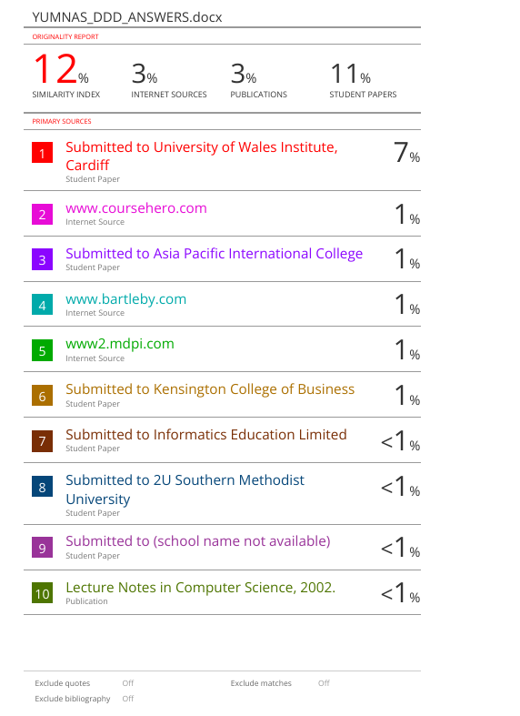

Table of Contents
Contents
Cover page 1
Feedback form 2
Acknowledgment 3
Executive summary 4
Turnitin report 5
Introduction 7
Tasks 8
1. Data Models. 8
a. Definitions. 8
b. Comparison. 8
c. Reason for replacement. 9
2. Entity relationship diagram. 10
a. Image of ERD. 10
3. Relational schema and Normalization. 11
a. Relational schema 11
b. Normalization. 16
4. Database implementation. 18
5. SQL queries. 22
6. Test plan, test strategy, and test cases. 24
Conclusion 30
References 31

Table of tables
Table 1 10
Table 2 27
Table 3 27
Table 4 28
Table 5 28
Table 6 29
Table 7 29
Table 8 30

Table of figures
Figure 1 11
Figure 2 13
Figure 3 14
Figure 4 14
Figure 5 15
Figure 6 16
Figure 7 16
Figure 8 17
Figure 9 19
Figure 10 20
Figure 11 20
Figure 12 21
Figure 13 21
Figure 14 22
Figure 15 22
Figure 16 23
Figure 17 23
Figure 18 24
Figure 19 24
Figure 20 25

Introduction
The text discusses a project aimed at developing a structured database solution for Global University to manage academic data, including student enrollments and course registrations. The project's primary objective is to create a University Course Registration System by applying database design principles. It covers the entire database lifecycle, including conceptual modeling, logical design, physical implementation, and testing. Key tasks involve comparing data models, creating an ERD, mapping it to a normalized schema, implementing the database in SQL Server, writing complex SQL queries, and developing a comprehensive test suite. The report documents the process and demonstrates competencies in data modeling, SQL programming, and quality assurance.

Tasks

Data Models.

Definitions.
A data model is a blueprint that defines the structure, relationships, and constraints for data in a database. It outlines what data is stored, how it links together, and the rules it must follow. (Ramez Elmasiri & Shamkant B. Navathe, 2015). It reduces complexity by focusing on what the data represents, rather than the details of its storage on a disk. (Raghu Ramakrishnan & Johannes Gehrke, 2002). By providing a logical structure, data models are essential for efficient organization, retrieval, and management of data. (Colin Ritche, 2006).

Comparison.
Criteria | Relational | Hierarchical | Network | Object oriented | Object relational | No SQL
Structure | Tables | Tree structure | Graph structure | Object & class | Tables and objects (Ramez Elmasiri & Shamkant B. Navathe, 2015). | Key values and documents (Colin Ritche, 2006).
Data relationship | Tables are linked when they share matching data values in specific columns (Colin Ritche, 2006). | Parent records directly point to their children. | A child record can have multiple parents pointing to it. | Objects link directly to other objects, just like in code. | It uses both foreign keys and object links. | It keeps all related data together in one place (Raghu Ramakrishnan & Johannes Gehrke, 2002).
Flexibility | We must define the structure first; it's strict but reliable. | Changing the structure is very hard and often breaks things. | It is harder to change than a tree, but still very difficult (Ramez Elmasiri & Shamkant B. Navathe, 2015). | Very flexible and perfect for complex data. | More flexible than basic tables, but still have rules. | We can store data now and figure out the structure later.
Ease of modification | Changing the table structure is difficult (Colin Ritche, 2006). | It is tough to modify; it often breaks the system. | Difficult to change due to complex connections. | Easy to add new data types. | Moderately difficult; mixing tables and objects is complex. | Very easy to change; no fixed structure to worry about.
Query language | Uses simple, standard SQL. | Requires complex, step-by-step navigation. | Requires complex navigation through the web. | Use a special object query language (Ramez Elmasiri & Shamkant B. Navathe, 2015). | Uses a modified version of SQL. | Uses simple custom commands.
Primary use case | Standard business applications like banking | Old legacy systems, like manufacturing bills | Complex systems like circuit design. | Complex applications like CAD software. | Apps need both tables and objects. | Modern web apps and big data (Raghu Ramakrishnan & Johannes Gehrke, 2002).
Table 1

Reason for replacement.
Modern data requirements have outgrown the capabilities of older models. To handle the data explosion from IoT and social media, the industry has adopted horizontally scalable systems. Older databases couldn’t scale in this manner, but newer NoSQL systems, such as MongoDB and Cassandra, could (Raghu Ramakrishnan & Johannes Gehrke, 2002). Today’s data types are unstructured and don’t work with old, fixed-format systems. New databases were more flexible, allowing data to be structured when it’s used, not when it’s stored (Ramez Elmasiri & Shamkant B. Navathe, 2015). Old methods make complex queries slow. New SQL methods make them fast and scalable. For these reasons, newer systems are replacing the old ones.

Entity relationship diagram.

Image of ERD.
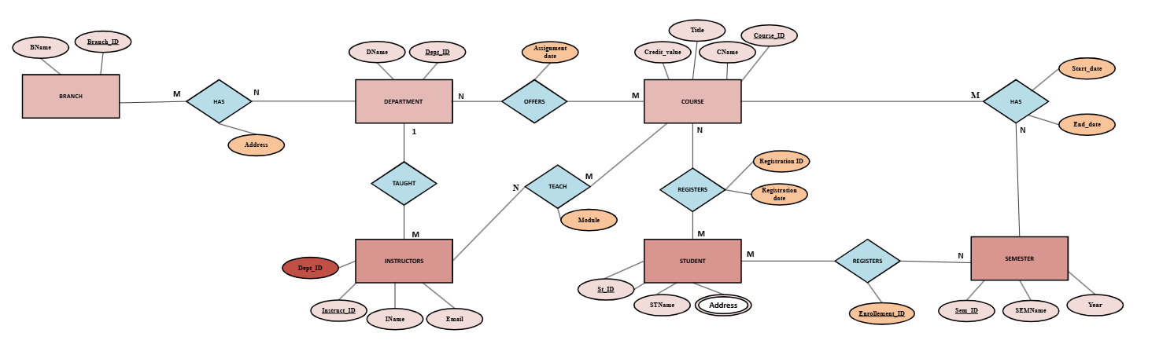
Figure 1
Assumptions
Entities: Department, Course, Instructors, Student, Semester, Branch
Attributes;
- Department: Dep_ID (Primary key), DName, Location.
- Course: Course_ID (Primary key), CName, Title, Credit Value.
- Instructors: Instruct_ID (Primary key), IName, Email, Dep_ID.
- Student: St_ID (Primary key), STName, Address.
- Semester: Sem_ID (Primary key), SEMName, Year.
- Branch: Branch_ID (Primary key), BName
- Student_Course: St_ID (Primary key), Course_ID (Primary key), Registration_ID, Registration_Date.
- Branch_Department: Branch_ID (Primary key, Dep_ID (Primary key), address.
- Department_Course: Dep_ID (Primary key), Course_ID (Primary key), assignment date.
- Instructor_Course: Instruct_ID (Primary key), Course_ID (Primary key), Module.
- Course_Semester: Course_ID (Primary key), Sem_ID (Primary key), Start date, End date.
- Student_Semester: St_ID (Primary key), Sem_ID (Primary key), enrollment date.
Relationships;
- Department - Course (M: N).
- Department - Instructor (1:M).
- Course - Instructor (M: N).
- Course – Student (M: N).
- Course- Semester (M: N).
- Student -Semester (M: N).
- Branch - Department (M: N)

Relational schema and Normalization.

Relational schema
Mapping from the ERD to the relational schema is as follows:
This color indicates a primary key

Step 1; Strong entities
- Department table
Dept_ID | DName | Location
- Instructor table
Instruct_ID | IName | Email
- Course table
Course_ID | CName | Title | Credit value
- Student table
St_ID | STName | Address | Enrollment date
- Semester table
Sem_ID | SEM Name | Year
- Branch table
Branch_ID | BName

- Student_Address (Multivalued)
Primary key = St_ID + Address
St_ID | Address

Student

Step 2; 1:M mapping
- Department: Instructor
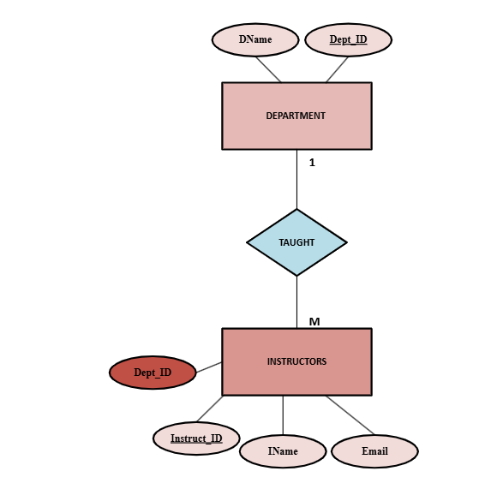
Figure 2

Department
Dept_ID | DName | Location
Instruct_ID | IName | Email | Dept_ID
Instructor

Department

Step 3: M: N mapping
- Branch: Department
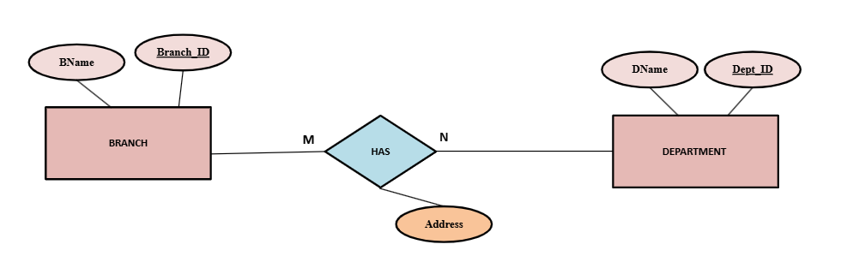
Figure 3
Branch
Branch_ID | BName
Department
Dep_ID | DName

Branch_ID | Dep_ID | Address

Branch Department
- Department: Course
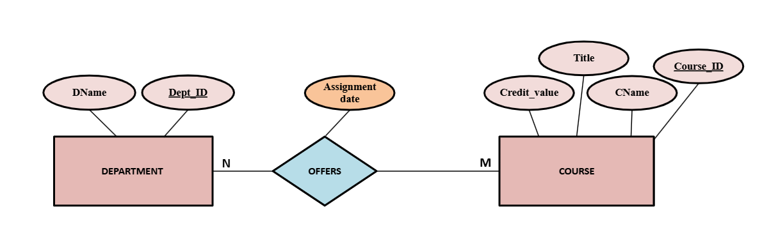
Figure 4

Department
Dep_ID | DName
Course
Course_ID | CName | Title | Credit value
Department_Course
Dep_ID | Course_ID | Assignment date

Department Course
- Instructor: Course
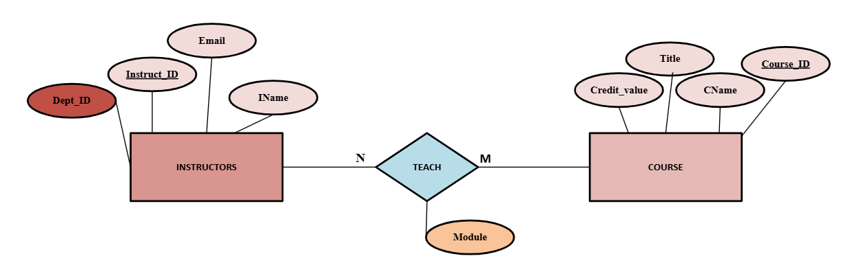
Figure 5

Instructor
Instruct_ID | IName | Email | Dep_ID

Department
Course
Course_ID | CName | Title | Credit value
Instructor_Course
Instruct_ID | Course_ID | Module

Instructor Course
- Student: Course
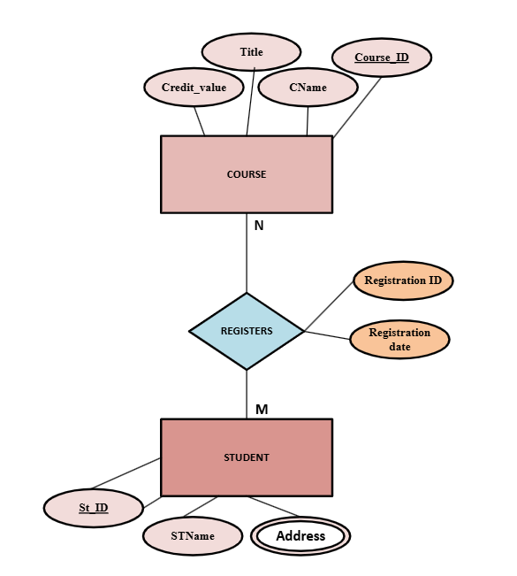
Figure 6
Course
Course_ID | CName | Title | Credit value
Student
Student_ID | STName
Student_Address
Student_ID | Address

Student
Course_Student
Course_ID | Student_ID | Registration_ID | Registration Name

Course Student

- Course: Semester
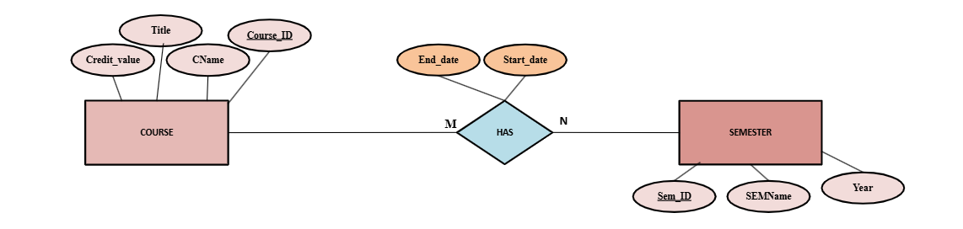
Figure 7
Course
Course_ID | CName | Title | Credit value
Semester
Semester_ID | SEMName | Year
Course_Semester
Course_ID | Semester_ID | Start date | End date

Course Semester
- Student: Semester
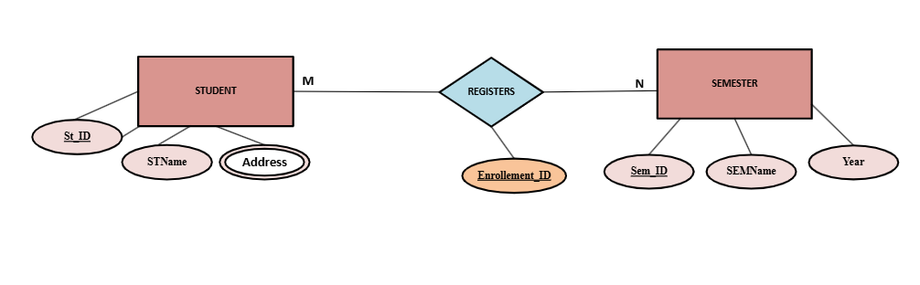
Figure 8
Student
St_ID | STName
Student_Address
St_ID | Address
Semester
Sem_ID | SEMName | Year
Student_Semester
St_ID | Sem_ID | Enrollment_ID

Student Semester

Normalization.

1NF – no multivalued or composite allowed.
Student
St_ID | STName
Student_Address (Multivalued)
St_ID | Address
Course
Course_ID | Title | Credit value
Instructor
Instruct_ID | IName | Email | Dept_ID
Department
Dept_ID | DName | location
Semester
Sem_ID | SEMName | Year
Branch
Branch_ID | BName
Branch_Department (M: N)
Branch_ID | Dep_ID | Address
Student_Course (M: N)
St_ID | Course_ID | Registration date
Department_Course (M: N)
Dep_ID | Course_ID | Assignment date
Instructor_Course (M: N)
Instruct_ID | Course_ID | Module
Course_Semester (M: N)
Course_ID | Sem_ID | Start date | End date
Student_Semester (M: N)
St_ID | Sem_ID | Enrollment ID
No repeating groups.
- Each column contains atomic values.
- Multivalued attributes are correctly assigned separately.

2NF – It must be in 1NF and have no partial dependency on the key.
A functional dependency exists when any column can depend on the primary key.
A partial dependency exists when a non-prime attribute is functionally dependent on part of a candidate key.
- Department
Dept_ID {DName, Location} Functional dependent.
- Instructor
Instruct_ID {IName, Email, Dept} Functional dependent.
- Course
Course_ID {CName, Title, Credit value} depends fully on the primary key.
- Student
St_ID {STName, Enrollment date} functional dependent.
- Semester
Sem_ID {SEMName, Year} functional dependent.
- Student_Course
St_ID, Course_ID {Address} functional dependent.
Composite Primary key = St_ID, Course_ID. So, the address depends on both St_ID and Course_ID.

3NF- It must be in 2NF and no transitive dependencies.
A transitive dependency occurs when an indirect relationship causes functional dependency.
- Course
Course_ID CName, title, credit value – no transitive dependency.
- Instructor
Instruct_ID IName, Email, Dept_ID – Dept_ID is a foreign key, not a transitive dependency.
- Department
Dep_ID DName, location – both depend directly on the primary key.
- Student
St_ID STName, Enrollment date – no transitive dependency.
According to my tables given here, there are no transitive dependencies. All tables satisfy 3NF.

Database implementation.

Tables
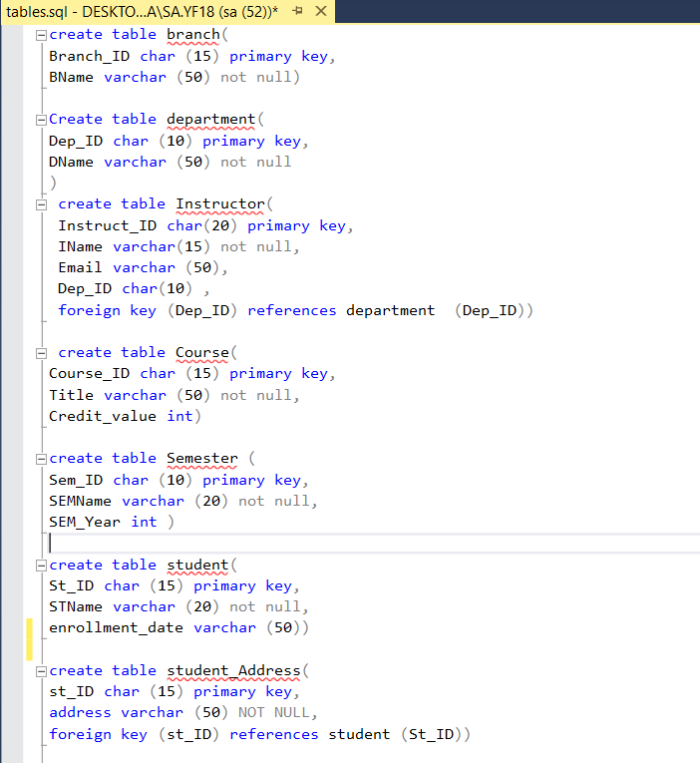
Figure 9
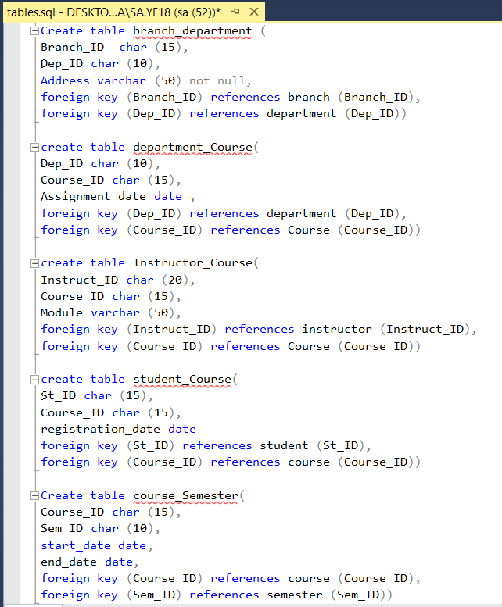
Figure 10

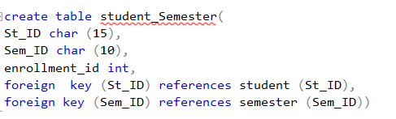
Figure 11

Records
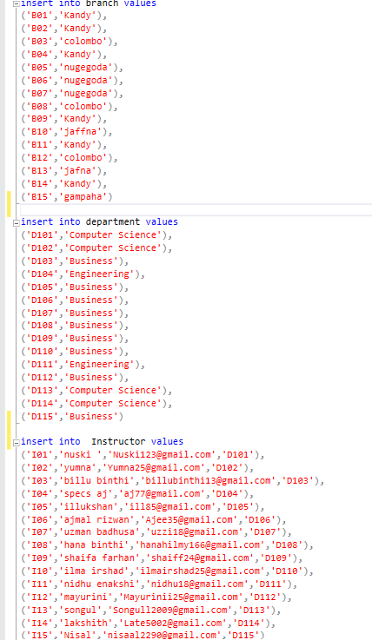
Figure 12
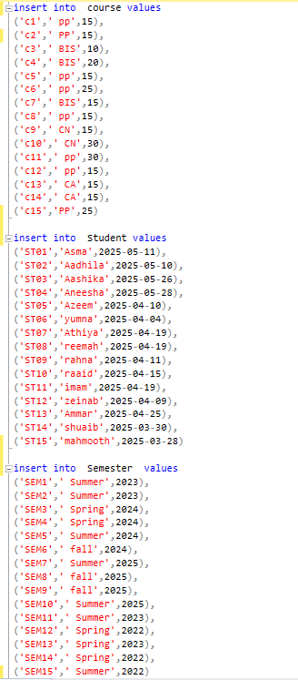
Figure 13
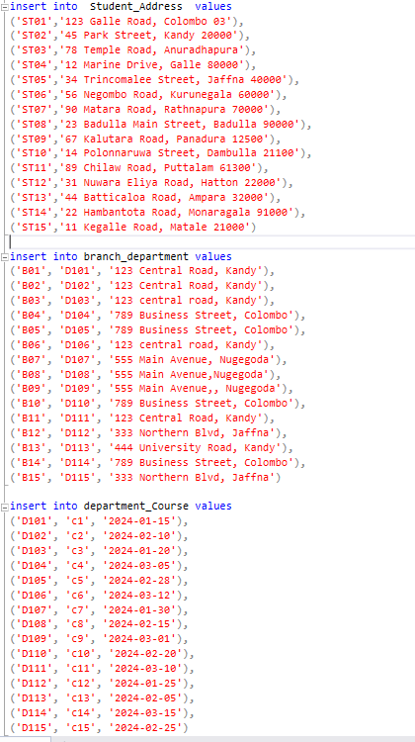
Figure 14
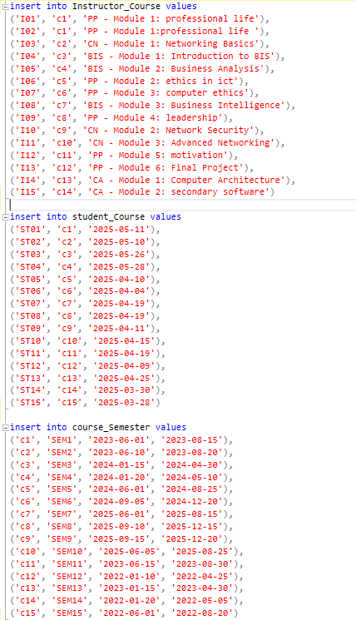
Figure 15

SQL queries.

Retrieve the list of all available courses.
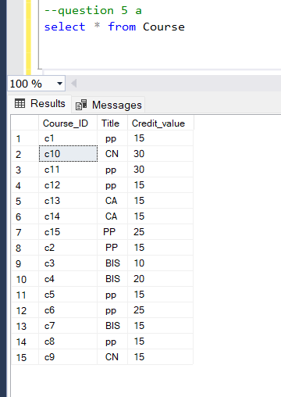
Figure 16

Find all students enrolled in the computer science department.
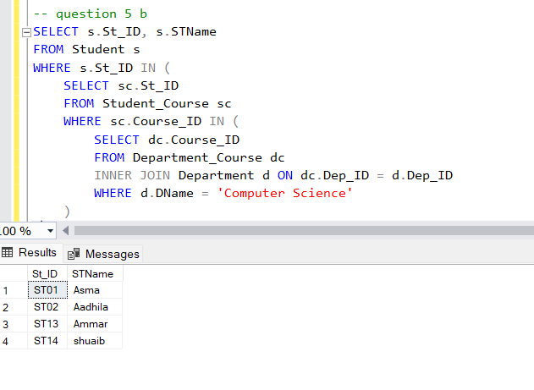
Figure 17

Display courses along with their assigned instructors.
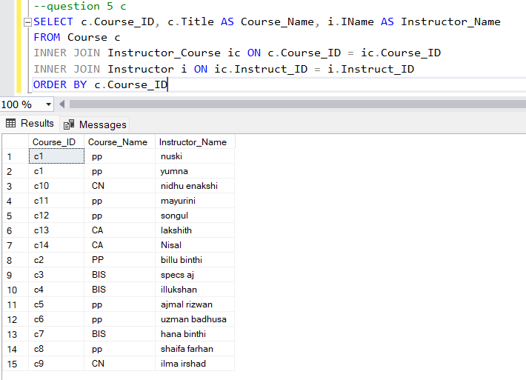
Figure 18

Count how many students registered for each course.
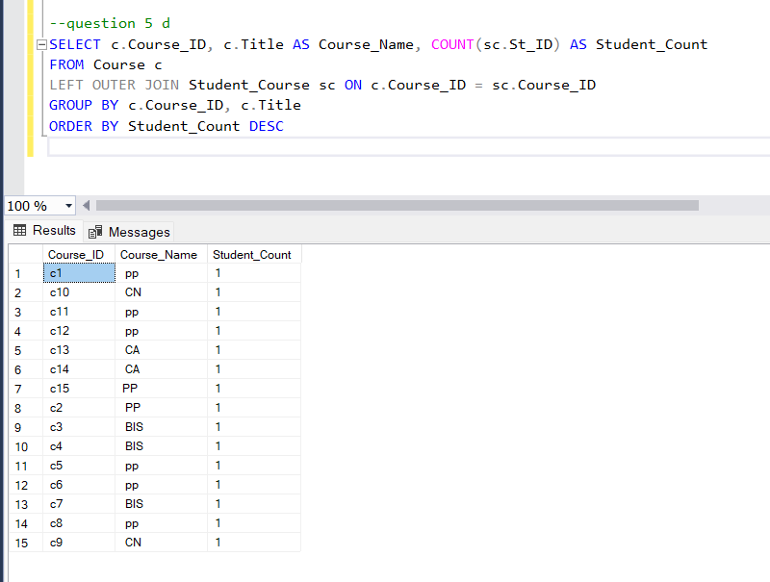
Figure 19

List of students who have registered for all courses offered by the IT department
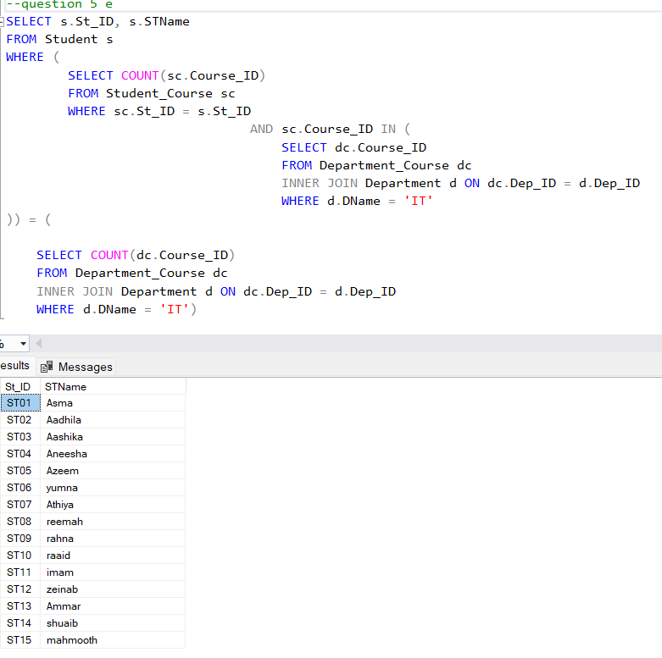
Figure 20

Test plan, test strategy, and test cases.

Test plan
- Objectives:
  - To verify the correct implementation and enforcement of all data integrity constraints, ensuring the database prevents invalid data entry and maintains logical consistency across all tables (Colin Ritche, 2006).
  - All logical data model relationships must be validated in the physical schema. This includes confirming the correct implementation of cardinality (1:M, M: N) and ensuring that foreign key constraints are actively enforcing referential integrity to prevent records (Ramez Elmasiri & Shamkant B. Navathe, 2015).
  - Execute and validate all defined SQL queries against controlled datasets to confirm they return accurate and expected results in accordance with business rules.
  - Ensure the database design is normalized to eliminate data redundancy.
  - Conduct performance testing under expected production load conditions.
- Scope:
What will be tested:
- All database tables, like department, course, student, semester, branch, instructor, and all junction tables such as Branch_Department, Department_Course, Instructor_Course, Course_Semester, Student_Semester, Student_Course, Student_Address.
- All constraints like primary keys, foreign keys, not null, unique, and check constraints.
- 1:M, M: N relationships as defined in the ERD.
- 1NF,2NF and 3NF requirements are tested.
- All five required SQL queries with various test scenarios.
What will NOT be tested:
- User experience.
- Network security.
- backup and recovery procedures.
- Multi-user concurrency and locking mechanisms.
- Database server performance tuning or optimization (Ramez Elmasiri & Shamkant B. Navathe, 2015)
- Resources:
- SQL Server Management Studio 2016 is used.
- Risks:
- Risk of unintentional production data alteration during testing.
- Insufficient performance under realistic data volumes.
- Incomplete validation of all functional requirements.
- Non-production environment inconsistencies.
- Schedule limitations restricting comprehensive validation (s. Esakkirajan, sumathi, 2007).
- Entry and exit criteria
When can testing begin:
- Database schema creation scripts are complete and verified.
- Test cases are documented and reviewed.
- Sample test data is prepared and validated.
When testing is complete:
- All planned test cases have been executed.
- All SQL queries return correct results as per requirements.
- Test summary report is completed and signed off.

Test strategy
The validation strategy follows an incremental path:
- Black box testing: It validates the database’s external behavior against its requirements and business logic, without relying on knowledge of its internal implementation (s. Esakkirajan, sumathi, 2007). Using black box methodology, testing focuses on the database’s specified functionality. Test cases are designed based solely on requirements, independently of the internal schema.
- White box testing: this approach leverages knowledge of the database’s internal schema and logic to conduct targeted validation (Colin Ritche, 2006). This internal testing approach is on three core activities. First, it validates that all database objects are built as designed. Second, it tests every logical route within SQL code to ensure full coverage. Finally, it methodically checks each implemented constraint to guarantee data integrity.
- Incremental testing: this testing plan builds from the ground up, starting with small pieces and moving on to the whole system.
  - Unit testing: First, I tested every single part of the database, like each table and the basic save function by itself, to make sure it works correctly.
  - Integration testing: we test how these pieces fit together. I check that the links between tables work and that data flows correctly from one part to another.
  - System testing: Then I tested the entire database working as one unit. I run realistic research and operations to see if they meet all the needs and can handle typical use.
This step-by-step method makes sure every small part is solid before testing the bigger connections. It uses different testing styles, like checking the internal code and testing from a user’s perspective, to catch all types of problems, leading to a strong and reliable database.

Test cases
  - Test 1
Test id | Test 1
Purpose | Verify table creation
Test data | Execute CREATE TABLE scripts for all entities.
Expected result | All tables were created successfully without errors.
Actual result | All 12 tables were created successfully.
Status | Pass
Screen shoot | 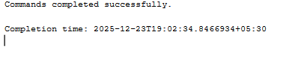
Table 2
  - Test 2
Test id | Test 2
Purpose | Validate primary key constraints.
Test data | Attempt to insert duplicate PK values  create table branch (Branch_ID char (15) primary key,  BName varchar (50) not null)  insert into branch values ('B01',' Kandy'),('B02','Kandy')
Expected result | Second insert fails with primary key violation error.
Actual result | Error: violation of primary key constraint
Status | Pass
Screen shoot
Table 3
  - Test 3
Test id | Test 3
Purpose | Validate NOT NULL constraints
Test data | insert into department values  ('D101',' NULL')
Expected result | Insert fails with “Cannot insert Null” error.
Actual result | Error: “cannot insert the value NULL.”
Status | Pass
Screen shoot | 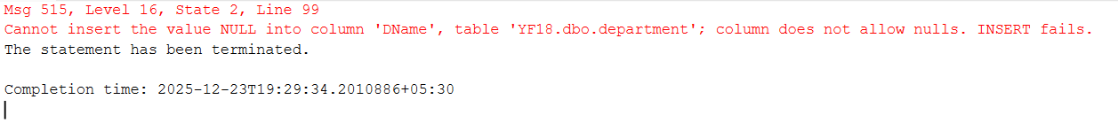
Table 4
  - Test 4
Test id | Test 4
Purpose | Validate foreign key relationships – department to instructor.
Test data | insert into Instructor values  ('I01','nuski ','Nuski123@gmail.com','D119')
Expected result | Insert fails with foreign key violation.
Actual result | Error: Foreign key constraint violation.
Status | Pass
Screen shoot
Table 5
  - Test 5
Test id | Test 5
Purpose | M: N relationship – Student_Course Junction table
Test data | Insert valid records  Student (St_ID)  Course (Course_ID)  Student_Course (St_ID, Course_ID, Registration_Date)
Expected result | The junction table accepts valid foreign key combinations.
Actual result | Records were inserted successfully.
Status | Pass
Screen shoot | 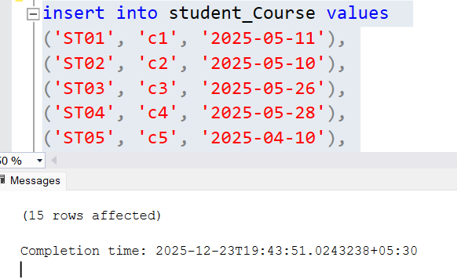
Table 6
  - Test 6
Test id | Test 6
Purpose | Validate data types – credit_Value
Test data | insert into course values ('c1',' pp',' ABC')
Expected result | Insert fails due to a data type mismatch.
Actual result | Error: Conversion failed
Status | Pass
Screen shoot | 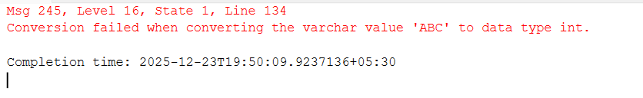
Table 7
  - Test 7
Test id | Test 7
Purpose | Query 1: Retrieve all courses
Test data | select * from Course
Expected result | Returns all 15 course records with correct attributes
Actual result | 15 courses returned with full details
Status | Pass
Screen shoot | 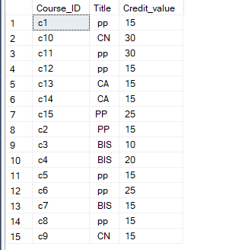
Table 8
  - Test 8
Test id | Test 8
Purpose | Update operations
Test data | UPDATE Student SET STName = 'Updated Name' WHERE St_ID = 'ST01'
Expected result | Single record updated successfully.
Actual result | 1 row affected, name changed.
Status | pass
Screen shoot | 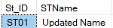  

Conclusion
The University Course Registration System database has been designed and validated following specific requirements. The project involved selecting the relational model, creating an Entity Relationship Diagram, and developing a normalized relational schema compliant with Third Normal Form for data integrity. Implementation was done in SQL Server with rigorous testing through complex SQL queries. Key challenges include designing many-to-many relationships, maintaining normalization while optimizing query performance, and developing a comprehensive test strategy. Lessons learned emphasized the importance of upfront design, clear documentation, and iterative problem-solving in creating reliable database solutions, ultimately enhancing skills in database design, SQL optimization, and validation.

References
Colin Ritche, 2006. relational database principles. 2nd ed. s.l.:cengage learning.
Raghu Ramakrishnan & Johannes Gehrke, 2002. database management system. 3rd ed. s.l.:McGraw-Hill.
Ramez Elmasiri & Shamkant B. Navathe, 2015. fundamentals of database systems. 7th ed. s.l.:pearson.
s. Esakkirajan, Sumathi, 2007. s.l.:Springer-Verlag Berlin Heidelberg.

