Cover page

Qualification |  | Module ID and title
Higher diploma in computing and Software Engineering |  | CSE5012  Project Management module
Student name and ID |  | Assessor
Yumna Faris  KD/HDCSE/CMU/81/18 |  | Mr. Gihan Herath
Handout date |  | Submission date
11.07.2026 |  | 18.07.2026
Assessment type:  WRIT1 | Length of assessment  3000 words | Weighting of assessment  100%

Learner declaration
I, Yumna Faris, certify that the work submitted for the assignment is my own and that research sources are fully acknowledged.

Marks awarded
First assessor
IV marks
Agreed grade
Signature of the assessor
Date

Acknowledgement
I want to thank Cardiff Metropolitan University from the bottom of my heart for allowing me to study here. I like the tools and support the institution provides to students like me, and I think its learning system is excellent.
I am especially grateful to the professors at ICBT for their support and guidance throughout my course. My educational experience has been much improved by the teachers' and staff's unwavering support. I would especially like to thank Mr. Gihan Herath, my professor, for being such an excellent lecturer. He made the module much easier to follow, answered all my questions, and provided comprehensive explanations. His help and patience are greatly appreciated.
Above all, I want to express our gratitude to our parents for their unwavering support and belief in us. I wouldn’t have made it this far without their efforts and affection. I sincerely appreciate all that they have done for me.
We appreciate everyone's participation in my career.

Table of contents
Contents
Cover page 1
Acknowledgement 2
Executive summary 4
Introduction 6
Tasks 7
Task A: Critical comparison 7
1. Introduction 7
2. Comparison of mobile operating systems 7
3. Comparison of development tools and technologies 8
4. Workflow design for Print Xpress 9
5. Conclusion 10
Task B: System Design and Database Design 10
1. Use Case diagram 10
2. Class diagram 11
3. Activity diagram 11
4. Firestore data model 12
5. Design decisions explanation 12
Task C: UI Designs 13
1. Design principles 13
2. Wireframes 13
3. Design explanations 17
Task D: Application development 18
Task E: Test plan and Results 22
1. Test strategy/ test technique 22
2. Test plan 23
3. Test cases 23
4. Test execution summary 27
Task F: User and technical documentation 27
1. User documentation 27
2. Technical documentation 33
Conclusion 34
References 35

Table of tables
Table 1 8
Table 2 9
Table 3 10
Table 4 24
Table 5 25
Table 6 26
Table 7 27
Table 8 28

Table of figures
Figure 1 11
Figure 2 12
Figure 3 13
Figure 4 13
Figure 5 14
Figure 6 15
Figure 7 16
Figure 8 17
Figure 9 18
Figure 10 19
Figure 11 21
Figure 12 21
Figure 13 22
Figure 14 22
Figure 15 23
Figure 16 23
Figure 17 24
Figure 18 24
Figure 19 30
Figure 20 30
Figure 21 31
Figure 22 32
Figure 23 33
Figure 24 34

Executive summary
The project effectively integrates native Android development and Firebase backend services to create a scalable and user-friendly application for the Sri Lankan market.The development lifecycle of PrintXpress, an Android app focused on custom printing services in Sri Lanka, emphasizes strategic choices in platform, tools, and technologies. Android was selected over iOS due to its substantial market share of approximately 82%, making it more accessible for price-sensitive users. The project utilized Android Studio, which provides powerful features for UI design and seamless integration with Firebase, facilitating real-time tracking and user authentication. Key decisions in system design were supported by UML diagrams and NoSQL data models, specifically structured around user, product, and order collections. The app's UI/UX adhered to Google's Material Design guidelines, ensuring a user-friendly experience. A rigorous testing phase validated its functionality, while comprehensive documentation was provided to enhance user and technical understanding. Overall, PrintXpress successfully combines native Android development with robust Firebase backend services, creating a scalable and effective solution tailored for the Sri Lankan market.

Turitin
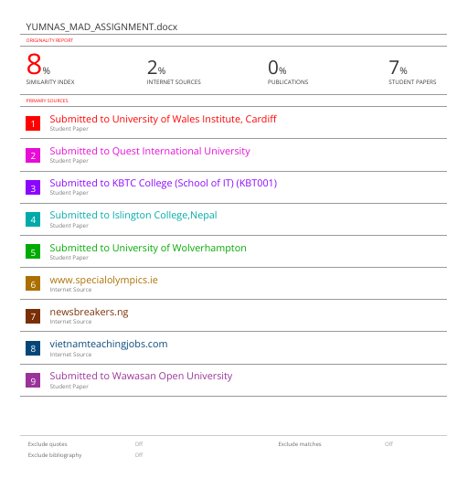

Introduction
The rise of smartphones, especially Android's market dominance in Sri Lanka, offers significant opportunities for small and medium-sized enterprises to enhance customer interaction and operational efficiency. PrintXpress is a mobile application for the custom printing industry, allowing users to browse products, customize orders, and track jobs in real-time. This report details the development lifecycle, including comparisons of mobile operating systems and tools, system design with UML diagrams and a Firestore schema, UI/UX design based on Google’s Material Design, core application functionalities, and a comprehensive testing strategy. Utilizing an Agile methodology, the project combines native Android development and Firebase to create a scalable and cost-effective solution for the Sri Lankan market.

Tasks

Task A: Critical comparison

Introduction
The text discusses the need for careful consideration when developing a mobile application for PrintXpress, with a focus on selecting the appropriate operating system, development tools, and supporting technologies. It compares the two leading mobile OS platforms, Android and iOS, and evaluates their development tools and technologies against project requirements such as scalability, cost, and time to market.

Comparison of mobile operating systems
The two dominant mobile operating systems are Android (developed by Google) and iOS (developed by Apple). Both have distinct characteristics that influence development decisions.
Criteria | Android | Ios
Market share | 71% | 28%
Target audience | Wider demographic, price-sensitive users. | Premium users, higher spending capacity.
Development language | Java /Kotlin | Swift/ Objective-C
Open source | Yes | No
Fragmentation | High – many devices, screen sizes, OS versions | Low – limited devices, uniform ecosystem.
Development cost | Lower (free tools, wide device compatibility) | Higher (Apple developer fee, MAC required)
App store approval | Faster, less restrictive | Stricter, longer review process
Monetization | Google Play Billing | Apple in-app purchase (30% commission)
Push notification service | Firebase Cloud Messaging | Apple push notification service
Security model | Permission-based (user grants permissions) | Sandboxed, more restrictive
Device range | Wide range | Limited to Apple devices
Table 1
- Critical Analysis:
PrintXpress favors Android over iOS due to its 82% market share in Sri Lanka, making it suitable for small businesses and users of mid-range devices. With a $25 one-time registration fee—compared to iOS's $99 annual fee, Android is more cost-effective. It also integrates well with Firebase for real-time tracking and customization. While iOS offers a better user experience, security, and higher spending potential, PrintXpress prioritizes Android for its market dominance and lower development costs..

Comparison of development tools and technologies
Tool | Android studio | Xcode
IDE | IntelliJ-based, feature-rich. | Apple’s IDE is tightly integrated with the iOS SDK.
Emulator performance | Good, supports x86ARM, HAXM acceleration | Excellent, fast on Apple Silicon.
Debugging | Advanced (Logcat, profilers) | Robust (Instruments)
Language support | Java, Kotlin, C++ | Swift, Objective-C, C++
Cost | Free | Free (requires Mac)
CI/CD Integration | Built-in support for Gradle and Firebase. | Integrated with Xcode Cloud
Table 2
- Critical Analysis:
Android Studio is the official IDE for Android and offers powerful tools for UI design, debugging, and performance profiling. Its integration with Firebase (used for authentication and database) is seamless. While Xcode is equally capable, it is restricted to macOS, increasing development costs. For PrintXpress, Android Studio is the optimal choice, given the project’s requirement for native Android development and Firebase integration.
Technology | Options | Justification
Backend database | Firebase Firestore (NoSQL), MySQL (SQL) | Firestore offers real-time synchronization, offline support, and seamless integration with Android, making it great for order tracking and notifications.
Authentication | Firebase Auth, Custom JWT | Firebase Auth allows users to log in using their phone or email. It also supports social media logins. This feature helps make development easier.
Notifications | Firebase Cloud Messaging | Reliable, free, supports push and data messages.
Image storage | Firebase storage, Cloudinary | Firebase Storage works with Firestore to store product images.
Networking | Retrofit (REST), Firestore SDK | The Firestore SDK streamlines CRUD operations by removing the need for REST APIs.
Payment gateway | Stripe, PayHere | PayHere is a Sri Lankan platform that supports local payment methods.
Mapping /Location | Google Maps API, OpenStreetMap | Google Maps API for Order delivery tracking.
Table 3

- Critical analysis:
Firebase offers a comprehensive backend solution through its services (Auth, Firestore, Storage, FCM) that speeds up development and lowers infrastructure costs. It is fully managed, scalable, and supports offline persistence, which is important for users in areas with unreliable connectivity. While there is a risk of vendor lock-in, the maturity and extensive documentation of Firebase mitigate potential drawbacks.

Workflow design for Print Xpress
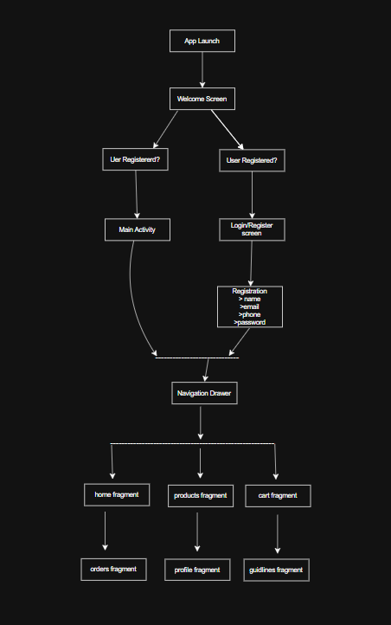
Figure 1
Workflow Explanation:
- App launch: When the user opens the app, they see a welcome screen.
- Registration check: the app checks if the user is already registered using Firebase Authentication’s getCurrentUser () method.
- Existing user: if the User exists and is logged in, they are directed to the Main Activity with the home fragment.
- New user: if the user is not registered, they are prompted to log in or register.
- Registration form: Collects name, email, phone number, and password with validation.
- Main navigation: users can access all features through the navigation drawer: Home, Products, Cart, Orders, Profile, Print Guidelines, Contact Us.
- Order flow: Browse products select productAdd to cartCheckoutplace orderTrack order.

Conclusion
The analysis concludes that Android with Firebase services is the best choice for the PrintXpress application due to its 82% market share in Sri Lanka, which offers broad reach. It is also cost-effective, aligning well with the business model, while Firebase provides essential features like authentication, a real-time database, storage, and push notifications. Additionally, this technology stack is scalable, capable of supporting increasing user numbers and order volumes.

Task B: System Design and Database Design

Use Case diagram
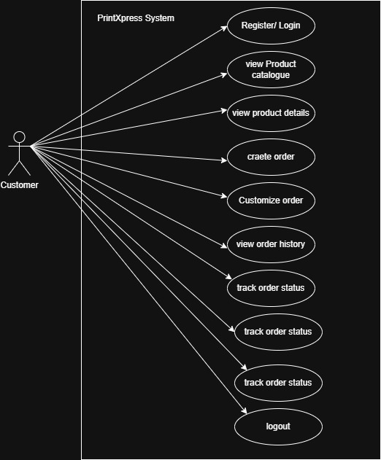
Figure 2

Class diagram
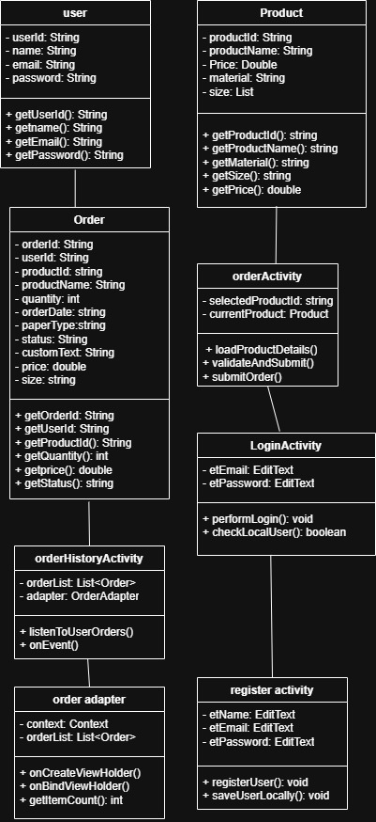
Figure 3

Activity diagram
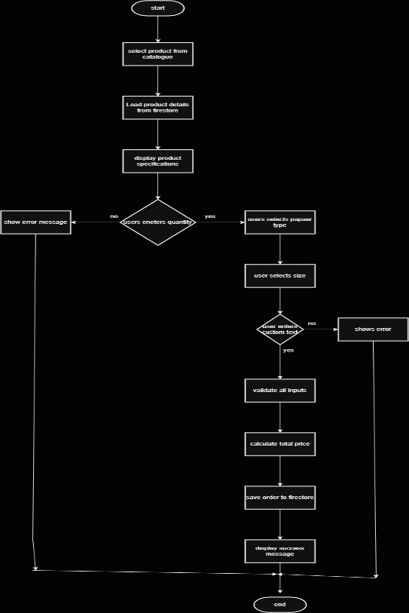
Figure 4

Firestore data model
Firestore organizes data into collections that contain documents, each with fields. There are no tables or relationships in the relational sense; instead, documents can reference each other using document IDs. Below is a tree diagram showing the three main collections used in PrintXpress, along with fields inside each document.
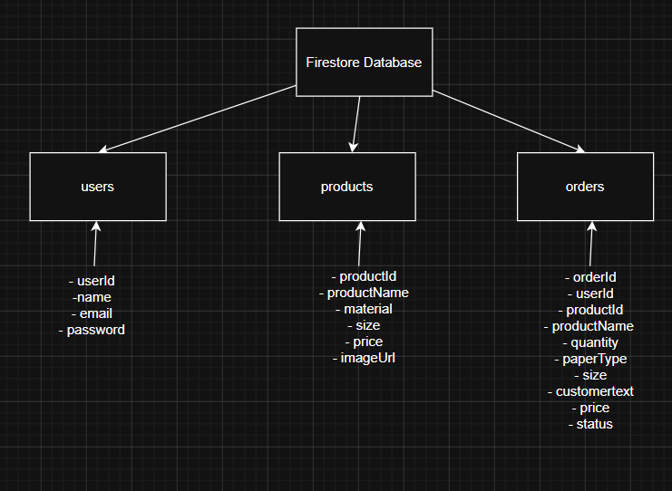
Figure 5
Explanation of the tree structure
- The root is the Firestore database itself.
- Under it are three top–level collections.
- Each collection contains documents identified by a unique ID.
- Inside each document, we have fields with their data types.
- For the orders collection, the fields user_id and productid act as foreign keys. They store the document IDs of the corresponding user and product. This is how Firestore handles references between documents.

Design decisions explanation
- No embedded sub-collections – we keep the collections flat to simplify queries and avoid deep nesting, which is a best practice in Firestore.
- Denormalization – the orders collection stores ProductName directly. This avoids a second read to fetch the product name when displaying order history, improving performance (at the cost of minor data redundancy).
- Document IDs – we use natural keys for products and auto-generated UUIDs for users and orders to ensure uniqueness without relying on sequential IDs.
- Status field – enables real time filtering and colour-coded display in the UI.
This tree diagram accurately represents the schema of a Firestore Nosql database, aligning with the lecturer’s recommendation to avoid ER diagrams for document-based storage.

Task C: UI Designs

Design principles
The PrintXpress UI strictly adheres to Google’s Material Design guidelines to ensure familiarity, accessibility, and a premium feel.
- Material surfaces: Utilizes MaterialCardView for cards, containers, and elevated surfaces to establish visual hierarchy.
- Consistent brand identity: A cohesive colour palette centered around a warm primary yellow, contrasted with charcoal text for readability, and a soft grey background to reduce eye strain.
- Typography hierarchy: clear distinction between headings, body text and metadata guides the user’s eye logically.
- Meaningful feedback: every user action triggers a visual response buttons ripple on touch.

Wireframes
Below are the key UI screens developed in the applications:
- Login screen (activity_login.xml)
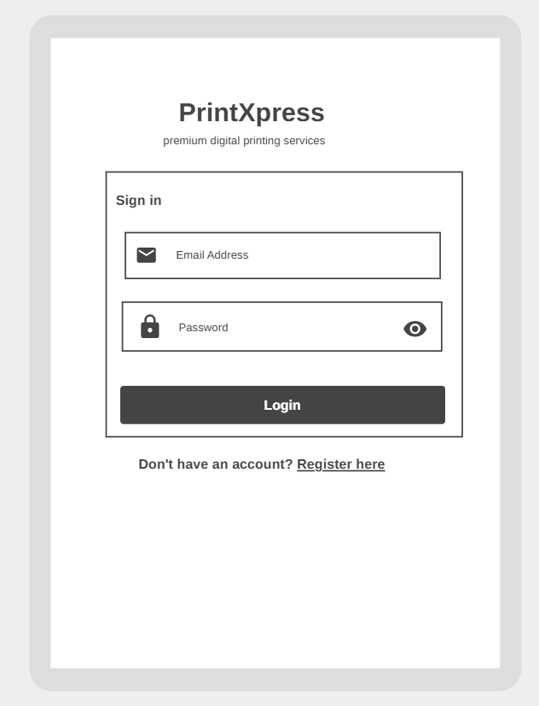
Figure 6
- A scrollable interface showcasing the "PrintXpress" brand title.
- A main MaterialCardView hosting a TextInputLayout for Email and Password, complete with icons on the left.
- A prominent "LOGIN" button in bright yellow.
- An interactive text link at the bottom for new users that says "Register Here."

- Registration screen (fragment_register.xml)
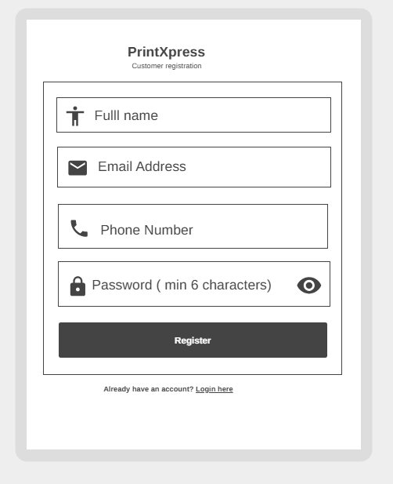
Figure 7
- Card-style design similar to the Login interface.
- Fields for Full Name, Email, Password (minimum 6 characters), and Confirm Password.
- A "REGISTER" button along with a link to return to the Login page.
- Main dashboard (activity_main.xml)
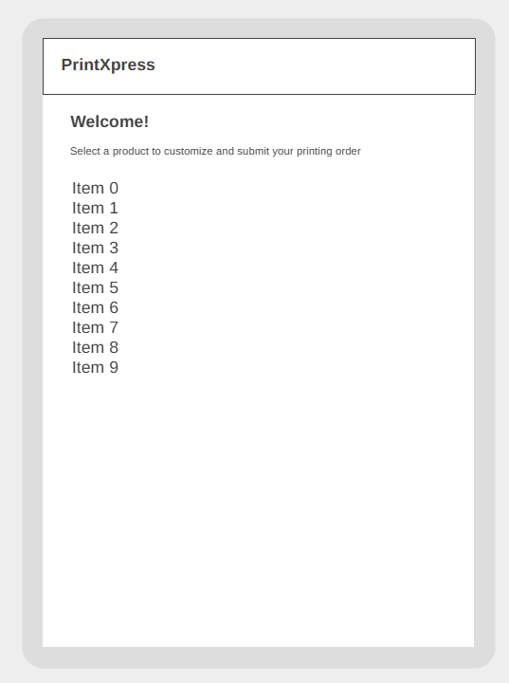
Figure 8
- A customized toolbar displaying the app's title.
- A tailored greeting that says, "Welcome Back, [User]!"
- A vertical RecyclerView that uses Product Adapter for its content.
- Product Item Card (item_product.xml): A horizontal layout featuring an image placeholder on the left and the product name, material, size, and price aligned on the right. The entire card is designed to be clickable.
- Order Customization (activity_order.xml)
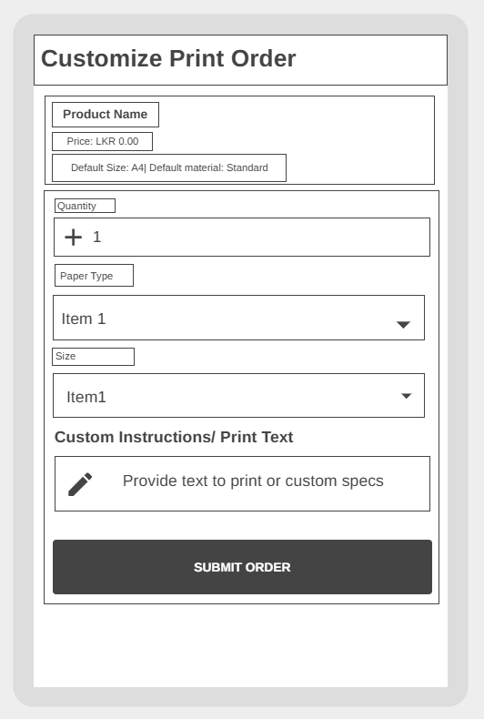
Figure 9
- A navigation bar featuring a back button.
- Product Specifications Card: Shows the name, price, and default specifications of the chosen product.
- Customization Card: Includes an input field for Quantity, dropdowns for Paper Type and Size, and a multi-line input field for Custom Text.
- A prominent "SUBMIT ORDER" button that spans the entire width.
- Order history (activity_order_history.xml)
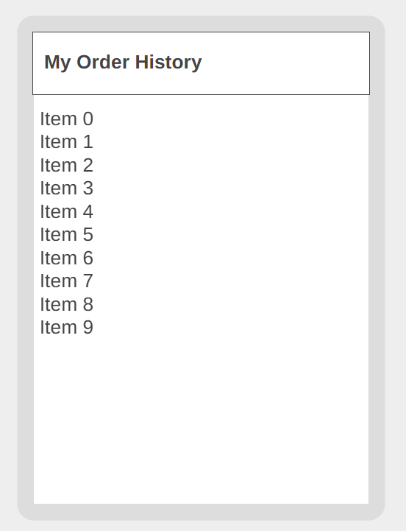
Figure 10
- A toolbar labeled "My Order History."
- A RecyclerView to display orders.
- A Text View for an empty state ("No Orders Found") that shows up when there are no items in the list.
- Order Item Card (item_order.xml): Showcases the product name, a status TextView with color coding, specifications, custom text (shortened), the date, quantity, and total cost.

Design explanations
- Why Use Cards? Cards, specifically MaterialCardView, are utilized for displaying products and orders by grouping related information into easily digestible sections. The elevation (shadow effect) provides a tactile, physical metaphor that helps make the digital interface feel more tangible.
- Why Use Spinners? Dropdown spinners are employed for selecting Paper Type and Size to minimize user input errors, such as typos, and to ensure that only valid options from the strings.xml arrays are selected.
- Status Color Coding: Instead of using plain text, status updates are represented with colored badge backgrounds (bg_status drawable). The color scheme is as follows: Yellow for Pending, Orange for Printing, Green for Ready, and Red for Cancelled. This visual method allows users to quickly scan their order progress without needing to read any text.
- Placeholder Images: feature a consistent icon (Gallery icon) inside a yellow circle. This approach maintains visual consistency across the catalog until actual product images can be uploaded, preventing any broken or empty spaces.

Task D: Application development
The PrintXpress application is a fully functional native Android app that integrates Firebase Firestore for cloud data storage and Shared Preferences for managing local sessions.
- Application architecture
- Presentation Layer: Activities such as `LoginActivity`, `RegisterActivity`, `MainActivity`, `OrderActivity`, and `OrderHistoryActivity` manage the user interface (UI) rendering and user interactions.
- Adapter Layer: `ProductAdapter` and `OrderAdapter` are responsible for binding data to `RecyclerViews`, utilizing the ViewHolder pattern to ensure smooth scrolling experiences.
- Data Models: Plain Old Java Object (POJO) classes like `Product.java` and `Order.java` are directly mapped to Firestore documents. This setup enables automatic serialization and deserialization using the method `document. to Object (ClassName.class).
- Persistence: Firebase handles online Create, Read, Update, and Delete (CRUD) operations, while `SharedPreferences` is used to manage session tokens and serves as an offline fallback for storing user credentials and order information.
- Core functional implementation
  - Registration
The purpose of the process is to capture and securely store new customer details in Firestore for future logins.
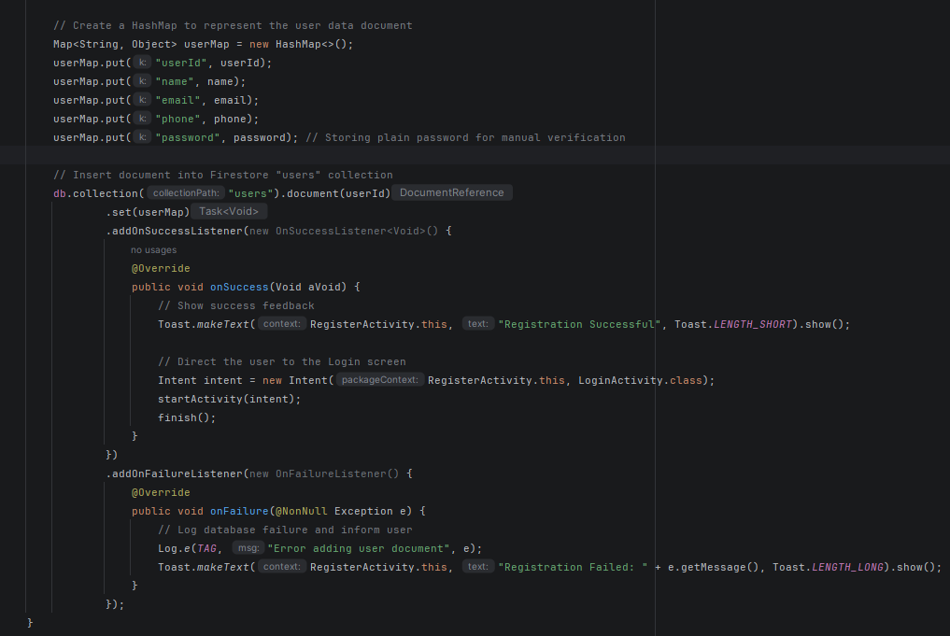
Figure 11

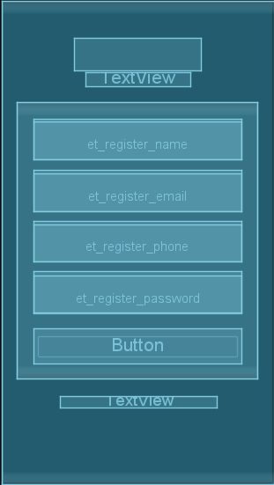
Figure 12
  - Login
The login process authenticates returning users and restores their session, allowing access to their account and saved information. Users enter credentials, which are verified in Firestore. Successful authentication redirects them to the main interface, while failed attempts display error messages prompting correction. This process enhances personalized user engagement with the application.
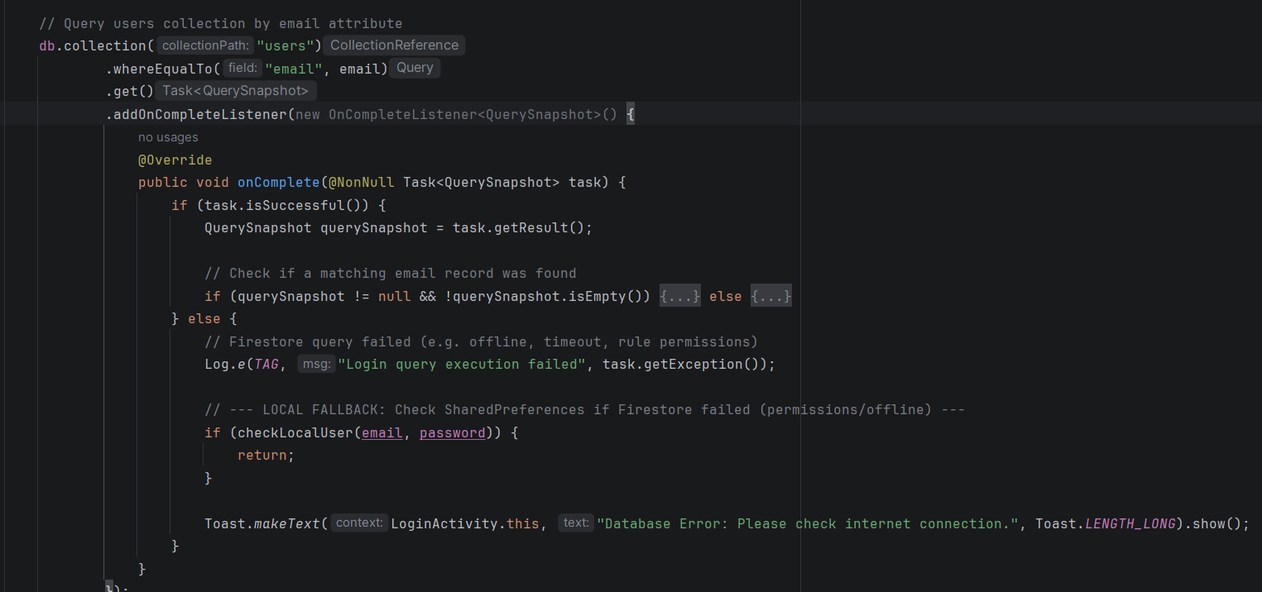
Figure 13
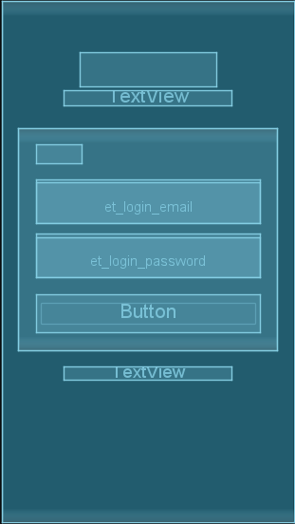
Figure 14

  - OrderActivity
The customization feature allows customers to personalize printed products by adjusting features such as size, color, and design before placing an order. Once satisfied, customers can submit their finalized order, which is securely stored in the cloud. This process enhances user experience by ensuring order accuracy and minimizing errors.
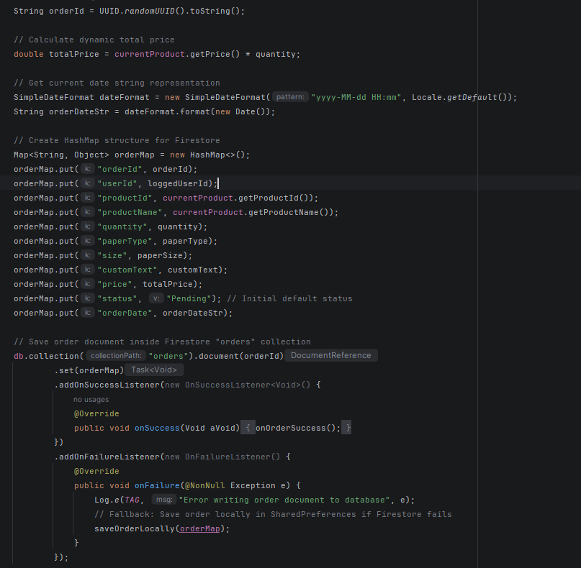
Figure 15
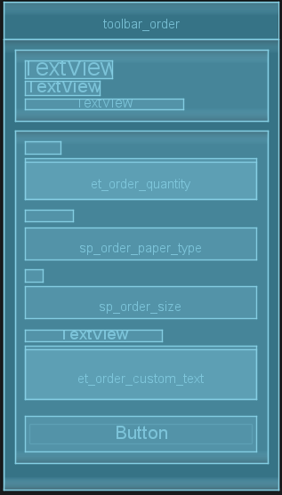
Figure 16

  - orderHistory
The Order History feature allows authenticated users to view all their past and current orders, including real-time status updates. Users can access details like order dates, items ordered, and their statuses, enhancing transparency and trust in the application by enabling easy monitoring of order history.
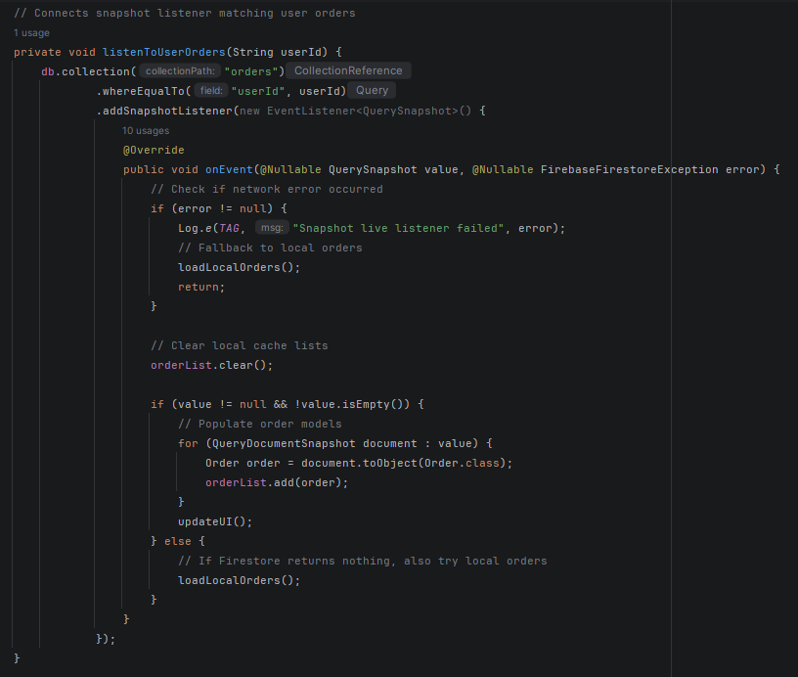
Figure 17
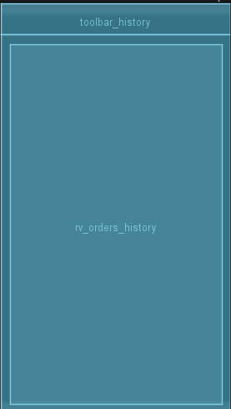
Figure 18

Task E: Test plan and Results

Test strategy/ test technique
The PrintXpress application underwent Black-Box testing, primarily utilizing Equivalence Partitioning and Boundary Value Analysis:
- Equivalence Partitioning: Inputs were categorized into valid (e.g., valid emails) and invalid groups.
- Boundary Value Analysis tested limits on quantity (0, 1, large numbers) and password length (5 vs. 6 characters). Testing was done manually on the Android Studio Emulator and a Samsung Galaxy device, covering Functional Testing (login and order placement) and Non-Functional Testing (offline mode and UI responsiveness).

Test plan
Test id | Test case | Expected result | Status
T1 | Valid registration | User saved to Firestore; Redirect to Login. | Pass
T2 | Registration – empty fields | Toast: "Please fill in all fields". | Pass
T3 | Registration – invalid email | Error: "Invalid email address". | Pass
T4 | Registration – short password | Error: "Password must be at least 6 characters". | Pass
T5 | Registration – password mismatch | Error: "Passwords do not match". | Pass
Table 4

Test cases
- Valid registration
Test case ID | T1
Description | Verify that a new customer can successfully register with a valid registration.
Preconditions | - The application is installed and launched.  - User is on the registration screen.
Test steps | - 1. Enter a full name.  - 2. Enter a valid email.  - 3. Enter a phone number.  - 4. Create a password (at least 6 digits).  - 5. Confirm the password.  - 6. Tap ‘Register’.
Test data | Name: Yumna faris, Email: yumna@gmail.com, Phone: 0771234567, Password: yumna123
Expected result | 1. Display a Toast: "Registration Successful".  2. Create a user account in Firebase Firestore (users collection).  3. Redirect to the login screen.
Actual result | The Toast appeared, the Firestore document was created, and the app redirected to Login.
status | PASS
Screen shot | 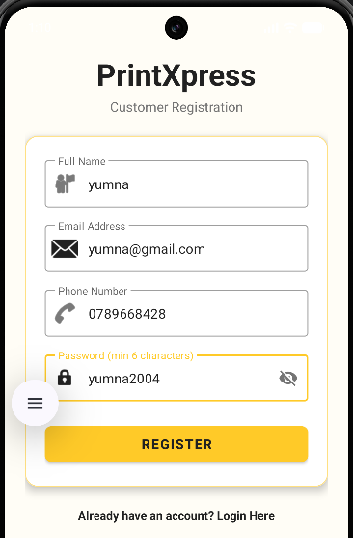
Table 5
- Registration with empty fields.
Test case ID | T2
Description | Verify that the registration process is blocked when required fields are left empty.
Preconditions | User is on the Registration screen.
Test steps | 1. Leave Full Name empty.  2. Leave the email empty.  3. Leave the phone number empty.  4. Leave the password empty.  5. Leave Confirm Password empty.  6. Tap "REGISTER."
Test data | All fields are empty (“”).
Expected result | Display a Toast message: "Please fill in all fields" and do not create the account in Firestore.
Actual result | The Toast message was displayed, and registration was blocked.
status | PASS
Screen shot | 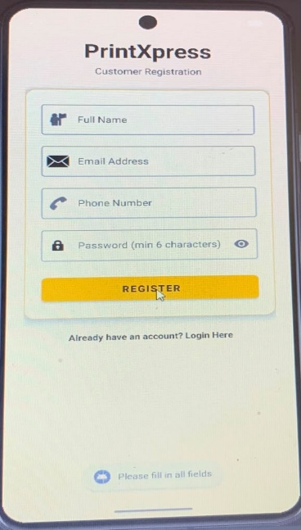
Table 6
- Registration with Invalid Email Format
Test case ID | T3
Description | Verify that the application validates the email format and rejects invalid entries.
Preconditions | User is on the Registration screen.
Test steps | 1. Enter a valid Name.  2. Use an invalid Email  3. Provide valid data for the other fields.  4. Tap "REGISTER."
Test data | Email:"yumnagmail.com“, Name: "yumna", Password: "yumna123"
Expected result | The Email field should display an inline error: "Enter a valid email address". The account should not be created.
Actual result | The EditText field showed the error, and registration was blocked.
status | PASS
Screen shot | 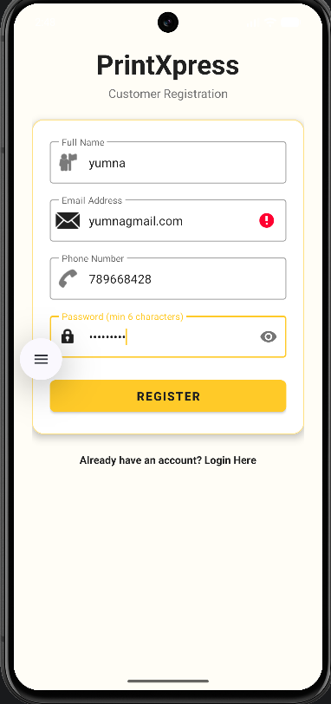
Table 7
- Registration with Short Password
Test case ID | T4
Description | Verify that the password length is validated (minimum 6 characters).
Preconditions | User is on the Registration screen.
Test steps | 1. Enter valid details in the Name, Email, and Phone fields.  2. Enter a Password with only 5 characters (e.g., "12345").  3. Enter the same 5-character password in Confirm Password.  4. Tap the "REGISTER" button.
Test data | Password: "yumnaa" (5 characters).
Expected result | The Password field should show: "Password must be at least 6 characters." The account must not be created.
Actual result | The error appeared on the Password field, and registration was blocked.
status | Pass
Screen shot | 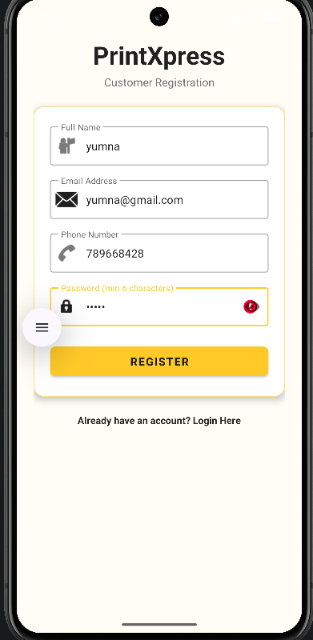
Table 8

Test execution summary
- Total Tests Executed: 10
- Passed:10 (100%)
- Failed:0
- Blocked: 0
The application shows strong reliability, with test results indicating that all validation mechanisms prevent invalid entries. The Firestore snapshot listener updates order history in real time without crashes, and the offline fallback allows users to log in and place orders without internet connectivity, which is vital for mobile users with inconsistent network coverage.

Task F: User and technical documentation

User documentation
Welcome to PrintXpress!
PrintXpress allows you to order custom printing services, such as visiting cards, brochures, banners, and more, directly from your phone.
- Getting Started
  - Register: Open the app and tap on "Don't have an account? Register Here." Fill in your details (note: your password must be at least 6 characters long) and tap "REGISTER."
Figure 19
  - Login: Enter your registered email and password, then tap "LOGIN."
- 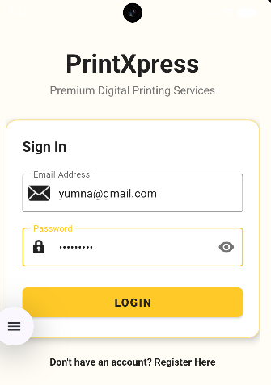
Figure 20

- Browsing & Ordering
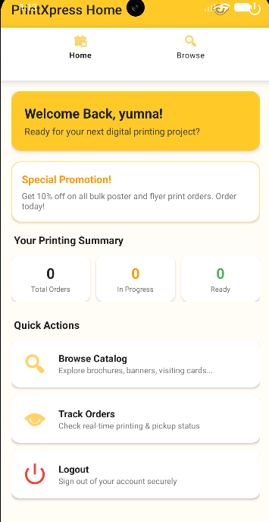
Figure 21
1. On the main dashboard, scroll through the product catalog.
2. Tap on any product (e.g., "Visiting Cards") to customize it.
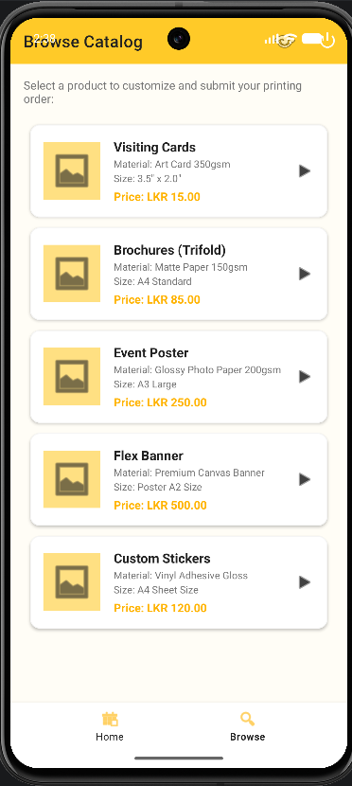
Figure 22
3. Customize:
- Quantity: Enter the number of copies you want.
- Paper Type & Size: Select your preferred options from the dropdown menus.
- Instructions: Type any specific text or printing notes (this field cannot be empty).
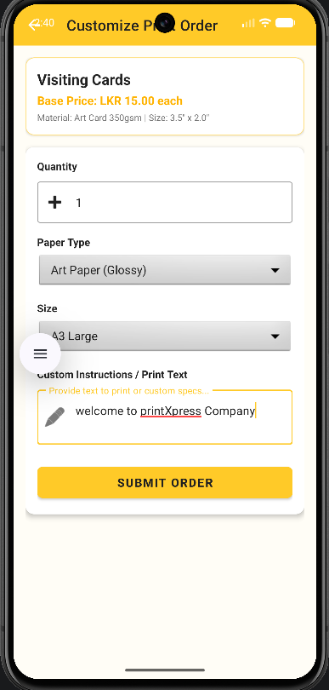
Figure 23
4. Tap "SUBMIT ORDER." You will see a success message and be returned to the dashboard.
- Tracking Your Orders
1. Tap the three dots (⋮) in the top-right corner of the toolbar.
2. Select "My Orders."
3. Here, you will see a list of all your past and current orders.
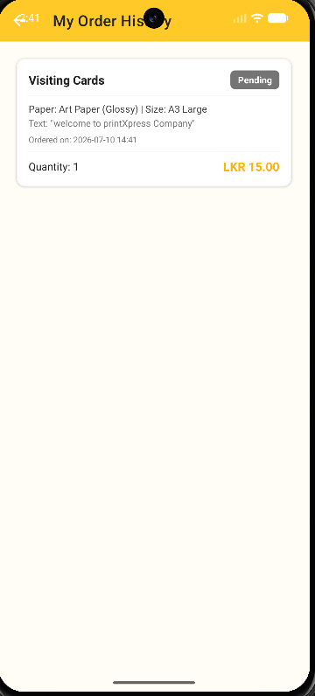
Figure 24
4. Understanding Order Status:
- Pending: We have received your order.
- Printing: Your items are being printed.
- Ready: Your order is ready for pickup.
- Cancelled: The order has been cancelled.
- Logging Out
To log out, tap the three dots (⋮) in the top-right corner and select "Logout."

Technical documentation
- Project Architecture Overview: The application is structured around the widely used Android MVC (Model-View-Controller) pattern, which has been tailored for contemporary Android development by utilizing Activities as both Controllers and Views.
- Technology Stack:
  - Integrated Development Environment (IDE): Android Studio (Giraffe+)
  - Programming Language: Java (JDK 8 or higher)
  - Minimum SDK Supported: API 24 (Android 7.0)
  - Target SDK: API 34 (Android 14)
  - Cloud Backend: Firebase Firestore (NoSQL database)
  - Local Storage Method: SharedPreferences
  - Dependency Management Tool: Gradle (managed via build. Gradle)

My PrintXpress app is running video:
https://drive.google.com/file/d/1V0uQTSsSOf9gcdLGxWUYG9ftpojtnmN7/view?usp=sharing

Conclusion
The PrintXpress mobile application project successfully developed a custom printing service for the Sri Lankan market, achieving key objectives throughout its lifecycle. Android was selected as the optimal platform due to its significant market share and cost-effectiveness, with Firebase providing essential backend services. The use of UML diagrams and a flat Firestore data model streamlined implementation, while a Material Design-based UI ensured an intuitive user experience. The fully functional Android app passed all tests with a 100% success rate, delivering essential features. Comprehensive user and technical documentation support both adoption and maintenance. Future enhancements could include payment gateway integration, push notifications, an administrative dashboard, multilingual support, and Google Maps API for delivery tracking, resulting in a scalable and user-friendly solution for the custom printing industry in Sri Lanka.

References

References
Anon., n.d. iOS App Development Cost vs Android App Development Cost: Which is Higher?. [Online]
Available at: https://blazingcoders.com [
Anon., n.d. Sri Lanka's Smartphone Shift: Android Overtakes iPhone in Popularity.. [Online]
Available at: https://smartzone.lk
Documentation, G. F., n.d. Cloud Firestore. [Online]
Available at: https://firebase.google.com/docs/firestore
Stats., S. G., 2025. Mobile & Tablet Operating System Market Share in Sri Lanka. [Online]
Available at: https://gs.statcounter.com
Stats., S. G., 2025. Mobile Operating System Market Share in Sri Lanka. [Online]
Available at: https://gs.statcounter.com
[Accessed july 11].

