Cover page

Qualification |  | Module Number and title
Higher National Diploma in Computing and Software Engineering |  | CSE 4006  Object-Oriented Programming
Student Name and Number |  | Assessor
Yumna Faris  KD/HDCSE/CMU/81/18 |  | Ms. Dilini Kanchana
Handout date |  | Submission date
06.01.2026 |  | 08.01.2026
Assignment type | Duration/ length of Assessment | Weighting of assessment

Learner Declaration
I, Yumna Faris, certify that the work submitted for the assignment is my own and that research sources are fully acknowledged.

Marks Awarded
First assessor
IV marks
Agreed grade
Signature of the assessor
Date

Feedback form
Module:
Assessor:
Assignment:
Strong features of your work:
Marks awarded:
Areas for improvement:

Acknowledgement
First and foremost, I would like to express my sincere gratitude to Cardiff Metropolitan University for providing an outstanding academic platform and essential resources that have greatly supported my educational journey. The university’s commitment to excellence and student success is truly commendable. I also extend my heartfelt thanks to ICBT and its dedicated faculty and staff for their continuous guidance, encouragement, and support throughout my studies; their expertise and commitment have significantly enriched my learning experience. A special note of appreciation goes to Mr. Dilini Kanchana for his exceptional instruction in Object-Oriented Programming; his clear explanations, practical approach, and patient guidance have been instrumental in deepening my understanding of the subject. Lastly, and most importantly, I am profoundly grateful to my parents for their unwavering love, sacrifices, and belief in me. Their support has been the foundation of my achievements, and I could not have reached this point without them. I sincerely thank everyone who has been a part of my academic and professional growth.

Executive summary
This report details the design and development of a retail management system using object-oriented principles. The system accommodates two primary user roles: Store Manager and Sales Assistant, each with specific functionalities tailored to their responsibilities. To model the system's structure and interactions, we use UML diagrams, including Use Case, Class, and Sequence diagrams. Core features such as product management, sales processing, inventory tracking, and reporting are implemented in Java, highlighting key object-oriented programming concepts like inheritance, polymorphism, encapsulation, and abstraction. The system aims to streamline store operations, enhance security through role-based access, and provide a scalable foundation for future enhancements.

Table of Contents
Contents
Cover page 1
Feedback form 2
Acknowledgement 3
Executive summary 4
Introduction 8
Tasks 9
Task 1: UML diagrams and explanations 9
I. USE CASE DIAGRAMS 9
II. CLASS DIAGRAM 11
III. SEQUENCE DIAGRAM 13
Task 2: Technical documentation 13
A. CORE FUNCTIONS 13
B. OOP CONCEPTS 17
Task 3:user manual 23
I LOGIN SCREEN 23
II ADDING A PRODUCT 24
Conclusion 27
References 28

Table of Figures
Figure 1 10
Figure 2 12
Figure 3 14
Figure 4 15
Figure 5 15
Figure 6 16
Figure 7 17
Figure 8 17
Figure 9 18
Figure 10 18
Figure 11 18
Figure 12 19
Figure 13 19
Figure 14 19
Figure 15 19
Figure 16 19
Figure 17 20
Figure 18 20
Figure 19 20
Figure 20 20
Figure 21 20
Figure 22 20
Figure 23 21
Figure 24 21
Figure 25 21
Figure 26 21
Figure 27 22
Figure 28 22
Figure 29 22
Figure 30 22
Figure 31 23
Figure 32 23
Figure 33 23
Figure 34 23
Figure 35 23
Figure 36 23
Figure 37 24
Figure 38 24
Figure 39 24
Figure 40 24
Figure 41 25
Figure 42 25
Figure 43 25
Figure 44 26
Figure 45 26
Figure 46 26
Figure 47 27
Figure 48 27

Turnitin
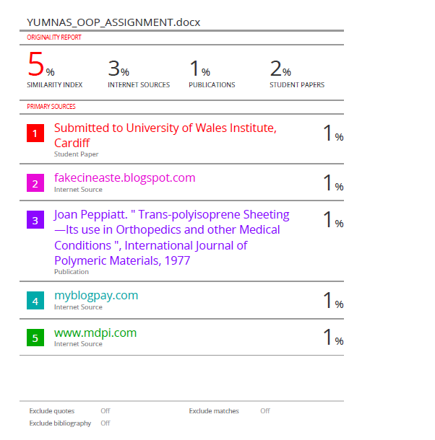

Introduction
This document outlines the design and implementation of a retail management system aimed at enhancing operational efficiency and data security in a retail environment. The system is developed using object-oriented programming (OOP) principles to ensure modularity, reusability, and maintainability. It is designed to support daily tasks such as product management, sales processing, inventory monitoring, and report generation. Through a structured approach that includes UML modeling and iterative development, the system provides a clear division of responsibilities. Sales Assistants concentrate on customer-facing activities, while Store Managers handle administrative and analytical functions. This introduction sets the foundation for a detailed exploration of the system’s design, functionality, and technical implementation.

Tasks

Task 1: UML diagrams and explanations

USE CASE DIAGRAMS
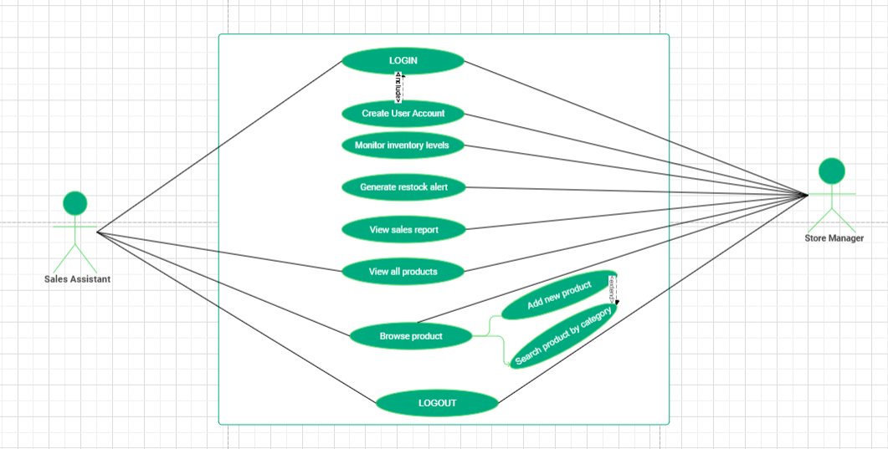Figure 1
- Diagram overview
This diagram shows how workers use the computer system. There are two types of workers: a Sales assistant who handles customers, and the other is the store manager who runs the store. What the system does is: Everyone must log in and log out, the sales assistant can see products and prices, make a sale at the counter, and process returns. Meanwhile, the store manager can do all the above, plus update or remove products and check stock levels and create reports. <<include>> means you cannot complete one action without doing another. <<extend>> means an action may sometimes trigger an extra step (Alistair Cockburn, 2001).
- Actor description.
Two workers use the system:
- Sales assistant: They help customers and update the product list. They have basic system access. They can look up items, add new stock, and put items in the right category. And they make customers happy and keep the product information correct.
- Store manager: They oversee the store and its security. They have full system access, and they can do everything the assistant can, plus manage user accounts, check reports, and control the whole system. They keep the store running safely and make smart decisions using data. The manager is like a super-powered assistant. They have all the same basic tools, plus the master key for extra admin tasks (Alistair Cockburn, 2001).
- Relationships.
The system features a secure workflow requiring users to log in, with sales assistants and store managers both able to view products and search for items. To end a session, both roles must log out. However, only the manager has exclusive administrative rights to create user accounts, monitor inventory, and access sales reports. A conditional feature is the restock alert, which is activated only when the manager checks inventory and stock levels fall below a specified threshold. This highlights a key system rule that extends main tasks under certain conditions. (Management Group, 2017).
- System boundaries clarified.
The system is designed for specific tasks, including user login, product management, and sales reporting. It is self-contained and saves data in files. It does not process payments, manage suppliers, track customer accounts, handle deliveries, connect to accounting software, or control physical hardware. Users interact with it through typing and clicking to receive information and alerts. Its primary purpose is to assist inventory and sales staff, alerting them to low stock for manual restocking outside the system. (Karl Wiegers and Joy Beatty, n.d.).
- Notable design decisions.
The system is designed for ease and security, providing tailored tools for different roles: sales assistants have simple screens, while managers have additional controls. It requires user logins to protect data and clarify actions. To prevent stock shortages, it notifies managers when inventory is low, and sales reports are restricted to managers, allowing assistants to focus on customer service. Additionally, all team members have access to product information uniformly, ensuring consistent support for customers. (Jakob Nielsen, 19994).

CLASS DIAGRAM
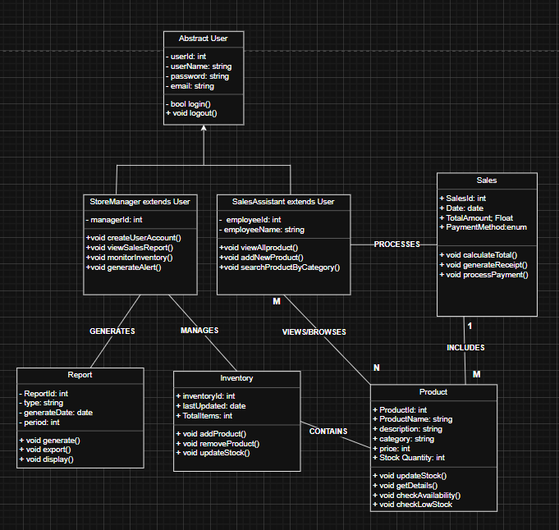
Figure 2
- Diagram type and its purpose.
A UML class diagram for a retail management system acts as a visual blueprint, mapping out the system’s core components before any code is written. It uses boxes to represent classes such as user, product, report, inventory, etc., and details their attributes like price and name, along with their behaviors or methods. Lines connecting these boxes clearly define the relationship between them, showing how, for example, a customer places an order that contains products. This upfront planning is crucial, as it organizes the structure of the entire system, preventing the confusion of tangles and making the software easier to understand, modify, and maintain in the long run.
- Main components and their roles.
The system is centered around an Abstract user that defines essential login and logout functions for security and code efficiency. It includes two user roles: the store manager, who manages users and overseas operations, and the sales assistant, who handles daily tasks like sales processing. Supporting these roles are transactions, reports that present data, inventory for tracking stock levels, and products defined by their attributes, such as price and expiry date. Together, these elements outline the system's basic structure and user interactions.
- Relationships.
- Inheritance
In the system, there is a parent class called User. Two child classes are inherited from the user: Store Manager and Sales Assistant. The child classes automatically get all the general features from the user, like login () and logout (), but they also have their own special abilities. For example, storeManager might have a generateReport () method, while salesAssistant has process Sale ().
- Polymorphism
This allows the system to treat a Store Manager or sales assistant as just a User when needed.
- Abstraction
In the system, the user class might be abstracted, meaning it defines what a user should do without specifying exactly how each user type does it. The actual implementation is hidden inside the store manager and sales Assistant classes.
- Encapsulation
Each class keeps its data safe and private. For example, the product class likely has private fields like price and stock level. Other classes cannot directly change the price they must use public methods like setPrice () that can include validation rules.
- Design pattern.
The system design incorporates three main concepts to enhance organization and security. Firstly, it utilizes a blueprint approach with an abstract User class that acts as a master template, allowing for specialized roles such as store managers and sales assistants to inherit common features like Login/Logout while adding their unique capabilities. This flexibility enables the addition of new roles without the need to rewrite existing code. Secondly, the system adheres to the principle of “one job per part” by separating responsibilities into distinct classes, making it easier to maintain and update without affecting other areas. Finally, user roles are carefully differentiated to align with real-world workflows, with managers receiving full administrative access and assistants having limited, task-specific permissions, ensuring that each user has only the necessary access to effectively perform their job.

SEQUENCE DIAGRAM
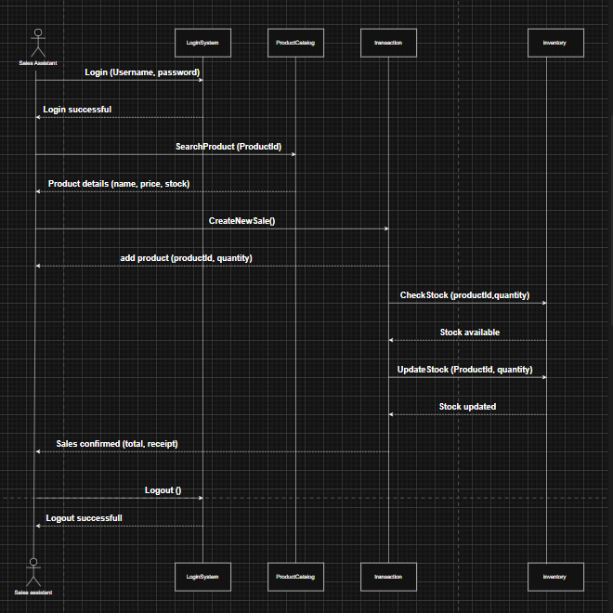
Figure 3

Task 2: Technical documentation

CORE FUNCTIONS
- View all products
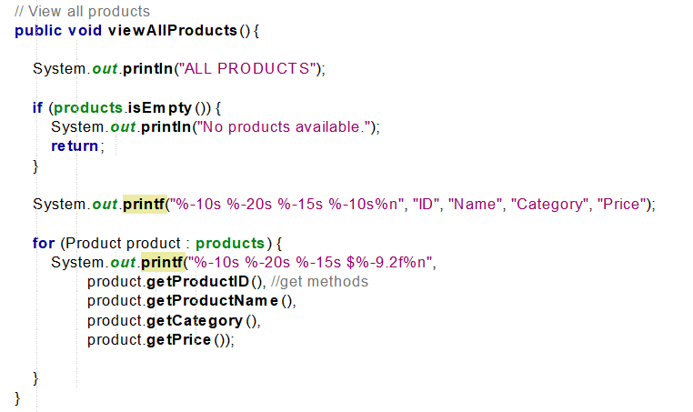
Figure 4
- Add new product
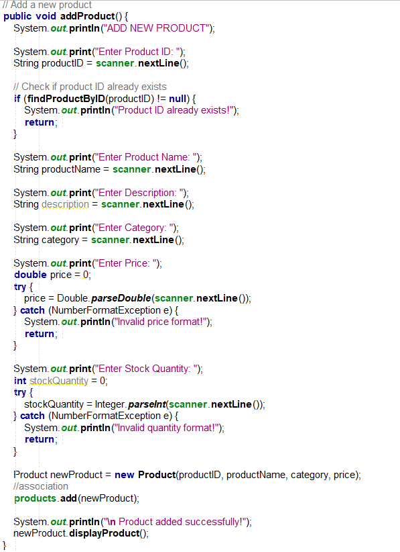
Figure 5
- Search by category
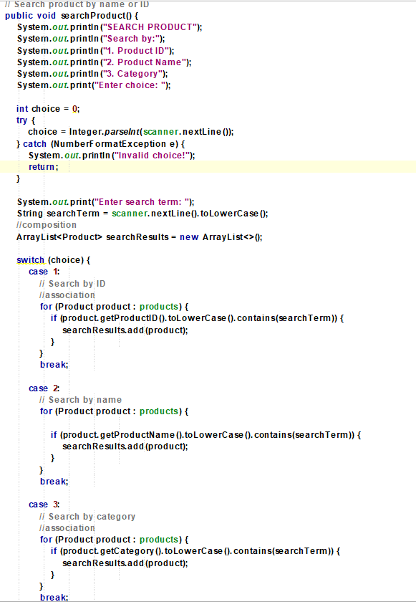

Figure 6
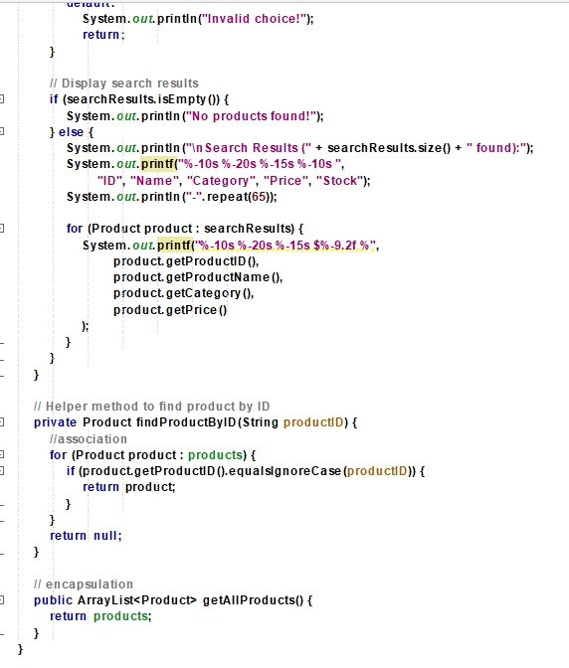
Figure 7
- Login
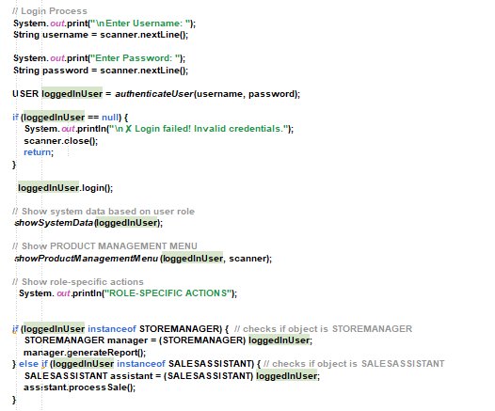
Figure 8
- Logout
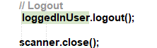
Figure 9
- User Authentication System
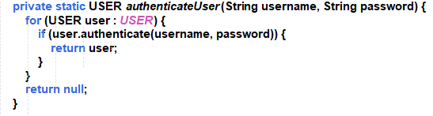
Figure 10
- Role-based
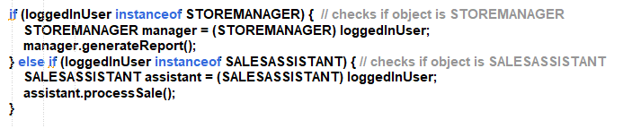
Figure 11

OOP CONCEPTS
- Polymorphism: is a fundamental concept in object-oriented programming that allows developers to interact with different entities through a single interface, thereby enhancing flexibility and extensibility in code. It includes two main types: method overloading, where multiple methods share the same name but differ in the number or type of parameters, improving readability and ease of use; and method overriding, which enables a subclass to provide a specific implementation of a method already defined in its superclass, promoting customization and code reusability. Overall, polymorphism contributes to the creation of more generic and reusable components in programming.
- Inheritance: The common themes in the superclass can be inherited by the subclass without repeating the same variables and methods inside the subclass.
- Encapsulation: wrapping relevant variables and methods inside the class and providing different access control to those variables and methods.
- Abstraction: It's about hiding complex implementation details and showing only the necessary features to the user.

MAIN CLASS – GREENMANAGEMENT
- Polymorphism
Figure 12
- Abstraction
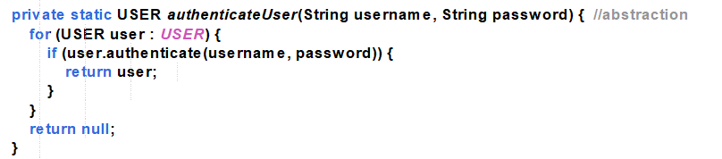
Figure 13

USER CLASS
- Constructors
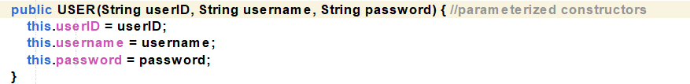
Figure 14
- Polymorphism
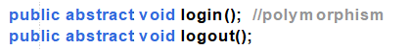
Figure 15
- Encapsulation
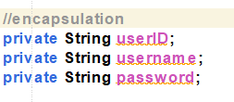
Figure 16

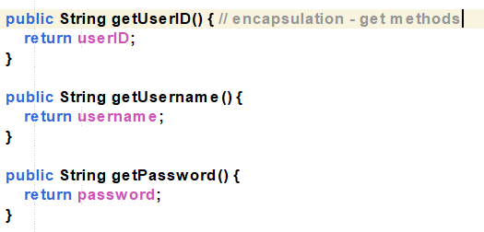
Figure 17
- Abstraction
Figure 18

STOREMANGER CLASS
- Constructors
Figure 19
- Inheritance
Figure 20
- Polymorphism
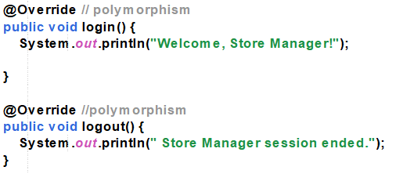
Figure 21

SALESASSISTANT CLASS
- Constructors
Figure 22
- Inheritance
Figure 23
- Polymorphism
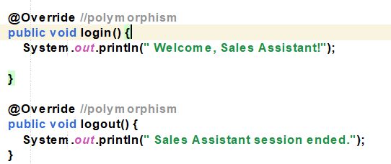
Figure 24

PRODUCT CLASS
- Constructors
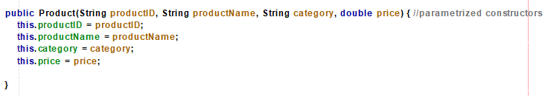
Figure 25
- Encapsulation
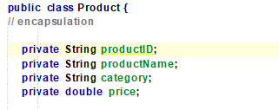
Figure 26
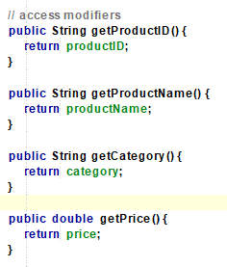
Figure 27

SALES CLASS
- Constructors
Figure 28
- Encapsulation
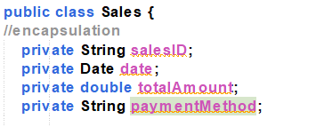
Figure 29

INVENTORY CLASS
- Constructors
Figure 30
- Encapsulation
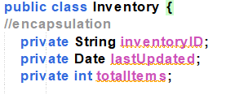
Figure 31
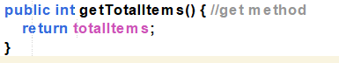
Figure 32

REPORT CLASS
- Constructors
Figure 33
- Encapsulation
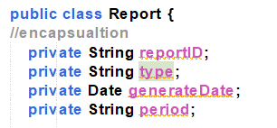
Figure 34
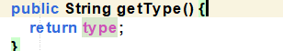
Figure 35

PRODUCT MANAGER CLASS
- Constructors
Figure 36
- Encapsulation
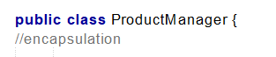
Figure 37
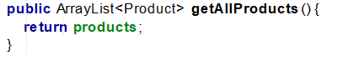
Figure 38

Task 3:user manual

LOGIN SCREEN
- The system starts with a login screen.
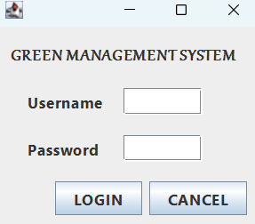
Figure 39
- The user can be the store manager or sales assistant; they enter the system by providing the correct credentials and logging in to the system.
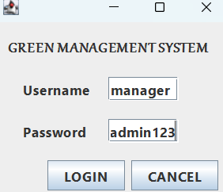
Figure 40
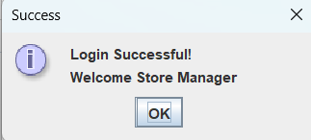
Figure 41
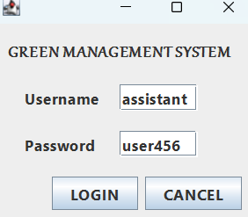
Figure 42
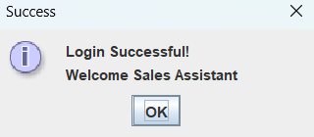
Figure 43

ADDING A PRODUCT

- Once the user logs in to the system, they are presented with an interface where they can add a product.
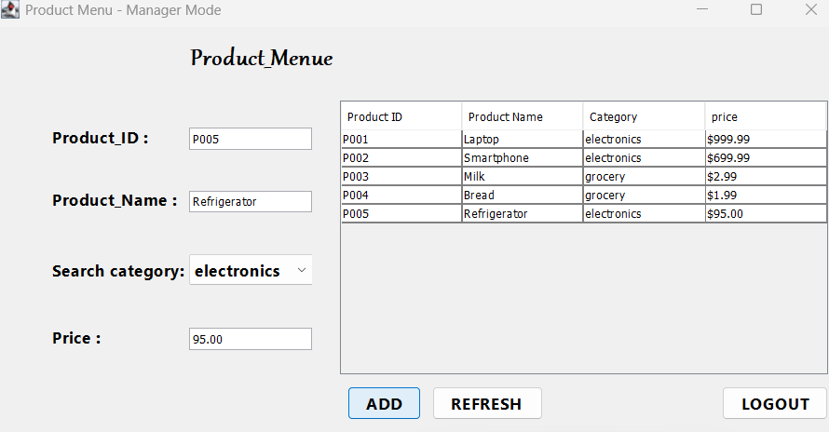
Figure 44

- When a user adds a product, a message will appear confirming that the product has been added successfully.
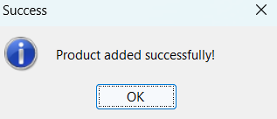
Figure 45
- If the user wants to refresh, they can click the refresh button and receive a message indicating that the form was refreshed successfully.

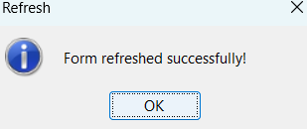
Figure 46
- If the user logs out of the system, they receive a confirmation message indicating successful logout.
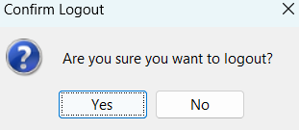
Figure 47
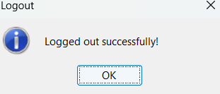
Figure 48

Conclusion
The retail management system effectively demonstrates the application of object-oriented design and programming principles to address real-world business needs. By utilizing UML diagrams, a well-structured class hierarchy, and role-based access control, the system provides a secure, efficient, and user-friendly platform for managing store operations. Key object-oriented programming concepts, such as inheritance, polymorphism, encapsulation, and abstraction, have been successfully implemented to create a modular and maintainable codebase. The system achieves its primary objectives of streamlining sales processes, improving inventory visibility, and supporting managerial decision-making. Future enhancements could include functionality for online sales integration, advanced analytics, and supplier management modules.

references
Alistair Cockburn, 2001. Writing effective use cases.. 1st ed. s.l.:Addison-Wesley.
Jakob Nielsen, 19994. Usability engineering. 1st ed. s.l.:Morgan Kaufmann.
Karl Wiegers and Joy Beatty, n.d. Software requirements. 3rd ed. s.l.:Microsoft Press.
Management Group, 2017. Unified Modeling Language, s.l.: Object Management Group.

