Cover page

Qualification |  | Module ID and title
Higher diploma in computing and Software Engineering |  | CSE4007  Professional practice
Student name and ID |  | Assessor
Yumna Faris KD/HDCSE/CMU/81/18  Usman Badhusha KD/HDCSE/CMU/81/46  Hana binth Hilmy KD/HDCSE/CMU/81/18  Ajmal Rizwan KD/HDCSE/CMU/81/45 |  | Ms. Poornima Thilakarathne
Handout date |  | Submission date
21.11.2025 |  | 25.11.2025
Assessment type  WRIT1 – Coursework {Group} | Duration/length of assessment  2000 word | Weighting of assessment  75%

Learner declaration
I, Yumna Faris, certify that the work submitted for the assignment is my own and that research sources are fully acknowledged.

Marks awarded
First assessor
IV marks
Agreed grade
Signature of the assessor
Date

Feedback form
Module:
Assessor:
Assignment:
Strong features of our work:

Areas for improvement:
Marks awarded:

Acknowledgement
We want to thank Cardiff Metropolitan University from the bottom of our hearts for allowing us to study here. I like the tools and support the institution provides to students like me, and I think its learning system is excellent.
We are especially grateful to the professors at ICBT for their support and direction during my course. My educational experience has been much improved by the teachers' and staff's unwavering support. We would especially like to thank Poornima, my professor, for being such an excellent teacher. She made the module much easier to follow, answered all our questions, and provided comprehensive explanations. Her help and patience are greatly appreciated.
Above all, we want to express our gratitude to our parents for their unwavering support and belief in us. We wouldn't have made it this far without their efforts and affection. We sincerely appreciate all that they have done for us.
Appreciate everyone's participation in my career.

Executive summary
This report provides a comprehensive analysis of the professional, ethical, social, and legal considerations for the development of an "Immersive VR Classroom Experience," an emerging technology in distance learning. The analysis identifies key challenges, including potential user harm, data privacy risks, and the threat of exacerbating educational inequality due to high costs. It also highlights opportunities for enhanced learning engagement and global accessibility.
The report outlines a framework for responsible development, emphasizing the need for strict adherence to data protection regulations like the Data Protection Act 2018, a multi-layered approach to intellectual property protection, and the integration of Green IT principles to minimize environmental impact. Key recommendations include developing a universal access strategy to ensure equity, implementing 'Privacy by Design' as a core development tenet, and establishing a continuous reflective practice for the development team. Ultimately, the success of this transformative educational tool depends not only on its technical innovation but also on the ethical and professional integrity with which it is built and deployed.

Turnitin
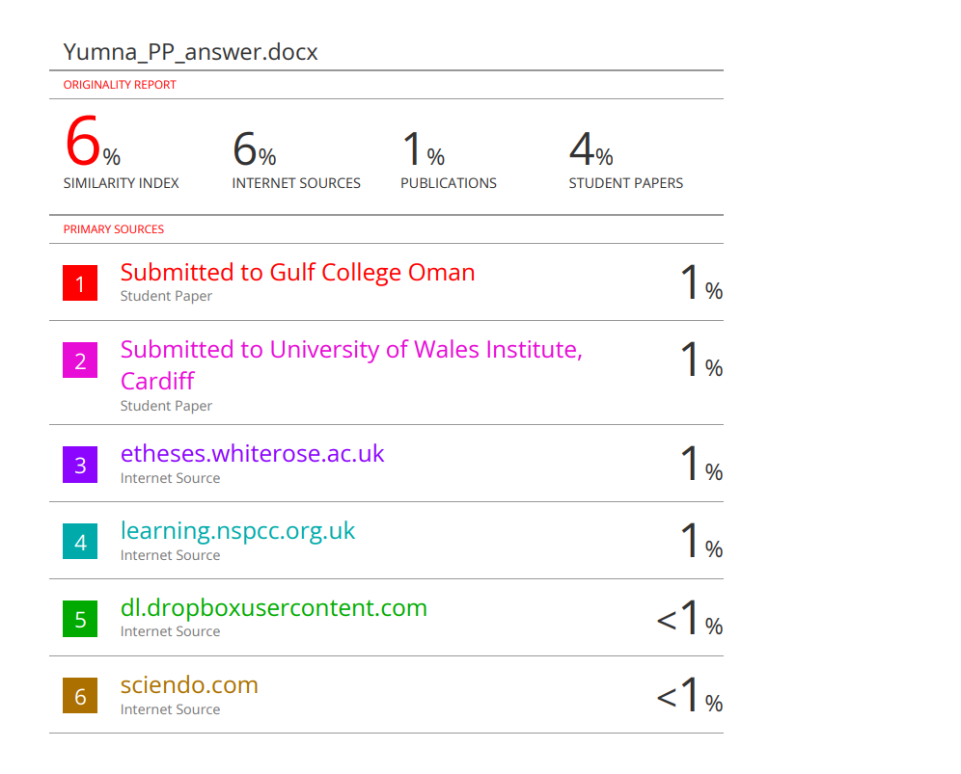
Table of contents
Contents
Cover page 1
Feedback form 2
Acknowledgement 3
Executive summary 4
Introduction 7
Tasks: 8
1. Ethical, social, professional, and legal issues. 8
2. Intellectual property and patent issues. 9
3. Data protection and regulations. 9
4. Emerging technology overview. 10
5. Social impacts of technology. 10
6. Green IT initiatives. 11
7. Conclusion and recommendations. 11
Conclusion 13
References 14

Introduction
The report discusses the potential of Virtual Reality (VR) to enhance education by creating immersive and interactive learning environments through an "Immersive VR Classroom Experience." It aims to evaluate the broader implications of implementing this technology, focusing on ethical, social, professional, and legal issues, including intellectual property, data protection, and the social impact on learning communities. Additionally, it considers environmental aspects related to Green IT. By utilizing established theories and frameworks, the report seeks to provide actionable recommendations for the responsible and sustainable development of VR classrooms, promoting equitable and effective education.

Tasks:

Ethical, social, professional, and legal issues.

Selected Emerging technology: Immersive VR classroom experience.

Ethical issues: A major ethical issue is the potential for harm to users’ safety and mental health. Spending too much time in VR can not only make users feel sick in the short term but may also carry unknown risks for children’s developing brains, according to research. (johnson,d, 2008). Without proper safeguards, users in deeply immersive experiences can be exposed to psychological manipulation or traumatic content against which they have little defense. Using a student’s own physiological responses, like eye movements and emotions, to tailor education is ethically problematic, as it exploits intimate data for which informed consent is nearly impossible, and future misuse is a grave concern. (Baase, s, 2012).

Social issues: A major concern is that this project may leave behind individuals with limited internet access or outdated devices. The high entry cost for VR could exacerbate educational inequality, creating a scenario where underprivileged students are relegated to outdated digital resources while wealthier students have access to better technology. (Baase, s, 2012). On the positive side, it can make remote learners feel more connected and collaborative, reducing the loneliness of typical video calls. Conversely, there is a risk that overuse could diminish real-world social competencies. This occurs as students acclimate to the structured environment of virtual spaces, which lack the complex, non-verbal cues of physical interaction.

Professional issues: As developers, our job is to make products that are safe and reliable. It would be unethical to release an application that causes significant user harm, such as severe motion sickness, or fails to safeguard student data. (johnson,d, 2008). Their duty is simple: do good and avoid harm. They must achieve this through end-to-end testing and by being transparent about the software’s risks, rather than overpromising profits.

Legal issues: The project must follow the strict data privacy rules of the Data Protection Act 2018. Children’s data or sensitive biometric information constitutes ‘special category data’ which demands strong security and clear user permission. The organization is also vulnerable to legal action if the hardware hurts a student or if a software bug negatively impacts their academic performance. In accordance with copyright law (Baase, s, 2012). The platform must ensure that all incorporated assets, from 3D models to textual materials, are utilized under valid licenses.

Intellectual property and patent issues.
The development of an immersive VR classroom experience gives rise to several protectable intellectual property assets. A software patent could safeguard the core technical innovations behind the VR experience, specifically the low-latency synchronization for multiple users and the efficient rendering of complex models. According to (johnson,d, 2008), while basic ideas cannot be patented, a concrete and innovative technical process can be. A specific method, like using gaze-tracking to optimize VR performance, would meet the criteria for a patent.

Under copyright law, the source code, 3D models, and user interface designs are protected from the moment of their creation. Trademark registration offers a legal mechanism to protect the brand’s name and logo, safeguarding its commercial identity and preventing mark dilution. To conclude, confidentiality agreements with all involved parties are the primary mechanism for protecting the project’s core trade secrets: its unique VR teaching methodologies and its datasets on immersive learning patterns. (Baase, s, 2012). This multi-layered approach to intellectual property is essential for both attracting investment and maintaining a competitive market position by preventing direct imitation.

Data protection and regulations.
To protect the extensive user data it collects, the immersive VR classroom experience will be designed in full compliance with the Data Protection Act 2018 ( Information Commissioner's Office (ICO), 2018). To ensure lawfulness, fairness, and transparency, explicit and verifiable parental consent will be secured for minors, while adult users will provide clear consent, with both groups being fully informed of the specific data collected and its purpose. (Baase, s, 2012) ( Information Commissioner's Office (ICO), 2018) . The purpose of data minimization will be rigorously applied. For example, while eye tracking data may inform engagement analysis, it will be anonymized and aggregated to prevent the unnecessary profiling of individual users.

The use of end-to-end encryption for all data in transit between the user’s headset and our servers will be implemented to uphold data integrity and confidentiality. Personal data access will be technically restricted to authorized personnel via role-based controls and organizationally reinforced through mandatory staff training on secure data protocols, a vital modern employability skill. (cottrell,s, 2015). The platform will establish a straightforward process for individuals to exercise their data rights, including access, rectification, and erasure, ensuring complete adherence to the Data Protection Act.

Emerging technology overview.
Virtual reality is a simulated digital environment that fully immerses the user, replacing their physical surroundings with a computer–generated world. The combined use of head-mounted display and tracking sensors immerses the user, facilitating intuitive interaction with the virtual space and its objects as if they were tangible.

Pros with Real-world Example:
- Better learning and memory: VR lets people learn by doing, which helps them remember more. For example, medical students using “Osso VR” can practice surgery safely again, learning faster and better than from books.
- Access anywhere: It lets students visit places they otherwise couldn’t, like inside the human body or ancient Rome. This makes learning more exciting and breaks down cost and distance barriers.
Cons of Real-world Example:
- High cost: VR needs expensive headsets and strong computers. Many schools and students cannot afford this, which could make the gap between rich and poor schools even bigger.
- Health and safety: Using VR can sometimes make people feel sick, dizzy, or give them a headache. There is also a risk of tripping over something in the real room while wearing the headset (Baase, s, 2012).

Social impacts of technology.

Bringing VR into online education has the power to transform our daily routines and the very structure of our society. For students, VR changes “going to school” from just watching a video call to actively being in a virtual classroom. Consequently, students must cultivate digital literacies and personal attributes suited to virtual spaces, skills that are increasingly critical for professional success. (Hind, D.W.G and Moss,s, 2011). Consequently, students need strong self-regulation and independent learning skills to navigate this blended environment. (cottrell,s, 2015).

From a societal perspective, VR-based learning holds the potential to democratize access to higher-caliber educational resources. A top teacher could give a lesson to thousands of students worldwide at once. This could make the reputation of a famous university matter less. However, this global classroom could come at the local one, potentially fracturing the sense of community found in traditional universities. VR changes how we make friends and learn, making deep digital worlds a normal part of growing up and job training. This changes what it means to know something and be part of the group. (Baase, s, 2012).

Green IT initiatives.
The development of the immersive VR classroom experience will actively incorporate Green IT principles to reduce its environmental impact. To ensure environmental responsibility, we will comply with the ISO 14001 standard and select cloud partners that meet the EU Code of Conduct for Data Centers and are committed to using renewable energy sources.

A key implementation is optimizing software for energy efficiency. The VR content will be engineered for optimal performance, minimizing the processing power required by both user hardware and central servers to achieve a direct reduction in energy usage. Additionally, an automated power management system will be implemented to transition the VR headset into a low-power sleep mode during periods of user inactivity. The societal benefits of these Green IT initiatives are twofold. The direct benefit is a lower carbon footprint for digital learning itself. The indirect, and potentially larger, benefit is a substantial reduction in transportation emissions, as a high-quality remote experience diminishes the need for daily commutes to campus. Ultimately, this reflects the broader philosophy that Green IT’s true impact is achieved by fostering sustainable societal practices, extending beyond simple direct energy reduction. (Bassot, B, 2013).

Conclusion and recommendations.
In conclusion, the immersive VR classroom experience represents a transformative development in distance learning, providing unprecedented opportunities for immersive education. However, the realization of this potential is contingent upon addressing significant challenges related to equitable access, data protection, user welfare, and ecological impact. The long-term success and societal value of the project will be measured less by its technical innovation and more by the ethical and professional frameworks that govern its development.
To ensure its responsible development, the following actions are recommended for the immersive VR classroom experience, based on the professional theories outlined:
- Develop a Universal Access Strategy: Work with schools and the government to make VR equipment cheaper. This is vital to stop the gap between students with and without technology from getting worse, which is a core social duty (Baase, s, 2012).
- Implement ‘Privacy by Design: Build privacy directly into the system, don’t just follow the rules. This includes data anonymous automatically and giving users clear control, which is part of being an honest and trustworthy professional (johnson,d, 2008).
- Establish a Continuous Reflective Practice: The developers should keep personal journals to regularly think about the social and ethical effects of their work. This helps them make each new version of the software more responsible and better than the one before (Bassot, B, 2013).
By focusing on these steps, the VR classroom can grow from a simple tech demo into a powerful and fair educational tool for everyone.

Conclusion
The immersive VR classroom has the potential to transform remote education through engaging and interactive learning. However, its development faces challenges such as equitable access, data privacy, user well-being, and environmental impact. The project's success and social value depend on the ethical standards of its developers. By addressing issues of cost, privacy, and sustainability, the immersive VR classroom can serve all users fairly. A commitment to responsible, user-centric development is essential for realizing its promise as an inclusive educational tool.

References
Information Commissioner's Office (ICO), 2018. Guide to the UK General Data Protection Regulation (UK GDPR). s.l.:s.n.
Baase, s, 2012. A Gift of Fire: Social, Legal and Ethical Issues for Computing and the Internet.. 4th edition ed. s.l.:Pearson Education..
Bassot, B., 2013. The Reflective Journal. 1st ed. Basingstoke: Palgrave Macmillan.
Cottrell,s, 2015. Skills for Success: Personal Development and Employability. 3rd edition. Basingstoke, UK: Palgrave Macmillan.
Hind, D.W.G. and Moss,s, 2011. Employability Skills. 2nd ed. Sunderland: Business Education Publishers Ltd..
Johnson, D., 2008. computer ethics. 4th edn. Upper Saddle River: Pearson/Prentice Hall.

