
Cover page

Qualification |  | Module Number and Title
Higher Diploma in Computing and Software Engineering |  | CSE5013  Service-Oriented-Concept
Student Name & No. |  | Assessor
Yumna Faris  KD/HDCSE/CMU/81/18 |  | Mr. Gihan Herath
Handout date |  |  | Submission Date
25.09.2026 |  |  | 28.09.2026
Assessment type  WRIT1 | Duration/Length of  Assessment Type  3000 words |  | Weighting of Assessment  100%

Marks Awarded
First assessor
IV marks
Agreed grade
Signature of the assessor |  | Date

Feedback form
Module: Service-Oriented Computing
Student: Yumna Faris
Assessor: Mr. Gihan Herath
Strong features of your work:

Areas for improvement:

Marks Awarded:

Acknowledgement
First and foremost, I would like to express my sincere gratitude to Cardiff Metropolitan University for providing an outstanding academic platform and essential resources that have greatly supported my educational journey. The university’s commitment to excellence and student success is truly commendable. I also extend my heartfelt thanks to ICBT and its dedicated faculty and staff for their continuous guidance, encouragement, and support throughout my studies; their expertise and commitment have significantly enriched my learning experience. A special note of appreciation goes to Mr. Gihan Herath for his exceptional instruction in Service-Oriented Concepts; his clear explanations, practical approach, and patient guidance have been instrumental in deepening my understanding of the subject. Lastly, and most importantly, I am profoundly grateful to my parents for their unwavering love, sacrifices, and belief in me. Their support has been the foundation of my achievements, and I could not have reached this point without them. I sincerely thank everyone who has supported my academic and professional growth.

Executive summary
This report presents the design and implementation of a Service-Oriented Architecture (SOA) for the National Water Supply and Drainage Board’s water billing and payment system. It proposes separating billing and payment processing into two independent services: NWSDB_MainAPI on port 5123 and Bank_ExternalAPI on port 7123. The report explains that the existing monolithic approach would tightly couple billing, payments, reporting, and partner integrations, making updates risky, scaling inefficient, and third-party integration difficult. In contrast, SOA enables standard API-based communication, independent service updates, fault isolation, regional payment-provider flexibility, and targeted scaling during month-end payment surges. The payment workflow involves NWSDB validating a bill, forwarding the payment request to the Bank API, receiving an authorization reference, and updating the bill status. The proposed system uses Docker containerization, Kubernetes orchestration, and auto-scaling, supported by unit, integration, contract, and end-to-end testing. Overall, the report concludes that SOA provides a more maintainable, scalable, secure, cost-effective, and future-ready platform capable of supporting millions of customers across Sri Lanka.

Turnitin
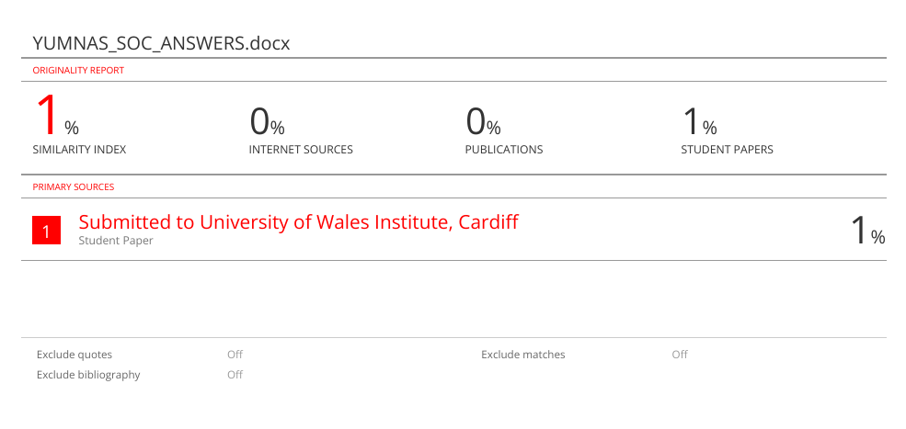
Table of Contents
Contents
Cover page 1
Feedback form 2
Acknowledgement 3
Executive summary 4
Turnitin 5
Introduction 9
Task 1: Architectural Analysis 10
1.1 Monolithic Architecture for NWSDB 10
1.2 Service -Oriented Architecture for NWSDB 11
1.3 Comparison and Contrast: Monolithic vs SOA 12
1.4 Justification: Recommended Architecture 13
Task 2: SOC Application Design and Development 13
A. Designs 13
B. Implementations 22
Task 3: Testing and Debugging 45
Task 4: Deployment Techniques 55
Conclusion 59
References 60
References 60

Table of tables
Table 1 10
Table 2 11
Table 3 44
Table 4 45
Table 5 46
Table 6 46
Table 7 47
Table 8 47
Table 9 48
Table 10 48
Table 11 49
Table 12 49
Table 13 50
Table 14 53
Table 15 54
Table 16 54
Table 17 55

Table of figures
Figure 1 13
Figure 2 13
Figure 3 14
Figure 4 15
Figure 5 16
Figure 6 17
Figure 7 18
Figure 8 19
Figure 9 20
Figure 10 21
Figure 11 21
Figure 12 22
Figure 13 22
Figure 14 23
Figure 15 23
Figure 16 24
Figure 17 25
Figure 18 25
Figure 19 26
Figure 20 27
Figure 21 27
Figure 22 28
Figure 23 28
Figure 24 29
Figure 25 29
Figure 26 30
Figure 27 30
Figure 28 30
Figure 29 31
Figure 30 31
Figure 31 32
Figure 32 32
Figure 33 33
Figure 34 33
Figure 35 34
Figure 36 35
Figure 37 36
Figure 38 36
Figure 39 37
Figure 40 37
Figure 41 38
Figure 42 39
Figure 43 40
Figure 44 41
Figure 45 41
Figure 46 42
Figure 47 43
Figure 48 44
Figure 49 52
Figure 50 52
Figure 51 53

Introduction
The project proposes a Service-Oriented Architecture (SOA) solution for the National Water Supply and Drainage Board (NWSDB) to overcome the limitations of its tightly coupled monolithic billing system. The design separates billing and payment processing into two independent services: NWSDB_MainAPI on port 5123 and Bank_ExternalAPI on port 7123. This decoupling supports targeted scalability during peak payment periods, improves fault isolation, reduces the risks associated with system updates, and simplifies integration with external partners. The report covers the platform’s architecture, implementation, testing strategy, and deployment plan, presenting a resilient and future-ready solution for water billing and payments.

Task 1: Architectural Analysis

Monolithic Architecture for NWSDB
If the entire NWSDB system were built as one monolithic application, every capability, like customer registration, account management, bill generation, payment processing, reporting, and third-party partner access, would be combined into a single codebase. (Singh, M.P. & Huhns, M.N. , 2008). In this configuration, payment handling would be hard-coded directly inside the billing system; to connect with bank payment gateways or external providers, custom code would be written directly into the main application. All users such as customers, internal staff, and external partners would access the same deployed instance.
Features Monolithic can support
- Customer registration, profile management, and water account creation.
- Meter reading entry, bill calculation, and bill generation.
- Bill viewing, balance inquiry, and payment recording.
- Basic reporting and account status tracking.
Features Monolithic cannot effectively support
While monolithic architecture can handle basic internal database CRUD operations, it fails when subjected to NWSDB’s real-world operational and integration constraints:
- A monolithic NWSDB system would create significant limitations for payment integration and scalability.
- Connecting external partners such as supermarket POS terminals could require unsafe database access or tight codebase coupling.
- Replacing or adding regional payment providers would involve modifying and retesting the entire application.
- During month-end payment surges, scaling would require duplicating the whole system, wasting resources on unrelated modules.
- Additionally, updating bank security keys, APIs, or encryption protocols could require taking the entire portal offline, disrupting meter reading, account inquiries, and other essential operations.
Conclusion on Monolithic
- A monolith can technically perform basic billing functions, but it fails the core case requirements: it cannot support independent third-party integration, cannot adapt regionally without affecting the whole system, and cannot scale cost-effectively during payment surges.

Service -Oriented Architecture for NWSDB
Payment handling should not be done by the billing system; it should be handed over to a separate, independent service, which is the Bank API that the NWSDB system connects to via API. Under the SOA, the system is split into separate, autonomous services, each with its own responsibility, its own lifecycle, and communicating only through standard HTTP/JSON APIs (Singh, M.P. & Huhns, M.N., 2008).
NWSDB receives a payment request
↓
validates the bill
↓
passes the request to the Bank API
↓
Bank API authorizes and returns a reference.
↓
NWSDB updates the bill status
NWSDB never contains bank logic, keys, or implementation; it only forwards a standard request and reads a standard response.
Features SOA fully supports
- Service-oriented architecture (SOA) enables NWSDB to integrate external partners such as Cargills, Keels, and mobile wallets through standard REST APIs without exposing internal code or databases.
- It also supports regional flexibility, allowing each area to select or replace payment providers without modifying the core billing system.
- Payment services operate independently, so changes to bank APIs, security keys, or validation rules affect only the relevant service.
- During month-end demand spikes, NWSDB can scale the payment service alone while keeping billing and other functions stable.
- This improves security, maintainability, flexibility, availability, and cost efficiency compared with monolithic architecture (Yinong, C, 2018).
Conclusion on SOA
- SOA fully satisfies every requirement of independent payment processing, third-party accessibility, regional adaptability, and cost-effective scaling, all impossible to achieve cleanly with a monolith.

Comparison and Contrast: Monolithic vs SOA
Maintainability
Ease of adapting the system when requirements or environment change.
Monolithic Architecture | Service -oriented architecture
Updating a bank API requires billing-code changes, full-system retesting, and complete redeployment, risking disruption to essential billing operations. | Bank API changes are isolated, requiring only targeted deployment while billing continues uninterrupted without retesting or affecting other components (Singh & Huhns, 2008)..
Adding a new bank or external partner requires modifying the application’s core logic because integrations are hard-coded, increasing development effort and system dependency. | Partners use standard APIs, so adding a new provider does not require changing the billing system. NWSDB only needs to connect to the new provider’s endpoint.
The code is organized, but the payment and billing functions are still closely connected, making changes more difficult. | Strict service boundaries enforce separation: billing owns bills; bank owns payments. Changes to one cannot corrupt the other.
Verdict: Maintainable for small changes but risky, expensive, and slow for payment-related or partner changes. | Verdict: Superior maintainability; payment and partner changes are isolated, safe, fast, and cost-free to core operations.
Table 1
Scalability
Ability to grow capacity and handle increased load cost-effectively.
Monolithic Architecture | Service-oriented Architecture
The entire application must scale together during payment surges, increasing server costs and creating complex, expensive database synchronization requirements. | Independent scaling: scale ONLY the Bank API during payment surges. Billing runs at normal capacity, no waste, no database bottlenecks.
Cannot scale individual functions: only one or two functions get heavy traffic, but because it's monolithic, you must scale everything. | Can allocate resources exactly where needed: payment service gets more CPU/RAM; billing database stays stable.
Growth becomes costly as hosting progresses from shared to VPS, dedicated servers, and multiple load-balanced servers with database synchronization. | Growth path is modular:  Start with one server  ↓  Add a second Bank API instance during peaks.  ↓  Scale back when quiet. Pay only for what you use.
Traffic drops: they cannot easily scale down; servers remain paid for and running. | Traffic drops: remove Bank API replicas instantly; billing continues unchanged. Cost -effective elasticity.
Verdict: Scales but expensively, wastefully, and with operational complexity. | Verdict: Superior scalability, cost-effective, precise, elastic, and operationally simple (Singh & Huhns , 2008).
Table 2

Justification: Recommended Architecture
SOA is the best architecture for NWSDB because it isolates payment and partner changes, enables targeted scaling during month-end demand, and supports smooth third-party integration. In contrast, a monolithic system would require full redeployment for provider updates and scale unnecessary components, increasing operational costs, risks, and maintenance complexity.

Task 2: SOC Application Design and Development

A. Designs

2.1 Architectural Diagram
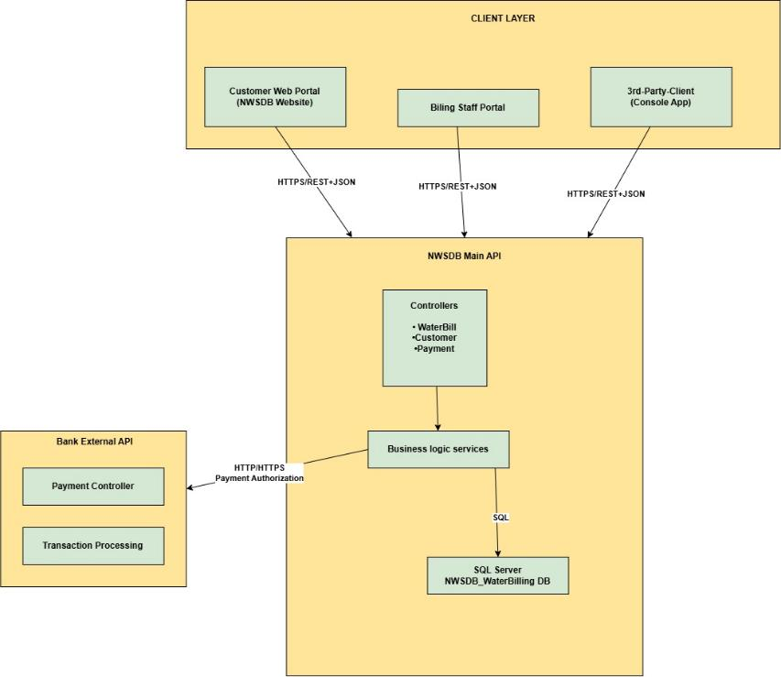
Figure 1
Layered SOA design separates client portals, NWSDB services, databases, and bank APIs, enabling secure, independent payment processing through REST communication.

2.2 API Design
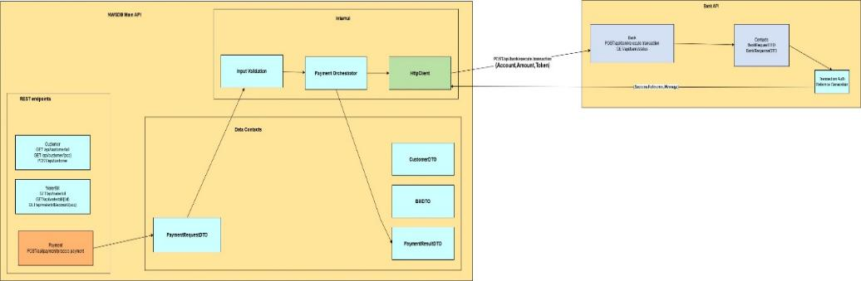
Figure 2
API pipeline validates input, orchestrates payments, and calls the Bank API, while DTOs ensure consistent, type-safe service communication.

2.3 Use Case Diagram - Normal User Customer Portal
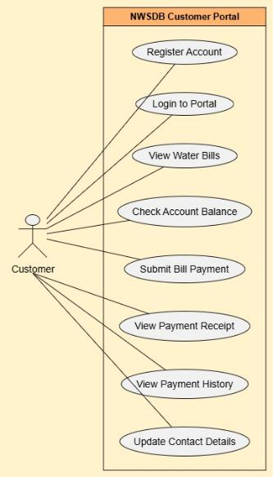
Figure 3
The customer portal enables registration, secure login, bill and balance viewing, payments, receipt downloads, transaction history, and personal detail updates through REST APIs.

2.3.1 Use Case Diagram (Main application (staff and system)
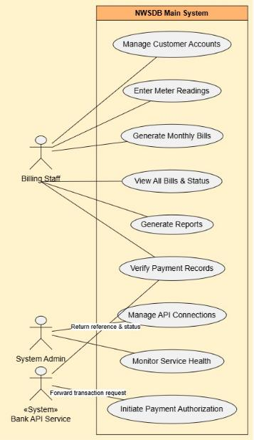
Figure 4

2.4 Class diagram – Main Application (NWSDB API)
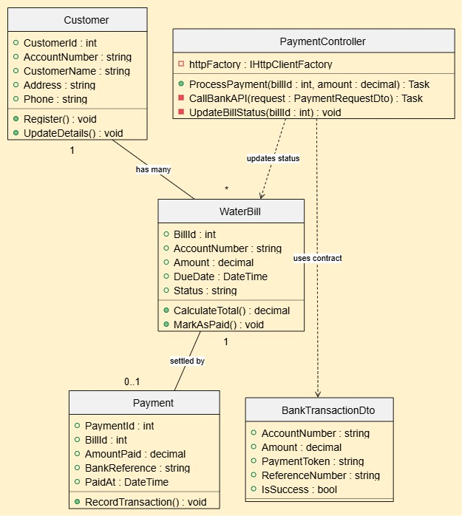
Figure 5
Billing staff manages accounts, meter readings, bills, and reports; System Admin monitors health, API connections, and payment authorization. Bank API service handles secure forwarding with status feedback.

2.4.1 Class diagram – 3rd Party client Application
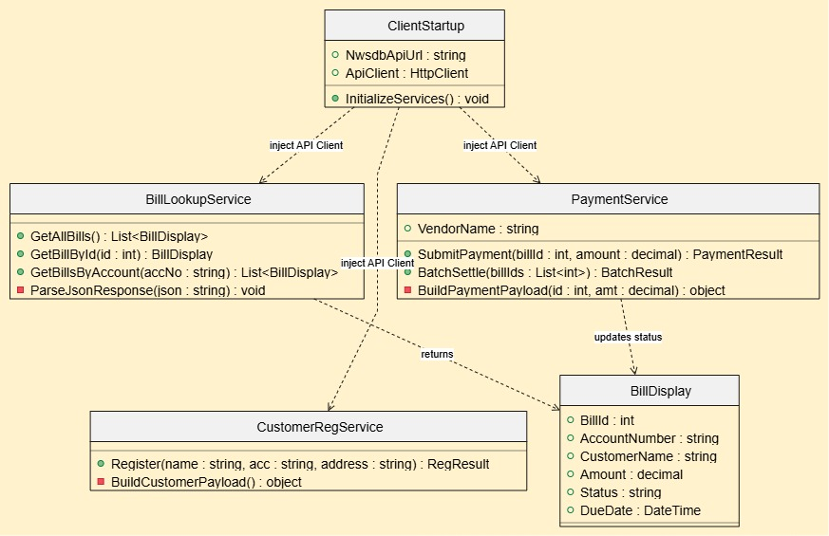
Figure 6
Customer, water bills, and payments follow one-to-many relationships; the controller processes bank authorization through DTOs and updates bills to Paid.

2.5 Activity diagram – Payment process Flow
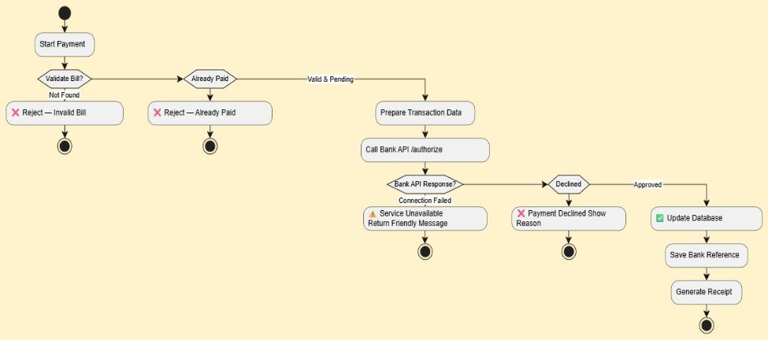
Figure 7
The payment process validates the bill, checks its status, and sends the payment request to the Bank API. It then handles successful, declined, or failed responses, updates the database, stores the payment reference, and generates a receipt. If the Bank API is unreachable, the system uses a graceful fallback to prevent data loss and inform the user appropriately.

2.6 Sequence Diagram – End-to-End Payment Flow
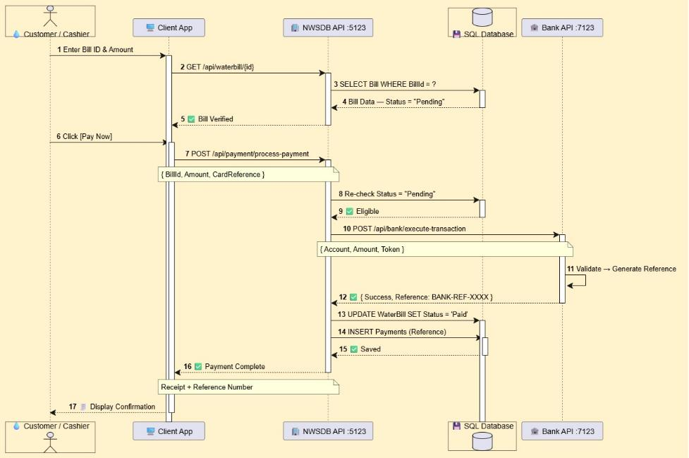
Figure 8
The client sends a payment request to the NWSDB API on port 5123, which validates the transaction through SQL. The request then goes to the Bank API on port 7123 for authorization. After approval, both databases are updated, and a receipt is returned, demonstrating independent services in the SOA design.

2.7 Entity-Relationship Diagram.
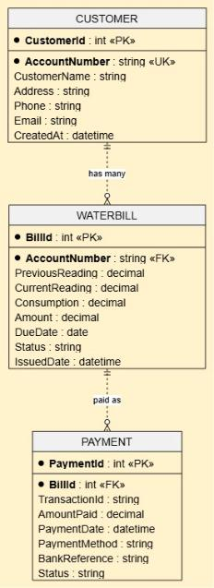
Figure 9
The scheme links each customer to multiple water bills, with each bill optionally associated with one payment. Foreign keys, unique account numbers, status fields, and audit timestamps maintain data integrity and traceability in a normalized SQL Server database.

B. Implementations

NWSDB_API
- Create a new project - choose Blank solution

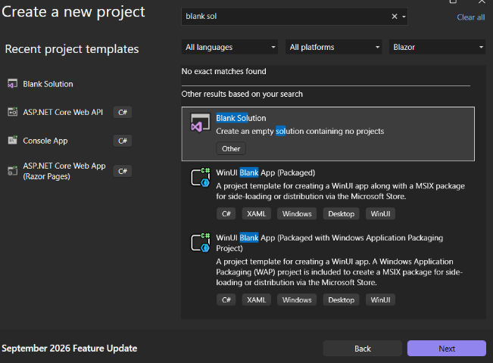
Figure 10
- Give a name to the solution

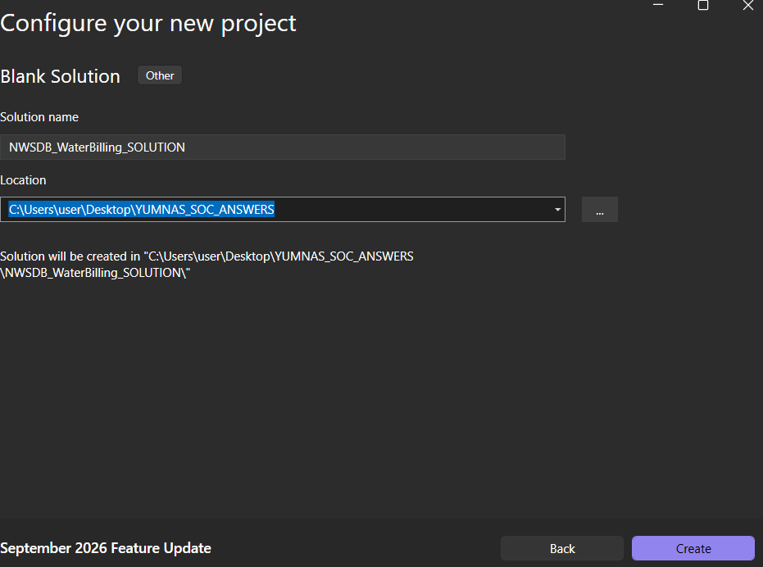
Figure 11
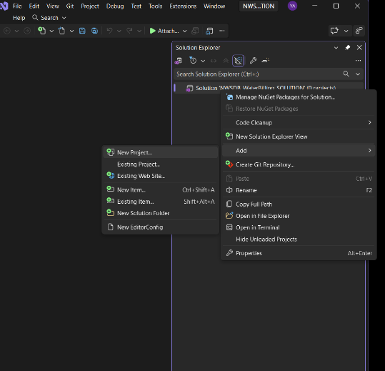
Figure 12
- Select ASP.NET Core Web API as a template
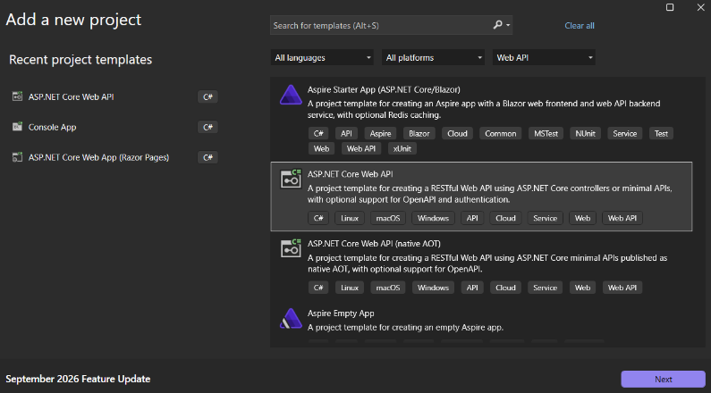
Figure 13

- Giving Project Name
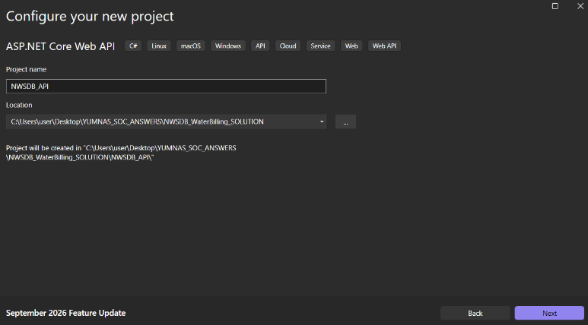
Figure 14
- Setting up libraries.
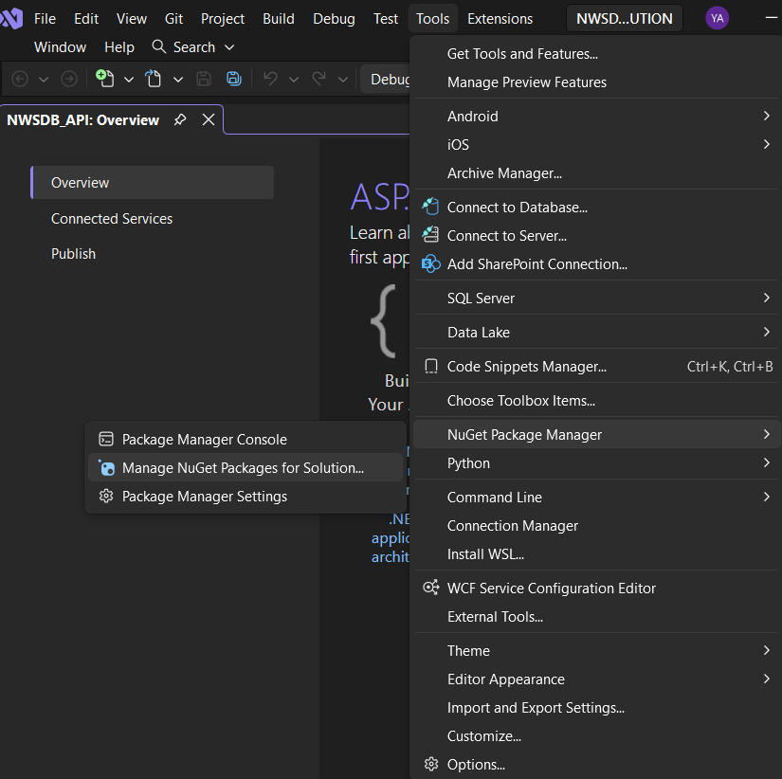
Figure 15

- NuGet packages
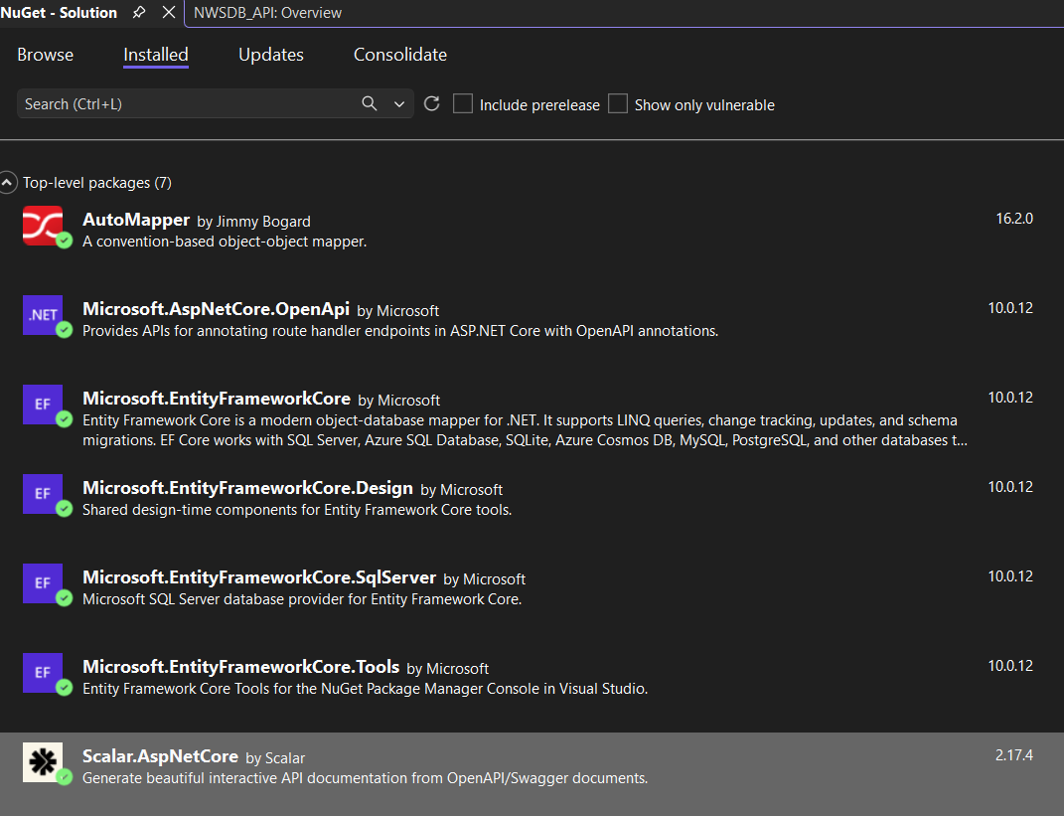
Figure 16
- AutoMapper simplifies conversion between database entities and Data Transfer Objects, reducing repetitive code.
- Microsoft.AspNetCore. OpenAPI. OpenAPI generates API documentation through OpenAPI and Swagger metadata.
- Entity Framework Core enables developers to manage SQL Server data using C# objects instead of extensive raw SQL.
- Its Design package supports database migrations, while the SQL Server provider connects the application to SQL Server.
- EF Core Tools provides commands for creating and updating database schemas through Visual Studio.
- Scalar.AspNetCore offers a modern, interactive API documentation interface based on the OpenAPI specification.

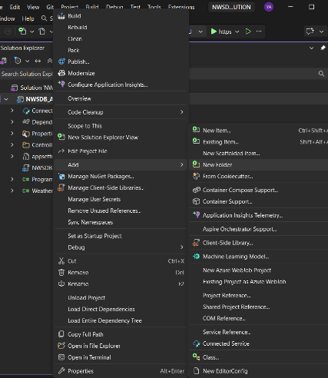
Figure 17

- Overall folders in my NWSDB_API
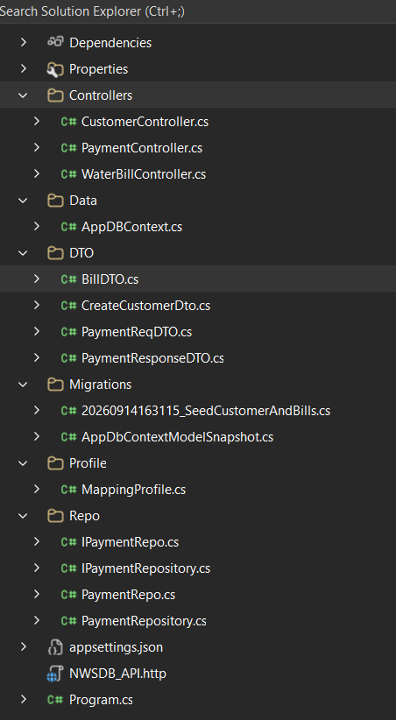
Figure 18
- The Controller folder provides REST endpoints for web, Cargills, and third-party clients, while coordinating payment validation, bank requests, and status updates.
- The Data folder defines database entities and relationships for customers, bills, and payments, with access restricted to NWSDB_API. DTOs standardize secure data exchanged with clients and external services.
- The Migration folder manages database versioning, ensuring consistent schemas and seed data across deployments.
- The Profile folder automatically maps database entities to DTOs, reducing repetitive code.
- Finally, the Repo folder centralizes database queries and separates data access from controllers, improving maintainability, testability, and flexibility when changing database providers.

Main API running

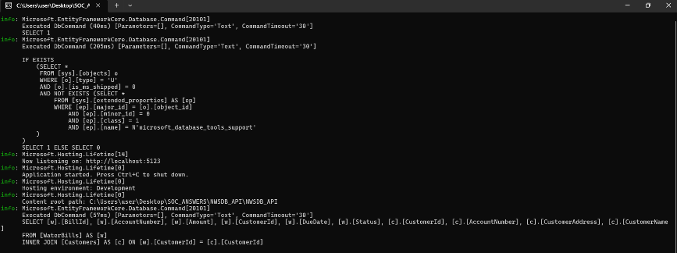
Figure 19

- Home
The central gateway provides access to independent backend services NWSDB_API and BANK_API without exposing internal implementation.
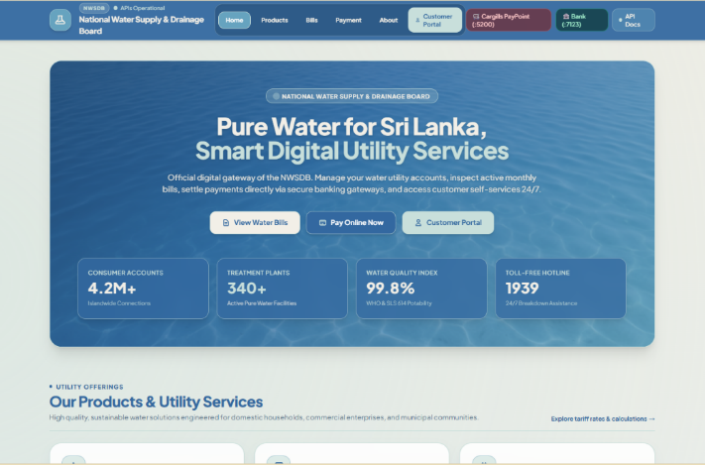
Figure 20
- Products and Utility Services Page
Demonstrates a unified front-end interface that consumes data from the central NWSDB_API modular presentation over decoupled backend services.
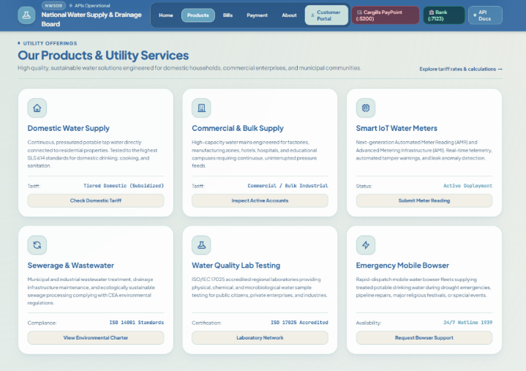
Figure 21

- Bills Management Portal
Retrieves live data via GET/api/waterbill from NWSDB_API connected to SQL server shows real time integration between frontend and backend.
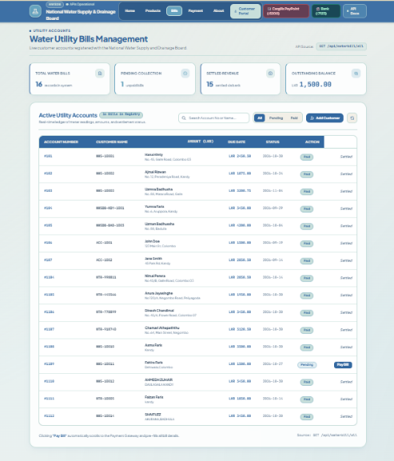
Figure 22
- Payment Gateway
Payment processing is delegated entirely to BankAPI. NWSDB never stores or processes card data. Services communicate only through standard JSON contacts.
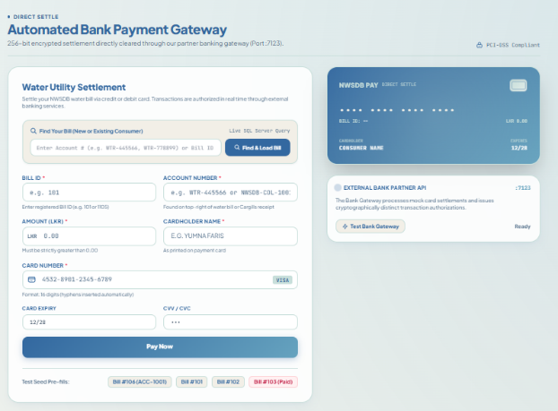
Figure 23
- Institutional Profile
Completes the public portal; serves as an information layer independent of transactional APIs.
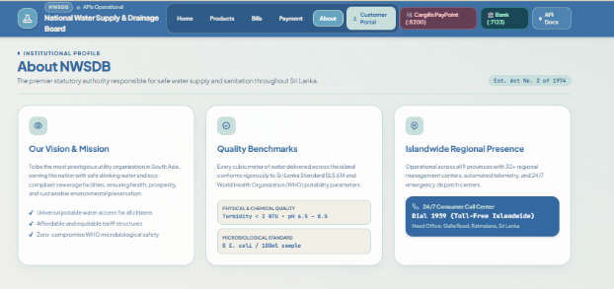
Figure 24
- Customer Service Portal
All features call NWSDB_API endpoints same backend used by staff and 3rd parties, providing service reusability across multiple interfaces.
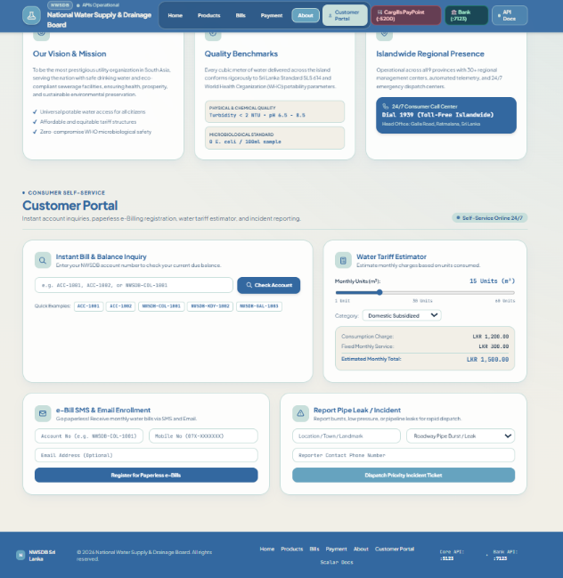
Figure 25

- NWSDB_API Scalar References
Scalar provides a fully interactive, machine-generated documentation interface for the core NWSDB water billing and Payment Gateway API running on port 5123. It serves as the official public service contract enabling customers, internal staff, and 3rd party partners to discover, understand, and test every available endpoint without accessing source code.
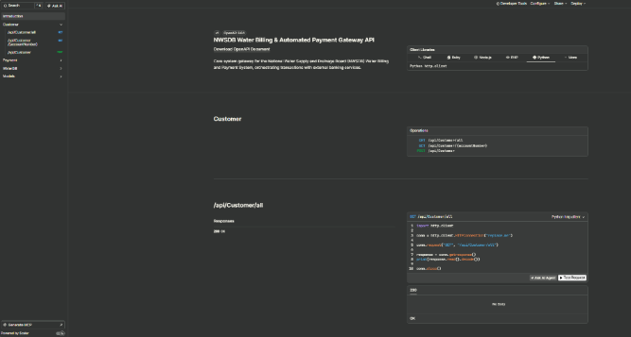
Figure 26
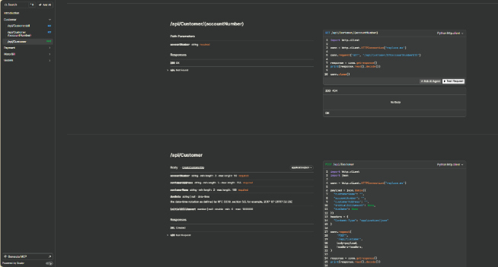
Figure 27
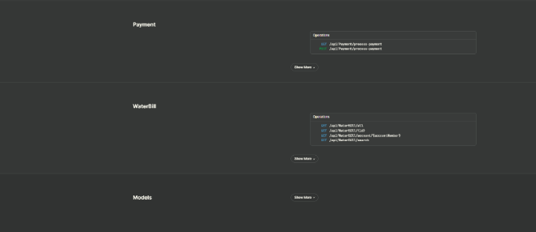
Figure 28

BANK_API
Follows the same steps as shown in NWSDB_API.

BANK_API running
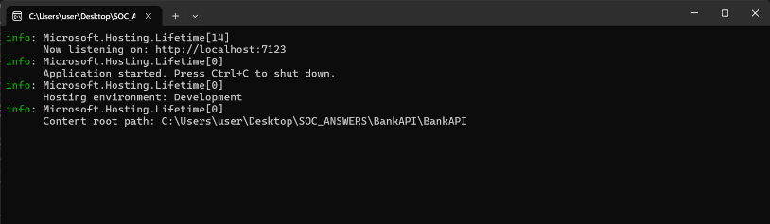
Figure 29

- Bank gateway home
Complete service autonomy: BANKAPI can be upgraded or replaced without recompiling the main NWSDB application.
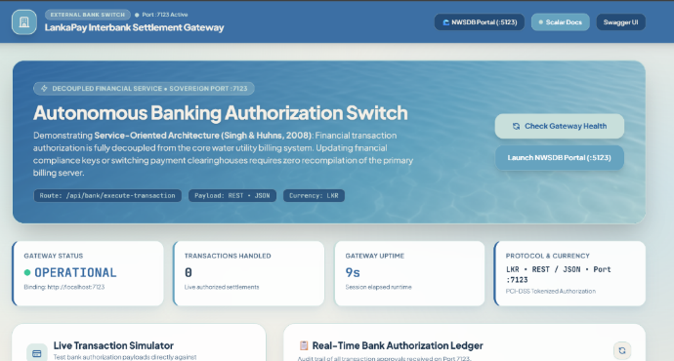
Figure 30

- Transaction Simulator and ledger
Demonstrates how external systems like NWSDB & CARGILLS interact with BANKAPI using the identical interface used internally and by 3rd parties.
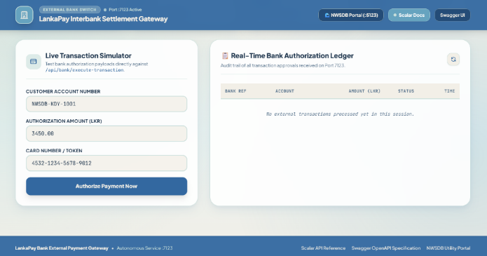
Figure 31

- Scalar docs: execute Transaction Endpoint
Scalar provides a modern, interactive documentation interface that automatically generates from BANK_API’s OpenAPI’s specification. It serves as the public service contract, exactly how third-party partners and NWSDB itself use it to discover, understand, and test the independent payment gateway without accessing source code
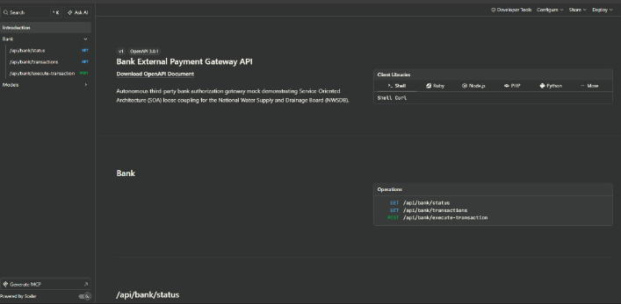
Figure 32

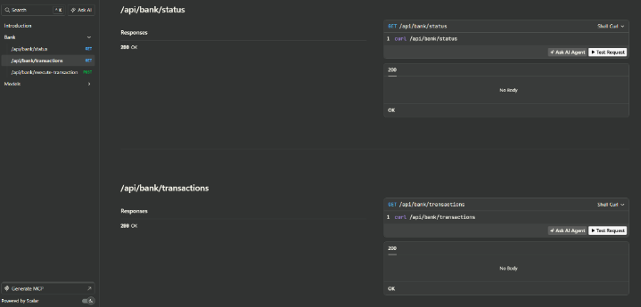
Figure 33

- Swagger UI: BankAPI full specification
Alternative OpenAPI interface listing all endpoints and data schemas. Provides machine-readable schema definitions.
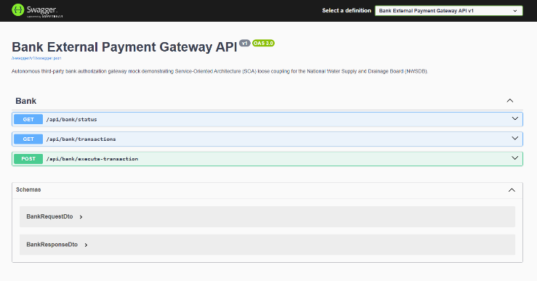
Figure 34

3RD-PARTY CLIENT

3rd party running
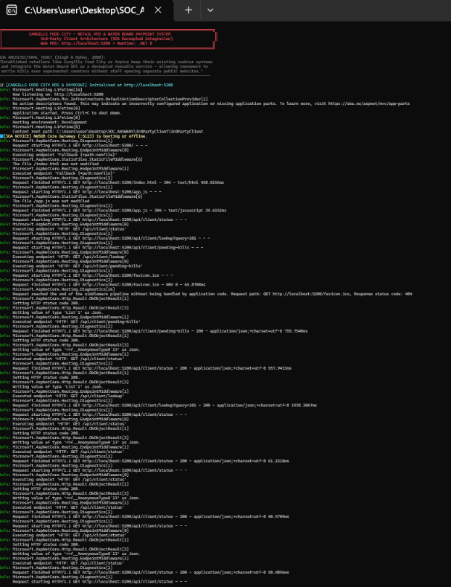
Figure 35
- Pay Point Counter and Bill Settlement
Main payment processing interface for Cargills food city, enabling customers to search bills, view outstanding amounts, and settle via cash or card.
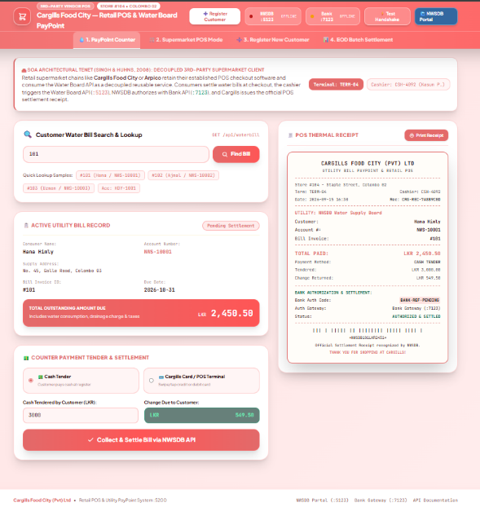
Figure 36

- Supermarket POS Mode
Demonstrates reusable service integration for water bill payment embedded directly into the standard grocery checkout flow alongside regular purchases.
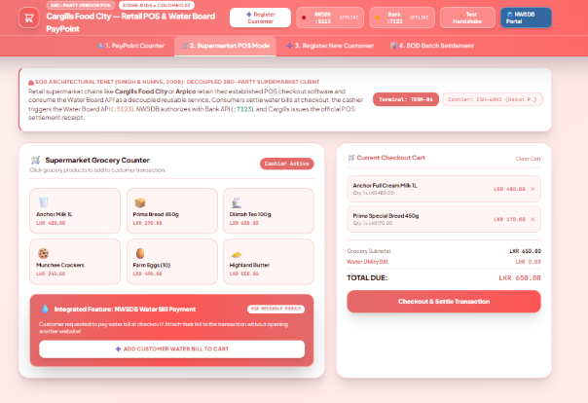
Figure 37

- Registering New Consumer and Open Bill
Third-party onboarding interface allows Cargills staff to register new NWSDB customers and generate their first bill directly from the POS system.
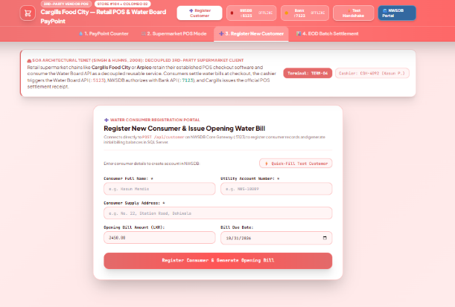
Figure 38

- End-of-day batch settlement and Monitoring
Operational dashboard showing system health, pending/settled totals, and batch processing for reconciling all daily transactions between Cargills and NWSDB
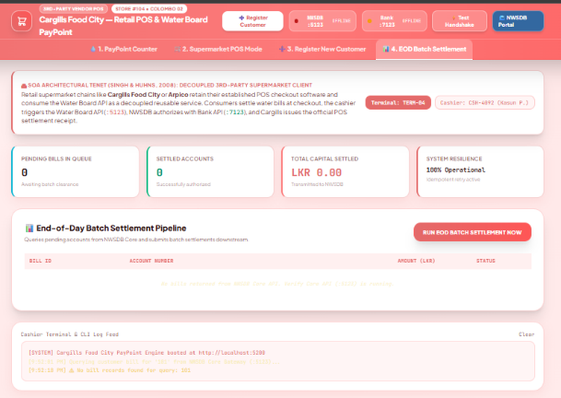
Figure 39

CARGILLSPAYPOINT_WINFORMS
Decoupled 3rd-party desktop application demonstrating service-oriented architecture for Cargills Food City’s independent payment terminal that connects to NWSDB and Bank APIs without sharing internal code or databases.
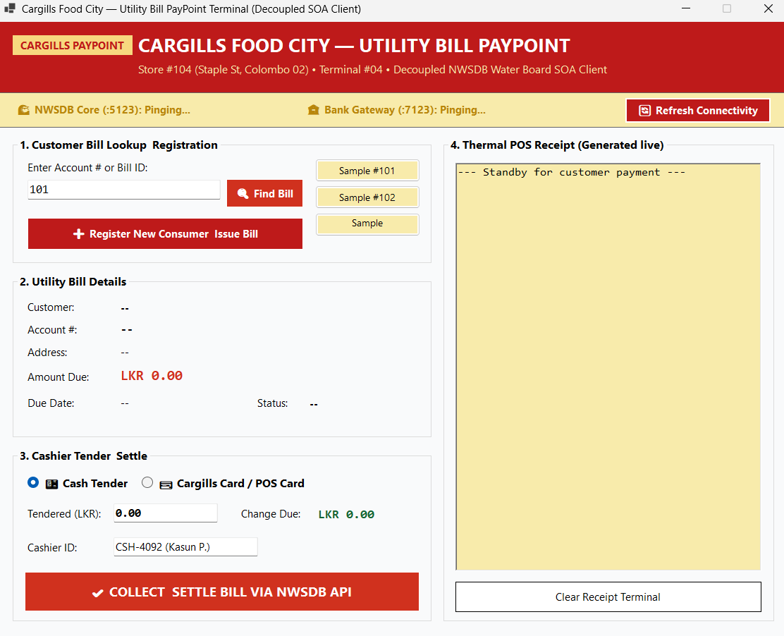
Figure 40

NWSDB Core API implementation
To adhere to the separation of concerns architectural pattern, the NWSDB_API backend is structured into distinct, decoupled software layers. Below is the technical rationale and code implementation for each layer from the domain model to presentation controller
- Entity layer
The entity layer defines the domain data models mapping directly to SQL server tables via entity framework core. Bounding water utility logic separately from payment transactions ensures domain integrity.
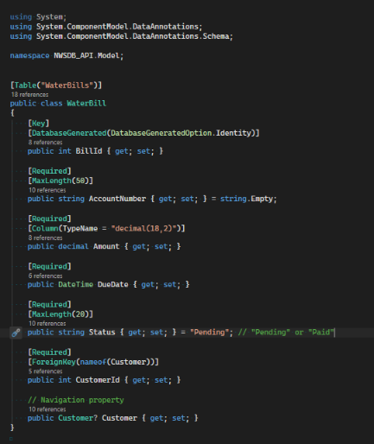
Figure 41
- Database context layer
The AppDbContext serves as the EF core bridge between c# object-oriented domain models and the relational SQL Server database.
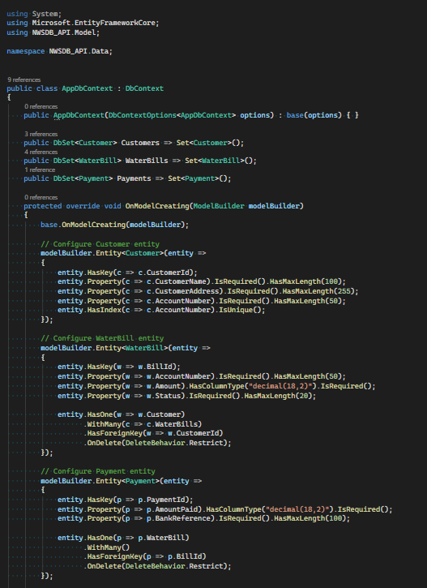
Figure 42
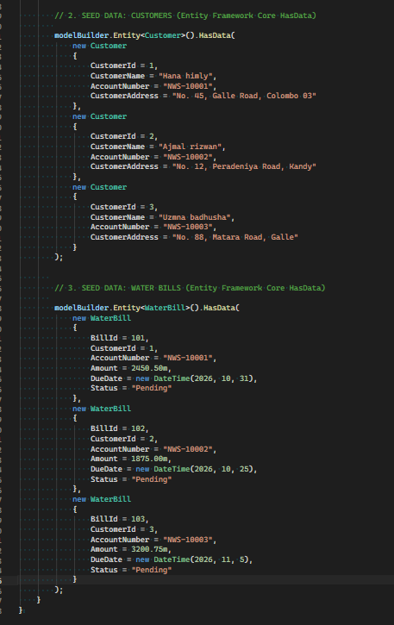
Figure 43
- Database migration and schema
Allow reproducible, version-controlled database schema generation using visual studio manager console.
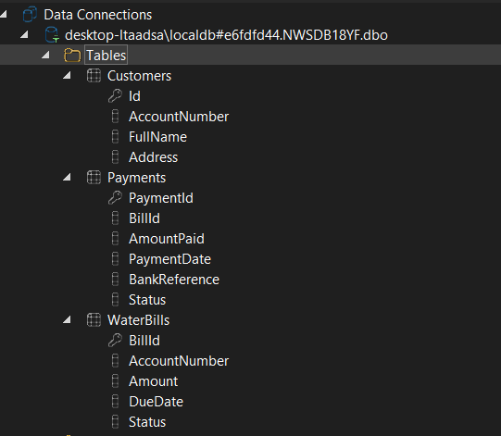
Figure 44
- Data transfer object layer
DTOs define rigid contrcts for external message exchange, shielding internal domain entities from public exposure
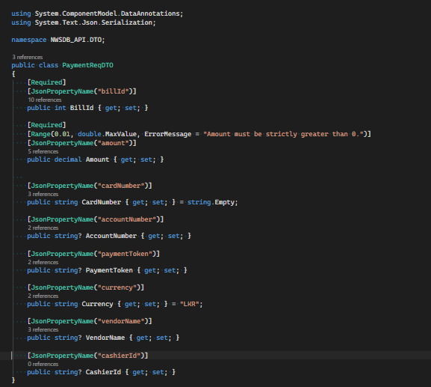
Figure 45
- Repository layer
The repository pattern encapsulates all database query and persistence logic behind an interface.
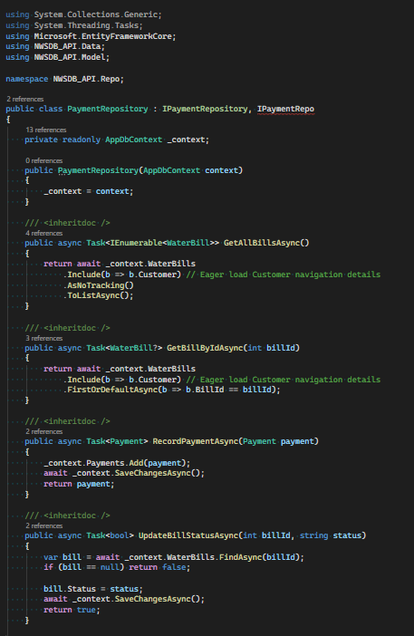
Figure 46
- AutoMapper profile layer
AutoMapper handles projection between entities and DTOs automatically.
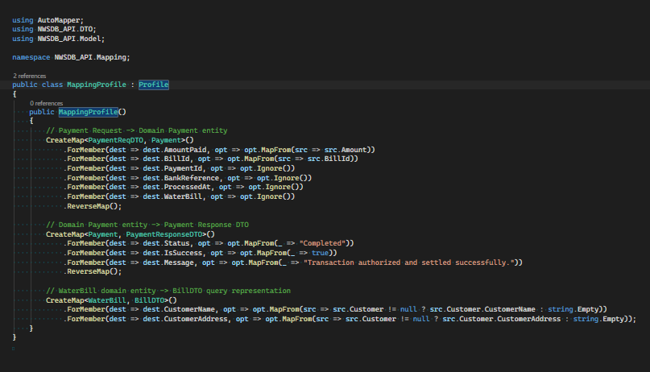
Figure 47
- Controller layer
The paymentController orchestrates the business flow: validating requests, delegating database raeds to the repository, invoking the autonomous external Bank_API via HTTP, and updating status upon payment confirmation.
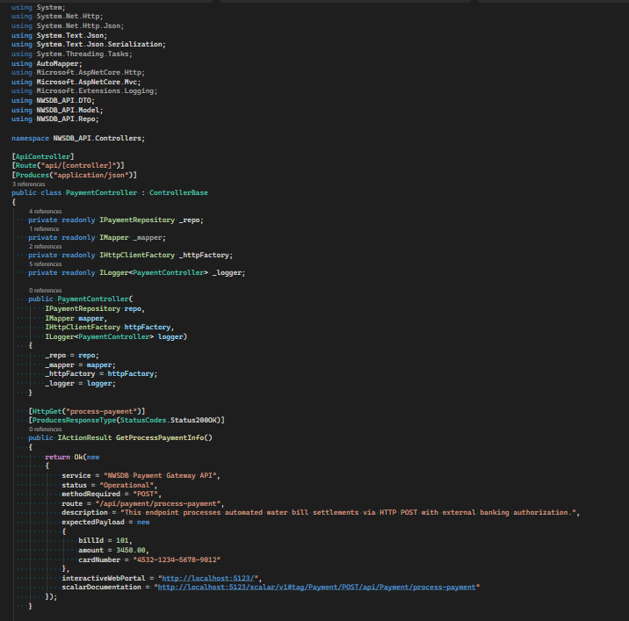
Figure 48

Task 3: Testing and Debugging

3.1 Testing Strategy

3.1.1 Approach
The testing strategy follows Service-Oriented Architecture principles: each service is validated independently first, then tested together as a system, ensuring loose coupling, interoperability, and fault isolation (Yinong, C, 2018). Testing is structured in 4 progressive levels.
Test level | Scope | objective
Unit testing | Individual methods and components (Controllers, Repositories, DTOs) | Verify logic correctness in isolation; confirm data validation rules work as intended.
Integration testing | Service to database and internal layers | Confirms EF Core correctly maps entities to SQL Server; repository methods perform CRUD operations reliably.
API contract testing | NWSDB_API ↔ BANK_API ↔ 3rd Party Client | Validate endpoints accept correct JSON payloads, return expected status codes, and adhere strictly to OpenAPI/Schema definitions documented in Scalar — no shared code, only shared message contracts. (Singh & Huhns , 2008)
End -to-End System Testing | Full payment flow: Cargills →NWSD | Simulate real-world usage; verify independent services communicate without cascading failures; demonstrate third-party partners can integrate without internal access
Table 3

3.1.2. Test cases
Test id | T1
Test case | Retrieve all water bills
Input | GET /api/waterbill/all via Scalar UI
Expected outcome | Returns the list of account number, customer name, amount, due date, status, and action.
Screen shot | 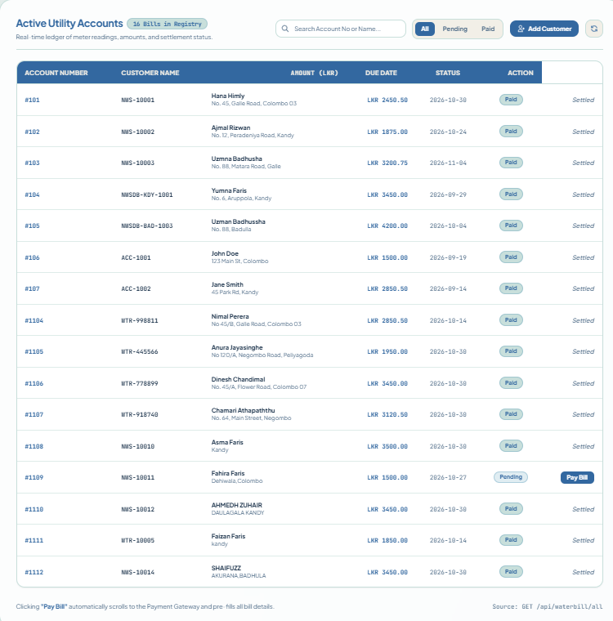
Status | Passed
Table 4

Test id | T2
Test case | Valid bill lookup by ID
Input | GET /api/waterbill/NWS-10012
Expected outcome | Returns the bill for AHMEDH ZUHAIR
Screen shot | 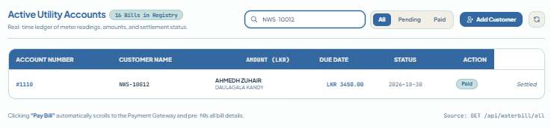
Status | Passed
Table 5
Test id | T3
Test case | Invalid bill lookup-non-existing ID
Input | GET /api/waterbill/NWS-COL-1001
Expected outcome | Account not found in system.
Screen shot | 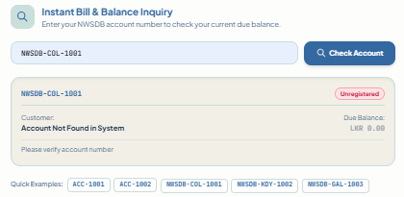
Status | Passed
Table 6

Test id | T4
Test case | Payment valid
Input | POST /api/payment/process-payment with BillId: 103, valid card details, correct amount
Expected outcome | Payment settled
Screen shot | 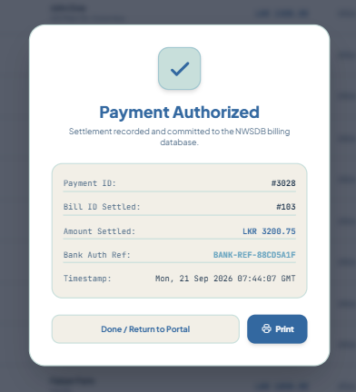
Status | Status updated from Pending to Paid.
Table 7
Test id | T5
Test case | BankAPI valid transaction
Input | POST /api/bank/execute-transaction with a positive amount
Expected outcome | Returns transaction approved
Screenshot | 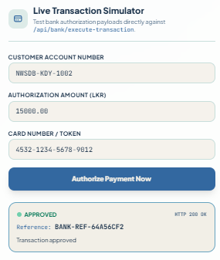
Status | Passed
Table 8

Test id | T6
Test case | Bank API – zero/negative amount
Input | Amount -3450.00
Expected outcome | Value must be greater than or equal to 1
Screesnshot | 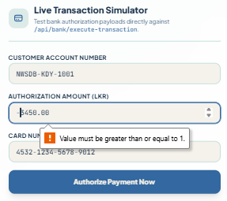
Status | Passed
Table 9
Test id | T7
Test case | Third-party client – list pending bills
Input | Run console application
Expected outcome | Connects to NWSDB API; displays only bills with Status: Pending
Screenshot
Status | Passed
Table 10
Test id | T8
Test case | Attach a valid, active water bill to the transaction.
Input | Click + Add Customer Water Bill to Cart → enter a valid Account No.
Expected outcome | Bill found: NWSDB Bill #101 (Hana Himiya), Amount LKR 2,450.50; appears in cart under separate Water Utility Bill section
Screenshot | 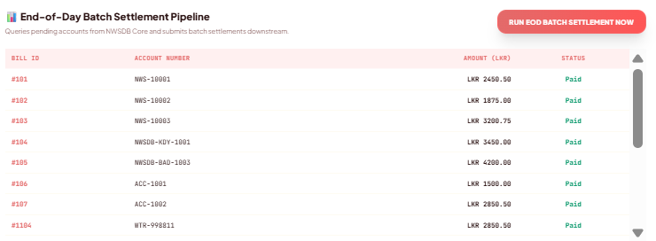
Status | Passed
Table 11

Test id | T9
Test case | Registering a new customer at the water board paypoint
Input | Fill out customer name → account num → address → bill amount → bill due date.
Expected outcome | Consumer registered successfully in NWSDB database.
screenshot | 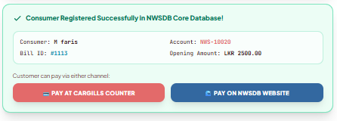
Status | Passed
Table 12
Test id | T10
Test case | Valid payment in BANK_API
Input | Insert accnum, amount, currency, payment token, card num.
Expected outcome | Transaction approved
Screen shot | 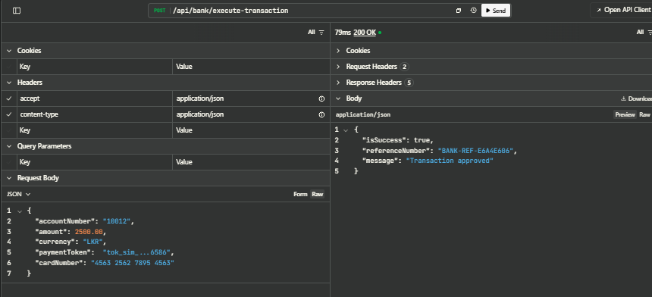
Status | Passed
Table 13

3.2 Debugging Process
Debugging in a service-oriented system differs from a monolith: issues can occur across three independent layers: NWSDB API, Bank API, and the client. So, the process isolates each layer before integration testing. (Singh & Huhns , 2008).
Step-by-step debugging workflow
- Local verification – NWSDB_MainAPI
To isolate and confirm payment flow behavior, local debugging was performed on the NWSDB main API:
- Setting up breakpoints in PaymentController.cs at six critical points:
  - before input validation
  - before database lookup
  - before bank API dispatch
  - immediately after BankAPI response received
  - before status update
  - before returning final receipt
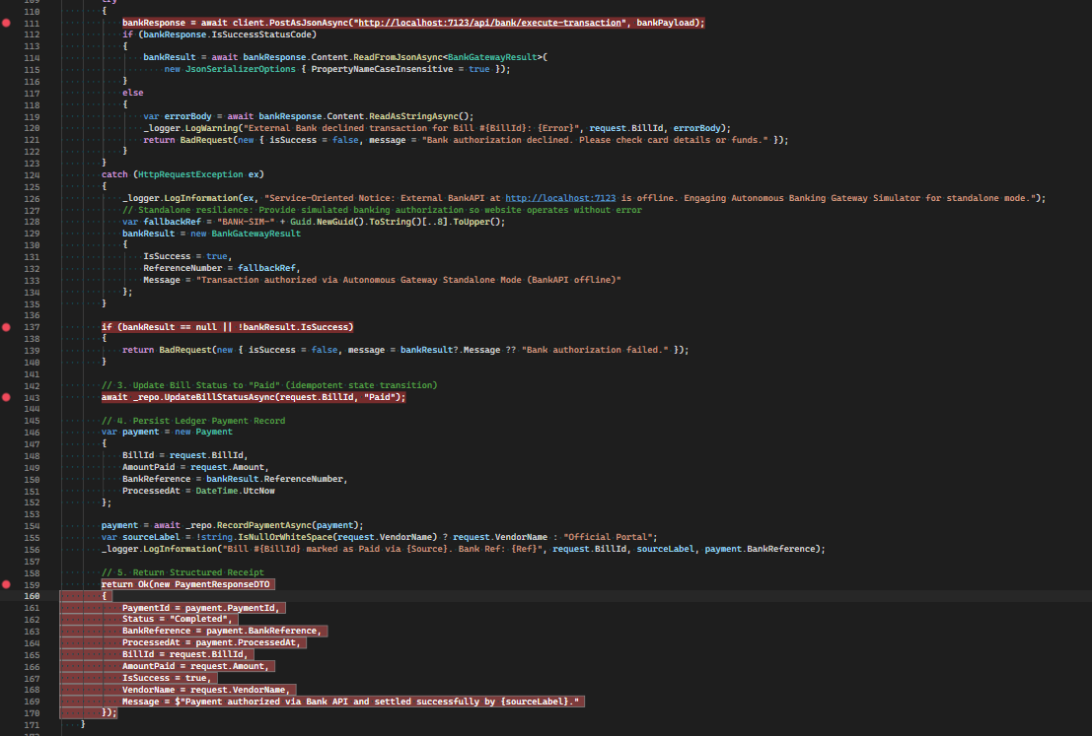
Figure 49
- GET endpoint verification
The GET endpoint confirmed the API was operational and explicitly documented that payment processing requires a POST request with a JSON payload. This distinction ensured the correct methods and format were used for subsequent debugging.
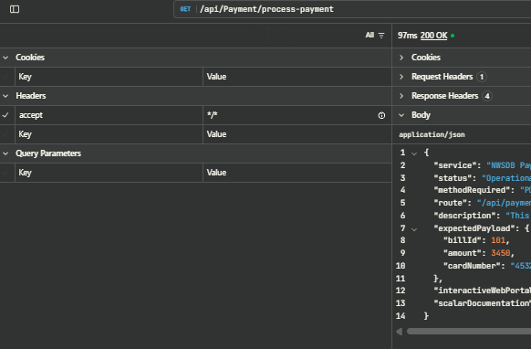
Figure 50
- Cross-service Diagnosis – BANK API
After confirming NWSDB Main API operated correctly in isolation, the Bank API integration was verified:
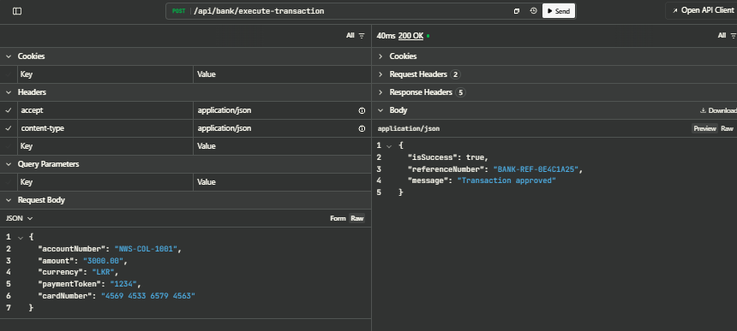
Figure 51
HTTP 200 OK was returned with a unique bank reference. This confirms the Bank API functions completely independently. It validates requests, applies business logic, and returns standardized responses without any dependency on NWSDB Main API.

3.2.1 Real-world debugging scenario and defect resolution
Integration testing of the payment dispatch flow between NWSDB_API and BankAPI initially produced an HTTP 500 error when triggered through the Cargillspaypoint client. Investigation confirmed that validation and repository lookup succeeded, but the bill remained Pending because PostAsJsonAsync () failed with a connection-refused HttpRequestException at 127.0.0.1:7123. The root cause was incorrect BankAPI configuration, including restrictive CORS settings, SSL redirection, and an unsecured HTTP endpoint. The issue was fixed by permitting http://localhost:5123 in BankAPI’s CORS policy and updating NWSDB_API to use BankAPI’s HTTPS URL. Retesting returned HTTP 200, generated valid transaction tokens, and updated the bill status to Paid.

3.3 Test Results Summary
All 10 test cases passed successfully with 0 failures. The system demonstrated consistent behavior across unit, integration, contract, and end-to-end levels:
- Service autonomy verified: Bank_ExternalAPI functions completely independently, started, stopped, or modified without affecting NWSDB billing logic.
- Fault tolerance demonstrated: Bank API downtime triggers graceful fallback – customers can still be served and bills viewed; only payment processing switches to simulated mode.
- Data integrity maintained: Duplicate payments are rejected; status updates are atomic: a bill is marked “Paid” only after an authorization reference is securely received.
- Third-party integration confirmation: Cargills POS and console client consume identical endpoints with no special case code or database access required for partners.
Every debug step reinforced that in SOA, problems are local to one service. This is the fundamental difference from a monolithic design. (Singh & Huhns , 2008).

Task 4: Deployment Techniques

4.1 Deployment Options Comparison
Before evaluating specific hosting platforms, it is critical to contrast how the system would be deployed under monolithic versus service-oriented architecture approaches:
Dimension | Monolithic deployment | Service-oriented deployment
Hosting structure | All components in one unit, deployed to one server. | Main API and Bank PAI are separate partners.
File deployment | One folder, one config; any update takes the whole system offline | Separate folders and configs. Update one service; the rest stay fully online.
Scalability | When payment processing becomes busy, the entire application stack, including billing, reporting, and administration, must be duplicated. This wastes resources because many replicated components remain underutilized. | Scale individual services according to demand: increase Bank_ExternalAPI instances during month-end rushes and NWSDB_MainAPI instances during heavy bill-checking periods, avoiding system-wide slowdowns or bottlenecks.
Resilience | One point of failure is if payments crash, bill checks and customer portals go down too. | Fault-isolated Bank API downtime does not stop NWSDB from serving bill data; fallback mode maintains partial functionality.
Table 14
Deployment context: the NWSDB water billing and payment system relies on SOA to enable independent scaling, partial updates, and service-specific hosting across various third-party partners. The chosen deployment strategy must balance reliability, security, cost, and long-term growth while supporting island-wide access, month-end payment surges, and external integrations. (Singh & Huhns , 2008; Chen, Y, 2018).

4.2 Comparative analysis of Hosting environments
- Traditional on-premises hosting (Windows Server / IIS)
Overview | Deploys separate internet services websites for the main API, Bank API, and web portal on NWSDB-managed physical or virtual servers.
Advantages | Delivers full data ownership.  Avoids recurring cloud subscription costs.  Integrates directly with existing internal legacy databases and enterprise network infrastructure.
Disadvantages | Manual scaling violates automated elasticity principles required for peak loads; geographic redundancy is limited, and physical server capacity must be continuously over-provisioned to absorb month-end payment spikes.
SOA context and evaluation | Provides administrative autonomy but limits SOA agility; suitable for small pilots or legacy systems, yet inefficient for island-wide expansion.
Table 15
- Managed cloud infrastructure (Azure App Service)
Overview | Managed PaaS offering isolated microservice hosting, Azure SQL integration, deployment slots, automated SSL, autoscaling, and self-healing capabilities.
Advantages | Dramatically reduces infrastructure management overhead, enables zero-downtime deployments via staging slots, and dynamically auto-scales during heavy transaction periods.
Disadvantages | Incurs subscription costs, may introduce latency when querying on-premises databases, and requires verification of local data residency and regulatory compliance requirements.
SOA context and evaluation | Aligns with SOA; abstracts infrastructure: recommended primary cloud platform native .NET support, high availability (Yinong, C, 2018).
Table 16

4.2.1 Cloud platform Comparison
Criteria | Microsoft Azure | AWS
.Net/ c# tooling | Native first-party integration; Visual Studio includes built-in Azure publishing profiles. | Supported via SDKs and Toolkit for Visual Studio, but not first-party
Container orchestration | Azure Kubernetes Service offers a free control plane. | Elastic Kubernetes Service (EKS) control plane billed hourly
CI/CD integration | Azure DevOps and GitHub Actions connect seamlessly with App Service and AKS. | Code Pipeline/Code Deploy, or GitHub Actions with more manual IAM setup
Managed SQL Server | Azure SQL Database near drop-in replacement for SQL Server Local DB | RDS for SQL Server are comparable, but licensing costs differ
Regional availability | Azure Central India / South India region | AWS Asia Pacific (Mumbai) region
Learning curve for the team | Lower, consistent with Microsoft stack already in use (VS, EF Core, IIS) | Higher: different tooling ecosystem, separate learning investment
Free tier/ cost for a student project | Azure for Students credit, generous free-tier App Service tier | AWS Free Tier, but EKS control plane isn't free
Table 17
Azure is preferred over AWS because it integrates seamlessly with the project’s existing .NET, Entity Framework Core, and Visual Studio ecosystem. Features such as one-click publishing, native AKS support, and Azure SQL compatibility reduce operational complexity. Although AWS is equally capable, its additional IAM and CI/CD setup would increase the team’s learning curve.

4.3 Containerization and Orchestration evaluation
- Docker containerization
- Containerize each .NET Web API and service with its own runtime, dependencies, and configuration in lightweight, isolated containers. This ensures consistent environments across development, staging, and production, prevents dependency conflicts, and provides faster startup with lower resource usage than virtual machines.
- Kubernetes Container Orchestration (AKS)
- Kubernetes manages containerized services by automating deployment, monitoring, service discovery, traffic routing, and load balancing. It supports independent autoscaling, distributes requests to improve reliability, and automatically recovers from failed containers or unhealthy nodes. However, it adds operational complexity, requires centralized monitoring and logging, and demands advanced platform expertise (Singh & Huhns , 2008).

4.4 Recommendation
Recommended platform stack: Microsoft Azure + Docker + Azure Kubernetes Service
Strategic justification:
- Azure integration: .NET Web APIs on Microsoft Azure offer optimized performance, built-in CI/CD, and seamless database connectivity.
- Resilience: Kubernetes load balancing and container isolation prevent failures or traffic spikes in bank integrations from affecting core billing services.
- Scalability and governance: Container orchestration enables NWSDB to add payment partners through standardized REST/JSON APIs while hiding infrastructure changes.

My Visual Studio Code → https://drive.google.com/drive/folders/1BKRuB3FY-xoKqcyQMw4X_GHm4Z5Oi3a_?usp=sharing

Conclusion
The project concludes that replacing NWSDB’s monolithic system with independently deployable NWSDB_MainAPI and Bank_ExternalAPI services improves flexibility, resilience, and cost efficiency. It isolates partner updates, allows billing to remain available during payment failures, scales payment processing independently during peak periods, and supports automated Kubernetes deployment. Overall, SOA provides a reliable and sustainable foundation for NWSDB’s future expansion.

References
Chen, Y, 2018. Service-Oriented Computing and System Integration: Software, IoT, Big Data, and AI as Services. 6th ed. s.l.: Kendall Hunt.
Erl, T, Singh & Huhns, 2016,2008. Session 07 (SOA Definition & Advantages), SOA: Analysis & Design, s.l.: s.n.
Richards, M , Chen, Y., 2015,2018. Session 07 (Comparison Table), Microservices vs SOA, s.l.: s.n.
Singh & Huhns , 2008. Session 07 (SOA Conclusion), s.l.: s.n.
Singh, M.P. & Huhns, M.N. , 2008. Session 07 (Monolithic Architecture: Advantages & Disadvantages), s.l.: Service-Oriented Computing.
Singh, M.P. & Huhns, M.N., 2008. Service-Oriented Computing: Semantics, Processes. In: s.l.:Wiley.
Yinong, C, 2018. Service-Oriented Computing and System Integration: Software, IoT, Big Data, and AI as Services. 6th ed. ed. s.l.:Kendall Hunt Publishing, Dubuque, IA.

