ASSIGNMENT COVER SHEET

Qualification |  | Module Number and Title
Higher Diploma in Computing and Software Engineering |  | CSE4004  System analysis and design
Student Name and No |  | Assessor
Yumna Faris  KD/HDCSE/CMU/81/18 |  | Sir, Induranga De Silva
Handout date |  | Submission date
2025.08.28 |  | 2025.08.30
Assessment type  WRIT1 – Coursework {individual} | Duration/Length of Assessment Type  3000 WORDS | Weighting of Assessment  100%

Learner declaration
I, Yumna Faris, certify that the work submitted for the assignment is my own and that research sources are fully acknowledged.
Marks Awarded
First assessor
Iv marks
Agreed grade
Signature of the assessor
Date

FEEDBACK FORM
MODULE: SYSTEM ANALYSIS AND DEVELOPMENT
ASSESSOR: SIR, INDURANGA DE SILVA
ASSIGNMENT: STUDENT INFORMATION SYSTEM FOR ICBT COLLEGE
STRONG FEATURES OF YOUR WORK:
MARKS AWARDED:
AREAS FOR IMPROVEMENT:

ACKNOWLEDGEMENT
Thank you to Cardiff Metropolitan University and ICBT for the excellent learning tools and support. A special thanks to all the professors, especially Induranga Sir, for his excellent teaching, patience, and comprehensive explanations. I am also deeply grateful to my parents for their unwavering belief and affection; I couldn't have done it without them. I sincerely appreciate everyone's role in my educational journey.

EXECUTIVE SUMMARY
This report reviews ICBT College’s student enrollment and records system. The current manual process is inefficient, prone to errors, and insecure. A new Student Information System (SIS) is proposed as the solution. The report outlines the system requirements and uses Agile development. It includes functional and data models. This new SIS will automate key tasks, ensure data accuracy, and provide a scalable platform, saving time and improving the experience for staff and students.

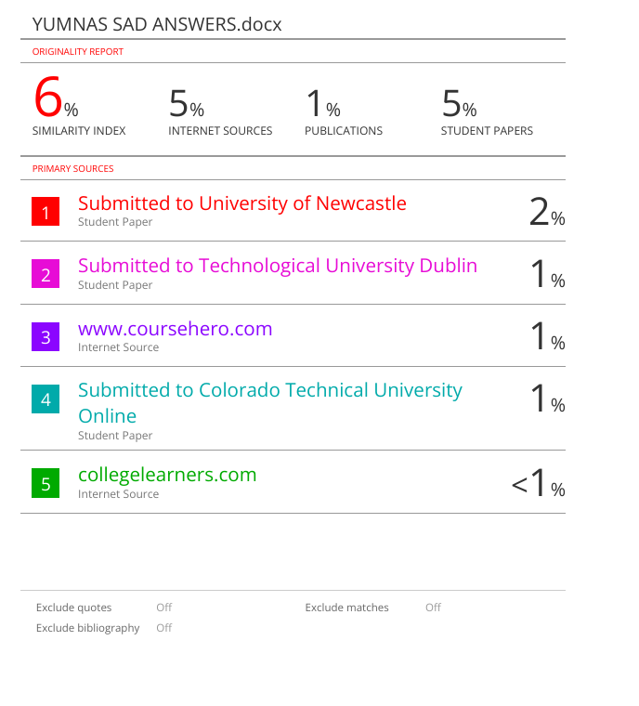
TABLE OF CONTENTS
Contents
ACKNOWLEDGEMENT 3
EXECUTIVE SUMMARY 4
INTRODUCTION 7
TASK 8
1. Organizational analysis and system requirements. 8
2. Software development lifecycle 11
3. Data model design 12
4. Functional model design 14

TABLE OF TABLES
Table 1 9
Table 2 10
Table 3 13
Table 4 20

TABLE OF FIGURES
Figure 1 8
Figure 2 9
Figure 3 11
Figure 4 12
Figure 5 13
Figure 6 14
Figure 7 16
Figure 8 17
Figure 9 17
Figure 10 18
Figure 11 19
Figure 12 19
Figure 13 20

INTRODUCTION
This report proposes a new digital system to fix ICBT College’s messy student records. The current paper-and-spreadsheet method is slow, error-prone, and inefficient. Our solution is a single, unified computer system. We will analyze current problems, detail the new plan, and advocate for a flexible agile build. Data flow and ER diagrams will design the system. The goal is to establish an automated, accurate digital foundation that can grow with the college.

TASK

Organizational analysis and system requirements.

Organization Name: ICBT College.
Industry: Private higher education institution.
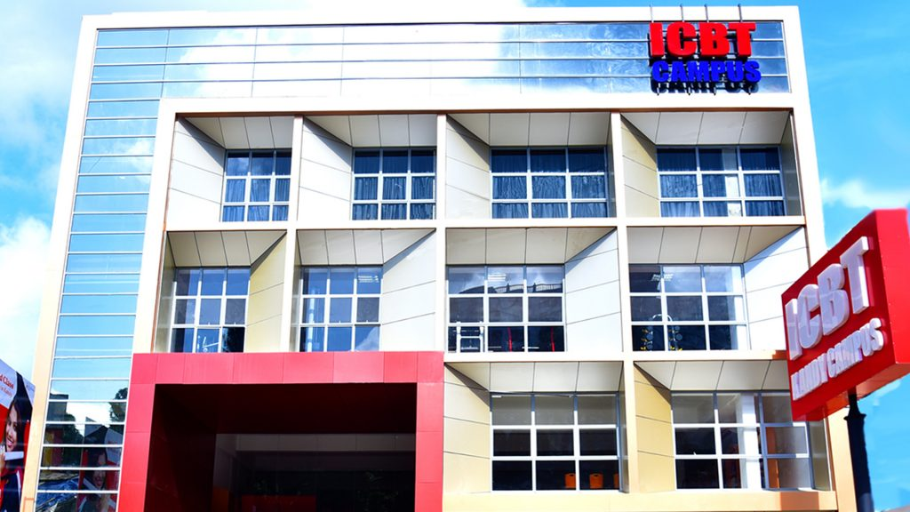
Figure 1

ICBT College is a leading private university in Sri Lanka, offering undergraduate, graduate, and diploma programs in business, IT, engineering, and hospitality management. With about 5,000 local and international students yearly, it provides flexible study options for graduates and working professionals, focusing on industry-relevant courses. ICBT features modern classrooms and labs across its campuses in Colombo, Kandy, and the UK, along with strong industry connections and job support for graduates.
Vision, Mission, and Core Objectives
- Vision - College aims to be a world-class institution that equips students with practical skills for successful careers.
- Mission - to provide accessible, high-quality education through modern teaching methods and partnerships with employers.
- Objectives- The college focuses on designing relevant courses, promoting innovation and research, maintaining affordable education options, and upholding high standards of professionalism. These goals significantly impact students' lives and careers.
Current system analysis
Function: Student Enrollment and Academic Record-keeping.

ICBT College currently relies on a mixed manual and semi-automated system for student enrollment and academic record management. Students fill out paper application forms, which staff then manually type into Excel files to keep records.
Staff must check multiple documents for the same information, creating duplicate data. Records are mainly paper-based with little digital backup, risking data loss. The college’s online learning system isn’t connected to students' records. Teachers must update records by hand in different systems, causing delays and mistakes. Without one main system, workers waste time fixing errors across paper, spreadsheets, and websites.
Our current outdated system causes 3 major problems:
- Typing in all data manually makes admissions and grading unnecessarily time-consuming.
- Information becomes unreliable because our different systems don’t communicate.
- Teachers and students can’t view up-to-date records instantly.

Figure 2
The college has problems and its impact:
- The student enrollment process has problems and its impact:
Problem | Impact
Manual eligibility verification  - A staff member must physically look at paper result sheets and manually check them against the requirements | Slow process, students must wait.  Human errors in grading checks.  Inconsistent decisions.
Paper-based decisions  - All documents are physical papers. | High risk of loss or damage.  No backup copies.  It is difficult and slow to find files.
Siloed and manual data entry  - After the documents are verified, someone must manually type the student’s personal and academic details into the ‘ICBT’ system.  - The data exists on paper first and is then re-typed into a computer | Typing errors are common.  Wastes staff time.  Data exists in two places, causing confusion
No clear connection between payment and registration  - The student pays the fee at the finance office.  - The academic office that runs the classes doesn't automatically know the payment happened. | Registration delays for students.  Students get frustrated proving they paid

- Academic record-keeping

Problem | Impacts
Manual data entry at the source  - All student data, like personal details, grades from O/L and A/L, is on paper.  - A staff member must manually type this information into the ‘ICBT system’ to create the student’s academic record. | Student records start with errors.  Wastes academic staff's time.
Reliance on physical documents  - The official student documents are stored in a physical file.  - This paper file is the primary source of truth, not the digital system. | Hard to access records remotely.  Permanent loss if files are damaged.  Digital and paper records can disagree.

Table 1
ICBT uses fact-finding methods:
For a real-world assignment, my team and I studied at ICBT College for over two weeks in August 2025. We used surveys, interviews, and observations, with key insights from staff interviews. I have authored the final report myself, combining all findings to complete the project and deepen our understanding of the college.
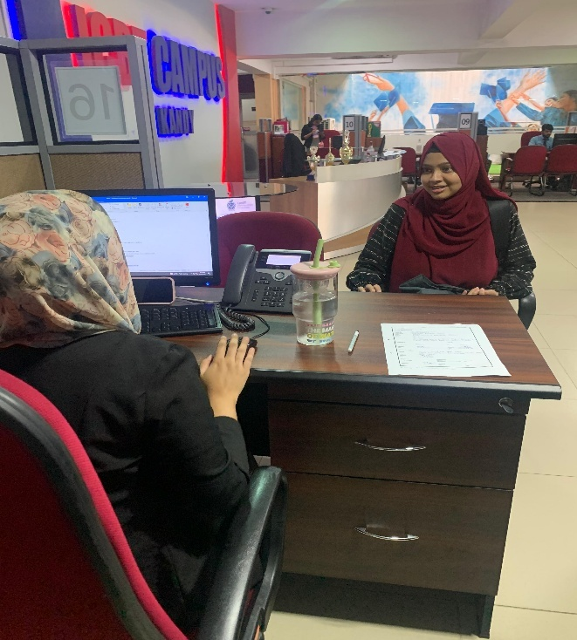
Figure 3

- Through structured interviews with marketing counselors, we gathered detailed insights into the current student enrollment process.
- A software engineering degree is about a 3-year program, offered as the HND and TOP-UP. It cannot be done online.
- The HND program comprises 15 modules and offers both full-time and part-time study options. The full-time track can be completed in 18 months, while the part-time track is designed to be completed in 24 months.
- The entry requirements for the software engineering program are an ordinary level qualification and a minimum of 3 passes at the advanced level.
They reward highly with scholarships:
- LKR 36,000 scholarship for an ‘A’ pass at A/L.
- LKR 27,000 scholarship for a ‘B’ pass at A/L.
- According to the observation strategy, I have observed some points within the ICBT campus and the system.
- I have personally observed the procedure where a counselor provides students with a form to complete. This form requires them to attach their O/L and A/L answer sheets, which the counselor then uses to update their records in the system.
- Also, I have noticed that some lecturer guides students to enter Moodle by having an extra class schedule, and by sending videos.

Proposed solution:
The proposed student information system will transform ICBT into:
- No more paper forms: Students apply and submit documents through a single online portal. The system instantly and automatically verifies if their academic grades meet the course requirements. This eliminates slow, error-prone manual checks and prevents documents from being lost.
- Everything is connected: Online fee payment is instantly and automatically shared between the finance and academic departments. This immediately activates the students’ registration, eliminating any delays in accessing classes.
- Saves time and reduces frustration: Automation saves time. Staff help students instead of typing. Students get faster service. No more running around.
Management hierarchy:
ICBT College has a clear management structure with distinct levels of responsibility.
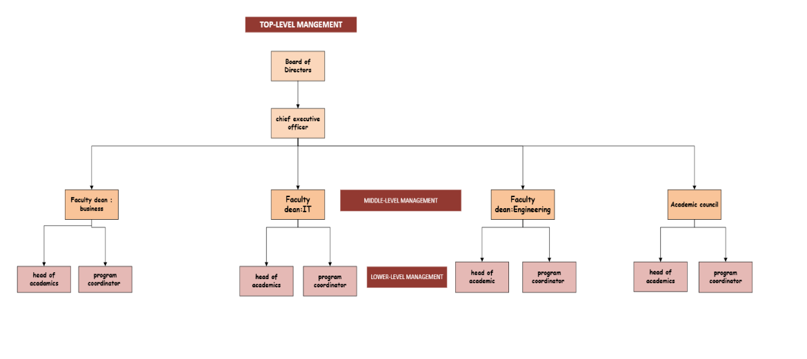
Figure 4
- Top-level management – The board of directors sets policies and strategies and strategic direction. The CEO manages the college’s daily activities.
- Middle-level management – Faculty deans manage specific departments. The Academic Council develops curriculum standards and quality assurance.
- Lower-level management- Heads of Academics supervise teaching quality within departments. Program coordinators implement specific courses and monitor delivery.

Software development lifecycle
SDLC is a clear plan to build ICBT’s student system. Each step makes sure the system works well for the college.
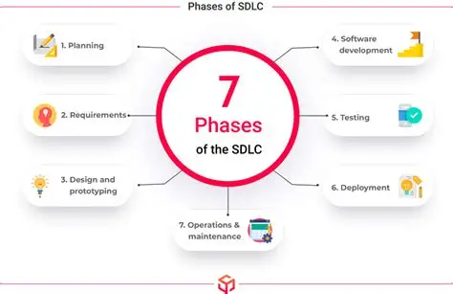

Figure 5
- Communication (Requirement gathering) – Ask students and teachers what they need. Write down their problems and wishes for the new system.
- Planning – Check if we can do it. Plan money and what to build first.
- Designing – Draw system plans and layouts. Make database and student portal designs.
- Development – Write code for the system. Connect it to Moodle for attendance.
- Testing – Test all parts of the system. Have users try it before launch.
- Implementation- start using the system. First test in one department, then teach everyone.
- Maintenance – keep fixing and improving the system. Add new features when needed.
By following these stages, ICBT has a good system now. It can improve later, too.
Comparison of SDLC Models and justification for Agile.
There are three main ways to build software systems:
- Waterfall model – This method has clear steps. Too stiff for ICBT’s changing needs.
- Spiral model – This method handles risks well. Too complex and costly for ICBT.
- Agile model – This method is the best because it's easy to change as needs grow. Perfect for school systems that keep evolving.

Justification for Agile: Agile is ideal for ICBT as it easily adapts to changing needs, delivers updates quickly, and incorporates user feedback, ensuring high satisfaction and a system that truly meets everyone's requirements.

Benefits of standard SDLC for ICBT’s SMS
Using SDLC helps ICBT’s student system in many ways.
- It keeps the project organized and stops money waste by planning carefully.
- Catch issues fast and fix them quickly.
- Teachers stay involved, so the system works for real needs.
- This design lets ICBT add new features later easily.
- Everything is well-documented, making government checks simpler.

Data model design
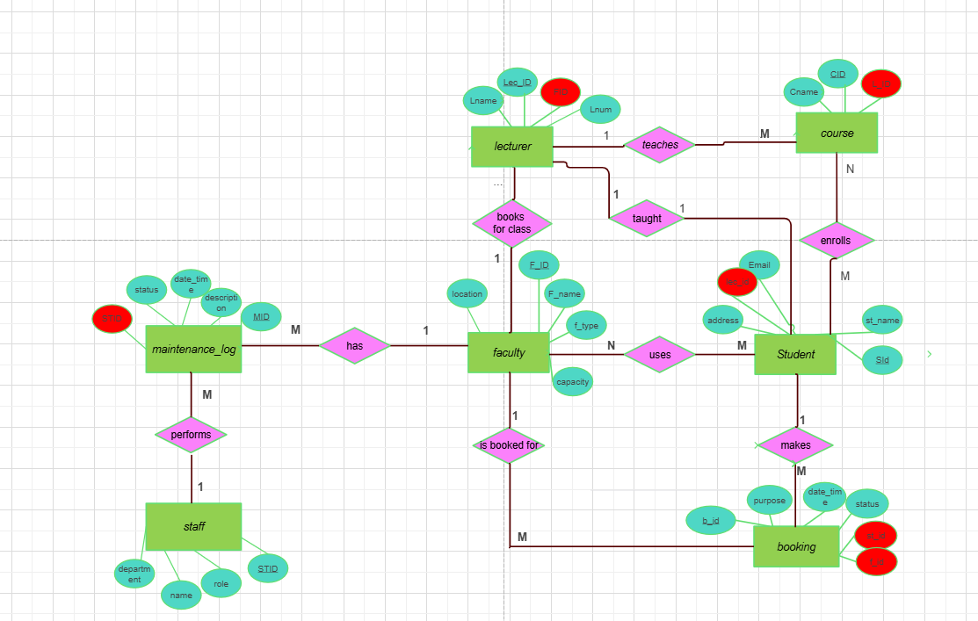
Figure 6
Technique and suitability: Chen's notation was chosen for its simplicity, using clear boxes and diamonds to show table relationships and connections (cardinality). It perfectly fits ICBT’s needs, clearly mapping student courses, lecturer modules, and attendance
Data dictionary:
Table name | Field name | Type and size | Description
Student | STUDENTID | Char (10) | Primary key
Student | Stname | Varchar (25) | Not null
Student | Email | Varchar (50) | Not null
Student | phone | Varchar (10) | Not null
Student | LECID | Char (10) | Foreign key
Booking | BOOKINGID | Char (10) | Primary key
Booking | Purpose | Varchar (10) | Not null
Booking | Status | Varchar (10) | Not null
Booking | Date time | Date time (10) | Not null
Booking | STUDENTID | Char (10) | Foreign key
Booking | FACULTYID | Char (10) | Foreign key
Faculty | FACULTYID | Char (10) | Primary key
Faculty | Fname | Varchar (25) | Not null
Faculty | Ftype | Varchar (10) | Not null
Faculty | Capacity | Int (10) | Not null
Faculty | Location | Varchar (10) | Not null
Lecturer | LECTURERID | Char (10) | Primary key
Lecturer | Lname | Varchar (25) | Not null
Lecturer | Email | Varchar (50) | Not null
Lecturer | FACULTYID | Char (10) | Foreign key
Course | COURSEID | Char (10) | Primary key
Course | Cname | Varchar (25) | Not null
Course | LECTURERID | Char (10) | Foreign key
Staff | STAFFID | Char (10) | Primary key
Staff | Sname | Varchar (15) | Not null
Staff | Srole | Varchar (20) | Not null
Staff | Department | Varchar (10) | Not null
Maintenance log | MAINTENANCEID | Char (10) | Primary key
Maintenance log | Date time | Date time (20) | Not null
Maintenance log | Description | Varchar (20) | Not null
Maintenance log | FACULTYID | Char (10) | Foreign key
Maintenance log | STAFFID | Char (10) | Foreign key
Student_faculty | STUDENTID | Char (10) | Composite primary key
Student_faculty | FACULTYID | Char (10) | Composite primary key
Student_course | STUDENTID | Char (10) | Composite primary key
Student_course | COURSEID | Char (15) | Composite primary key
Table 3

How does it support ICBT’s needs?
Our new data model solves ICBT’s main problems. It replaces the old, messy paper and spreadsheet system with one clear, connected digital system. This stops mistakes, saves staff time, and makes finding information quick and easy for everyone.
- The new system stores each piece of information just once, in its own place. This stops duplicates and conflicting data. It also uses special codes to link information correctly, preventing mistakes like signing up a student for a course that doesn’t exist. This ensures that all the data is accurate and reliable.
- The new system automates boring tasks, like checking room availability, so staff don’t have to do it by hand. It also finds any information, like who is in a class, super fast. This saves everyone a lot of time.
- The new system connects everything, making it easy to add cool features later. For example, it can automatically update grades and attendance. It's also built to grow, so adding new things like online payments is simple and won’t break the system.
- The system turns data into useful reports. It shows what’s popular, like which courses are full, and what needs improvement, like which room is always busy. This helps managers make smart decisions and easily prove they are following the rules.

Functional model design
- Context-level data flow diagram
This diagram defines the limits of the SIS by illustrating it as one process and identifying all incoming and outgoing communications with people and other systems.
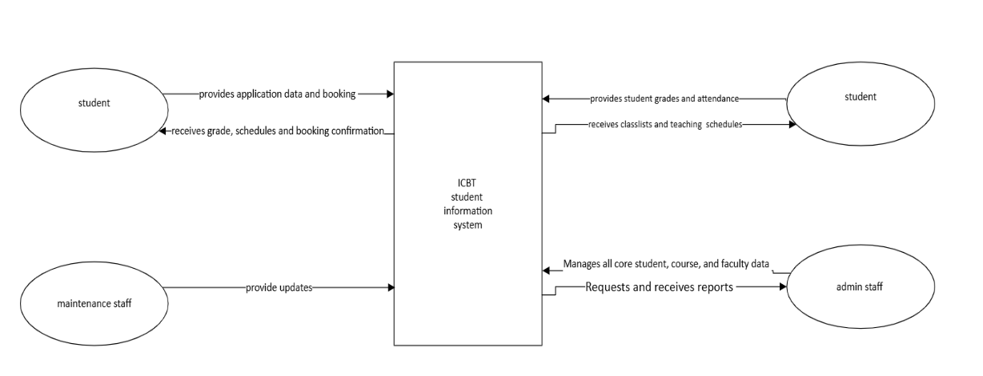
Figure 7
- Level 0 DFD
The level 0 DFD breaks down the main system into key parts, showing how data moves between processes and storage.

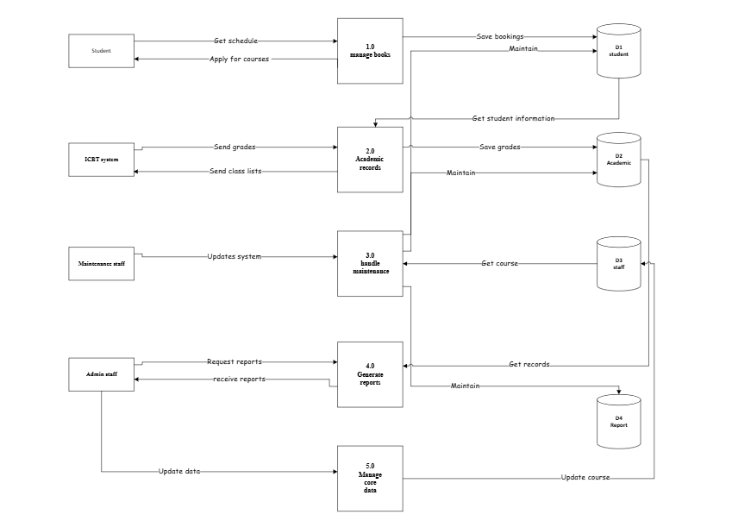
Figure 8
- Level 1 DFD
This diagram breaks down the “manage academic records” process into its core sub-processes for handling grades and attendance.
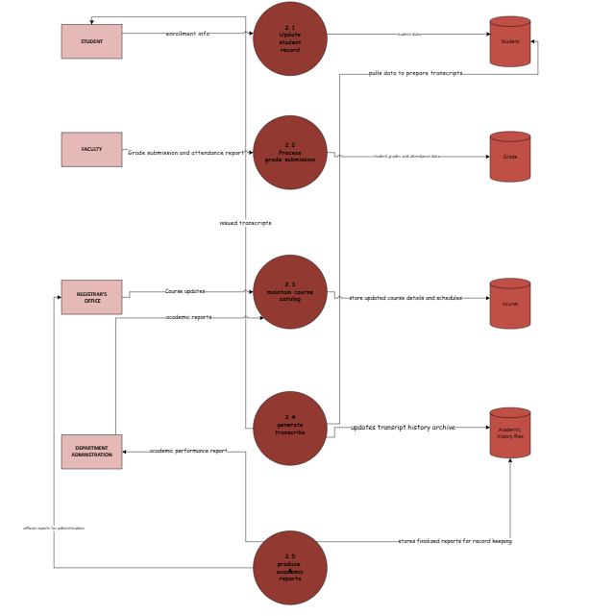
Figure 9

- Use case diagram
A use case diagram is a simple picture that shows who uses a system and what they can do with it. It lists the different types of users, called actors, and the main tasks they need to perform. This gives everyone a quick and easy overview of what the system is supposed to do without getting into the complicated details of how it works.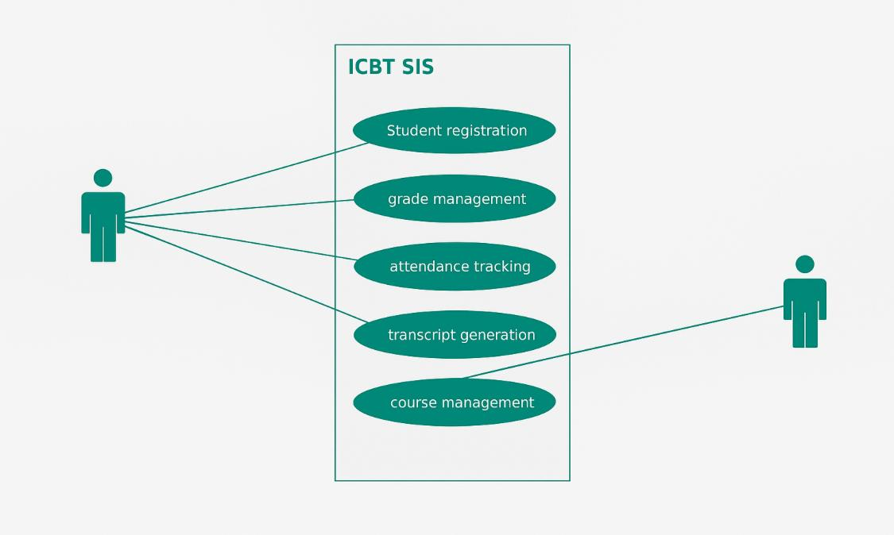
Figure 10
- Sequence diagram
The picture below illustrates the step-by-step process that occurs inside the computer when a student successfully books a room. It lists the exact order of messages passed between different parts of the system to complete the booking.

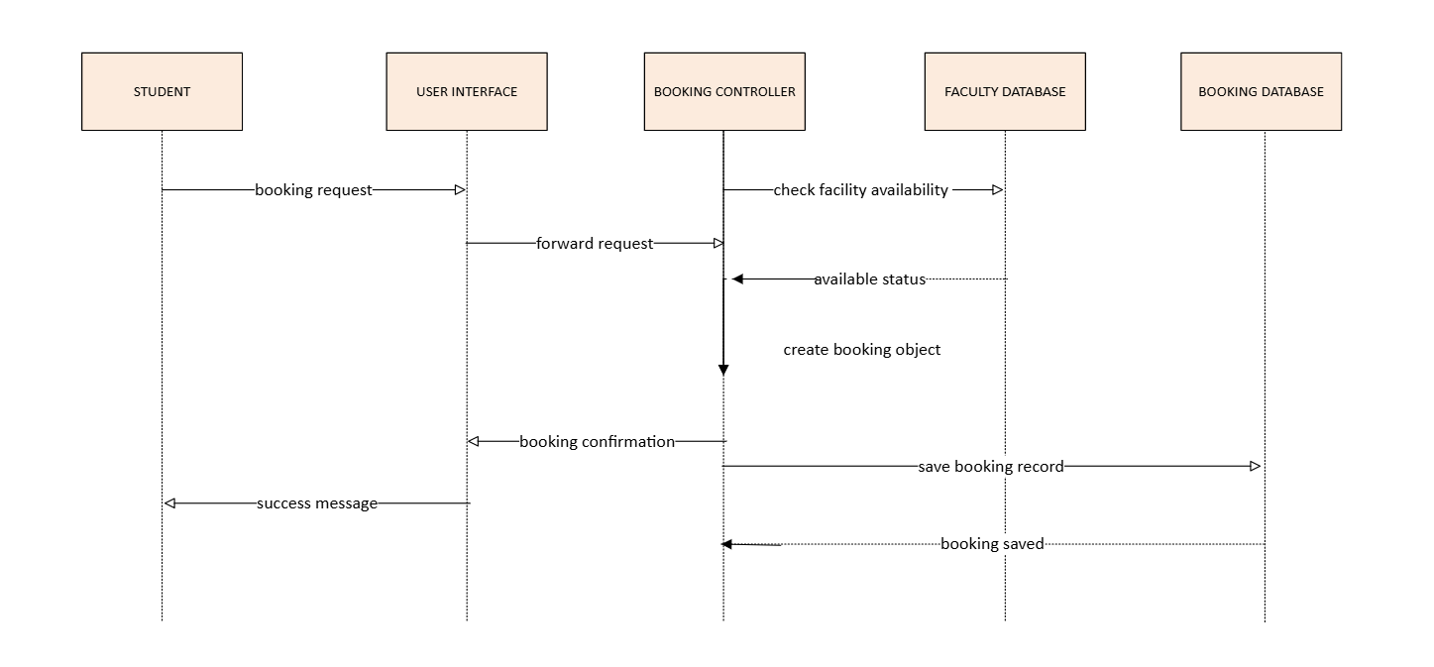
Figure 11
- Class diagrams
A class diagram is a blueprint for the software. It shows the main data types like student or course, the information each one holds, what actions they can perform, and how they connect. It’s a plan used to build the system correctly.

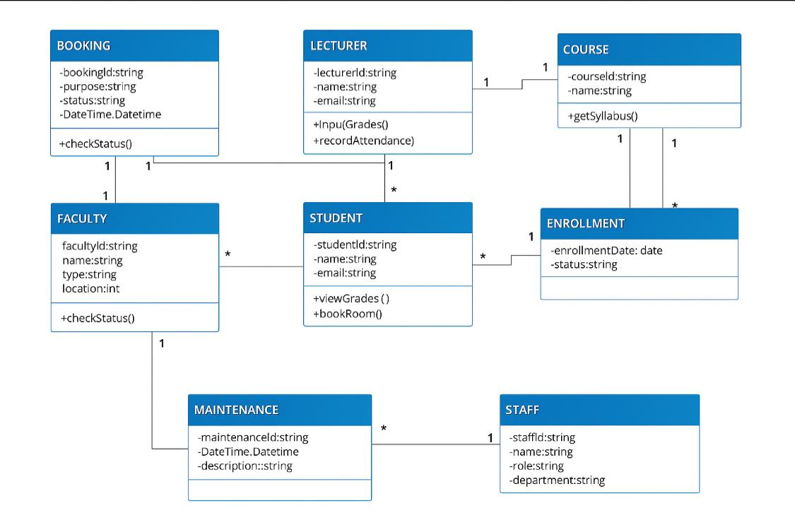
Figure 12
- Explanation of Techniques and Justification

For the functional modeling of the proposed Student Information System, a Top-Down Design approach was used. This method was chosen to break down the complex system into smaller, manageable parts. I started with a simple overview and then created more detailed designs step-by-step. This approach made the large project easier to understand and design.
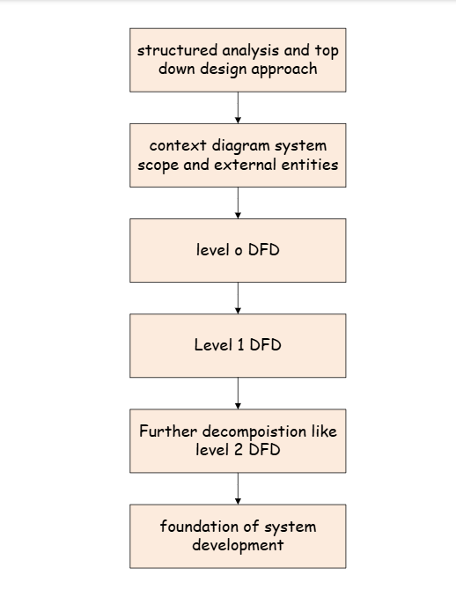
Figure 13
Technique used: I began by sketching a simple map of the entire system to see who uses it and where it ends. Then, I broke that map down into its main sections, like enrollment. Finally, I zoomed in on one section to list every small task inside it. This step-by-step method kept everything organized and easy to understand.
Justification for application: This method is perfect for ICBT. It uses simple pictures that everyone can understand, ensuring agreement on goals. It directly solves problems like duplicate data and slowing work by mapping better workflows. It also gives developers a clear plan, preventing mistakes and ensuring the new system works smoothly for the college.
Data dictionary for level 0 DFD
Type | Name | Description | Source | Destination | Composition
Data flow | Application form | The online form that a student fills out to sign up for a course. | Student | Process 1.0 | Student Name + Student Email + Student Phone + Course Choice
Data flow | Payment details | The financial information required to process a fee payment. | Student | Process 1.0 | Student ID + Payment Amount + Payment Method
Data flow | Enrollment confirmation | The confirmation is sent to a student upon successful enrollment. | Process 1.0 | student | Student ID + Student Name + Course Name + Start Date + Enrollment Status
Data flow | Booking request | A request from a student to book a faculty room for study purposes. | Student | Process 2.0 | Student ID + Preferred Date Time + Faculty ID + Purpose
Data flow | Booking confirmation | The confirmation (or denial) is sent to a student for their room booking request. | Process 2.0 | Student | Booking ID + Status (Confirmed/Denied) + Faculty ID + Date Time + Purpose
Data flow | Grade input | The grades or marks awarded by a lecturer for a student's work. | lecturer | Process 3.0 | Lecturer ID + Student ID + Course ID + Module Name + Assignment Type + Marks
Data flow | Attendance input | The attendance record (Present/Absent) for a student in a specific class. | lecturer | Process 3.0 | Lecturer ID + Student ID + Course ID + Date Time + Status
Data flow | Academic record | A request for a student's academic history, including grades and attendance. | Process 3.0 | Student /lecturer | Student ID + Student Name + [Course ID + Grade + Attendance Percentage] (repeating for each course)
Data flow | Maintenance request | A request from staff to log a maintenance issue for a faculty room. | Staff | Process 4.0 | Staff ID + Faculty ID + Date Time Reported + Issue Description
Data flow | Maintenance log | The record of a maintenance activity that has been completed. | Process 4.0 | Staff | Maintenance ID + Faculty ID + Staff ID + Date Time Completed + Work Description + Status
Data flow | Moodle syn | Data packets containing grades and attendance records are sent to the LMS. | Process 3.0 | Moodle (LMS) | Student ID + Course ID + Grade Data + Attendance Data
Data flow | LMS data | Course and module data received from the LMS to ensure consistency. | Moodle (LMS) | Process 3.0 | Course ID + Module ID + Module Name
Table 4

Word count used for task 1-3 2569

CONCLUSION
This report proposes a new computer system to fix ICBT College's messy paper records. It automates everything. Students apply online, payments are instant, and records are updated in real-time. Designed to be flexible, it will grow with the college. Our detailed plans ensure the new system is organized, accurate, and efficient for everyone.

REFERENCES
ICBT, n.d. ICBT kandy campus. [Online]
Available at: https://icbt.lk/icbt-kandy-campus/
Kendall, K.E. and Kendall, J.E., n.d. Systems Analysis and Design. 9th ed. ed. s.l.:Pearson Education.
Lucidchart, n.d. What is an Entity Relationship Diagram (ERD)?. [Online]
Available at: https://www.lucidchart.com/pages/er-diagrams
Paradigm, V., n.d. What is Data Flow Diagram (DFD)? How to Draw DFD? [online]. [Online]
Available at: https://www.visual-paradigm.com/guide/data-flow-diagram/what-is-data-flow-diagram/
Sommerville, I., n.d. Software Engineering. 10th ed ed. s.l.:Pearson Education..

