Student ID: 6788183
Operating system: 64-bit operating system
Docker context: default Current DOCKER_HOST based configuration npipe:////./pipe/docker_engine
Repository: https://github.com/Yumon-lab/itcs258-691-lab11-Dockerization-for-Production
1) preflight
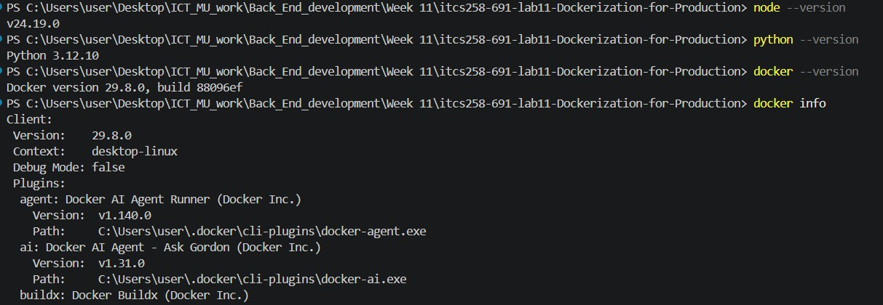
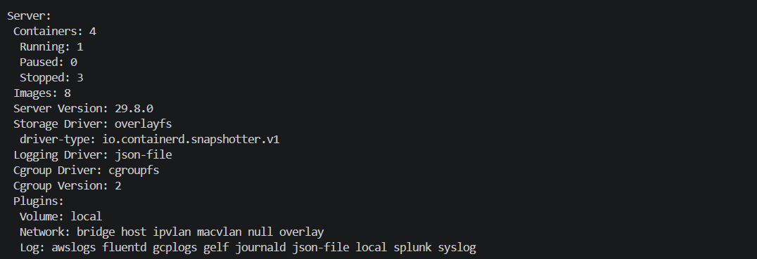
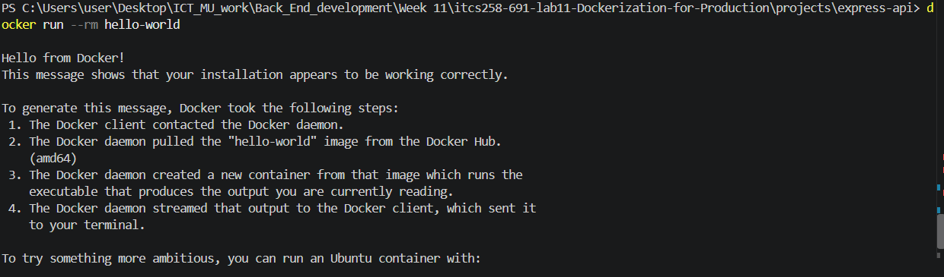
Before we start our docker application, we have to check node and python version as these two are crucial for development, we must also check docker version to see Docker client where we issue docker command and docker server that manipulate image. We then run docker info to reveal the information of docker engine.
docker run --rm hello-world we run this to test whether docker client can communicate with the engine

2) express demo
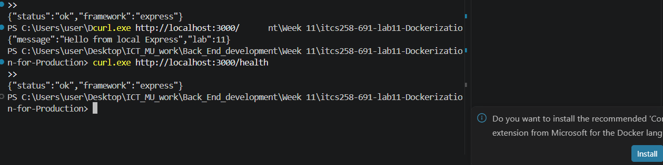
/ endpoint and /health endpoint answer
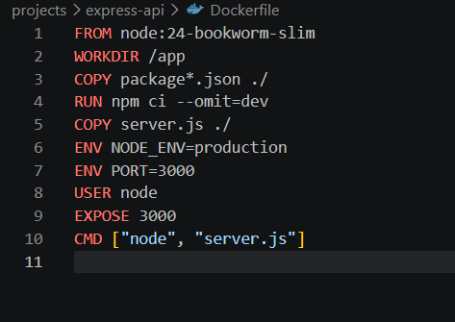
Dockerfile
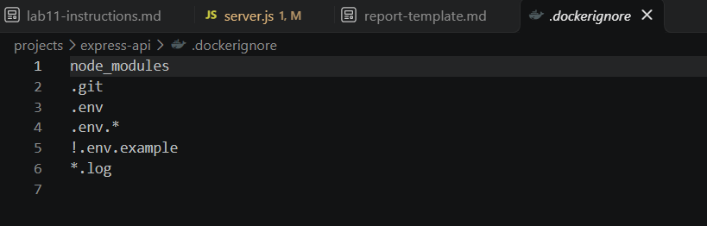
.dockerignore
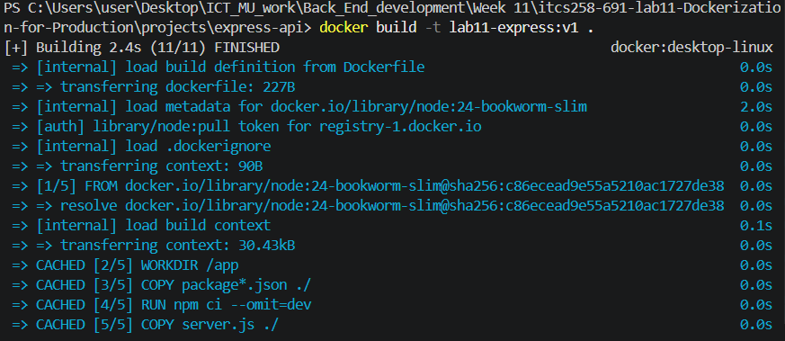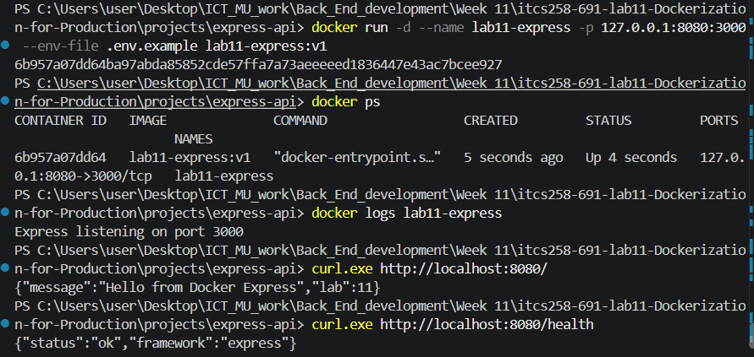
image build; docker run, docker ps, logs and 8080:3000 mapping;
Verify from inside
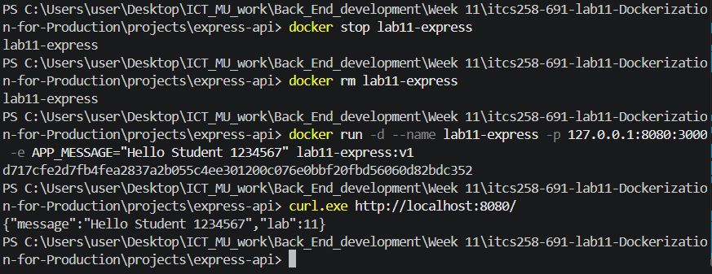
Change configuration without rebuilding and express container
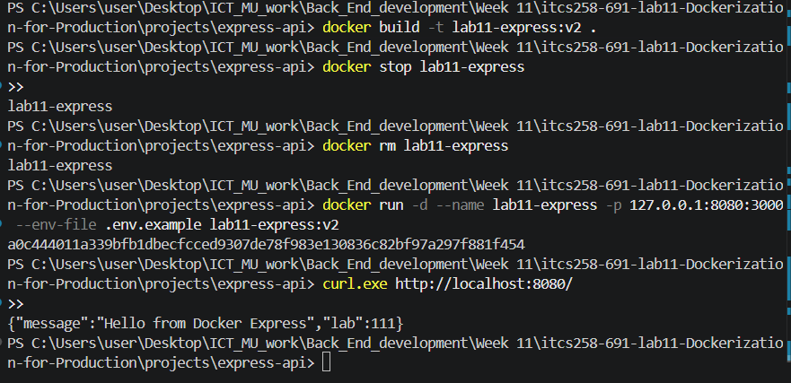
Show the greeting change using a runtime variable, then the lab: 111 result after editing source, rebuilding and recreating the container, we do this because we must remove the old one and replace with the new container we have created
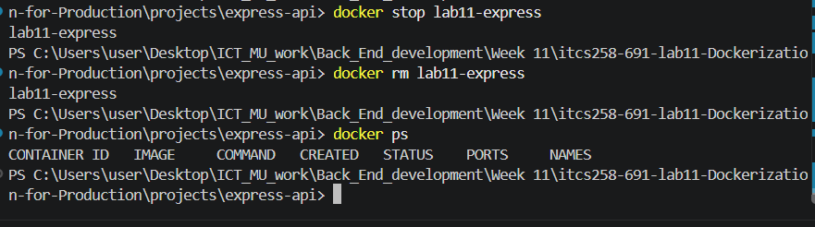
Stop and Removed the lab container after finished

