This is a basic game of Pong for 2 players that was made by myself in Python. Each player controls his pad, using either up and down or W ans S keys, and tries to push ball on an opponents side to earn a point. The firt player to reach 3 points wins.

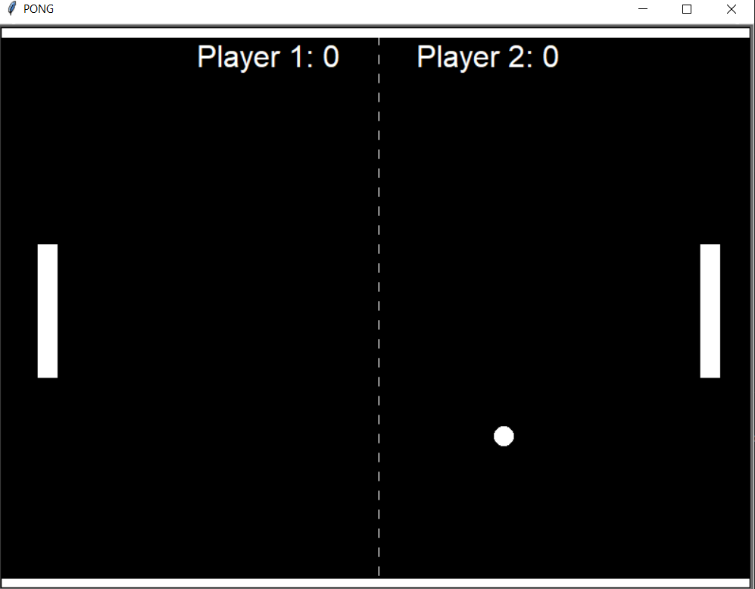

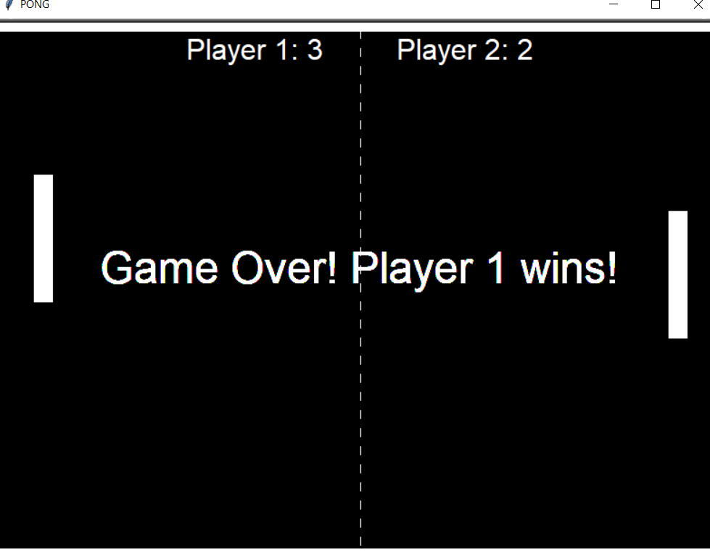

The game was made using Turrle module for graphics and physics, and Winsoud for sounds. You can change shapes of the pad and ball, their speed, amounts of points to win and hitboxes of pads easily by changing few lines of code.

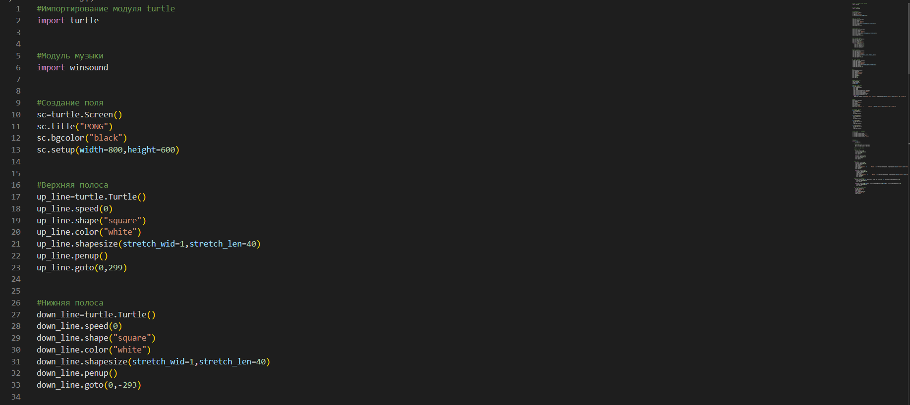

Programm in of itself consists of 193 lines of code in blocks functions of which is written in comments so changing something to your preferences shoudnt be hard.

DISCLAIMER: Althoug there is sound in the game, winsound is NOT in python by default so to fully experience pong you need to install it.