Once again, hello, and today as always we will talk about my big task, culinary blog:

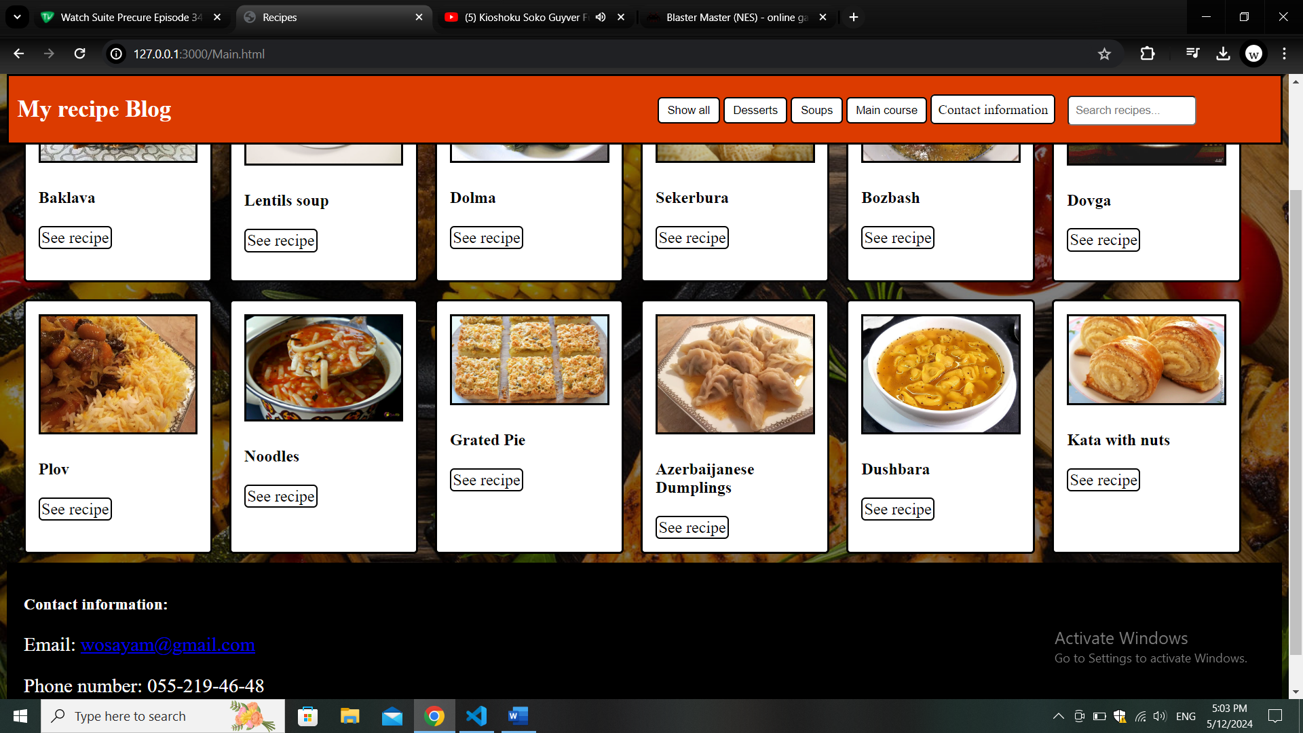

The structure of the site itself is fairly straightforward, we have our navbar, inside we have buttons to filter recipes by categories, “button” that takes us to our footer, and searchbar to search up recipes by their name. The blocks of recipes also are very simple, they have the photo of the dish, its name and a “button” to go and see a recipe. And I’ll explain everything here how it was made.

First we will need to talk about our recipe cards to understand everything else:

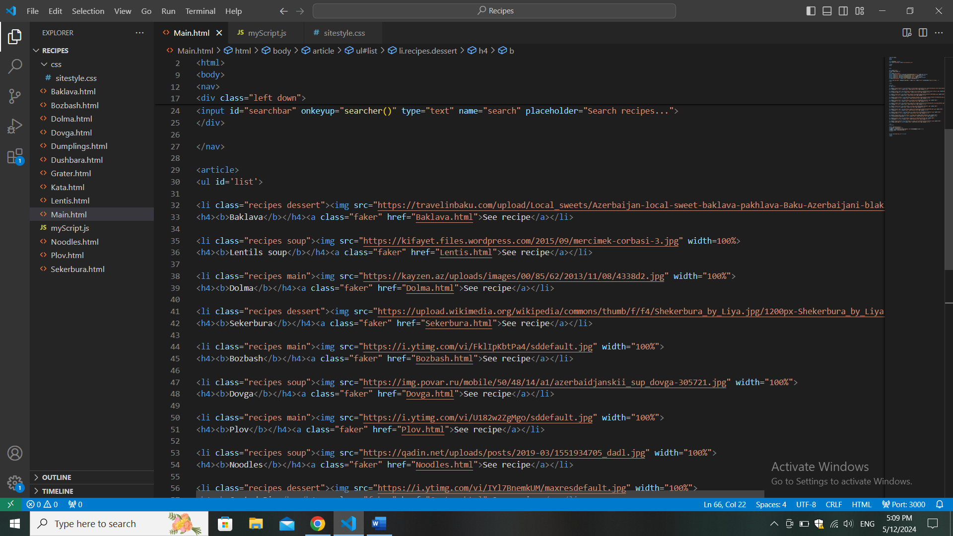

They are essentially a list, each of the members of which have a class of a recipe and specific recipe type class, it’s all needed to our 2 different filtration methods

First, class filters, they work essencially by giving and taking specific classes our show class, because by default our recipe blocks are hidden

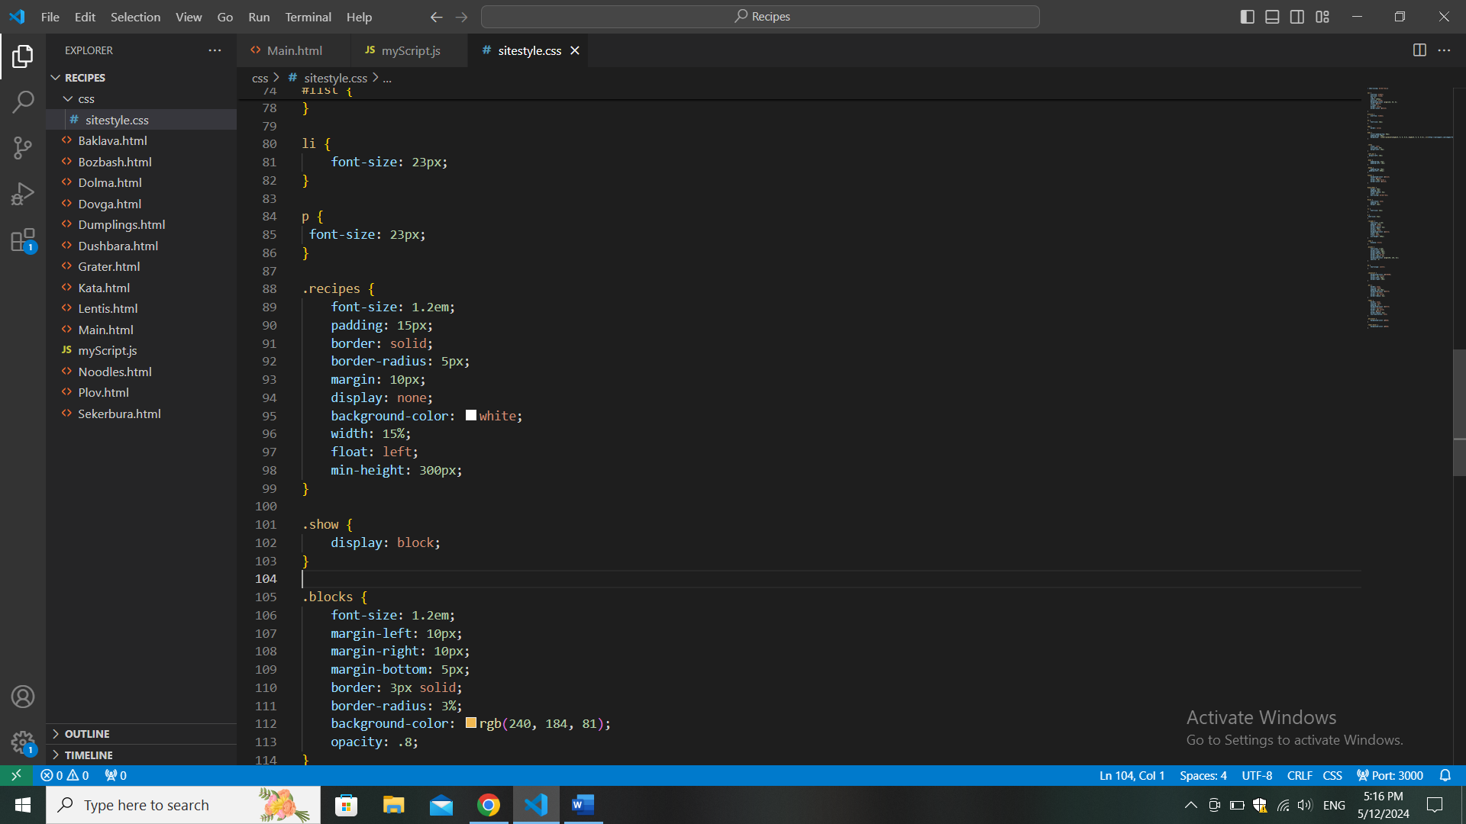

But we can see somehow all of our elements, this is of course because of our JavaScript code:

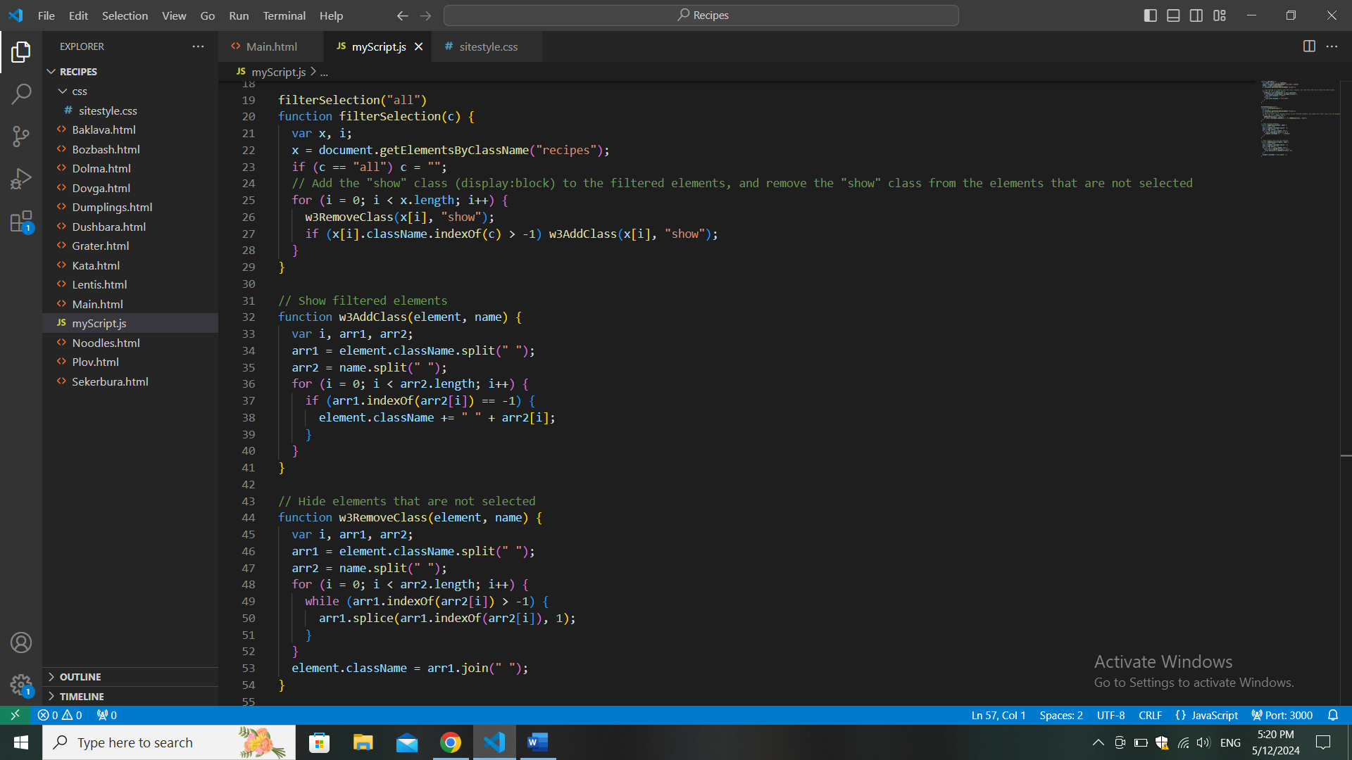

This function decides which elements to show based on the class passed to it. If you click “Show all”, it shows all elements. Otherwise, it shows only the elements with the class you clicked on. For example, if you click “desserts”, it shows only elements with the class “desserts”.

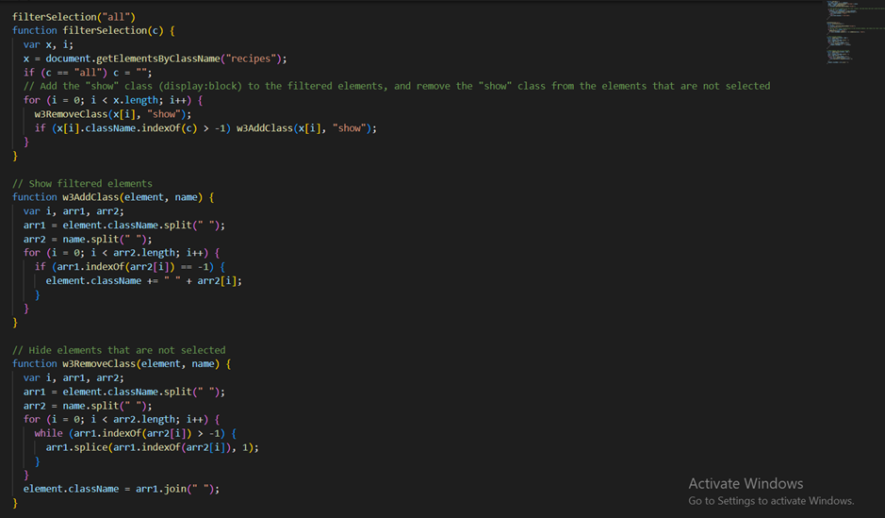

This function adds a class to an element, making it visible. It checks if the class is already present on the element. If not, it adds it.

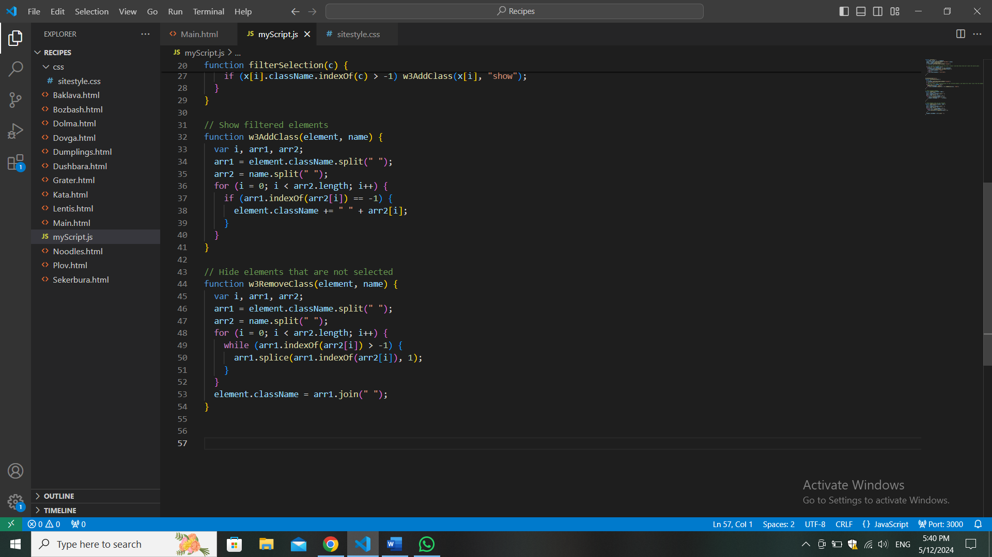

And this function works by the same principle but in opposite way, it removes a class from an element, hiding it. It checks if the class exists on the element. If yes, it removes it.

So basically they splits the existing class names of the element into an array, then split the class name to be added into an array. And finally checks if each class in the name array is already present in the element's class list. One adds if not added, other deletes if not already deleted

So that’s basically how our filter buttons work, and now to explain our searchbar

The function searcher is created to filter and display recipes based on a search query entered in a search bar

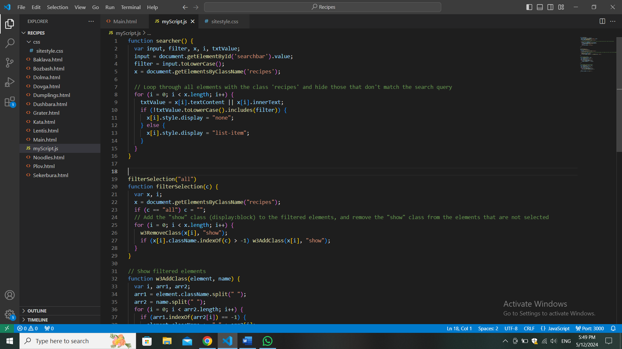

First we declare some variables, input: Stores what the user typed in the search bar ; filter: Converts the searched text to lowercase for easier comparison; x: Represents all the recipe elements on the page; i: Looper; txtValue: Stores the text content of each recipe.

Well, first we convert to lowercase text inputted into searchbar by user, then gather all recipes on the page, go through each recipe, then if name of our recipe doesn't contain text being searched, it hides the recipe. BUT If it DOES contain searched text, it shows the recipe.

So that’s basically it for our site’s main functions, I don’t think it’s neccesarry to talk about our decorations, and there isn’t much on our recipe pages (but I tried my best to greatly decorate all of this nonetheless!!!!!)