验证74LS00的基本功能
1.源文件
`timescale 1ns / 1ps

module MY_74LS00(
input A1, A2, // 第一个2输入与非门
input B1, B2, // 第二个2输入与非门
input C1, C2, // 第三个2输入与非门
input D1, D2, // 第四个2输入与非门
output Y1, Y2, Y3, Y4 // 四个输出
);
// 74LS00包含四个独立的2输入与非门
assign Y1 = ~(A1 & A2);
assign Y2 = ~(B1 & B2);
assign Y3 = ~(C1 & C2);
assign Y4 = ~(D1 & D2);
endmodule
2.引脚约束
set_property IOSTANDARD LVCMOS33 [get_ports A1]
set_property IOSTANDARD LVCMOS33 [get_ports A2]
set_property IOSTANDARD LVCMOS33 [get_ports B1]
set_property IOSTANDARD LVCMOS33 [get_ports B2]
set_property IOSTANDARD LVCMOS33 [get_ports C1]
set_property IOSTANDARD LVCMOS33 [get_ports C2]
set_property IOSTANDARD LVCMOS33 [get_ports D1]
set_property IOSTANDARD LVCMOS33 [get_ports D2]
set_property IOSTANDARD LVCMOS33 [get_ports Y1]
set_property IOSTANDARD LVCMOS33 [get_ports Y2]
set_property IOSTANDARD LVCMOS33 [get_ports Y3]
set_property IOSTANDARD LVCMOS33 [get_ports Y4]
set_property PACKAGE_PIN R1 [get_ports A1]
set_property PACKAGE_PIN N4 [get_ports A2]
set_property PACKAGE_PIN M4 [get_ports B1]
set_property PACKAGE_PIN R2 [get_ports B2]
set_property PACKAGE_PIN P2 [get_ports C1]
set_property PACKAGE_PIN P3 [get_ports C2]
set_property PACKAGE_PIN P4 [get_ports D1]
set_property PACKAGE_PIN P5 [get_ports D2]
set_property PACKAGE_PIN K3 [get_ports Y1]
set_property PACKAGE_PIN M1 [get_ports Y2]
set_property PACKAGE_PIN L1 [get_ports Y3]
set_property PACKAGE_PIN K6 [get_ports Y4]
3.仿真结果和分析
`timescale 1ns / 1ps

module sim_74x00(
);
// 输入信号
reg A1, A2; // 第一个门输入
reg B1, B2; // 第二个门输入
reg C1, C2; // 第三个门输入
reg D1, D2; // 第四个门输入

// 输出信号
wire Y1, Y2, Y3, Y4;

// 实例化74LS00
MY_74LS00 u_MY_74LS00(A1, A2, B1, B2, C1, C2, D1, D2, Y1, Y2, Y3, Y4);

// 初始化输入
initial begin
{A1, A2, B1, B2, C1, C2, D1, D2} = 8'b0;
end

// 每10ns递增输入值
always begin
#10;
{A1, A2, B1, B2, C1, C2, D1, D2} = {A1, A2, B1, B2, C1, C2, D1, D2} + 1'B1;
end

endmodule

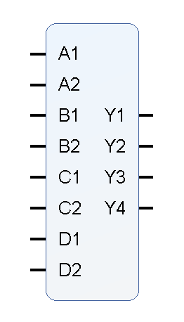
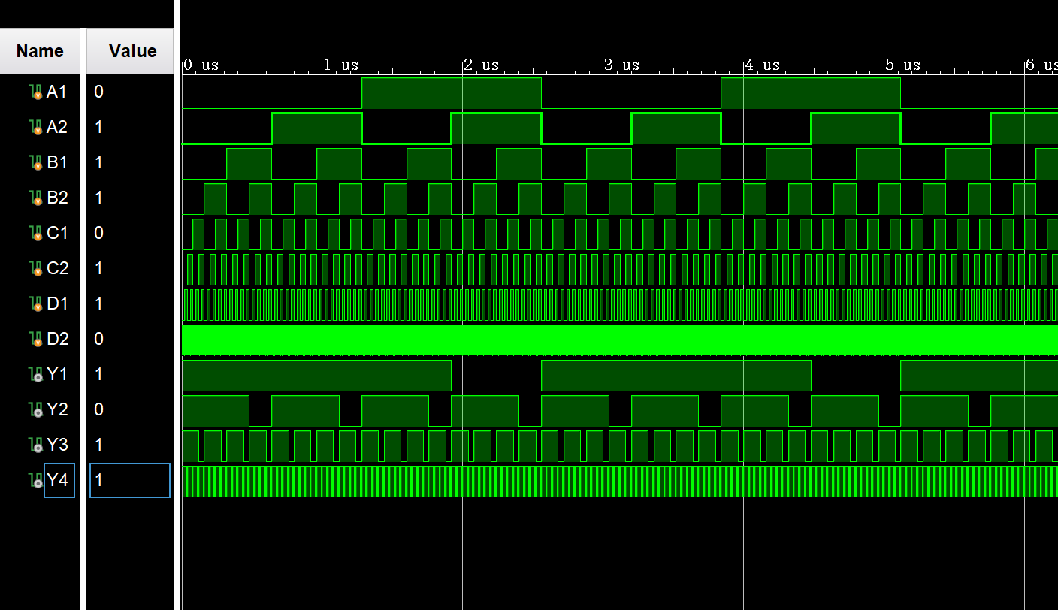
4.封装IP核

