验证74LS151的基本功能
1.源文件
`timescale 1ns / 1ps

// 74LS151 8选1数据选择器模块（低有效使能S，Y为输出，Y_NOT为反相输出）
module MY_74LS151(
input S,A2,A1,A0,
input D7,D6,D5,D4,D3,D2,D1,D0,
output reg Y,Y_NOT
);

always @(*)
begin
if(S==1'b1)
Y = 1'b0;
else
begin
case({A2,A1,A0})
3'b000: Y=D0;
3'b001: Y=D1;
3'b010: Y=D2;
3'b011: Y=D3;
3'b100: Y=D4;
3'b101: Y=D5;
3'b110: Y=D6;
3'b111: Y=D7;
endcase
end
Y_NOT = ~Y;
end

endmodule
2.引脚约束
set_property IOSTANDARD LVCMOS33 [get_ports A0]
set_property IOSTANDARD LVCMOS33 [get_ports A1]
set_property IOSTANDARD LVCMOS33 [get_ports A2]
set_property IOSTANDARD LVCMOS33 [get_ports D0]
set_property IOSTANDARD LVCMOS33 [get_ports D1]
set_property IOSTANDARD LVCMOS33 [get_ports D2]
set_property IOSTANDARD LVCMOS33 [get_ports D3]
set_property IOSTANDARD LVCMOS33 [get_ports D4]
set_property IOSTANDARD LVCMOS33 [get_ports D5]
set_property IOSTANDARD LVCMOS33 [get_ports D6]
set_property IOSTANDARD LVCMOS33 [get_ports D7]
set_property IOSTANDARD LVCMOS33 [get_ports S]
set_property IOSTANDARD LVCMOS33 [get_ports Y]
set_property IOSTANDARD LVCMOS33 [get_ports Y_NOT]
set_property DRIVE 12 [get_ports Y]
set_property PACKAGE_PIN T3 [get_ports A0]
set_property PACKAGE_PIN R3 [get_ports A1]
set_property PACKAGE_PIN V4 [get_ports A2]
set_property PACKAGE_PIN R1 [get_ports D0]
set_property PACKAGE_PIN N4 [get_ports D1]
set_property PACKAGE_PIN M4 [get_ports D2]
set_property PACKAGE_PIN R2 [get_ports D3]
set_property PACKAGE_PIN P2 [get_ports D4]
set_property PACKAGE_PIN P3 [get_ports D5]
set_property PACKAGE_PIN P4 [get_ports D6]
set_property PACKAGE_PIN P5 [get_ports D7]
set_property PACKAGE_PIN T5 [get_ports S]
set_property PACKAGE_PIN K3 [get_ports Y]
set_property PACKAGE_PIN M1 [get_ports Y_NOT]
3.仿真结果
`timescale 1ns / 1ps

module sim_MY_74LS151(

);
// 仿真信号定义
reg S,A2,A1,A0;
reg D7,D6,D5,D4,D3,D2,D1,D0;
wire Y,Y_NOT;

MY_74LS151 u_MY_74LS151(S,A2,A1,A0,D7,D6,D5,D4,D3,D2,D1,D0,Y,Y_NOT);

initial
begin
{S,A2,A1,A0,D7,D6,D5,D4,D3,D2,D1,D0}=12'b0;
end

always
begin
#10;
{S,A2,A1,A0,D7,D6,D5,D4,D3,D2,D1,D0}={S,A2,A1,A0,D7,D6,D5,D4,D3,D2,D1,D0}+12'b1;
end

endmodule
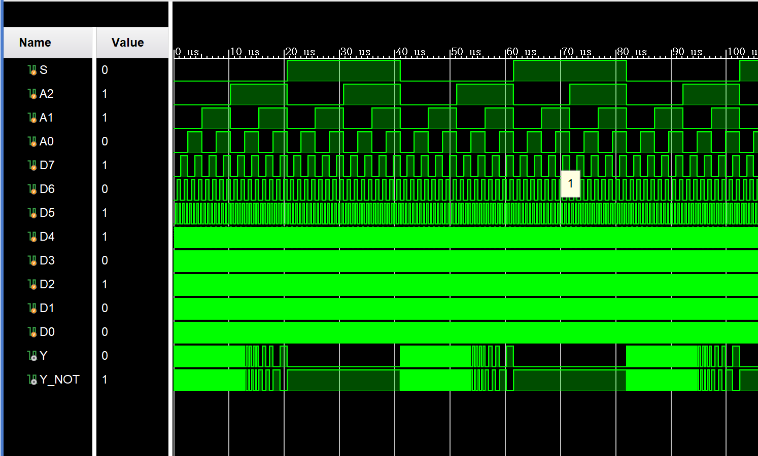
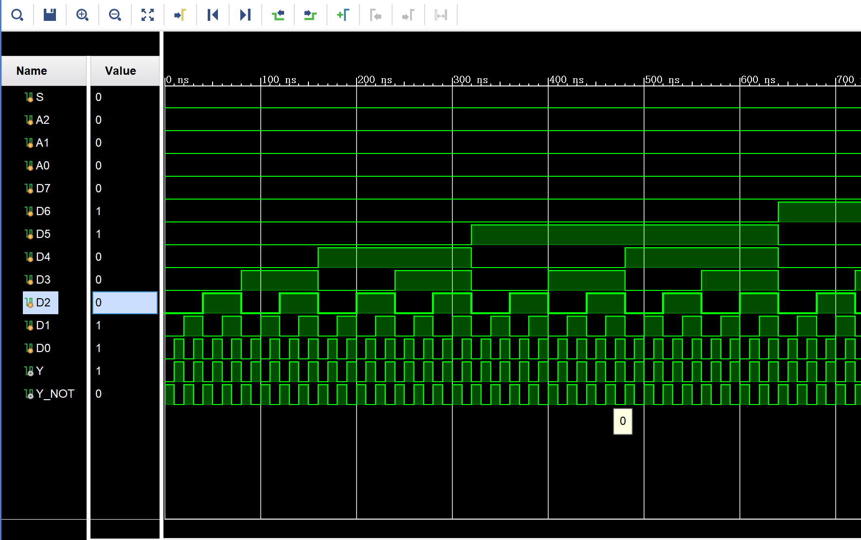
当A2=A1=1，A0=0时，Y=D6，Y_NOT= ~Y 当A2=A1=A0=0时，Y=D0，Y_NOT= ~Y
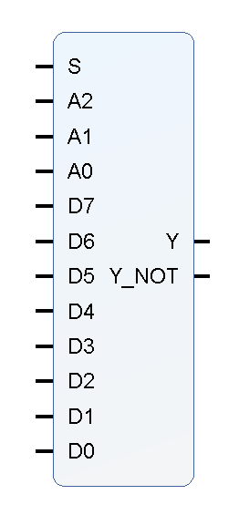
同理可验证A2A1A0=dx时，Y=Dx，Y_NOT= ~Y； 封装IP核：
当S = 1时，数据选择功能停止，Y=0, Y_NOT=1

验证74LS10的基本功能
1.源文件
`timescale 1ns / 1ps

module MY_74LS10(
input A1, A2, A3, // 第一个3输入与非门
input B1, B2, B3, // 第二个3输入与非门
input C1, C2, C3, // 第三个3输入与非门
output Y1, Y2, Y3 // 三个输出
);
// 74LS10包含三个独立的3输入与非门
assign Y1 = ~(A1 & A2 & A3);
assign Y2 = ~(B1 & B2 & B3);
assign Y3 = ~(C1 & C2 & C3);
endmodule
2.仿真文件
`timescale 1ns / 1ps

module sim_MY_74x10(
// 测试74LS10
);
// 输入信号
reg A1, A2, A3; // 第一个门输入
reg B1, B2, B3; // 第二个门输入
reg C1, C2, C3; // 第三个门输入

// 输出信号
wire Y1, Y2, Y3;

// 实例化74LS10
MY_74LS10 u_MY_74LS10(A1, A2, A3, B1, B2, B3, C1, C2, C3, Y1, Y2, Y3);

// 初始化输入
initial begin
{A1, A2, A3, B1, B2, B3, C1, C2, C3} = 9'b0;
end

// 每10ns递增输入值
always begin
#10;
{A1, A2, A3, B1, B2, B3, C1, C2, C3} = {A1, A2, A3, B1, B2, B3, C1, C2, C3} + 1;
end

endmodule
3.引脚约束
set_property IOSTANDARD LVCMOS33 [get_ports A1]
set_property IOSTANDARD LVCMOS33 [get_ports A2]
set_property IOSTANDARD LVCMOS33 [get_ports A3]
set_property IOSTANDARD LVCMOS33 [get_ports B1]
set_property IOSTANDARD LVCMOS33 [get_ports B2]
set_property IOSTANDARD LVCMOS33 [get_ports B3]
set_property IOSTANDARD LVCMOS33 [get_ports C1]
set_property IOSTANDARD LVCMOS33 [get_ports C2]
set_property IOSTANDARD LVCMOS33 [get_ports C3]
set_property IOSTANDARD LVCMOS33 [get_ports Y1]
set_property IOSTANDARD LVCMOS33 [get_ports Y2]
set_property IOSTANDARD LVCMOS33 [get_ports Y3]
set_property PACKAGE_PIN R1 [get_ports A1]
set_property PACKAGE_PIN N4 [get_ports A2]
set_property PACKAGE_PIN M4 [get_ports A3]
set_property PACKAGE_PIN R2 [get_ports B1]
set_property PACKAGE_PIN P2 [get_ports B2]
set_property PACKAGE_PIN P3 [get_ports B3]
set_property PACKAGE_PIN P4 [get_ports C1]
set_property PACKAGE_PIN P5 [get_ports C2]
set_property PACKAGE_PIN K3 [get_ports Y1]
set_property PACKAGE_PIN M1 [get_ports Y2]
set_property PACKAGE_PIN T5 [get_ports C3]
set_property PACKAGE_PIN L1 [get_ports Y3]

仿真图
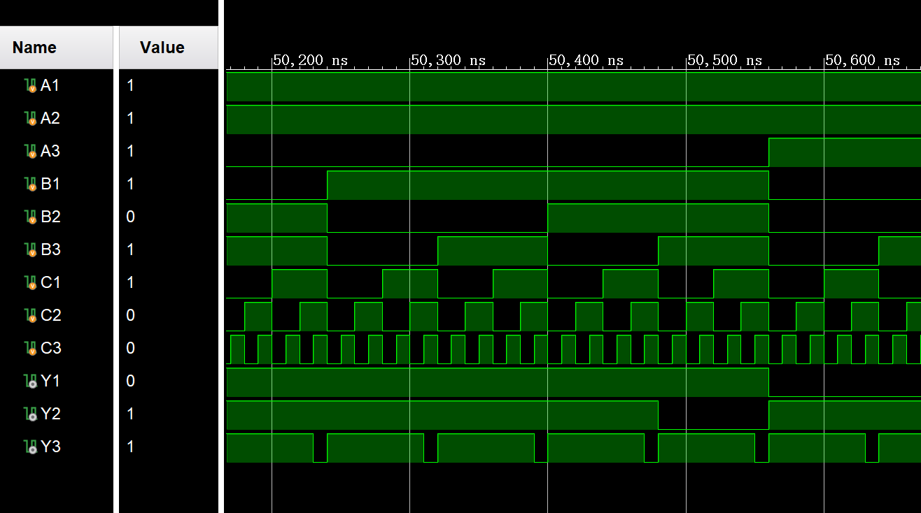
当且仅当A1A2A3=111时，Y1=0；B1B2B3=111时，Y2=0；C1C2C3=111时，Y3=0

封装IP核
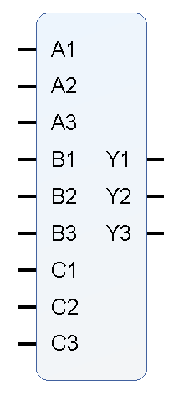

验证74LS138的基本功能
1.源文件
`timescale 1ns / 1ps

module MY_74LS138(
input S3,S2,S1,
input A2,A1,A0,
output reg Y7,Y6,Y5,Y4,Y3,Y2,Y1,Y0
);

reg [7:0]Y;

always @(*)
begin
if({S3,S2,S1}==3'b100)
begin
case({A2,A1,A0})
3'b000: Y=8'b1111_1110;
3'b001: Y=8'b1111_1101;
3'b010: Y=8'b1111_1011;
3'b011: Y=8'b1111_0111;
3'b100: Y=8'b1110_1111;
3'b101: Y=8'b1101_1111;
3'b110: Y=8'b1011_1111;
3'b111: Y=8'b0111_1111;
endcase
end
else
Y=8'b1111_1111;
end

always @(*)
begin
Y0=Y[0];
Y1=Y[1];
Y2=Y[2];
Y3=Y[3];
Y4=Y[4];
Y5=Y[5];
Y6=Y[6];
Y7=Y[7];
end

endmodule
2.引脚约束
set_property IOSTANDARD LVCMOS33 [get_ports Y3]
set_property IOSTANDARD LVCMOS33 [get_ports Y4]
set_property IOSTANDARD LVCMOS33 [get_ports Y5]
set_property IOSTANDARD LVCMOS33 [get_ports Y6]
set_property IOSTANDARD LVCMOS33 [get_ports Y7]
set_property IOSTANDARD LVCMOS33 [get_ports Y2]
set_property IOSTANDARD LVCMOS33 [get_ports Y1]
set_property IOSTANDARD LVCMOS33 [get_ports S3]
set_property IOSTANDARD LVCMOS33 [get_ports Y0]
set_property IOSTANDARD LVCMOS33 [get_ports A0]
set_property IOSTANDARD LVCMOS33 [get_ports A1]
set_property IOSTANDARD LVCMOS33 [get_ports A2]
set_property IOSTANDARD LVCMOS33 [get_ports S1]
set_property IOSTANDARD LVCMOS33 [get_ports S2]
set_property PACKAGE_PIN R1 [get_ports A0]
set_property PACKAGE_PIN N4 [get_ports A1]
set_property PACKAGE_PIN M4 [get_ports A2]
set_property PACKAGE_PIN R2 [get_ports S1]
set_property PACKAGE_PIN P2 [get_ports S2]
set_property PACKAGE_PIN P3 [get_ports S3]
set_property PACKAGE_PIN K3 [get_ports Y0]
set_property PACKAGE_PIN M1 [get_ports Y1]
set_property PACKAGE_PIN L1 [get_ports Y2]
set_property PACKAGE_PIN K6 [get_ports Y3]
set_property PACKAGE_PIN J5 [get_ports Y4]
set_property PACKAGE_PIN H5 [get_ports Y5]
set_property PACKAGE_PIN H6 [get_ports Y6]
set_property PACKAGE_PIN K1 [get_ports Y7]
3.仿真结果和分析
`timescale 1ns / 1ps

module sim_MY_74LS138(
);

reg S3,S2,S1;
reg A2,A1,A0;
wire Y7,Y6,Y5,Y4,Y3,Y2,Y1,Y0;

MY_74LS138 u_MY_74LS138(S3,S2,S1,A2,A1,A0,Y7,Y6,Y5,Y4,Y3,Y2,Y1,Y0);

initial
begin
{S3,S2,S1,A2,A1,A0}=6'b0;
end

always
begin
#10
{S3,S2,S1,A2,A1,A0}={S3,S2,S1,A2,A1,A0}+1'b1;
end

endmodule
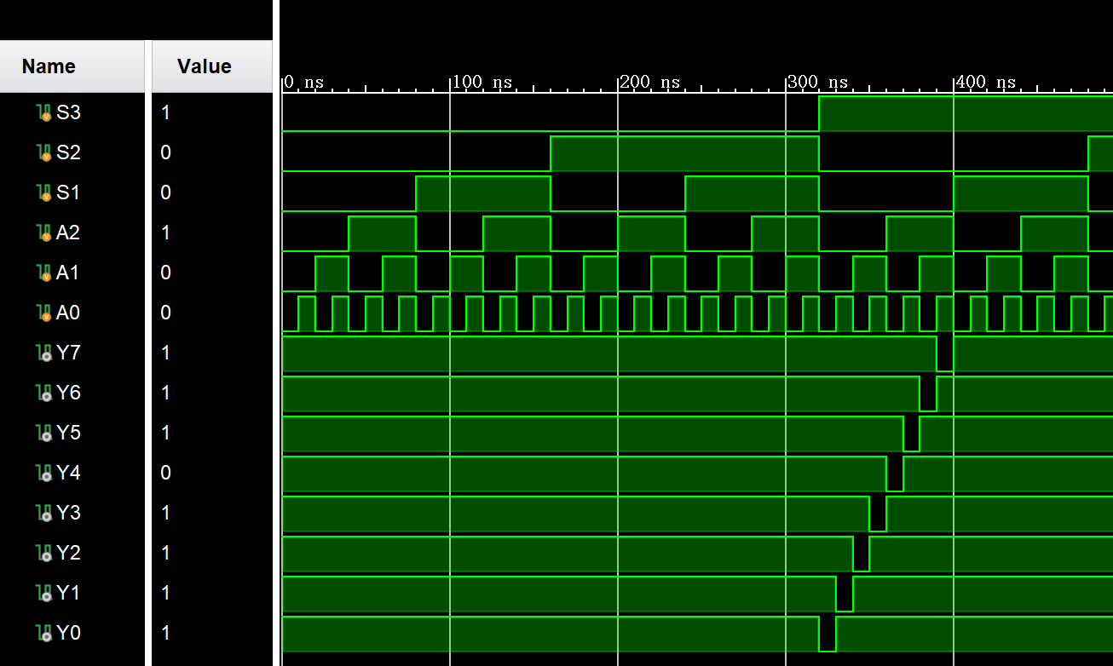
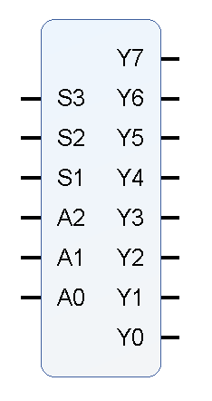
4.封装IP核

当S3=1，S2=x，S1=0时，进行译码功能；
否则，Y7=Y6=Y5=Y4=Y3=Y2=Y1=Y0=1

四、基于原理图的FGPA设计
设计一个数据判别器，输入为3位二进制X2X1X0，输出Y，设定阈值（100）4，当输入小于等于4是，Y=1，否则Y=0。
方案一：仅使用与非门实现
1.图形编程
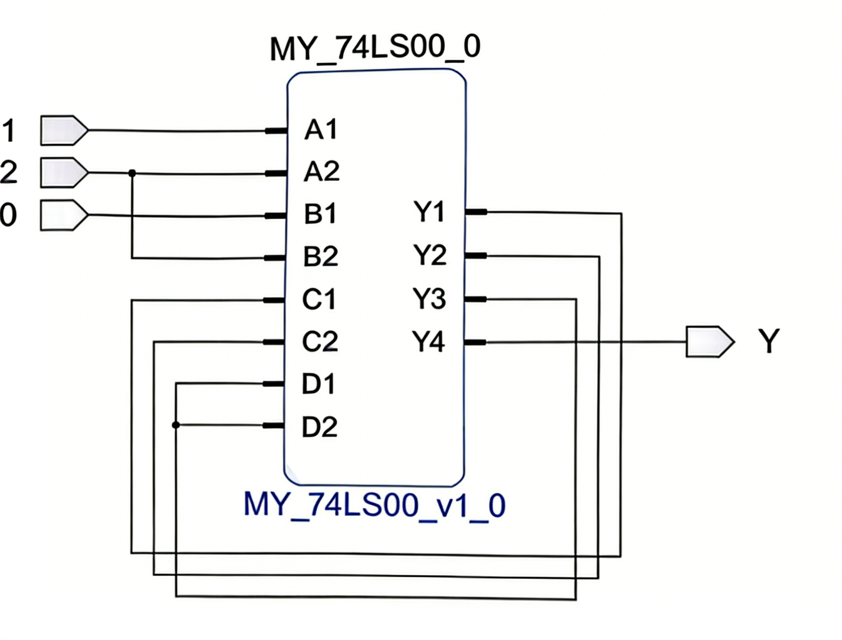
2.引脚约束：
set_property PACKAGE_PIN R1 [get_ports X0]
set_property PACKAGE_PIN N4 [get_ports X1]
set_property PACKAGE_PIN M4 [get_ports X2]
set_property PACKAGE_PIN K3 [get_ports Y]

set_property IOSTANDARD LVCMOS33 [get_ports X0]
set_property IOSTANDARD LVCMOS33 [get_ports X1]
set_property IOSTANDARD LVCMOS33 [get_ports X2]
set_property IOSTANDARD LVCMOS33 [get_ports Y]
3.仿真分析
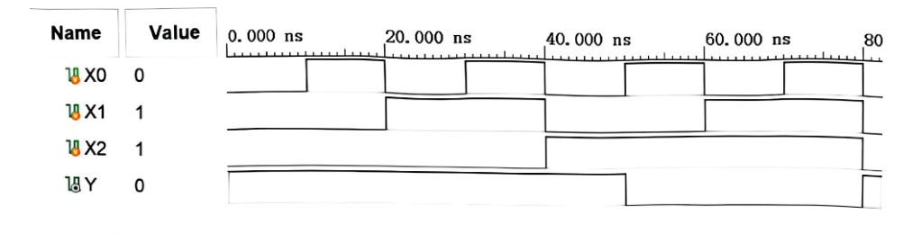
当且仅当X2X1X0≥d5时，Y=0

方案二：使用74LS138和与非门实现
1.图形编程
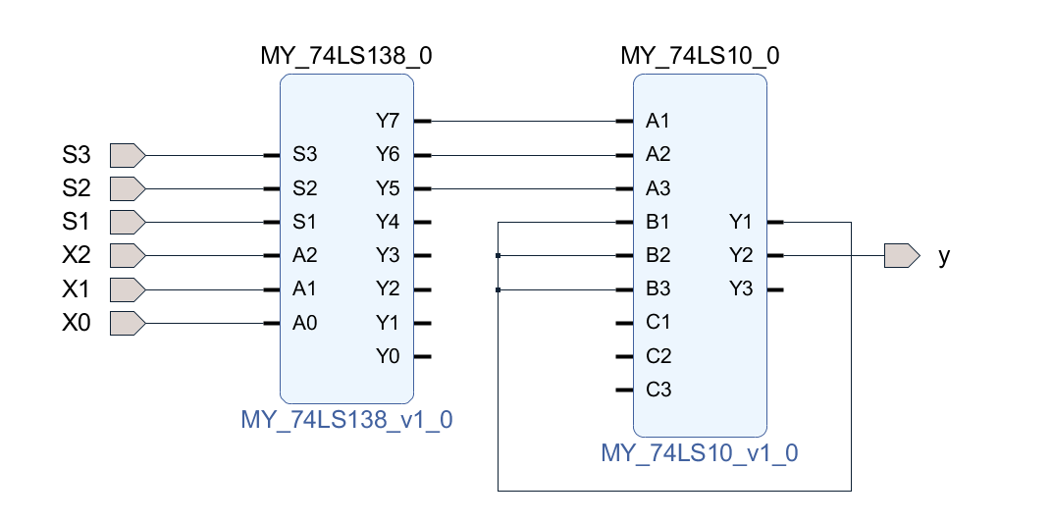

引脚约束：
set_property IOSTANDARD LVCMOS33 [get_ports S1]
set_property IOSTANDARD LVCMOS33 [get_ports y]
set_property IOSTANDARD LVCMOS33 [get_ports X2]
set_property IOSTANDARD LVCMOS33 [get_ports X1]
set_property IOSTANDARD LVCMOS33 [get_ports X0]
set_property IOSTANDARD LVCMOS33 [get_ports S3]
set_property IOSTANDARD LVCMOS33 [get_ports S2]

set_property PACKAGE_PIN R1 [get_ports S1]
set_property PACKAGE_PIN M4 [get_ports X2]
set_property PACKAGE_PIN N4 [get_ports S2]
set_property PACKAGE_PIN R2 [get_ports X1]
set_property PACKAGE_PIN P2 [get_ports X0]
set_property PACKAGE_PIN P3 [get_ports X2]
set_property PACKAGE_PIN K3 [get_ports y]

3.仿真结果
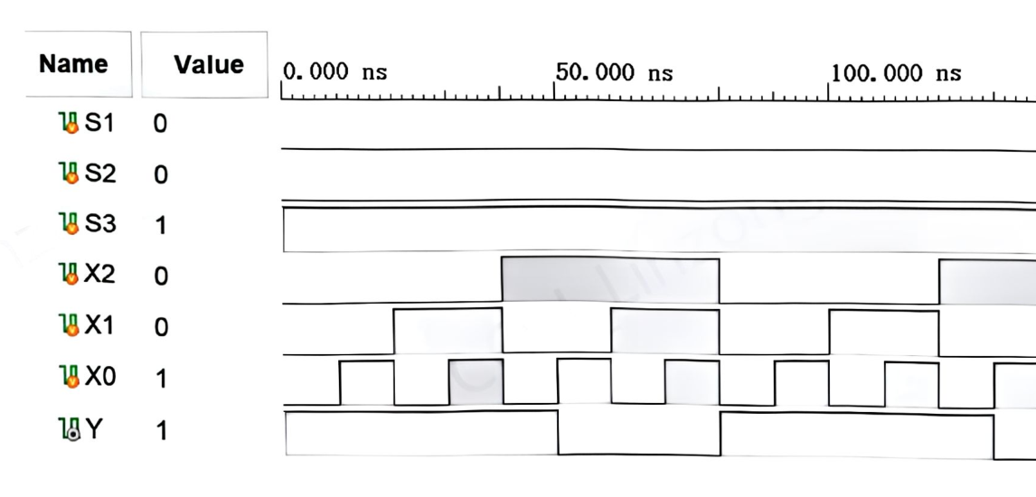
当且仅当X2X1X0≥d5时，y=0

方案三：仅使用74LS151实现
1.图形编程
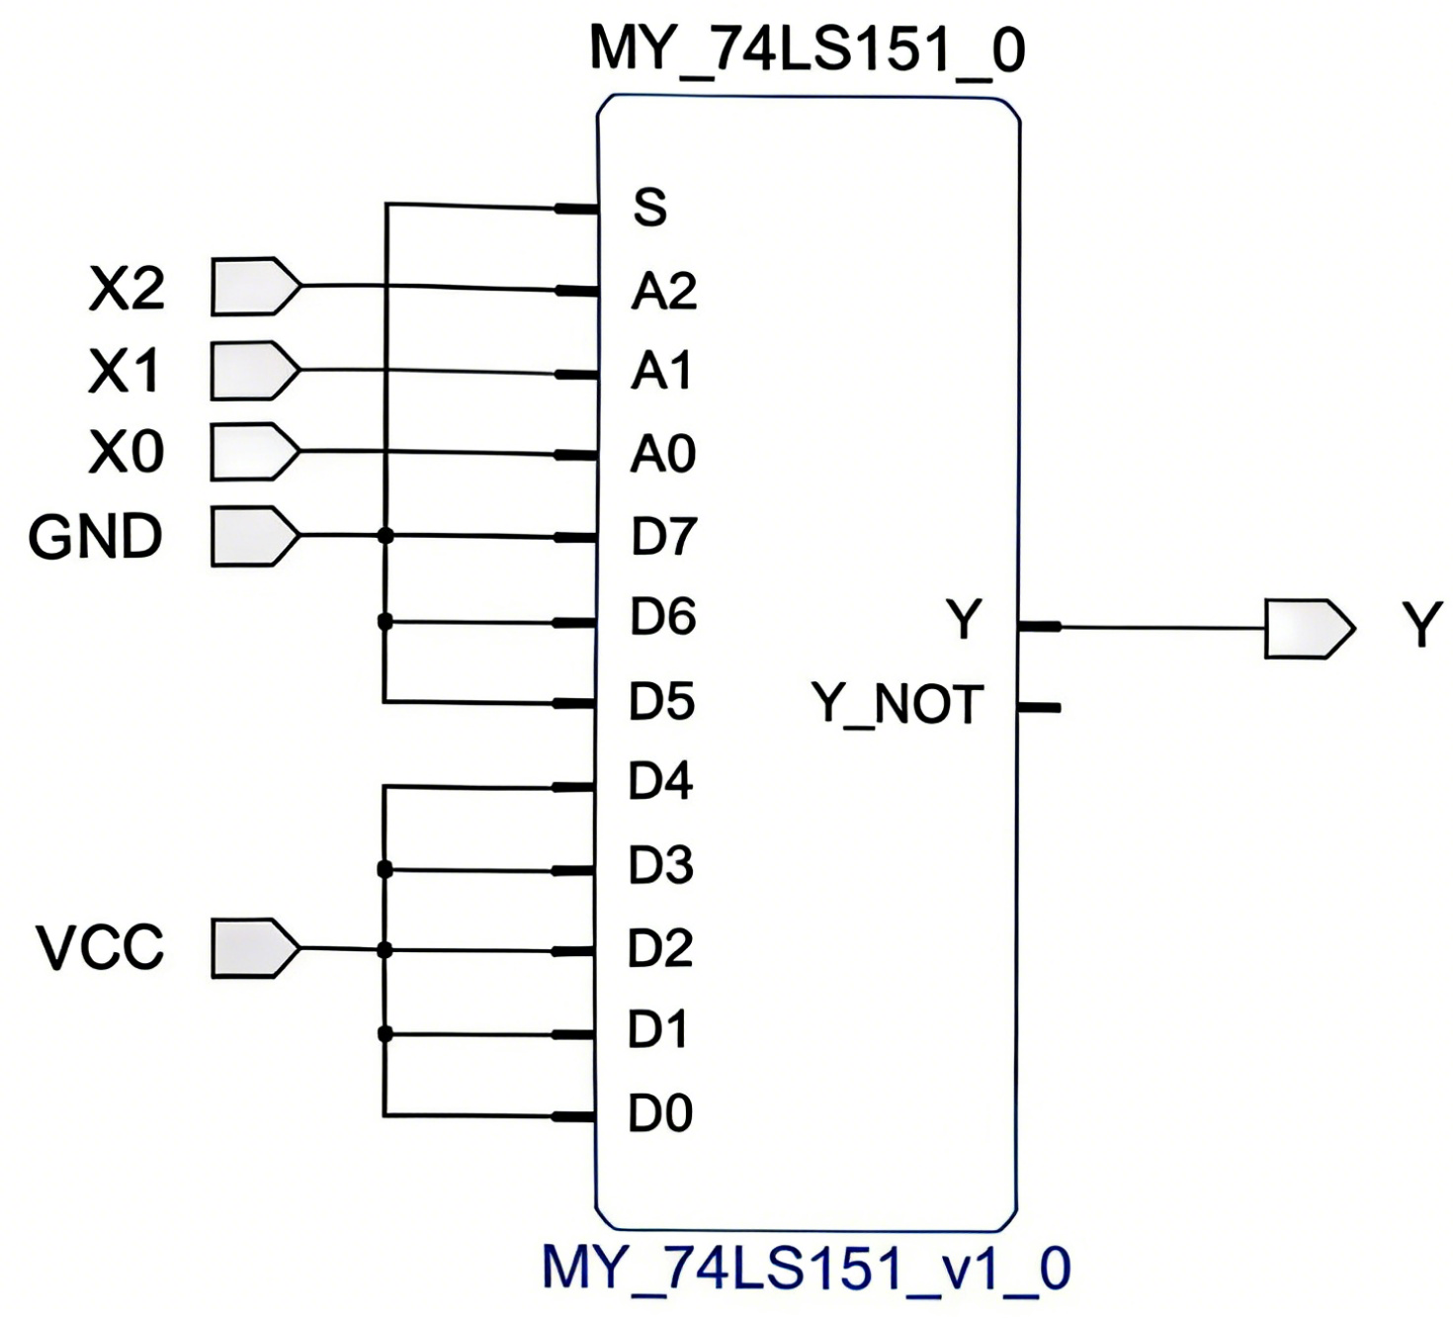
2.引脚约束：
set_property IOSTANDARD LVCMOS33 [get_ports GND]
set_property IOSTANDARD LVCMOS33 [get_ports VCC]
set_property IOSTANDARD LVCMOS33 [get_ports X0]
set_property IOSTANDARD LVCMOS33 [get_ports X1]
set_property IOSTANDARD LVCMOS33 [get_ports X2]
set_property IOSTANDARD LVCMOS33 [get_ports Y]

set_property PACKAGE_PIN P4 [get_ports GND]
set_property PACKAGE_PIN P5 [get_ports VCC]
set_property PACKAGE_PIN R1 [get_ports X0]
set_property PACKAGE_PIN N4 [get_ports X1]
set_property PACKAGE_PIN M4 [get_ports X2]
set_property PACKAGE_PIN K3 [get_ports Y]

3.仿真分析图
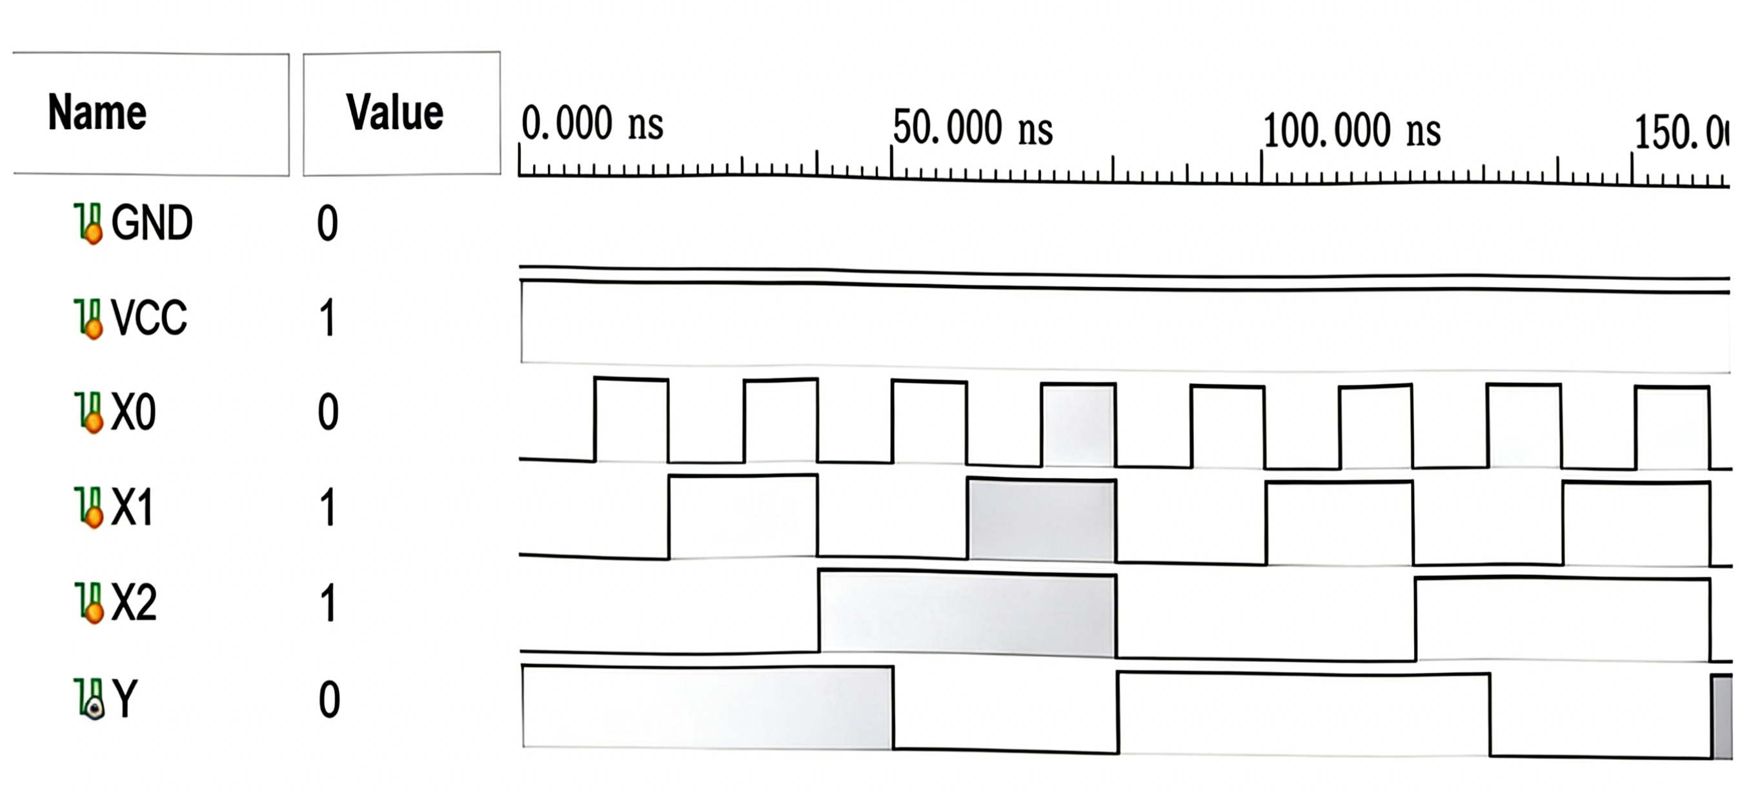
当且仅当X2X1X0≥d5时，Y=0

