验证74LS138的基本功能
1.源文件
`timescale 1ns / 1ps

module MY_74LS138(
input S3,S2,S1,
input A2,A1,A0,
output reg Y7,Y6,Y5,Y4,Y3,Y2,Y1,Y0
);

reg [7:0]Y;

always @(*)
begin
if({S3,S2,S1}==3'b100)
begin
case({A2,A1,A0})
3'b000: Y=8'b1111_1110;
3'b001: Y=8'b1111_1101;
3'b010: Y=8'b1111_1011;
3'b011: Y=8'b1111_0111;
3'b100: Y=8'b1110_1111;
3'b101: Y=8'b1101_1111;
3'b110: Y=8'b1011_1111;
3'b111: Y=8'b0111_1111;
endcase
end
else
Y=8'b1111_1111;
end

always @(*)
begin
Y0=Y[0];
Y1=Y[1];
Y2=Y[2];
Y3=Y[3];
Y4=Y[4];
Y5=Y[5];
Y6=Y[6];
Y7=Y[7];
end

endmodule
2.引脚约束
set_property IOSTANDARD LVCMOS33 [get_ports Y3]
set_property IOSTANDARD LVCMOS33 [get_ports Y4]
set_property IOSTANDARD LVCMOS33 [get_ports Y5]
set_property IOSTANDARD LVCMOS33 [get_ports Y6]
set_property IOSTANDARD LVCMOS33 [get_ports Y7]
set_property IOSTANDARD LVCMOS33 [get_ports Y2]
set_property IOSTANDARD LVCMOS33 [get_ports Y1]
set_property IOSTANDARD LVCMOS33 [get_ports S3]
set_property IOSTANDARD LVCMOS33 [get_ports Y0]
set_property IOSTANDARD LVCMOS33 [get_ports A0]
set_property IOSTANDARD LVCMOS33 [get_ports A1]
set_property IOSTANDARD LVCMOS33 [get_ports A2]
set_property IOSTANDARD LVCMOS33 [get_ports S1]
set_property IOSTANDARD LVCMOS33 [get_ports S2]
set_property PACKAGE_PIN R1 [get_ports A0]
set_property PACKAGE_PIN N4 [get_ports A1]
set_property PACKAGE_PIN M4 [get_ports A2]
set_property PACKAGE_PIN R2 [get_ports S1]
set_property PACKAGE_PIN P2 [get_ports S2]
set_property PACKAGE_PIN P3 [get_ports S3]
set_property PACKAGE_PIN K3 [get_ports Y0]
set_property PACKAGE_PIN M1 [get_ports Y1]
set_property PACKAGE_PIN L1 [get_ports Y2]
set_property PACKAGE_PIN K6 [get_ports Y3]
set_property PACKAGE_PIN J5 [get_ports Y4]
set_property PACKAGE_PIN H5 [get_ports Y5]
set_property PACKAGE_PIN H6 [get_ports Y6]
set_property PACKAGE_PIN K1 [get_ports Y7]
3.仿真结果和分析
`timescale 1ns / 1ps

module sim_MY_74LS138(
);

reg S3,S2,S1;
reg A2,A1,A0;
wire Y7,Y6,Y5,Y4,Y3,Y2,Y1,Y0;

MY_74LS138 u_MY_74LS138(S3,S2,S1,A2,A1,A0,Y7,Y6,Y5,Y4,Y3,Y2,Y1,Y0);

initial
begin
{S3,S2,S1,A2,A1,A0}=6'b0;
end

always
begin
#10
{S3,S2,S1,A2,A1,A0}={S3,S2,S1,A2,A1,A0}+1'b1;
end

endmodule
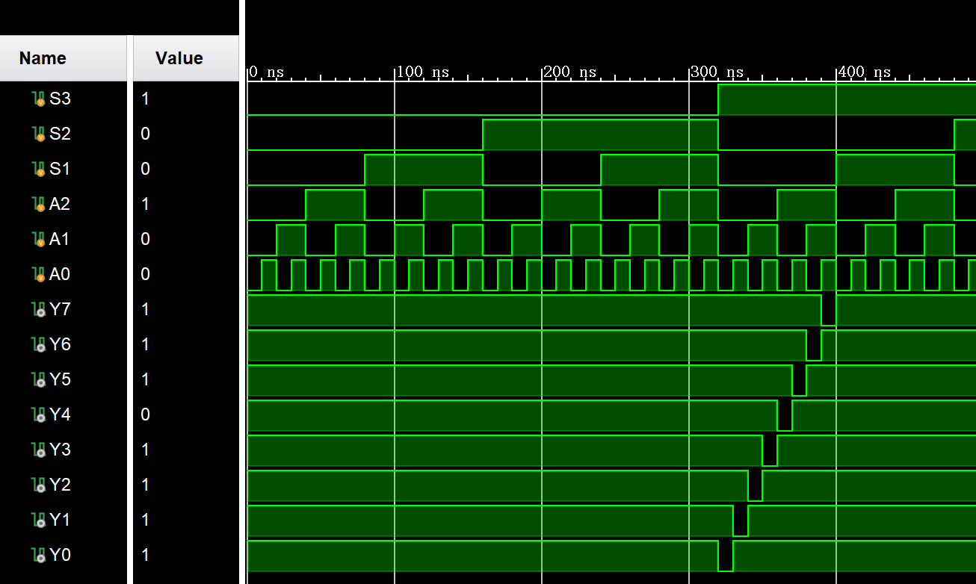
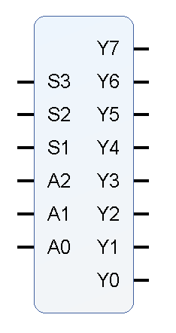
4.封装IP核

当S3=1，S2=x，S1=0时，进行译码功能；
否则，Y7=Y6=Y5=Y4=Y3=Y2=Y1=Y0=1

