验证74LS151的基本功能
1.源文件
`timescale 1ns / 1ps

// 74LS151 8选1数据选择器模块（低有效使能S，Y为输出，Y_NOT为反相输出）
module MY_74LS151(
input S,A2,A1,A0,
input D7,D6,D5,D4,D3,D2,D1,D0,
output reg Y,Y_NOT
);

always @(*)
begin
if(S==1'b1)
Y = 1'b0;
else
begin
case({A2,A1,A0})
3'b000: Y=D0;
3'b001: Y=D1;
3'b010: Y=D2;
3'b011: Y=D3;
3'b100: Y=D4;
3'b101: Y=D5;
3'b110: Y=D6;
3'b111: Y=D7;
endcase
end
Y_NOT = ~Y;
end

endmodule
2.引脚约束
set_property IOSTANDARD LVCMOS33 [get_ports A0]
set_property IOSTANDARD LVCMOS33 [get_ports A1]
set_property IOSTANDARD LVCMOS33 [get_ports A2]
set_property IOSTANDARD LVCMOS33 [get_ports D0]
set_property IOSTANDARD LVCMOS33 [get_ports D1]
set_property IOSTANDARD LVCMOS33 [get_ports D2]
set_property IOSTANDARD LVCMOS33 [get_ports D3]
set_property IOSTANDARD LVCMOS33 [get_ports D4]
set_property IOSTANDARD LVCMOS33 [get_ports D5]
set_property IOSTANDARD LVCMOS33 [get_ports D6]
set_property IOSTANDARD LVCMOS33 [get_ports D7]
set_property IOSTANDARD LVCMOS33 [get_ports S]
set_property IOSTANDARD LVCMOS33 [get_ports Y]
set_property IOSTANDARD LVCMOS33 [get_ports Y_NOT]
set_property DRIVE 12 [get_ports Y]
set_property PACKAGE_PIN T3 [get_ports A0]
set_property PACKAGE_PIN R3 [get_ports A1]
set_property PACKAGE_PIN V4 [get_ports A2]
set_property PACKAGE_PIN R1 [get_ports D0]
set_property PACKAGE_PIN N4 [get_ports D1]
set_property PACKAGE_PIN M4 [get_ports D2]
set_property PACKAGE_PIN R2 [get_ports D3]
set_property PACKAGE_PIN P2 [get_ports D4]
set_property PACKAGE_PIN P3 [get_ports D5]
set_property PACKAGE_PIN P4 [get_ports D6]
set_property PACKAGE_PIN P5 [get_ports D7]
set_property PACKAGE_PIN T5 [get_ports S]
set_property PACKAGE_PIN K3 [get_ports Y]
set_property PACKAGE_PIN M1 [get_ports Y_NOT]
3.仿真结果
`timescale 1ns / 1ps

module sim_MY_74LS151(

);
// 仿真信号定义
reg S,A2,A1,A0;
reg D7,D6,D5,D4,D3,D2,D1,D0;
wire Y,Y_NOT;

MY_74LS151 u_MY_74LS151(S,A2,A1,A0,D7,D6,D5,D4,D3,D2,D1,D0,Y,Y_NOT);

initial
begin
{S,A2,A1,A0,D7,D6,D5,D4,D3,D2,D1,D0}=12'b0;
end

always
begin
#10;
{S,A2,A1,A0,D7,D6,D5,D4,D3,D2,D1,D0}={S,A2,A1,A0,D7,D6,D5,D4,D3,D2,D1,D0}+12'b1;
end

endmodule
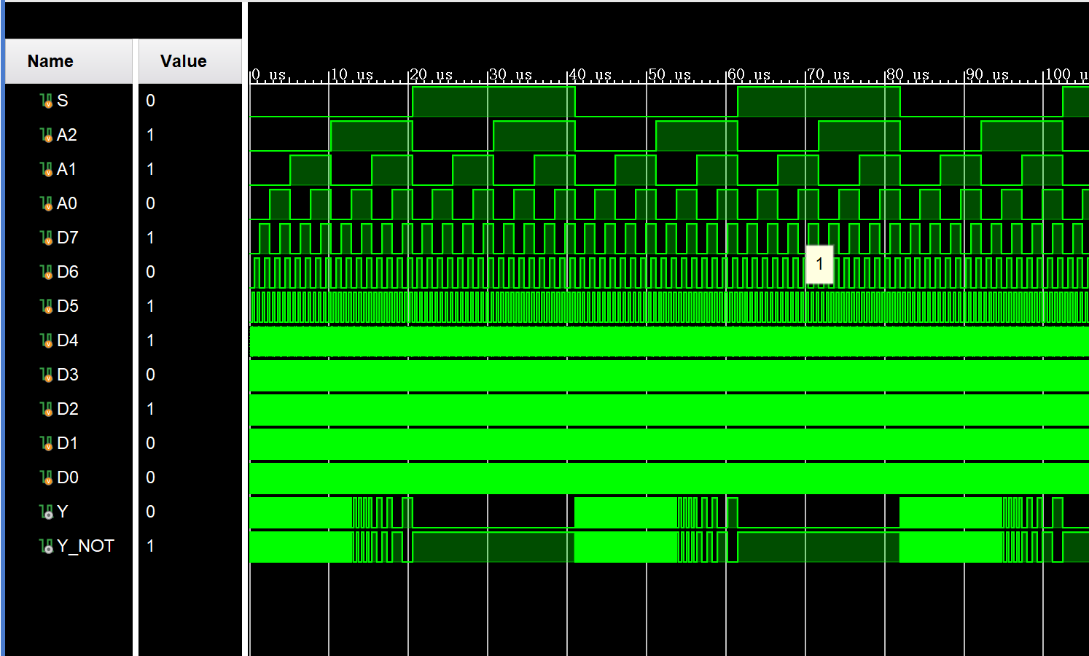
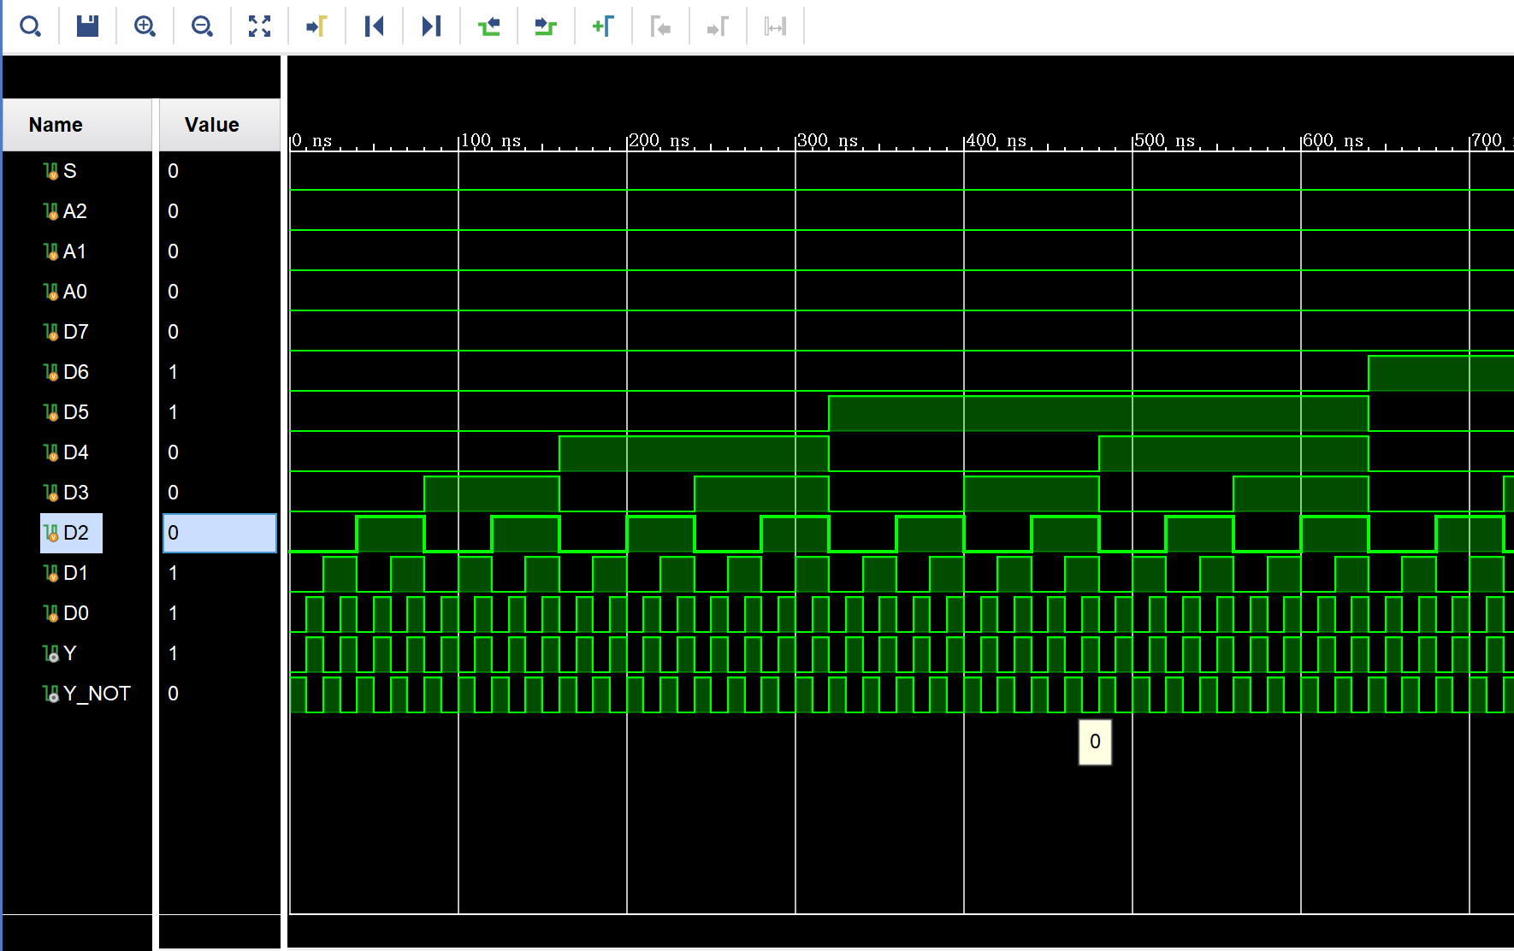
当A2=A1=1，A0=0时，Y=D6，Y_NOT= ~Y 当A2=A1=A0=0时，Y=D0，Y_NOT= ~Y
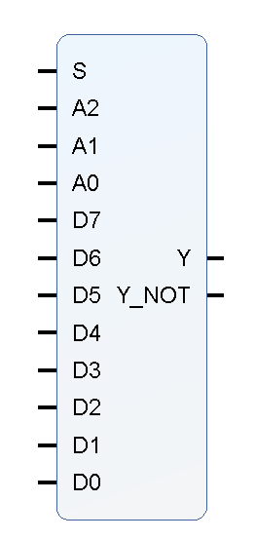
同理可验证A2A1A0=dx时，Y=Dx，Y_NOT= ~Y； 封装IP核：
当S = 1时，数据选择功能停止，Y=0, Y_NOT=1

