验证74LS10的基本功能
1.源文件
`timescale 1ns / 1ps

module MY_74LS10(
input A1, A2, A3, // 第一个3输入与非门
input B1, B2, B3, // 第二个3输入与非门
input C1, C2, C3, // 第三个3输入与非门
output Y1, Y2, Y3 // 三个输出
);
// 74LS10包含三个独立的3输入与非门
assign Y1 = ~(A1 & A2 & A3);
assign Y2 = ~(B1 & B2 & B3);
assign Y3 = ~(C1 & C2 & C3);
endmodule
2.仿真文件
`timescale 1ns / 1ps

module sim_MY_74x10(
// 测试74LS10
);
// 输入信号
reg A1, A2, A3; // 第一个门输入
reg B1, B2, B3; // 第二个门输入
reg C1, C2, C3; // 第三个门输入

// 输出信号
wire Y1, Y2, Y3;

// 实例化74LS10
MY_74LS10 u_MY_74LS10(A1, A2, A3, B1, B2, B3, C1, C2, C3, Y1, Y2, Y3);

// 初始化输入
initial begin
{A1, A2, A3, B1, B2, B3, C1, C2, C3} = 9'b0;
end

// 每10ns递增输入值
always begin
#10;
{A1, A2, A3, B1, B2, B3, C1, C2, C3} = {A1, A2, A3, B1, B2, B3, C1, C2, C3} + 1;
end

endmodule
3.引脚约束
set_property IOSTANDARD LVCMOS33 [get_ports A1]
set_property IOSTANDARD LVCMOS33 [get_ports A2]
set_property IOSTANDARD LVCMOS33 [get_ports A3]
set_property IOSTANDARD LVCMOS33 [get_ports B1]
set_property IOSTANDARD LVCMOS33 [get_ports B2]
set_property IOSTANDARD LVCMOS33 [get_ports B3]
set_property IOSTANDARD LVCMOS33 [get_ports C1]
set_property IOSTANDARD LVCMOS33 [get_ports C2]
set_property IOSTANDARD LVCMOS33 [get_ports C3]
set_property IOSTANDARD LVCMOS33 [get_ports Y1]
set_property IOSTANDARD LVCMOS33 [get_ports Y2]
set_property IOSTANDARD LVCMOS33 [get_ports Y3]
set_property PACKAGE_PIN R1 [get_ports A1]
set_property PACKAGE_PIN N4 [get_ports A2]
set_property PACKAGE_PIN M4 [get_ports A3]
set_property PACKAGE_PIN R2 [get_ports B1]
set_property PACKAGE_PIN P2 [get_ports B2]
set_property PACKAGE_PIN P3 [get_ports B3]
set_property PACKAGE_PIN P4 [get_ports C1]
set_property PACKAGE_PIN P5 [get_ports C2]
set_property PACKAGE_PIN K3 [get_ports Y1]
set_property PACKAGE_PIN M1 [get_ports Y2]
set_property PACKAGE_PIN T5 [get_ports C3]
set_property PACKAGE_PIN L1 [get_ports Y3]

仿真图
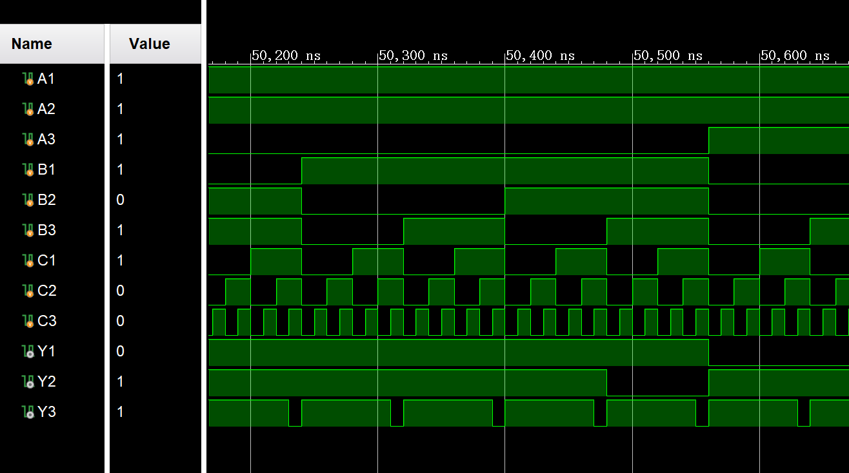
当且仅当A1A2A3=111时，Y1=0；B1B2B3=111时，Y2=0；C1C2C3=111时，Y3=0

封装IP核
