Gerrymandering Project

**02/09**

1. Decided to go with city council districts shapefiles Gustavo shared after learning that Census does not provide city-level data. Census MSAs (metropolitan areas) are different from cities.
2. Created a for loop that (1) reads each city’s council districts shapefile; (2) dissolves districts polygons; (3) removes unnecessary holes in the dissolved city boundary; and (4) assign it as a new object named “*cityname*_city_boundary.”
   1. i.e.) Before vs after removing unnecessary holes in New York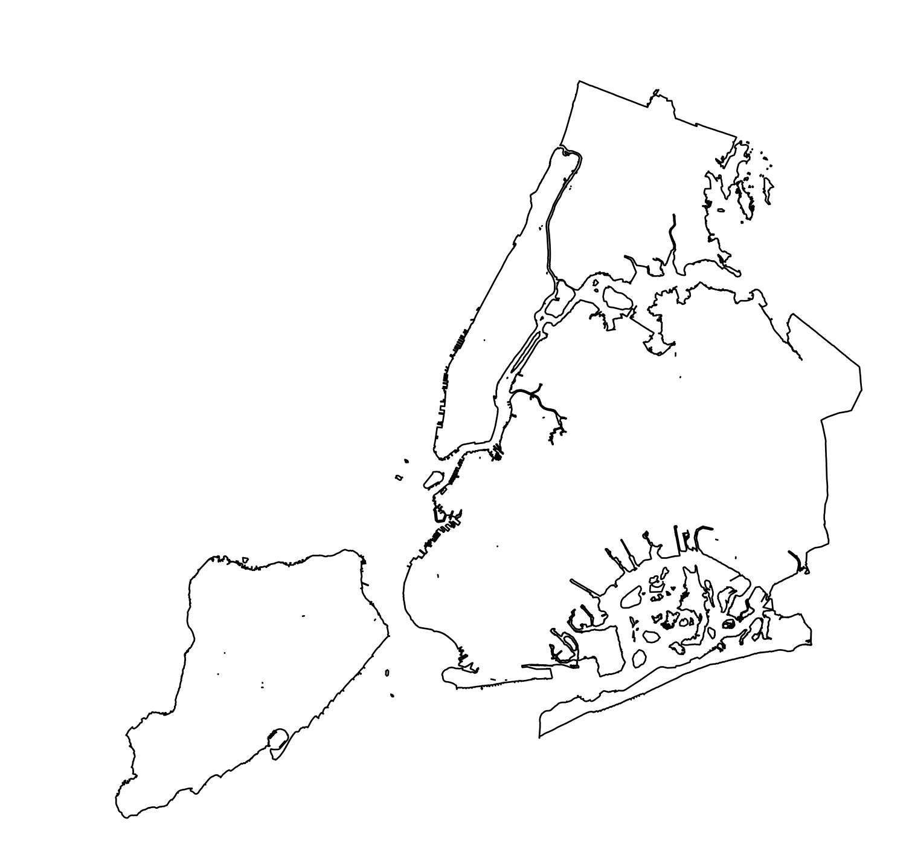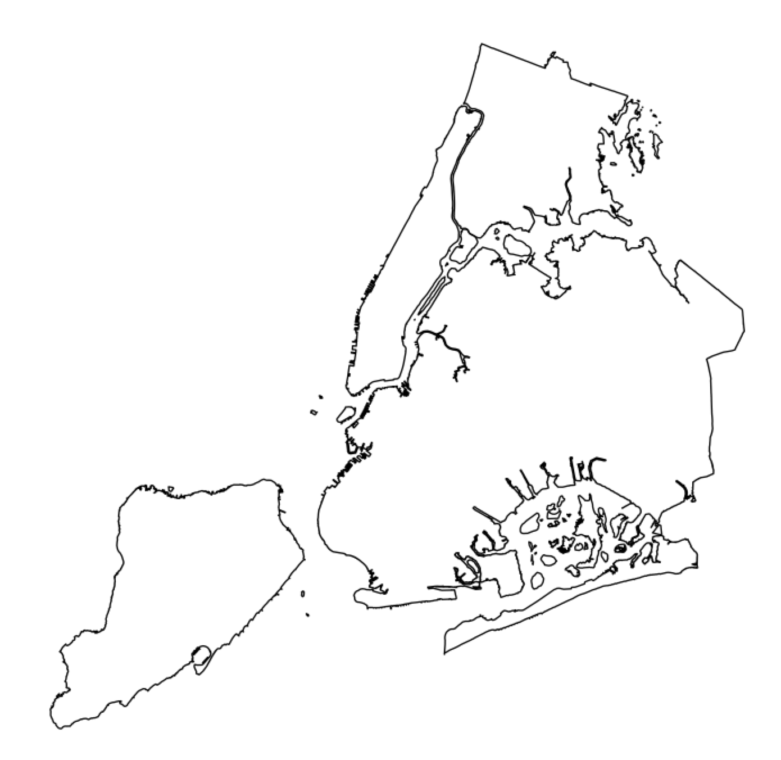
3. Created a for loop that (1) imports each city’s tract AND block-level demographics shapefiles; (2) filters tracts and blocks within the city boundary; (3) and assign them as new objects, named “*cityname*_tracts_boundary” and “*cityname*_blocks_boundary,” respectively.
   1. I have finished writing this loop, but intersection is not working yet because different levels of boundary files (city, tract) currently have different datum and projection. To make the intersection function work, I have to make sure all the boundary files have the same datum and projection.

**Next steps:** (1) Fix Houston and Austin geometry issue; (2) Make sure all cities’ boundary files and Census tract and block-level datasets have the same datum and projection;