哈尔滨工业大学

<<数据库系统>>
实验报告之二

(2019年度春季学期)

姓名： | 冯运
学号： | 1160300524
学院： | 计算机学院
教师： | 高宏

实验二 使用高级语言操作MySQL数据库

一、实验目的
学会使用高级语言访问MySQL数据库，并进行查询。

二、实验环境
Ubuntu 18.04.2 LTS 操作系统
MySQL Ver 14.14 Distrib 5.7.25, for Linux (x86_64)
openjdk version "1.8.0_191"
Visual studio code 1.32.3

三、实验过程及结果
这次实验我使用java语言，通过JDBC驱动链接MySQL数据库，完成查询
首先配置java的运行环境，添加java依赖库mysql-connector-java
然后开始编写java程序
首先对输入的参数进行解析,判断合法性，如果参数格式错误就给出错误提示
然后根据传入的参数动态的构造SQL查询语句
1：参加了项目编号为%PNO%的项目的员工号，其中%PNO%为C语言编写的程序的输入参数；
sql = "select ESSN from WORKS_ON where PNO = '" + args[4] + "';";
输入命令：
company_query -q 1 -p P1
运行截图如下：
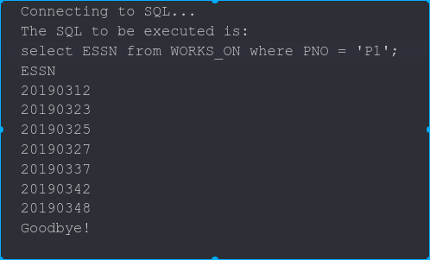
2：参加了项目名为%PNAME%的员工名字，其中%PNAME%为C语言编写的程序的输入参数；
sql = "select ENAME from EMPLOYEE,PROJECT,WORKS_ON where EMPLOYEE.ESSN=WORKS_ON.ESSN and PROJECT.PNO=WORKS_ON.PNO and PNAME='"
+ args[4] + "';";
输入命令：
company_query -q 2 -p 工程P0
运行截图如下：
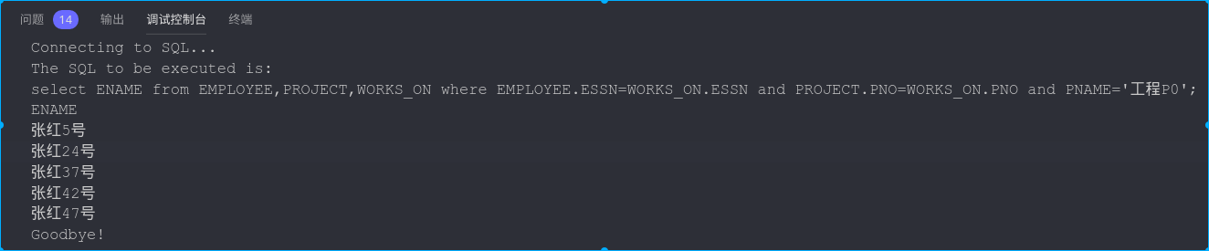
3：在%DNAME%工作的所有工作人员的名字和地址，其中%DNAME%为C语言编写的程序的输入参数；
sql = "select ENAME,ADDRESS from EMPLOYEE,DEPARTMENT where EMPLOYEE.DNO=DEPARTMENT.DNO and DNAME='"
+ args[4] + "';";
输入命令：
company_query -q 3 -p Research Department
运行截图如下：
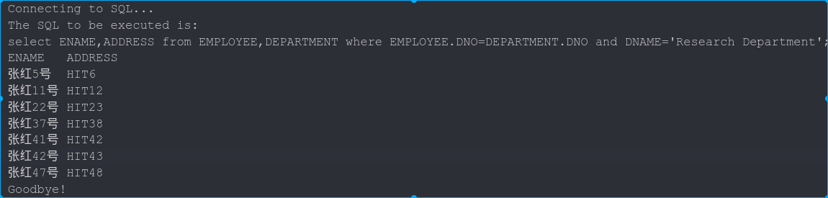
4：在%DNAME%工作且工资低于%SALARY%元的员工名字和地址，其中%DNAME%和%SALARY%为C语言编写的程序的输入参数；
int salaryLimit = Integer.parseInt(args[5]);
sql = "select ENAME,ADDRESS from EMPLOYEE,DEPARTMENT where EMPLOYEE.DNO=DEPARTMENT.DNO and DNAME='"
+ args[4] + "' and SALARY<" + salaryLimit + ";";
输入命令：
company_query -q 4 -p Research Department 3000
运行截图如下：
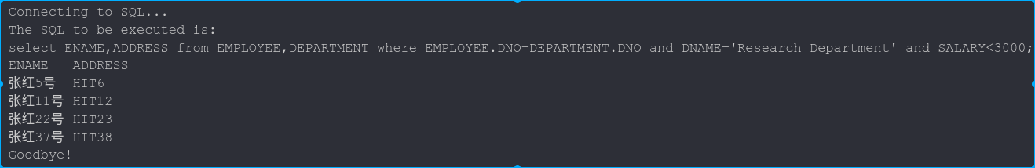
5：没有参加项目编号为%PNO%的项目的员工姓名，其中%PNO%为C语言编写的程序的输入参数；
sql = "select ENAME from EMPLOYEE where ESSN not in(select ESSN from WORKS_ON where PNO='"
+ args[4] + "');";
输入命令：
company_query -q 5 -p P1
运行截图如下：
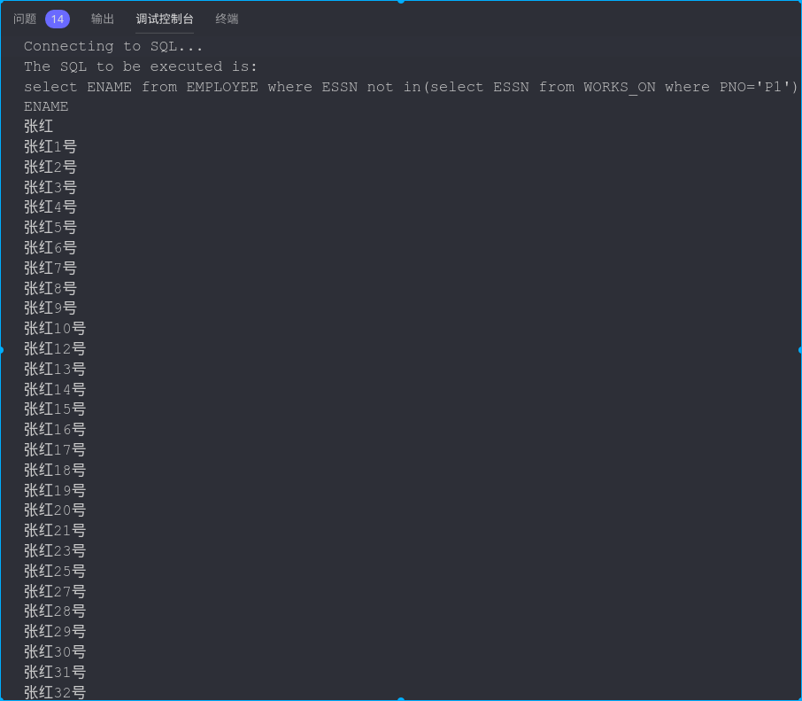
6：由%ENAME%领导的工作人员的姓名和所在部门的名字，其中%ENAME%为C语言编写的程序的输入参数；
sql = "select ENAME,DNAME from EMPLOYEE,DEPARTMENT where SUPERSSN=(select ESSN from EMPLOYEE where ENAME='"
+ args[4] + "') and EMPLOYEE.DNO=DEPARTMENT.DNO;";
输入命令：
company_query -q 6 -p 张红
运行截图如下：
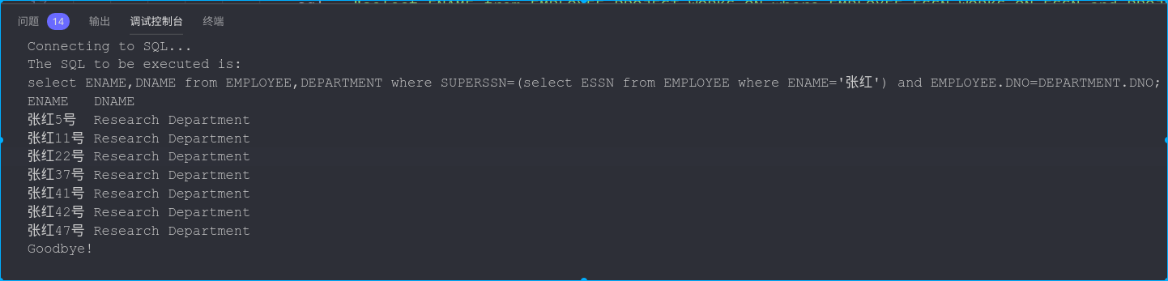
7：至少参加了项目编号为%PNO1%和%PNO2%的项目的员工号，其中%PNO1%和%PNO2%为C语言编写的程序的输入参数；
sql = "select ESSN from EMPLOYEE where ESSN in(select ESSN from WORKS_ON where PNO='" + args[4]
+ "') and ESSN in(select ESSN from WORKS_ON where PNO='" + args[5] + "')";
输入命令：
company_query -q 7 -p P1 P2
运行截图如下：
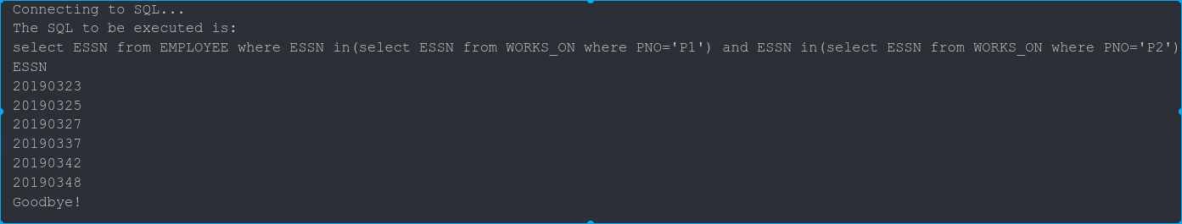
8：员工平均工资低于%SALARY%元的部门名称，其中%SALARY%为C语言编写的程序的输入参数；
int salary = Integer.parseInt(args[4]);
sql = "select DNAME from EMPLOYEE,DEPARTMENT where EMPLOYEE.DNO=DEPARTMENT.DNO group by DNAME having avg(SALARY)<"
+ salary + ";";
输入命令：
company_query -q 8 -p 3000
运行截图如下：
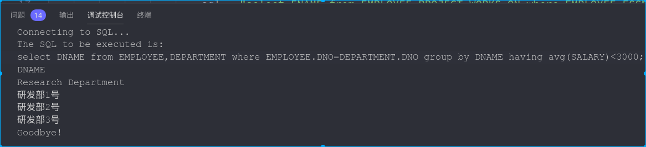
9：至少参与了%N%个项目且工作总时间不超过%HOURS%小时的员工名字，其中%N%和%SALARY%为C语言编写的程序的输入参数；
int projectNumLimit = Integer.parseInt(args[4]);
int hourLimit = Integer.parseInt(args[5]);

sql = "select ENAME from EMPLOYEE where ESSN in (select ESSN from WORKS_ON group by ESSN having count(distinct PNO)>="
+ projectNumLimit + " and sum(HOURS)<=" + hourLimit + ");";
输入命令：
company_query -q 9 -p 3 8
运行截图如下：
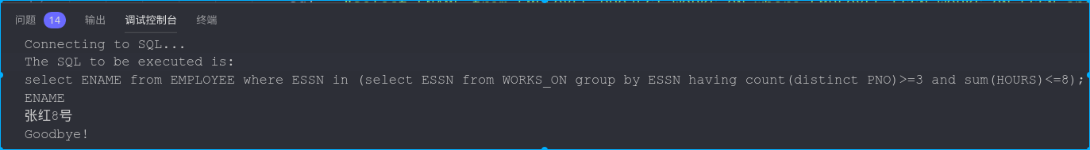

四、实验心得
通过这次实验，我学会了在java语言中嵌入SQL代码，在代码中动态的生成SQL操作语句，使用java连接SQL数据库，通过这种方式可以大大拓宽SQL的应用范围和功能，能够进行更多复杂的复杂功能的开发。各种高级语言使用SQL的方式大致相同，可以达到举一反三的效果。

五、实验完整代码
- import java.sql.*;

- public class Main {
- public static void main(String[] args) {
- String sql = ""; // the final SQL sentence to be executed
- try {
- int choice;
- if (args.length >= 5) {
- if (args[0].equals("company_query") && args[1].equals("-q") && args[3].equals("-p")) {
- // the parsing result of parameter <number>
- choice = Integer.parseInt(args[2]);
- switch (choice) {
- case 1:
- sql = "select ESSN from WORKS_ON where PNO = '" + args[4] + "';";
- break;
- case 2:
- sql = "select ENAME from EMPLOYEE,PROJECT,WORKS_ON where EMPLOYEE.ESSN=WORKS_ON.ESSN and PROJECT.PNO=WORKS_ON.PNO and PNAME='"
- + args[4] + "';";
- break;
- case 3:
- sql = "select ENAME,ADDRESS from EMPLOYEE,DEPARTMENT where EMPLOYEE.DNO=DEPARTMENT.DNO and DNAME='"
- + args[4] + "';";
- break;
- case 4:
- int salaryLimit = Integer.parseInt(args[5]);
- sql = "select ENAME,ADDRESS from EMPLOYEE,DEPARTMENT where EMPLOYEE.DNO=DEPARTMENT.DNO and DNAME='"
- + args[4] + "' and SALARY<" + salaryLimit + ";";
- break;
- case 5:
- sql = "select ENAME from EMPLOYEE where ESSN not in(select ESSN from WORKS_ON where PNO='"
- + args[4] + "');";
- break;
- case 6:
- sql = "select ENAME,DNAME from EMPLOYEE,DEPARTMENT where SUPERSSN=(select ESSN from EMPLOYEE where ENAME='"
- + args[4] + "') and EMPLOYEE.DNO=DEPARTMENT.DNO;";
- break;
- case 7:
- sql = "select ESSN from EMPLOYEE where ESSN in(select ESSN from WORKS_ON where PNO='" + args[4]
- + "') and ESSN in(select ESSN from WORKS_ON where PNO='" + args[5] + "')";
- break;
- case 8:
- int salary = Integer.parseInt(args[4]);
- sql = "select DNAME from EMPLOYEE,DEPARTMENT where EMPLOYEE.DNO=DEPARTMENT.DNO group by DNAME having avg(SALARY)<"
- + salary + ";";
- break;
- case 9:
- int projectNumLimit = Integer.parseInt(args[4]);
- int hourLimit = Integer.parseInt(args[5]);
- sql = "select ENAME from EMPLOYEE where ESSN in (select ESSN from WORKS_ON group by ESSN having count(distinct PNO)>="
- + projectNumLimit + " and sum(HOURS)<=" + hourLimit + ");";
- break;
- default:
- throw new Exception(); // the <number> value not illegal
- }
- }
- } else {
- throw new Exception(); // the format not illegal
- }
- } catch (Exception e) {
- System.err.println("Usage:\ncompany_query â€“q <Number> -p [Parameters]");
- return;
- }
- // JDBC driver name
- final String JDBC_DRIVER = "com.mysql.cj.jdbc.Driver";
- // JDBC url
- final String DB_URL = "jdbc:mysql://localhost:3306/COMPANY?characterEncoding=utf-8"; // in order to fix the
- // query contains Chinese
- // words
- final String USER = "root";
- final String PASS = "123456";
- Connection connection = null;
- Statement statement = null;
- try {
- // register JDBC driver
- Class.forName(JDBC_DRIVER);

- // establish connection with sql server
- System.out.println("Connecting to SQL...");
- connection = DriverManager.getConnection(DB_URL, USER, PASS);

- statement = connection.createStatement();
- System.out.println("The SQL to be executed is: ");
- System.out.println(sql);
- ResultSet resultSet = statement.executeQuery(sql);
- printTable(resultSet);
- // close result set to release memory
- resultSet.close();
- statement.close();
- connection.close();
- } catch (SQLException se) {
- se.printStackTrace();
- } catch (Exception e) {
- e.printStackTrace();
- } finally {
- try {
- if (statement != null)
- statement.close();
- } catch (SQLException se2) {
- }
- try {
- if (connection != null)
- connection.close();
- } catch (SQLException se) {
- se.printStackTrace();
- }
- }
- System.out.println("Goodbye!");
- }

- /**
- * automatically print the whole table according to query result
- *
- * @param resultSet SQL query result
- * @throws SQLException parse result exception
- */
- static void printTable(ResultSet resultSet) throws SQLException {
- // see if the query result is NULL, if so, print empty result to the console
- if (!resultSet.next()) {
- System.out.println("Empty result");
- return;
- }
- resultSet.previous(); // when check if result is NULL, the cursor had been move forward one unit

- ResultSetMetaData resultMetaData = resultSet.getMetaData();
- // print table property name
- for (int i = 1; i <= resultMetaData.getColumnCount(); i++) {
- System.out.print(resultMetaData.getColumnName(i) + "\t");
- }
- System.out.println("");
- // print table value
- while (resultSet.next()) {
- for (int i = 1; i <= resultMetaData.getColumnCount(); i++) {
- String columnValue = resultSet.getString(i);
- System.out.print(columnValue + "\t");
- }
- System.out.println("");
- }
- }
- }

