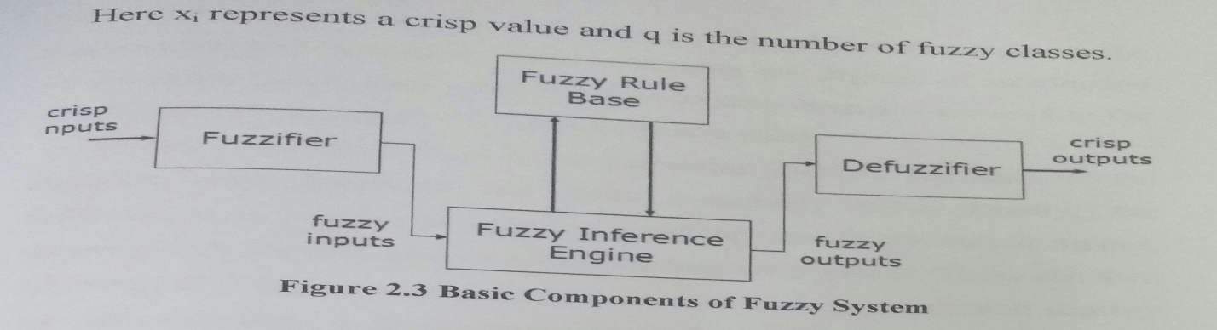

The fuzzy sets are characterized by membership functions which portray the degree of belonging of xi to the values in U, µF (xi): U🡪 [0, 1]. The rule base is constituted by an ensemble of fuzzy rules and the knowledge is expressed in the following form:

IF x1 is Ak l  AND. . . AND xn is Akn THEN yl is Aki AND. . .AND ym is bkm,

(2.3) where the index k = 1, . . . ,K indicates the k-th rule among the K rules in the rule base; Ak i and bkj are fuzzy sets. These are defined over the input components xi, i = 1, . . . n, and the output components yj ,j = 1, . ,m, respectively. The rule is a fuzzy implication that is usually represented by a Cartesian product of the membership functions of antecedents and consequents.

The fuzzy inference process can be described by starting with the definition of the membership functions µa(.) related to the kth fuzzy rule and evaluated for each input component of a sample vector x = (x1, ... xn). The most commonly employed membership functions are the triangular and the Gaussian functions. The values obtained by the fuzzification contribute to the AND conjunction of each rule, which is

11

interpreted by a particular I -norm. This is most commonly the min or the algebraic product operators. After evaluating the degrees of satisfaction for the entire set of fuzzy rules. the K activation strengths; are used in the OR disjunction represented by the alternative rules.

These interpreted by a particular S- norm, the max or the •algebraic sum operators are most commonly used. Finally, the deffuzzification process is used to reconvert the fuzzy output values, deriving from the in mechanism into crisp values. These can then be eventually employed in different contexts. The most common strategy 16r defuzzification is to use the center of area method which gives the center of gravity. of the output membership function.

**2.2.2 Fuzzy Sets**

Fuzzy techniques in the form of approximate reasoning provide decision support and expert systems with powerful reasoning capabilities. The permissiveness of fuzziness in the human thought process suggests that much of the logic behind thought processing is not traditional two valued logic or even multivalued logic, but logic with fuzzy truths. fuzzy connectedness. and fuzzy rules of inference. A fuzzy set is an extension of a crisp set. Crisp sets allow only full membership or no membership at all, whereas fuzzy sets allow partial membership. In a crisp set membership or non-membership of element x in set A is described by a characteristic function , where and . Fuzzy set theory extends this concept by defining partial membership. A fuzzy set A on a universe of discourse is characterized by a membership function that takes values in the interval. Fuzzy sets represent commonsense linguistic labels like slow, fast, small, large, heavy, low, medium, high, tall, etc. A given element

12

can be a member of more than one fuzzy set at a time. A fuzzy set A in U may be represented as a set of ordered pairs [3,9].

2.23 Membership Functions

Various types of membership functions are used, including triangular, trapezoidal, generalized bell shaped, Gaussian curves, polynomial curves. and sigmoid functions. The membership function maps each element of X to a membership value between 0 and 1. Several basic functions are: • piece-wise linear functions

• the Gaussian distribution function

• the sigmond curve

• quadratic and cubic polynomial curves

The simplest membership functions are formed using straight lines. In Figure 2.5, the simplest is the triangular membership function, and it has the function name trimf . This function is nothing more than a collection of three points forming a triangle. In Figure 2.6, the trapezoidal membership function, trapmf, has a flat top and really is just a truncated triangle curve. These straight line membership functions have the advantage of simplicity

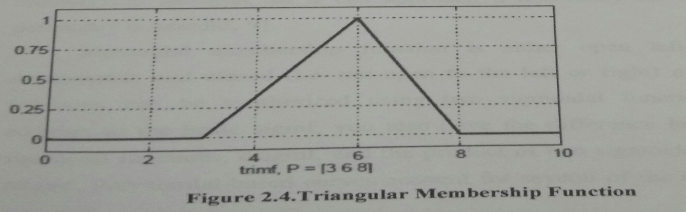

13

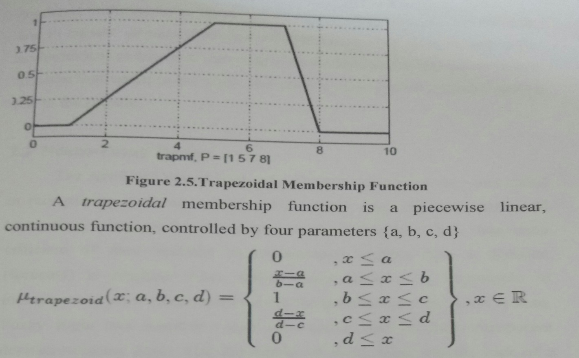

Two membership functions are built on the Gaussian distribution curve: a simple Gaussian curve and a two-sided composite of two different Gaussian curves. The generalized bell membership function is specified by three parameters and has the function name gbellmf. The bell membership function has one more parameter than the Gaussian membership function, so it can approach a non-fuzzy set if the free parameter is tuned [3, 9].

Sigmoidal membership function is either open left or right. Asymmetric and closed (i.e. not open to the left or right) membership functions can be synthesized using two sigmoidal functions, so in addition to the basic sigmf you also have the difference between two sigmoidal functions, dsigmf, and the product of two sigmoidal functions psigmf. Polynomial-based curves account for several of the membership

14

functions in the toolbox. Three related membership functions are the Z, S and Pi curves, all named because of their shape. The function zmf is the asymmetrical polynomial curve open to the left; smf is the mirror-image function that opens to the right, and pimf is zero on both extremes with a rise in the middle.

**2.3 Neuro-Fuzzy Design**

The Artificial Neural Networks (ANNS) have been very successful in recognizing nonlinear patterns from noisy, high frequency data and have been very useful forecasting tools. However, there has been criticism of their inability to transparently explain how a decision (forecast) is reached. Also, unlike fuzzy logic it is impossible to incorporate a priori information about the problem into the ANN system. Fuzzy logic can quantify vague information and produce transparent decision-making logic. The drawbacks of fuzzy logic are the lack of a learning capability and the necessity for an expert knowledge about the system.

Neural fuzzy inference systems introduce a parallel architecture and learning capability to a fuzzy inference system. Each fuzzy rule is created using the ANN and it is a data driven process. Fuzzy neural networks embed fuzzy logic into the ANN by fuzzifying the learning algorithms. This system uses a neuro-fuzzy combination where the ANN is used for identification (forecasting) and FLC extracts the decision from the ANN's output.

Finding a trading rule with FLC should not be confused with training of an ANN. An ANN uses a learning algorithm to map input variables (e.g. lagged interest rate, lagged order flow) into output variables (e.g. exchange rate change). In other words an ANN is a

15

nonlinear and dynamic system that learns from known input-output combinations. ANNs have been shown to have very good forecasting ability, but lack explanatory capability. By contrast, FLCs have no training capability and the mapping between inputs and output is generated from expert knowledge in the form of “if-then” rules. That is why it would be ideal to combine ANNs and FLCs to create a so-called neuro-fuzzy(NF) technology [1].

**2.3.1 Introduction of Fuzzy Logic**

Fuzzy sets were introduced by Zadeh [3] as a means of representing and manipulating data that was not precise, but rather fuzzy. There is a strong relationship between Boolean logic and the concept of a subset there is a similar strong relationship between fuzzy logic and fuzzy subset theory. In classical set theory, a subset A of a set X can be defined by its characteristic function XA as a mapping from the elements of X to the elements of the set {0, 1}. XA:X🡪{0,1}.

This mapping may be represented as a set of ordered pairs, with exactly one ordered pair present for each element of X. The first element of the ordered pair is an element of the set X, and the second element is an element of the set {0, 1}. The value zero is used to represent non-membership, and the value one is used to represent membership. The truth or falsity of the statement "x is in A” which is determined by the ordered pair (x,!A( x)) .The statement is true if the second element of the ordered pair is 1, and the statement is false if it is 0.

Similarly, a fuzzy subset A of a set X can be defined as a set of ordered pairs, each with the first element from X, and the second element from the interval [0,1], with exactly one order pair present for each

16

Element of X. This defines a mapping, µA, between elements of the set X and values in the interval [0, 1]. The value zero is used to represent complete nonmembership; the value one is used to represent complete membership, and values in between are used to represent intermediate degree, of membership.

The set X is referred to as the universe of discourse for the fuzzy subset A. Frequently, the mapping µA is described as a function, the membership function of A. The degree to which the statement "x is in A" is true is determined by finding the ordered pair (x, µA (x)). The degree of truth of the statement is the second element of the ordered pair. It should be noted that the terms membership function and fuzzy subset get used interchangeably.

**2.4 Neural Fuzzy Systems**

While fuzzy logic performs an inference mechanism under cognitive uncertainty, computational neural networks offer exciting advantages, such as learning, adaptation, fault-tolerance, parallelism and generalization. Neural networks are used to tune membership functions of fuzzy systems that are employed as decision-making systems for controlling equipment. Although fuzzy logic can encode expert knowledge directly using rules with linguistic labels, it usually takes a lot of time to design and tune the membership functions which quantitatively define these linguistic labels. Neural network learning techniques can automate this process and substantially reduce development time and cost while improving performance [4].

In theory, neural networks and fuzzy systems are equivalent in that they are convertible, yet in practice each has its own advantages and disadvantages. For neural networks, the knowledge is automatically

17

acquired by the backpropagation algorithm, but the learning process is relatively slow and analysis of the trained network is difficult (black box). Neither is it possible to extract structural knowledge (rules) from the trained neural network, nor can we integrate special information about the problem into the neural network in order to simplify the learning procedure .

Fuzzy systems are more favorable in that their behavior can be explained based on fuzzy rules and thus their performance can be adjusted by tuning the rules. But since, in general, knowledge acquisition is difficult and also the universe of discourse of each input variable needs to be divided into several intervals, applications of fuzzy systems are restricted to the fields where expert knowledge is available and the number of input variables is small.

To overcome the problem of knowledge acquisition, neural network are extended to automatically extract fuzzy rules from numerical data. Cooperative approaches use neural networks to optimize certain parameters of an ordinary fuzzy system, or to preprocess data and extract fuzzy (control) rules from data. The basic processing elements of neural networks are called artificial neurons, or simply neurons. The signal flow form of neuron inputs, xj , is considered to be unidirectional as indicated by arrows, as is a neuron's output signal flow. All signals and weights are real numbers. The input neurons do not change the input signals so their output is the same as their input. The signal xi interacts with the weight w1 to produce the product pi = wixi, i=1,..., n. The input information pi is aggregated by addition, to produce the input net = p1+…+pn =w1x1+…+wnxn to the neuron. The neuron uses its transfer function f, which could be a

18

sigmoidal function, f(t) = 11 + e-t to compute the output y = f(net) =f(w1x1+…+wnxn).

This simple neural net, which employs multiplication, addition, and sigmoidal f, will be called as regular(or standard) neural net.

**2.5Neuro-Fuzzy Engineering**

The basic idea behind the neuro-fuzzy engineering approach is to pass the spatial information through a series of steps:

1.Convert real-value spatial data into a fuzzified representation of the same information.

2.Train the fuzzified spatial information with a three-layer multilayer perceptron neural network. The output of the neural network is taken to be a fuzzy representation of the desired output.

3. The output of the neural network in step 2 is then de-fuzzified to produce individual real values of the desired output [7].

After the neural network in step 2 is trained to satisfaction, it is anal ted in order to extract fuzzy rules that can be used in association with the defined fuzzy membership functions used in steps 1 and 3.

**2.5.1 Fuzzy Neural Networks Architecture**

A fuzzy neural network seeks to blend the elements of these fuzzy and neural network computations into single connectionist architecture. There are several fuzzy neural network architectures [5, 8, 9]. The model of FuNN consists of five layer: input variable layer, condition elements ( input fuzzy membership function) layer, rule layer, action elements (output fuzzy member function) layer, and output variables layer.

19

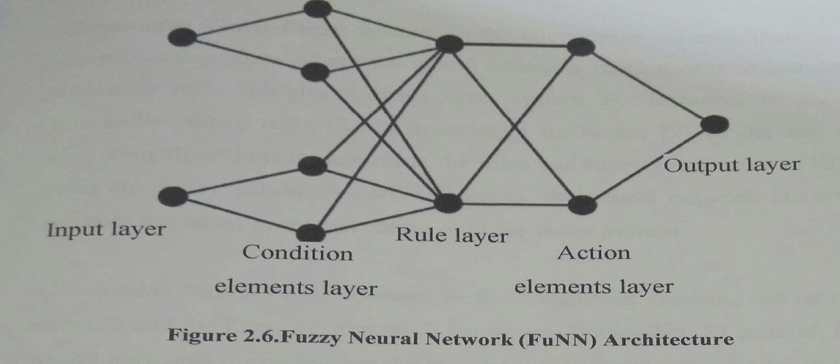

These elements are shown schematically in Figure 2.6. A bias node can also be included in this architecture but is not shown in the figure. Ordinarily, we employ triangular membership functions for the second and fourth layers. In the simplified scheme shown in Figure 2.8, each of the two inputs can be fuzzified in the condition layer by showing the degree of their membership in a fuzzy set (such as the degree to which they are HIGH or LOW). The number of fuzzy values need not be the same for the various inputs. Thus, one input could be connected to two condition layer nodes, and another input could be connected to four condition layer nodes.

**2.6 Types of Neuro-Fuzzy Systems**

In general, all the combinations of techniques based on neural networks and fuzzy logic can be called neuro-fuzzy systems. The different combinations of these techniques can be divided, in accordance with [10], in the following classes:

20

***Cooperative Neuro-Fuzzy System:*** In the cooperative system,there is a pre-processing phase where the neural networks mechanism of learning determine some sub-blocks of the fuzzy system.For instance, the fuzzy sets and/or fuzzy rules(fuzzy associative memories [2] or the use of clustering algorithms to determine the rules and fuzzy sets position [10]).After the fuzzy sub-blocks are calculated. the neural network learning methods ate taken away, executing only the fuzzy system.

***Concurrent Neuro-Fuzzy System***: In the concurrent systems, the neural networks and the fuzzy system work continuously together. In general, the neural networks pre-processes the inputs (or pos-processes the outputs) of the fuzzy system [2, 10].

***Hybrid Neuro-Fuzzy System:*** In this category, a neural network is used to learn some parameters or the fuzzy system (parameters of the fuzzy sets fuzzy rules and weights of the rules) of a fuzzy system in an iterative way. The majority of the researchers uses the neuro-fuzzy term to refer only hybrid neuro-fuzzy system [2, 10].

***2.6.1 Cooperative Neuro-Fuzzy Systems***

In a cooperative system, the neural networks are only used in an initial phase [2, 10], In this case, the neural networks determine sub -blocks of the fuzzy system using training data. After this, the neural networks are removed and only the fuzzy system is executed. In the cooperative neuro-fuzzy systems, the structure is not total interpretable what can be considered a disadvantage in Figure 2.7.

21

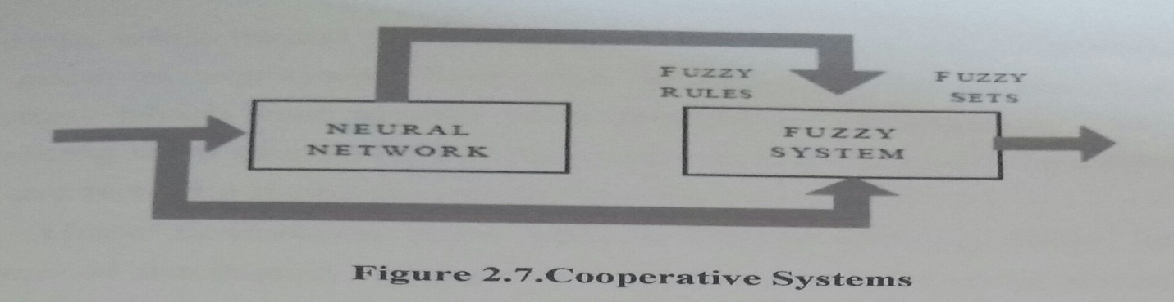

**2.6.2 Concurrent Neuro-Fuzzy Systems**

A concurrent system is not a neuro-fuzzy system in the strict sense, because the neural network works together with the fuzzy system. This means that the inputs entered in the fuzzy system are pre-processed and then the neural network processes the outputs of the concurrent system or in the reverse way. In the concurrent neuro-fuzzy systems, the results are not completely interpretable, what can be considered a disadvantage in Figure 2.8 [2, 10].

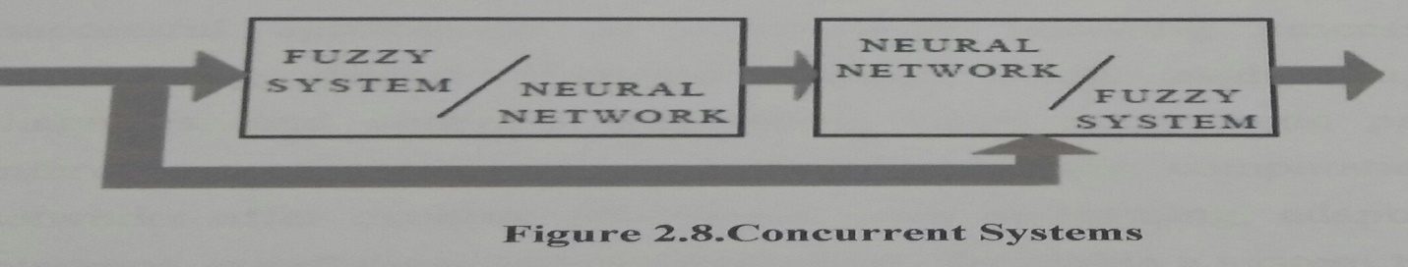

**2.7 Hybrid Systems** Hybrid systems combining fuzzy logic, neural networks, genetic algorithms, and expert systems are proving their effectiveness in a wide variety of real-world problems. Every intelligent technique has particular computational properties (e.g. ability to learn, explanation of decisions) that make them suited for particular problems and not for others. For example, while neural networks are good at recognizing patterns, they are not good at explaining how they reach their decisions. Fuzzy logic systems, which can reason with imprecise information, are good at

22

explaining their decisions but they cannot automatically acquire the rules they use to make those decisions [2, 10].

These limitations have been a central driving force behind the creation of intelligent hybrid systems where two or more techniques are combined in a manner that overcomes the limitations of individual techniques. Hybrid systems are also important when considering the varied nature of application domains. Many complex domains have many different component problems, each of which may require different types of processing. If there is a complex application which has two distinct sub-problems, say a signal processing task and a serial reasoning task, then a neural network and an expert system respectively can be used for solving these separate tasks.

The use of intelligent hybrid systems is growing rapidly with successful applications in many areas including process control, engineering design, financial trading, credit evaluation, medical diagnosis, and cognitive simulation. While fuzzy logic provides an inference mechanism under cognitive uncertainty, computational neural networks offer exciting advantages, such as learning, adaptation, fault tolerance, parallelism and generalization. To enable a system to deal with cognitive uncertainties in a manner more like humans, one may incorporate the concept of fuzzy logic into the neural networks. The resulting hybrid system is called fuzzy neural, neural fuzzy, neuro-fuzzy or fuzzy-neuro network.

23

**2.7.1 Model of Fuzzy Neural Systems**

Two possible models of fuzzy neural system are:

1. In response to linguistic statements: the fuzzy interface block provides an input vector a multi-layer neural network. The neural network can be adapted (trained) to yield desired command outputs or decisions [8] shown in Figure2.9.

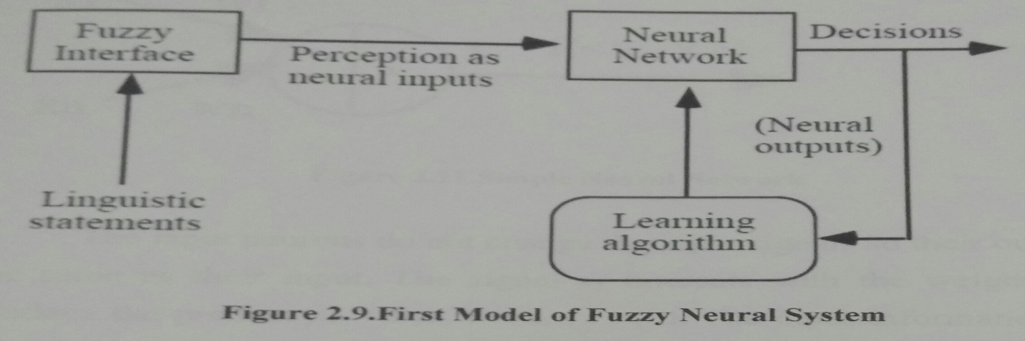

2. A multi-layered neural network drives the fuzzy inference mechanism shown in Figure 2. 10.

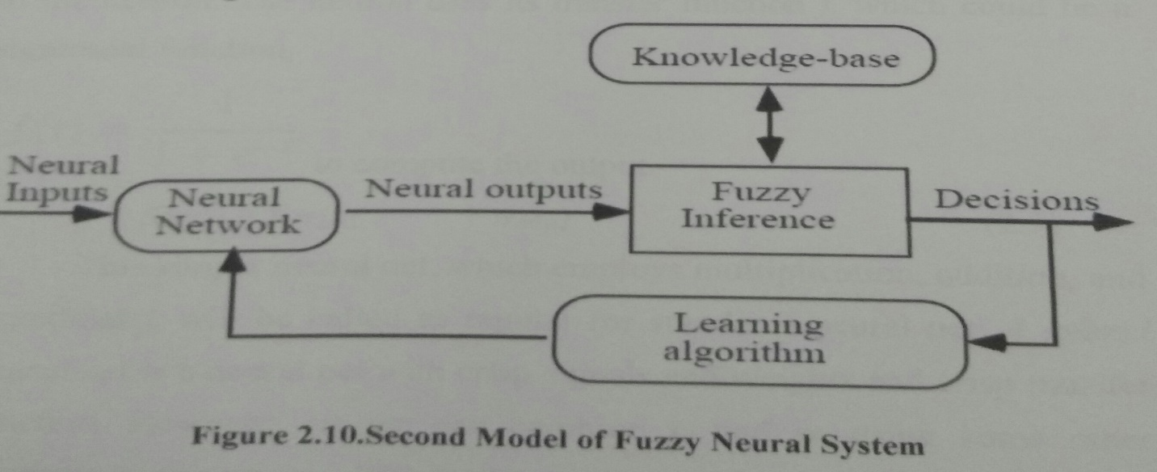

24

The basic processing elements or neural networks are called artificial neurons, or simply neurons. The signal flow form of neuron inputs, xj , is considered to be unidirectionals indicated by arrows, as is a neuron's output signal flow. In Figure 2.11, all signals and weights are real numbers.

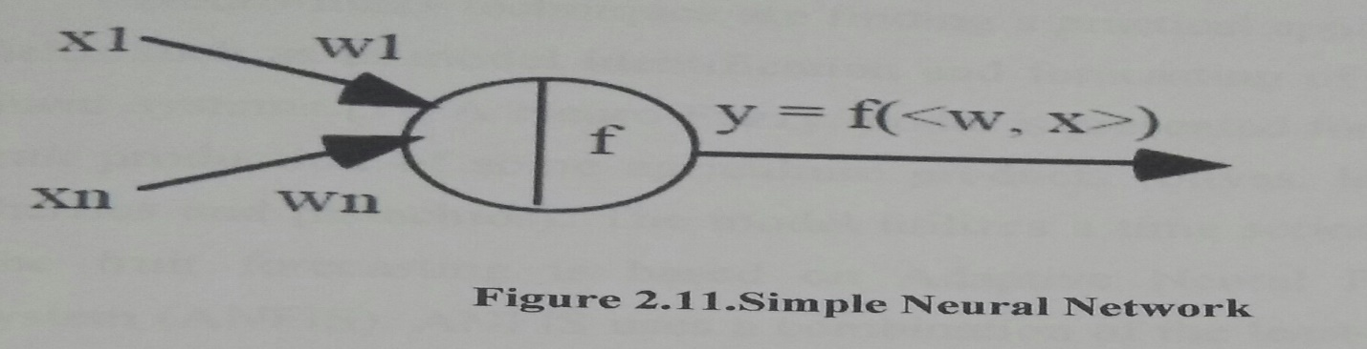

The input neurons do not change the input signals so their output is the same as their input. The signal xi interacts with the weight wi to produce the product pi = wixi, i = 1, . . . , n. The input information pi is aggregated, by addition, to produce the input

net =p1 + … +pn =w1x1+…+ wnxn, (2.4) to the neuron. The neuron uses its transfer function f, which could be a sigmoidal function,

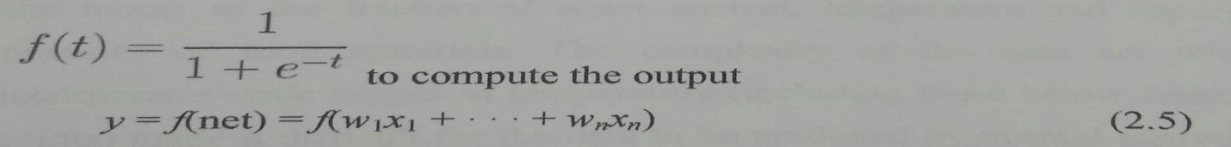

This simple neural net, which employs multiplication, addition, and sigmoidal f,will be called as regular (or standard) neural net. A hybrid neural net is a neural net with crisp signals and weights and crisp transfer function. However, (i) we can combine xi, and wi using some other continuous operation; (ii) we can aggregate the pi's with some other

25

continuous function; (iii)f can be any continuous function from input to output. We emphasize here that all inputs, outputs and the weights of a hybrid neural net are real numbers taken from the unit interval to [0,1]. A processing element of a hybrid neural net is called fuzzy neuron.

**2.8 Related Works**

Neuro-fuzzy techniques are finding a practical application in many fields such as in model identification and forecasting of linear and non-linear systems [1].A Neuro-Fuzzy model is presented for forecasting the fruit production of some agriculture products (olives, lemons, oranges, cherries and pistachios). The model utilizes a time series of yearly data. The fruit forecasting is based on Adaptive Neural Fuzzy Inference System (ANFIS). ANFIS uses a combination of the least-squares method and the backprobagation gradient descent method to estimate the optimal food forecast parameters for each year. The results are compared to those of an Autoregressive (AR) model and an Autoregressive Moving Average model (ARMA) A Neuro-Fuzzy modeling technique was used to predict the effective of thermal conductivity of various fruits and vegetables. A total of 676 data point was used to develop the neuro-fuzzy model considering the inputs as the fraction of water content, temperature and apparent porosity of food materials. The complexity of the data set which incorporates wide ranges of temperature (including those below freezing points) made it difficult for the data to be predicted by normal analytical and conventional models. However, the adaptive neuro-fuzzy model (ANFIS) was able to predict conductivity values which closely matched the experimental values by providing lowest mean square error compared to multivariable regression and

26

conventional artificial neural network (ANN) models. This method also alleviates the problem of determining the hidden structure of the neural network layer by trial and error[5]. T.Kavitha,M.Chandra Sekhar, and CNV Sridhar [9] proposed a neuro fuzzy rule-based approach to generate models relating car seat design variables to affective user satisfaction. Affective user satisfaction such as body contact, sweat and heat generation, shoulder support, head rest support, lumbar support and child safety were modeled for Car seat designs. The main objective is to generate a new car seat model in order to provide maximum human comfort. Maximum human comfort is estimated by an intelligence system called Neuro fuzzy system, where it gives the comfort of seat with respect to its influencing parameters. By adopting this Neuro-Fuzzy logic eliminated the antiquity of modifications,whether they are correct or not and the results give us an accurate decision to adopt the change or not [9].

One benefit of fuzzy systems [3] is that the rule base can be created from expert knowledge, used to specify fuzzy sets to partition all variables and a sufficient number of fuzzy rules to describe the input/output relation of the problem at hand. However, a fuzzy system that is constructed by expert knowledge alone will usually not perform as required when it is applied because the expert can be wrong about the location of the fuzzy sets and the number of rules. A manual tuning process must usually be appended to the design stage which results in modifying the membership functions and/or the rule base of the fuzzy system. This tuning process can be very time-consuming and error-prone. Also, in many applications expert knowledge is only partially available or not at all. It is therefore useful to support the definition of the fuzzy rule base by automatic learning approaches that make use of

27

available data samples.

This is possible since, once the components of the fuzzy system is put in a parametric form, the fuzzy inference system becomes a parametric model which can be tuned by a learning, procedure.

Fuzzy logic and artificial neural networks are complementary technologies in the design of intelligent systems. The combination of these two technologies into an integrated system appears to be a promising path toward the development of Intelligent Systems capable of capturing qualities characterizing the human brain. Both neural networks and fuzzy logic are powerful design techniques that have their strengths and weaknesses. The integrated system will have the advantages of both neural networks (e.g. learning abilities, optimization abilities and connectionist structures) and fuzzy systems (humanlike IF-THEN rules thinking and ease of incorporating expert knowledge) [2].

28