Оглавление

Git Hub Link 1

Git Practice. Guide 2

Git Practice. Example 4

## Git Hub Link

<https://github.com/YunSergey/study>

## Git Practice. Guide

Tasks 01-10:

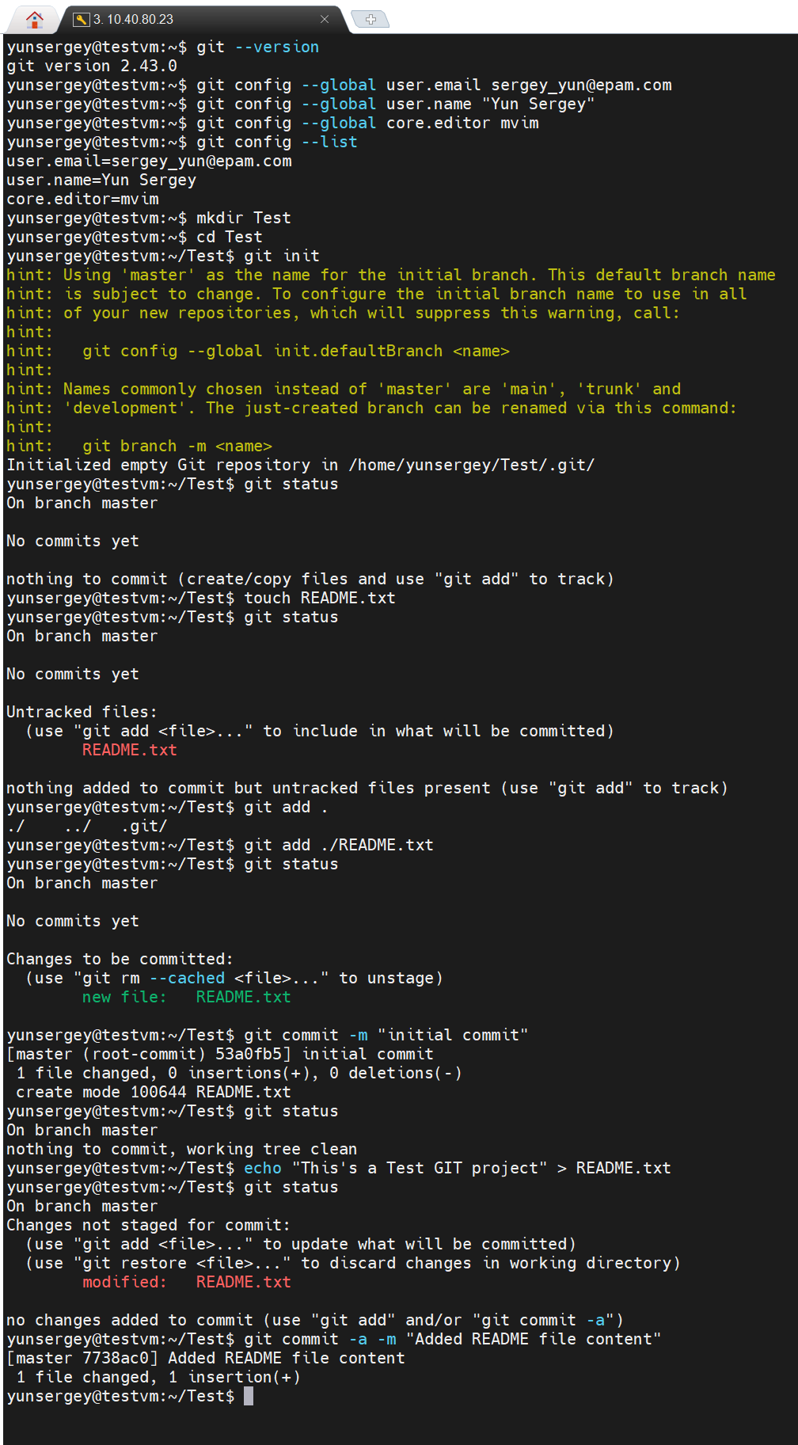

Tasks 11-12

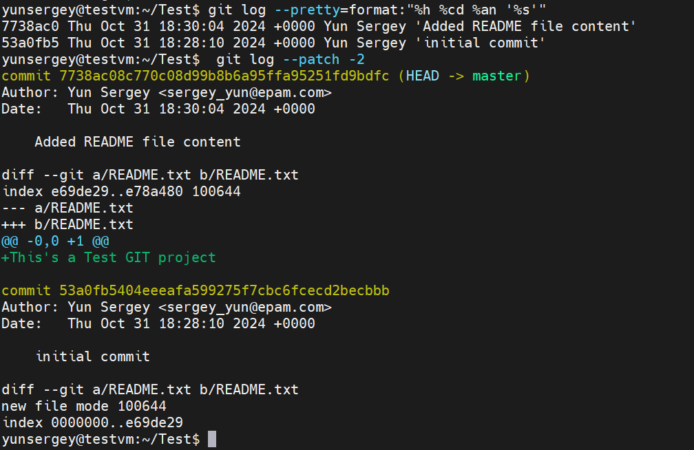

## Git Practice. Example

Task 01

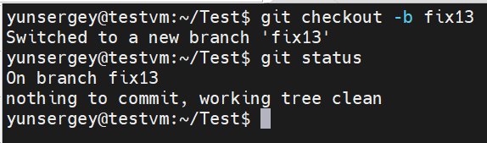

Task 02

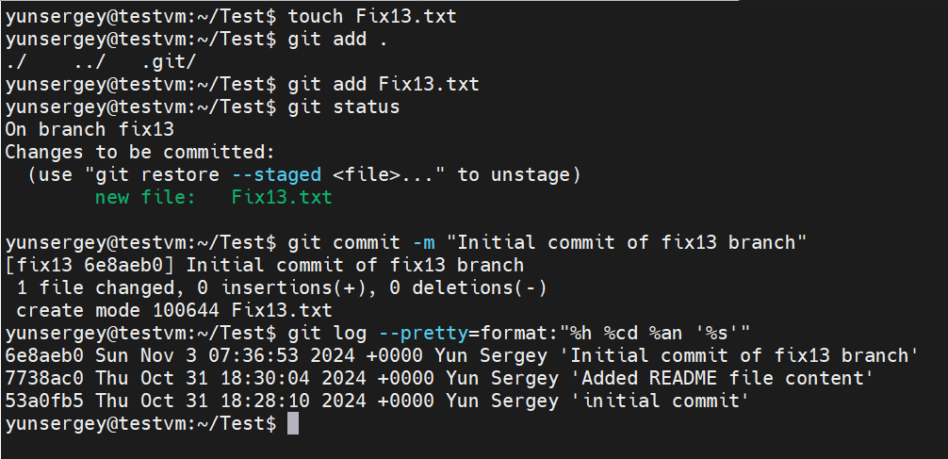Task 03

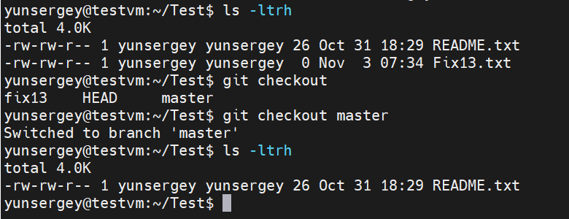

Task 04

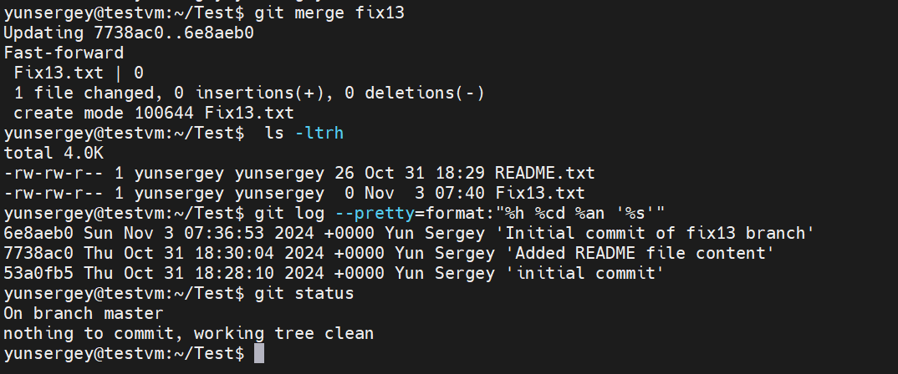

Task 05

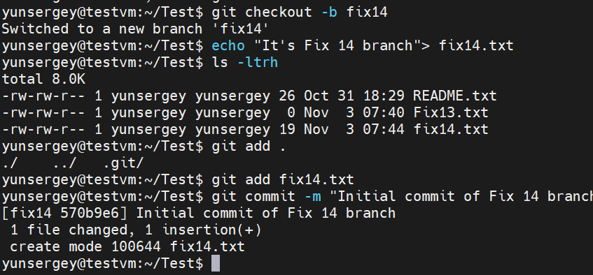

Task 06

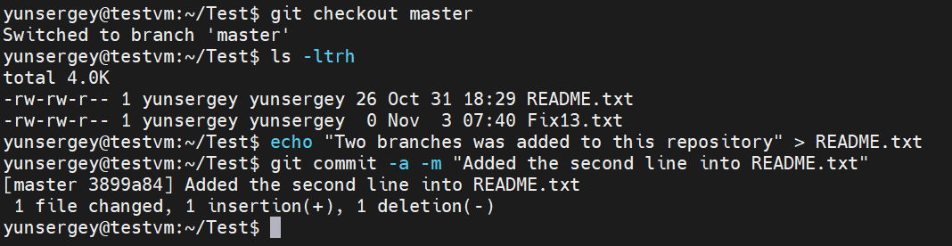

Task 07

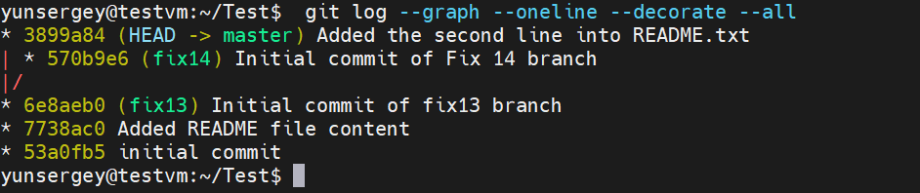

Task 08

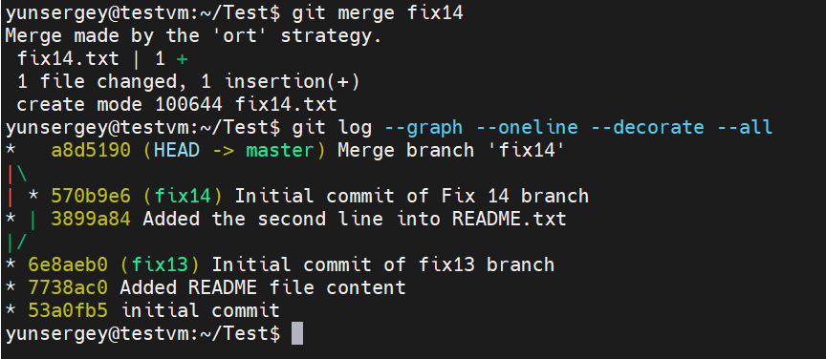

Task 09

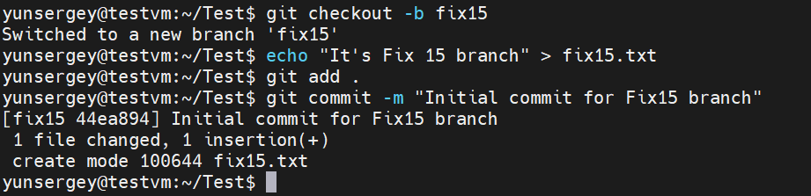

Task 10

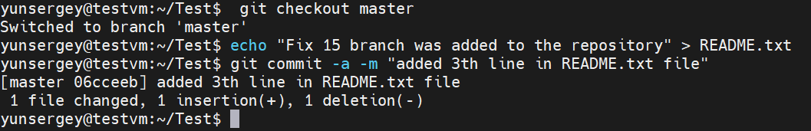

Task 11

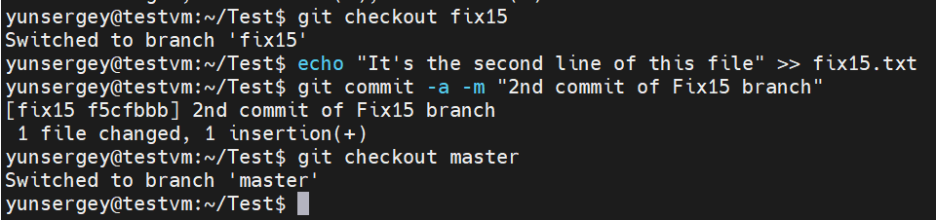

Task 12

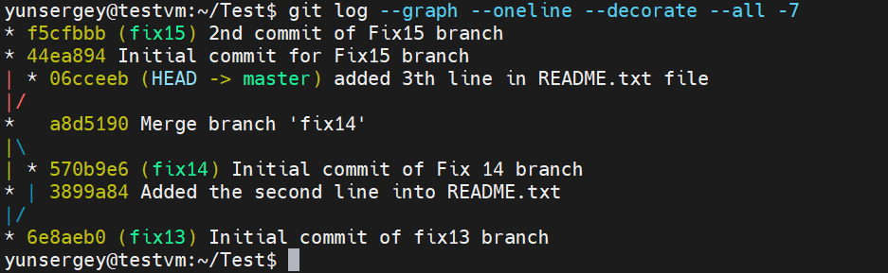

Task 13

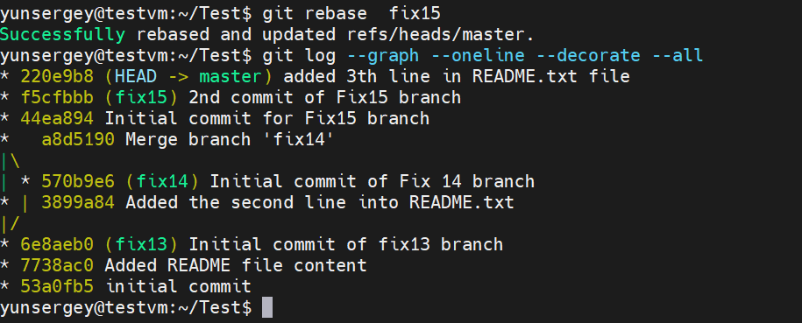

Task 14

