
Principles of Secure Operating Systems - Coursework
Sino-British Collaborative Programme, Oxford Brookes University & Chengdu University of Technology


Semester 2, Date, 2024
成都理工大学中英合作项目
CHENGDU UNIVERSITY OF TECHNOLOGY SINO-BRITISH COLLABORATIONS
A coursework submitted in partial fulfillment of the requirements for the module – Principles of Secure Operating Systems


Title: | Understanding and Modifying An
 | OS -File Encryption
 | Name: Lucy Lin
Major: |  | BSc (Hons) Computer Science/Software Engineering
Student Number: |  | 202018010103
Name of Course: |  | Principles of Secure Operating System
Name of Lecturer: |  | Dr. Chiagoziem Chima Ukwuoma/Dr. Joojo
University: |  | Oxford Brookes University

Table of Contents (Follow this structure)

A Description of File Encryption 5
Functional and Non-Functional Requirements 6
Functional Requirements 6
Non-Functional Requirements 7
Security Features 8
Design Of Software 9
Software Architecture Overview 9
System Architecture Diagram 11
Implementation 12
Testing Plan 21
Integrating 24
Integration Testing 26
Possible Limitations, Failures 28
Conclusion 29
Reflections 30
References 31

(words count: 1650 words, not including table, figure, and references)

List of Figures and Tables
Table 2. Functional Requirement 7
Table 3. Functional Requirement for Multithreading 7
Table 4. Non-Functional Requirements 8
Table 5. Non-Functional Requirement for Multithreading 8
Table 6. Security Features 8
Table 7. Design Module 11
Figure 1. Code for step 1 and 2 12
Figure 2. Code for step 3, 4 and 5. 13
Figure 3. Code for ase_encrypt_file function 14
Figure 4. Code for aes_decrypt_thread function 16
Figure 5. aes_decrypt_file function 17
Figure 6. Operation for algorithm selection 17
Figure 7. perform_encryption and select_encryption_algorithm 18
Figure 8. Producer thread 19
Figure 9. Consumer thread 20
Figure 10. Environment 24
Figure 11. Place encrypt.h 25
Figure 12. Get program executable file 25
Figure 13. Check the program file 25
Figure 14. Encryption 26
Figure 15. Decryption 27

A Description of File Encryption
File encryption protects data from outside prying eyes by automatically encoding the contents of the file, which mainly consists of two steps: encryption and decryption. In this paper, we use the symmetric encryption algorithm AES, which supports a variety of key lengths, and here I have used AES-256[1] to improve security.

In specific operation, AES_encrypt_file and AES_decrypt_file functions handle the encryption and decryption process respectively. These functions receive the file path and key string, generate the AES key and initialization vector (IV), and perform the corresponding encryption or decryption operation, and finally write the result to the output file.

In order to improve the efficiency, multi-threading technique is introduced, and the encryption and decryption of data blocks are processed in parallel using the producer-consumer model, which effectively improves the processing speed and resource utilization [2].

Functional and Non-Functional Requirements

Functional Requirements
FR | Details
File encryption | 1. Users select the path to the file to be encrypted via the command line.  2. Users are allowed to select the path of the output file after encryption.  3. Encrypts the file through CBC mode using the AES-256 algorithm.  4. Generates and uses initialization vectors (IVs) during the encryption process.  5. writes the encrypted data to the output file and records the total number of bytes written.
File decryption | 1. Users can select the path of the file to be decrypted via the command line.  2. Allow the user to select the path to the output file after decryption.  3. User inputs the key to be used for decryption.  4. AES-256 algorithm is used to decrypt the file in CBC mode.  5. Input data is read from the input file and decrypted data is written to the output file.
Random key generation | 1. Use OpenSSL's RAND_bytes function to generate a 32-byte random key.  2. Convert the generated key to a string format for easy storage and use.  3. Provide the function of saving the generated key to a file for subsequent decryption.
Algorithm selection | 1. Support user to choose different encryption algorithms: 1). Symmetric encryption algorithm 2). Asymmetric encryption algorithm 3). Hash function 4). Hybrid encryption algorithm  2. The system carries out the corresponding encryption or decryption operation according to the user-selected algorithm.
Multiple file type encryption and decryption | 1. Support encryption and decryption of multiple file types.  2. Generates keys and initialization vectors (IVs) using CBC mode [3] and SHA-256 hash algorithm [4].  3. Ensure data integrity and security of different types of files during encryption and decryption.  4. Handle the encryption and decryption requirements of various file formats and ensure compatibility of multiple file types.
Table 1. Functional Requirement

FR for multithreading | Details
Producer-Consumer Threads | The producer thread is responsible for putting the data block into the buffer and the consumer thread is responsible for taking the data block out of the buffer for encryption or decryption.
Avoiding Race Conditions | The use of mutex locks ensures exclusive access to shared resources, prevents multiple threads from accessing shared resources at the same time, and avoids contention conditions.
Data Block Processing | The producer thread loops through the specified number of data blocks and puts them into a buffer, and the consumer thread loops through the blocks from the buffer to process them until all the data blocks have been processed.
Synchronized Production and Consumption | Use the conditional variables full and empty to implement a wait and wake-up mechanism between threads to ensure that the producer and consumer threads can coordinate their work properly.
Table 2. Functional Requirement for Multithreading

Non-Functional Requirements
NFR | Details
Reliability | Handles error conditions and provides appropriate error messages.
High Performance | Encrypts and decrypts large files efficiently using multiple threads to avoid excessive memory consumption.
Security | Uses the AES-256 algorithm to encrypt and decrypt.
Flexibility | Supports the selection of different file paths and key strings for encryption and decryption operations.
Table 3. Non-Functional Requirements

NFR for multithreading | Details
Portability | Use standard pthread library functions to create, synchronize and destroy threads.
Readability | The code is well named and commented.
Table 4. Non-Functional Requirement for Multithreading

Security Features
Features | Details
AES-256 Algorithm | AES is a symmetric encryption algorithm that uses a 256 key and is a widely used encryption algorithm today.
CBC Mode | Use CBC mode to provide stronger data protection and increase the randomness of the cipher by introducing initialization vectors (IVs) and key block links.
Random Key Generation | Increases the randomness and security of keys by generating 32-byte random keys using OpenSSL's RAND_bytes function.
File Deletion Option | Provides the option to delete the original file to avoid security risks associated with the original file.
Table 5. Security Features

Design Of Software

Software Architecture Overview
The design of the file encryption software contains the following main modules:
- File encryption module
- File decryption module
- Multi-threaded processing module
- File read/write module
- Encryption key management module
The details will be described in Table 5
Module | Details
File encryption module | 1. Receive user input: Get user-specified input file path and output file path.  2. Generate key and IV: Generate the AES key and initialization vector (IV) using the key string provided by the user.  3. Initialize encryption context: create and initialize EVP_CIPHER_CTX object, configure AES-256 algorithm and key, IV.  4. Read the file and encrypt: read the data from the input file block by block, encrypt the data using EVP_EncryptUpdate function, and write the encrypted data to the output file.  5. Finish the encryption process: use the EVP_EncryptFinal_ex function to process any remaining data and write it to the output file.  6. Clean up resources: release the encryption context object, close the file handle, and prompt the user to delete the original file.
File decryption module | 1. Receive user input: Get the user-specified input file path and output file path, as well as the key required for decryption.  2. Generate key and IV: Generate the AES key and initialization vector (IV) using the key string provided by the user.  3. Initialize decryption context: create and initialize EVP_CIPHER_CTX object, configure AES-256 algorithm and key, IV.  4. Read the file and decrypt: read the data of the input file block by block, decrypt the data using EVP_DecryptUpdate function, and write the decrypted data to the output file.  5. Complete the decryption process: Use the EVP_DecryptFinal_ex function to process any remaining data and write it to the output file.  6. Clean up resources: release the decryption context object and close the file handle.
Multi-threaded processing module | 1. Producer thread: responsible for reading data blocks from the input file and putting them into the buffer.  2. Consumer thread: takes out the data block from the buffer for encryption or decryption processing, and then writes the processed data into the output file.  3. Synchronization: Use mutex to ensure exclusive access to the buffer to avoid data contention [5]. The use of condition variables (condition variables) to achieve coordination between threads, such as buffer full notify the producer thread to wait, buffer empty notifies the consumer thread to wait.
File read/write module | 1. Open files: Use the fopen function to open input and output files. If the file fails to open, an error message is returned.  2. Read file: use fread function to read data from the input file block by block, and pass the data to the encryption or decryption module.  3. Write file: use fwrite function to write the encrypted or decrypted data into the output file block by block.  4. Close the file: use the fclose function to close the input and output files to ensure that the resources are released.
Encrypt key management module | 1. Key generation: Use the RAND_bytes function of the OpenSSL library to generate a 32-byte random key to ensure the security and unpredictability of the key.  2. Key saving: convert the generated key to string format and save it to a file for subsequent decryption.  3. Key reading: read the saved key from the file for use in decryption operations.  5. Key Verification: verifies whether the key provided by the user is correct during the decryption process.
Table 6. Design Module

System Architecture Diagram
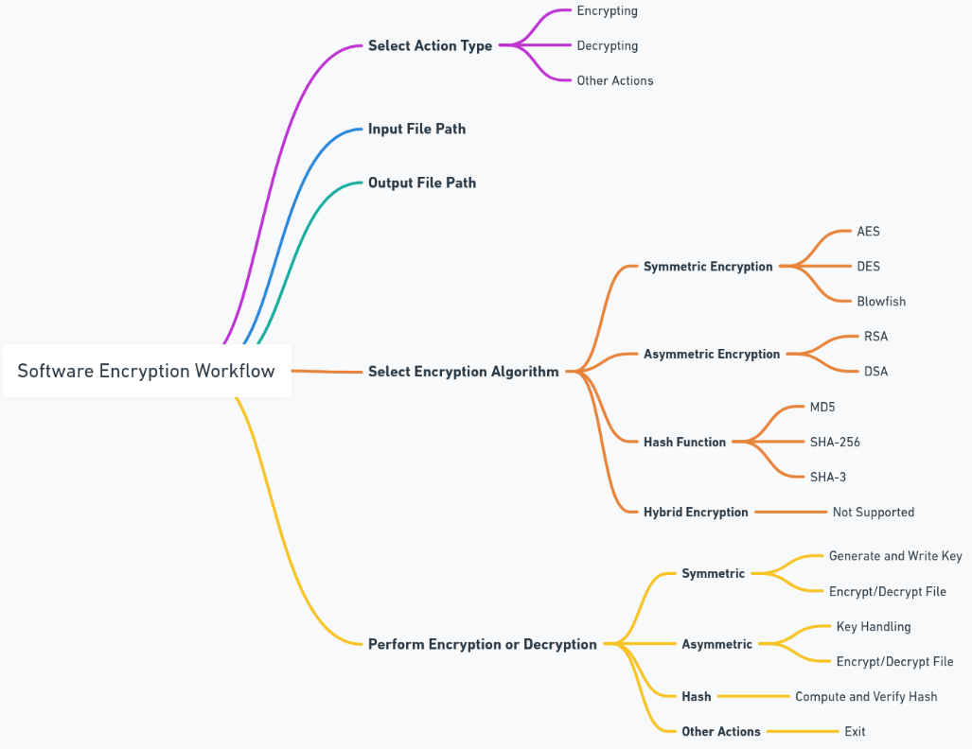

Implementation
File encryption
For encrypting a file using the AES-256 algorithm, in the code, two functions are created: aes_encrypt_thread and aes_encrypt_file to implement it. First, in the aes_encrypt_thread function, the following steps are performed: 1. open the file 2. generate the key and IV 3. initialize the encryption context 4. read and encrypt the data 5. complete the encryption process 6. release the resources and delete the original file. Specifically, for steps 1,2, first, the function tries to open the input file and output file, and if it fails it prints an error message and returns. Next, the AES key and initialization vector (IV) are generated from the key string using EVP_BytesToKey. The specific code is shown in Figure 1.
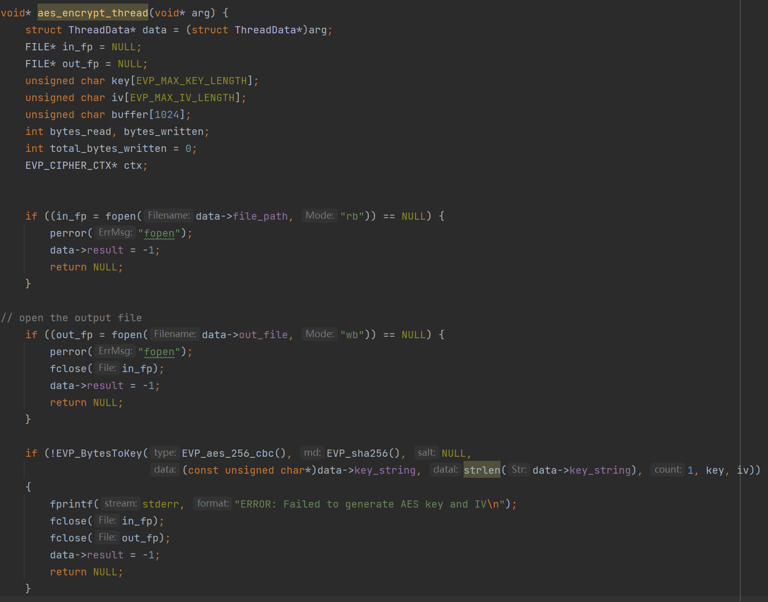
Figure 1. Code for step 1 and 2
For steps 3, 4, and 5. The specific code is shown in Figure 2. First, the encryption context is created and initialized, and if it fails it will release the resources and return. During the encryption process, the function loops through the input file and encrypts the data using EVP_EncryptUpdate, then writes the encrypted data to the output file. Finally, EVP_EncryptFinal_ex is called to process the final padded data and write it to the output file. After encryption is complete, the function releases the encryption context, closes the file, and asks the user whether to delete the original file. If the user chooses to delete, it attempts to delete the original file.
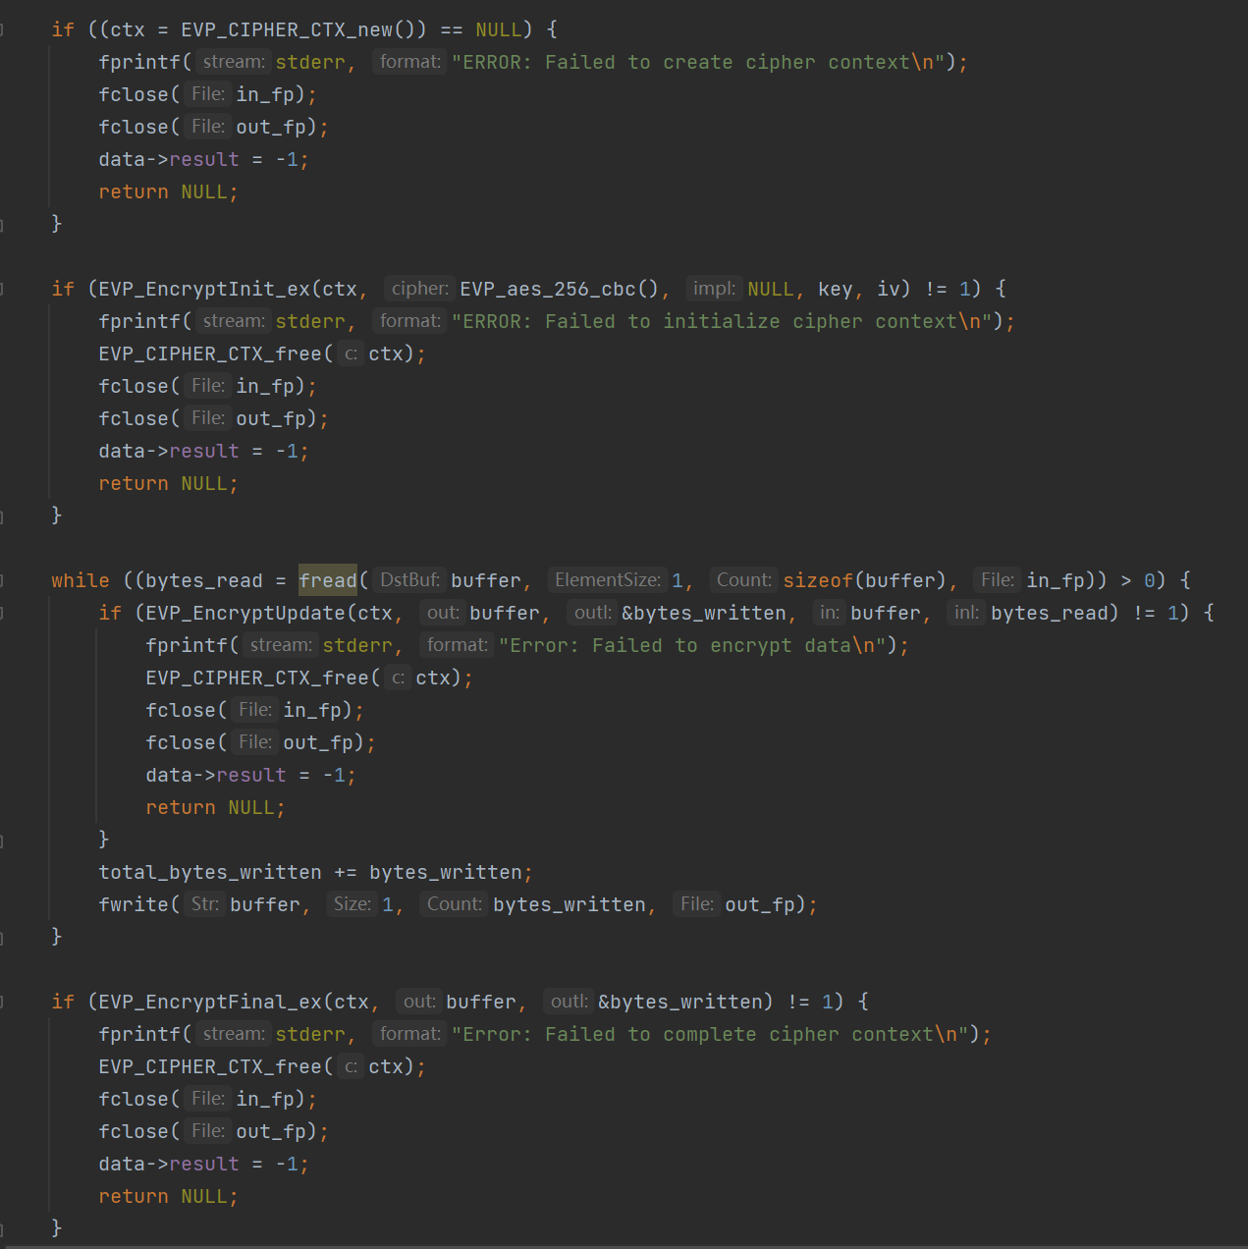
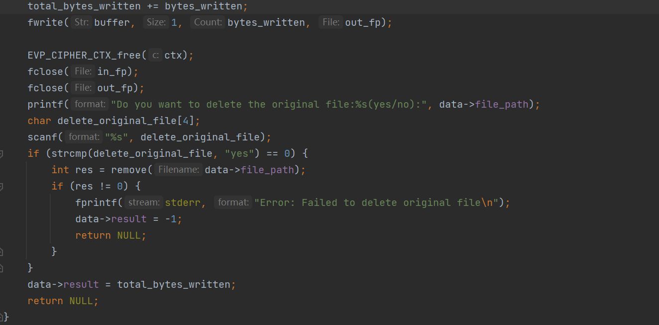
Figure 2. Code for step 3, 4 and 5.

In the encryption function aes_encrypt_file, the thread data is first initialized, and then pthread_create is called to create a new thread to execute the aes_encrypt_thread function. If the thread creation fails, an error message is printed and an error code is returned. Finally, pthread_join is called to wait for the thread to finish execution and return the result of the encryption operation. The source code is shown in Figure 3.
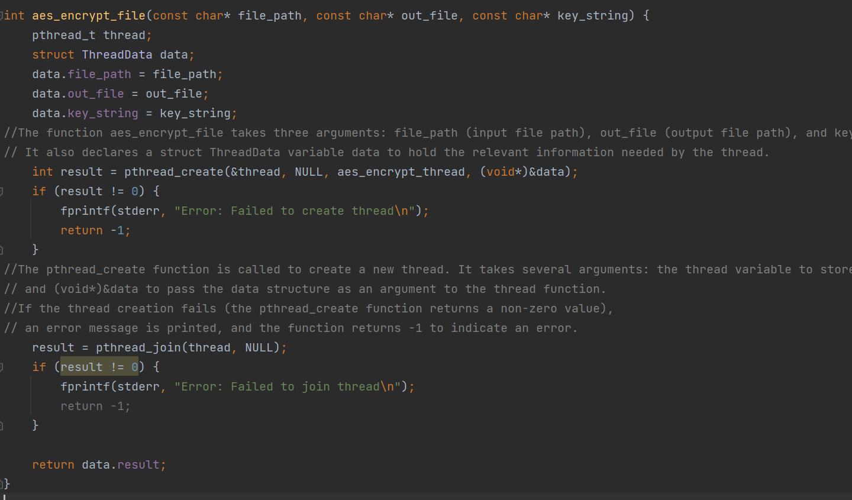
Figure 3. Code for ase_encrypt_file function

File decryption
In the decryption section, the aes_decrypt_thread function has similar logic to the encrypt thread function, but performs an AES-256-CBC decryption operation. It first opens the input and output files, generates the AES key and initialization vector (IV) from the key string, and then creates and initializes the decryption context. During the decryption process, the function loops through the input file and decrypts the data using EVP_DecryptUpdate, then writes the decrypted data to the output file. Finally, EVP_DecryptFinal_ex is called to process the final filled data and write it to the output file. When decryption is complete, the function releases the decryption context and closes the file.
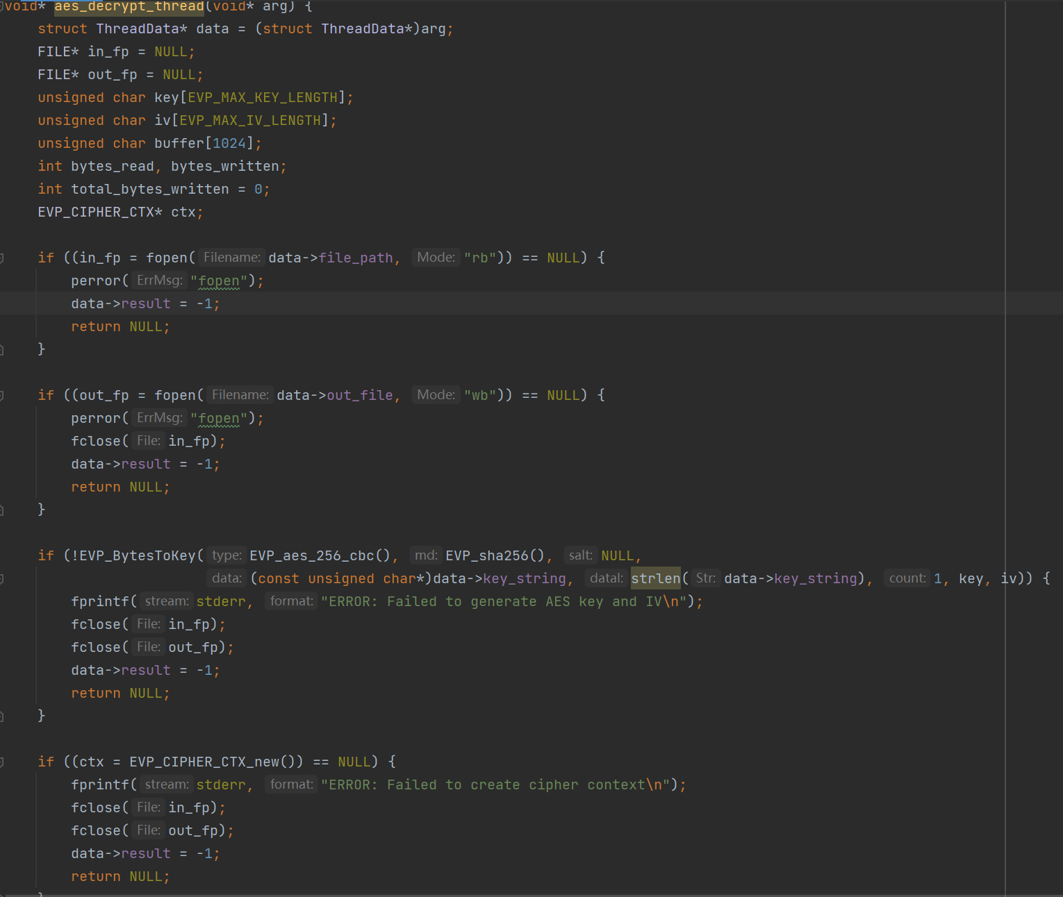
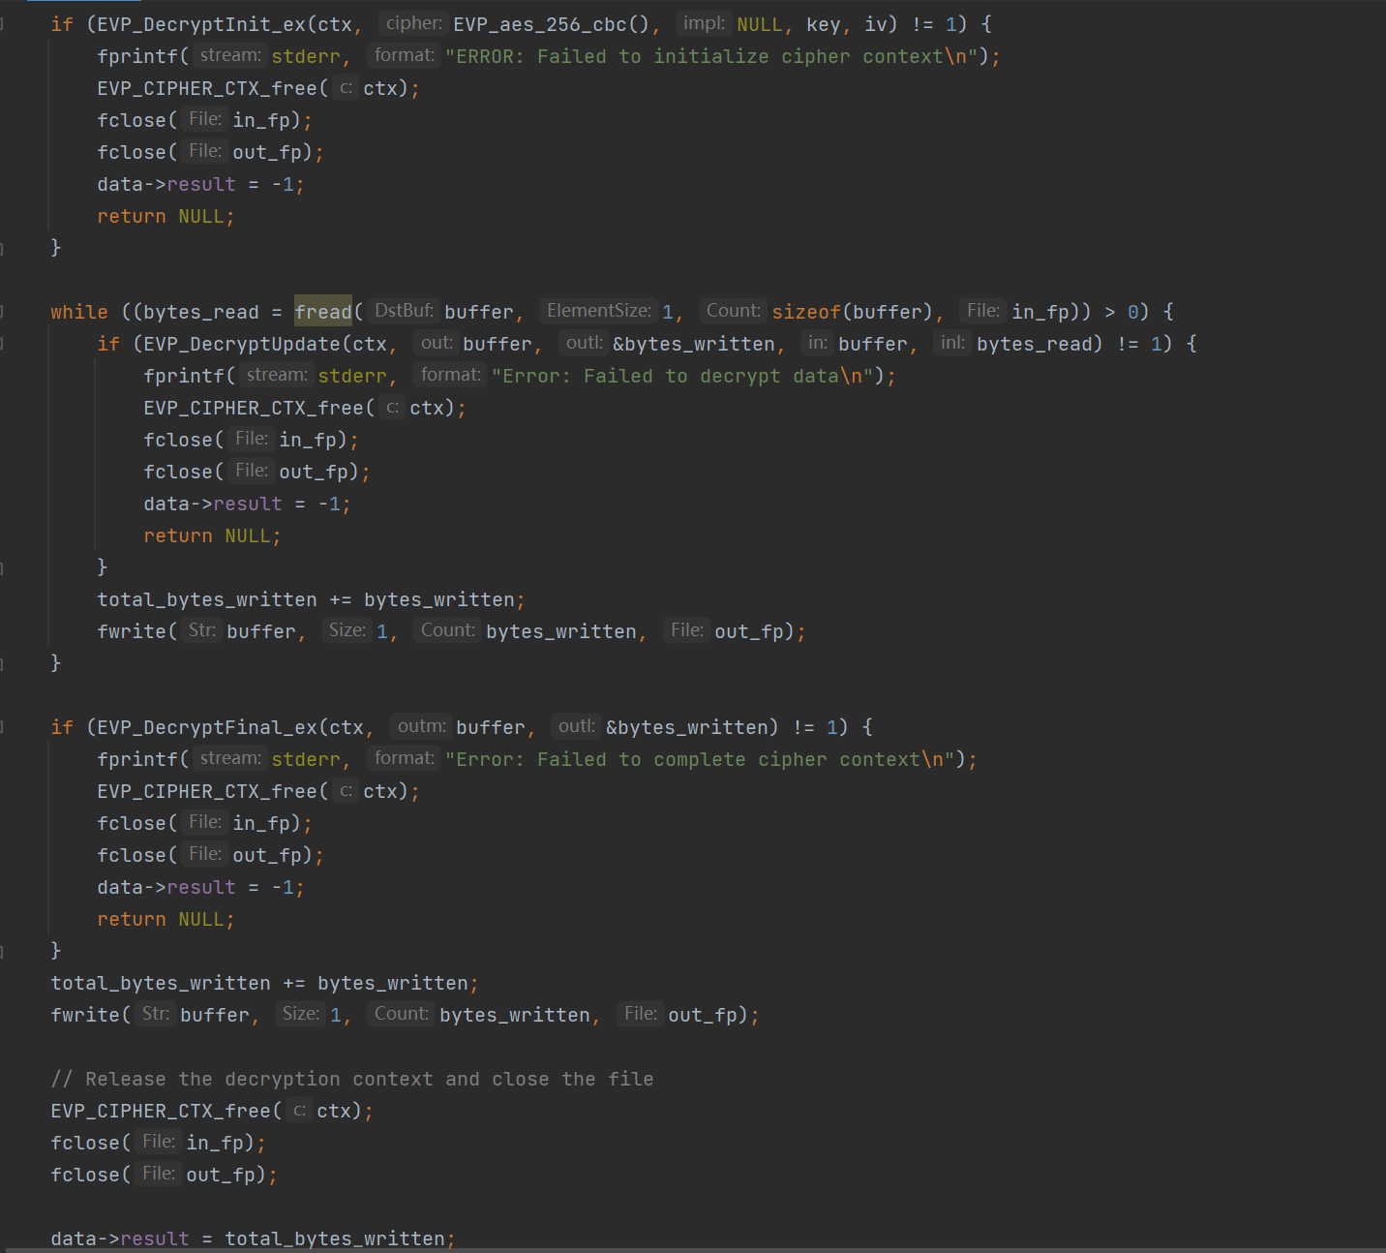
Figure 4. Code for aes_decrypt_thread function
For the decryption function aes_decrypt_file, first initialize the thread data, then call pthread_create to create a new thread to execute the aes_decrypt_thread function. Finally, pthread_join is called to wait for the thread to finish execution and return the result of the decryption operation.
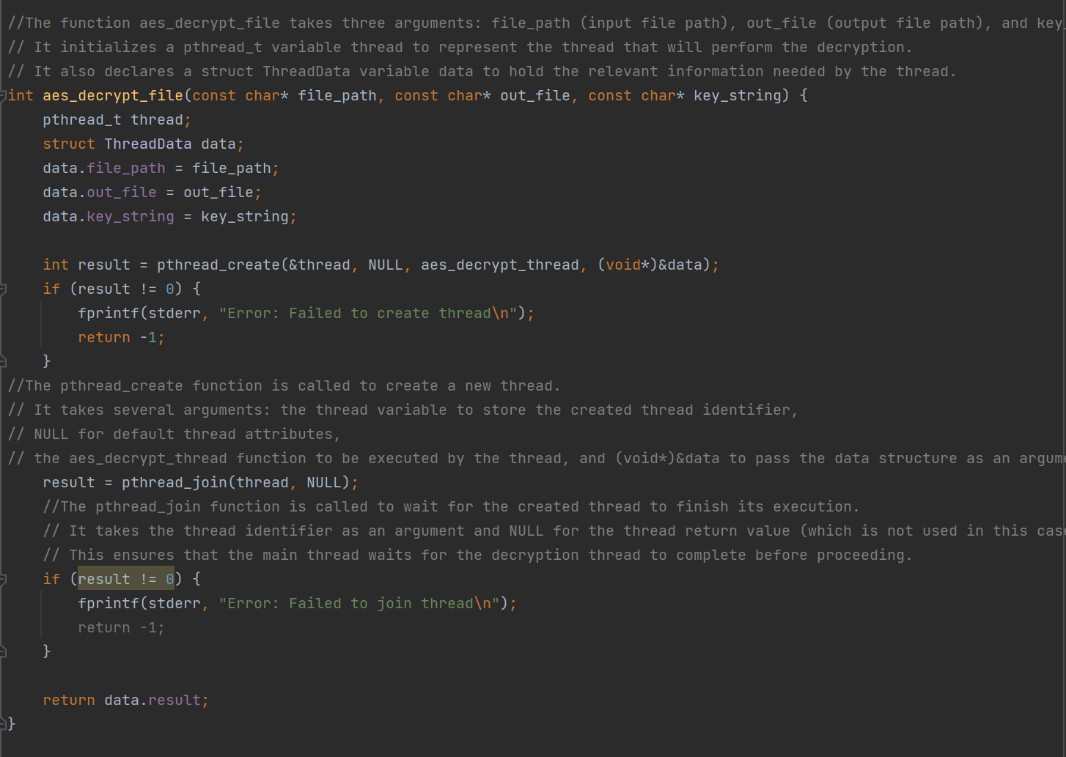
Figure 5. aes_decrypt_file function

Algorithm selection
In order to provide flexibility so that users can choose the appropriate algorithms and operations according to their needs, so as to meet different security needs and use scenarios, for the file encryption system to increase the algorithm selection function, the specific operation is shown in Figure 6.
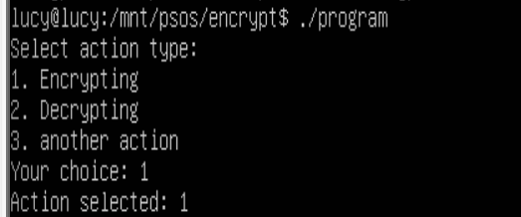
Figure 6. Operation for algorithm selection
The specific code is as follows: we can see perform_encryption and select_encryption_algorithm functions, to allow the user to first select the type of operation. If the user selects an encryption or decryption operation, the user is asked to select the type of encryption and decryption algorithms required, and then go on to select different specific algorithms based on these encryption types. The specific code is shown in Figure 7.
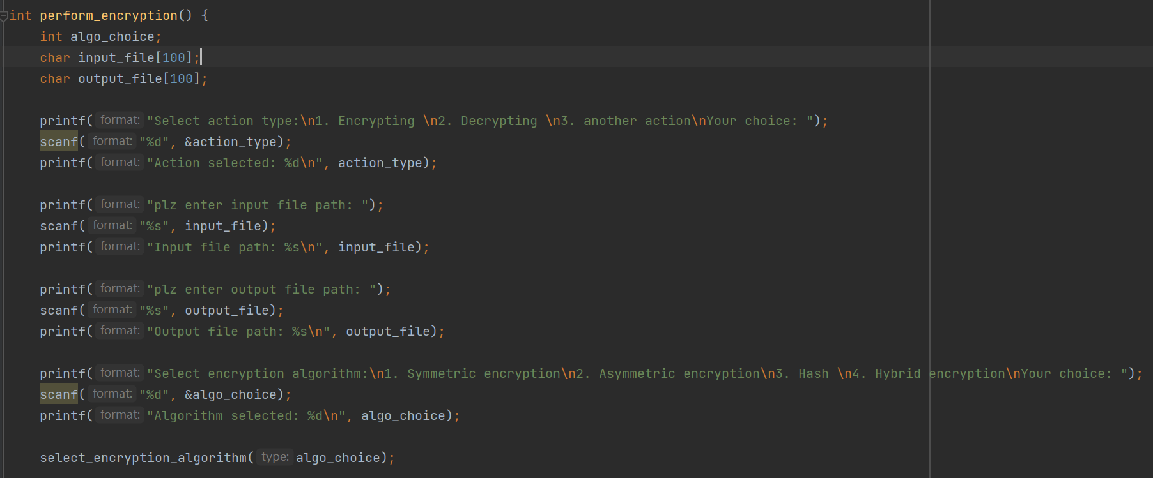
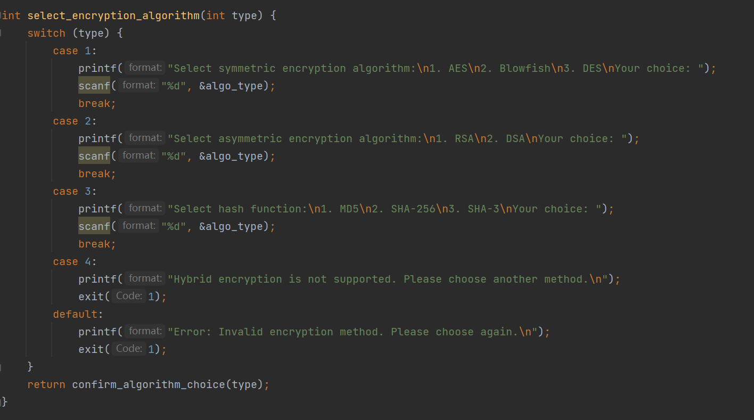
Figure 7. perform_encryption and select_encryption_algorithm

Multithreading
Multithreading solves the producer-consumer problem by using mutex locks and conditional variables. The producer thread produces 1000 items by looping through the buffer; when the buffer is full, the producer waits; when there is free space in the buffer, the producer puts the items into the buffer and increments the count, and then notifies the consumer that a new item is available for consumption. The code is shown in Figure 8.
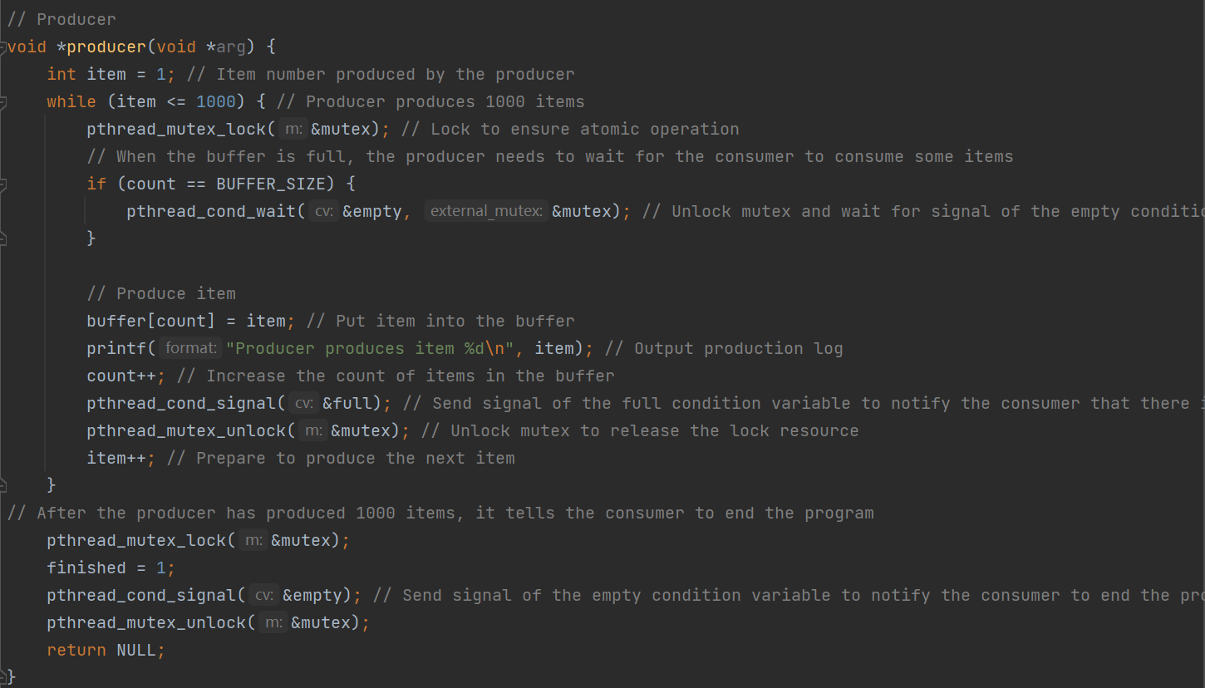
Figure 8. Producer thread
The consumer thread keeps consuming items in the buffer, waiting when the buffer is empty and consuming and decreasing the count when a new item is available. The program ends when the consumer consumes the 1000th item. With this design, the producer and consumer can coordinate properly to ensure that the buffer does not overflow or get read empty. This is shown in Figure 9.
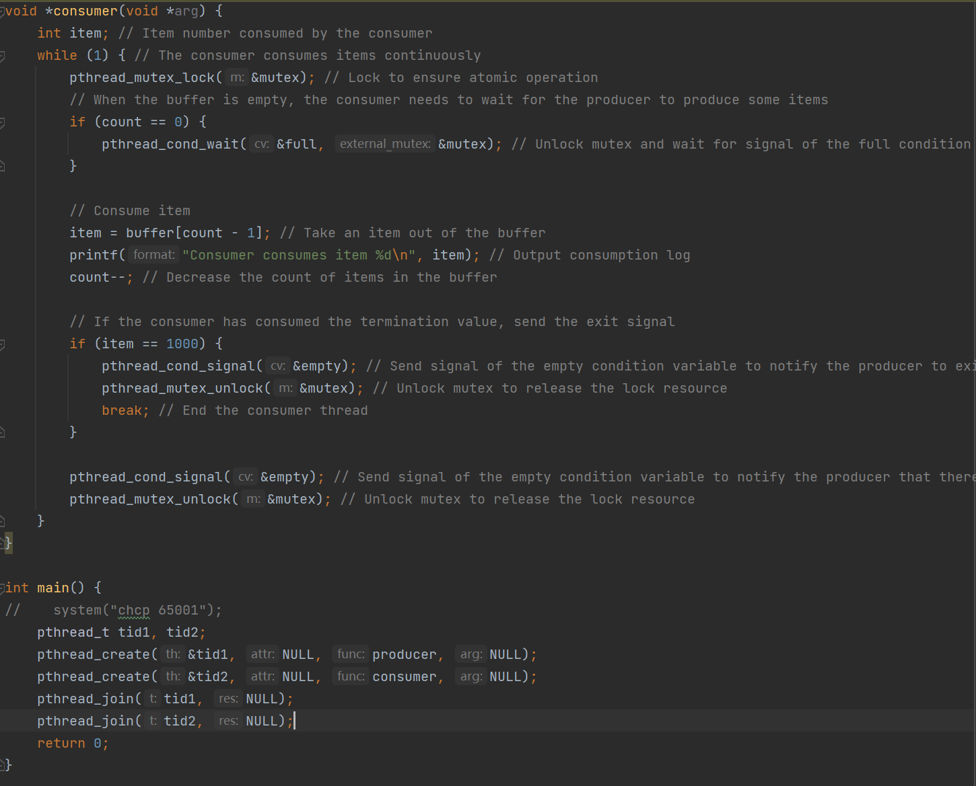
Figure 9. Consumer thread

Testing Plan
Basic Function Test
Test Item | Expect Results | Actual Result
Encrypt the example.txt file, the content of example.txt is "Hello, Lucy".  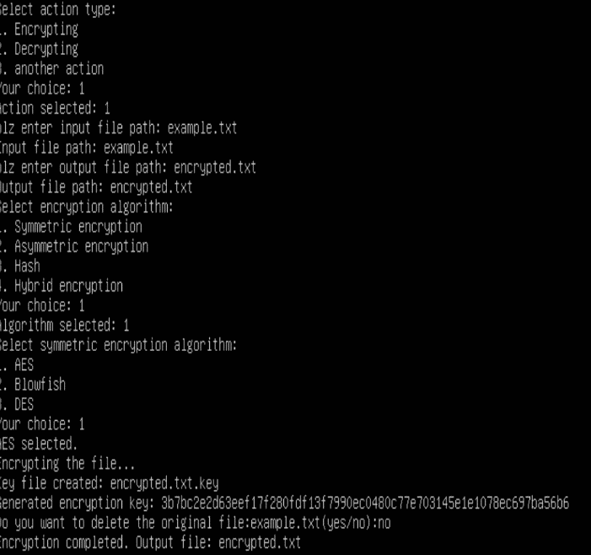 | Encrypts the file as gibberish and generates a corresponding key file containing a 32-byte random key string |   
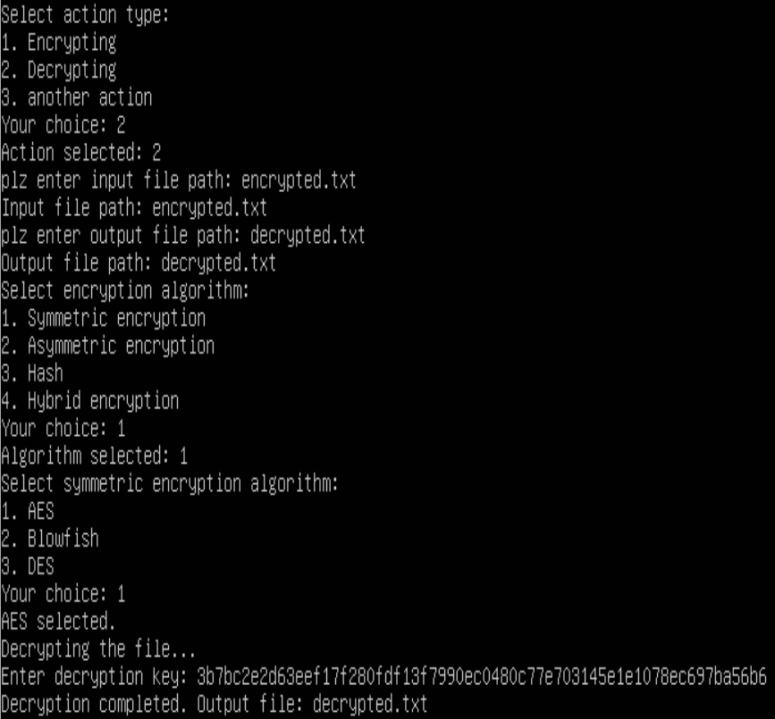  Decrypt the encrypted.txt file obtained during encryption and use the corresponding generated key. | The contents of the decrypted file are the same as the initial example.txt, both are "Hello, Lucy". |   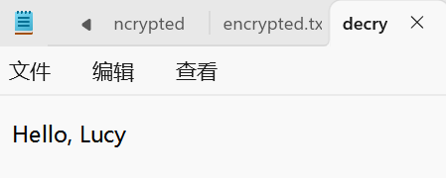

Safety Test
Test Item | Expect Results | Actual Result
Random key generation, which generates a key by performing multiple encryption operations on the same original file. | Each time the key is generated it is different and unpredictable. | 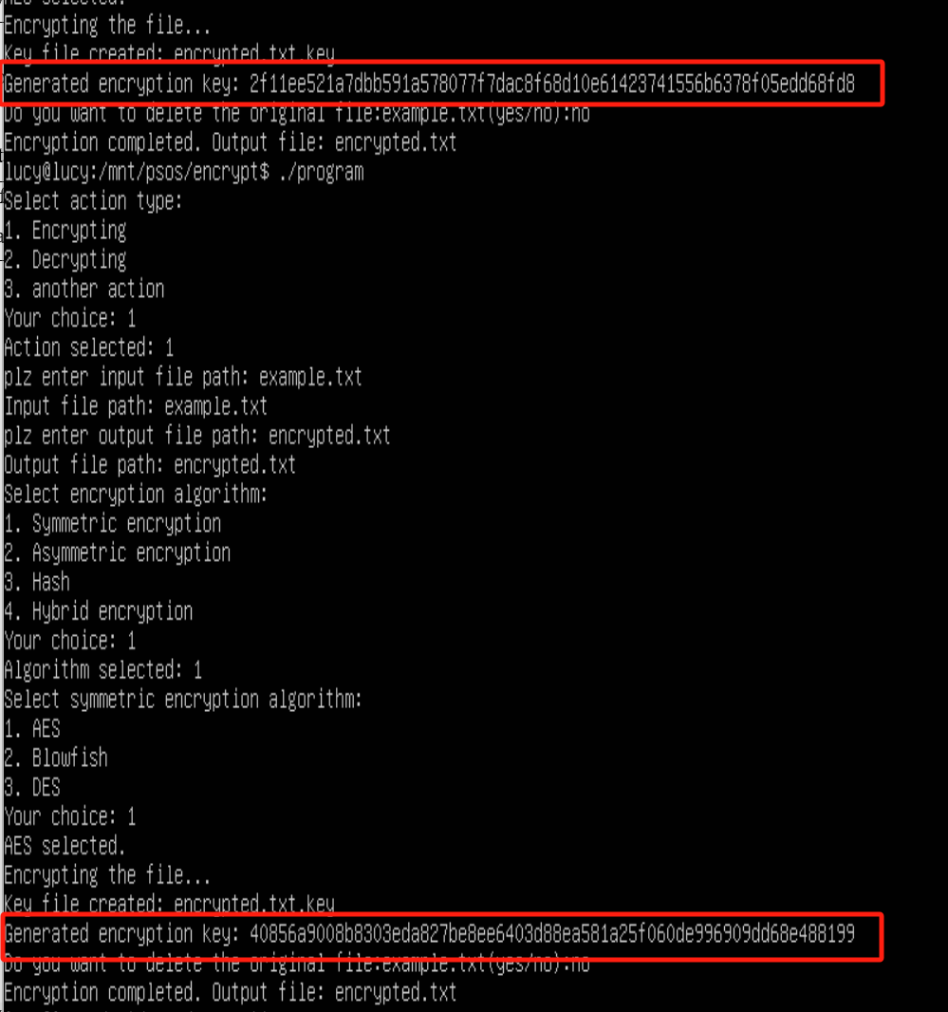
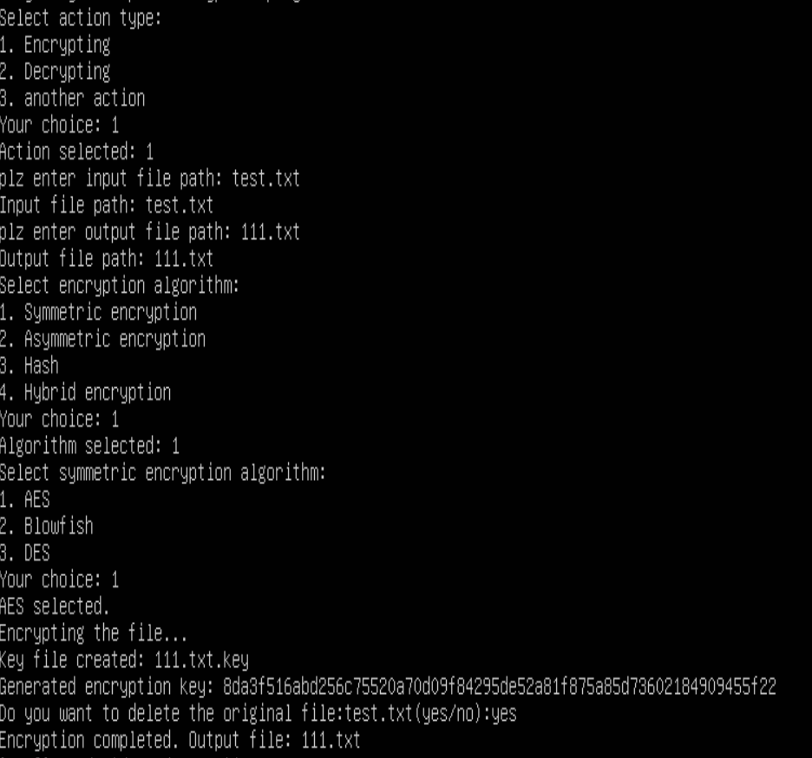  See if the original file: test.txt can be deleted normally after encryption. | The original file is successfully deleted | 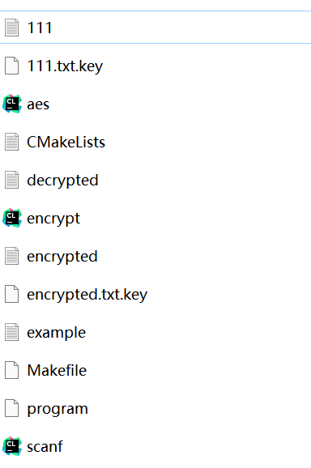

Multithreading Test
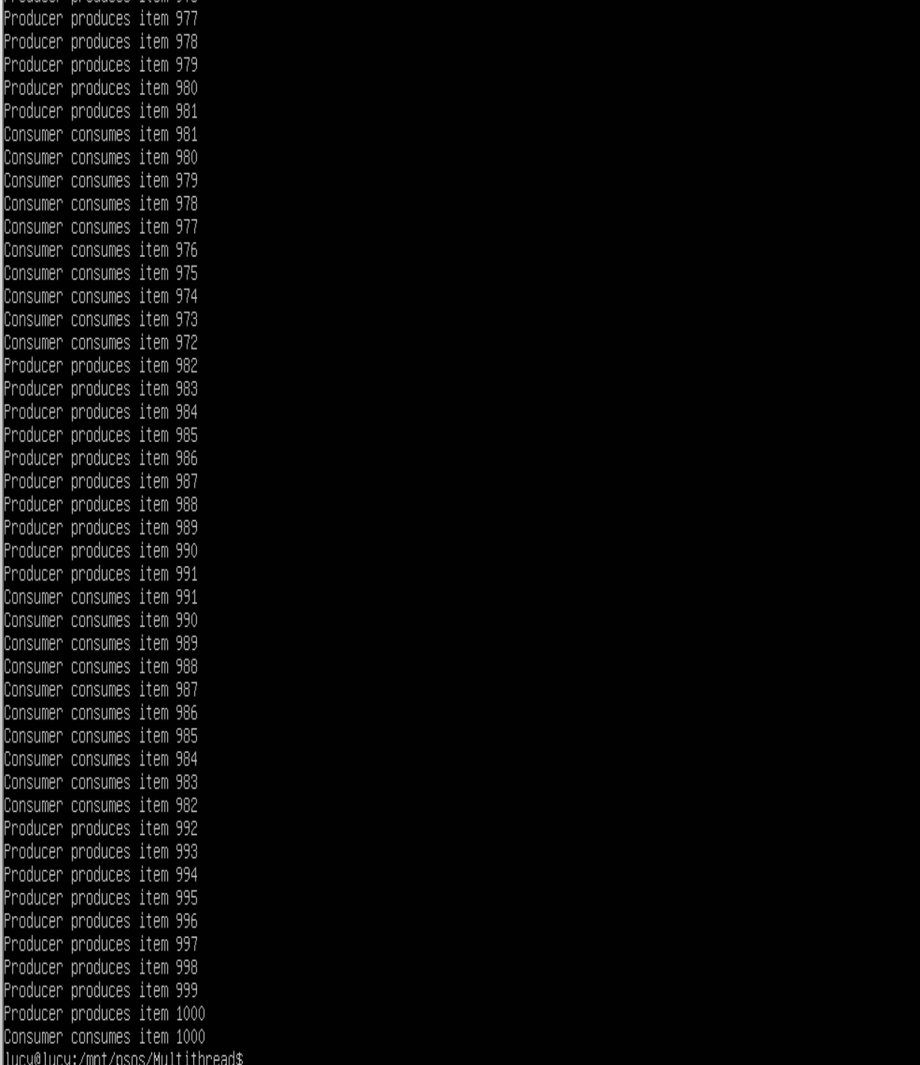

Integrating
Here, I will integrate the files into the Linux environment. Before integration, the environment needs to be installed. such as gcc, cmake, and GUN make. as shown in Figure 10.
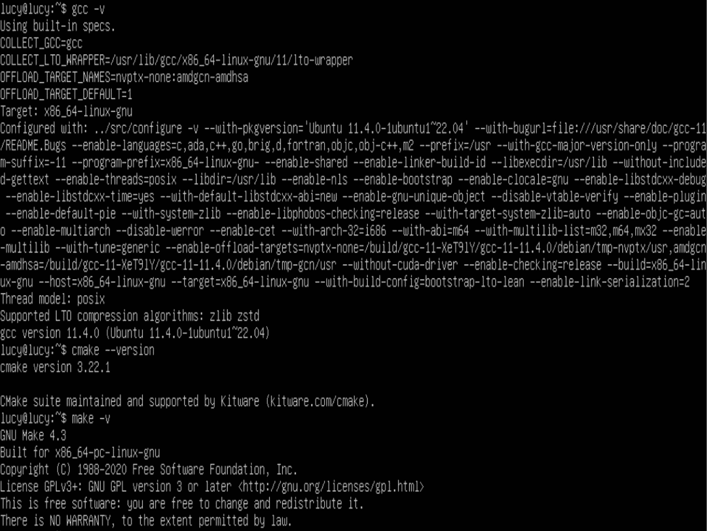
Figure 10. Environment

After the environment is set up, use the sudo cp /mnt/psos/encrypt/encrypt.h /usr/include/ command to place the encrypt.h header file in the /usr/include directory of linux, as shown in Figure 11.
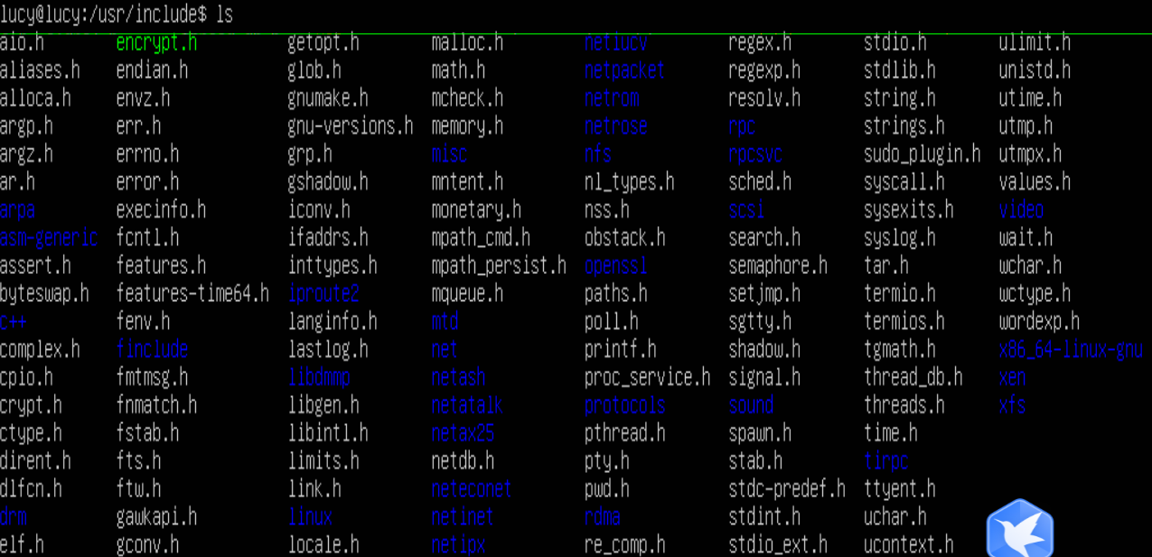
Figure 11. Place encrypt.h

At the very beginning, I mounted the required files in a Linux environment and then used gcc to run the aes.c and scanf.c files to get the program executable. As illustrated in Figure 12.
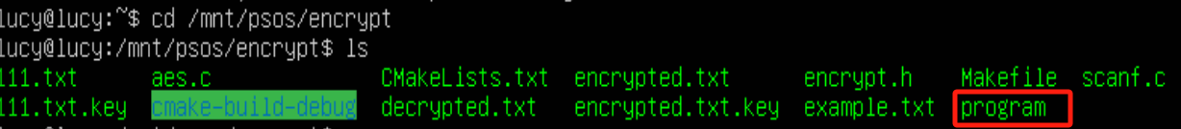
Figure 12. Get program executable file

Then place this executable in the /usr/bin directory, as shown in Figure 13.
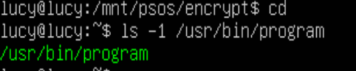
Figure 13. Check the program file
Then you do not need to mount the shared file, directly enter program, you can see that the run successfully
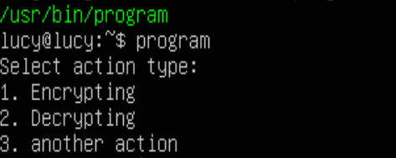

Integration Testing
After integration, run program directly. test the file encryption and file decryption functions. In file decryption, as shown in Figure 14, enter the document under the /mnt/psos/encrypt directory, and it shows that the encryption is successful.
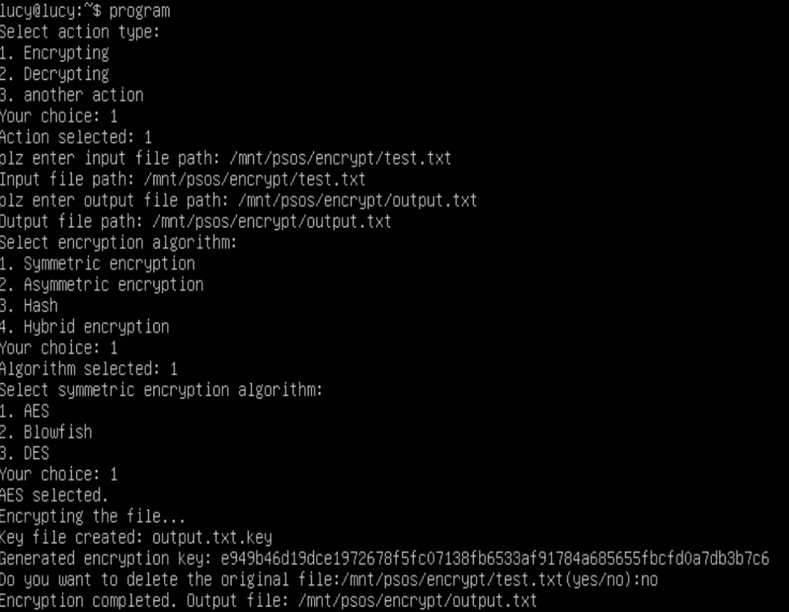
Figure 14. Encryption
Then get the key file, which can be seen in the linux user home directory.
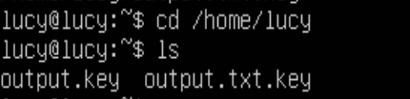
Finally, the decryption operation is performed, similar to encryption, by entering the key string and then displaying the decryption success.

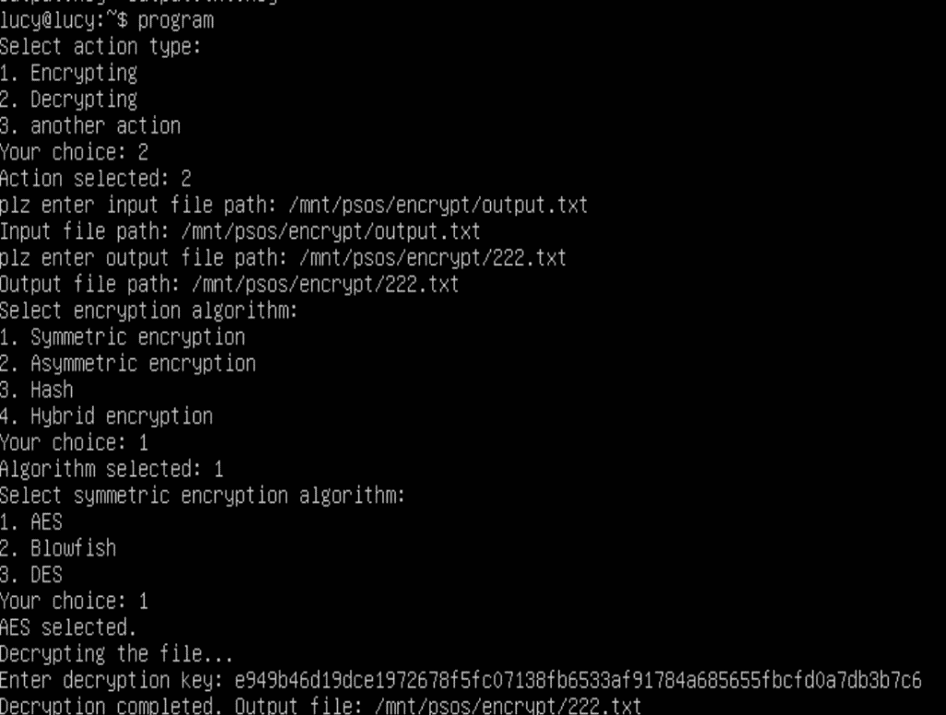
Figure 15. Decryption
Get the contents of the original file


Possible Limitations, Failures
In the initial stage, I tried to find code on file encryption and decryption in Minix environment, but due to scarce resources and not working correctly, I moved to using Linux system for development. So, I used AES-256 encryption algorithm and generated AES key and initialization vector (IV) from a given key string in a simple way. However, this method may be vulnerable to brute force decryption or dictionary attacks. Although the software provides a choice of algorithms, in practice only AES operations are implemented, which does not satisfy the needs of users using other algorithms. Regarding multithreading, although the relevant code is available, I do not have a good understanding of the concept of multithreading and have not been able to implement multithreaded processing for encryption and decryption.

Conclusion
The main objective of this paper is to develop a file encryption and decryption system based on AES algorithm on Linux operating system environment, which is implemented by C language and OpenSSL library to provide basic file encryption functions. Through the command line interface, users can select files, encryption algorithms, and perform encryption or decryption operations. The software is stable in basic functions and can meet the basic file encryption needs.

However, it still needs to be improved in some aspects at present. In the future, I will introduce modern cryptographic functions such as PBKDF2 or Argon2 to enhance security. And add support for its encryption algorithms, such as Blowfish, RSA, etc., so that users have more choices.

Reflections
This file encryption project allowed me to learn how to run Linux commands on a virtual machine and master how to integrate C code into the Linux operating system. In addition, by delving into the AES encryption algorithm, I gained a deeper understanding of encryption. Meanwhile, by introducing multi-threading technology, I realized that multi-threading can significantly improve performance compared to single-threading and gave me a better understanding of the working mechanism of multi-threading.

References
[1] Alenezi, M.N., Alabdulrazzaq, H., Alhatlani, H.M., Alobaid, F.A., 2024. On the performance of AES algorithm variants. IJICS 23, 322–337. https://doi.org/10.1504/IJICS.2024.138494

[2] Abhishek Sai, A.M., Reddy, D., Raghavendra, P., Kiran, G.Y., R, R.V., 2022. Producer-Consumer problem using Thread pool, in: 2022 3rd International Conference for Emerging Technology (INCET). Presented at the 2022 3rd International Conference for Emerging Technology (INCET), IEEE, Belgaum, India, pp. 1–5. https://doi.org/10.1109/INCET54531.2022.9824031

[3] Zhang, L., Liu, B., Zhang, X., Yuan, H., Yang, J., Huang, H., 2023. Dual IV Design Scheme: An Improved AES Encryption Approach: in: Proceedings of the 2nd International Seminar on Artificial Intelligence, Networking and Information Technology. Presented at the The International Seminar on Artificial Intelligence, Networking and Information Technology, SCITEPRESS - Science and Technology Publications, Chiang Mai, Thailand, pp. 310–314. https://doi.org/10.5220/0012282400003807

[4] Zhang, Z., Tang, J., Zhang, F., Huang, T., Lu, M., 2024. Medical image encryption based on Josephus scrambling and dynamic cross-diffusion for patient privacy security. IEEE Trans. Circuits Syst. Video Technol. 1–1. https://doi.org/10.1109/TCSVT.2024.3394951

[5] Ehis, A.T., 2023. Analysis of Multi-Threading and Cache Memory Latency Masking on Processor Performance Using Thread Synchronization Technique. Braz. J. of Sci. 3, 159–174. https://doi.org/10.14295/bjs.v3i1.458

