ARPing Project Report
Project No.2
Version 1.0
Student ID: 201920081203009 Student Name: Yang Rui
2019-9-30
College of Computer Science and Cybersecurity, CUC

I declare that the assignment here submitted is original except for source material explicitly acknowledged. I also acknowledge that I am aware of University policy and regulations on honesty in academic work, and of the disciplinary guidelines and procedures applicable to breaches of such policy and regulations.

Name: Yang Rui Student ID: 201920081203009
Notes:

Section I Problem Specification
The problem of mapping Internet addresses to physical addresses is known as the address resolution problem.
The purpose of this project is to develop a software tool “arping” that is used to discover hosts on a local area network. The program tests whether a given IP address is in use on the local network, and can get additional information (like MAC address) about the device using that address.
The arping tool is analogous in function to ping, which probes hosts using the ICMP at the Internet Layer. Arping operates at the Link Layer using the ARP for probing hosts on the local network only, as ARP cannot be routed across gateways (routers).
One computer broadcasts an ARP request to all stations on the network. Another computer responds with an ARP Reply which contains the hardware address.

This is Ethernet Frame Format (ARP Packet):
Destination address | Source address | Type 0x0806 | ARP Request or ARP Reply | Padding | CRC
6B | 6B | 2B | 28B | 18B | 4B

ARP Format:

Hardware type | Protocol type | Hardware address | Protocol address length | Operation code | Source hardware address | Source protocol address | Target hardware address | Target protocol address
2B | 2B | 1B | 1B | 2B | 6B | 4B | 6B | 4B

Section II Solution Method and Design

At first, we need install WinPcap. Download it and link it with VS 2019.
- Property Pages -> C/C++ -> General -> Additional Include Directories -> Add `..\WpdPack\Include`
- Property Pages -> Linker -> General -> Additional Library Directories -> Add `..\WpdPack\Lib`
- Property Pages -> Linker -> Input -> Additional Dependencies -> Add `wpcap.lib`&`ws2_32.lib`&`Iphlpapi.lib`

This is the project structure:

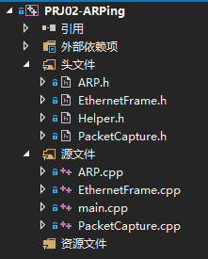
Class Helper (Common Method and Lib):
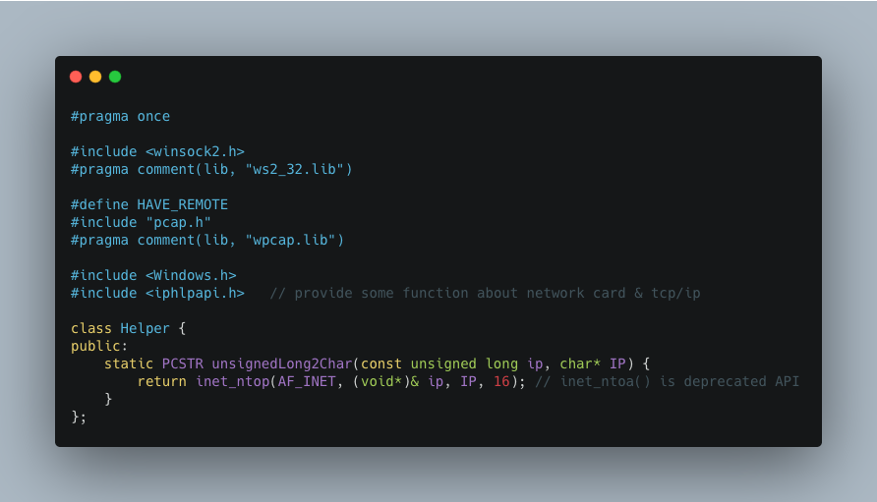

Class ARP:
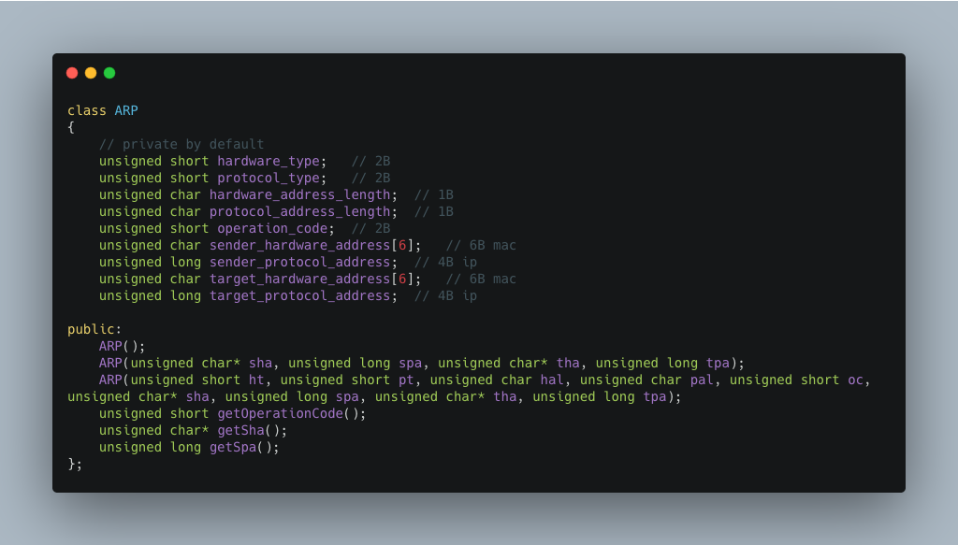

Class EthernetFrame:
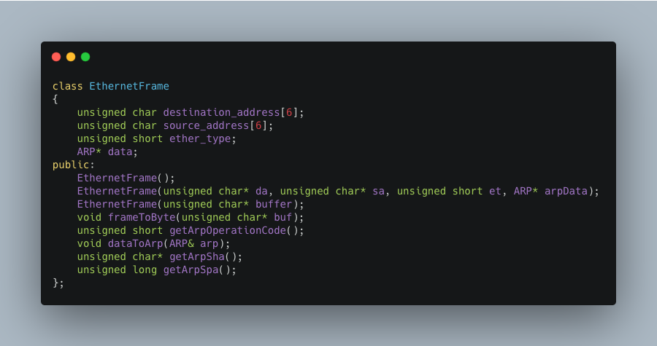

The main flow of arping
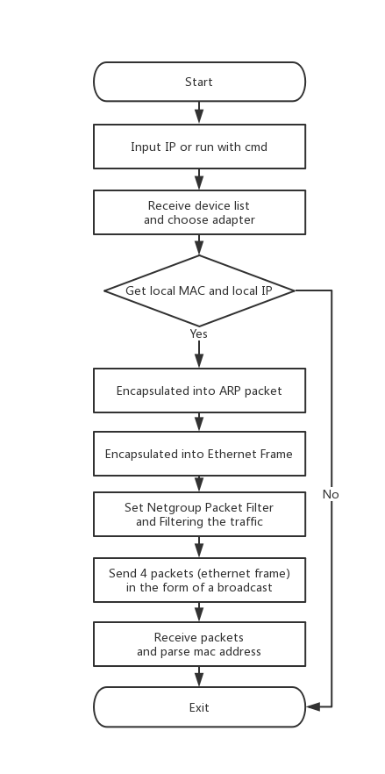

Section III Test Cases and Results Analysis
Test case is run in my Lab LAN. So I input `PRJ02-ARPing 10.64.132.30`. (Debug in x86)
We can run it with CMD:
(For better demonstration and experimentation, I show the adapter information.I wrote the code for automatic selection.)
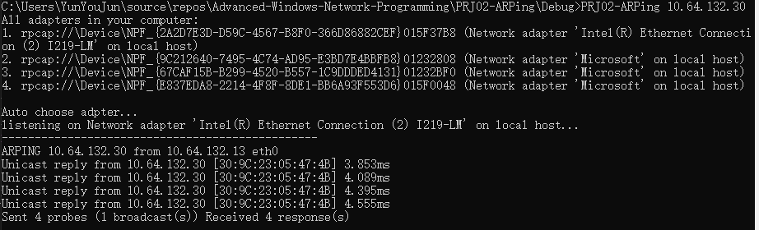

Or just run it and then input IP in it:
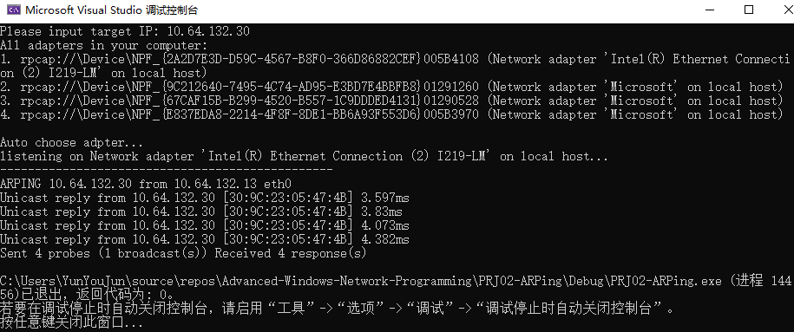

Section IV Conclusion
Through this experiment, I have more deeper understanding of the ARP structure and protocol. I learned how it worked and referred to some of the code on the web to implement it. At the same time, I learned how to use Winpcap with Visual Studio. I made extensive use of classes and improved the reusability of the program code.
However, I'm not familiar with the use of Winpcap and c++, the implementation took me a lot of time. I think I also need to increase my proficiency.

Section V References
- WinPcap: Exported function https://www.winpcap.org/docs/docs_40_2/html/group__wpcapfunc.html
- C++获取网卡MAC地址 https://blog.csdn.net/linfengmove/article/details/47428131
- ARP详解 https://blog.csdn.net/lm409/article/details/80299823
- Unit 2 ARP.pdf http://tlc.cuc.edu.cn/Course/Course/showAction/id/30
- Unit 2 WinPcap.pdf http://tlc.cuc.edu.cn/Course/Course/showAction/id/30

ARP请求与接收解析C++源码 https://download.csdn.net/download/liaachen/8141289

Section VI Appendix
This is the basic flow that matches the flowchart.（The picture is too long, please see next page.）
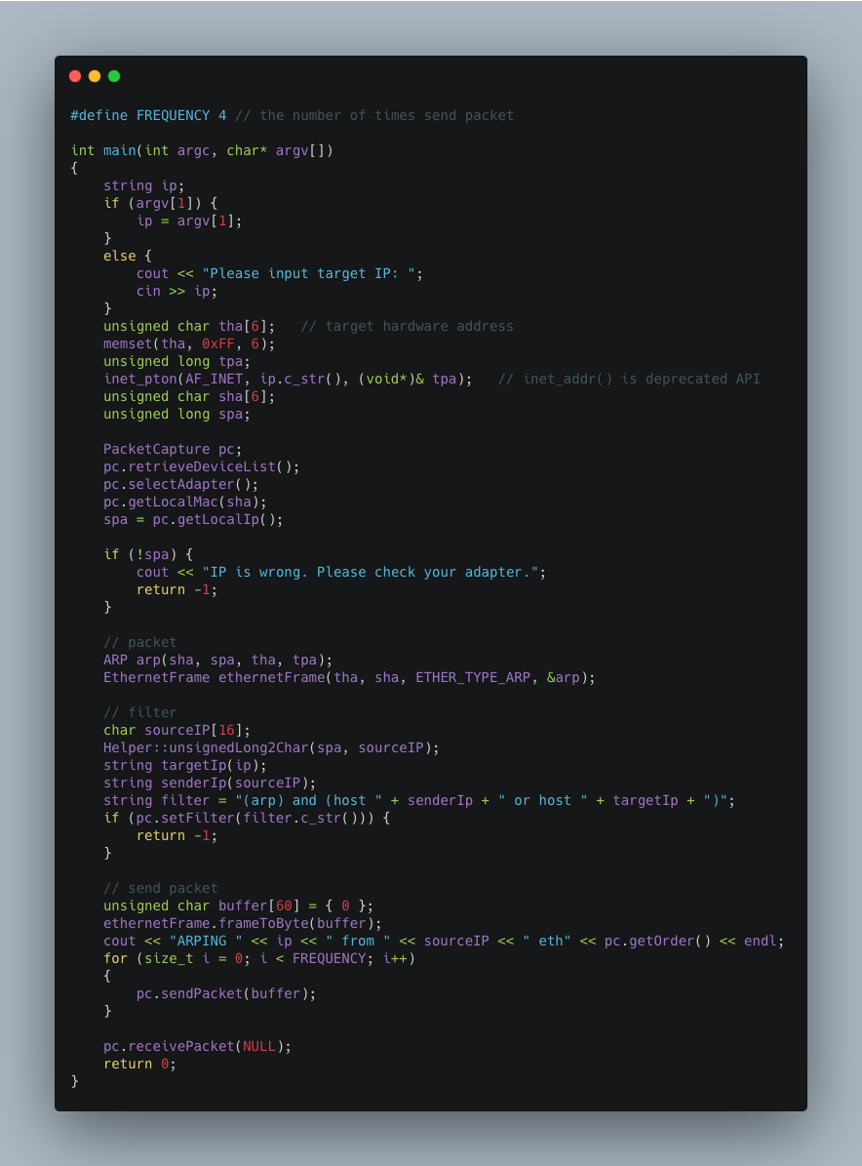
ARP and Ethernet Frame Classes are easy and not important.
Ethernet Frame structure can be seen in previous report.
So I'm not going to paste it here.

Next up is PacketCapture Class.
Free the device list in the destructor.
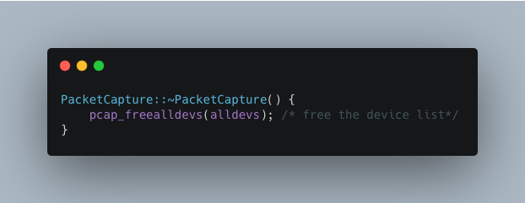

Receive device list and print it:

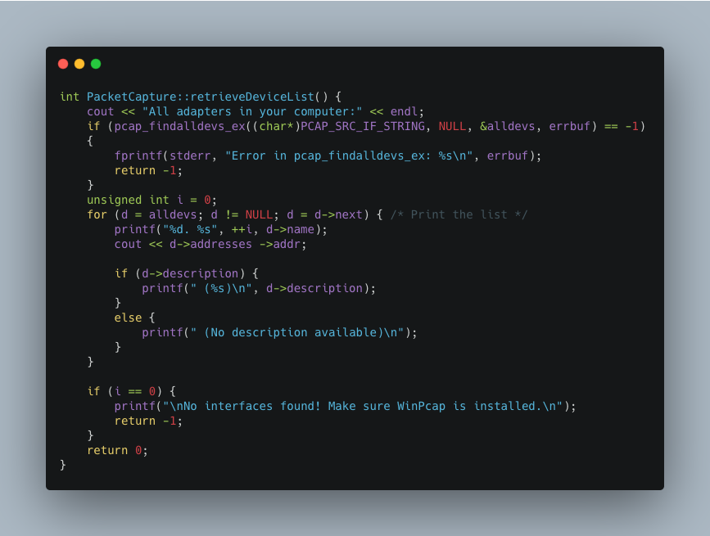

Automatic select adapter which has IP:

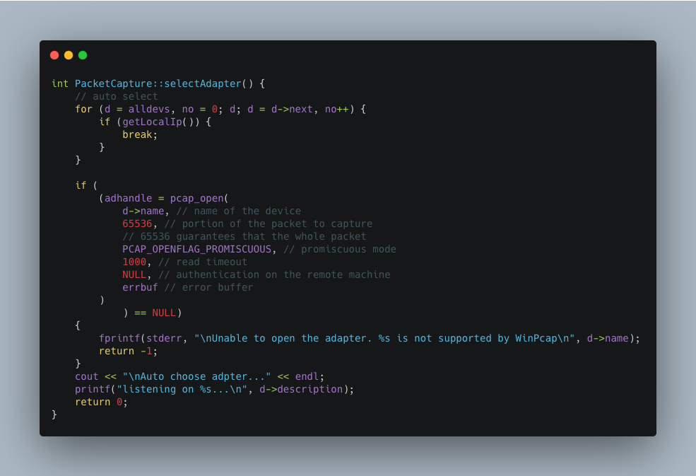

Get Local MAC:

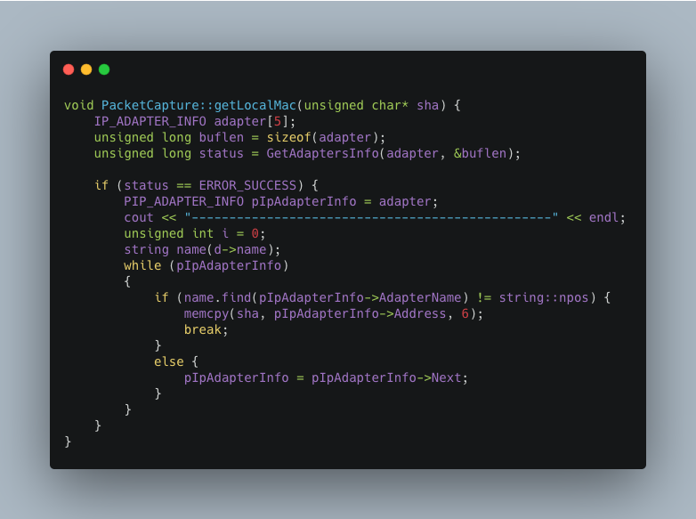

Get Local IP:
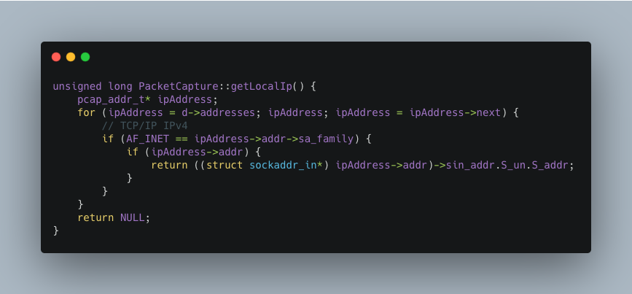

Flitering the traffic:

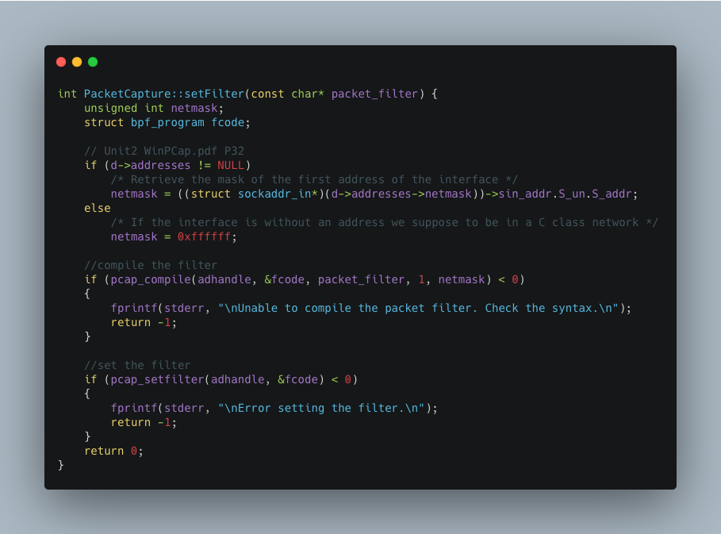

Send ARP packet in Ethernet Frame:

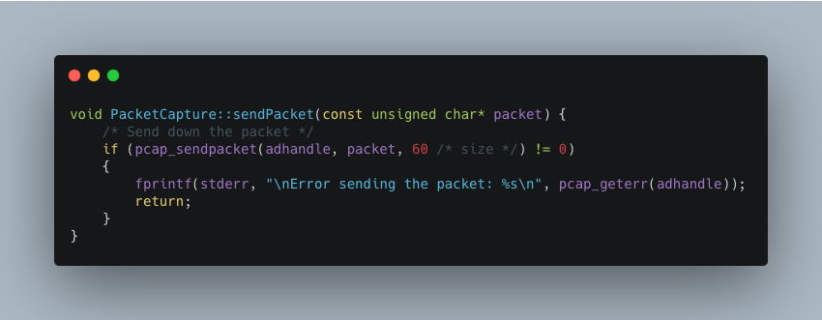

Receive packet which has reply code, print mac address and calculate time:

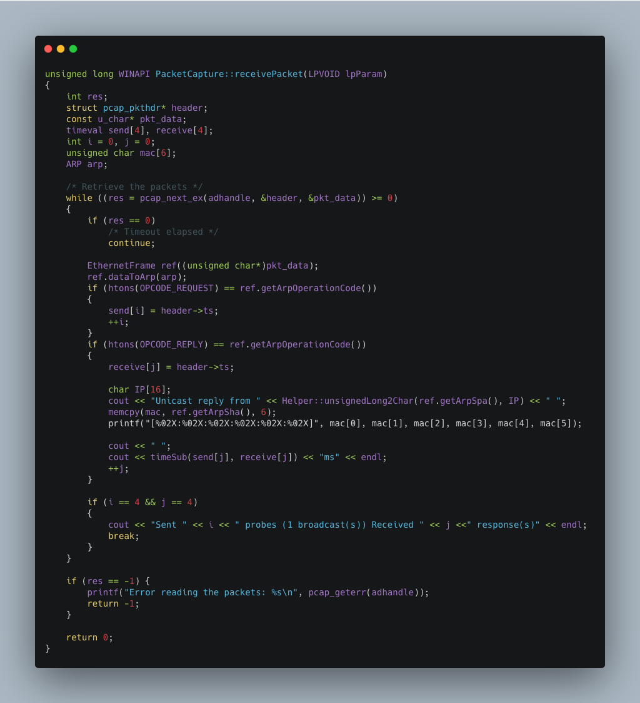

That's all the important parts, thanks.

