EchoCS Project Report
Project No.7
Version 1.0
Student ID: 201920081203009 Student Name: Yang Rui
2019-11-10
College of Computer Science and Cybersecurity, CUC

I declare that the assignment here submitted is original except for source material explicitly acknowledged. I also acknowledge that I am aware of University policy and regulations on honesty in academic work, and of the disciplinary guidelines and procedures applicable to breaches of such policy and regulations.

Name: Yang Rui Student ID: 201920081203009
Notes:

Section I Problem Specification
The purpose of this project is to develop two simple console mode programs: EchoServer and EchoClient, when the Echoclient sends a string message to the EchoServer, the EchoServer will bounce the message back to the EchoClient.
We develop the server and the client with blocking sockets - by default, a Winsock call blocks, meaning that it will not return until it has completed its task or has failed while trying.
The EchoServer should be listening on a given port 8888 and read everything they receive and send it back verbatim. And we can customize the port number.The clients send data to the server and check that the reply matches what was sent. The client programs can wait a bit before shutting the connection down, so that you Must run multiple clients to test multi-connection servers. The clients will actually work with any echo server: the Windows server derivatives and most Unixes have an optional service that sits on port 7 and works just like your EchoServer does. Because the echo service can be harnessed to attack a network, most system administrators leave that service disabled.
We can safely use "0.0.0.0" all the time as the listening server IP address: when we bind( ) to the "any" address, Winsock sends incoming connections from any network interface to our program.
We can set the connection backlog size to 1 with the listen( ) call to try Winsock's connection backlog mechanism by running two copies of basic-client against this server with the "shutdown delay" set to some largish value. Then try running three copies of basic-client.

About backlog:
The server will only handle a single connection at a time, but the connection backlog is set to 1. Multiple clients can have connections pending at one time. The first client that connects is accepted, and the server will echo its packets back until it closes the connection. Meanwhile, one other client can connect, because we set the connection backlog size to 1 with the listen( ) call. That additional client will then send data which the stack will queue up, but it won't see a reply until the first client disconnects so that the server can accept( ) this subsequent connection. And the third client connection request will fail during the same period.

WinSock:
The Windows Sockets (abbreviated "Winsock" or "WinSock") specification defines a network programming interface for Microsoft Windows which is based on the "socket" paradigm popularized in BSD Unix.
It encompasses both familiar Berkeley socket style routines and a set of Windows-specific extensions.

And more important info about windows socket in PDF Windows Socket Get Started. P48, P55, P56, P57, P59, P61, P63, P65, etc.

Problem:
Because thread is not allowed with current project, I don’t know how to server many clients. (Except for queue)

Section II Solution Method and Design

Development Environment:
- OS: Microsoft Windows 10
- Language: C++
- Tool: Microsoft Visual Studio 2017

This is the project structure(use Object Oriented Programming with C++):

Some files are automatically generated:

- pch.cpp: source file corresponding to the precompiled header; required for successful compilation
- pch.h: header file corresponding to the cpp

I added two console applications EchoClient and EchoServer to the solution called EchoCS. So I can manage them in a solution.

This is the sequence diagram:

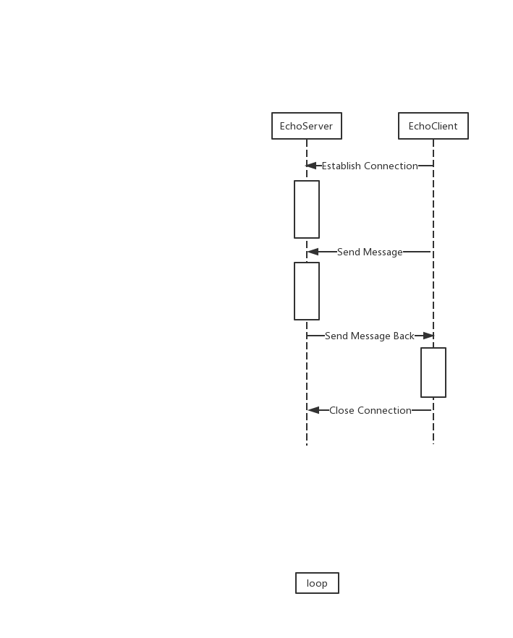

This is flow chart in EchoServer & EchoClient:

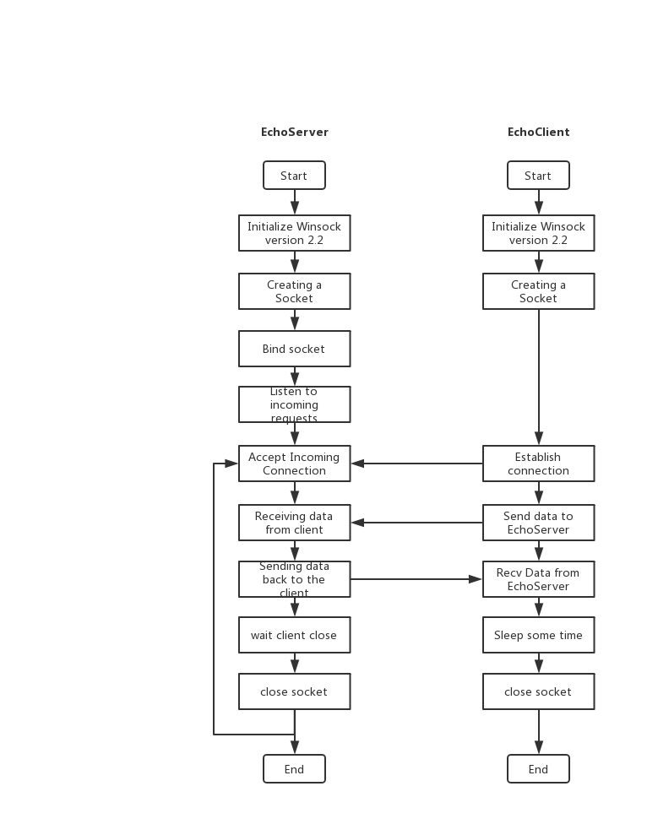

Section III Test Cases and Results Analysis

This is my test result:

- Input ‘EchoServer.exe 8888’ to open server in CMD. (Listen on 8888, other customized port is ok. I use 8888 as default port, so just input EchoServer.exe can work too.)
- Then input ‘EchoClient.exe 10.64.132.147 8888’ to open client in CMD. (Send to ip which is the server in, and we can customize message by third param. Like this: ‘EchoClient.exe 10.64.132.147 8888 nihao’.)
- Next is test result when backlog is 1. (So the first client worked, and the second client was in queue. When the first client closed connection, the second client continued to establish connection. But the third client failed to establish a connection.)
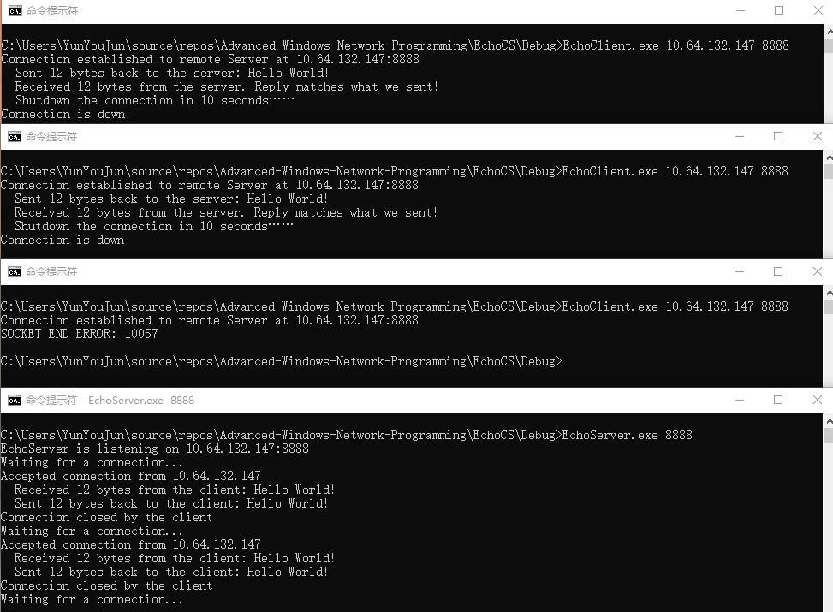

- Change backlog to 3.(The fourth client was in queue, but the fifth client failed to establish a connectionl.)
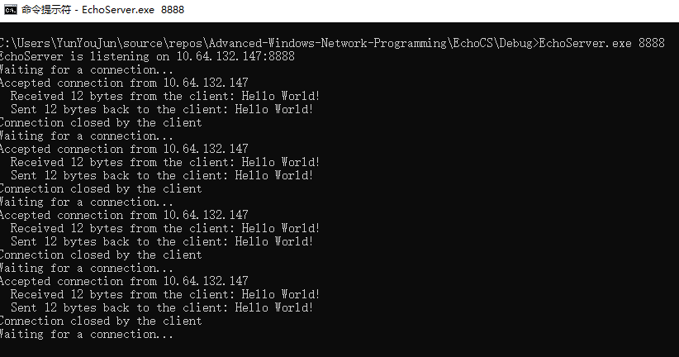
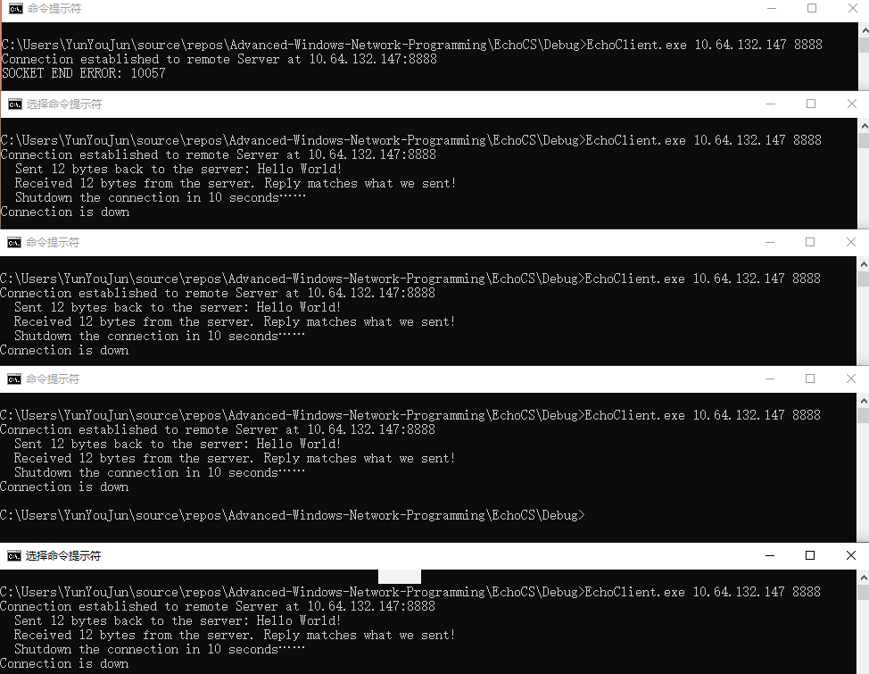

Section IV Conclusion
Through this experiment, I have a preliminary understanding of socket programming. The amount of code for socket programming is less and easier than the previous underlying protocol. But there are also many places that need to be carefully and meticulously. I think I prefer to use high-level language to quickly implement the features I want, which will be very rewarding.
Since this experiment does not allow multi-threading, I also recognize the importance of the queue. This project can also be written by an object-oriented approach, but due to time issues and the project is small, it is more convenient to use a process-oriented approach.

Section V References
- Windows Socket Get Started.pdf http://tlc.cuc.edu.cn/Course/Course/showAction/id/30
- Windows Sockets 2 | MSDN https://docs.microsoft.com/zh-cn/windows/win32/api/_winsock/

Section VI Appendix

This is the EchoServer file matches the flowchart.

Include socket header file:
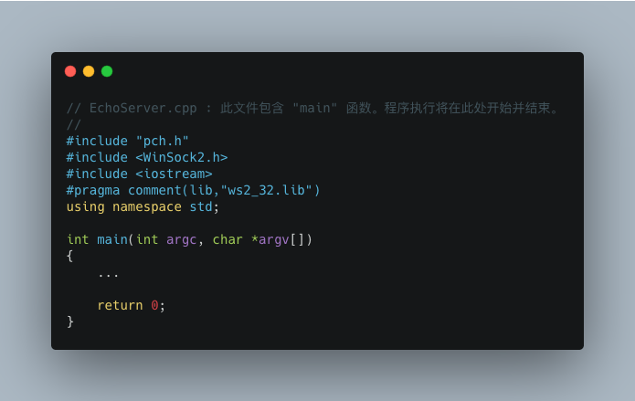

Use 8888 as default port to increase robustness.
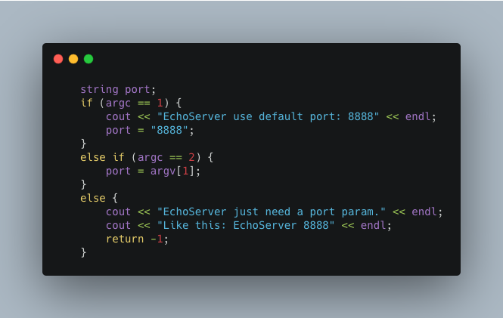

Initialize Winsock2, create a socket and bind socket to listen socket.

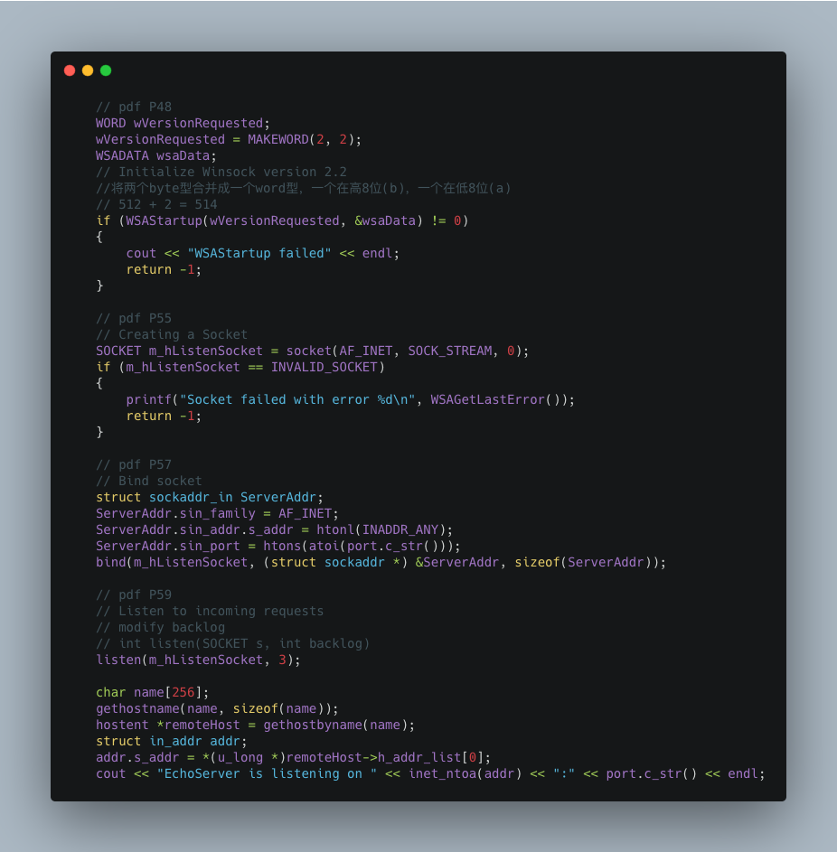

Receive data from EchoClient and send same data back to EchoClient. Then wait EchoClient to close connection.
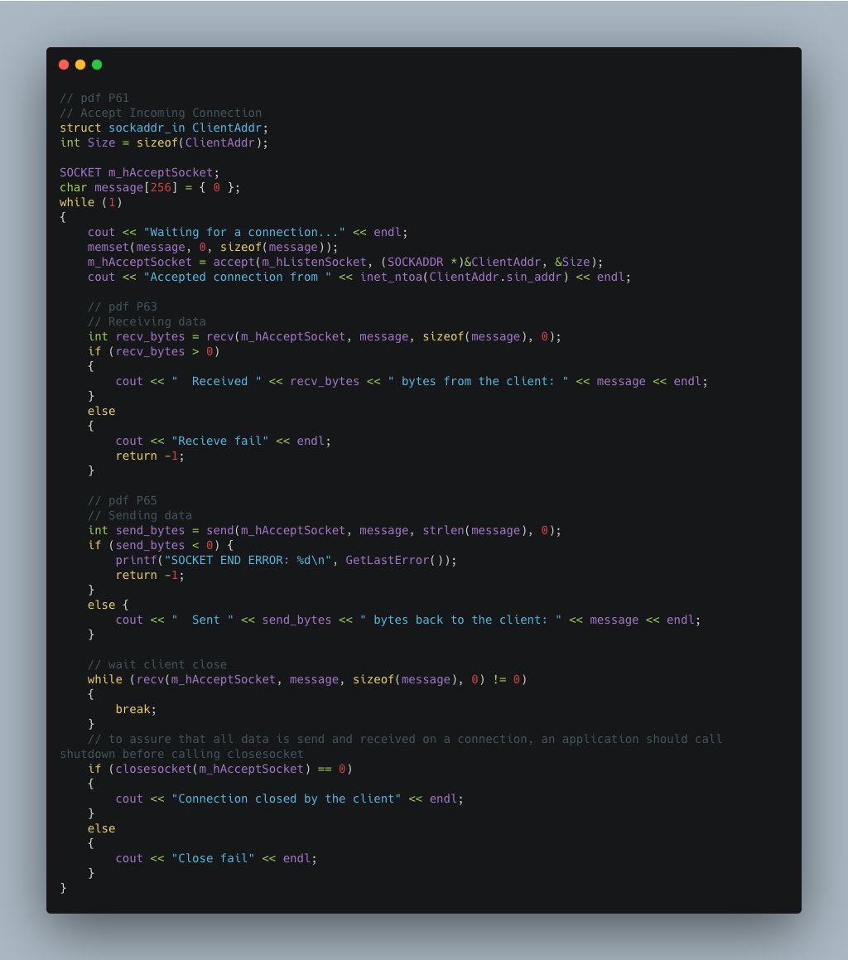

Error Cheking and Handling.
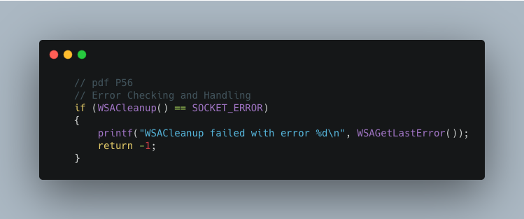

This is the EchoClient file matches the flowchart.(Many content is similiar to EchoServer, so I will not paste them.)

Set default params and input prompt to increase robustness.

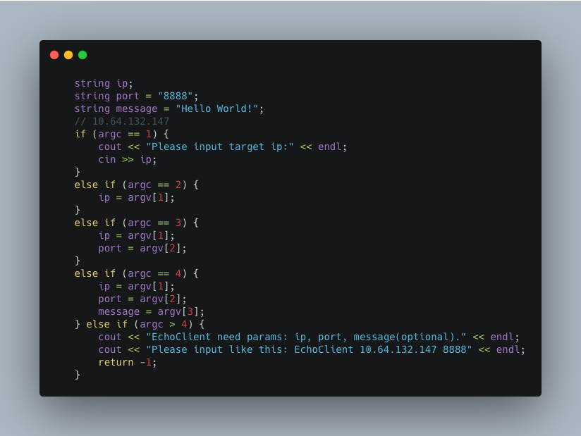

Establish Connection then send data to EchoServer, receive data from EchoServer.
Judge if they are same, then close socket.
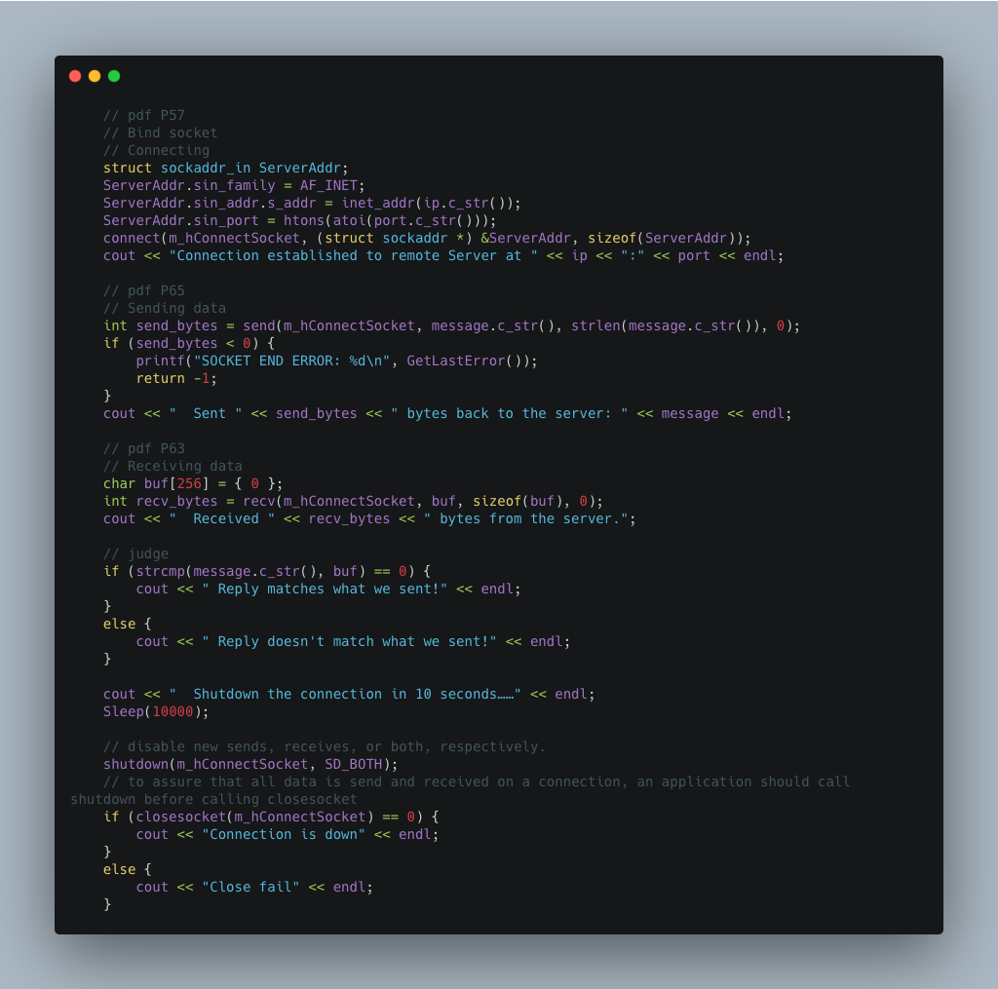
That's all the important parts, thank you for reading my report.

