IPMonitor Project Report
Project No.4
Version 1.0
Student ID: 201920081203009 Student Name: Yang Rui
2019-10-20
College of Computer Science and Cybersecurity, CUC

I declare that the assignment here submitted is original except for source material explicitly acknowledged. I also acknowledge that I am aware of University policy and regulations on honesty in academic work, and of the disciplinary guidelines and procedures applicable to breaches of such policy and regulations.

Name: Yang Rui Student ID: 201920081203009
Notes:

Section I Problem Specification
The purpose of this project is to develop a software tool “IP Monitor” that is used to monitor the IP traffic with IP packets statistics. This experiment is based on the last experiment PRJ03 LANScanner. (We need change the filtering rule of receiving packet.)
This program should be able to list out detail information of IP traffic that includes source IP address and destination address pair, protocol type, and incoming or outgoing IP packets statistics. The statistics of IP packets should be updated in real-time. This program should allow user to select one of NICs installed on the computer. The “Monitor” function should be processed through threads, and post messages to the main thread for updating user interface.
This program just need to receive packet.

Protocol Data Unit Encapsulation (IP Packet):
Ethernet Header | IP Header | TCP Header | Application Data | Ethernet Trailer
14B | 20B | 20B | 6B-1460B | 4B

IP Header + TCP Header + Application Data = 46 to 1500 B

The IPv4 (Internet Protocol) header:

A row is 32 bit.

Version | IHL | Differentiated Services | Total length
Identification |  |  |  | DF | MF | Fragment offset
Time to live |  | Protocol | Header check sum
Source address
Destination address
Options(0 or more words)

Section II Solution Method and Design

At first, we need install WinPcap. Download it and link it with VS 2019.
- Property Pages -> C/C++ -> General -> Additional Include Directories -> Add `..\WpdPack\Include`
- Property Pages -> Linker -> General -> Additional Library Directories -> Add `..\WpdPack\Lib`
- Property Pages -> Linker -> Input -> Additional Dependencies -> Add `wpcap.lib`&`ws2_32.lib`&`Iphlpapi.lib`

This is the project structure(use Object Oriented Programming with C++):

(At first, I tried to use DHTML to design the interface of MFC. But this time there's a little bit of a problem. Many blank items were inserted in list. I back to MFC components and it worked.)

Some files are automatically generated:

- Resource.h: define interface element id
- stdafx.h: precompiled header file
- IPMonitor.cpp: main dialog and control message and thread
This is class diagram:
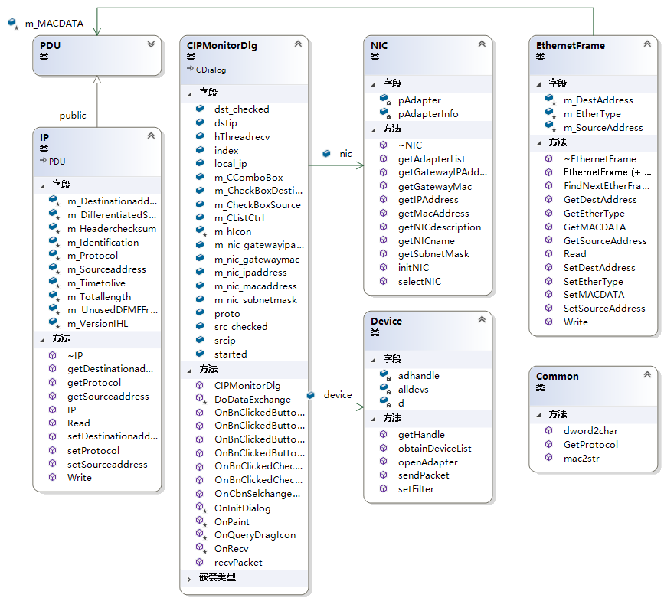

This is sequence diagram:
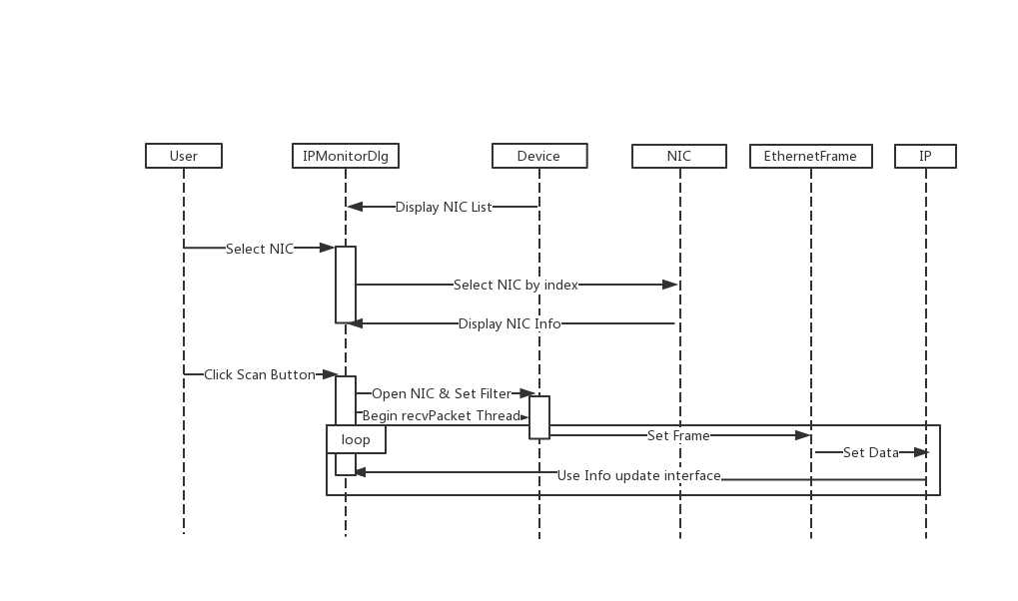

This is flow chart in IPMonitorDlg:

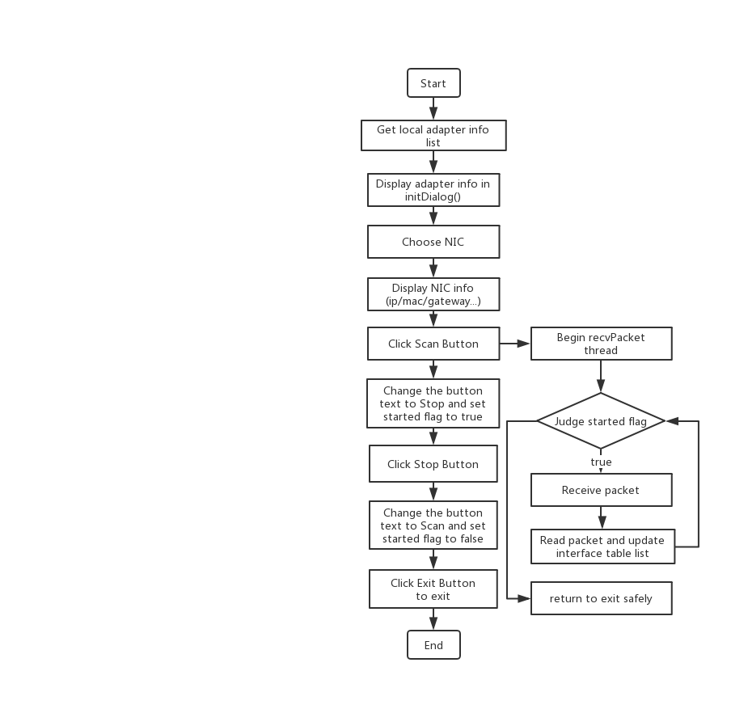

Section III Test Cases and Results Analysis

This is my test result:

- Select the NIC

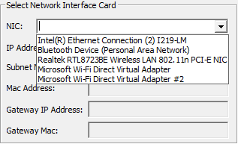

- Click Scan Button without checking source & destination box.
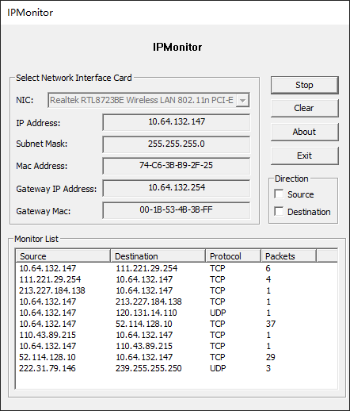

- Click Scan Button with checking source box.
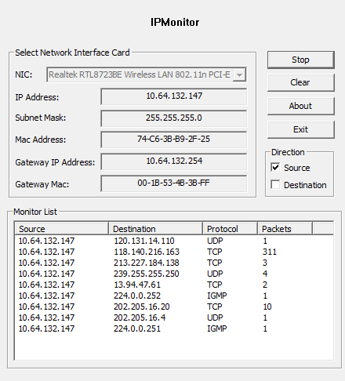

- Click Scan Button with checking destination box.
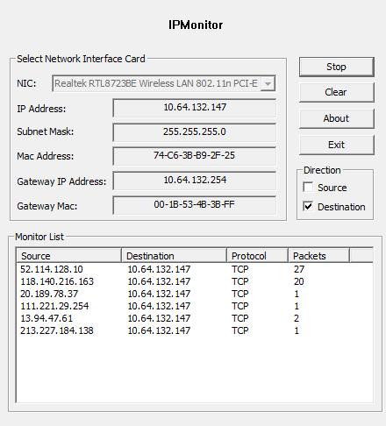
- Click Scan Button with checking source & destination box.
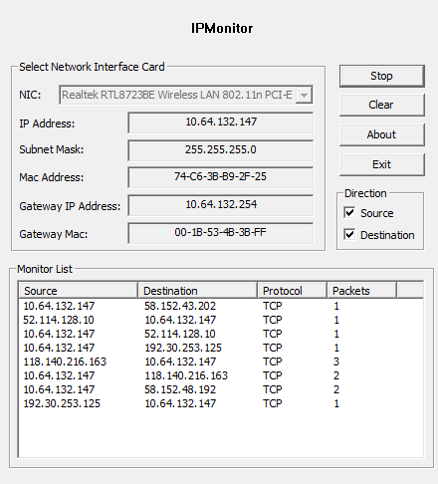

- Click About Button (This is my logo. XP )
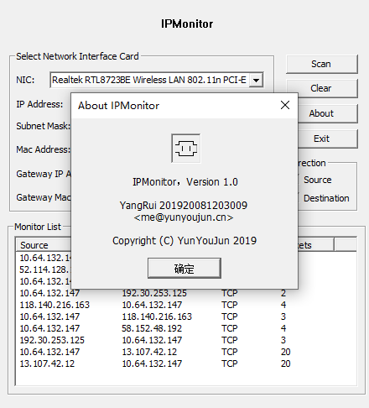
7. Click Clear Button to clear items in Monitor List.

Section IV Conclusion
Through this experiment, I have more deeper understanding of the operation of IP protocol and MFC framework. I learned how it worked and referred to some of the code on the web to implement it. At the same time, I made extensive use of classes and improved the re-usability of the program code. At first, I try to use DHTML to do data exchange, but something wrong. So I back to MFC components.
But due to my own programming ability is not enough, there are many difficulties in the process. For example, the bind select event is invalid. I have to use Combo-box to replace it. And check box is too.
Of course, when I actually did it, I felt a sense of accomplishment. But I also realized that my ability and proficiency needed to be further improved.

Section V References
- WinPcap: Exported function https://www.winpcap.org/docs/docs_40_2/html/group__wpcapfunc.html
- Unit 2 WinPcap.pdf http://tlc.cuc.edu.cn/Course/Course/showAction/id/30
- Unit 3 Multi-Threaded Programming.pdf http://tlc.cuc.edu.cn/Course/Course/showAction/id/30
- Unit 3.5 Introduction to Object-Oriented Analysis/Design/Programming.pdf http://tlc.cuc.edu.cn/Course/Course/showAction/id/30
- Unit 5 IP Monitoring.pdf http://tlc.cuc.edu.cn/Course/Course/showAction/id/30
- Multithreading: Terminating Threads in MFC | MSDN https://docs.microsoft.com/en-us/cpp/parallel/multithreading-terminating-threads?view=vs-2019
- Multithreading with C++ and MFC | MSDN https://docs.microsoft.com/en-us/cpp/parallel/multithreading-with-cpp-and-mfc?redirectedfrom=MSDN&view=vs-2019
- CListCtrl Class | MSDN https://docs.microsoft.com/en-us/cpp/mfc/reference/clistctrl-class?view=vs-2019
- EtherType: 以太网类型字段及值 ｜ CSDN https://blog.csdn.net/eydwyz/article/details/65446328

Section VI Appendix
This is the basic flow that matches the flowchart.(main content in IPMonitorDlg.cpp)

NIC\PDU\Device is same as last project.

Common.h (Common Helper)
It is used to convert some formats or get protocol.
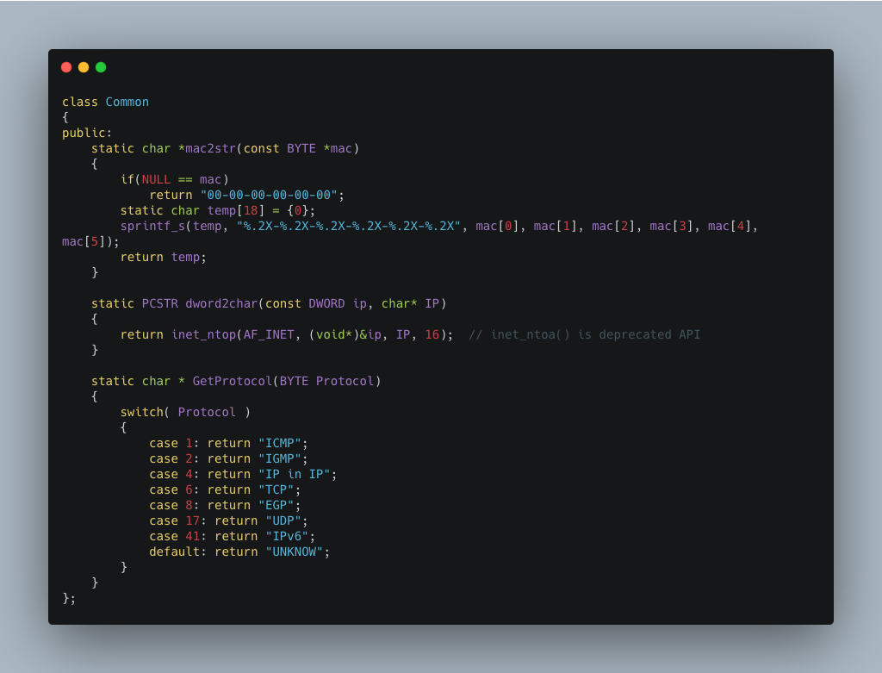

Bind Variable to MFC components:
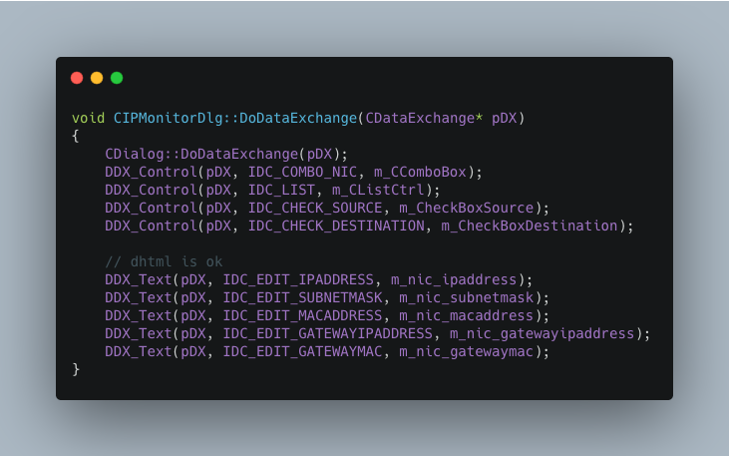

Bind Message with function:
WM_RECV message is used to trigger OnRecv function.
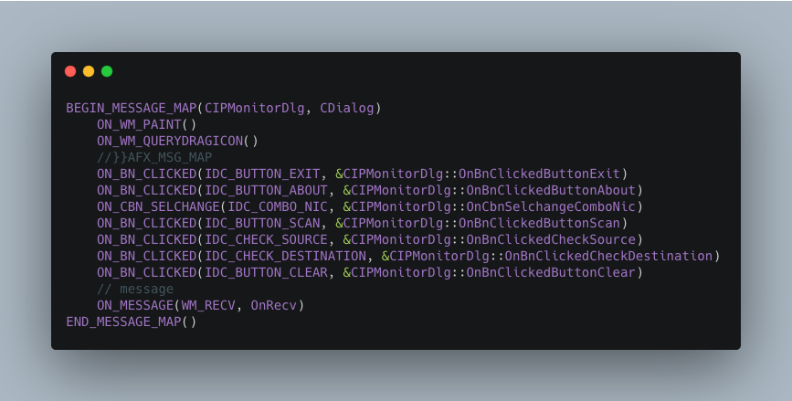
Init dialog (program interface):
And display NIC list info.
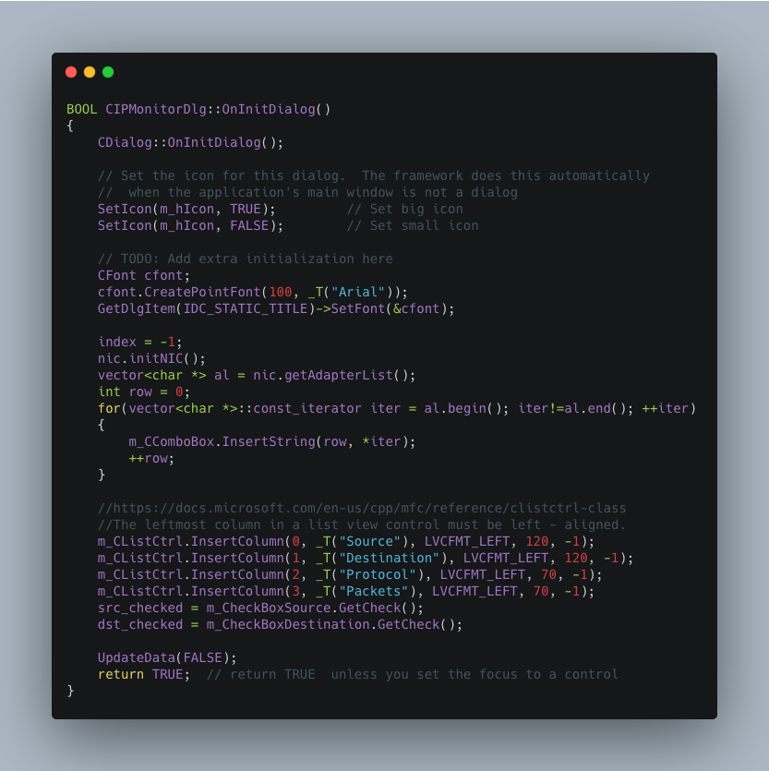

Scan funtion(Run when the scan button is clicked):
Create the thread of receiving packets.
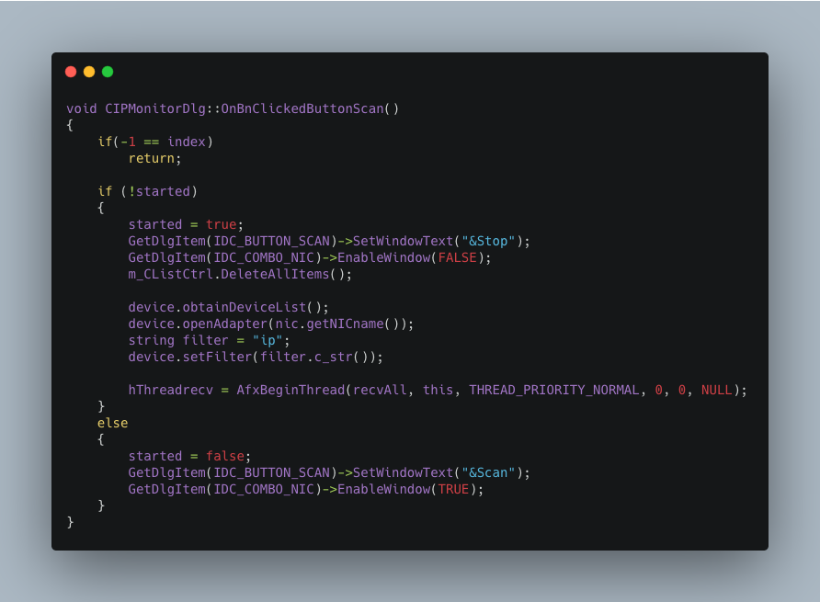

Receive packets and display it by the value of check box(source/destination).
It trigger a message to update interface.

We have three ways to end a thread.
For safety reasons and operation, I choose the way of judging started flag.

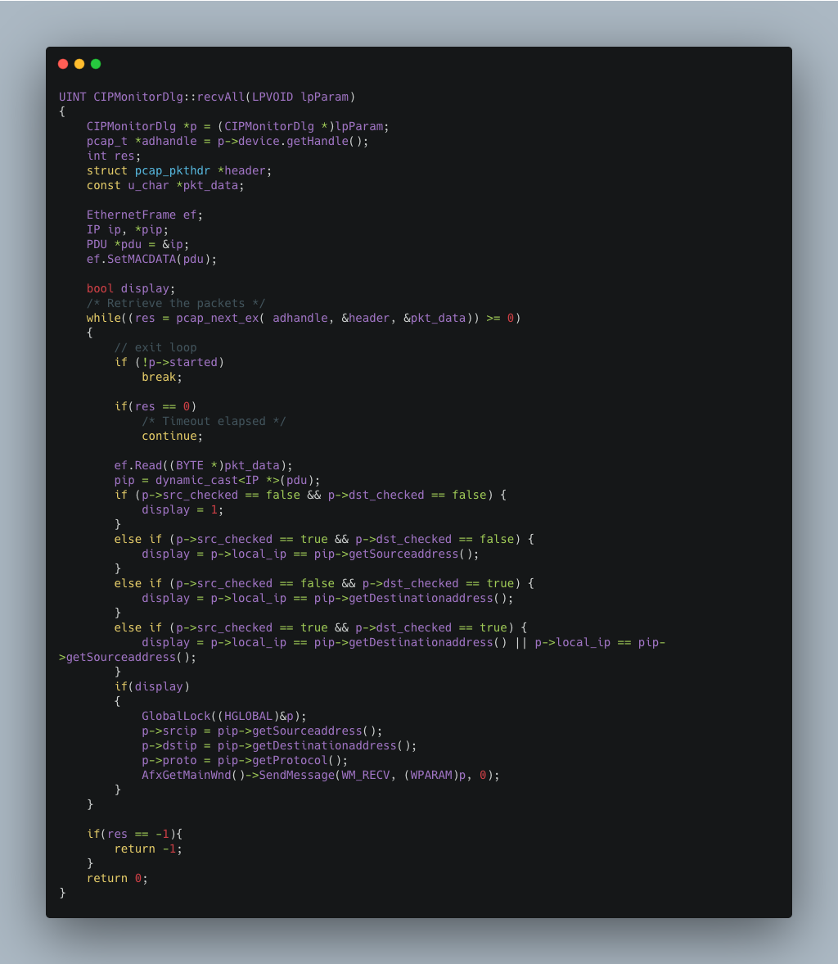

Loop to determine the rows that need to be changed and update interface.

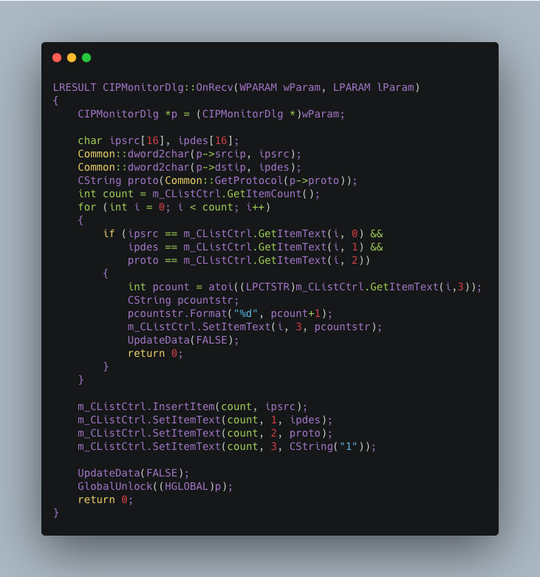
That's all the important parts, thank you for reading my report.

