LANScanner Project Report
Project No.3
Version 1.0
Student ID: 201920081203009 Student Name: Yang Rui
2019-10-13
College of Computer Science and Cybersecurity, CUC

I declare that the assignment here submitted is original except for source material explicitly acknowledged. I also acknowledge that I am aware of University policy and regulations on honesty in academic work, and of the disciplinary guidelines and procedures applicable to breaches of such policy and regulations.

Name: Yang Rui Student ID: 201920081203009
Notes:

Section I Problem Specification
The purpose of this project is to develop a software tool “LAN Scanner” that is used to discover all active hosts on a local area network with a user interface.This experiment is based on the last experiment PRJ02 arping.
Last program tests whether a given IP address is in use on the local network, and can get additional information (like MAC address) about the device using that address.
This program need scan and show the active hosts on the LAN.Although one or more network interface cards are installed on a computer, this program can scan by selecting one of NICs. The “Scan” function will be processed through threads, and post messages to the main thread for updating the user interface.
And more process info in the flowing chart.

This is Ethernet Frame Format (ARP Packet):
Destination address | Source address | Type 0x0806 | ARP Request or ARP Reply | Padding | CRC
6B | 6B | 2B | 28B | 18B | 4B

ARP Format:

Hardware type | Protocol type | Hardware address | Protocol address length | Operation code | Source hardware address | Source protocol address | Target hardware address | Target protocol address
2B | 2B | 1B | 1B | 2B | 6B | 4B | 6B | 4B

Section II Solution Method and Design

At first, we need install WinPcap. Download it and link it with VS 2019.
- Property Pages -> C/C++ -> General -> Additional Include Directories -> Add `..\WpdPack\Include`
- Property Pages -> Linker -> General -> Additional Library Directories -> Add `..\WpdPack\Lib`
- Property Pages -> Linker -> Input -> Additional Dependencies -> Add `wpcap.lib`&`ws2_32.lib`&`Iphlpapi.lib`

This is the project structure(use Object Oriented Programming with C++):

(I try to use DHTML to design the interface of MFC. So this project has a file called ‘LANScanner.htm’.)

Some files are automatically generated:

- Resource.h: define interface element id
- stdafx.h: precompiled header file
- LANScannerDlg.cpp: main dialog and control message and thread
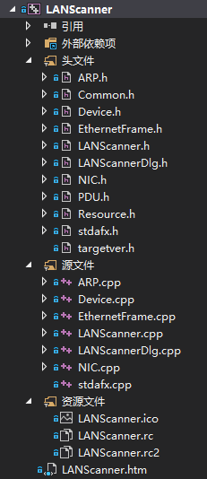

Class Common (Common Method and Lib)(In last project, I named it ‘Helper’.):

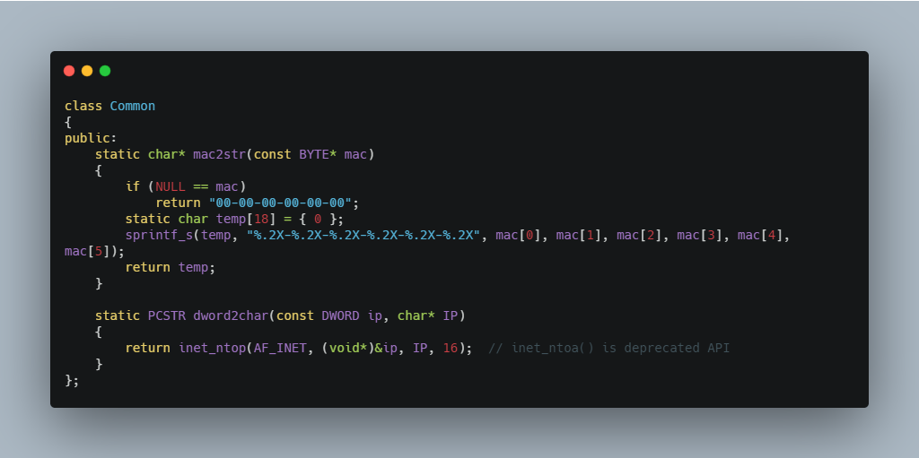

Class ARP:

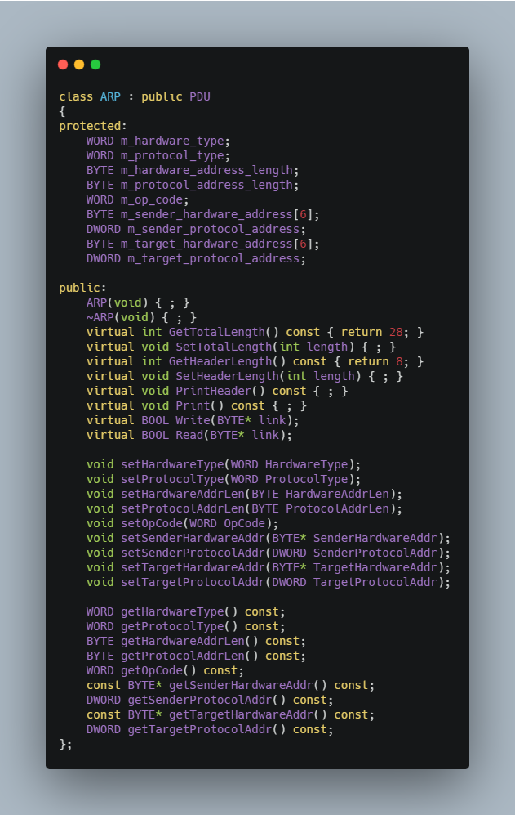

Class EthernetFrame:

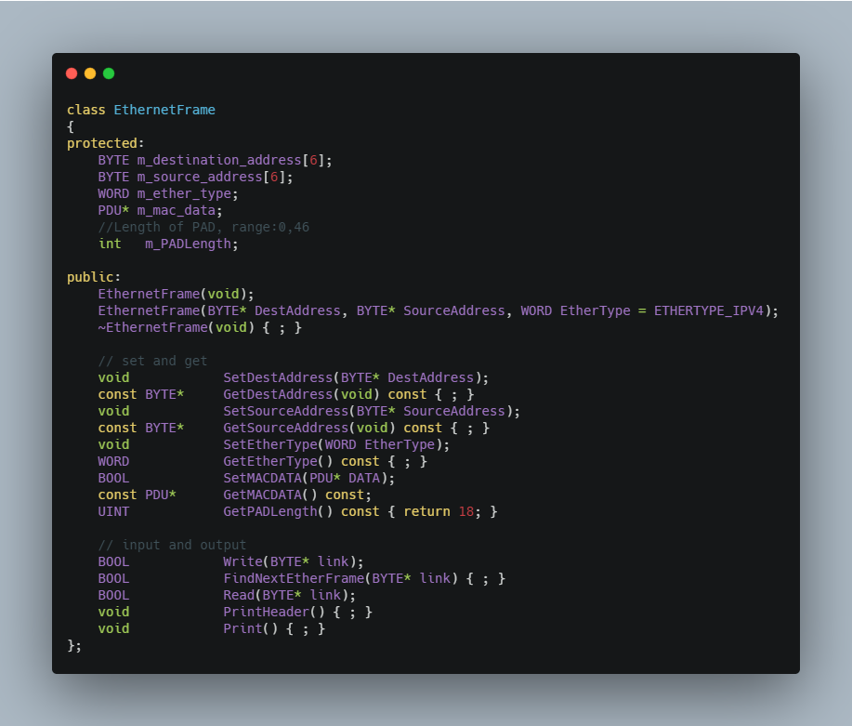

Class Device(I split Class PacketCapture in PRJ02 to class Device and class NIC):

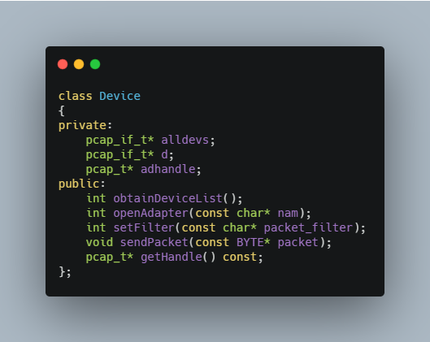

Class NIC:
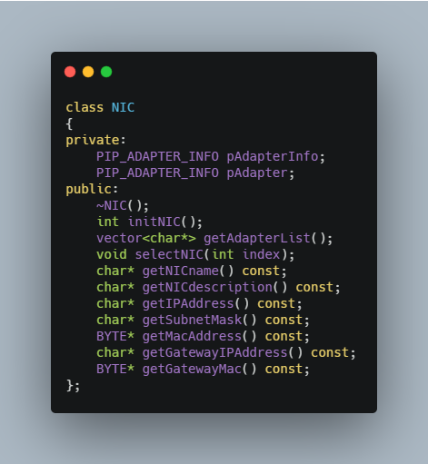

Class PDU(I add it because of the last class lecture of teacher):

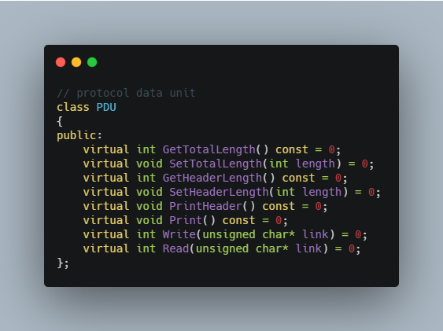
The main flow of LANScanner
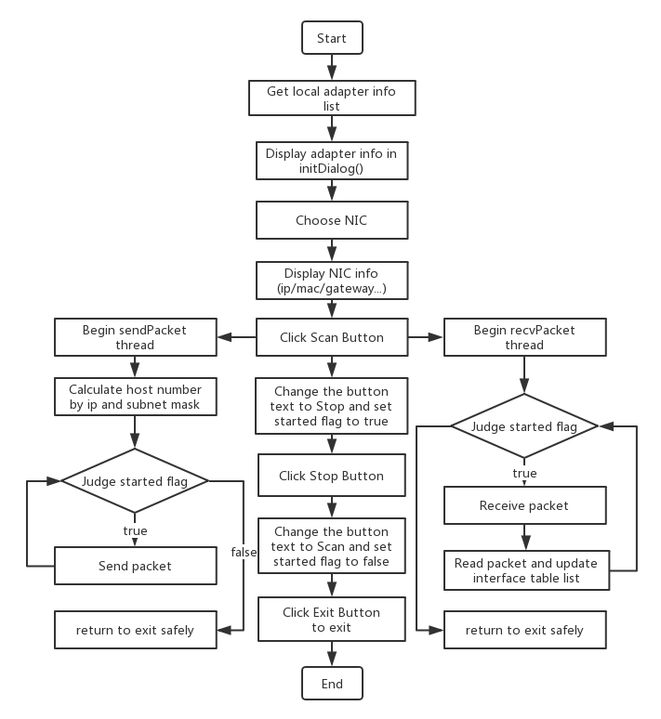

Section III Test Cases and Results Analysis

This is my test result:

- Select the NIC

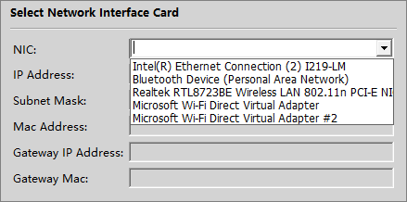

- Click Scan Button
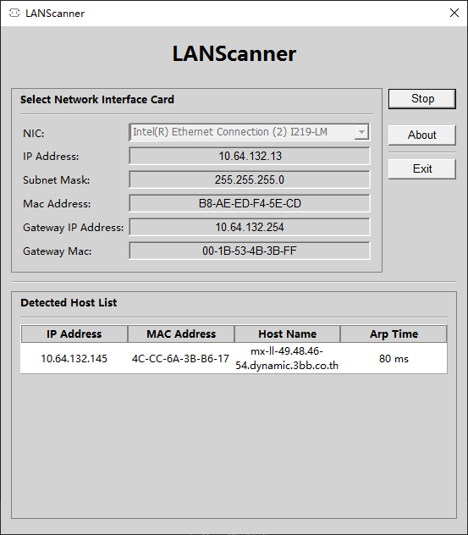
(My classmates all turned out bogon. I also use gethostbyaddr function, but I return this.
I find bogon mean adjective or false.)
- Click About Button (This is my logo. XP )

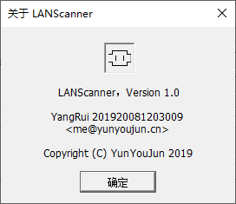

Section IV Conclusion
Through this experiment, I have more deeper understanding of the operation of ARP protocol and MFC framework. I learned how it worked and referred to some of the code on the web to implement it. At the same time, I made extensive use of classes and improved the reusability of the program code. I try to use DHTML to do data exchange and it worked.
But due to my own programming ability is not enough, there are many difficulties in the process. For example, the bind select event is invalid. I have to use Combo-box to replace it. And the host name is strange.
When I actually did it, I felt a sense of accomplishment.

Section V References
- WinPcap: Exported function https://www.winpcap.org/docs/docs_40_2/html/group__wpcapfunc.html
- Unit 2 ARP.pdf http://tlc.cuc.edu.cn/Course/Course/showAction/id/30
- Unit 2 WinPcap.pdf http://tlc.cuc.edu.cn/Course/Course/showAction/id/30
- Unit 3 Multi-Threaded Programming.pdf http://tlc.cuc.edu.cn/Course/Course/showAction/id/30
- IHTMLSelectElement Object https://docs.microsoft.com/en-us/previous-versions/office/developer/office-2003/aa209097(v%3doffice.11)
- Multithreading: Terminating Threads in MFC https://docs.microsoft.com/en-us/cpp/parallel/multithreading-terminating-threads?view=vs-2019
- Multithreading with C++ and MFC https://docs.microsoft.com/en-us/cpp/parallel/multithreading-with-cpp-and-mfc?redirectedfrom=MSDN&view=vs-2019
- DHtmlExplore 示例：演示 MFC DHtml 类的使用https://docs.microsoft.com/zh-cn/previous-versions/visualstudio/visual-studio-2008/cca2a89k%28v%3dvs.90%29
- CDHtmlDialog Class https://docs.microsoft.com/en-us/cpp/mfc/reference/cdhtmldialog-class?view=vs-2019

Section VI Appendix
This is the basic flow that matches the flowchart.(main content in LANScannerDlg.cpp)

Bind DHTML EVENT with button:
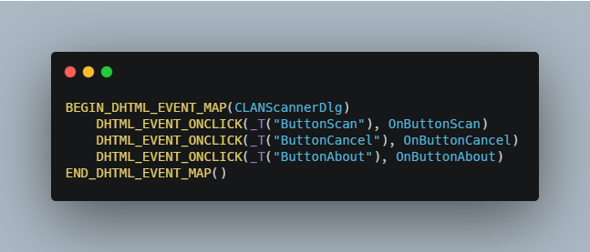

Binding DDX DHTML Variable:
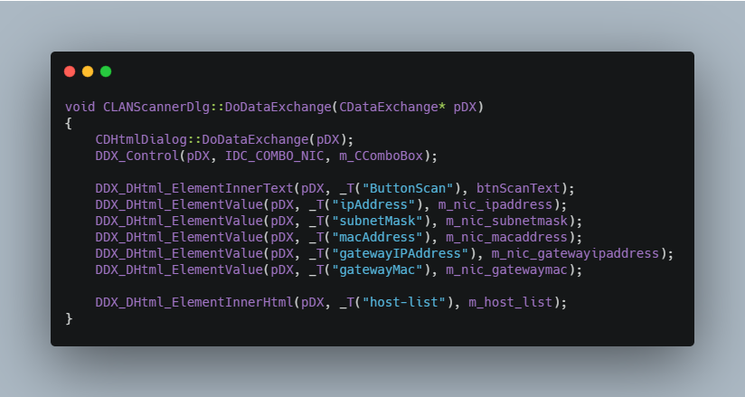
Bind Message with function:
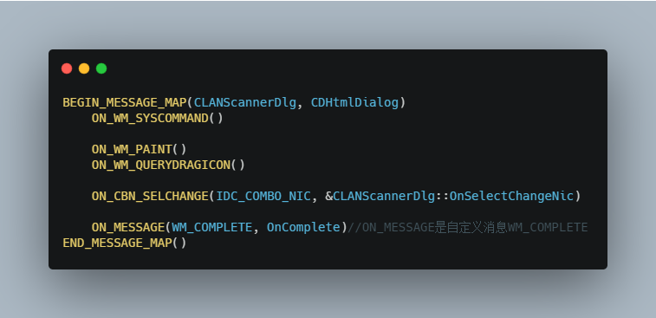

Init dialog (program interface):
And display NIC list info.
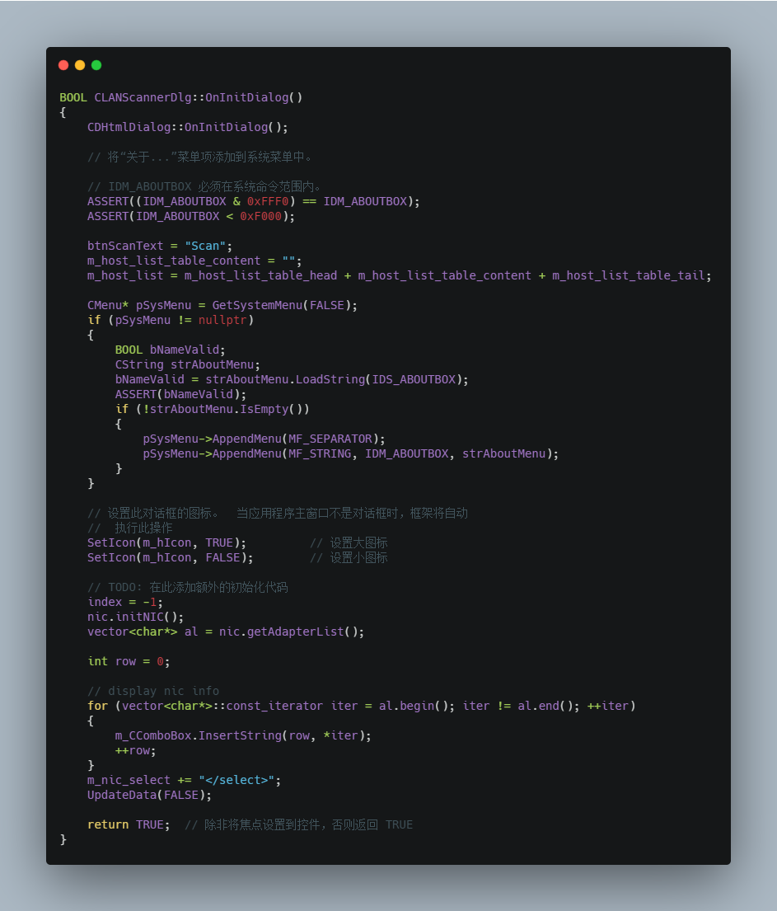

Display NIC info when change select:
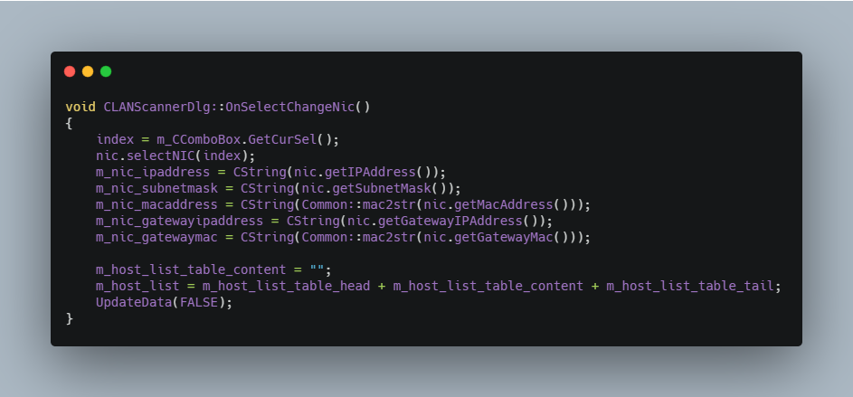

Scan funtion(Run when the scan button is clicked):

The comments at the end describes three ways to end a thread.
For safety reasons and operation, I choose the way of judging started flag.

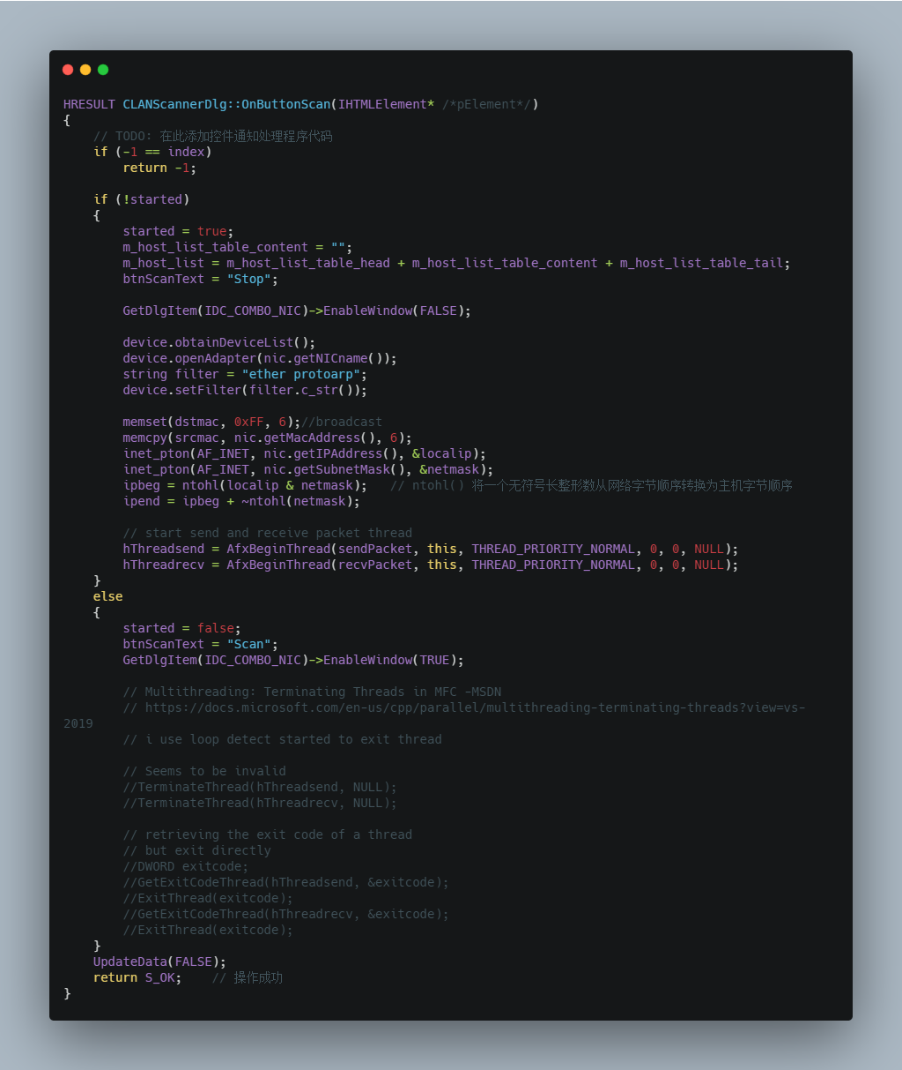

Send packet loop by judge started flag:
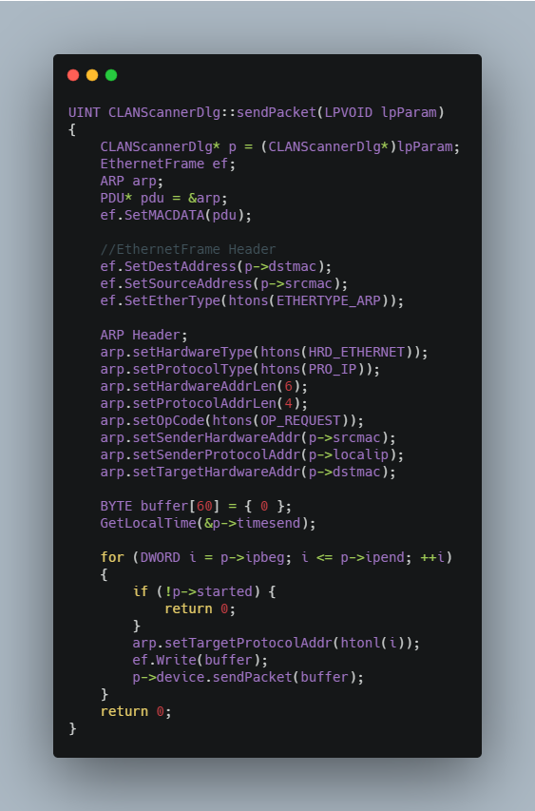

Receive packet by started flag and update interface by DHTML(table):
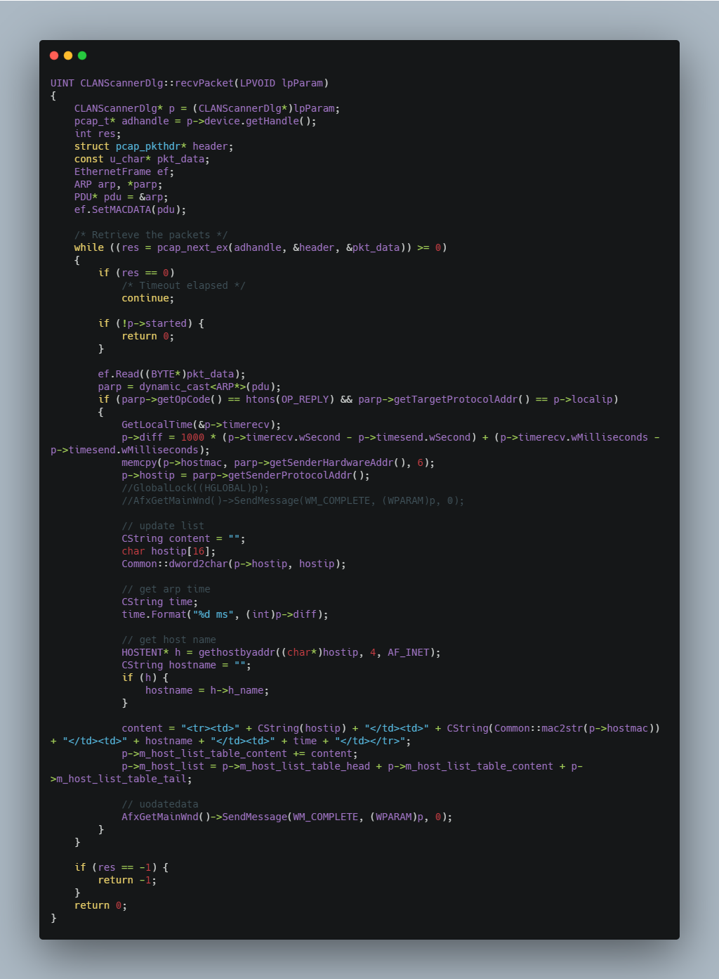

That's all the important parts, thank you for reading my report.

